

**POVIEW.AI Project Plan and Risk Register**

**Timeline**: April 2025 - March 2026

**TRL 3 (Completed) – Concept Validation**

* **Objective**: Test and validate the initial concept using OpenAI's general model with sample client data.
* **Key Tasks**: Process data samples from Product Documents, Marketing Collateral, and Client Statements.
* **Dependencies**: N/A (Initial Phase).

**TRL 4 (April 2025 - May 2025) – Dataset Acquisition and Model Architecture**

* **Objective**: Acquire a full training dataset, cleanse it, and implement the model architecture.
* **Key Tasks**:
  + Data acquisition and cleansing
  + Model architecture selection and implementation
  + Initial UX scoping and design
* **Dependencies**:
  + Completion of TRL 3 validation phase
  + Full acquisition of the training dataset
* **Risks**: Potential delays in data acquisition; challenges in finding suitable resources.

**TRL 5 (June 2025 - October 2025) – Model Training and UX Development**

* **Objective**: Train the model, conduct quality assurance, and refine the UX.
* **Key Tasks**:
  + Model training with curated datasets
  + Evaluation and optimization of content governance
  + Initial development of UX/application based on model insights
* **Dependencies**:
  + Successful completion of TRL 4 dataset acquisition and model architecture
* **Risks**: Resource availability; significant issues during beta testing; UX adjustments.

**TRL 6 (November 2025 - March 2026) – Final Testing and Beta Phase**

* **Objective**: Conduct legal and governance checks, beta testing, and finalize UX.
* **Key Tasks**:
  + Legal and regulatory compliance validation
  + Beta testing with partner feedback loops
  + Final UX and application development
* **Dependencies**:
  + Completion of TRL 5 model training and initial UX
* **Risks**: Compliance challenges; delays or issues with beta tester feedback; resource availability.

**Initial Commercial Launch (March 2026 onwards)**

* **Objective**: Launch with initial partner customers, onboard additional clients, and refine the application.
* **Key Tasks**:
  + Partner onboarding and customer support setup
  + Execution of go-to-market plan
  + Planning for V2 UX/application based on feedback
* **Dependencies**: Completion of TRL 6 and beta feedback incorporation
* **Risks**: Market entry challenges; onboarding issues; skilled resources demand.

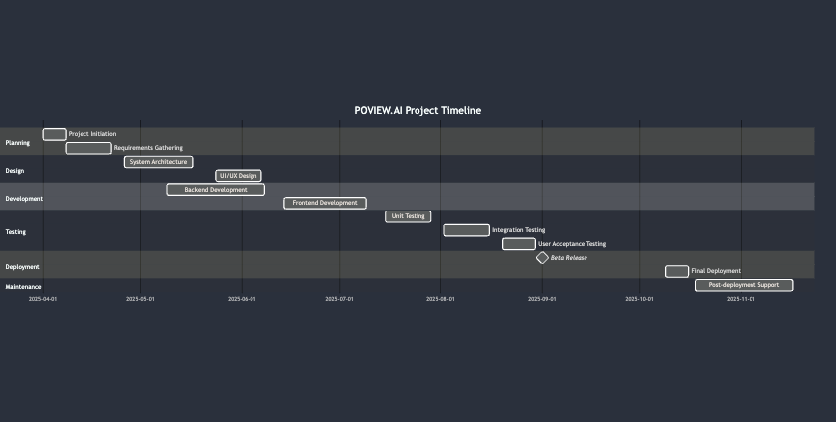

*We have allowed 5 months of contingency given the highly complex nature of AI development projects and to allow staff to take leave.*

**Risk Register**

|  |  |  |  |  |  |
| --- | --- | --- | --- | --- | --- |
| **Risk** | **Type** | **Likelihood** | **Impact** | **Mitigation Strategy** | **Interdependencies** |
| **Data Acquisition Delays** | **Technical** | **Medium** | **High** | **Formal data-sharing agreements with partners** | **Essential for TRL 4 dataset preparation** |
| **Right People Resources Availability** | **Managerial** | **Medium** | **High** | **Advance hiring strategy and use of external networks** | **Affects all TRLs and launch phases** |
| **Model Training Challenges** | **Technical** | **High** | **High** | **Implement iterative feedback and fallback models** | **Dependent on TRL 4 data acquisition** |
| **Significant Issues in Beta Testing** | **Technical** | **Medium** | **High** | **Allocate extra testing time; proactive issue tracking** | **Affects TRL 5-6 completion and timeline** |
| **Legal and Compliance Issues** | **Legal/Commercial** | **Medium** | **High** | **Engage legal counsel from project start, adhere to Consumer Duty guidelines** | **Linked to TRL 6 completion** |
| **Customer Onboarding Delays** | **Commercial** | **Medium** | **Medium** | **Develop customer support resources in advance** | **Essential for successful initial launch** |
| **Environmental Impact** | **Environmental** | **Low** | **Medium** | **Minimize energy use through cloud-based infrastructure** | **Not directly interdependent** |