IoT-BASED SMART HOME
MONITORING & AUTOMATION SYSTEM
Client Overview • Design, Components & Capabilities
Controller: ESP32 DevKit V1 • Low-voltage prototype • Wi-Fi phone control
Version 1.1 • August 2026 • Compact physical model (Living / Bedroom / Kitchen / Door)

Purpose — What this document is
A clear, non-technical overview of what will be built, which parts are used, how the rooms work, and what you can control from your phone. No budget tables, no wiring schematics — just the design and the features you will see in the demo.

1. Overview — What We Will Build
A compact, low-voltage smart-home model with four spaces — living room, bedroom, kitchen and main door — controlled by a single ESP32. Sensors are installed room-wise and wired to a central breadboard; the ESP32 handles all automation locally and exposes a Wi-Fi dashboard you open on your phone (same Wi-Fi, no app needed).
Monitoring  Temperature, humidity,  motion, light level,  door & gas level | Automation  Lights, fan & exhaust  run on sensor rules  with phone override | Security  Door alert when armed  & gas warning  with buzzer

2. System Architecture — Simple View
One controller, room sensors, relay-switched lights/fans, and your phone over Wi-Fi. The relay separates the ESP32 (control) from the loads (power) — the ESP32 never drives a fan/light directly.
PHONE / WEB DASHBOARD — Wi-Fi
│
▼
ESP32 DevKit V1 (central brain)
Sensors ─────┼───── Relay ───── Buzzer
DHT11 • PIR×2 • LDR×2 • MQ-2 • Reed CH1 Living Light • CH2 Bedroom Light • CH3 Room Fan • CH4 Exhaust
All automation runs on the ESP32 itself; the phone only monitors and sends manual commands. If Wi-Fi drops, local automation still works.

3. Components Included
Everything needed for the prototype — sensing, control, and the house model. All loads are low-voltage 5V DC.
Component | Qty | Purpose in Your Home
ESP32 DevKit V1 | 1 | Main controller + Wi-Fi — runs automation & hosts dashboard
DHT11 module | 1 | Measures temperature & humidity (living room)
PIR motion sensor (HC-SR501) | 2 | Detects person/movement — living room & bedroom
LDR light sensor | 2 | Measures brightness — decides if dark enough to turn lights on
MQ-2 gas/smoke module | 1 | Kitchen air-quality threshold — triggers exhaust + buzzer
Magnetic reed switch | 1 | Main-door open/closed detection
4-channel relay module | 1 | Switches lights & fans safely (ESP32 only sends signal)
5V mini DC fan | 2 | Room ventilation + kitchen exhaust
5V LED lights | 2–4 | Living & bedroom lights (and optional kitchen light)
Active buzzer | 1 | Beep for door-security & gas warning
Breadboard + jumper wires | 1 set | Central wiring — clean, labelled, reusable
5V power supply + USB cable | 1 | Powers the whole prototype
House model (foam/cardboard) | 1 set | 4-room physical model — sensors mounted inside

4. Room-Wise Design — Where Everything Goes
Living Room — PIR #1 + LDR #1 + DHT11 • Light (Relay CH1) + Fan (Relay CH3)
→ Auto light (motion + dark) • Temp-based fan • Manual override from phone
Bedroom — PIR #2 + LDR #2 • Light (Relay CH2)
→ Auto light (motion + dark) — same logic as living room
Kitchen — MQ-2 • Exhaust (Relay CH4) + Buzzer
→ Gas threshold → exhaust + buzzer — threshold set during demo warm-up
Main Door — Reed switch (magnet on door, switch on frame)
→ Shows OPEN/CLOSED • When armed, opening triggers buzzer

4a. Model Layout — Front & Top-Down (Real Use)
Door at front enters living room. From living you go to bedroom or kitchen. Exhaust at back wall.
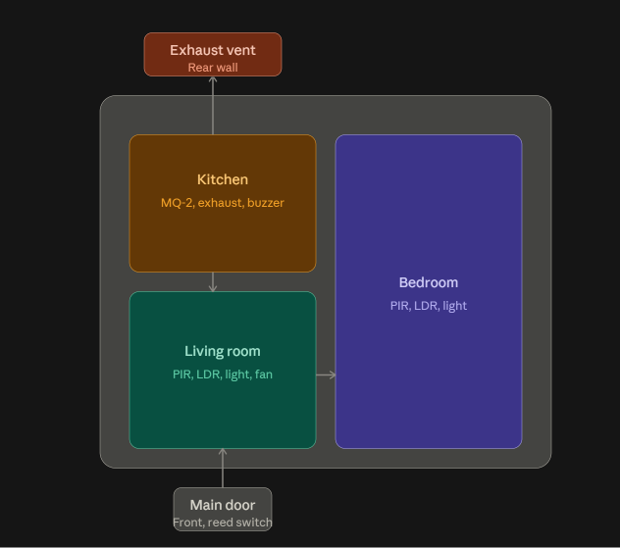

5. What It Will Do — Features You Will See
Six things your home will do — demonstrated live with the model and your phone side by side:
Capability | What Happens | How You Control It
🌡️ Temperature & Humidity | Live readings on the dashboard (living room) | View only — updates automatically
💡 Auto Lights | If someone moves AND the room is dark → light turns ON; turns OFF after ~30s with no motion | Auto, or tap ON/OFF on phone
🌀 Smart Fan | Turns ON when warm (~30 °C), OFF when cool (~28 °C) — avoids flickering | Auto, or manual ON/OFF
🚪 Door Security | Shows CLOSED/OPEN; when armed, opening the door triggers buzzer + alert | ARM / DISARM from phone
🔥 Gas / Smoke Warning | If MQ-2 crosses threshold → buzzer + kitchen exhaust turn ON | Auto — threshold set during warm-up
📱 Phone Dashboard | One web page shows all sensor values and buttons (no app to install) | Wi-Fi — open in any browser

All features work together — e.g., you can leave lights in AUTO while controlling the fan manually, or arm security at night while lights stay automatic.

6. How Automation Works — In Plain Language
Lights: Motion + Dark → ON • No motion for a while → OFF. The LDR prevents lights turning on in a bright room.
Fan: Two limits (30 °C and 28 °C) instead of one — so the fan doesn’t rapidly click ON/OFF near the threshold.
Door: Reed switch with magnet: door closed = quiet; door opened while ARMED = buzzer + “DOOR OPEN” on dashboard.
Kitchen: MQ-2 is a threshold sensor (not a lab meter). We warm it 2–3 min, note its clean-air level, then set a project threshold above that.
AUTO MODE  Sensors decide —  lights, fan & exhaust  follow the rules above | MANUAL MODE  You decide —  phone buttons directly  turn lights/fans ON/OFF

7. Phone Dashboard — What You Will See
A single web page hosted by the ESP32 — open it from any phone/laptop on the same Wi-Fi. No separate app, no Bluetooth, no paid cloud.
SMART HOME
Temperature : 28.4 °C Humidity : 63 %
Motion : Living / None Door : CLOSED Gas : NORMAL
────────────────────────────────────────────────────
Living Light [ ON ] Bedroom Light [ OFF ]
Room Fan [ ON ] Kitchen Exhaust [ OFF ]
Mode: AUTO Security: ARMED
- Top row: live temperature, humidity, motion, door and gas status.
- Middle: four buttons — Living Light, Bedroom Light, Room Fan, Kitchen Exhaust.
- Bottom: AUTO/MANUAL toggle and Security ARM/DISARM.
Your phone talks only to the ESP32 — not to each sensor separately. The ESP32 gathers sensor data and forwards it to the dashboard.

8. What You Will Receive
Deliverable | What It Means For You
Physical model | 4-room house with sensors mounted and labelled, electronics underneath/behind
ESP32 control unit | Breadboard circuit with ESP32, dividers, reed wiring, and relay beside the board
Relay-controlled loads | Lights and fans switching through the relay (low-voltage 5V only)
Phone dashboard | Wi-Fi web page with live readings and manual controls
Automation | All rules above running locally on the ESP32
Testing & handover | Full end-to-end demo + brief on how to operate and re-test each feature

Optional (on request): project report, presentation slides, viva/demo preparation.

9. Notes
- All lights and fans in the student prototype are low-voltage 5V DC — no 220V AC is introduced.
- The MQ-2 is demonstrated as a relative threshold (not a calibrated gas concentration) — shown safely without flame or gas leak.
- The ESP32 dashboard works on the local Wi-Fi; no internet, Bluetooth module, or paid service is needed for this prototype.
- The relay module isolates power: the ESP32 sends a small control signal; the relay does the switching.
- Optional future additions (camera, RFID, voice assistant, OLED, paid cloud) are possible later but are not needed to demonstrate this prototype.
ESP32 • Monitoring • Automation • Security • Phone Control — Compact, low-cost final-year prototype

