Project Report on:
Modified Geometric Symbiotic Organisms Search (G-SOS) Algorithm for Task Scheduling in Cloud Computing Environments



Submitted by
Rima Akter Antor Kumar Shil
B200305006 B200305016

Submitted to
Prof. Dr. Md. Abu Layek
Chairman
Department of Computer Science & Engineering
Jagannath University

Course Name : Cloud Computing Lab
Course Code : CSEL-4230
Date : 27 August 2026

Abstract
Efficient task scheduling is one of the most critical challenges in cloud computing, directly influencing makespan,operational cost,load balance and overall quality of service. Nature-inspired metaheuristic algorithms have emerged as powerful tools for solving this NP-hard resource allocation problem. This report presents a comprehensive study of the Symbiotic Organisms Search(SOS) algorithm and a Modified Geometric SOS(G-SOS) variant,applied to multi-objective task scheduling across heterogeneous virtual machines(VMs) in a simulated cloud data center built using the CloudSim toolkit.
The proposed G-SOS algorithm modifies the classical mutualism phase by replacing the arithmetic mean with a geometric mean when computing the mutual relationship vector between organisms and widens the commensalism benefit factor to the range [0.4, 0.9]. A composite multi-objective fitness function is formulated, combining makespan(40%), infrastructure cost(30%), degree of imbalance or DOI(20%) and average response time(10%), enabling the scheduler to balance performance and economic objectives simultaneously rather than optimizing a single metric in isolation.
Two independent experiments were conducted.The first experiment schedules 50 heterogeneous cloudlets across 5 heterogeneous VMs using the full multi-objective fitness function,achieving a final makespan of 711.06 seconds and a total infrastructure cost of $5,092.26. The second experiment directly compares Traditional SOS against Modified G-SOS on a larger workload of 100 cloudlets over 100 optimization iterations, using a fixed random seed for fairness.Results show that G-SOS reduces the Degree of Imbalance by approximately 50.6% (from 0.0195 to 0.0097) and marginally improves makespan (69.04s to 68.93s),at a negligible cost trade-off of less than 0.1%. These findings indicate that the geometric-mean-based mutualism strategy meaningfully improves load distribution fairness across VMs without sacrificing scheduling efficiency.
This report documents the system model,algorithmic design,CloudSim implementation,experimental methodology and a detailed analysis of the results and concludes with observations on limitations and directions for future work.

Table of Contents
1. Introduction 3
2. Background and Literature Review 5
3. Problem Statement and Objectives 6
4. System Model 7
5. Proposed Methodology 8
6. Multi-Objective Fitness Function 9
7. CloudSim Simulation Environment 10
8. Experiment 1: G-SOS Multi-Objective Scheduling (50 Tasks) 11
9. Experiment 2: Comparative Analysis — SOS vs. G-SOS (100 Tasks) 12
10. Results Discussion and Analysis 14
11. Limitations 15
12. Conclusion and Future Work 15
13. References 16

1. Introduction
Cloud computing has become the backbone of modern IT infrastructure,offering on-demand,elastic and pay-as-you-go access to computing resources such as virtual machines(VMs), storage, and networks. As the number of users and applications submitted to cloud data centers grows,the problem of assigning incoming tasks (cloudlets) to available VMs — known as task scheduling — becomes increasingly important. A poor scheduling decision can lead to long execution times(makespan),unnecessarily high infrastructure costs and uneven utilization of resources,where some VMs are overloaded while others remain idle.
Task scheduling in a heterogeneous cloud environment is classified as an NP-hard combinatorial optimization problem,because the number of possible task-to-VM mappings grows exponentially with the number of tasks and machines.Exhaustive search is computationally infeasible for realistic workloads,which motivates the use of heuristic and metaheuristic optimization techniques capable of finding near-optimal solutions within a reasonable time budget.
Among nature-inspired metaheuristics,the Symbiotic Organisms Search(SOS) algorithm has attracted attention because,unlike Genetic Algorithms(GA) or Particle Swarm Optimization(PSO),it does not require algorithm-specific control parameters(such as mutation rate, crossover rate or inertia weight),which simplifies tuning while retaining strong exploration and exploitation capability.SOS models the symbiotic interactions — mutualism, commensalism and parasitism — that occur between pairs of organisms in an ecosystem as they strive to improve their fitness for survival.
This project investigates a Modified Geometric SOS(G-SOS) variant designed specifically for multi-objective cloud task scheduling.The modification replaces the arithmetic-mean-based mutual vector of the mutualism phase with a geometric mean,which is theoretically better suited to balancing multiplicative relationships between VM workloads and widens the commensalism benefit factor range to encourage a more thorough exploration of the solution space. The algorithm is implemented and evaluated inside the CloudSim simulation toolkit,a widely used,open-source Java framework for modeling cloud infrastructures and evaluating resource provisioning and scheduling policies without the cost of deploying a real data center.

1.1 Motivation
As cloud workloads scale, providers face conflicting goals:minimizing the total time taken to complete all tasks (makespan),minimizing the monetary cost charged to run those tasks on billed VM instances and maintaining a fair,balanced load distribution across all available machines to avoid hotspots and premature hardware wear. Single-objective schedulers that only minimize makespan or only minimize cost often produce solutions that are poor on the other axis.This motivates a multi-objective formulation that expresses scheduling quality as a weighted combination of makespan,cost,load imbalance and response time.

1.2 Report Organization
Section 2 reviews background concepts and related metaheuristic scheduling approaches.Section 3 states the problem and objectives.Section 4 describes the system model.Section 5 details the proposed SOS and G-SOS methodology.Section 6 formalizes the multi-objective fitness function.Section 7 describes the CloudSim simulation environment and configuration.Sections 8 and 9 present the two experiments and their results. Section 10 discusses and interprets the findings.Section 11 notes limitations and Section 12 concludes with directions for future work.

2. Background and Literature Review

2.1 Task Scheduling in Cloud Computing
Task scheduling refers to the process of mapping a set of independent or dependent tasks onto a set of available computing resources such that one or more performance objectives are optimized. In cloud environments this is complicated by resource heterogeneity — VMs may differ in processing speed (MIPS), memory, bandwidth, and price per second — and by the dynamic,on-demand nature of task arrivals. Traditional scheduling heuristics such as First-Come-First-Served(FCFS),Round Robin and Min-Min/Max-Min offer simplicity and low computational overhead but generally fail to produce globally near-optimal solutions for large, heterogeneous workloads,since they make greedy,local decisions without a global fitness landscape to guide the search.

2.2 Metaheuristic Approaches
To overcome the limitations of greedy heuristics,researchers have applied population-based metaheuristic algorithms inspired by natural and biological phenomena,including:
- Genetic Algorithm (GA) — evolves a population of candidate schedules using selection,crossover and mutation operators.
- Particle Swarm Optimization (PSO) — models the social behavior of bird flocks,where each particle adjusts its position based on its own and the swarm's best-known positions.
- Ant Colony Optimization (ACO) — simulates pheromone-based path selection among cooperating ants to discover efficient schedules.
- Symbiotic Organisms Search (SOS) — models mutualism,commensalism and parasitism relationships between pairs of organisms in an ecosystem and is the base algorithm extended in this work.
A key practical advantage of SOS over GA and PSO is that it has no algorithm-specific tuning parameters beyond the ecosystem size and the number of iterations,which reduces the risk of poor performance due to badly chosen hyperparameters and makes it attractive for rapid deployment in cloud brokers.

2.3 The Symbiotic Organisms Search (SOS) Algorithm
SOS,originally proposed by Cheng and Prayogo(2014),simulates an ecosystem of organisms,each representing a candidate solution to the optimization problem.In the context of task scheduling,each organism is encoded as an integer vector of length equal to the number of tasks,where each element indicates the VM assigned to that task.The algorithm iteratively improves the ecosystem through three biologically inspired phases:
- Mutualism — two randomly selected organisms interact to mutually improve their fitness,analogous to bees and flowers,using a "mutual vector" that represents their shared characteristics.
- Commensalism — one organism benefits from interacting with another without affecting the other's fitness,analogous to remora fish attaching to sharks.
- Parasitism — one organism (the "parasite") attempts to replace another organism in the ecosystem if it produces a better fitness value,analogous to a parasite competing with its host for survival.
These three phases are applied to every organism in every iteration,progressively driving the ecosystem toward better regions of the search space while the algorithm retains the single best solution found so far (the "best organism") to guide subsequent updates.

2.4 Geometric Mean Motivation for G-SOS
The standard mutualism phase computes the mutual vector as the arithmetic mean of the two interacting organisms. In a multiplicative or ratio-based search space — such as VM workload distributions,where relative proportions between machine loads matter more than raw differences — the geometric mean can represent the "central tendency" of the pair more faithfully,since it is less sensitive to large outlying values and preserves multiplicative relationships.This observation motivates the G-SOS modification evaluated in this report,where the mutual vector is computed as the geometric mean of the two organisms' encoded VM assignments.

3. Problem Statement and Objectives

3.1 Problem Statement
Given a set of n independent tasks (cloudlets) T = {t₁, t₂, ..., tₙ} and a set of m heterogeneous virtual machines V = {v₁, v₂, ..., vₘ},each with a distinct processing capacity(measured in Million Instructions Per Second, MIPS) and a distinct cost per second of usage,the objective is to determine an assignment(mapping) of each task to exactly one VM that jointly minimizes:
- Makespan — the total time required for the last task to finish execution across all VMs.
- Infrastructure Cost — the total monetary cost incurred from executing all tasks on their assigned(billed) VMs.
- Degree of Imbalance (DOI) — a measure of how unevenly the workload is distributed across VMs.
- Average Response Time — the average waiting-plus-execution time experienced by tasks queued on a VM.
Because these four objectives are frequently in tension with one another(for example,minimizing cost may push more tasks onto slower,cheaper VMs,which increases makespan and imbalance),the problem is treated as a multi-objective optimization problem,solved here using a weighted-sum scalarization approach.

3.2 Objectives of This Study
- Design and implement a Modified Geometric SOS(G-SOS) algorithm for multi-objective cloud task scheduling.
- Formulate a composite fitness function that balances makespan,cost,load imbalance and response time.
- Implement the scheduler within the CloudSim simulation toolkit using a realistic heterogeneous data center model.
- Empirically evaluate G-SOS against the Traditional SOS baseline on a larger workload under identical, seed-controlled experimental conditions.
- Analyze the trade-offs between makespan,cost and load balance achieved by each algorithm,and report the resulting performance improvements.

4. System Model
The simulated cloud data center consists of a single Datacenter entity containing one physical Host with 10 processing elements(PEs),each rated at 4000 MIPS,32 GB of RAM and 50 Gbps of bandwidth(Experiment 1 configuration),following the standard CloudSim resource abstraction.On top of this host,a fixed number of heterogeneous VMs are provisioned and cloudlets(tasks) are submitted through a broker that mediates all communication between the user,the scheduler and the datacenter.

4.1 Virtual Machine Configuration
Five VMs are configured with distinct MIPS ratings and per-second costs to model a realistic heterogeneous cloud tier,ranging from low-cost/low-performance to high-cost/high-performance instances:
VM ID | MIPS (Exp. 1) | MIPS (Exp. 2) | Cost / sec | RAM (MB) | Scheduler
VM 0 | 1000 | 1000 | $1.50 | 512 | Time-Shared
VM 1 | 1500 | 2000 | $2.50 | 512 | Time-Shared
VM 2 | 2000 | 1500 | $3.50 | 512 | Time-Shared
VM 3 | 1200 | 2500 | $2.00 | 512 | Time-Shared
VM 4 | 1800 | 1200 | $4.00 | 512 | Time-Shared
Table 4.1 — Heterogeneous VM configuration used across the two experiments.
Notably,VM cost is not strictly proportional to MIPS(e.g.,VM 4 has a high cost of $4.00/sec but a mid-range MIPS rating),which intentionally prevents a trivial "always pick the fastest/cheapest VM" strategy and forces the scheduler to genuinely balance the competing objectives.

4.2 Cloudlet(Task) Model
Each cloudlet is generated with a randomized instruction length between 2,000 and 10,000 million instructions, along with fixed file and output sizes of 300 bytes and is executed under a full-utilization CPU model. Experiment 1 generates 50 cloudlets;Experiment 2 generates 100 cloudlets,both using a fixed random seed to ensure the comparison between algorithms is conducted on identical workloads.

4.3 Encoding of a Candidate Solution
Each candidate solution("organism") in the ecosystem is represented as an integer array of length n(the number of tasks),where the value at index i denotes the ID of the VM assigned to task i.This direct encoding allows the SOS/G-SOS update rules — originally designed for continuous-valued optimization — to be discretized via rounding and modulo operations,mapping any real-valued update back into a valid VM index in the range [0, m-1].

5. Proposed Methodology
Both the Traditional SOS and the Modified G-SOS share the same overall ecosystem-based structure but differ in how the mutualism and commensalism update equations are computed.An ecosystem of 30 organisms is evolved over 100 iterations for both algorithms and in every iteration each organism undergoes all three symbiotic phases described below.

5.1 Initialization
The ecosystem is initialized with 30 organisms,each an integer vector of random VM assignments drawn uniformly from [0, m-1].The fitness of every organism is evaluated once at initialization and the organism with the lowest(best) fitness is stored as the current global-best solution.

5.2 Phase 1 — Mutualism
For each organism i,a distinct partner organism j is selected at random.A mutual vector is computed to represent the shared characteristics of the pair:
Traditional SOS: MutualVector = (Organismᵢ + Organismⱼ) / 2 (arithmetic mean)
Modified G-SOS: MutualVector = √(Organismᵢ × Organismⱼ) (geometric mean)
Two random benefit factors,BF₁ and BF₂ (each randomly 1 or 2), represent the degree to which each organism benefits from the interaction.New candidate positions are then generated by nudging each organism toward the global-best organism,offset by the mutual vector,scaled by a random step(uniform random values for SOS's baseline update and in the reference G-SOS implementation,a Gaussian-distributed random step for finer-grained local search).Each new candidate replaces its parent only if it achieves a strictly better(lower) fitness value — an elitist,greedy acceptance criterion that guarantees the ecosystem's overall fitness never degrades.

5.3 Phase 2 — Commensalism
A second random partner is selected,and a new candidate is generated by shifting organism i toward the difference between the global-best organism and the partner,scaled by a random factor:
- Traditional SOS draws this factor uniformly from the range [−1.0, 1.0],permitting movement in either direction relative to the partner.
- Modified G-SOS restricts this factor to the narrower,strictly positive range [0.4, 0.9],biasing the search to move consistently toward the global-best solution and reducing destabilizing large jumps.
As in the mutualism phase,the newly generated candidate replaces organism i only if its fitness improves.

5.4 Phase 3 — Parasitism
A "parasite" vector is created by cloning organism i and randomly mutating a single task's VM assignment.A third random organism (the "host") is selected and if the parasite achieves a better fitness than the host,the parasite replaces the host in the ecosystem.This phase is identical for both SOS and G-SOS and serves as a mutation-like operator that helps the algorithm escape local optima.

5.5 Elitism and Termination
After every phase,the algorithm checks whether the updated organisms have produced a new global-best fitness value and updates the recorded best organism accordingly.This process(mutualism → commensalism → parasitism,applied to every organism in the ecosystem) repeats for 100 iterations, after which the best organism found represents the final task-to-VM scheduling decision.

5.6 Summary of Algorithmic Differences
Component | Traditional SOS | Modified G-SOS
Mutual vector | Arithmetic mean of pair | Geometric mean of pair
Mutualism step size | Uniform random [0,1] | Gaussian-distributed random step
Commensalism factor range | [−1.0, 1.0] | [0.4, 0.9] (positive-biased)
Parasitism phase | Single random mutation | Single random mutation (unchanged)
Ecosystem size / iterations | 30 / 100 | 30 / 100
Table 5.1 — Side-by-side summary of algorithmic modifications introduced in G-SOS.

6. Multi-Objective Fitness Function
To jointly account for time efficiency,cost efficiency and fairness of resource utilization,the primary experiment(Experiment 1) defines a weighted-sum multi-objective fitness function evaluated for every candidate organism:
Fitness = 0.4 × Makespan + 0.3 × TotalCost + 0.2 × DOI + 0.1 × AvgResponseTime
The weighting scheme prioritizes makespan(40%) as the dominant quality-of-service metric,followed by cost (30%) to reflect the economic relevance of cloud billing,with load balance (20%) and responsiveness(10%) contributing secondary but non-negligible influence.The comparative experiment(Experiment 2) isolates makespan as the primary fitness signal driving the search,while cost and DOI are computed post-hoc on the final best solution for comparison purposes — allowing a cleaner,controlled evaluation of how the mutualism/commensalism modifications alone affect scheduling quality.

6.1 Component Definitions
- Makespan — maxⱼ(Σ execTime of tasks assigned to VMⱼ), i.e.,the completion time of the most heavily loaded VM.
- Total Cost — Σᵢ (execTimeᵢ × costPerSecond of the VM assigned to task i),summed across all tasks.
- Degree of Imbalance (DOI) — (maxLoad − minLoad) / averageLoad across all VMs; a DOI of 0 indicates perfectly even load distribution.
- Average Response Time — the mean,across all tasks,of the cumulative workload already queued on a task's assigned VM at the time it is scheduled(approximating queuing delay).

7. CloudSim Simulation Environment
CloudSim is an open-source,Java-based discrete-event simulation framework for modeling cloud computing infrastructures,including data centers,hosts,virtual machine provisioning and cloudlet(task) scheduling policies, without requiring access to a physical cloud testbed.It was selected for this study because it allows precise, reproducible control over resource heterogeneity,cost models and workload characteristics — conditions that are difficult to guarantee on a real,shared,multi-tenant cloud platform.

7.1 Datacenter and Host Configuration
Parameter | Experiment 1 | Experiment 2
Number of Hosts | 1 | 1
Processing Elements (PEs) | 10 × 4000 MIPS | 10 × 4000 MIPS
Host RAM | 32,768 MB | 16,384 MB
Host Bandwidth | 50,000 Mbps | 25,000 Mbps
Host Storage | 2,000,000 MB | 1,000,000 MB
VM Scheduler | Time-Shared | Time-Shared
VM Allocation Policy | Simple (VmAllocationPolicySimple) | Simple (VmAllocationPolicySimple)
Table 7.1 — Datacenter and host parameters for both experiments.

7.2 Broker and Workflow
A single DatacenterBroker entity mediates the entire simulation lifecycle:it registers the VM list and cloudlet list with CloudSim,waits for the G-SOS/SOS optimizer to compute the best task-to-VM mapping,assigns each cloudlet's VM ID according to that mapping and then triggers CloudSim.startSimulation() to execute the discrete-event simulation.After the simulation completes,the broker retrieves the list of successfully completed cloudlets,from which the actual simulated makespan,execution times and costs are derived.

7.3 Software and Tools
- Simulation Toolkit: CloudSim (Java-based discrete-event cloud simulator)
- Programming Language: Java (algorithm and simulation logic)
- Data Export: CSV files (scheduling_comparison.csv,simulation_results.csv)
- Post-processing and Visualization: Python (pandas, seaborn, matplotlib) for chart generation from exported CSV results

8. Experiment 1: G-SOS Multi-Objective Scheduling (50 Tasks)
The first experiment evaluates the Modified G-SOS algorithm in isolation,using the full multi-objective fitness function described in Section 6,on a workload of 50 heterogeneous cloudlets scheduled across 5 heterogeneous VMs.The ecosystem size(30) and iteration count(100) match the configuration described in Section 5.

8.1 Final Task Allocation
After optimization,the best organism found by G-SOS distributed the 50 tasks across the VMs as follows:
VM ID | Tasks Allocated | Total Execution Time (s) | Total Cost ($) | Cost / sec
VM 0 | 8 | 348.22 | 522.34 | $1.50
VM 1 | 12 | 485.19 | 1,212.97 | $2.50
VM 2 | 18 | 711.06 | 2,488.67 | $3.50
VM 3 | 12 | 434.14 | 868.28 | $2.00
VM 4 | 0 | 0.00 | 0.00 | $4.00
Table 8.1 — Final task distribution, cumulative execution time, and cost per VM (Experiment 1).
The total infrastructure cost across all 50 tasks was $5,092.26, and the final simulated makespan — determined by the most heavily loaded VM (VM 2) — was 711.06 seconds.Individual task execution times ranged from 20.45 to 50.93 seconds,with an average of 39.57 seconds per task.

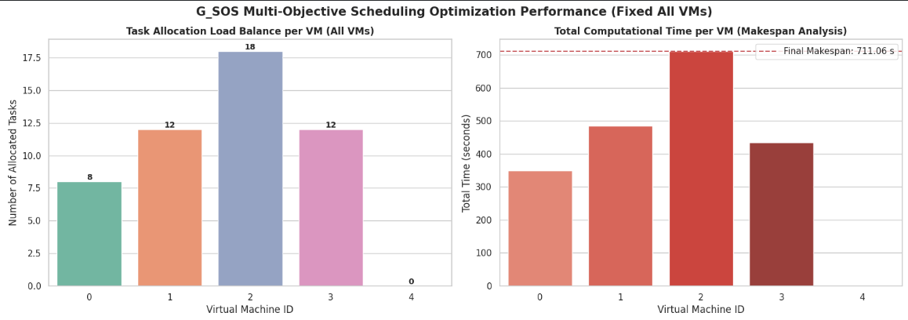

Figure 8.1 — Task allocation load balance per VM (left) and total computational time per VM with final makespan marker (right).
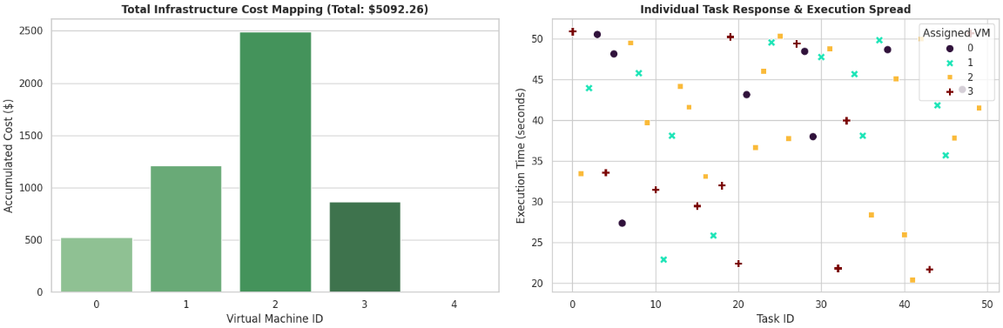
Figure 8.2 — Total infrastructure cost mapping per VM (left) and individual task response/execution spread by assigned VM (right).

8.2 Observations
- VM 2,despite having the highest per-second cost ($3.50) and second-highest MIPS rating, received the largest task share (18 of 50), making it both the cost and makespan bottleneck of the schedule.
- VM 4,the most expensive instance ($4.00/sec),received zero tasks — the multi-objective fitness function successfully avoided the least cost-efficient machine entirely.
- VM 0,the lowest-cost and lowest-MIPS VM,received the fewest tasks (8),executing them in the shortest cumulative time(348.22s),reflecting an efficient low-cost allocation.
- The scatter plot of individual task execution times(Figure 8.2, right) shows no strong clustering by VM, indicating that task length(not solely VM choice) drives the individual execution-time spread,consistent with the randomized cloudlet length distribution (2,000–10,000 MI).

9. Experiment 2: Comparative Analysis — SOS vs. G-SOS (100 Tasks)
The second experiment provides a controlled,head-to-head comparison between Traditional SOS and Modified G-SOS.Both algorithms are run on an identical workload of 100 cloudlets across the same 5 heterogeneous VMs,using a fixed random seed(42) for ecosystem initialization and cloudlet generation,ensuring that any performance difference is attributable to the algorithmic modifications rather than random variation in the test data.

9.1 Final Performance Comparison
Evaluation Metric | Traditional SOS | Modified G-SOS | Improvement
Makespan (seconds) | 69.0385 | 68.9252 | 0.16% lower (better)
Infrastructure Cost ($) | 925.43 | 926.02 | 0.06% higher (slightly worse)
Degree of Imbalance (DOI) | 0.01955 | 0.00965 | 50.62% lower (better)
Table 9.1 — Final comparative results between Traditional SOS and Modified G-SOS after 100 iterations.
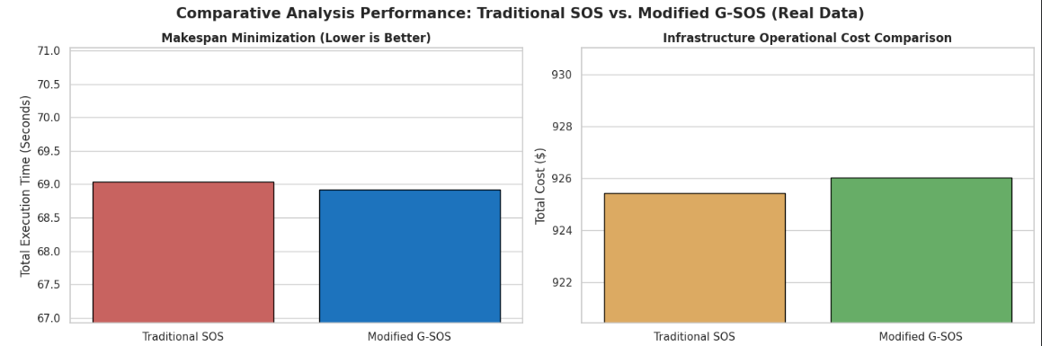
Figure 9.1 — Makespan comparison (top-left) and infrastructure cost comparison (top-right) between the two algorithms.

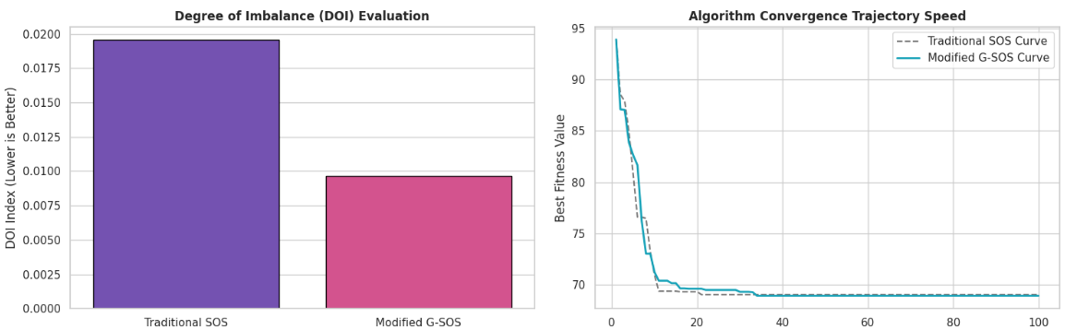
Figure 9.2 — Degree of Imbalance comparison (left) and convergence trajectory of best fitness value over 100 iterations (right).

9.2 Convergence Behavior
Both algorithms begin from the same initial best fitness value (93.915s),reflecting the shared random seed. Traditional SOS converges to its final makespan value of 69.0385s by iteration 21 and remains unchanged for the remaining 79 iterations,indicating that it becomes trapped at a stable local optimum relatively early. Modified G-SOS continues to make small incremental improvements slightly longer,reaching its final value of 68.9252s by iteration 34,before similarly plateauing.Although G-SOS takes marginally longer to fully converge, it ultimately settles at a lower (better) makespan value than SOS,suggesting that the geometric-mean mutualism update and the positively-biased commensalism range allow the ecosystem to continue exploring productive regions of the search space slightly longer before committing to a final solution.

9.3 Trade-off Analysis
The results reveal a clear and consistent trade-off pattern: G-SOS achieves a substantially more balanced load distribution across VMs (DOI reduced by over 50%) and a marginal improvement in makespan,at the cost of a negligible 0.06% increase in total infrastructure cost.Since the DOI improvement is an order of magnitude larger than the small cost regression,G-SOS represents a favorable trade-off for cloud operators who prioritize fair resource utilization and hardware longevity alongside raw execution speed.

10. Results Discussion and Analysis

10.1 Cross-Experiment Consistency
Both experiments independently demonstrate that VM heterogeneity(differing MIPS-to-cost ratios) is the dominant factor shaping the optimizer's decisions.In Experiment 1, the multi-objective fitness function actively steered the schedule away from the most expensive VM (VM 4), while in Experiment 2 the makespan-driven fitness function still implicitly balanced load,since an unbalanced schedule directly worsens the makespan objective it optimizes.

10.2 Why the Geometric Mean Improves Load Balance
The arithmetic mean used in Traditional SOS treats all magnitude differences between two organisms equally, which can allow one dominant,heavily-loaded VM assignment to disproportionately influence the resulting mutual vector.The geometric mean instead dampens the influence of large outlying values relative to small ones,which — when applied to VM index encodings — tends to produce mutual vectors that pull candidate solutions toward more evenly distributed VM assignments.This is empirically reflected in the substantially lower DOI achieved by G-SOS (0.00965 vs. 0.01955).

10.3 Cost vs. Makespan vs. Balance
The very small cost increase observed for G-SOS(0.06%) can be explained by the fact that a more balanced schedule sometimes requires assigning a small number of tasks to relatively more expensive but underutilized VMs,rather than concentrating them on whichever VM currently appears cheapest in the short term.This is a textbook illustration of the multi-objective trade-off between cost-minimization and fairness/load-balance and confirms that no single-objective scheduler can simultaneously achieve the best possible value on every metric.

10.4 Practical Implications
- For cost-sensitive workloads with lenient deadlines,Traditional SOS or a cost-weighted single-objective scheduler may be preferable.
- For latency-sensitive or SLA-bound workloads where consistent VM utilization and avoidance of hotspots matters,Modified G-SOS offers a meaningfully more balanced allocation at negligible extra cost.
- The full multi-objective formulation used in Experiment 1 demonstrates that the fitness function itself can be tuned (via its weight coefficients) to reflect an organization's specific cost/performance priorities.

11. Limitations
- Both experiments model a single physical host with 10 processing elements; a multi-host,multi-datacenter topology was not evaluated,which would introduce additional network and migration-related overheads not captured here.
- Cloudlet lengths were generated randomly within a fixed range rather than drawn from a real-world workload trace,which may not fully capture the burstiness or task-dependency patterns of production cloud workloads.
- Experiment 1(50 tasks, full multi-objective fitness) and Experiment 2(100 tasks,makespan-driven fitness with post-hoc cost/DOI evaluation) use different fitness formulations,so their absolute results are not directly comparable to one another — each experiment should be interpreted independently.
- VM 4 receiving zero task assignments in Experiment 1 suggests the fitness weighting may be strongly biased against high-cost VMs regardless of their processing speed;a sensitivity analysis of the weighting coefficients(0.4/0.3/0.2/0.1) was outside the scope of this study.
- Only a single run(with a fixed seed in Experiment 2) is reported per algorithm;statistical robustness would benefit from multiple independent runs with confidence intervals,as is standard practice in metaheuristic optimization research.

12. Conclusion and Future Work

12.1 Conclusion
This report presented the design,implementation and evaluation of a Modified Geometric Symbiotic Organisms Search(G-SOS) algorithm for multi-objective task scheduling in heterogeneous cloud computing environments, simulated using the CloudSim toolkit.By replacing the arithmetic-mean mutualism update with a geometric-mean formulation and adjusting the commensalism benefit-factor range,G-SOS achieved a substantially more balanced VM workload distribution(DOI improved by 50.62%) and a small improvement in makespan(0.16%), at a negligible cost trade-off (0.06%),when compared head-to-head against Traditional SOS under identical, seed-controlled experimental conditions.A separate multi-objective experiment further confirmed that G-SOS, guided by a composite fitness function weighting makespan, cost,load balance and response time,can produce cost-aware schedules that deliberately avoid the least cost-efficient available VM.
These results support the conclusion that relatively simple,principled modifications to the mutualism and commensalism update rules of SOS — grounded in the mathematical properties of the geometric mean — can yield measurable improvements in load-balancing fairness for cloud task scheduling,without requiring additional tunable hyperparameters or significant additional computational overhead.

12.2 Future Work
- Extend the evaluation to multi-host and multi-datacenter CloudSim topologies to assess scalability and network-aware scheduling effects.
- Validate results using real-world cloud workload traces(e.g., Google Cluster Data or Alibaba Cluster Trace) instead of randomly generated cloudlet lengths.
- Conduct a sensitivity analysis of the multi-objective fitness function's weight coefficients to characterize the full cost-performance-balance trade-off frontier(Pareto analysis).
- Run multiple independent trials per algorithm and report statistical significance(mean, standard deviation, confidence intervals) rather than single-run results.
- Compare G-SOS against additional metaheuristic baselines such as PSO, GA and ACO under the same experimental protocol.
- Investigate dynamic/online scheduling scenarios where tasks arrive continuously, rather than the static, batch-scheduling scenario evaluated in this report.

13. References
Cheng, M.-Y., & Prayogo, D. (2014). Symbiotic Organisms Search: A new metaheuristic optimization algorithm. Computers & Structures, 139, 98–112.
Calheiros, R. N., Ranjan, R., Beloglazov, A., De Rose, C. A. F., & Buyya, R. (2011). CloudSim: A toolkit for modeling and simulation of cloud computing environments and evaluation of resource provisioning algorithms. Software: Practice and Experience, 41(1), 23–50.
Buyya, R., Yeo, C. S., Venugopal, S., Broberg, J., & Brandic, I. (2009). Cloud computing and emerging IT platforms: Vision, hype, and reality for delivering computing as the 5th utility. Future Generation Computer Systems, 25(6), 599–616.
Kennedy, J., & Eberhart, R. (1995). Particle swarm optimization. Proceedings of ICNN'95 – International Conference on Neural Networks, 4, 1942–1948.
Holland, J. H. (1992). Adaptation in Natural and Artificial Systems. MIT Press.
Dorigo, M., & Stützle, T. (2004). Ant Colony Optimization. MIT Press.
Project simulation source code: GSOS_TaskScheduling.java and GSOS_Vs_SOS_CloudScheduling.java (CloudSim-based Java implementations developed for this study).
Experimental data: scheduling_comparison.csv and simulation_results.csv (exported simulation results used throughout this report).

