Homework 1

Akira Sasaki

11/19/2017

library(knitr)  
opts_chunk$set(message = FALSE, error = TRUE, fig.pos = 'H',   
tidy.opts=list(width.cutoff=65), tidy=TRUE, fig.path='figs/', cache.path='cache/graphics-',   
fig.pos ='H', fig.align='center', fig.width = 5, fig.height = 4,   
fig.show = 'hold',  
cache = TRUE, par = TRUE)

install.packages("tidyverse", repos = "https://cran.rstudio.com/")

##   
## There is a binary version available but the source version is  
## later:  
## binary source needs_compilation  
## tidyverse 1.1.1 1.2.1 FALSE

library(tidyverse)  
install.packages("gapminder", repos = "https://cran.rstudio.com/")

##   
## The downloaded binary packages are in  
## /var/folders/_x/xwtgvqzn39qbq704v4zwfhk80000gp/T//Rtmp6BgoZb/downloaded_packages

library(gapminder)

##Plot 1

data(mpg)  
p <- ggplot(data = mpg, mapping = aes(x = displ, y = hwy))  
p + geom_point(mapping = aes(color = class)) + geom_smooth(se = FALSE) +   
 labs(title = "Fuel efficiency generally decreases with engine size",   
 subtitle = "Two seaters (sports cars) are an exception because of their light weight",   
 caption = "Data from fueleconomy.gov")

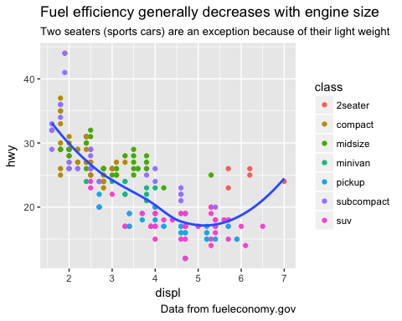

##Plot 2

p <- ggplot(data = mpg, mapping = aes(x = displ, y = hwy))  
p + geom_point(mapping = aes(color = drv, fill = drv)) + geom_smooth(mapping = aes(linetype = drv),   
 se = FALSE)

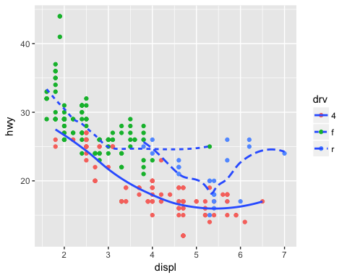

##Plot 3

data(diamonds)  
p <- ggplot(data = diamonds, mapping = aes(x = price, fill = cut))  
p + geom_histogram()

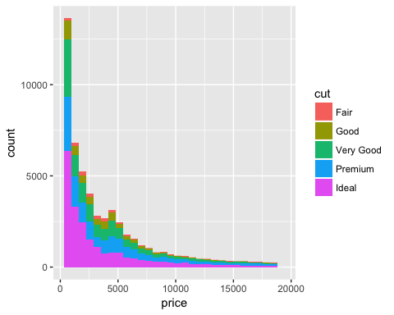

##Plot 4

p <- ggplot(data = diamonds, mapping = aes(x = carat, y = price))  
p + geom_smooth() + facet_grid(cut ~ color)

