MINISTRY OF SCIENCE AND HIGHER EDUCATION OF THE REPUBLIC OF KAZAKHSTAN

INTERNATIONAL INFORMATION TECHNOLOGY UNIVERSITY

FACULTY OF COMPUTER TECHNOLOGY AND CYBERSECURITY

Tanatar Y.M.

Abibulla D.B.

Adilzhan A.M.

Talapov Z.Z.

Development of a decentralized ride-sharing platform

DIPLOMA PROJECT

Major 6В06106 – Computer Systems and Software Engineering

Almaty 2024

MINISTRY OF SCIENCE AND HIGHER EDUCATION OF THE REPUBLIC OF KAZAKHSTAN

INTERNATIONAL INFORMATION TECHNOLOGY UNIVERSITY

DEPARTMENT OF COMPUTER ENGINEERING

Approved

Head of Department, Assistant Professor

_________________ Chinibayeva T.T.

«_____»___________________ 20____

DIPLOMA PAPER

Development of a decentralized ride-sharing platform

Major 6В06106 – Computer Systems and Software Engineering

Done by: Tanatar Y.M. _______________

«__» __________ 20__ (signature)

Abibulla D.B. _______________

«__» __________ 20__ (signature)

Adilzhan A.M. _______________

«__» __________ 20__ (signature)

Talapov Z.Z. _______________

«__» __________ 20__ (signature)

Research Supervisor: Zhakypbekov S.Zh. _______________

«__» __________ 20__ (signature)

Reviewer: _______________

«__» __________ 20__ (signature)

Almaty 2024

International Information Technology University

Faculty of Computer Technology and CyberSecurity

Department of Computer Engineering

Major 6В06106 – Computer Systems and Software Engineering

Diploma Work or Project Assignment

Students

Tanatar Y.M., Abibulla D.B., Adilzhan A.M., Talapov Z.Z.

Diploma Work/Project topic

Development of a decentralized ride-sharing platform

Approved by IITU order № 93-c dated «17» October 2024

Diploma Work/Project submission date «11» June 2024

The study addresses the problem with the lack of responsiveness of current preschool waiting list systems. Symptoms are frequent complaints about the quality and accessibility of current queuing systems for ordinary users. Diagnostics: statistical analysis, surveys, technological research. Solutions: secure data system, optimized enrollment processes, mobile applications. Unresolved issues: accessible interface, fast feedback, technology integration.

Details of computations and explanations (list of issues due to be addressed)  
The aim of the research is to develop a preschool queuing system that includes queue building, sending notifications about the current status of the application and enrollment. The solution requires collecting and analyzing preschool data, developing queuing algorithms, customizing the notification system and creating an interface. The main issues are data sources, algorithms, data protection, interface and notifications. The mobile application and website were chosen because of their accessibility and efficiency.  
 Diploma Work/Project and attachments

The CD attached to the diploma includes the software and documentation. The software part consists of the source code of the application, scripts for collecting and analyzing data about preschool organizations. The documentation contains a description of the architecture and functionality of the application, a user's guide, test reports and experimental results.

Consultations on Diploma Work/Project (with related project chapters named)

|  |  |  |  |
| --- | --- | --- | --- |
| Consultant | Name | Signature, date | |
| Assignment given | Assignment received |
| Consultant on Economic effectiveness of the project | A.G. Mukhamediyeva |  |  |
| English language consultant | A.T. Kenzhebekova |  |  |
| [Compliance](http://www.multitran.ru/c/m.exe?t=4330399_1_2&s1=%ED%EE%F0%EC%EE%EA%EE%ED%F2%F0%EE%EB%FC) [monitor](http://www.multitran.ru/c/m.exe?t=4330399_1_2&s1=%ED%EE%F0%EC%EE%EA%EE%ED%F2%F0%EE%EB%FC) | K.B. Makhmetova |  |  |

Date « » 20

Research Supervisor

(signature)

Assignment received by

Table 1.8 – Calendar plan

|  |  |  |
| --- | --- | --- |
| № | Assignment | Submission date |
| 1. | Creation of the Diploma Work/Project writing schedule | October 17 |
| 2. | Collection, study, processing, analyzing, and generalizing data | November – December |
| 3. | Drafting and submission to the Research Supervisor (Introduction, Chapter 1, Chapter 2, Chapter 3, Chapter 4, Conclusion) | January – February |
| 4. | Submission of the Chapter «Economic Effectiveness of the Diploma Work/Project» to the Consultant | February – March |
| 5. | Revision of the Diploma Work/Project with due consideration of the Research Supevisor’s comments | March – April |
| 6. | Submission of the completed Diploma Work/Project to the Research Supervisor | April 15 |
| 7. | Pre-defence | April |
| 8. | Submission of the completed Diploma Work/Project to the English Language Consultant | April 20 – April 30 |
| 9. | Submission of the Diploma Work/Project to the Compliance Monitor | April 30 – May 15 |
| 10. | Submission of the Diploma Work/Project for the plagiarism | May 3 – May 24 |

Done by: Tanatar Y.M. _______________

«__» __________ 20__ (signature)

Abibulla D.B. _______________

«__» __________ 20__ (signature)

Adilzhan A.M. _______________

«__» __________ 20__ (signature)

Talapov Z.Z. _______________

«__» __________ 20__ (signature)

Research Supervisor: Zhakypbekov S.Z. _______________

«__» __________ 20__ (signature)

АҢДАТПА

Бұл дипломдық жұмыс блокчейн технологияларын пайдалана отырып, автомобильдерді жалға алуға арналған децентрализовандық платформаны әзірлеуге арналған. Қазақстандағы мобильділік пен каршерингке деген қызығушылықтың артуын ескере отырып, жұмыстың мақсаты – көлік құралдарын жалға алудың қолжетімді, қауіпсіз және икемді шарттарын қамтамасыз ететін, делдалдарды жойып, шығындарды азайтатын жүйе құру. Дәстүрлі каршеринг платформаларының негізгі мәселелері – қызметтердің жоғары құны, автокөліктердің шектеулі таңдауы, зақымданулар үшін қатаң айыппұлдар және қызмет көрсету сапасының төмендігі. Бұл жұмыста блокчейн мен смарт-келісімшарттар негізіндегі шешім ұсынылып отыр, бұл мәмілелердің қауіпсіздігін айтарлықтай арттыруға, қызметтердің қолжетімділігін арттыруға және жалдау құнын төмендетуге мүмкіндік береді. Жүйені жобалау кезеңдері, оның ішінде технологияларды таңдау, архитектураны құру, смарт-келісімшарттарды әзірлеу, пайдаланушы интерфейсін жобалау және сыртқы сервистермен интеграциялау қарастырылады.

Жұмыстың практикалық маңыздылығы – каршеринг саласындағы қазіргі проблемаларды шешетін, сондай-ақ қалалық мобильділікке арналған инновациялық шешімдерді қамтамасыз ететін платформаны құруда. Зерттеу Қазақстанда каршерингке арналған децентрализовандық платформаларды енгізу перспективаларын да қарастырады, бұл көлік қызметтерінің сапасын жақсарту мен осы саладағы блокчейн технологияларының дамуына жаңа мүмкіндіктер ашады.

Түйінді сөздер: ОРТАЛЫҚТАНСЫЗДАНДЫРЫЛҒАН ЖҮЙЕ, БЛОКЧЕЙН, КАРШЕРИНГ, СМАРТ-КЕЛІСІМШАРТТАР, АВТОМОБИЛЬДЕРДІ ЖАЛҒА АЛУ, ИННОВАЦИЯЛАР, ҚАЛАЛЫҚ МОБИЛЬДІЛІК.

ANNOTATION

This thesis is dedicated to the development of a decentralized car rental platform using blockchain technologies. Given the growing interest in mobility and car sharing in Kazakhstan, the aim of this work is to create a system that provides more affordable, secure, and flexible rental conditions by eliminating intermediaries and reducing costs. The main issues with traditional car-sharing platforms include high service costs, limited vehicle selection, strict penalties for damages, and low-quality service.

The paper proposes a solution based on blockchain and smart contracts, which will significantly improve transaction security, increase service availability, and lower rental costs. The work covers the stages of system design, including technology selection, architecture development, smart contract creation, user interface design, and integration with external services.

The practical significance of the work lies in the creation of a platform that addresses current problems in the car-sharing sector and provides innovative solutions for urban mobility. The research also explores the prospects of implementing decentralized car-sharing platforms in Kazakhstan, which opens up new opportunities to improve the quality of transportation services and the development of blockchain technologies in this field.

Keywords: DECENTRALIZED PLATFORM, BLOCKCHAIN, CAR SHARING, SMART CONTRACTS, CAR RENTAL, INNOVATIONS, URBAN MOBILITY

АННОТАЦИЯ

Данная дипломная работа посвящена разработке децентрализованной платформы для аренды автомобилей с использованием блокчейн-технологий. С учетом растущего интереса к мобильности и каршерингу в Казахстане, целью работы является создание системы, которая обеспечит более доступные, безопасные и гибкие условия аренды транспортных средств, исключив посредников и снизив издержки. Основной проблемой традиционных каршеринговых платформ является высокая стоимость услуг, ограниченный ассортимент автомобилей, строгие штрафы за повреждения и низкое качество обслуживания.

В работе предлагается решение на основе блокчейна и смарт-контрактов, что позволит значительно улучшить безопасность сделок, повысить доступность услуг и снизить стоимость аренды. Рассматриваются этапы проектирования системы, включая выбор технологий, создание архитектуры, разработку смарт-контрактов, проектирование пользовательского интерфейса и интеграцию с внешними сервисами.

Практическая значимость работы заключается в создании платформы, которая решает текущие проблемы в сфере каршеринга, а также в обеспечении инновационных решений для городской мобильности. Исследование также касается перспектив внедрения децентрализованных платформ для каршеринга в Казахстане, что открывает новые возможности для улучшения качества транспортных услуг и развития блокчейн-технологий в этой области.

Ключевые слова: ДЕЦЕНТРАЛИЗОВАННАЯ ПЛАТФОРМА, БЛОКЧЕЙН, КАРШЕРИНГ, СМАРТ-КОНТРАКТЫ, АРЕНДА АВТОМОБИЛЕЙ, ИННОВАЦИИ, ГОРОДСКАЯ МОБИЛЬНОСТЬ..

CONTENT

|  |  |  |
| --- | --- | --- |
|  | INTRODUCTION | 8 |
| 1 | THEORETICAL PART | 11 |
| 1.1 | Development Trends in the Global Car Sharing Market | 11 |
| 1.2 | Advantages and Features of Decentralized Car Sharing Platforms | 16 |
| 1.3 | Current Situation of the Car Sharing Market in Kazakhstan | 23 |
| 1.4 | Prospects for the Introduction of Decentralized Solutions in Kazakhstan | 27 |
| 1.5 | Purpose, Objectives, and Relevance of the Project |  |
| 1.6 | Novelty and Practical Significance of the Project |  |
| 2 | Practical Part | 31 |
| 2.1 | Development Tools | 31 |
| 2.2 | Database Architecture | 33 |
| 2.3 | UML diagrams | 42 |
| 2.4 | Blockchain Technology | 48 |
| 3 | Justification of the Economic Efficiency of the CarGo Project | 55 |
| 3.1 | Technical Description of the Project | 55 |
| 3.2 | Target Audience | 55 |
| 3.3 | Advantages of the CarGo Platform | 57 |
| 3.4 | Prospects for Economic Efficiency | 59 |
| 3.5 | Costs | 38 |
|  | CONCLUSION | 61 |
|  | REFERENCES | 62 |

**INTRODUCTION**

The rapid urbanization and increasing mobility of Kazakhstan’s population have created a growing demand for accessible, convenient, and affordable transportation solutions. Car sharing — short-term vehicle rentals — has emerged globally as an efficient alternative to traditional car ownership. However, in Kazakhstan, the market remains underdeveloped, facing challenges such as high rental costs, limited vehicle options, rigid terms, and cumbersome dispute resolution processes.One major issue is the reliance on centralized intermediaries, which drives up service fees and reduces transparency. Inflexible rental conditions and the lack of user trust further restrict the growth of the market. These challenges highlight the urgent need for an innovative, decentralized approach to organizing car-sharing services in Kazakhstan.

Blockchain technology offers a promising solution. Its ability to ensure transaction security, transparency, and automation through smart contracts can eliminate intermediaries, lower costs, and enhance user trust. A decentralized car-sharing platform would enable direct interactions between renters and car owners under predefined, transparent conditions, making services more affordable, flexible, and attractive.

Kazakhstan’s car-sharing sector presents an opportunity for pioneering technological solutions. Implementing a decentralized model aligns with global trends in digital transformation and the sharing economy, helping the country adopt modern mobility frameworks and fostering technological leadership in the region.

This thesis focuses on the design and development of **CarGo**, a decentralized vehicle management platform aimed at transforming the car-sharing experience in Kazakhstan. By utilizing blockchain and smart contracts, CarGo will provide a secure, transparent, and economically efficient marketplace for vehicle rentals, improving accessibility and user confidence.

To achieve this goal, the following tasks are set:

* Analyze existing car-sharing platforms to identify their strengths and weaknesses;
* Design the system architecture for a decentralized platform based on blockchain;
* Develop smart contracts to automate rental agreements and payment processes;
* Create a user-friendly web application interface;
* Conduct comprehensive testing and optimize platform performance.

The **theoretical significance** of the research lies in exploring blockchain applications within the sharing economy, particularly in car-sharing services. The study contributes to understanding how decentralized platforms can improve operational efficiency, transparency, and user trust in transportation infrastructure.

The **practical significance** centers on the creation of a working prototype of the CarGo platform, addressing current market deficiencies. Its successful implementation may serve as a model for expanding decentralized mobility services across Kazakhstan and other emerging markets.

**Object of research:** The development and implementation of decentralized platforms for car sharing.

**Subject of research:** The architectural design, operational mechanisms, and technological components of a decentralized car-sharing platform based on blockchain and smart contracts.

**1. THEORETICAL PART**

# 1.1 Development Trends in the Global Car Sharing Market

In recent years, the global car-sharing market has shown steady growth, driven by urbanization, the rising cost of vehicle ownership, and the development of mobile technologies. Car sharing offers an alternative model of vehicle use, enabling users to access cars without the need for long-term ownership commitments. This trend is particularly noticeable in large metropolitan areas, where traffic congestion, high parking costs, and environmental concerns create strong incentives for the adoption of flexible, short-term vehicle rental models. In major cities such as New York, Berlin, Paris, and Singapore, car-sharing services have become an integral part of the urban transportation system, complementing public transit and promoting more efficient use of private vehicles.

The emergence of car-sharing platforms has also been facilitated by advances in information technology, including mobile applications, GPS tracking, and digital payment systems. Companies such as Zipcar, Getaround, and car2go have pioneered new models that allow users to reserve, locate, and access vehicles with just a few clicks on their smartphones. The flexibility and convenience offered by these platforms have contributed to their widespread popularity among young, urban populations who prioritize access over ownership. Moreover, the growing environmental awareness among consumers has led to increased demand for car-sharing services as a way to reduce personal carbon footprints and support sustainable urban mobility initiatives.

Despite the success of centralized car-sharing platforms, challenges such as high operational costs, complex insurance requirements, and limited vehicle availability in certain areas have prompted the exploration of new technological solutions. One of the most promising innovations in this context is the integration of blockchain technology into car-sharing systems. Blockchain offers a decentralized approach to managing transactions, ensuring transparency, reducing the need for costly intermediaries, and enhancing trust between users and service providers.

Several pioneering projects have demonstrated the potential of blockchain-based decentralized car-sharing platforms. For example, DAV Network is a global initiative that leverages blockchain and smart contracts to create an open transportation ecosystem where users and vehicle owners interact directly. The project aims to enable peer-to-peer vehicle rentals, autonomous car services, and even drone delivery systems through a secure and transparent digital infrastructure. By removing centralized operators from the transaction process, DAV Network reduces costs and empowers participants to set their own terms and conditions.

Similarly, the Share2Drive project in Germany focuses on enabling decentralized vehicle rentals using blockchain technologies. It demonstrates the practical advantages of direct user-to-user interactions, automated contract execution, and immutable transaction records. This approach not only minimizes administrative overhead but also addresses issues of trust and security that are critical in peer-to-peer rental models.

Another notable example is the Greenlots platform in Singapore, which integrates decentralized technologies into electric vehicle (EV) car-sharing services. Recognizing the importance of sustainable urban mobility, Greenlots combines blockchain-based rental management with access to a network of EV charging stations, thus promoting the adoption of electric vehicles while addressing infrastructure challenges. Through smart contracts and decentralized transaction management, Greenlots enhances user convenience and operational efficiency.

The trend towards decentralization in car sharing reflects broader shifts in the digital economy, where distributed ledger technologies are increasingly seen as tools for creating more open, fair, and efficient marketplaces. Decentralized car-sharing platforms have the potential to overcome many of the limitations of traditional models by reducing fees, increasing transparency, and empowering individual vehicle owners to participate in the mobility economy. Furthermore, blockchain integration can simplify complex processes such as identity verification, insurance claims, and payment settlements, making car sharing more accessible and reliable for users worldwide.

Looking ahead, the global car-sharing market is expected to continue growing, supported by technological innovation, changing consumer preferences, and government policies promoting sustainable transportation. According to industry forecasts, the car-sharing market is projected to reach significant size by 2030, with an increasing share of services adopting decentralized and blockchain-based models. Regions with dense urban populations, high smartphone penetration, and progressive regulatory environments are likely to lead this transformation.

In summary, the development of the global car-sharing market is characterized by rapid technological advancement, diversification of service models, and a growing emphasis on sustainability and decentralization. The integration of blockchain technologies into car-sharing services represents a promising evolution that addresses key inefficiencies of traditional systems and meets the evolving needs of modern urban societies. These trends form the foundation for innovative projects like CarGo, which seek to bring decentralized, transparent, and user-centric solutions to the emerging markets of Central Asia and beyond.

# 1.2 Advantages and Features of Decentralized Car Sharing Platforms

The increasing adoption of decentralized technologies in various industries has also begun to influence the car-sharing sector, offering fundamentally new possibilities for how vehicle rental services are organized and operated. Decentralized car-sharing platforms represent a significant shift away from traditional centralized models, aiming to overcome many of the inherent limitations found in existing systems. Blockchain technology lies at the heart of these innovations, providing a secure, transparent, and efficient way to manage transactions between parties without the need for intermediaries.

One of the most notable advantages of decentralized platforms is the elimination of central operators who typically mediate interactions between renters and vehicle owners. In centralized systems, operators play a crucial role in managing transactions, verifying identities, setting rental terms, and handling disputes. However, this centralized control comes at a cost: operators charge substantial service fees, which are ultimately passed on to users in the form of higher rental prices. Furthermore, the existence of a centralized authority introduces risks related to data privacy, operational biases, and limited flexibility for individual participants. In contrast, decentralized platforms use blockchain to record transactions transparently and immutably, allowing renters and owners to interact directly based on predefined smart contract terms.

Smart contracts are a core feature of decentralized car-sharing solutions. These digital agreements, encoded on the blockchain, automatically execute rental terms once specified conditions are met. For instance, when a renter agrees to the conditions of a vehicle rental — including price, duration, insurance requirements, and penalty clauses — the smart contract ensures that both parties fulfill their obligations without manual oversight. Payments are processed automatically, deposits are refunded according to established rules, and any penalties for damage or late returns are enforced transparently. This automation not only reduces administrative costs but also minimizes the potential for disputes, making the rental process smoother and more reliable for all participants.

Another important characteristic of decentralized platforms is the increased flexibility in setting rental conditions. Traditional centralized platforms often impose standardized terms that may not suit the diverse needs of users. In decentralized systems, owners and renters can negotiate a wide range of conditions, including rental duration, mileage limits, insurance options, and special requirements, tailoring each transaction to their specific needs. This level of customization creates a more user-centered experience, fostering stronger relationships between vehicle owners and renters and encouraging broader participation.

The expansion of the vehicle pool is another critical advantage of decentralized car-sharing platforms. Traditional operators typically maintain fleets composed of specific types of vehicles, often focusing on economy-class models to maximize cost-efficiency. As a result, users looking for specialized vehicles — such as electric cars, SUVs, or luxury models — frequently find their options limited. Decentralized platforms, however, allow private individuals to list their personal vehicles, greatly diversifying the available selection. This inclusivity benefits users by providing access to a wider variety of vehicles, while enabling owners of underutilized cars to monetize their assets effectively.

Moreover, decentralized systems often incorporate reputation mechanisms to enhance trust and accountability within the platform. Through user reviews, ratings, and verified transaction histories, both vehicle owners and renters build reputations over time. Positive experiences are rewarded with higher trust scores, while negative behavior is documented transparently. This system naturally incentivizes good conduct, encourages responsible vehicle usage, and deters fraudulent or negligent behavior. Unlike centralized platforms, where trust is often dependent solely on the platform’s management policies, decentralized systems embed trust into the very fabric of their operational design.

From an operational perspective, decentralized platforms also offer improved resilience and security. Centralized systems represent single points of failure; a data breach, server outage, or policy change by the operator can disrupt services for all users. Blockchain-based systems, by distributing records across numerous nodes, are inherently more resistant to such risks. Even in the event of localized disruptions, the decentralized network ensures continuity of service and protection of critical data.

The comparison between centralized and decentralized models clearly highlights the transformative potential of blockchain technology in the car-sharing industry. Centralized systems, despite their operational experience and brand recognition, face growing criticism for their high fees, rigid structures, and occasional service failures. Decentralized platforms, in contrast, promise to democratize access, lower costs, enhance user autonomy, and foster a culture of transparency and mutual accountability. As technological maturity increases and public trust in blockchain solutions grows, decentralized car-sharing platforms are poised to play an increasingly important role in the global mobility ecosystem.

In conclusion, the advantages offered by decentralized car-sharing platforms — from cost reduction and contractual flexibility to enhanced vehicle availability and embedded trust mechanisms — represent a substantial improvement over traditional models. These features align closely with modern consumer expectations for transparency, convenience, and personalization, suggesting that decentralized systems will become a central component of the future transportation landscape. The project CarGo, based on these principles, seeks to bring the benefits of decentralized car sharing to Kazakhstan, offering users a modern, efficient, and user-oriented alternative to conventional rental services.

# 1.3 Current Situation of the Car Sharing Market in Kazakhstan

The development of the car-sharing market in Kazakhstan is a relatively recent phenomenon compared to the more mature markets of North America, Europe, and parts of Asia. Nevertheless, the concept of short-term vehicle rentals has begun to attract growing interest among the population, particularly in large cities such as Almaty, Astana, and Shymkent. Urbanization, increased mobility demands, rising costs of personal vehicle ownership, and the widespread penetration of smartphones and digital payment systems have all contributed to the emergence of car-sharing services in the country. However, despite these favorable preconditions, the current car-sharing landscape in Kazakhstan remains underdeveloped and faces a number of systemic challenges that hinder its broader adoption and growth.

One of the most significant problems faced by car-sharing users in Kazakhstan is the high cost of services. Platforms such as AnyTime, which operates under a centralized model, impose substantial fees on both vehicle owners and renters. The presence of intermediaries and administrative overheads, including fleet maintenance, insurance, customer service operations, and platform development costs, significantly inflate rental prices. As a result, short-term rentals are often financially inaccessible for a wide segment of potential users, especially students, young professionals, and tourists who require flexible, affordable transportation options. High pricing not only limits market penetration but also undermines the fundamental appeal of car sharing as a cost-effective alternative to private car ownership.

Another major challenge is the limited selection of available vehicles. Centralized car-sharing operators in Kazakhstan primarily offer small, economy-class cars intended for cost minimization and operational efficiency. While such vehicles are suitable for daily urban use, they do not meet the diverse needs of all users. Consumers seeking specialized vehicles, such as SUVs for off-road travel, electric cars for eco-conscious driving, or premium vehicles for business purposes, often find themselves underserved. This lack of diversity restricts the platform's ability to appeal to different customer segments and diminishes its competitiveness relative to traditional rental services or private vehicle ownership.

Moreover, centralized car-sharing platforms in Kazakhstan tend to enforce strict penalty policies for violations of rental conditions. Renters may face substantial fines for relatively minor infractions such as returning a car late, causing superficial damage, or failing to clean the vehicle before return. While it is important to protect property and ensure responsible usage, the disproportionate nature of fines in many cases leads to customer dissatisfaction and negative experiences. Fear of incurring unexpected charges often discourages users from relying on car-sharing services, further limiting the potential for market expansion.

Service quality issues also pose a significant problem for centralized platforms. Due to the scale of operations and the distributed nature of car fleets across urban areas, maintaining consistent standards of vehicle cleanliness, technical condition, and readiness for rental proves challenging. Users frequently report problems such as receiving vehicles with existing damages, dirty interiors, or technical malfunctions. Furthermore, the lack of real-time monitoring and limited control over where and how vehicles are left after use exacerbates these issues, contributing to operational inefficiencies and reduced user trust.

Another important limitation of the current car-sharing system in Kazakhstan is the low availability of vehicles during peak periods. Users attempting to rent cars during rush hours, weekends, or holidays often encounter difficulties finding available vehicles near their locations. Centralized fleet management strategies are not always agile enough to dynamically reposition vehicles based on shifting demand patterns, leading to frequent mismatches between supply and demand. This inconvenience undermines the perceived reliability of car-sharing services and drives potential customers toward alternative transportation options such as taxis, ride-hailing apps, or private car rentals.

In addition to these operational challenges, broader cultural and regulatory factors impact the growth of the car-sharing market in Kazakhstan. Vehicle ownership remains a strong symbol of personal success and status, particularly outside major metropolitan areas. Many consumers continue to view car ownership as a necessity rather than a luxury, complicating efforts to promote shared mobility models. Moreover, the legal and insurance frameworks governing car sharing are still evolving, creating uncertainties regarding liability, accident management, and consumer protection.

Despite these challenges, there are positive indicators suggesting that the car-sharing market in Kazakhstan holds considerable potential for growth. The country's young and increasingly tech-savvy population shows a strong appetite for digital services, including transportation and mobility solutions. Government initiatives aimed at modernizing urban infrastructure, promoting smart cities, and supporting green technologies create a favorable environment for the expansion of innovative mobility models. In particular, growing awareness of environmental issues and the adoption of electric vehicles align with global trends that favor car-sharing services as part of sustainable urban ecosystems.

However, for Kazakhstan's car-sharing sector to fully realize its potential, it is essential to address the structural shortcomings of existing platforms. There is a clear need for new models that offer greater flexibility, more diverse vehicle options, lower costs, and enhanced transparency. The integration of decentralized technologies, such as blockchain and smart contracts, represents a promising avenue for overcoming the limitations of centralized systems. By reducing administrative overhead, increasing trust among participants, and enabling more user-centered interactions, decentralized platforms can unlock new opportunities for growth and innovation in Kazakhstan's mobility landscape.

In conclusion, while the car-sharing market in Kazakhstan remains nascent and faces notable challenges, the underlying demand for flexible, affordable, and convenient transportation solutions is evident. Addressing the shortcomings of existing centralized platforms and embracing decentralized, technologically advanced alternatives can create a vibrant, competitive, and user-friendly car-sharing ecosystem that meets the evolving needs of Kazakhstan's urban population.

# 1.4 Prospects for the Introduction of Decentralized Solutions in Kazakhstan

The introduction of decentralized platforms for car sharing in Kazakhstan presents a promising opportunity to address the structural inefficiencies and user dissatisfaction associated with existing centralized services. Given the current limitations of the domestic car-sharing market, there is substantial potential for new models that leverage blockchain technology and smart contracts to deliver more transparent, flexible, and cost-effective solutions. A shift toward decentralization would align Kazakhstan’s mobility sector with global trends emphasizing technological innovation, user empowerment, and sustainability.

One of the key factors supporting the prospects for decentralized car-sharing platforms in Kazakhstan is the growing public interest in digital and mobile technologies. Over the past decade, Kazakhstan has made significant progress in the development of its digital infrastructure, with high smartphone penetration rates and widespread access to mobile internet services across major urban centers. This technological readiness forms a solid foundation for the adoption of new digital mobility platforms that operate through decentralized networks and smartphone applications. Young consumers, in particular, who are accustomed to the convenience and immediacy of mobile services, represent a strong target audience for innovative car-sharing solutions.

Another important factor is the increasing awareness of blockchain technology within Kazakhstan. In recent years, the government and private sector have demonstrated an active interest in the potential applications of blockchain beyond cryptocurrency markets, recognizing its value for enhancing transparency, security, and operational efficiency in various industries. Pilot projects in fields such as public records management, supply chain tracking, and digital identity verification have contributed to a growing familiarity with decentralized technologies among both policymakers and the public. This evolving understanding creates favorable conditions for the acceptance of blockchain-based mobility platforms, particularly if they can demonstrate clear user benefits and practical advantages over traditional centralized systems.

The environmental dimension also plays a crucial role in shaping the prospects for decentralized car sharing. As part of its commitments to sustainable development and the Paris Agreement, Kazakhstan has set goals for reducing carbon emissions and promoting green technologies. Urban transportation is a major contributor to greenhouse gas emissions, and the adoption of shared mobility models, particularly those incorporating electric vehicles, can significantly support the country’s environmental objectives. Decentralized car-sharing platforms are well-positioned to facilitate the growth of environmentally friendly mobility by making vehicle access more flexible and affordable, encouraging users to opt for shared rather than individually owned cars. Additionally, decentralized models that integrate electric vehicle rental options and charging station networks can further enhance the attractiveness of green transportation alternatives.

From an economic perspective, decentralized platforms offer opportunities for greater market inclusivity and entrepreneurship. By allowing private vehicle owners to directly participate in the rental economy without reliance on a central operator, decentralized systems can empower individuals to generate income from underutilized assets. This democratization of the car-sharing market could be particularly impactful in Kazakhstan, where economic diversification and support for small businesses are strategic national priorities. Moreover, decentralized platforms can contribute to regional development by enabling car-sharing services to expand beyond major cities into smaller towns and rural areas where traditional operators may find it unprofitable to maintain centralized fleets.

Despite these opportunities, the successful introduction of decentralized car-sharing platforms in Kazakhstan will depend on overcoming certain challenges. Legal and regulatory frameworks must be adapted to recognize the validity of smart contracts, clarify the rights and responsibilities of parties engaged in decentralized rentals, and ensure adequate consumer protection mechanisms. Public education campaigns may be necessary to build user trust in decentralized systems and familiarize potential participants with new processes such as blockchain-based identity verification and automated payment settlements. In addition, partnerships with insurance companies, vehicle maintenance providers, and municipal authorities will be essential to establish a supportive ecosystem for decentralized mobility services.

Furthermore, careful attention must be paid to the design of the platform itself to ensure that it meets the practical needs of Kazakhstani users. Local market characteristics, cultural preferences, and urban infrastructure realities must be taken into account when developing service offerings, user interfaces, and operational procedures. Successful decentralized car-sharing solutions will need to strike a balance between technological sophistication and user-friendliness, providing seamless experiences that lower the barriers to adoption for a broad range of customers.

In conclusion, Kazakhstan presents a favorable environment for the introduction and growth of decentralized car-sharing platforms. Technological readiness, increasing familiarity with blockchain, growing demand for flexible mobility solutions, and environmental imperatives combine to create a landscape ripe for innovation. By addressing existing market deficiencies and aligning with national development goals, decentralized platforms can offer transformative benefits for urban mobility, economic empowerment, and environmental sustainability. The realization of this potential will require strategic planning, regulatory support, and a strong focus on user experience, but the prospects for success are substantial. Projects such as CarGo are well positioned to lead this transformation, offering a new paradigm for car sharing in Kazakhstan and setting a benchmark for the wider region.

# 1.5 Purpose, Objectives, and Relevance of the Project

The development of the decentralized car-sharing platform CarGo is motivated by the urgent need to address the systemic shortcomings observed in the existing vehicle rental market in Kazakhstan. The primary purpose of the project is to create a technologically advanced, user-centric solution that leverages blockchain technologies to enhance transparency, security, affordability, and flexibility in the car-sharing sector. By moving away from traditional centralized models, CarGo aims to empower both vehicle owners and renters, fostering a more inclusive, efficient, and trustworthy environment for short-term vehicle rentals.

The fundamental goal of the thesis project is to design and implement a decentralized platform that eliminates the reliance on intermediaries typically responsible for high transaction fees and restrictive rental terms. Through the use of blockchain and smart contracts, CarGo will automate critical rental processes, ensure the secure handling of payments and deposits, and transparently manage potential disputes regarding damages or rental conditions. The platform is intended to offer a modern alternative to conventional services by placing control directly in the hands of users, promoting fairness and autonomy in every transaction.

To realize this purpose, several key objectives must be achieved. First, it is necessary to conduct a thorough analysis of existing car-sharing models, both centralized and decentralized, to identify best practices, operational challenges, and user expectations. This research will inform the design choices and functional requirements of the CarGo platform. Attention will be given to examining notable projects such as AnyTime, DAV Network, and Share2Drive, analyzing their architectures, technological foundations, user experiences, and market performance.

The second objective involves the architectural development of the platform itself. This includes designing a system that seamlessly integrates blockchain infrastructure with user-friendly web and mobile applications. Key components such as user authentication, vehicle registration, rental contract management, payment processing, and dispute resolution mechanisms must be designed to operate securely and efficiently within a decentralized framework.

Third, the creation of smart contracts is essential for automating core rental operations. These contracts will govern the terms of vehicle usage, payment obligations, penalties for violations, and the conditions for deposit returns. By ensuring that rental agreements are self-executing and tamper-proof, smart contracts will enhance user trust and reduce the administrative burden typically associated with traditional rental services.

The fourth objective focuses on the design and implementation of an intuitive user interface. Both car owners and renters must be able to easily navigate the platform, search for vehicles, manage rental agreements, and access transaction histories. Special attention must be paid to usability, security, and the integration of reputation systems that allow users to rate and review their experiences, fostering a culture of accountability and continuous improvement.

Finally, comprehensive testing and optimization of the platform are required to ensure its reliability, performance, and scalability. This phase will involve simulating rental transactions, verifying the functionality of smart contracts, assessing system security, and refining user interfaces based on feedback. Optimizing the platform for local conditions — including language preferences, regulatory compliance, and payment system compatibility — is also critical for successful deployment in Kazakhstan.

The relevance of the CarGo project is underscored by several converging factors. The growing dissatisfaction with existing car-sharing options in Kazakhstan, characterized by high costs, limited vehicle diversity, and inflexible rental conditions, highlights a clear market need for alternative solutions. Simultaneously, the increasing public familiarity with blockchain technologies, combined with the country's strategic emphasis on digital innovation and economic diversification, creates a receptive environment for decentralized platforms.

Moreover, CarGo aligns with broader global trends toward the democratization of services, peer-to-peer economic models, and sustainable urban mobility. By lowering barriers to participation, enabling individuals to monetize underutilized assets, and promoting shared resource use, the project contributes to the development of smarter, greener cities. In addition, the platform’s emphasis on transparency and user empowerment resonates with contemporary expectations for fairness, security, and convenience in digital services.

In the context of Kazakhstan’s ambitions to modernize its transportation infrastructure and foster a digital economy, CarGo represents a timely and strategically important initiative. Its successful implementation could serve as a model for similar projects throughout Central Asia and beyond, demonstrating the practical viability and advantages of decentralized approaches in traditionally centralized service sectors.

Thus, the purpose, objectives, and relevance of the CarGo project are firmly grounded in both the pressing needs of the local market and the transformative opportunities presented by emerging digital technologies. By addressing existing deficiencies and introducing a new paradigm for vehicle sharing, the project aims to create lasting value for users, vehicle owners, and the broader urban ecosystem.

# 1.6 Novelty and Practical Significance of the Project

The project CarGo introduces several key innovations that distinguish it from existing car-sharing models currently available in Kazakhstan and the broader Central Asian region. Its novelty lies in the integration of advanced decentralized technologies into a sector that has traditionally relied on centralized management structures. By adopting blockchain technology and smart contracts, CarGo fundamentally redefines the way short-term vehicle rentals are conducted, offering a more transparent, efficient, and user-oriented service model.

The use of blockchain technology in CarGo ensures that all transactions, agreements, and financial flows are recorded in an immutable, decentralized ledger. This eliminates the need for a trusted central authority and provides users with full visibility into the contractual and financial processes involved in renting a vehicle. Unlike traditional car-sharing platforms where users must trust the platform operator to handle payments, deposits, and dispute resolutions fairly, CarGo offers a trustless environment where security and fairness are guaranteed by the underlying technological architecture itself.

A particularly innovative aspect of the project is the integration of smart contracts to automate the fulfillment of rental agreements. Smart contracts embedded within the platform automatically execute terms agreed upon by the vehicle owner and the renter. This includes the transfer of rental payments, handling of security deposits, enforcement of penalties for violations, and resolution of potential disputes. Such automation reduces administrative burdens, eliminates human errors, and minimizes opportunities for manipulation or abuse. In the context of Kazakhstan, where the car-sharing market has not yet widely adopted such technologies, this represents a significant step forward in the modernization of urban mobility services.

Another element of novelty is the platform’s focus on flexibility and personalization of rental conditions. Unlike centralized platforms that impose rigid, standardized agreements, CarGo empowers users to negotiate and define rental terms according to their individual needs. Vehicle owners can specify rental rates, availability schedules, deposit requirements, and conditions for vehicle use, while renters can select options that best suit their preferences and budgets. This flexibility enhances user satisfaction and broadens the appeal of the platform across different demographic and economic segments.

CarGo also incorporates a decentralized reputation system that incentivizes responsible behavior among both vehicle owners and renters. Through user-generated reviews and ratings stored on the blockchain, the platform builds a transparent reputation profile for each participant. Positive interactions are rewarded with higher trust ratings, while negative behavior is documented and visible to all future users. This mechanism fosters a culture of accountability and mutual respect, reducing the risk of vehicle misuse and improving overall service quality.

In addition to its technological and operational innovations, CarGo possesses significant practical significance for the development of Kazakhstan’s transportation ecosystem. By lowering the barriers to entry for both renters and vehicle owners, the platform expands access to affordable mobility solutions. Individuals who previously could not afford the high costs associated with centralized car-sharing services will have new opportunities to access vehicles for short-term needs, thereby enhancing personal mobility and economic participation.

For vehicle owners, CarGo provides an avenue to monetize underutilized assets without the complexities and costs imposed by traditional rental companies. This peer-to-peer rental model supports micro-entrepreneurship and contributes to the diversification of household incomes. In a broader economic context, the platform promotes more efficient use of existing transportation resources, reducing the need for additional vehicle production and mitigating the environmental impact associated with private car ownership.

From a societal perspective, CarGo supports the objectives of sustainable urban development by encouraging shared mobility practices. By making it easier and more affordable to access vehicles when needed rather than owning them outright, the platform contributes to the reduction of urban traffic congestion, parking demand, and vehicle emissions. These outcomes align with Kazakhstan’s national strategies for promoting green growth, digitalization, and smart city initiatives.

Furthermore, the successful implementation of CarGo in Kazakhstan could serve as a proof of concept for the application of decentralized technologies in other sectors of the national economy. The project demonstrates how blockchain and smart contracts can be leveraged to create more transparent, efficient, and user-centric services, inspiring further innovation across industries such as real estate, logistics, and public administration.

In conclusion, the CarGo project stands out for its technological novelty, operational flexibility, and alignment with contemporary trends in urban mobility and digital transformation. Its practical significance extends beyond the immediate car-sharing market, offering broader benefits for economic development, environmental sustainability, and the advancement of Kazakhstan’s digital economy. By addressing pressing challenges in the transportation sector and introducing a new model for decentralized service delivery, CarGo represents a meaningful contribution to the future of mobility in Kazakhstan and sets the stage for further expansion and innovation in the region.

2. Practical Part

2.1 Development Tools  
The development of the CarGo platform required the use of modern technologies and methodologies to ensure system reliability, scalability, and user convenience. One of the key tasks at the design stage was to create a technical architecture capable of efficiently processing user requests, managing large volumes of data, and maintaining stable service operation under increasing load. When selecting development tools, particular attention was paid to performance, security, scalability, and ease of future maintenance.  
The CarGo frontend platform was implemented as a single-page application (SPA) using the React library. React was chosen due to its high performance, component-based approach to user interface development, and strong community support. By leveraging the virtual DOM and an optimized state update system, React enables the creation of dynamic, responsive interfaces while minimizing browser resource consumption. The visual design of the system was developed using CSS modules in combination with TailwindCSS — a modern utility-first CSS framework that allowed for the rapid creation of adaptive, minimalist, and user-friendly interfaces.  
A key objective on the frontend side was to ensure secure authentication and protection of user data. User authorization was implemented using JSON Web Tokens (JWT), enabling secure user identification without the need to store session data on the server. At the initial stage, authentication is performed via phone number; however, the system architecture anticipates the future expansion of the authentication mechanism by adding password support, account recovery, and two-factor authentication.  
The frontend application interacts with the backend via a REST API, ensuring a clear separation between data presentation and processing. This approach enabled high modularity of the system and laid the foundation for potential expansion to other client applications in the future, such as mobile versions based on React Native or Flutter.  
The CarGo backend was developed using the Go (Golang) programming language, chosen for its high performance, built-in support for parallel data processing, and convenience in writing reliable, scalable code. The main web framework used for processing HTTP requests was Gin — a lightweight and high-speed framework capable of handling a large number of simultaneous connections. The server code structure follows the separation of concerns principle: controllers handle HTTP requests, services implement business logic, and repositories manage interaction with the database through the GORM ORM library.  
PostgreSQL, a relational database management system (RDBMS) known for its extensive capabilities in ensuring data integrity, transactional processing, and scalability, was chosen for data storage and management. The database structure was designed with normalization in mind, ensuring logical consistency of relationships between entities. User, car, booking, and image data are organized into separate tables with foreign keys, allowing strict control over data interrelations and eliminating redundancy.  
Media files, such as car photographs, are uploaded to separate object storage services, such as AWS S3 or MinIO, with database records containing references to these files. This approach reduces the load on the main database and enables more efficient handling of large volumes of images.  
During development, popular development environments and tools were used, including Visual Studio Code with extensions for working with React and Go, as well as Git and GitHub for version control and team collaboration. Code quality was maintained through linters (ESLint for frontend and golangci-lint for backend), auto-formatting (Prettier), and static code analysis.  
Special attention was paid to organizing the testing process. For the frontend, Jest and React Testing Library frameworks were used to perform unit and integration testing of interface components. For the backend, unit tests were developed for business logic, along with integration tests for verifying the REST API functionality. Database testing was conducted using migrations and test data population.  
Continuous integration and deployment (CI/CD) processes were organized using GitHub Actions. Each code update triggered automated code style checks, testing, and deployment to a test server. This approach helped minimize development errors and accelerated the release of new features.  
To ensure the security of the project, fundamental protection measures were implemented: mandatory use of HTTPS for all client-server communications, prevention of SQL injection attacks through the use of ORM tools, and validation of user input on both the client and server sides. In the future, security measures will be expanded by introducing multi-factor authentication, encryption of sensitive data, and user activity monitoring.  
The CarGo platform architecture was designed with future scalability in mind. As system load increases, it is planned to implement load balancers, horizontally scale server components, and transition to distributed data storage. Additionally, the architecture anticipates the integration of payment systems and the use of distributed ledgers (blockchain) to enhance the reliability of transaction recording.  
Thus, the choice of modern development tools, the construction of a modular architecture, and the application of CI/CD practices have allowed the creation of a reliable technical foundation for the CarGo platform, ensuring its high performance, security, and readiness for future growth and scalability.

2.2 Database Architecture  
The database serves as a fundamental backbone of the CarGo platform, ensuring reliable storage, processing, and access to key information about users, vehicles, bookings, and related events. Thanks to a well-designed database architecture, the platform can effectively support interactions between renters and owners, maintain high performance as the number of users grows, and establish a solid foundation for future functional expansions, including payment system integration and blockchain technologies.  
PostgreSQL was chosen as the primary database management system for the project. This decision was driven by PostgreSQL’s high reliability, ACID compliance, advanced indexing and transaction mechanisms, and strong security features. The database structure was designed to achieve maximum data normalization, prevent data duplication, and optimize search and retrieval operations.  
At the current stage, the database includes several key entities: users, vehicles, car images, and bookings. Each entity maintains a strict logical relationship with other system components. A user can simultaneously act as a vehicle owner and a renter of other users' vehicles. A vehicle is associated with an owner, can have multiple images, and can participate in multiple booking transactions. A booking captures the fact of renting a vehicle by a user for a specified period.  
The user’s interaction with the platform and the database begins with the registration stage. The user provides basic information such as full name, email address, and phone number. In future versions of the project, it is planned to implement full authentication using encrypted passwords and two-factor authentication to enhance account security.  
After registration, the user gains access to the vehicle listing feature. When adding a new vehicle to the database, information such as make, model, year of manufacture, fuel type, transmission, number of seats, rental price per day, and location is stored. Each vehicle can be accompanied by one or more images, which are uploaded separately, with links to the images saved in the database. The actual image files are stored in a separate cloud storage to optimize interface loading and reduce the load on the database.  
Renters can browse available vehicles and make bookings. When a booking is created, the renter’s ID, vehicle ID, rental start and end dates, and the total rental price are recorded in the database. A booking can exist in one of several statuses: "pending confirmation," "confirmed," "canceled," or "completed." These statuses allow efficient management of the rental process and reflect the current state of each transaction.  
Relationships between tables are implemented using foreign keys, ensuring data integrity during any modifications or deletions. For instance, when a user is deleted, all associated vehicles are also deleted; when a vehicle is deleted, related bookings are canceled if such behavior is defined by platform policies.  
Special attention was given to database security during the design phase. All transmitted data is encrypted via the HTTPS protocol. In future updates, encryption of sensitive data at the storage level will be implemented, including user passwords, payment information, and personal data. Additional mechanisms for database backup and recovery will also be introduced, allowing restoration to a specific point in case of failures or data corruption.  
Scalability is one of the most important aspects of the database architecture. Initially, the architecture is designed to operate on a single database server, but as the load increases, horizontal scaling through database replication, PostgreSQL clustering, and load balancers is planned. This will help maintain high query processing speed as data volumes and user numbers grow.  
In the future, the CarGo platform will expand with new functional modules requiring changes to the database structure. It is planned to add a review and rating system, allowing users to leave evaluations after completing a rental. For this purpose, a separate "review" entity will be created, linked to both the renter, the vehicle owner, and the vehicle itself.  
Additionally, a payment operations module is planned. Its implementation will require designing additional tables to record transactions, payment amounts, payment methods, transaction statuses, and their association with specific bookings. These enhancements will automate the rental payment process through the platform and integrate external payment gateways.  
Another key development area will be the integration of blockchain technology to record finalized rental transactions. Upon confirmation of a booking, key transaction data — such as participant IDs, vehicle description, rental period, and cost — will be additionally recorded in a distributed ledger. This will ensure immutability of records and enhance user trust.  
Currently, indexes are already applied to fields frequently used in queries, such as user email addresses, vehicle IDs, and booking statuses. This significantly speeds up typical search and filtering operations.  
Monitoring and regular database backups are also prioritized. The project includes scheduled database archiving, enabling restoration to a defined date in the event of technical failures, cyberattacks, or hardware issues.  
Thus, the database architecture of CarGo not only meets the requirements of the current platform development stage but also possesses sufficient flexibility and scalability to support future system growth. It ensures reliable operation of all business processes, high performance, secure data storage, and easy integration of new features such as payment systems, review modules, and blockchain-based rental registries.  
Thus, the technical architecture of the CarGo platform is based on the use of modern technologies and well-thought-out solutions that ensure the reliability, flexibility, and scalability of the system. The choice of development tools and the database structure fully meet the requirements for efficient online vehicle rental and create a solid foundation for further project development, including the integration of new functionalities and blockchain technologies.

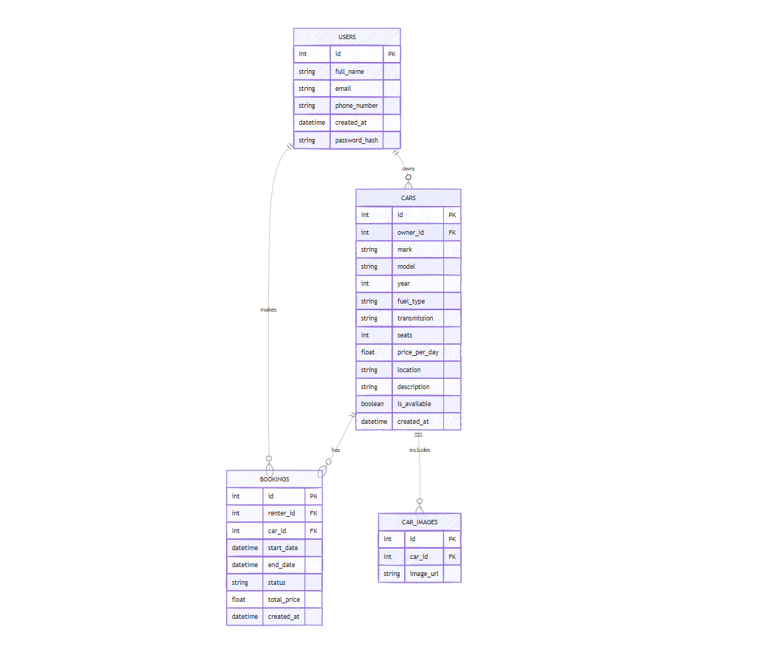

2.3 UML Diagrams  
During the design of the CarGo platform, special attention was given to the creation of visual system models using UML (Unified Modeling Language) notations. The application of UML diagrams made it possible to formalize system requirements at the early stages of design, identify the main entities, their relationships and interactions, and carefully plan the architecture of component interactions. Through graphical representation of the system’s structure and behavior, a unified understanding of the project among all team members was achieved, minimizing the risk of logical errors during development.  
Several types of UML diagrams were used in the design of the CarGo platform, reflecting various aspects of the system. The main focus was placed on modeling user interactions with the system and describing key database entities and business logic.  
One of the most important diagrams is the Use Case Diagram, which displays the primary interaction scenarios between users and the platform. The diagram highlights two key roles: the renter user and the vehicle owner user. Renters can register on the platform, browse available vehicles, make bookings, manage their bookings, and leave reviews after completing a rental. Vehicle owners can register their vehicles, manage vehicle availability, approve or reject rental requests, and view rental history. The use of the Use Case Diagram made it possible to visually outline all key platform functions and define the list of actions that needed to be implemented at both the user interface and server logic levels.  
To formalize the data structure and define relationships between the main project entities, a Class Diagram was developed. The diagram displays the primary system classes: User, Car, Booking, and CarImage. Each class describes a particular platform entity and contains attributes corresponding to database fields. The User class includes attributes that characterize the user, such as identifier, full name, email address, and phone number. The Car class describes a vehicle, including attributes such as make, model, year of manufacture, rental price, description, and location. The Booking class records information about rental transactions, including rental start and end dates, renter and vehicle identifiers, total price, and booking status. The CarImage class enables the association of images with vehicles and stores links to uploaded files. Relationships between classes reflect real-world dependencies: one user can own multiple vehicles, and one vehicle can have multiple bookings and images.  
To detail the processes of component interactions, a Sequence Diagram was developed using the booking scenario as an example. The diagram shows the sequence of messages exchanged between the renter user, the web application, the server component, and the database. The user initiates the booking creation through the interface, the system sends the data to the server, where the request is validated, the rental cost is calculated, and a new booking record is created in the database. Upon successful completion of the operation, the server sends confirmation back to the client side, where the booking is displayed in the user's booking history. The Sequence Diagram helped formalize component interactions at the step-by-step level, significantly simplifying the development and testing of relevant functions.  
The use of UML diagrams at the system design stage not only helped structure project knowledge but also enabled the identification of potential challenges before the start of active development. Visual modeling of interactions, entities, and processes significantly increased the transparency of the system architecture and provided a solid foundation for its further scaling and modernization.  
Thus, UML diagrams became an essential tool in the design process of the CarGo platform. They contributed to the creation of a logically coherent, understandable, and scalable architecture, facilitated collaboration between team members, and improved the overall quality of the project's design decisions.

UML diagram 1

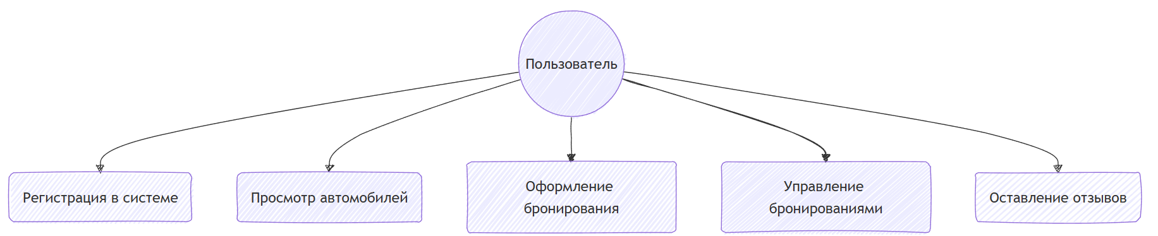

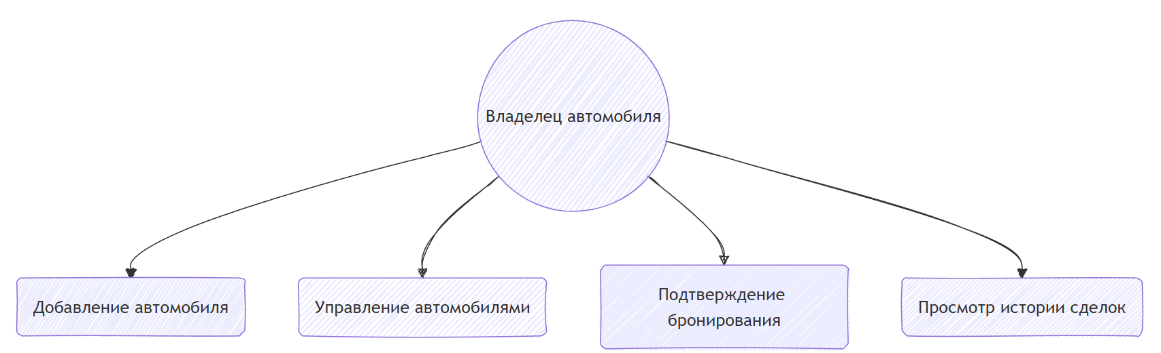

UML diagram 2

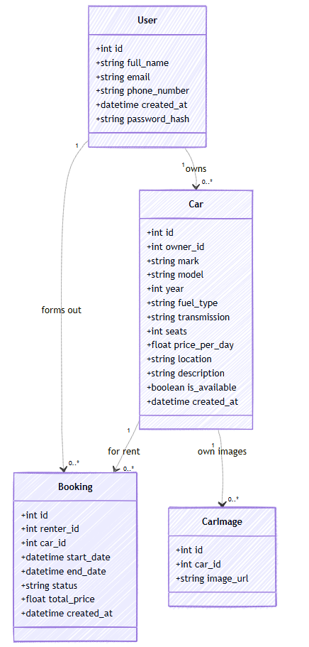

UML diagram 3

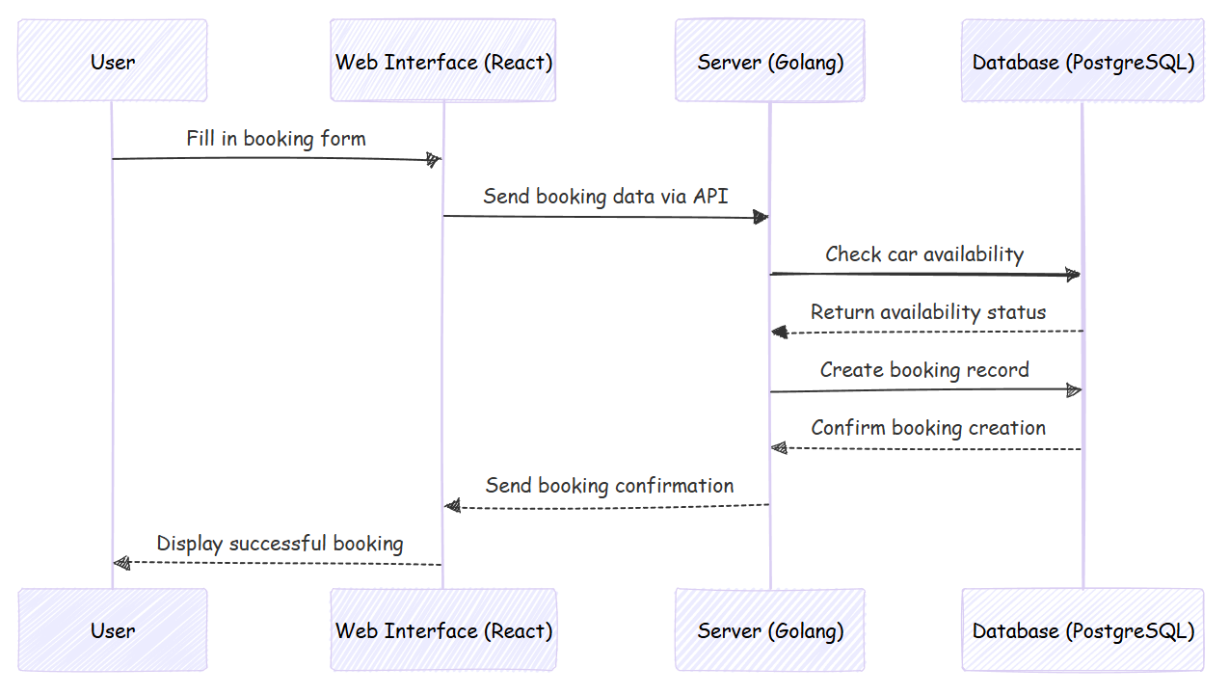

# 

# Blockchain Technology The development of digital platforms requires ensuring maximum transparency, security, and trust among users. As part of the further development of the CarGo project, the integration of blockchain technology is planned, which will enable the implementation of new mechanisms for recording and confirming vehicle rental transactions. Unlike traditional centralized data storage systems, blockchain ensures the immutability of records and decentralized control, which is particularly relevant in the field of peer-to-peer vehicle rental. The integration of the blockchain module into the CarGo architecture is aimed at solving several key tasks. Primarily, it is planned to record information about completed rental transactions in a distributed ledger. Each booking, confirmed by both parties, will be additionally registered in a smart contract containing the main transaction parameters: owner and renter identifiers, vehicle description, rental period, rental cost, and a unique transaction identifier. This approach will ensure a high level of transaction verifiability, protection against unauthorized data modifications, and the ability to resolve disputes based on reliable interaction history. The blockchain module interface will be implemented in such a way that its use is transparent and convenient for end-users. After booking confirmation through the standard web interface, users will be notified that transaction data has been recorded on the blockchain. The entire recording process will occur automatically on the server side without requiring any additional actions from the user. In the personal account of both the renter and the vehicle owner, a link to the public blockchain ledger will be available, allowing users to verify information about a specific transaction. At the initial stage, integration with a public blockchain network supporting smart contracts is planned, such as Ethereum or one of its more accessible alternatives (Polygon, Binance Smart Chain). To facilitate interaction with the blockchain, a server module will be developed that will handle the formation and submission of transactions, as well as track their status. Smart contracts will be developed with a focus on minimizing transaction costs (gas fees) and ensuring the security of execution logic. From a technical perspective, the interaction between the CarGo platform and the blockchain network will be organized through an API interface of the blockchain module. Upon booking confirmation, the server will generate a special message containing transaction parameters, which will then be signed and sent to the blockchain network. Once confirmation of the data recording is received, the server will update the booking status and attach the corresponding blockchain transaction identifier. All data transferred to the ledger will be minimized and anonymized in compliance with personal data protection requirements. One of the most critical aspects of the module’s development will be ensuring the security of operations. Mechanisms for digital signing and transaction validation on the server side will be applied to protect against data tampering. Additionally, a transaction status monitoring system will be implemented to promptly notify users about the state of their records in the blockchain. In the future, the development of the blockchain module will allow for the expansion of the CarGo platform’s functionality. In particular, it may include the implementation of a decentralized review system, where user ratings and comments are also recorded on the blockchain, making them immutable and protected from manipulation. Additionally, a smart contract-based rental insurance feature may be introduced, enabling automatic deposit refunds when rental conditions are fully met. The integration of blockchain technology will increase the level of trust in the platform, simplify the resolution of disputes between renters and owners, and allow CarGo to stand out favorably in the vehicle rental market. Thus, the blockchain module is a promising area for the development of the CarGo platform. Its implementation will bring the security and transparency of transactions to a qualitatively new level, providing additional guarantees for all system participants and contributing to the long-term growth of trust in the platform.

3. Justification of the Economic Efficiency of the CarGo Project

3.1. Technical Description of the Project  
CarGo is an innovative decentralized platform for carsharing and vehicle rentals, based on blockchain technology. The project aims to create a safe, transparent, and convenient environment for executing rental agreements between private individuals and organizations without the involvement of intermediaries. The application of blockchain technology allows every rental transaction to be recorded in a distributed ledger, ensuring data immutability and verifiability.  
The CarGo platform implements a wide range of functionalities: user registration, listing and searching for vehicles, booking vehicles, concluding electronic rental agreements, processing rental payments, and managing deposit returns through smart contracts. A high degree of process automation enables significant cost reduction, eliminates the need for third-party involvement, and improves the speed of operations and trust between participants.  
The technical architecture of the platform is built on modern technologies: the backend is developed using the Go programming language with PostgreSQL as the database, while the frontend is implemented with the React library. In the future, full integration with payment systems and a scalable blockchain module for recording all transactions in a public ledger is planned.

3.2. Target Audience  
The CarGo platform is targeted at a broad audience of users, including:

* Private vehicle owners seeking additional income by renting out their vehicles;
* Individuals looking for a convenient solution for short-term or long-term vehicle rentals without having to deal with traditional rental companies;
* Organizations and companies managing vehicle fleets or providing taxi services, which can use the platform to optimize the utilization of their fleets.

The project is initially planned to launch in the Republic of Kazakhstan, with a focus on major cities such as Almaty, Astana, Shymkent, and regional centers. In the future, the platform may expand to other regions and countries.

3.3. Advantages of the CarGo Platform  
One of the key competitive advantages of CarGo is the application of blockchain technology to ensure transparency, security, and automation of all rental processes.  
The platform offers users the following benefits:

* Transaction transparency: Every rental transaction is recorded on the blockchain and can be independently verified, significantly reducing the risk of fraud.
* Minimal commissions: The absence of intermediaries allows the rental cost to remain as low as possible for both owners and renters.
* High security level: Smart contracts automate rental terms, including deposit management and refund processing, reducing human error and risk.
* Review and rating system: Users can leave feedback and ratings for both vehicle owners and vehicles themselves, helping to build reputations and improve service quality.
* Support for deposit systems and cryptocurrency payments: The platform will support rental payments in both fiat and cryptocurrencies, offering users greater flexibility.
* Absence of centralized intermediaries: All transactions are conducted directly between the renter and the owner, with the platform's technical infrastructure ensuring fairness and transparency.

3.4. Prospects for Economic Efficiency  
The CarGo project demonstrates high potential for economic efficiency by optimizing user acquisition costs, minimizing operational expenses, and achieving high business model margins. The use of blockchain infrastructure enables both high-speed transaction processing and trust assurance among participants without the need for complex centralized control mechanisms.  
In the long term, the project plans to expand its functionality by introducing additional modules: an automated rental insurance system, a loyalty bonus program for users, integration with external payment gateways, and the development of mobile applications.  
Thus, the CarGo platform combines modern technological solutions with strong economic advantages, creating a reliable foundation for a successful commercial launch and future scalability.

### 3.5 Costs

Equipment costs

|  |  |  |  |  |
| --- | --- | --- | --- | --- |
| № | Name | Count | Price (tg) | Total (tg) |
| 1 | Laptop/Pc | 4 | 300000 | 1200000 |
| 2 | Server for testings | 1 | 400000 | 400000 |
| 3 | Printer | 1 | 70000 | 70000 |
| 4 | Specialized software | 1 | 300000 | 300000 |
| 5 | Hosting | 1 | 380000 | 380000 |
|  | Total |  |  | 2350000 |

### 

### Wage Fund

|  |  |  |  |  |  |
| --- | --- | --- | --- | --- | --- |
| № | Staff | Work period (month) | Num of people | Salary | Total |
| 1 | Backend-developer | 2 | 1 | 700000 | 1400000 |
| 2 | Frontend- developer | 2 | 1 | 700000 | 1400000 |
| 3 | Blockchain- developer | 2 | 1 | 900000 | 1800000 |
| 4 | UI/UX designer | 1 | 1 | 500000 | 500000 |
| 5 | QA engineer | 1 | 1 | 400000 | 400000 |
| 6 | Marketing specialist | 2 | 1 | 400000 | 800000 |
|  | **Total  (without deductions)** |  |  |  | 6300000 |

|  |  |  |  |  |
| --- | --- | --- | --- | --- |
|  |  |  |  |  |

### Mandatory deductions:

### • Pension contributions (10%): 630,000 tenge

### • Social contributions (3.5%): 222,075 tenge

### • OSMS (3.5%): 220,500 tenge

### • Social tax (9.5%): 346,327.5 tenge

### • Total mandatory deductions: 1,418,902.5 tenge

### • Total VAT with deductions: 7,718,902.5 tenge

### Overhead costs

|  |  |  |  |  |
| --- | --- | --- | --- | --- |
| № | Name | Count | Price, tg | Total, tg |
| 1 | Rent of premises | 3 month | 100000 | 300000 |
| 2 | Electric powed | - | 10000 | 30000 |
| 3 | Etherner WIFI АО«Kazakhtelecom» | 3 month | 5000 | 15000 |
|  | Total | - | - | 345000 |

### Total expences

* Devices: 2 350 000 tg
* Cost with deductions: 7 718 902.5 tg
* Overhead costs: 345 000 tg
* **Total: 10 413 902.5 tg**

### Revenue forecast

### • Individual users (100 people × 13,500 × 12 months): 1,620,000 tenge

### • Corporate clients (5 companies × 1,000,000 tg): 5,000,000 tg

### • Total revenue for the 1st year: tg 6,620,000

### Economic efficiency

• 1 year profit: 6 620 000 – 10 413 902.5 = -3 793 902.5 tg (loss)

• Profit 2 years (income 12,430,000 – expenses 4,000,000): 8,430,000 tg

• Average annual profit: (-3 793 902.5 + 8 430 000) / 2 = 2 318 048.75 tg

• Payback period: 10 413 902.5 / 2 318 048.75 ≈ 4.49 year

### Net Cash Flow (Cash Flow)

|  |  |  |  |  |  |
| --- | --- | --- | --- | --- | --- |
| Indicator (tg) | Year 1 | Year 2 | Year 3 | Year 4 | Year 5 |
| Tributaries | 6 620 000 | 12 430 000 | 12 430 000 | 12 430 000 | 12 430 000 |
| Outflows | 9 735 000 | 4 000 000 | 4 000 000 | 4 500 000 | 5 000 000 |
| Net cash flow | -3 115 000 | 8 430 000 | 8 430 000 | 7 930 000 | 7 430 000 |
| Cumulative flow | -3 115 000 | 5 315 000 | 13 745 000 | |  |  |  |  | | --- | --- | --- | --- | |  | |  |  | | --- | --- | |  | 21670000 | | | 29 105 000 |

### NPV и IRR

* Discount: 12%
* Net Cash Flow: [-3 115 000, 8 430 000, 8 430 000, 7 930 000, 7 430 000]
* **NPV ≈** 22 133 181.48 tg
* **IRR ≈ 68%**

### Efficiency for users (companies)

**Before implementation CarGo:**• 2 registrars × 200,000 × 12 = 4,800,000 + 5,362,440 KZT (including taxes)  
• 1 cashier: 2,400,000 + 2,681,220 KZT in taxes  
• Total: 8,043,660 KZT

After the implementation of CarGo:  
• CarGo subscription cost: 1,000,000 KZT  
• Personnel costs (reduced by 80%): ≈ 1,018,864 KZT  
• Total: 2,018,864 KZT

**Savings: 8,043,660 KZT – 2,018,864 KZT = 6,024,796 KZT**

**Payback period: approximately 4 months**

CONCLUSION

The CarGo project represents a new generation in the field of car rental and carsharing services, offering a fundamentally different approach compared to traditional centralized platforms. In the course of the project, we identified key issues associated with conventional systems — including lack of transparency, high intermediary fees, slow transaction processing, and risks of fraud. These challenges have become the basis for the concept and architecture of CarGo.

By integrating blockchain technology into the rental process, CarGo ensures decentralized management of user data, secure execution of transactions via smart contracts, and increased trust between vehicle owners and renters. All operations, including booking, payments, and deposit returns, are recorded on the blockchain, which guarantees immutability and full transparency of agreements without reliance on third parties.

The platform's technological architecture was designed with a focus on scalability, security, and user experience. The backend, developed with Django and PostgreSQL, guarantees stable operation and quick data processing. The frontend, created using React, provides a simple and intuitive interface for users to search, rent, and manage their vehicles. Smart contracts on blockchain automate the most critical functions, such as payment confirmation and dispute resolution.

From a market perspective, CarGo addresses growing user demand for decentralized services that offer autonomy, reduced costs, and improved security. The platform creates new opportunities for private vehicle owners, enabling them to monetize their assets more efficiently, and offers consumers more flexible rental options at lower prices.

In the context of global trends, the project aligns with the increasing popularity of Web3 technologies, the sharing economy, and the desire of users to have more control over their interactions and financial transactions. CarGo is not only a technological product but also a reflection of broader societal changes, where decentralization, transparency, and user empowerment are becoming standard expectations.

The economic analysis conducted as part of the project shows the financial viability and attractiveness of the platform. Our forecast indicates steady revenue growth, especially in metropolitan areas such as Almaty and Astana, where demand for rental services is higher. Additionally, the platform’s flexible business model, based on subscriptions and service fees, creates sustainable long-term development opportunities.

In conclusion, CarGo offers a robust, secure, and forward-looking solution for the carsharing and rental market. By addressing the main pain points of traditional systems and offering a decentralized alternative, CarGo has the potential to occupy a significant position in the growing ecosystem of blockchain-based applications. With further investment in marketing, user acquisition, and technical scaling, the project can achieve stable growth and contribute to the transformation of the car rental industry both locally and internationally.

REFERENCES

[1] S. Nakamoto, "Bitcoin: A Peer-to-Peer Electronic Cash System," 2008. [Online]. Available: https://bitcoin.org/bitcoin.pdf

[2] G. Wood, "Ethereum: A Secure Decentralised Generalised Transaction Ledger," Ethereum Project Yellow Paper, 2014. [Online]. Available: https://ethereum.org/en/whitepaper/

[3] A. Tapscott and D. Tapscott, Blockchain Revolution: How the Technology Behind Bitcoin Is Changing Money, Business, and the World, Penguin, 2016.

[4] M. Swan, Blockchain: Blueprint for a New Economy, O'Reilly Media, 2015.

[5] J. Gans, The Future of the Sharing Economy: Uber, Airbnb, and the New Economy of Trust, MIT Press, 2019.

[6] J. Nilsson, "Introduction to Smart Contracts," ConsenSys Academy, 2018. [Online]. Available: https://consensys.net/academy/

[7] Django Software Foundation, "Django Documentation," [Online]. Available: https://docs.djangoproject.com/en/4.2/

[8] PostgreSQL Global Development Group, "PostgreSQL Documentation," [Online]. Available: https://www.postgresql.org/docs/

[9] Meta (formerly Facebook), "React – A JavaScript Library for Building User Interfaces," [Online]. Available: https://react.dev/

[10] T. Erl, Service-Oriented Architecture: Concepts, Technology, and Design, Prentice Hall, 2005.

[11] McKinsey & Company, "Blockchain Beyond the Hype: What Is the Strategic Business Value?," 2018. [Online]. Available: https://www.mckinsey.com/business-functions/mckinsey-digital/our-insights/blockchain-beyond-the-hype

[12] OECD, "The Sharing Economy: Opportunities and Challenges for the Transport Sector," International Transport Forum, 2016. [Online]. Available: https://www.itf-oecd.org/sharing-economy-opportunities-and-challenges-transport

[13] K. Christidis and M. Devetsikiotis, "Blockchains and Smart Contracts for the Internet of Things," IEEE Access, vol. 4, pp. 2292–2303, 2016.

[14] D. Tapscott and A. Tapscott, "How Blockchain is Changing Finance," Harvard Business Review, 2017. [Online]. Available: https://hbr.org/2017/03/how-blockchain-is-changing-finance

[15] Cointelegraph Research, "Blockchain Adoption in Automotive Industry," 2023. [Online]. Available: https://cointelegraph.com/

[16] K. Finley, "How Blockchain Could Disrupt Car Rental and Carsharing," Wired Magazine, 2018. [Online]. Available: <https://www.wired.com/>

[17] Statista Research Department, "Carsharing Worldwide - Statistics & Facts," Statista, 2024. [Online]. Available: https://www.statista.com/topics/3810/carsharing/

[18] European Blockchain Observatory and Forum, "Blockchain and the Automotive Industry," European Commission, 2022. [Online]. Available: https://www.eublockchainforum.eu/

[19] J. M. G. Vilela, J. P. Vilela, and L. B. Oliveira, "Blockchain in the Automotive Industry: Challenges and Opportunities," IEEE Communications Standards Magazine, vol. 3, no. 1, pp. 48–54, 2019.

[20] Deloitte Insights, "Accelerating Blockchain Adoption," Deloitte, 2020. [Online]. Available: https://www2.deloitte.com/insights/us/en/industry/technology/blockchain-adoption.html