LL3GAMLSS: Support-Safe Three-Parameter Log-Logistic Distributional Regression for Non-Stationary SPEI
Software article
Tolga Barış Terzi
Karadeniz Technical University, Trabzon, Türkiye
Corresponding author: tolgabaristerzi@ktu.edu.tr

Abstract
The Standardized Precipitation-Evapotranspiration Index (SPEI) was defined using a three-parameter log-logistic distribution, but this shifted family is absent from the standard gamlss.dist catalogue used in many non-stationary drought-index studies. Comparisons can therefore confound the effect of non-stationarity with changes in distribution family or estimation method. LL3GAMLSS is an R package that enables stationary and covariate-dependent SPEI to be estimated within one likelihood-based LL3 framework. It combines a support-constrained threshold link, covariate models for scale and shape, boundary diagnostics, independent likelihood checks, bootstrap procedures, and calendar-month multiscale standardization. Numerical tests verified the probability functions, derivatives, and optimizer agreement. Monte Carlo experiments evaluated selection, parameter recovery, interval coverage, short records, serial dependence, and contamination. Of 4,500 stress-test datasets, 4,411 (98.0%) produced inference-ready fits; boundary contact fell from 4.8–6.2% with 30 observations to zero with 100 observations. End-to-end seasonal validation also exposed increasing false selection and non-regular alternative fits at longer overlapping accumulations. In seven quality-screened Seyhan-region stations, 17 of 28 station-scale analyses strongly favoured non-stationarity, always through scale. An open ERA5-Land application completed 52,608 cell-level and 192 basin-level monthly fits without convergence or boundary failures; selected non-stationary area increased from 18.8% at one month to 70.8% at twelve months. LL3GAMLSS isolates distributional change from distributional inconsistency while retaining diagnostics needed for cautious drought-index interpretation.
Keywords: distributional regression; GAMLSS; log-logistic distribution; non-stationarity; SPEI; statistical software

1 Introduction
The Standardized Precipitation-Evapotranspiration Index (SPEI) transforms accumulated climatic water balance into standard-normal units for comparison across locations, seasons, and accumulation periods (Vicente-Serrano et al. 2010). The original formulation fits a three-parameter log-logistic distribution separately to each calendar month. Its lower threshold allows the fitted variable to include negative water-balance values, while its scale and shape parameters accommodate the skewness observed across climates and accumulation periods. The reference SPEI software retains the three-parameter log-logistic family as its default, although alternative families may fit particular climates better (Beguería et al. 2014; Stagge et al. 2015; Beguería and Vicente-Serrano 2023).
Stationary SPEI assumes that the monthly water-balance distribution is invariant over the reference period. Non-stationary drought indices relax this assumption by linking one or more distribution parameters to time, climate indices, or other covariates. Generalized additive models for location, scale and shape (GAMLSS) are widely used for this purpose because they permit several parameters of a response distribution to vary with covariates (Rigby and Stasinopoulos 2005; Stasinopoulos and Rigby 2007). Study-specific non-stationary SPEI formulations, including formulations based on a time-varying log-logistic distribution, have already been reported (Bazrafshan et al. 2022; Masanta and Srinivas 2022). The novelty claimed here is therefore software and statistical comparability, not the first proposal of non-stationary SPEI.
A practical gap remains between these two traditions. The gamlss.dist catalogue does not provide the shifted three-parameter log-logistic family used by conventional SPEI (Stasinopoulos and Rigby 2023). Researchers must consequently implement LL3 themselves or substitute another available family. If conventional SPEI is calculated with LL3 and probability-weighted moments but non-stationary SPEI is calculated with another family or likelihood estimator, their difference combines at least three effects: the stationarity assumption, the probability family, and the estimation method. It cannot be attributed to non-stationarity alone. Study-specific LL3 code can avoid the family substitution, but it does not provide a shared implementation, common diagnostics, or a reproducible comparison contract.
LL3GAMLSS addresses this gap with stable distribution functions, a support-safe GAMLSS family, model-fitting and diagnostic helpers, independent likelihood verification, bootstrap procedures, and a calendar-month multiscale SPEI workflow. The validated formulation estimates all three LL3 parameters but keeps the lower threshold constant while scale and shape may depend on arbitrary parametric covariates. This restriction prevents a moving support boundary from being introduced without separate theoretical and simulation validation. The study objectives were to implement the family, verify its numerical and statistical behaviour, and demonstrate distribution-consistent stationary versus non-stationary comparison in station and gridded Earth-system applications.

2 Design and implementation

2.1 Distribution-consistent comparison and validated scope
The comparison contract holds the response, accumulation rule, seasonal partition, probability family, parameterization, and maximum-likelihood estimator constant. M0 is the stationary LL3 model nested within the covariate-dependent alternatives. Differences between M0 and a selected alternative can therefore be assigned to the fitted parameter-covariate relation rather than to a change of family or fitting method. Conventional PWM-SPEI is retained only as an external benchmark of estimator sensitivity; it is not the stationary member of the likelihood comparison.
The workflow begins with precipitation and temperature observations, estimates monthly potential evapotranspiration (PET), forms climatic water balance, accumulates the balance at a selected time scale, and fits a separate conditional LL3 distribution to each calendar month (Fig. 1). Conditional cumulative probabilities are mapped to standard-normal variates. Scale and shape predictors can contain time or other scientifically justified parametric covariates. The operational wrapper does not permit a covariate-dependent threshold because a moving threshold changes conditional support and requires separate theoretical and simulation treatment.
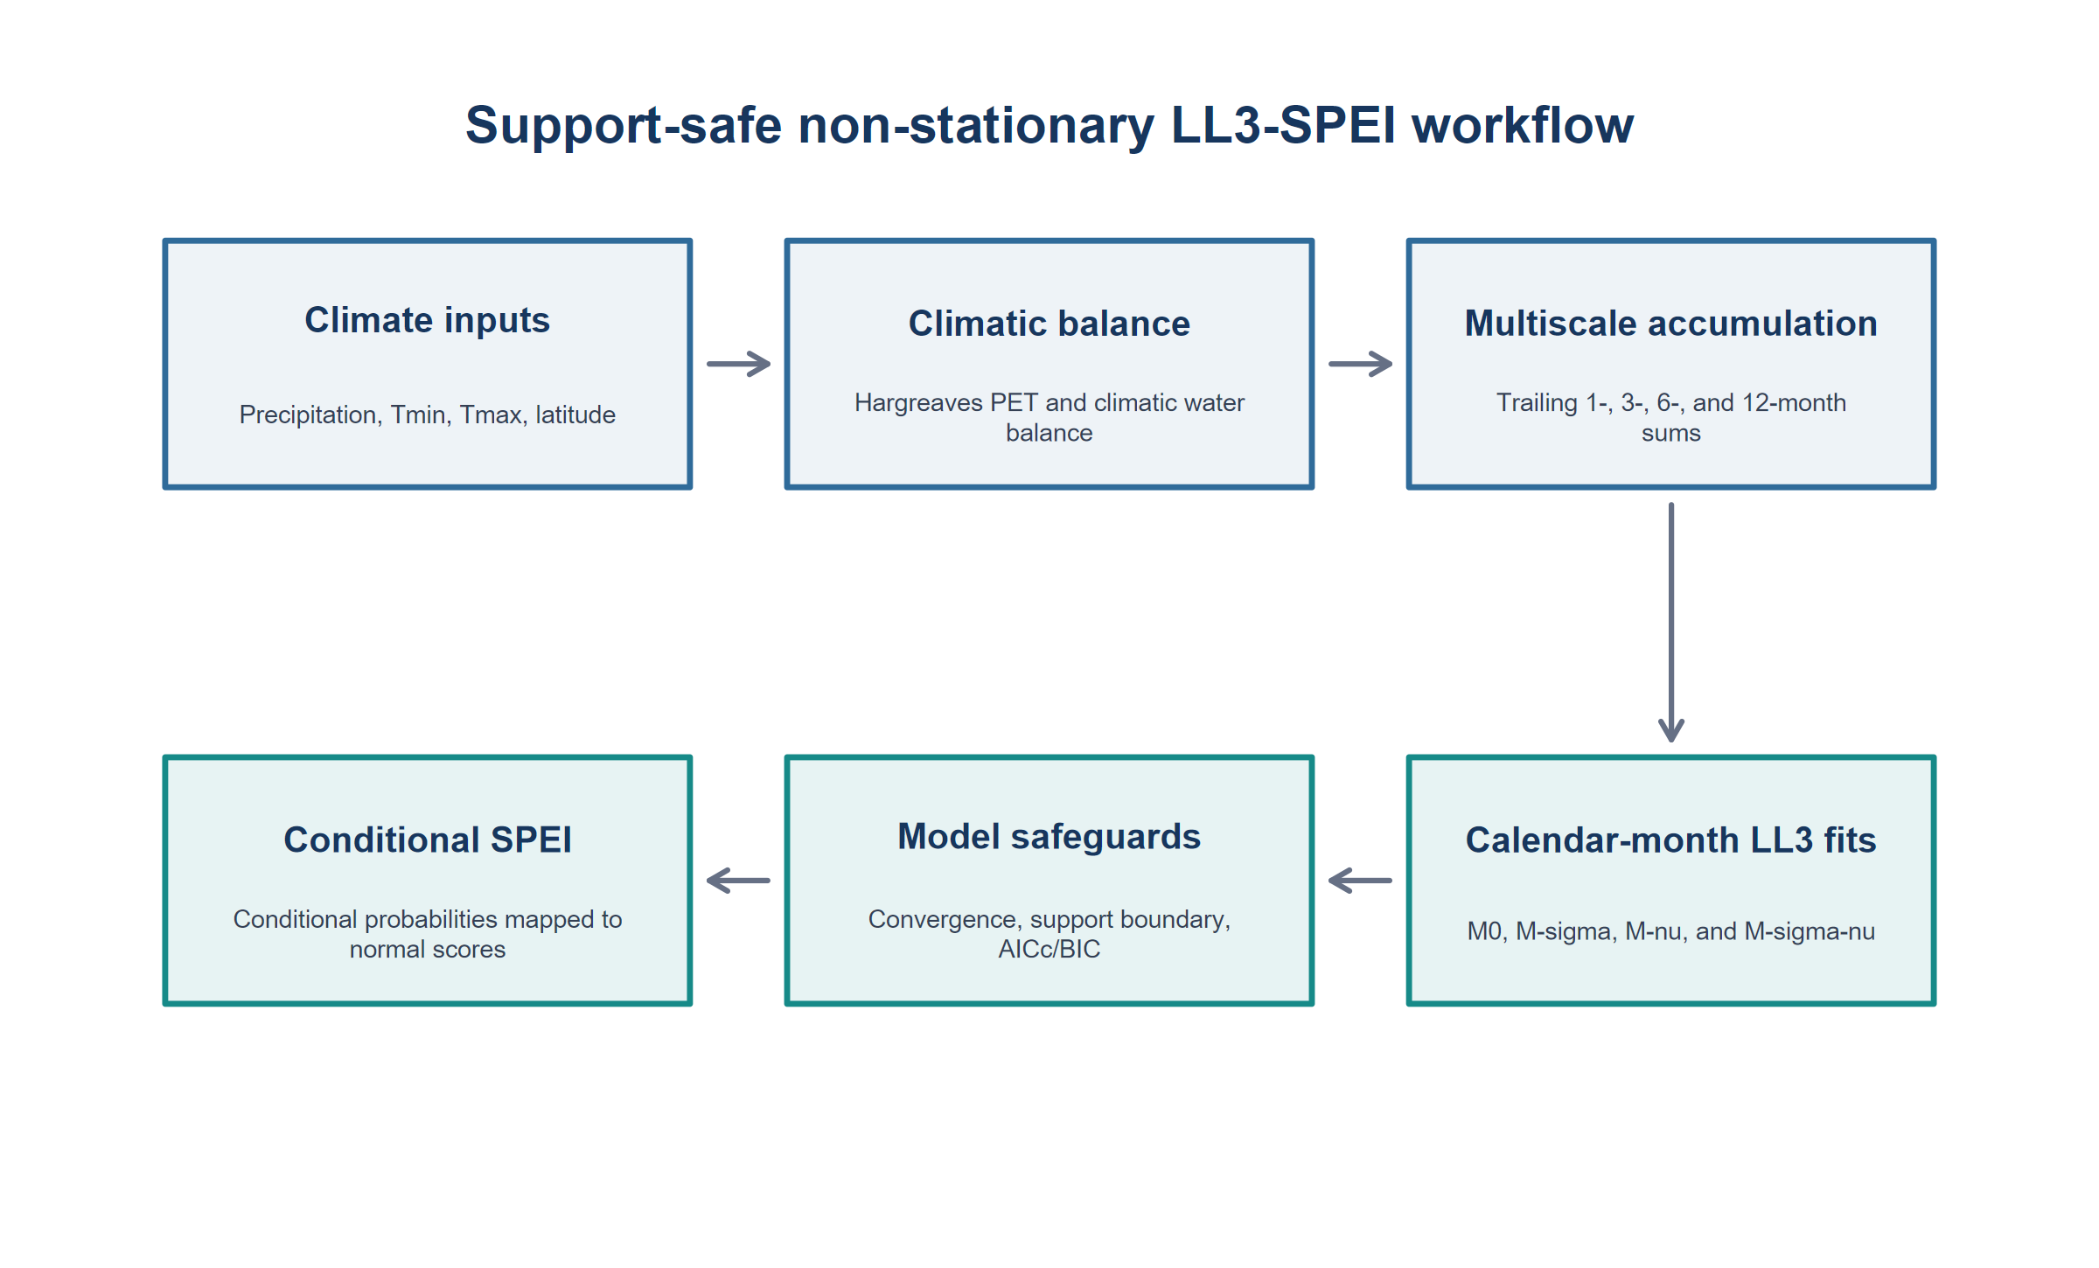
Fig. 1 Computational workflow for support-safe non-stationary LL3-SPEI estimation

2.2 Three-parameter shifted log-logistic distribution
Let Y denote accumulated climatic water balance. The LL3 distribution is parameterized by a threshold μ, a positive scale σ, and a positive shape ν. For y > μ, the cumulative distribution, density, and quantile functions are
$F(y|μ,σ,ν)={\left[1 + {\left(\frac{σ}{y−μ}\right)}^{ν}\right]}^{−1}$ (1)
$f(y|μ,σ,ν)=\frac{ν}{σ}{\left(\frac{y−μ}{σ}\right)}^{ν−1}{\left[1 + {\left(\frac{y−μ}{σ}\right)}^{ν}\right]}^{−2}$ (2)
$Q(p|μ,σ,ν)=μ+σ{\left(\frac{p}{1−p}\right)}^{\frac{1}{ν}},0<p<1$ (3)
The median equals the sum of the threshold and scale. The mean exists when the shape exceeds one, and the variance exists when the shape exceeds two. Probability calculations were implemented on log and logistic scales to reduce overflow and underflow in the tails. Conversion helpers link this parameterization to the equivalent distribution in the FAdist package.

2.3 Support-safe links and optimization
For each fitted calendar-month sample y, the upper limit b for the threshold and its positive numerical offset δ were defined as
$b = min(y) − δ$ (4)
$δ = max\{√εₘₐcₕ, 10⁻⁶s, 100εₘₐcₕ max[max|y|, 1]\}$ (5)
Here εₘₐcₕ is machine precision and s is the sample interquartile range. If the interquartile range was zero or non-finite, s was replaced successively by the sample standard deviation and the larger of the maximum absolute observation and one. The threshold link was
$ημ = log(b − μ), μ = b − exp(ημ)$ (6)
Every finite threshold predictor therefore maps strictly below b. Standard log links were used for scale and shape:
$log(σₜ) = Xσ,ₜβσ, log(νₜ) = Xν,ₜβν$ (7)
Type-8 sample quartiles defined the initial robust spread and numerical scale:
$r = q₀.₇₅ − q₀.₂₅$ (8)
$a = max\{1, |min(y)|, |q₀.₅₀|, r\}$ (9)
A zero or non-finite robust spread was replaced successively by the median absolute deviation with constant one, one quarter of the sample range, and the larger of 0.1 times the absolute median and one. The initial threshold gap and parameter values were
$g = max\{0.5r, √εₘₐcₕ a, 10⁻⁶\}$ (10)
$μ⁽⁰⁾ = min(y) − g$ (11)
$σ⁽⁰⁾ = max\{q₀.₅₀ − μ⁽⁰⁾, 0.5r, √εₘₐcₕ a, 10⁻⁶\}, ν⁽⁰⁾ = 2$ (12)
Models were estimated by maximum likelihood with the Rigby-Stasinopoulos algorithm in gamlss. The family supplied outer-product-of-gradients working curvature, floored at 10⁻¹², for numerical stability; this working curvature assists optimization and is not interpreted as an inferential covariance matrix. Unless an experiment states otherwise, fitting used a convergence criterion of 0.001, automatic step halving, no global-deviance tolerance limit, a maximum of 700 cycles, and step lengths of 0.05 for μ, σ, and ν. These controls and all experiment-specific overrides are included in the archived analysis code.
A fit was inference-ready only if it converged; all parameters were finite; σ and ν were positive; every response exceeded its fitted threshold; b was below all observations; and the solution did not contact the threshold boundary. The observation-specific boundary tolerance and contact rule were
$τ = 100εₘₐcₕ max\{1, |b|, |y|, |μ|\}$ (13)
$boundary contact ⇔ b − μ ≤ τ$ (14)
Material support violations generated an error. Boundary contact was treated as a non-regular solution for which ordinary Hessian, Wald, AIC, and BIC interpretations were not reported.

2.4 Candidate stationary and non-stationary models
For a record of T ordered monthly observations, time and its standardized covariate were defined over the complete record as
$t = 1, …, T, xₜ = [t − mean(t)]/sd(t)$ (15)
Each calendar-month subset retained the values of this common time axis. A coefficient is consequently the change in log scale or log shape per one standard deviation of position in the full monthly record, not per year. The four pre-specified structures were fitted separately to each calendar month:
$M0: log(σₜ) = β₀, log(νₜ) = γ₀$ (16)
$Mσ: log(σₜ) = β₀ + β₁xₜ, log(νₜ) = γ₀$ (17)
$Mν: log(σₜ) = β₀, log(νₜ) = γ₀ + γ₁xₜ$ (18)
$Mσν: log(σₜ) = β₀ + β₁xₜ, log(νₜ) = γ₀ + γ₁xₜ$ (19)
At least 30 finite accumulated observations were required in every monthly subset. The threshold was estimated but constant in all candidates (Table 1).
Table 1 Pre-specified LL3-GAMLSS candidate structures
Model | Threshold μ | Scale dependence | Shape dependence | Definition
M0 | Constant | Constant | Constant | Equation (16)
Mσ | Constant | Linear in xₜ | Constant | Equation (17)
Mν | Constant | Constant | Linear in xₜ | Equation (18)
Mσν | Constant | Linear in xₜ | Linear in xₜ | Equation (19)
Candidate fitting followed a fixed warm-start sequence to reduce numerical differences among nested models. M0 was fitted first; Mσ and Mν were initialized from the M0 parameter estimates; and Mσν was initialized with the M0 threshold, Mσ scale, and Mν shape estimates. The formulation is not restricted to linear time. Multiple standardized covariates, interactions, polynomial terms, or scientifically justified lagged climate indices can be supplied in X_σ and X_ν. Smooth terms can be fitted by the underlying family, but their out-of-sample prediction is not yet validated in the operational SPEI wrapper.

2.5 Multiscalar conditional SPEI
Monthly climatic water balance and its trailing accumulation at scale k were
$Dₜ = Pₜ − PETₜ$ (20)
$Dₜ⁽ᵏ⁾ = ∑ᵢ₌₀ᵏ⁻¹ Dₜ₋ᵢ$ (21)
The first k − 1 accumulated values were undefined. For observation t belonging to calendar month m, the fitted conditional probability and LL3-SPEI were
$pₜ = Fₘ[Dₜ⁽ᵏ⁾ | μₘ, σₘ,ₜ, νₘ,ₜ]$ (22)
$SPEIₜ⁽ᵏ⁾ = Φ⁻¹\{min[max(pₜ, ε), 1 − ε]\}$ (23)
Here Φ⁻¹ is the standard-normal quantile function, and ε was set to 10⁻¹⁰ to prevent infinite numerical indices. A trailing window was set to missing if any of its k input values was non-finite; dates were required to be unique and strictly increasing. All twelve monthly distributions used the same candidate structure but were estimated independently, consistent with the seasonal fitting convention of SPEI (Beguería et al. 2014). In the reported empirical analyses, the complete stated record was both the model-fitting and standardization reference period; the software also permits a fixed reference period followed by prediction outside that period.

2.6 Model comparison and attribution
For a station-scale-model combination, monthly deviances, effective degrees of freedom, and observation counts were summed across the twelve fitted months. The total parameter counts for M0, Mσ, Mν, and Mσν were, respectively,
$K = (36, 48, 48, 60)$ (24)
A candidate was eligible only if all twelve fits returned, converged, passed the inference-readiness checks, and produced finite information criteria. With total deviance D, parameter count K, and observation count N, the information criteria were
$AICc = D + 2K + 2K(K + 1)/(N − K − 1)$ (25)
$BIC = D + K log(N)$ (26)
The best non-stationary candidate was the minimum-AICc model among eligible Mσ, Mν, and Mσν fits. Evidence favouring non-stationarity was defined as
$ΔAICc = AICc(M0) − AICc(best non-stationary candidate)$ (27)
Evidence was classified as none below 2, weak from 2 to below 4, moderate from 4 to below 10, or strong at 10 or above (Akaike 1974; Burnham and Anderson 2002).
This information-criterion rule was treated as model ranking rather than a hypothesis test. The stationary-null simulation quantified family-wise false selection across the four candidates. Because all four candidates used the same LL3 likelihood and support convention, the ranking did not contain a distribution-family or estimator change. BIC, normalized probability-integral-transform residuals, residual autocorrelation, support margins, and out-of-sample calibration remain necessary complementary evidence.

2.7 Uncertainty and temporal dependence
The package includes two resampling procedures. The iid parametric bootstrap simulates from the fitted conditional LL3 distribution and refits the specified model. The moving-block residual bootstrap transforms observations to normalized conditional residuals, resamples circular blocks, and maps them back through the fitted LL3 quantile function. The default is 499 replicates. Unless the user supplies a value, the circular block length is
$ℓ = max\{2, ⌈n¹ᐟ³⌉\}$ (28)
Invalid or boundary-contact refits are excluded from interval quantiles, and their counts and rates are returned. The block procedure is intended when residual dependence remains after conditioning.
For the dedicated interval experiment, 95% Wald intervals were based on the inverse numerical Hessian from an independently coded LL3 likelihood optimized by L-BFGS-B, with at most 30,000 iterations, a factr control of 10, and pgtol of 10⁻¹². Richardson extrapolation in numDeriv supplied the gradient and Hessian. A Hessian was accepted only if finite, positive definite, and had a condition number no greater than 10¹²; otherwise the replicate was marked incomplete. Optimizer, Hessian, and final interval-completion rates were recorded separately.
A pre-specified recovery procedure was applied only to incomplete simulation replicates. It generated 24 initial parameter sets, evaluated nlminb and bounded L-BFGS-B candidates, polished the six best candidates with BFGS and stricter L-BFGS-B settings, and diagnosed up to the 20 best distinct solutions. Recovery required a maximum absolute gradient no greater than 10⁻³, a finite positive-definite Hessian with condition number no greater than 10¹², and finite standard errors; an optimizer status code alone was insufficient. If the original GAMLSS fit had failed, the accepted direct optimum was also used to initialize GAMLSS. Original outputs were preserved and the recovered summary was written separately.

2.8 Numerical and Monte Carlo validation

2.8.1 Numerical tests
Probability-function validation used four (μ, σ, ν) sets: (-100, 80, 1.2), (-50, 70, 1.8), (-20, 35, 3), and (0, 1, 5). Cumulative-quantile inversion was tested at 999 equally spaced probabilities from 0.001 to 0.999 and required absolute error < 10⁻⁹. Density integration used relative tolerance 10⁻⁹ and required mass error < 10⁻⁷. Agreement with FAdist required maximum density and cumulative-distribution differences < 10⁻¹⁰ and quantile differences < 10⁻⁸. Limiting support values, the median, moment formulas, and parameter round trips were also tested.
Analytical scores and Hessian components were compared with numDeriv at response values −20, 25, and 200, using threshold −50, scale 70, and shapes 1.2, 1.8, and 3. Maximum absolute discrepancies had to be below 10⁻⁶ for gradients and 10⁻⁵ for Hessians. A stationary sample of 1,000 observations from threshold −50, scale 70, and shape 1.8 was fitted by GAMLSS and independently by 20-start direct LL3 and FAdist optimizers. Absolute maximized-log-likelihood differences had to be below 10⁻⁴ for GAMLSS versus either independent fit and below 10⁻⁶ between the independent fits. Package-level tests additionally covered accumulation, seasonal fitting, prediction, boundary rejection, and moving-block bootstrap output.

2.8.2 Simulation experiments
Five complementary Monte Carlo experiments were conducted with xₜ equally spaced from −1 to 1. First, stationary-null data were generated with threshold −50, scale 70, and shape 1.8 for samples of 60, 100, 250, and 1,000 observations, with 500 replicates per sample size. Fits used a convergence criterion of 0.001, at most 1,000 cycles, and step lengths of 0.03, 0.04, and 0.04 for μ, σ, and ν; a failed primary fit received one additional attempt with 3,000 cycles. Second, scale non-stationarity followed
$log(σₜ) = log(70) + 0.55xₜ, μ = −50, ν = 1.8$ (29)
This experiment used 200 replicates per sample size. Third, joint non-stationarity additionally followed
$log(νₜ) = log(1.8) − 0.20xₜ$ (30)
The joint experiment also used 200 replicates per sample size. Joint fits used 700 cycles and step lengths of 0.03, 0.04, and 0.04; the scale-only experiment used the package defaults. Independent likelihood checks used three optimizer starts for the first 20 scale-trend replicates and ten starts for the first 10 joint-trend replicates at each sample size.
Fourth, 500 joint-model replicates at sample sizes 100 and 250 assessed 95% interval coverage using the joint data-generating process above, the 1,000-cycle primary fit, and the single 3,000-cycle additional attempt. The independently optimized Hessian procedure in Section 2.7 supplied interval estimates. Replicate denominators, failures, and Monte Carlo standard errors were retained in the raw and summary outputs rather than silently replacing incomplete runs.
Fifth, a stress test generated a moderate scale trend at sample sizes 30, 60, and 100:
$log(σₜ) = log(70) + 0.35xₜ$ (31)
The scenarios used iid probabilities, a Gaussian first-order autoregressive probability process, and contaminated iid data. The autoregressive latent scores and probabilities were
$zₜ = 0.55zₜ₋₁ + √(1 − 0.55²)eₜ, uₜ = Φ(zₜ)$ (32)
For the contaminated scenario, the number of randomly selected observations increased by four local scale units was
$c = max\{1, round(0.05n)\}$ (33)
Each of the nine design cells contained 500 replicates. A replicate was complete only when stationary and scale-trend fits returned, the scale-trend fit passed boundary diagnostics, and all reported statistics were finite. For a rate estimate p̂ based on m complete replicates, the Monte Carlo standard error was
$MCSE(p̂) = √[p̂(1 − p̂)/m]$ (34)

2.8.3 End-to-end seasonal model-selection experiment
A compact end-to-end experiment reproduced the empirical workflow rather than fitting a single synthetic calendar-month sample. Each replicate contained 66 years, or 792 ordered monthly observations. For calendar month m, the baseline parameters were
$μₘ = −150 + 25cos[2π(m − 1)/12]$ (35)
$σₘ = 75exp\{0.22sin[2π(m − 1)/12 − π/6]\}$ (36)
$νₘ = 4exp\{0.05cos[2π(m − 1)/12 + π/4]\}$ (37)
The M0 scenario held these monthly distributions constant through time. The Mσ scenario introduced the scale trend
$σₘ,ₜ = σₘ exp(0.25xₜ)$ (38)
Uniform probabilities were generated either independently or through a stationary Gaussian first-order autoregressive copula:
$zₜ = 0.4zₜ₋₁ + √(1 − 0.4²)eₜ, uₜ = Φ(zₜ)$ (39)
The probabilities were transformed with the LL3 quantile. Each truth-dependence cell had 30 replicates.
For every replicate, 1-, 3-, 6-, and 12-month trailing sums were formed and M0, Mσ, Mν, and Mσν were fitted independently to all twelve calendar months with the 2,000-cycle, 0.03-step station controls. Monthly deviance and effective degrees of freedom were aggregated exactly as in Section 2.6; the corresponding per-month sample size was 66 at one month and 65–66 at longer scales, depending on calendar month after the leading losses. False non-stationary selection under M0 and detection under Mσ were evaluated at ΔAICc thresholds of 2 and 10. Correct-Mσ selection, any-candidate boundary contact, all-four-candidate completion, and operational selection completion were also retained. Scale-slope bias and RMSE were evaluated at one month only because a sum of LL3 variables is not generally LL3 and therefore has no exact inherited LL3 slope target. Rate Monte Carlo standard errors followed Eq. (34); slope-bias and delta-method RMSE Monte Carlo errors were calculated from the replicate errors.

2.8.4 Stationary equivalence benchmark against SPEI maximum likelihood
Stationary M0 was compared with the maximum-likelihood generalized-logistic engine distributed in SPEI 1.8.1. For SPEI parameters ξ, α, and κ, lower-threshold LL3 equivalence requires a negative κ and the mapping
$ν = −1/κ, σ = −α/κ, μ = ξ + α/κ, κ < 0$ (40)
The benchmark comprised three simulated 66-year seasonal LL3 series, giving 36 calendar-month fits, plus January one-month Adana, July six-month Pinarbasi, and December twelve-month Sariz series. Fitted cumulative probabilities and standard-normal indices were compared by maximum probability difference, index mean absolute and maximum difference, and correlation.
The public SPEI call was requested with the log-Logistic distribution and the max-lik fitting method. In the installed version it returned non-finite coefficients because its fitting-method initialization branch does not implement max-lik. The archived benchmark therefore records that public-call result and, separately, invokes SPEI's shipped parglo.maxlik engine from its unbiased-PWM start. A second engine fit starts at the parameter-equivalent M0 solution to distinguish likelihood and parameterization agreement from optimizer initialization. Fits with non-negative κ have an upper finite endpoint and were explicitly marked outside the lower-threshold LL3 parameter space. This is an implementation validation benchmark; M0 remains the stationary model in all model rankings, while PWM-SPEI remains the estimator-sensitivity comparator.

2.9 Observational station application

2.9.1 Data, PET, and accumulation
The observational input contained one row per station and month with Date, Precipitation (mm month⁻¹), Average_Temp, Min_Temp, and Max_Temp (all °C). Numeric spreadsheet dates were decoded using the 1899-12-30 origin. Quality control enumerated missing months, duplicate dates, missing measurements, negative precipitation, Min_Temp > Max_Temp, and Average_Temp outside the Min_Temp-Max_Temp interval. No value was silently imputed or corrected. A deterministic-repetition screen compared each precipitation-minimum-temperature-maximum-temperature vector with the same calendar month in the preceding year and flagged runs of at least 12 consecutive exact annual matches.
The screen identified a 197-month climatological infill block at Pozanti (station 17934) from April 1993 through August 2009, including 185 consecutive months exactly equal to the corresponding previous-year vector. Because the infill suppressed interannual variance and produced artificially central SPEI values, Pozanti was excluded before defining the common analysis period. The retained application used seven stations from February 1965 through December 2025, giving 731 consecutive months per station. No months or measurement fields were missing in this common period. One retained source record carried a physical-consistency flag; it was retained because excluding or correcting an isolated value without authoritative provider metadata would introduce an undocumented intervention.
Monthly Hargreaves reference evapotranspiration was computed with SPEI::hargreaves in SPEI version 1.8.1 from monthly mean daily minimum and maximum temperature supplied as monthly time series and station latitude; extraterrestrial radiation was estimated internally (Hargreaves and Samani 1985). Water balance was precipitation minus PET in millimetres, and unweighted trailing accumulations of 1, 3, 6, and 12 months were analysed.
Table 2 Meteorological stations used in the application
Station | Name | Latitude (°N) | Longitude (°E) | Elevation (m) | Common months
17351 | Adana | 37.0041 | 35.3443 | 23 | 731
17802 | Pinarbasi | 38.7251 | 36.3904 | 1542 | 731
17837 | Tomarza | 38.4522 | 35.7912 | 1402 | 731
17840 | Sariz | 38.4781 | 36.5035 | 1599 | 731
17906 | Ulukisla | 37.5480 | 34.4867 | 1453 | 731
17936 | Karaisali | 37.2505 | 35.0628 | 240 | 731
17981 | Karatas | 36.5683 | 35.3894 | 22 | 731

2.9.2 Fitting and external stationary benchmark
The sequence from 1 through 731 was standardized across the full common record before division into calendar months. The complete February 1965–December 2025 period was used for fitting and standardization. M0, Mσ, Mν, and Mσν were fitted independently for every retained station, scale, and calendar month, yielding 1,344 monthly model fits. The RS algorithm used a convergence criterion of 0.001, automatic step halving, no global-deviance tolerance limit, at most 2,000 cycles, and step lengths of 0.03 for all three parameters. Candidate evidence was calculated only from complete twelve-month sets satisfying the eligibility rule in Section 2.6. Because stations were fitted independently, excluding Pozanti did not alter any retained-station parameter estimate.
As an external stationary benchmark, conventional SPEI was calculated from the same water-balance series with SPEI::spei, using accumulation scale k, the log-Logistic distribution, the ub-pwm fitting method, removal of missing values, and the package-default unshifted rectangular kernel over the full input period (Beguería and Vicente-Serrano 2023). This comparison assesses estimator sensitivity; exact equality was not expected because M0 uses maximum likelihood. M0, rather than PWM-SPEI, is the nested stationary comparator for Mσ, Mν, and Mσν.

2.9.3 Residual dependence and moving-block uncertainty
For all 17 station-scale cases with ΔAICc at least 10, normalized probability-integral-transform residuals were calculated separately for every calendar-month fit and lag-1 autocorrelation was recorded. The chronologically reassembled selected index supplied a complementary lag-1 diagnostic across month boundaries. For a computationally representative bootstrap, the strongest ΔAICc case at each of the four accumulation scales was selected; within that case, the calendar month having the largest absolute fitted scale slope was analysed. Each selected slope used 499 circular moving-block residual replicates with the block length in Eq. (28), the original model specification, and the empirical fitting controls. Percentile 95% intervals, invalid-refit rates, and boundary-refit rates were reported. The iid Wald intervals were not treated as dependence-robust.
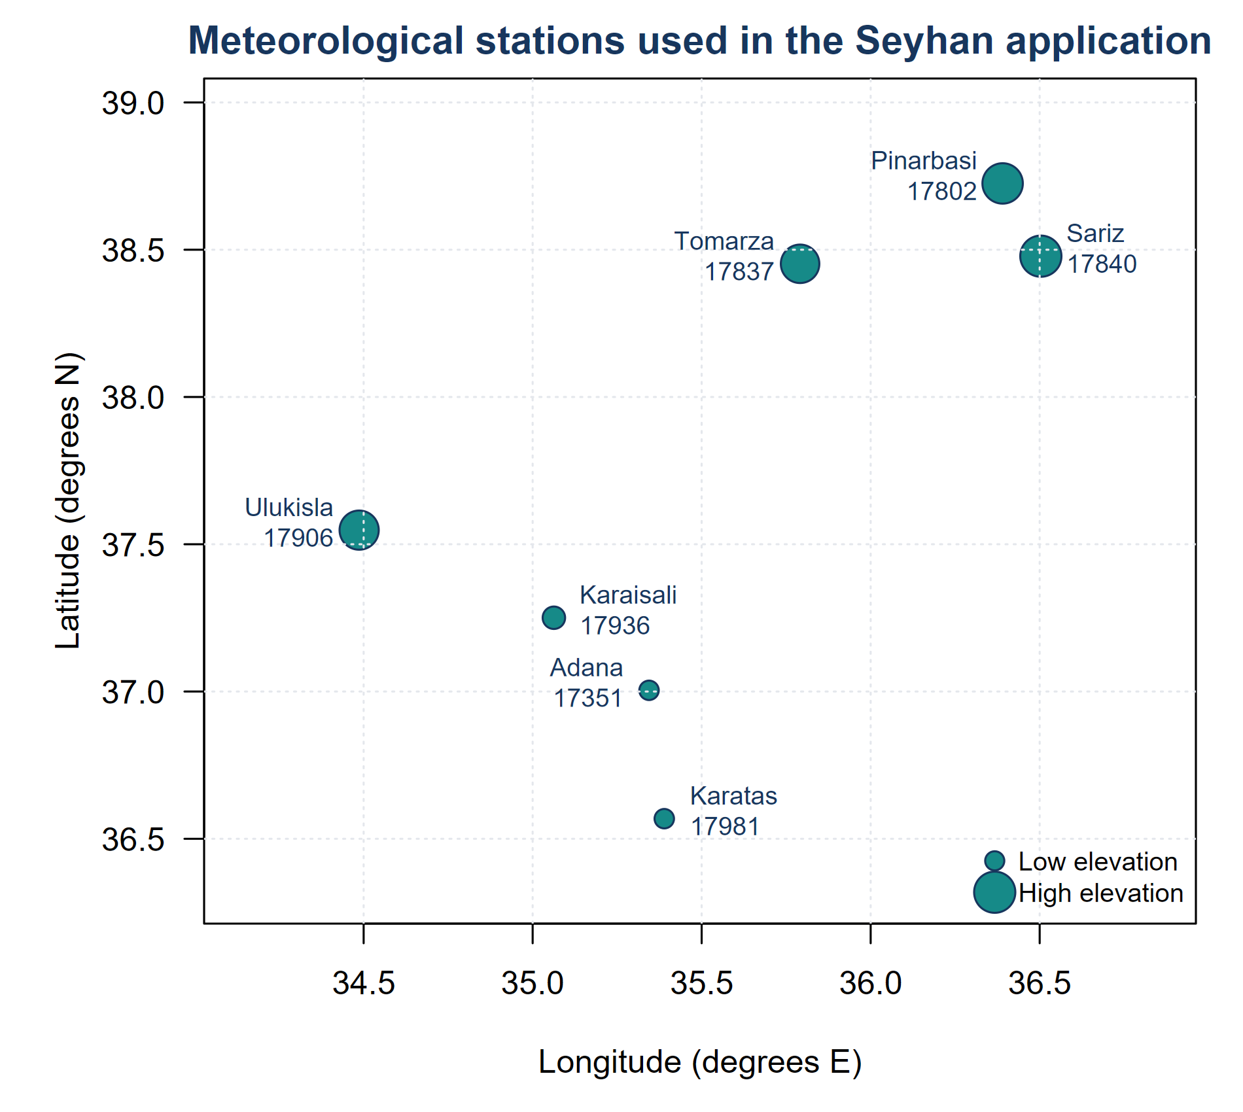
Fig. 2 Geographic distribution and relative elevation of the seven retained meteorological stations used in the Seyhan application

2.10 Open gridded application
An open-data application evaluated scalability and spatial reproducibility using the Copernicus ERA5-Land monthly-means product for January 1950 through December 2025 (Muñoz-Sabater et al. 2021). The request used the monthly averaged reanalysis product, the variables 2m_temperature, total_precipitation, snow_depth_water_equivalent, and volumetric_soil_water_layer_1 through layer_3, NetCDF output, all months, time 00:00, and bounding box [north 39.3°, west 34.3°, south 36.6°, east 37.0°]. The basin was HydroBASINS version 1c level 8 MAIN_BAS 2080001450 in EPSG:4326 (Lehner and Grill 2013).
All 0.1° grid cells intersecting the polygon were retained (274 cells). Exact fractional intersections were obtained with terra::extract using exact fractional weights. For cell j, the analysis weight was
$wⱼ = fⱼAⱼ$ (41)
where fⱼ is the polygon-intersection fraction and Aⱼ is the geodesic cell area in square kilometres from terra::cellSize. The weighted union represented 100% of the HydroBASINS polygon. Air temperature was converted from kelvin to degrees Celsius. For month m, total precipitation in metres per day from the monthly-averaged product was converted to millimetres per month as
$Pₘₘ,ₘ = 1000dₘPₘ,day$ (42)
where dₘ is the number of days in the calendar month.
A second ERA5-Land request used monthly averaged reanalysis by hour of day for total precipitation at 00:00, all months of 2022–2024, the same bounding box, and NetCDF output. Grid and date correspondence was verified before replacement. The product-consistency audit identified September 2022–February 2024 as affected in the main file; only those dates were replaced. The replacement changed 4,932 basin cell-months, and the archived audit records both cell-level and basin-mean differences.
PET was calculated independently for each cell with SPEI::thornthwaite in SPEI 1.8.1 using cell-centre latitude (Thornthwaite 1948). The same M0, Mσ, Mν, and Mσν structures and time convention were fitted by calendar month at 1-, 3-, 6-, and 12-month scales, using the 2,000-cycle and 0.03-step controls specified for the station analysis. A candidate was eligible only when all twelve monthly fits returned, converged, passed the inference-readiness gate, and returned finite AICc. M0 was retained unless the best eligible non-stationary candidate improved AICc by at least two.
Basin series were weighted monthly means using the intersection-area weights. Root-zone soil moisture and snow water equivalent at each cell were defined as
$SMroot = 0.07swvl1 + 0.21swvl2 + 0.72swvl3$ (43)
$SWE = max(1000sd, 0) mm$ (44)
The basin root-zone series was standardized separately within each calendar month and compared with basin nSPEI at response lags zero through six months. This is a process-consistency check, not independent observational validation, because both variables derive from ERA5-Land.

2.11 Software implementation and reproducibility
LL3GAMLSS version 0.1.1 exports density, distribution, quantile, and random-generation functions; GAMLSS family and fit wrappers; parameter extraction and diagnostics; independent likelihood comparison; iid and moving-block bootstraps; and an LL3-SPEI workflow. Automated tests comprised 33 expectations. The source package passed R CMD check without errors or warnings.
The research repository contains the package source, validation procedures, simulation designs, empirical workflows, derived manuscript inputs, and figure-building code. The archived outputs retain requested and completed denominators, fitting controls, convergence results, boundary diagnostics, and Monte Carlo uncertainty. Every manuscript table and figure can be regenerated from the archived intermediate results.
The repository-ready release contains package source, tests, examples, validation code, compact simulation summaries, derived application tables, and figures; complete raw Monte Carlo output is retained in the research archive. Exact replication of the station results requires the provider-restricted workbook, which is not redistributed; the required columns, units, quality-control decisions, analysis period, and transformation code are documented. The ERA5-Land analysis supplies the fully open empirical pathway, subject to normal upstream archive-version availability. Computational reproducibility of the method and open application is therefore distinct from access-controlled replication of the station case study.

3 Results

3.1 Numerical correctness and software stability
The implemented density integrated to one within numerical tolerance, and cumulative probabilities recovered their generating probabilities after quantile inversion. Support endpoints, median and moment conditions, and FAdist conversion tests passed. Numerical derivatives agreed with the analytical score and Hessian functions within the pre-specified tolerances. In the package unit test, the stationary GAMLSS fit agreed with a separately coded eight-start direct optimizer to an absolute log-likelihood difference below 10⁻³. All 33 package-test expectations passed, including the explicit withholding of information criteria from a boundary-contact fit, and the source package completed R CMD check without reported problems.
All 36 simulated calendar-month SPEI maximum-likelihood fits had negative κ and were therefore LL3-compatible. With the SPEI engine initialized at the parameter-equivalent M0 solution, the maximum probability difference was 0.000879; median index MAE was 0.000759, the largest index difference was 0.0276, and the minimum correlation was 0.999989. From SPEI's default PWM start, the corresponding maxima were 0.0421 for probability and 0.614 SPEI units, demonstrating optimizer sensitivity in one small monthly sample. The compatible empirical comparison had probability difference 0.0168, MAE 0.056, maximum index difference 0.222, and correlation 0.9974. Two empirical fits produced non-negative κ and were not parameter-equivalent to lower-threshold LL3. The public max-lik call returned finite coefficients in 0 of 39 archived comparisons; these engine-level results therefore validate the common likelihood and mapping, not the current public dispatch path.

3.2 Monte Carlo performance

3.2.1 Stationary-null selection and parameter recovery
All four candidate models returned in every stationary-null replicate. Minimum AIC selected a non-stationary model in 33.2%, 34.8%, 29.2%, and 29.8% of replicates at sample sizes 60, 100, 250, and 1,000, respectively. The corresponding BIC rates were 13.4%, 10.4%, 4.2%, and 3.2%. Thus, choosing the minimum AIC from four candidates had a substantial family-wise false-selection rate even in long samples and should not be interpreted as a formal test.
When only scale varied with xₜ, scale-slope RMSE declined from 0.228 at a sample size of 60 to 0.053 at 1,000. AIC selected the scale-trend model in 90.5% and 98.0% of replicates at sample sizes 60 and 100, whereas BIC selected it in 73.5% and 90.0%. Mean correlations between fitted and true scale curves exceeded 0.988 at all sample sizes. Under joint scale-shape non-stationarity, slope RMSE declined from 0.237 to 0.053 for scale and from 0.238 to 0.046 for shape as sample size increased from 60 to 1,000. Selection of the full joint model was more difficult: AIC selection increased from 25.5% to 99.0%, while BIC increased from 8.0% to 93.0%.
Table 3 Selected Monte Carlo results for the validated LL3-GAMLSS scope
Experiment | n | Replicates | Slope RMSE | AIC result | BIC / coverage result
Stationary null | 60 | 500 | - | 33.2% false NS | 13.4% false NS
Stationary null | 1,000 | 500 | - | 29.8% false NS | 3.2% false NS
Scale trend | 60 | 200 | 0.228 | 90.5% select trend | 73.5% select trend
Scale trend | 100 | 200 | 0.174 | 98.0% select trend | 90.0% select trend
Joint trend | 60 | 200 | σ 0.237; ν 0.238 | 25.5% select joint | 8.0% select joint
Joint trend | 1,000 | 200 | σ 0.053; ν 0.046 | 99.0% select joint | 93.0% select joint
95% intervals | 100 | 500 | - | σ coverage 95.6% | ν coverage 93.4%
95% intervals | 250 | 500 | - | σ coverage 93.8% | ν coverage 95.0%

3.2.2 Interval coverage and stress scenarios
All 1,000 joint-model interval replicates completed after numerical-Hessian recovery in 3.4% of runs with 100 observations and 2.2% of runs with 250 observations. Empirical 95% coverage at these two sample sizes was, respectively, 95.6% and 93.8% for the scale slope and 93.4% and 95.0% for the shape slope. Empirical standard deviations and mean standard errors were similar for both slopes.
In the 4,500-dataset stress test, 4,411 datasets (98.0%) met the complete inference-ready definition. Eighty-eight incomplete datasets were boundary-contact solutions, and one iid dataset with 60 observations did not return a fit. Boundary-contact rates ranged from 4.8% to 6.2% with 30 observations, from 0.2% to 0.6% with 60 observations, and were zero in every scenario with 100 observations. All returned scale-trend fits reported convergence.
Scale-slope RMSE under iid data decreased from 0.329 with 30 observations to 0.159 with 100 observations. The corresponding values were 0.528 to 0.315 under AR(1) dependence and 0.368 to 0.194 under contamination (Fig. 3a). With 60 observations, AIC selected the moderate trend in 57.4% of iid, 55.5% of AR(1), and 61.0% of contaminated complete replicates; BIC rates were 32.9%, 40.2%, and 32.4%. Serial dependence produced the largest RMSE and residual autocorrelation, indicating that an iid likelihood does not provide dependence-adjusted uncertainty.
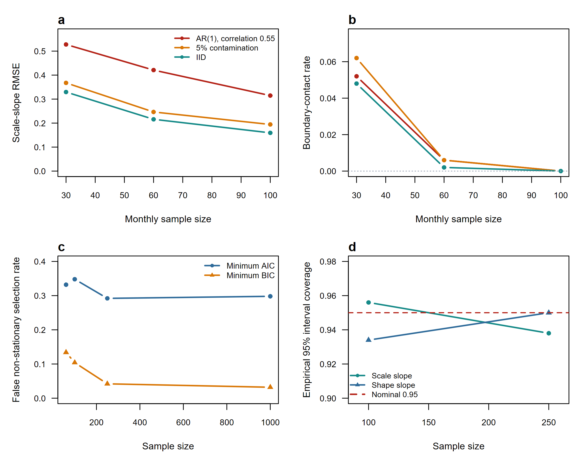
Fig. 3 Monte Carlo validation: (a) scale-slope RMSE in the stress test; (b) threshold-boundary contact; (c) false non-stationary selection under the stationary null; and (d) empirical 95% interval coverage for joint-model slopes

3.2.3 End-to-end seasonal model selection
Under stationary M0 truth, the false-selection rate at ΔAICc ≥ 2 ranged from 0.0% to 16.7% for iid data and from 3.3% to 23.3% for AR(1) data across the four accumulation scales; at the stronger threshold of 10 the corresponding ranges were 0.0-10.0% and 0.0-13.3% (Table 4). Monte Carlo errors were necessarily broad with 30 replicates per cell, reaching 7.7 percentage points for the largest estimate. The increasing rates at longer scales should be interpreted in light of overlapping trailing sums and the fact that sums of LL3 variables are not themselves exactly LL3. ΔAICc remains model-ranking evidence, not a test with nominal type-I error.
Under Mσ truth, operational model selection completed in every AR(1) replicate and in 83.3-100% of iid replicates. Detection power was 100% among completed selections at both thresholds. Correct Mσ selection at ΔAICc ≥ 2 ranged from 82.8% to 100%; the remaining detected selections favoured another non-stationary candidate. At one month, scale-slope bias was 0.0139 (MCSE 0.0050) under iid sampling and 0.0004 (0.0061) under AR(1), with RMSE 0.0305 (0.0056) and 0.0326 (0.0030), respectively. All-four-candidate completion declined with scale under Mσ truth because at least one misspecified alternative—usually involving shape—contacted the support boundary; any-candidate boundary rates ranged from 33.3% at one month to 100% at the longest iid scales. These failures were retained rather than converted into usable information criteria.
Table 4 End-to-end seasonal model-selection simulation; percentages show estimate (Monte Carlo standard error in percentage points)
Truth | Dependence | Scale | False / detection Δ2 | False / detection Δ10 | Correct Mσ Δ2 | All candidates complete / any boundary
M0 | iid | 1 | 0.0% (0.0 pp) | 0.0% (0.0 pp) | - | 100.0% (0.0 pp) / 0.0% (0.0 pp)
M0 | iid | 3 | 13.3% (6.2 pp) | 6.7% (4.6 pp) | - | 100.0% (0.0 pp) / 0.0% (0.0 pp)
M0 | iid | 6 | 10.0% (5.5 pp) | 6.7% (4.6 pp) | - | 100.0% (0.0 pp) / 0.0% (0.0 pp)
M0 | iid | 12 | 16.7% (6.8 pp) | 10.0% (5.5 pp) | - | 100.0% (0.0 pp) / 0.0% (0.0 pp)
M0 | AR(1) | 1 | 3.3% (3.3 pp) | 0.0% (0.0 pp) | - | 100.0% (0.0 pp) / 0.0% (0.0 pp)
M0 | AR(1) | 3 | 6.7% (4.6 pp) | 3.3% (3.3 pp) | - | 100.0% (0.0 pp) / 0.0% (0.0 pp)
M0 | AR(1) | 6 | 10.0% (5.5 pp) | 6.7% (4.6 pp) | - | 100.0% (0.0 pp) / 0.0% (0.0 pp)
M0 | AR(1) | 12 | 23.3% (7.7 pp) | 13.3% (6.2 pp) | - | 100.0% (0.0 pp) / 0.0% (0.0 pp)
Mσ | iid | 1 | 100.0% (0.0 pp) | 100.0% (0.0 pp) | 100.0% (0.0 pp) | 63.3% (8.8 pp) / 36.7% (8.8 pp)
Mσ | iid | 3 | 100.0% (0.0 pp) | 100.0% (0.0 pp) | 100.0% (0.0 pp) | 3.3% (3.3 pp) / 96.7% (3.3 pp)
Mσ | iid | 6 | 100.0% (0.0 pp) | 100.0% (0.0 pp) | 82.8% (7.0 pp) | 0.0% (0.0 pp) / 100.0% (0.0 pp)
Mσ | iid | 12 | 100.0% (0.0 pp) | 100.0% (0.0 pp) | 86.7% (6.2 pp) | 0.0% (0.0 pp) / 100.0% (0.0 pp)
Mσ | AR(1) | 1 | 100.0% (0.0 pp) | 100.0% (0.0 pp) | 100.0% (0.0 pp) | 66.7% (8.6 pp) / 33.3% (8.6 pp)
Mσ | AR(1) | 3 | 100.0% (0.0 pp) | 100.0% (0.0 pp) | 100.0% (0.0 pp) | 50.0% (9.1 pp) / 50.0% (9.1 pp)
Mσ | AR(1) | 6 | 100.0% (0.0 pp) | 100.0% (0.0 pp) | 90.0% (5.5 pp) | 40.0% (8.9 pp) / 60.0% (8.9 pp)
Mσ | AR(1) | 12 | 100.0% (0.0 pp) | 100.0% (0.0 pp) | 86.7% (6.2 pp) | 13.3% (6.2 pp) / 86.7% (6.2 pp)
In Table 4, the first two percentage columns are false-selection rates for M0 rows and detection rates for Mσ rows. Detection and correct-model rates use completed selections as their denominator. The final column reports completion of all four twelve-month candidate sets followed by contact of any candidate with the threshold boundary. Operational selection completion is reported in the text and archived summary.

3.3 Seyhan application

3.3.1 Fit completion and model support
The retained common-period dataset contained 5,117 station-month records before accumulation, with 20,342 finite accumulated observations across the four scales after the expected leading losses. Every selected model converged for all twelve calendar months in all 28 station-scale analyses, and no selected model contacted the threshold boundary. One rejected candidate row, the six-month shape-trend fit at Tomarza, contained a boundary contact and was excluded from ordinary inference.
Strong support for a non-stationary LL3 candidate occurred in 17 of 28 station-scale analyses; the remaining 11 showed no material support, and none fell in the weak or moderate categories. Strong-support counts increased from three of seven stations at one month to four at three months and five at both six and twelve months. Every strongly supported case selected Mσ, indicating that the detected non-stationarity operated through the LL3 scale parameter rather than through the estimated threshold or a shape trend.
Pinarbasi, Tomarza, and Sariz supported Mσ at all four scales. Ulukisla supported it at 3, 6, and 12 months, while Karaisali supported it at 6 and 12 months. Adana and Karatas retained M0 at every scale. Evidence generally increased with accumulation period: the median ΔAICc across retained stations was -1.5 at one month and 27.1 at twelve months (Fig. 4).
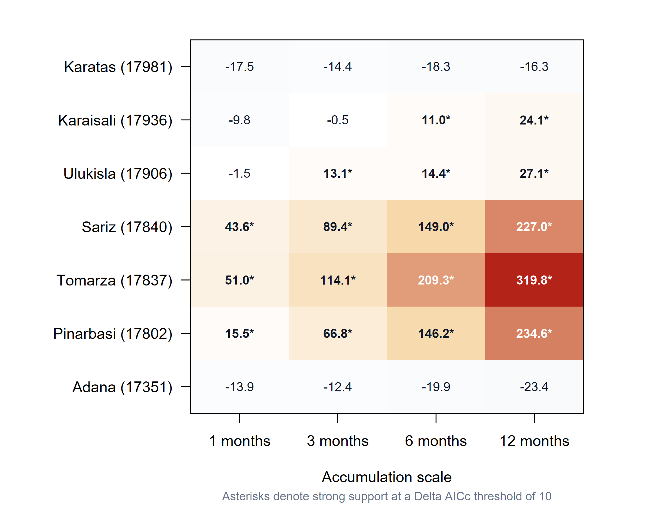
Fig. 4 Station-by-scale evidence for the best non-stationary LL3 candidate; positive ΔAICc favours non-stationarity and asterisks denote strong support (ΔAICc ≥ 10)
Table 5 Station-level summary of model support and index differences
Station | Strong scales | No-support scales | Median ΔAICc | Median MAE | Maximum difference | Extreme dry M0 / alternative
Adana | 0 | 4 | -16.9 | 0.089 | 0.505 | 61 / 65
Pinarbasi | 4 | 0 | 106.5 | 0.352 | 1.178 | 77 / 67
Tomarza | 4 | 0 | 161.7 | 0.416 | 1.434 | 81 / 77
Sariz | 4 | 0 | 119.2 | 0.372 | 1.272 | 78 / 73
Ulukisla | 3 | 1 | 13.8 | 0.182 | 0.836 | 65 / 73
Karaisali | 2 | 2 | 5.3 | 0.167 | 0.684 | 64 / 42
Karatas | 0 | 4 | -16.9 | 0.067 | 0.514 | 70 / 66

3.3.2 Consequences for the standardized index
Across all 28 station-scale comparisons, the median stationary/non-stationary correlation was 0.971 and the median mean absolute difference was 0.186 SPEI units. The maximum individual difference was 1.434 at Tomarza. Differences increased with accumulation scale: median MAE was 0.129 at one month, 0.178 at three months, 0.186 at six months, and 0.234 at twelve months. The twelve-month series illustrate near overlap at unsupported Adana and progressively larger time-dependent differences at supported Pinarbasi, Tomarza, and Sariz (Fig. 5).
The extreme-dry counts in Table 5 are sums across four accumulation scales and should not be interpreted as independent drought events. They demonstrate that non-stationary standardization can either increase or decrease threshold crossings depending on station and time. At Pinarbasi, Sariz, and Karaisali, for example, the best non-stationary candidates produced fewer values at or below -2 than M0, whereas Ulukisla produced more. Event-based duration and severity analysis was therefore kept outside the current software-validation objective.
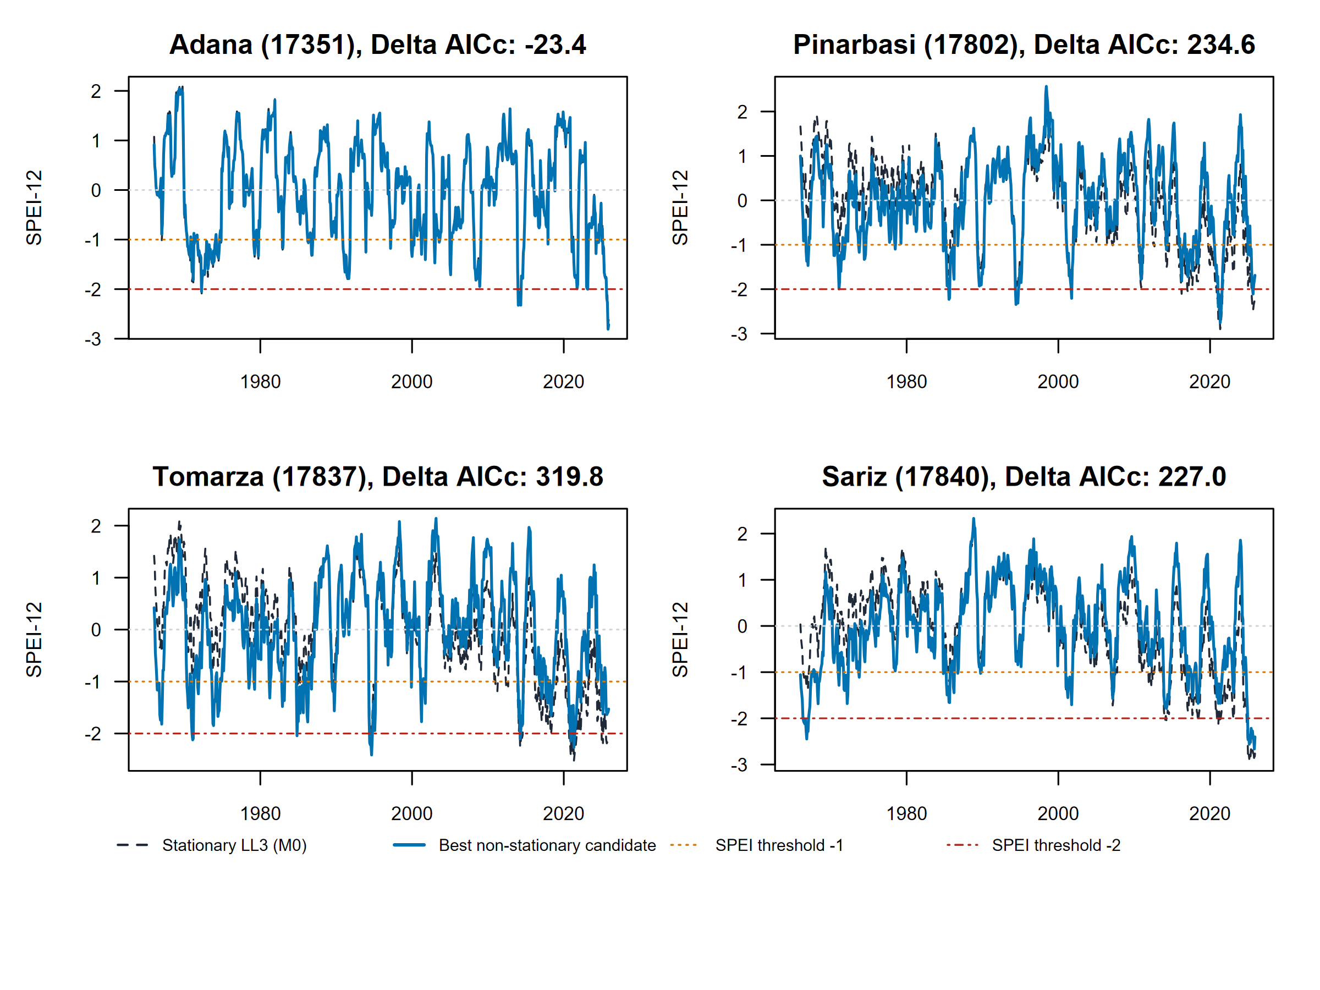
Fig. 5 Stationary M0 (dashed charcoal) and best non-stationary candidate (solid blue) at the 12-month scale for one unsupported station (Adana) and three strongly supported stations; the non-stationary candidate is Mσ in the supported cases

3.3.3 Stationary PWM benchmark
Stationary LL3-MLE and conventional stationary PWM-SPEI were highly correlated across all retained station-scale analyses: the median correlation was 0.9968. The median MAE was 0.056, with station-scale MAE values from 0.040 to 0.095 and a maximum individual difference of 0.737. Differences were concentrated in the distribution tails. Across the 28 station-scale series, PWM and MLE produced 199 and 496 values at or below -2, respectively. Thus, even without non-stationarity or a family change, estimation method materially affected some classifications. This result supports the use of M0, rather than PWM-SPEI, as the stationary comparator for the likelihood-based alternatives.

3.3.4 Dependence diagnostics and block-bootstrap uncertainty
The 17 retained strong-support station-scale cases yielded 204 calendar-month normalized-PIT residual series. Median absolute monthly lag-1 autocorrelation was 0.083, and the maximum was 0.290. In contrast, lag-1 autocorrelation of the chronologically reassembled selected index ranged from 0.080 to 0.938 and rose with accumulation scale, as expected from overlapping trailing sums. Consequently, the calendar-month residual diagnostic is the more direct check of fitted conditional independence, while block resampling remains prudent for uncertainty.
Tomarza supplied the strongest ΔAICc case at each scale. Its representative monthly scale slopes and moving-block 95% intervals were 1 month: -0.134 [-0.264, -0.051]; 3 months: -0.150 [-0.393, -0.066]; 6 months: -0.185 [-0.441, -0.137]; 12 months: -0.171 [-0.297, -0.108]. Every interval excluded zero. All 1996 of 1996 requested refits were valid, with zero boundary refits. These percentile intervals account for the resampled residual dependence structure; the ordinary iid Wald intervals were not interpreted as dependence-robust.

3.4 Open gridded application

3.4.1 Computational completion and spatial selection
The gridded application contained 249,888 finite cell-month records. All 52,608 cell-level candidate monthly fits and all 192 basin-level candidate monthly fits converged, passed the inference-readiness gate, and avoided threshold-boundary contact. No cell-scale selection failed. The selected non-stationary share of basin area increased from 18.8% at one month to 32.6%, 53.2%, and 70.8% at three, six, and twelve months, respectively (Table 6; Fig. 6). Mσ dominated at every scale. Mσν appeared at six and twelve months, and Mν appeared only at twelve months.
Table 6 Area-weighted ERA5-Land model selection across the Seyhan Basin
Scale | M0 area | Mσ area | Mν area | Mσν area | Basin-series model
1 month | 81.18% | 18.82% | 0.00% | 0.00% | M0
3 months | 67.41% | 32.59% | 0.00% | 0.00% | M0
6 months | 46.84% | 41.83% | 0.00% | 11.33% | M0
12 months | 29.19% | 58.16% | 5.58% | 7.07% | Mσ
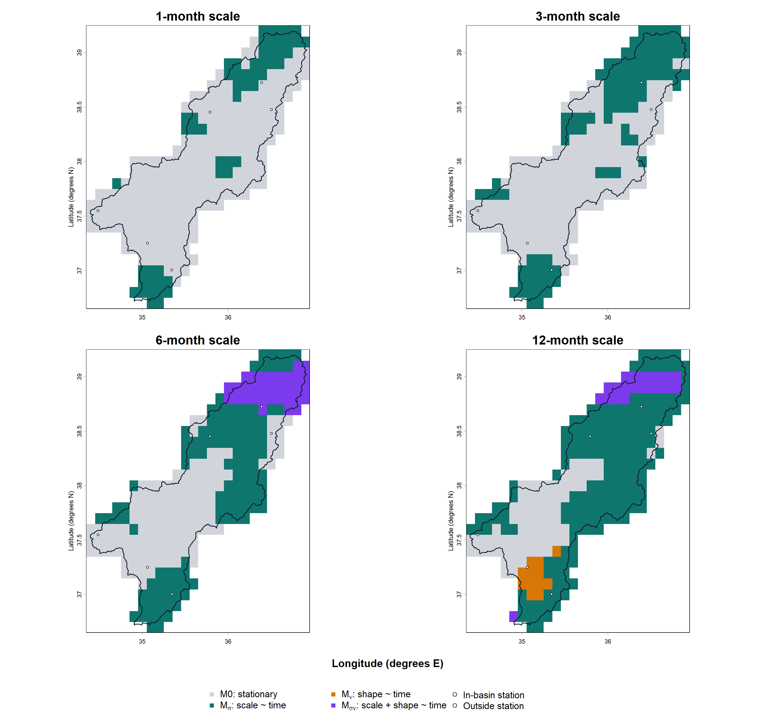
Fig. 6 Selected LL3 model for 274 ERA5-Land cells intersecting the Seyhan Basin at four accumulation scales; colours identify M0, Mσ, Mν, and Mσν, and the basin outline shows the fractionally weighted analysis boundary

3.4.2 Basin aggregation and process consistency
The area-weighted basin series retained M0 at one, three, and six months. At six months, the best non-stationary candidate improved AICc by 1.889, below the pre-specified threshold of two. Mσ was strongly supported at twelve months, with a ΔAICc of 13.265. Across cells, the mean selected-index standard deviation ranged from 0.9868 to 0.9906, and the mean of cell-level index means ranged from −0.0271 to −0.0153, indicating close marginal calibration after selection.
Area-weighted root-zone soil-moisture anomalies were positively associated with basin nSPEI. The highest Pearson correlations were 0.515, 0.709, 0.681, and 0.537 at one-, three-, six-, and twelve-month scales; the one-month relation peaked with soil moisture lagged by one month, whereas the longer scales peaked at zero lag. Among months with nSPEI at or below -1, the soil-moisture anomaly was negative in 80.0%, 89.9%, 92.1%, and 79.5% of cases. These results support internal process consistency but do not constitute validation against an independent observational product.

4 Discussion

4.1 Software contribution and distributional consistency
LL3GAMLSS fills a software gap between the original definition of SPEI and the GAMLSS framework commonly used to introduce non-stationarity. The original and reference implementations use a shifted three-parameter log-logistic distribution, whereas this family is absent from the standard gamlss.dist catalogue. The package supplies that family with explicit support handling, an inference-readiness gate, independent optimization checks, uncertainty helpers, automated tests, and an operational calendar-month workflow. It turns a study-specific modelling task into reusable Earth-science software without claiming that non-stationary SPEI itself is new.
The main inferential benefit is attribution. Comparing conventional LL3-PWM SPEI directly with a non-stationary index based on a different family and maximum likelihood leaves the source of any difference unresolved. LL3GAMLSS instead nests M0 and the covariate-dependent alternatives within the same LL3 likelihood. Their contrast estimates the consequence of the parameter-covariate relation under a common distributional specification. The separate PWM comparison then measures how much the estimator alone can change the index. This separation is important because the station application found tail-classification differences between PWM and maximum likelihood even when both methods used stationary LL3.

4.2 Interpretation of simulation and case-study evidence
The simulations support reliable numerical estimation when solutions remain interior. Bias and RMSE decreased with sample size, interval coverage was close to nominal, and boundary contact disappeared with 100 observations in the single-series stress test. Nevertheless, model detection and estimation uncertainty were distinct. A real moderate trend was frequently missed in samples of 30–60 observations, particularly by BIC, while minimum AIC falsely selected one of three non-stationary alternatives in roughly 29–35% of stationary-null replicates. The seasonal workflow showed lower but non-zero false selection under the pre-specified ΔAICc thresholds, rising at longer overlapping accumulations, and frequent boundary contact in misspecified alternatives under Mσ truth. These results support pre-specification, strong-evidence thresholds, residual checks, and explicit reporting of failed or boundary fits, consistent with cautions about overinterpreting non-stationarity under large uncertainty (Serinaldi and Kilsby 2015).
The quality-screened station application identified a coherent scale-driven pattern: all 17 strongly supported station-scale analyses selected Mσ. The effect strengthened at longer accumulation scales and substantially altered some index values, yet Adana and Karatas showed no material support. The ERA5-Land application confirmed that this heterogeneity persists in a complete gridded workflow: the non-stationary share increased with accumulation scale, while the basin-averaged series masked much of the cell-level change. These results argue against imposing a non-stationary standardization everywhere and show why the varying parameter must be reported.
The PWM comparison adds a separate caution. Two estimators of the same stationary family can be almost perfectly correlated in the centre while producing different extreme counts. The SPEI maximum-likelihood benchmark further showed that likelihood equivalence must be separated from optimizer initialization and parameter-space compatibility. Neither estimator should be treated as an automatic truth. For monitoring applications, tail calibration, record length, estimator choice, and sensitivity of drought classifications should be reported alongside fit criteria. The empirical block-bootstrap intervals supported the representative scale trends, but this does not convert ΔAICc into a hypothesis test or make iid Wald uncertainty dependence-robust.

4.3 Limitations and future validation
Five limitations define the validated scope. First, the threshold is estimated but constant; covariate-dependent support remains experimental. Second, the applications use linear standardized time, although the software accepts other parametric covariates. Climate-index applications should pre-specify lag structure, standardize predictors, evaluate collinearity, and avoid contemporaneous predictors that are components of the response unless the scientific objective justifies them. Third, calendar-month station samples contain approximately 60 observations, leaving shape and threshold estimates sensitive to tails. Fourth, serial dependence increases slope RMSE and invalidates naive iid uncertainty; the moving-block bootstrap should be used when normalized residual autocorrelation persists. Fifth, filled hydroclimatic records require explicit screening. The Pozanti series showed that long climatological infill can suppress SPEI variance and distort non-stationarity assessment.
The study does not establish that LL3 is optimal for every climate. Its purpose is to make LL3 available when consistency with the established SPEI definition is required. Applications that claim distributional superiority should compare plausible families on identical observations using likelihood-appropriate criteria, held-out log scores, probability-integral-transform calibration, and lower-tail scores. The ERA5-Land soil-moisture analysis is an internal process check rather than independent validation. Future work should test the software against independent impact or soil-moisture observations and extend validation to smooth predictors, spatial pooling, and covariate-dependent thresholds.

5 Conclusions
LL3GAMLSS supplies the shifted three-parameter log-logistic family missing from the standard GAMLSS distribution catalogue and uses it for stationary and covariate-dependent SPEI. Holding the family and maximum-likelihood estimator constant makes M0 and the non-stationary candidates directly comparable. This removes a common ambiguity in which differences attributed to non-stationarity may also reflect a changed probability family or estimator.
Numerical and Monte Carlo validation showed accurate probability calculations, improving parameter recovery with record length, near-nominal interval coverage, and explicit detection of non-regular boundary solutions. The end-to-end experiment showed why strong-evidence thresholds, candidate-completion reporting, and dependence diagnostics remain necessary at overlapping accumulation scales. The station and ERA5-Land applications showed that evidence for non-stationarity varies across location and scale and is commonly expressed through changes in the LL3 scale parameter. LL3GAMLSS provides reproducible infrastructure for evaluating that evidence; it does not require users to select a non-stationary model or assume that LL3 is optimal in every climate.

Software Files
The software archive contains the installable LL3GAMLSS source package, the complete R source tree, reference documentation, unit tests, worked stationary and non-stationary examples, Monte Carlo code, validation summaries, and code used to generate the manuscript figures and derived tables. The file LL3GAMLSS_0.1.1.tar.gz is the version evaluated in this manuscript. Source code is released under GPL-3. The public repository URL and archived-release DOI will accompany the submitted version.

Availability and requirements
Requirement | Specification
Project name | LL3GAMLSS
Version | 0.1.1
Operating system | Platform independent
Programming language | R 4.1.0 or later
Dependencies | gamlss, gamlss.dist; optional FAdist, numDeriv, testthat
Licence | GPL-3
Repository | Public repository URL to accompany the submitted manuscript
Archived release | Persistent archive DOI to accompany the submitted manuscript

Statements and Declarations
Competing interests: The author declares no competing interests.
Author contributions: Tolga Barış Terzi conceived the study, developed and validated the software, performed the analyses, interpreted the results, and prepared the manuscript.
Data availability: The station observations cannot be redistributed and will be available from the author on reasonable request, subject to provider conditions. ERA5-Land inputs are publicly obtainable from the Copernicus Climate Data Store. Derived analysis tables, simulation outputs, and reproducible scripts will accompany the archived software release.
Code availability: LL3GAMLSS source code, tests, examples, and validation scripts will be released under GPL-3 in a public repository and a persistent research archive before submission.
Ethics approval: Not applicable.
Consent to participate: Not applicable.
Consent for publication: Not applicable.

Acknowledgements
The author acknowledges the Copernicus Climate Change Service for access to ERA5-Land data.

References
Akaike H (1974) A new look at the statistical model identification. IEEE Trans Autom Control 19:716-723. https://doi.org/10.1109/TAC.1974.1100705
Bazrafshan J, Cheraghalizadeh M, Shahgholian K (2022) Development of a non-stationary standardized precipitation evapotranspiration index (NSPEI) for drought monitoring in a changing climate. Water Resour Manag 36:3523-3543. https://doi.org/10.1007/s11269-022-03209-x
Beguería S, Vicente-Serrano SM (2023) SPEI: calculation of the standardized precipitation-evapotranspiration index. R package version 1.8.1. https://CRAN.R-project.org/package=SPEI
Beguería S, Vicente-Serrano SM, Reig F, Latorre B (2014) Standardized precipitation evapotranspiration index (SPEI) revisited: parameter fitting, evapotranspiration models, tools, datasets and drought monitoring. Int J Climatol 34:3001-3023. https://doi.org/10.1002/joc.3887
Burnham KP, Anderson DR (2002) Model selection and multimodel inference: a practical information-theoretic approach, 2nd edn. Springer, New York
Hargreaves GH, Samani ZA (1985) Reference crop evapotranspiration from temperature. Appl Eng Agric 1:96-99. https://doi.org/10.13031/2013.26773
Lehner B, Grill G (2013) Global river hydrography and network routing: baseline data and new approaches to study the world's large river systems. Hydrol Process 27:2171-2186. https://doi.org/10.1002/hyp.9740
Masanta SK, Srinivas VV (2022) Proposal and evaluation of nonstationary versions of SPEI and SDDI based on climate covariates for regional drought analysis. J Hydrol 610:127808. https://doi.org/10.1016/j.jhydrol.2022.127808
Muñoz-Sabater J, Dutra E, Agustí-Panareda A et al (2021) ERA5-Land: a state-of-the-art global reanalysis dataset for land applications. Earth Syst Sci Data 13:4349-4383. https://doi.org/10.5194/essd-13-4349-2021
R Core Team (2024) R: a language and environment for statistical computing. R Foundation for Statistical Computing, Vienna. https://www.R-project.org/
Rigby RA, Stasinopoulos DM (2005) Generalized additive models for location, scale and shape. J R Stat Soc C Appl Stat 54:507-554. https://doi.org/10.1111/j.1467-9876.2005.00510.x
Serinaldi F, Kilsby CG (2015) Stationarity is undead: uncertainty dominates the distribution of extremes. Adv Water Resour 77:17-36. https://doi.org/10.1016/j.advwatres.2014.12.013
Stagge JH, Tallaksen LM, Gudmundsson L, Van Loon AF, Stahl K (2015) Candidate distributions for climatological drought indices (SPI and SPEI). Int J Climatol 35:4027-4040. https://doi.org/10.1002/joc.4267
Stasinopoulos DM, Rigby RA (2023) gamlss.dist: distributions for generalized additive models for location scale and shape. R package version 6.1-1. https://CRAN.R-project.org/package=gamlss.dist
Stasinopoulos DM, Rigby RA (2007) Generalized additive models for location scale and shape (GAMLSS) in R. J Stat Softw 23(7):1-46. https://doi.org/10.18637/jss.v023.i07
Thornthwaite CW (1948) An approach toward a rational classification of climate. Geogr Rev 38:55-94. https://doi.org/10.2307/210739
Vicente-Serrano SM, Beguería S, López-Moreno JI (2010) A multiscalar drought index sensitive to global warming: the standardized precipitation evapotranspiration index. J Clim 23:1696-1718. https://doi.org/10.1175/2009JCLI2909.1

