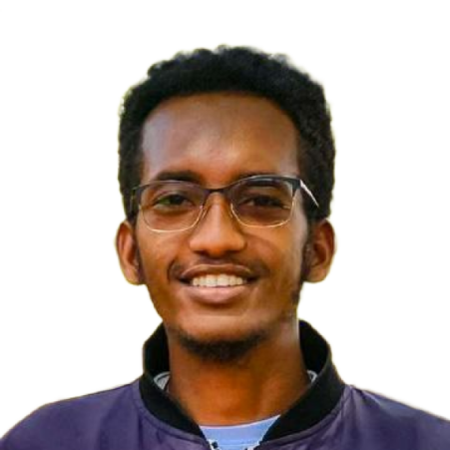  CONTACT  Wolaita-Sodo, South Ethiopia Region, Ethiopia  +251 983 708 869  +251 950 030 794  tesfatseyon16@email.com  linkedin.com/in/tesfatseyonmerkinh  KEY SKILLS  - Short-form editing (TikTok / Reels / Shorts)  - Hook writing & retention-driven pacing  - CapCut & DaVinci Resolve  - Color correction & grading  - Sound design, music sync & captions  - Repurposing long-form into short clips  - Trend & platform-algorithm awareness  - Client communication & fast turnaround  EDUCATION  B.Sc. Computer Science  Dilla University, Ethiopia  Expected 2027  INTERESTS  - Short-form video trends  - Travelling  - Classic films  - Learning new languages | TESFATSEYON MERKINEH  VIDEO EDITOR | SHORT-FORM & HIGH-RETENTION CONTENT  PROFILE  Video editor focused on short-form, high-retention content for TikTok, Instagram Reels, and YouTube Shorts. Experienced cutting for a range of clients and niches, with an eye for pacing, hooks, and story structure that keep viewers watching to the end. Comfortable working end-to-end in CapCut and DaVinci Resolve — from raw footage to color, sound, captions, and export-ready delivery across formats. Brings a technical background in software development, which translates into fast tool adoption, organized project files, and a methodical approach to testing what actually improves watch time.  EXPERIENCE  Freelance Video Editor — Short-Form Content 2024 – Present  Remote / Independent  - Edit short-form videos for clients across a mix of niches, delivering content optimized for TikTok, Instagram Reels, and YouTube Shorts.  - Structure edits around strong opening hooks, tight pacing, and clean cuts to maximize watch-through and retention.  - Handle the full workflow in CapCut and DaVinci Resolve: rough cuts, color grading, audio sync, sound design, and platform-ready exports.  - Add captions, on-screen text, and simple motion elements to boost accessibility and scroll-stopping impact.  - Manage multiple client projects and turnaround deadlines, keeping organized, versioned project files.  Content Creator — Personal Short-Form Projects 2023 – Present  Independent  - Plan, shoot, and edit personal short-form content, using it as a testing ground for hooks, pacing, and trend formats.  - Iterate on edits based on audience retention and engagement patterns to sharpen editing decisions over time.  Frontend & Web Developer 2023 – 2024  Freelance / Academic Projects — Dilla University, Ethiopia  - Built and deployed responsive websites, including a hotel design site and a university fellowship website, with a focus on clean UI and cross-device usability.  - Background in structured, detail-oriented technical work — a skillset that carries directly into organized editing workflows and fast adoption of new creative tools.

