School SMS — Logical Data Model
Entity-relationship overview of application tables. PK = primary key, FK = foreign key, UK = unique. Crow’s foot = many; circle = optional.
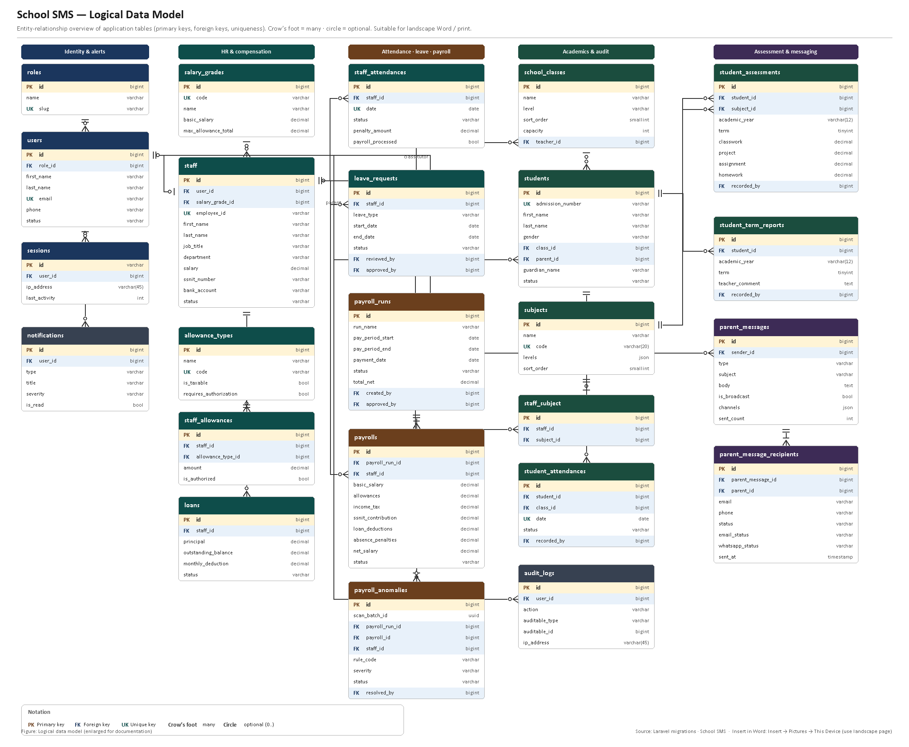
Note: Cross-domain foreign keys (e.g. parent_id, teacher_id, sender_id, recorded_by) are shown on subject-area diagrams where space allows. Source: backend/database/migrations.

