AOD-LAB-FAT

Poornesh Adhithya

19BCE2472

3. f(x)=xsin(x)

clc

clear all

syms x

f=input('Input the given function interms of x: ')

I=input('Input the given interval [a,b]:')

m=input('Input the number Harmonics required:')

pi = 3.14

a=0;

b=2\*pi;

L=(b-a)/2;

Fx=((1/L)\*int(f,a,b))/2;

for n=1:m

figure;

an(n)=(1/L)\*int(f\*cos(n\*pi\*x/L),a,b);

bn(n)=(1/L)\*int(f\*sin(n\*pi\*x/L),a,b);

Fx=Fx+an(n)\*cos(n\*pi\*x/L)+bn(n)\*sin(n\*pi\*x/L);

Fx=vpa(Fx,4)

ezplot(Fx,[a,b])

hold on

ezplot(f,[a,b])

title(['Fourier Series with',num2str(n),'Harmonics']);

legend('Fourier Series','Function plot');

hold off

end

disp(strcat('Fourier Series with: ',num2str(n),'Harmonics is: ',char(Fx)))

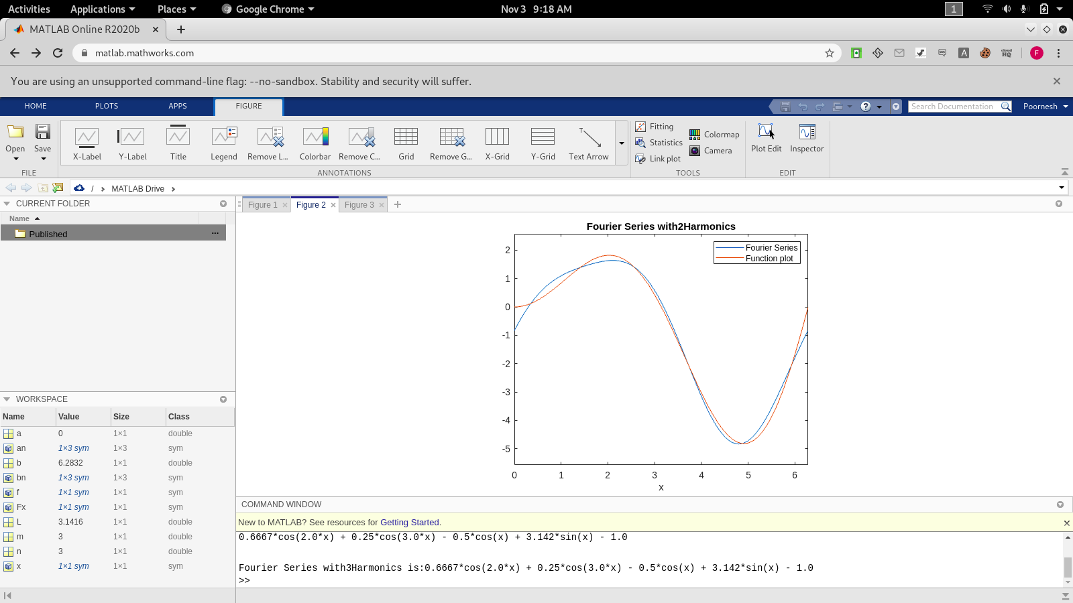

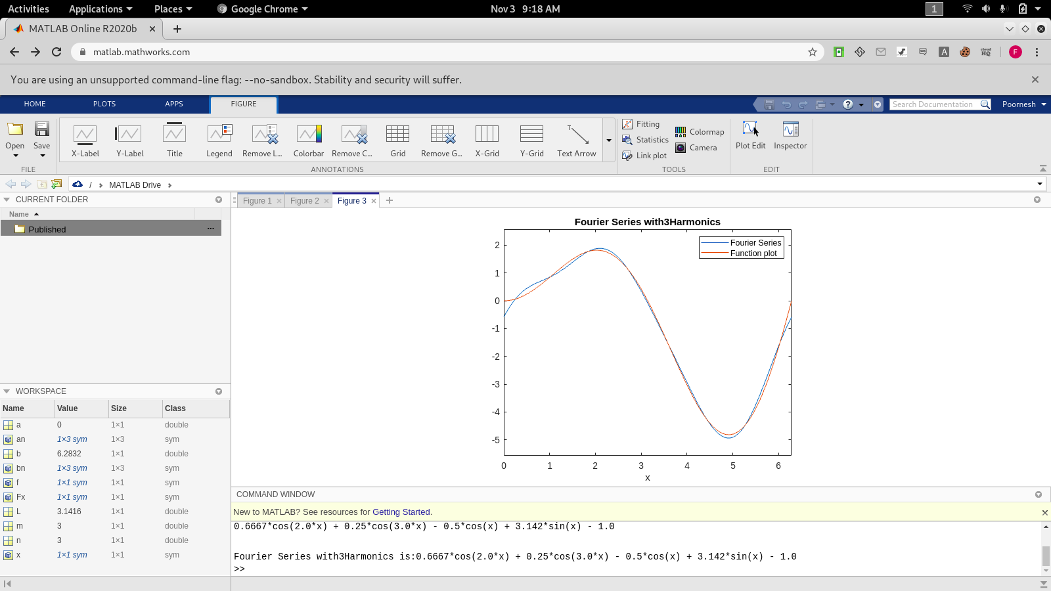

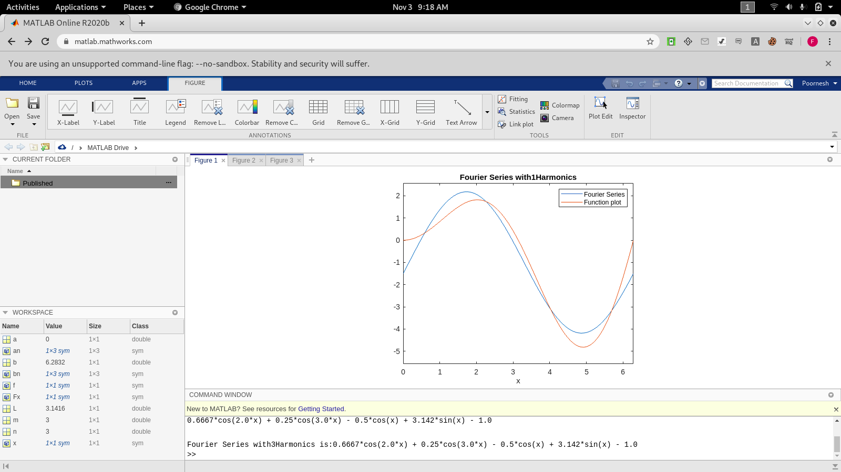

5. x = linspace (4,20,15)

6. syms x,y,z

7. Converts a number to string

8. sin(-pi/2)

9. error message