SECTION A
QUESTION 1-SOURCE BASED QUESTIONS
The Cold War – The Arms Race
Refer to Source A
- In what way did the Arms Race develop into a propaganda and intelligence war? (Level 3) 2x2=(4)
- What techniques did the two Super Powers use to spy on each other? (Level 3) (2)
- Define the term ‘nuclear deterrent’ in not more than 20 words. (Level 3) (3)
Refer to Source B
- Do you think the development of nuclear weapons was what Dulles might have had in mind? Explain your answer. (Level 7) (6)
Refer to Sources C and D
- Compare the two cartoons. Decide which is which and explain the message of each one. (Level 5) (10)
Refer to Source E and the Fact File on the U-2 Crisis of 1960
- What is the Soviet cartoon saying about the U-2 plane? (Level 4) (3)
- Why was the USSR so angry about the spy flights? (Level 3) 2x2=(4)
- How would the USA justify this violation of Soviet territory? (Level 6) (4)
- If the USSR had had U-2 planes do you think it would have used them? Explain your answer. (Level 4) (4)
Refer to Sources F and G
- Do you think people were reassured and their fears allayed by seeing photographs such as the one in Source G? Explain. (Level 4) (6)
- What two questions would you ask Betrand Russell in response to his comment in Source F? (Level 4) 2x2=(4)
50 marks

QUESTION 2-SOURCE BASED ESSAY
In this section of the paper, you will use all the sources to extract relevant information to answer a question.

You will be expected to:
Identify the relevant information from each source and reference the sources.
Group the sources and indicate which sources support or oppose the topic.
Weigh up the information supporting and opposing the topic.
Take a definite stand on the question.
Build a logical argument supporting the stand you have taken.
Acknowledge a counter argument, if there is one.
Discuss value and limitations of the sources to determine whether they are reliable.
Communicate your answer clearly.

Using the sources discuss which Super Power felt more threatened during the arms race, the USA or the USSR?

40 marks

QUESTION 3
SINGLE SOURCE ANALYSIS
China’s role in the Cold War

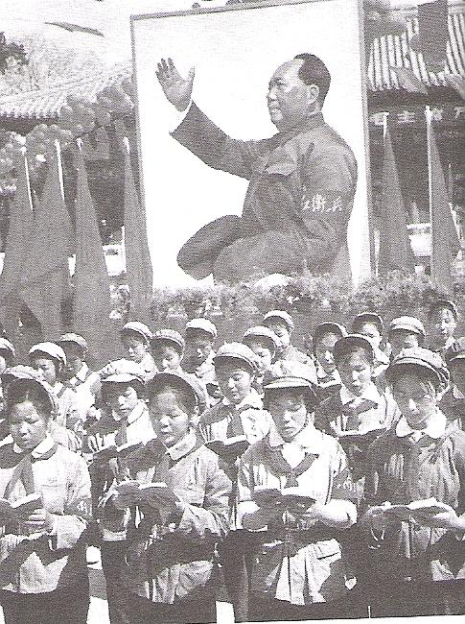

Red Guards reading the thoughts of Chairman Mao Zedong at a rally in 1967

- Describe what is happening in the photograph. (L3) (2)

- What methods of propaganda are being used in the photograph? (L3) 3x2=(6)

- In what way would the Chinese government use this photograph for propaganda purposes? (L7) (8)

- For what reasons did China become a perceived threat in 1949? (L2) (4)

20 marks

SECTION B
QUESTION 4
DISCURSIVE ESSAY
How did South Africa emerge as a democracy from the crises of the 1990s?

Answer the following essay question showing evidence of understanding, interpretation, analysis and argument.

“The release of Mandela in 1990 marked the dawn of a new era in South African history and put South Africa on the threshold of democracy”.
Analyse the validity of this statement and substantiate your argument with relevant events between 1989 and 1994.

70 marks

Question 5
Extended Writing-Stimulus Based Writing
Your answer must show evidence of historical knowledge and understanding.
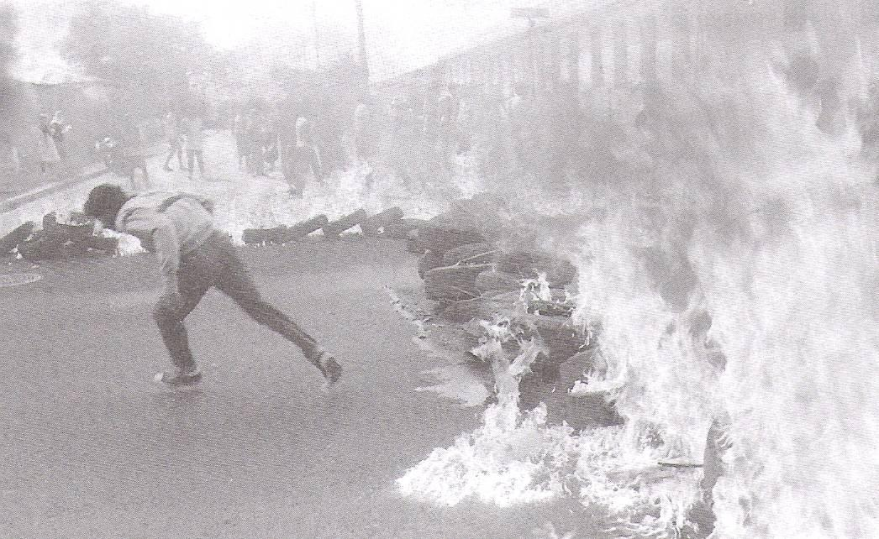

Burning road barricades in Belgravia Road, Athlone in 1985

Street battles were one way of resisting Apartheid in the mid-1980s.

What other methods were used at the time and how successful was this resistance in challenging the Apartheid state?
40 marks

SOURCES

SOURCE A

‘The Americans developed their first atomic bomb in 1945. They did not share the secret of their bomb with the USSR, even while they were still allies. When the USA dropped the first bombs on Hiroshima and Nagasaki in August 1945, 70 000 people were killed instantly. The awesome power of the explosions and the incredible destruction caused by the bombs made Japan surrender within a week. It was clear to both the USA and the USSR that atomic bombs were the weapons of the future.

The arms race developed into a propaganda and intelligence war as well as a forum for technological rivalry. Each side was anxious to show the other o be the one building all the bombs. Their own bombs were purely for protection! Thus the need for propaganda. At the same time both sides were keen to find out what the other side was up to. Thus the need for intelligence. The USSR tended to use human spies like Rudolf Abel. He worked in New York until he was arrested in 1957. The USA, on the other hand, preferred hi-tech spying using equipment like the U-2.

By 1961 both of the super powers had hundreds of missiles pointed at each other. The USA had more than the USSR, but the advantage did not really matter because both sides had enough to destroy each other many times over. On each side the theory was that such weapons made them more secure…This policy became known as MAD (Mutually Assured Destruction)’.
Modern World History, Ben Walsh, 2001, pgs 343-6

SOURCE B

We shall never have a secure peace and a happy world so long as Soviet Communism dominates one-third of all the world’s people and is in the process of trying to extend its rule to many others. Therefore we must have in mind the liberation of these captive peoples. Now liberation does not mean war. Liberation can be achieved by processes short of war. A policy which only aims at containing Russia is an unsound policy…If our only policy is to stay where we are, we will be driven back.

JF Dulles, US Secretary of State, speaking on his appointment in 1952

SOURCE C
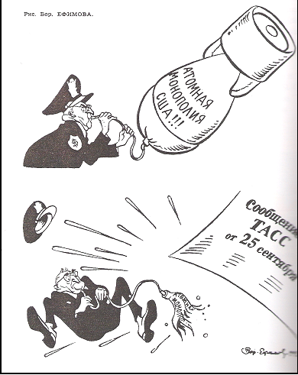

The text on the bomb shaped balloon reads “US atomic monopoly”. The balloon is burst by a communiqué from the Soviet news agency TASS on 25 September, announcing that the USSR now has an atomic bomb.

SOURCE D
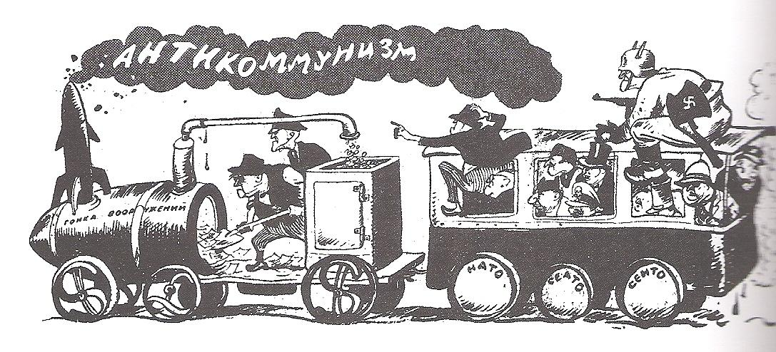
The wheels of the train are labeled NATO, SEATO and CENTO. The engine is labeled ‘armaments race’. The smoke is labeled ‘anti-Communism’.

SOURCE E
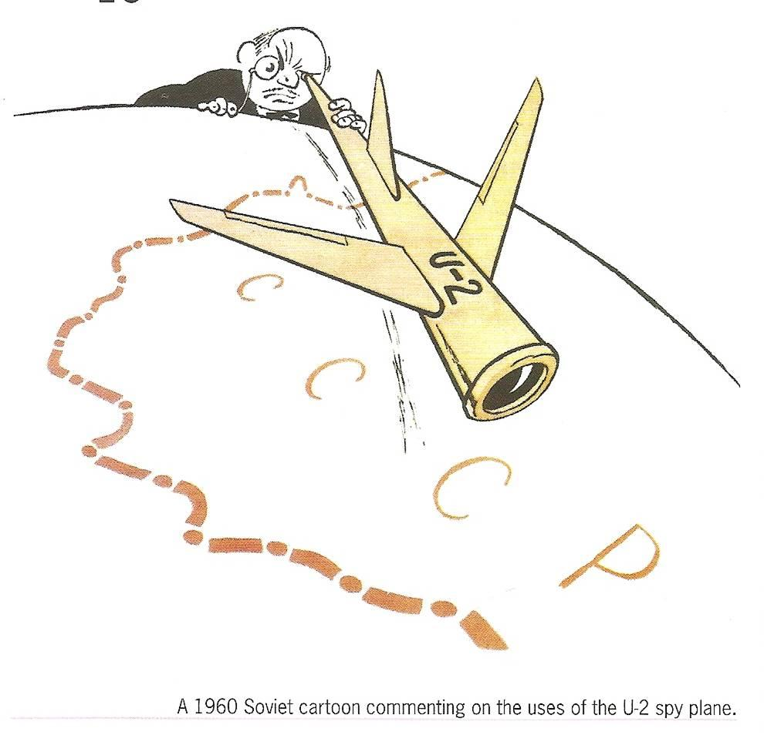
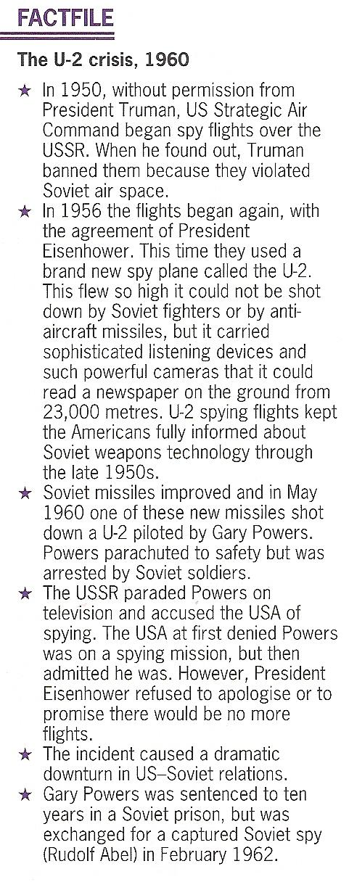

SOURCE F

Nuclear warfare is an utter folly, even from the narrowest point of view of self interest. To spread ruin, misery and death throughout one’s own country as well as that of the enemy is the act of madmen…The question every human being must ask is ‘can man survive?’

Betrand Russell, a leading member of Britain’s Campaign for Nuclear Disarmament (CDN).
SOURCE G

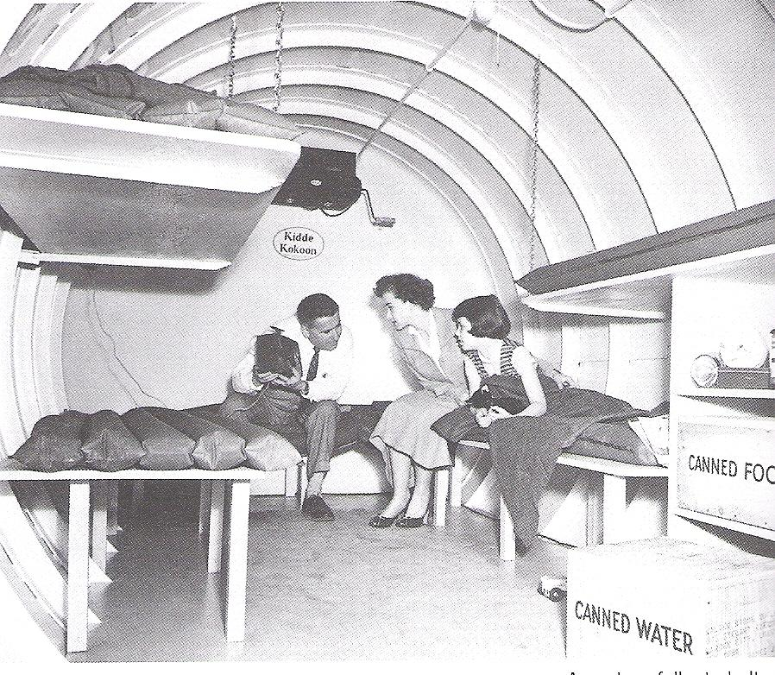

A nuclear fallout shelter

SOURCE H

