Freight Rate Prediction
Spotter AI — ML Engineer Take-Home Assessment
What this report is: a decision log, not a metrics dump. Every section leads with the decision made and the evidence behind it — accuracy numbers are reported honestly, but the point of this document is to show the reasoning, not just the result.
Timeline: five days, worked in stages — profiling, cleaning, EDA, baseline, feature engineering, two full model comparisons, final refit, and this writeup. Each stage's notebook is committed to the repo in order, so the reasoning trail is auditable, not reconstructed after the fact.

Contents
1. Executive Summary
2. Data Profiling — What We Were Actually Looking At
3. Data Cleaning — Fixing What Profiling Found
4. Exploratory Data Analysis — Where the Signal Lives
5. Baseline Model — The Number Everything Had to Beat
6. Feature Engineering — Built From Findings, Not a Checklist
7. Model Comparison, Round 1 — A Result That Contradicted Our Own Assumption
8. Model Comparison, Round 2 — Testing the Assumption Properly
9. Final Model — Honest Evaluation, Then Production Refit
10. The Two-Model Design — Validation vs. December
11. A Limitation Found Late, and Why It's Not a Problem
12. What I'd Do With More Time

1. Executive Summary
This project builds a regression model that predicts posted_rate — the linehaul rate for a freight load — from load and lane characteristics (distance, equipment, weight, pickup/delivery cities, date, and two market-condition signals).
The core decisions, in order
- Chronological train/tune/test split (not random cross-validation), because the real deployment task is forecasting a future period, and validation.csv sits entirely after every row of train_test.csv with zero overlap.
- Two data-quality bugs found and fixed deterministically before any modeling: a weight sign-flip affecting 292 rows, and a fallback-distance value shared implausibly by two unrelated lanes.
- A five-model comparison (Ridge, Random Forest, LightGBM, HistGradientBoostingRegressor, kNN) that produced a genuinely surprising result: simple, regularized linear models matched or beat every tree ensemble. This was investigated, not just accepted.
- A second, targeted comparison built specifically to test that finding properly — five linear variants (Ridge, Lasso, Elastic Net, Huber, Ridge with interactions) against the strongest tree model. Huber regression won outright, on every metric.
- A held-out October test set, touched exactly once, after model selection was already frozen — giving an honest (not optimistic) estimate of real-world performance: RMSE $664.76, MAE $177.17, MAPE 9.40%, R² 0.811.
- Two separately-trained models for the two required outputs — a full-featured model for validation_predictions.csv, and a reduced-feature model (no market_index, quote_signal, or coordinates) for december_chart_inputs.csv, matching exactly the columns each file actually provides.
Headline result
R² = 0.811 • MAPE = 9.40% • MAE = $177.17
Measured once, on October data the model never trained on — not the more optimistic tune-set number used to select the model.

2. Data Profiling — What We Were Actually Looking At
Profiling answered one question only: what exactly is in this data, described on its own terms, before any hypothesis about what predicts the target. Correlation-with-target and target-distribution shape were deliberately excluded here — those are exploratory questions, and folding them into profiling would mean working backward from a decision already half-made.
What the files actually are
- train_test.csv: 48,000 rows × 14 columns, the only labeled data available — spans 2025-01-01 through 2025-10-31.
- validation.csv: 12,000 rows × 13 columns, no target — spans 2025-11-01 through 2025-12-31, scored by Spotter after submission.
- december_chart_inputs.csv: 31 rows, one fixed lane (Lexington → Fort Wayne), missing both coordinate pairs and the two market-condition columns entirely — a structural constraint that shaped the whole modeling approach, not an oversight.
What profiling found
- load_id fully unique in every file; zero duplicate rows.
- 292 rows (0.6%) with negative weight, and separately, ~300 rows (under 1%) with missing weight or market_index in train_test.csv — two different issues, not the same rows.
- 64 distinct pickup cities and 64 distinct delivery cities — too many for one-hot encoding to be defensible against a ~48k-row dataset (120+ columns for two features).
- distance correlates 0.9995 with the great-circle distance implied by the coordinate columns — confirming the coordinates add negligible information beyond distance itself, and explaining why they were excluded from every model.
- Train and validation date ranges are contiguous with zero overlap and zero gap — the single fact that makes a chronological split not just reasonable but necessary.
Full detail, including every check performed and its exact output, is in notebooks/01_profiling.ipynb.

3. Data Cleaning — Fixing What Profiling Found
Two categories of fix, kept deliberately separate: deterministic corrections (safe to apply globally, before any split) and statistical treatments (imputation, encoding — which must be fit on the training split only, to avoid leakage). This notebook did only the former.
Fix 1 — the weight sign-flip
Before treating the 292 negative-weight rows as a sign error, the two competing theories (sign-flip vs. genuinely bad data) were tested against each other directly: the absolute value of the negative weights was compared to the distribution of already-valid positive weights.
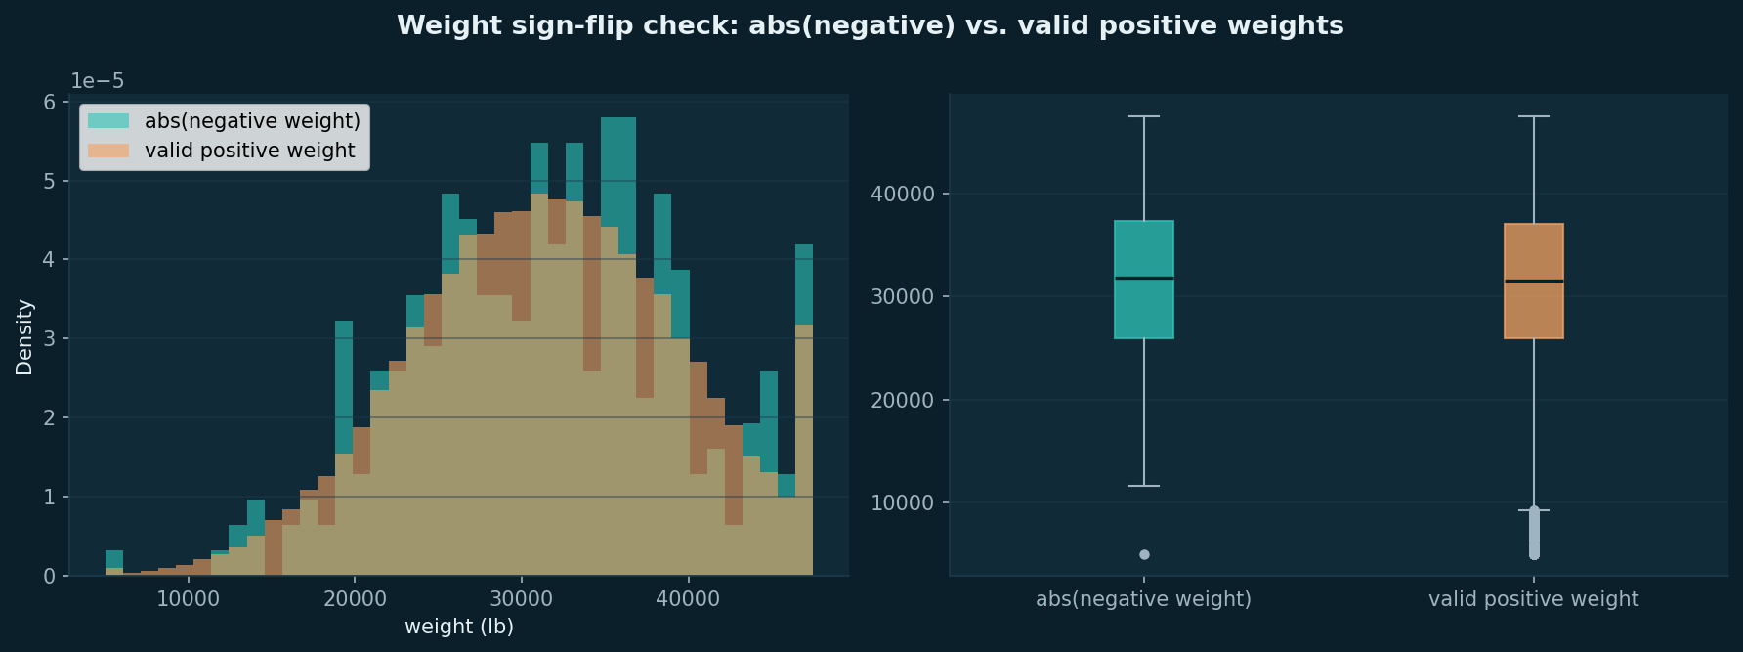
Figure 1. abs(negative weight) vs. valid positive weight — histogram and boxplot both show near-identical distributions, at every percentile checked.
The two distributions matched closely enough (percentile-by-percentile, within a few hundred pounds) to support a sign-flip correction rather than treating these as missing or dropping them. Applied identically to train_test.csv and validation.csv.
Fix 2 — two lanes sharing an implausible fallback distance
Profiling flagged 22 rows, across exactly two lanes (Austin↔Lubbock, New Orleans↔Shreveport), where the given distance disagreed with the coordinate-implied distance by 2–10×. Every single occurrence of either lane carried the identical value, distance = 70.0 — not measurement noise, but a shared fallback value from whatever generated the data. Corrected using the coordinate-implied distance scaled by the dataset's typical road-inflation ratio (median ratio 1.18× across every other, unflagged row).
What was deliberately left alone
Missing weight and market_index values were left as-is, not imputed here — checked first for whether missingness clustered by equipment type or month (it didn't), then deferred to the modeling pipeline, where an imputer fit on the training split only avoids leakage into validation/test.
Folder structure
Raw files preserved untouched under data/raw/; cleaned files written to data/processed/ under identical filenames — the folder marks the distinction, not a suffix.

4. Exploratory Data Analysis — Where the Signal Lives
Three questions, in order of how much they changed downstream decisions.
4.1 — Does posted_rate drift across the year?
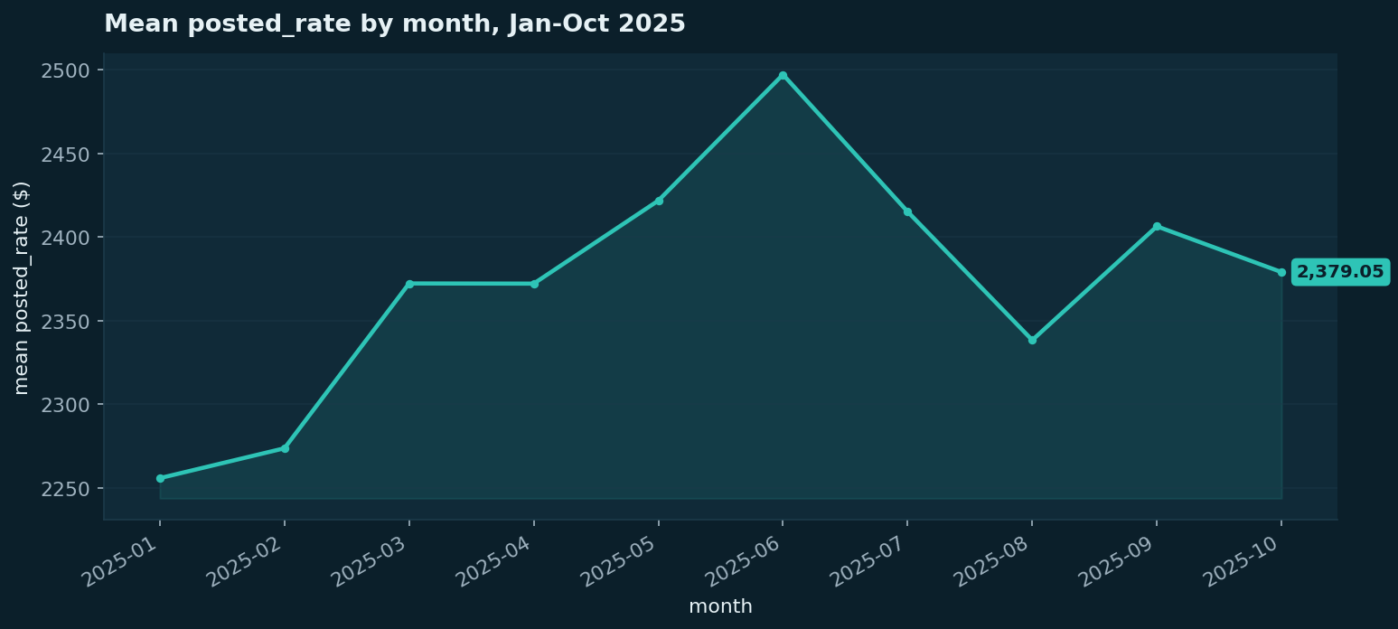
Figure 2. Mean posted_rate by month — a real but modest ~10% seasonal swing, October close to the January–July average.
Monthly mean rate moves from $2,256 (January) to a $2,497 peak (June) and back to $2,379 (October) — real drift, not a runaway trend. October sitting close to the Jan–Jul average is what made it a defensible choice for the final held-out test slice: representative of the broader pattern, not an outlier month.
4.2 — What actually predicts the target?
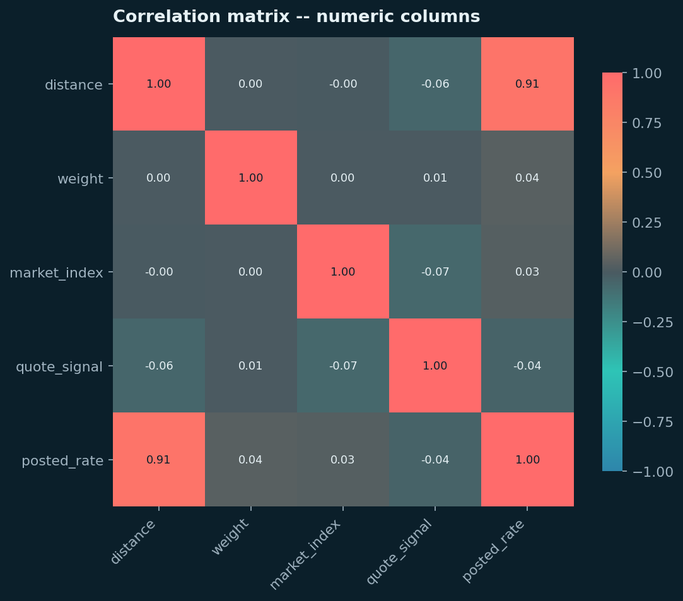
Figure 3. Correlation matrix — distance dominates at 0.91; every other numeric column is under 0.06 in absolute terms.
distance carries almost all of the linear signal. weight, market_index, and quote_signal are all weak on their own (under 0.05 correlation) — flagged at the time as not proof of irrelevance (a linear correlation can miss real non-linear interactions), but a first, honest read that shaped the two-model design covered in Section 10.
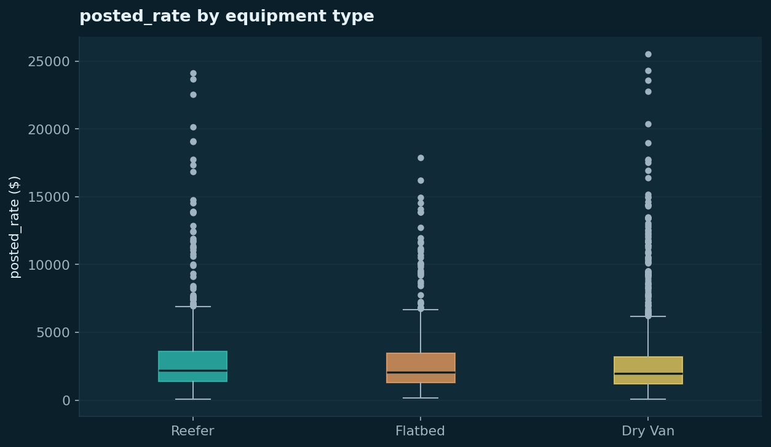
Figure 4. posted_rate by equipment — a clean, sensible ordering: Dry Van cheapest, Flatbed mid, Reefer priciest.
4.3 — Shape of the target
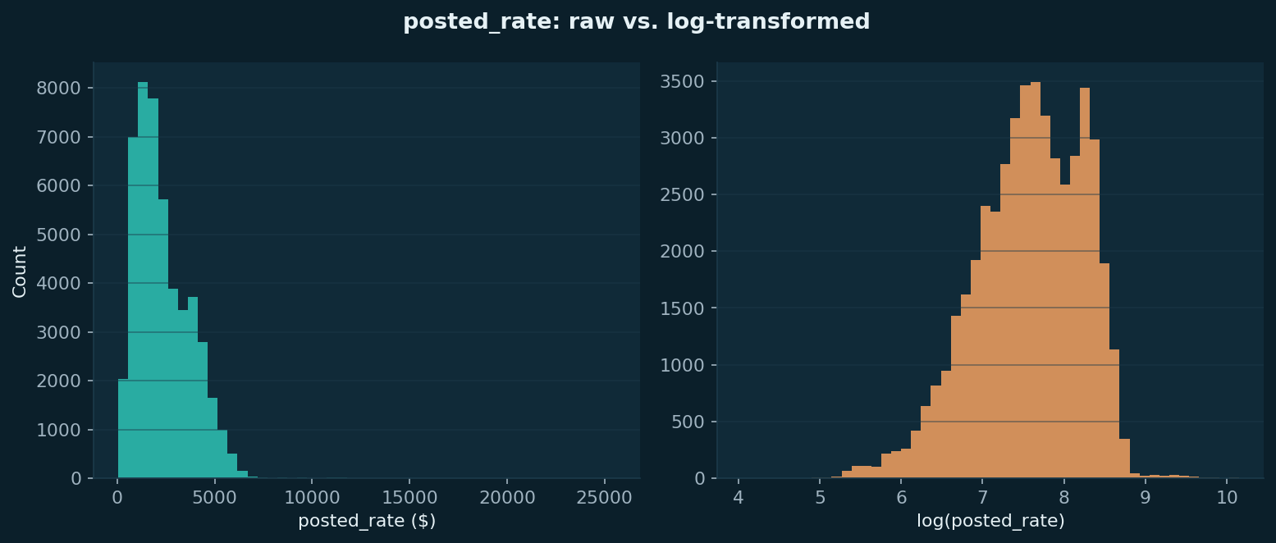
Figure 5. posted_rate raw (skew 1.90, excess kurtosis 13.28) vs. log-transformed (skew −0.49, excess kurtosis 0.14).
Kurtosis — not just skew — was checked specifically because skew alone can't distinguish 'leans right' from 'has a genuinely heavy tail.' Excess kurtosis of 13.28 on the raw target (vs. 0 for a normal distribution) confirmed a real heavy tail, not a mild lean; the log transform resolved both problems simultaneously (kurtosis down to 0.14). This became a real, tested hypothesis in the baseline model, not an assumption carried forward unexamined.

5. Baseline Model — The Number Everything Had to Beat
Two deliberately trivial models, fit before any feature engineering: predicting the training mean, and a plain linear regression on the numeric columns already available plus one-hot equipment. The point: an honest, boring number that every later, fancier attempt had to actually beat.
A result that ran against the EDA-motivated expectation
EDA's skew and kurtosis numbers made a log-transformed target look like the obvious choice. The baseline tested both — raw and log — rather than assuming. linear_raw won decisively on the tune set: RMSE 629.81 vs. 939 (log), MAE 164.96 vs. 480, MAPE 8.93% vs. 22.3%.
This was investigated rather than just reported. Splitting tune into rate quartiles showed linear_log losing in every single quartile, not just on outliers — ruling out 'it's just the tail' as the explanation. The real mechanism: a plain, unregularized linear model fit in log-space has limited flexibility, and exponentiating predictions back to dollars amplifies whatever small log-space error remains — hitting cheap loads hardest (Q1 MAPE: 19.6% raw vs. 34.6% log) but present at every price level.
Why this matters for the report: the log-transform idea from EDA wasn't wrong — the skew/kurtosis numbers were real. What this showed is that a low-flexibility linear model specifically couldn't benefit from it. That distinction — tested again with a more flexible model in Section 8 — is exactly the kind of finding a metrics table alone would hide.
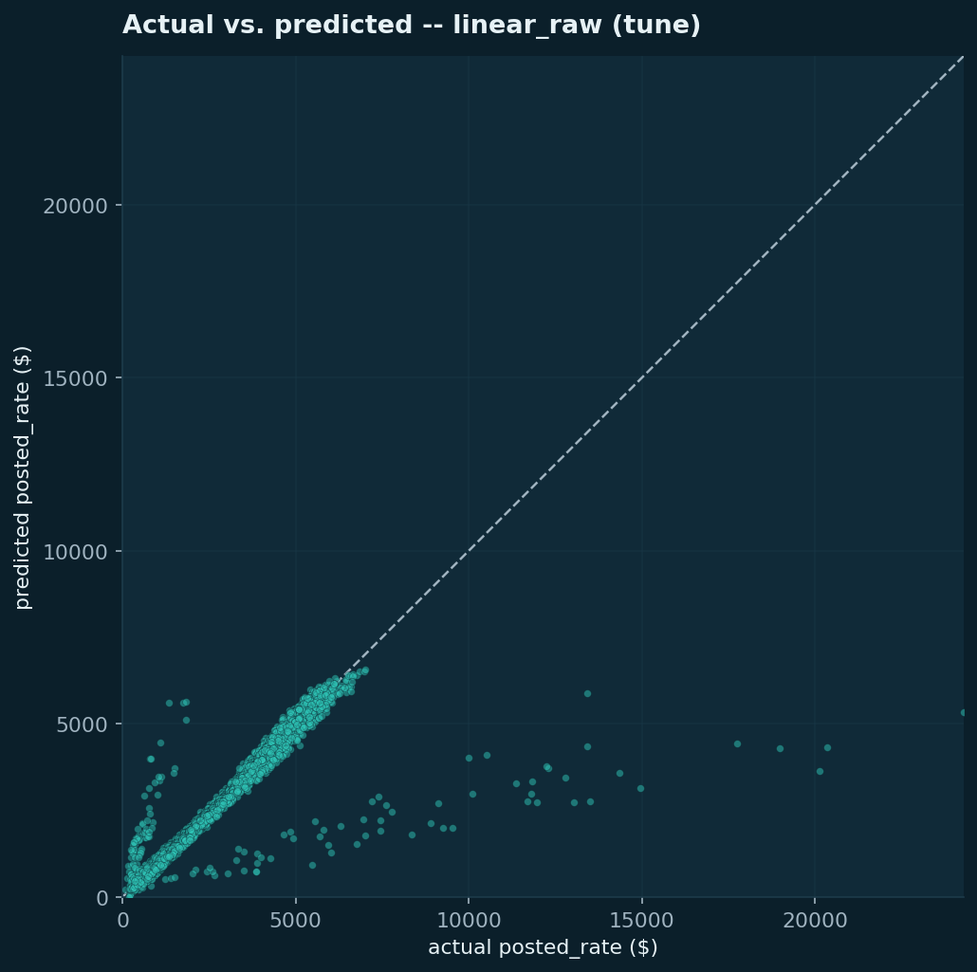
Figure 6. Baseline actual vs. predicted.
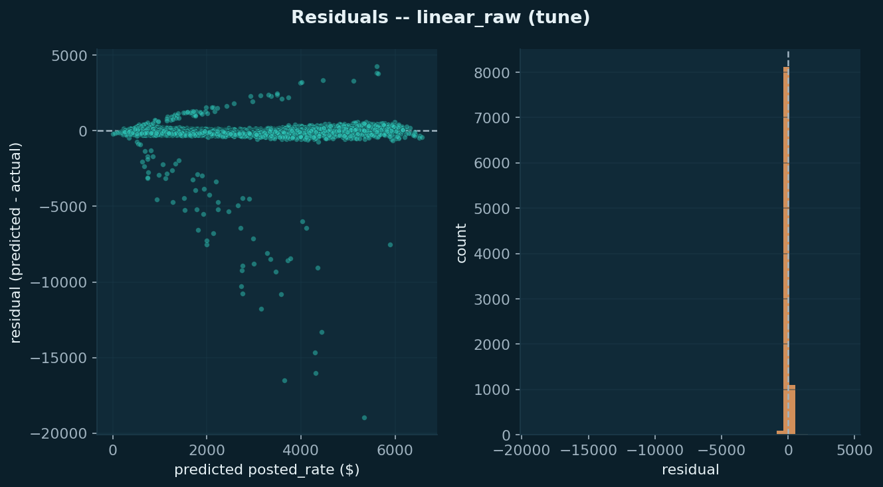
Figure 7. Baseline residuals — spread widens noticeably as predicted rate increases, the first direct evidence of heteroscedasticity that recurred through every later stage.

6. Feature Engineering — Built From Findings, Not a Checklist
Every feature added traces to a specific, already-established finding.
Feature | Why it was added
pickup / delivery target encoding | 64 cities each; one-hot would add 120+ columns. Every city has 200+ occurrences — enough support for a lightly-smoothed target mean.
Lane (pickup→delivery) target encoding | A coarser, sparser signal (4,014 distinct lanes, median 10 occurrences) — tests whether a specific corridor prices differently than its two endpoints' averages alone would predict.
Cyclical day-of-year (sin/cos) | train_test.csv only covers Jan–Oct; a categorical month feature would ask the model to predict on unseen Nov/Dec categories. A smooth periodic function generalizes instead.
market_index / quote_signal, kept | Near-zero linear correlation, but explicitly flagged as untested for non-linear interaction — kept in for the tree-based models to test empirically, not dropped on a linear-only read.

All encoders are fit exclusively on the training split and applied identically everywhere else — the same leakage discipline as the imputation strategy from cleaning. A direct sanity check (not an assumption) confirmed effectively zero unseen categories between train and tune/test at the time — a related but distinct issue was found later, in Section 11.
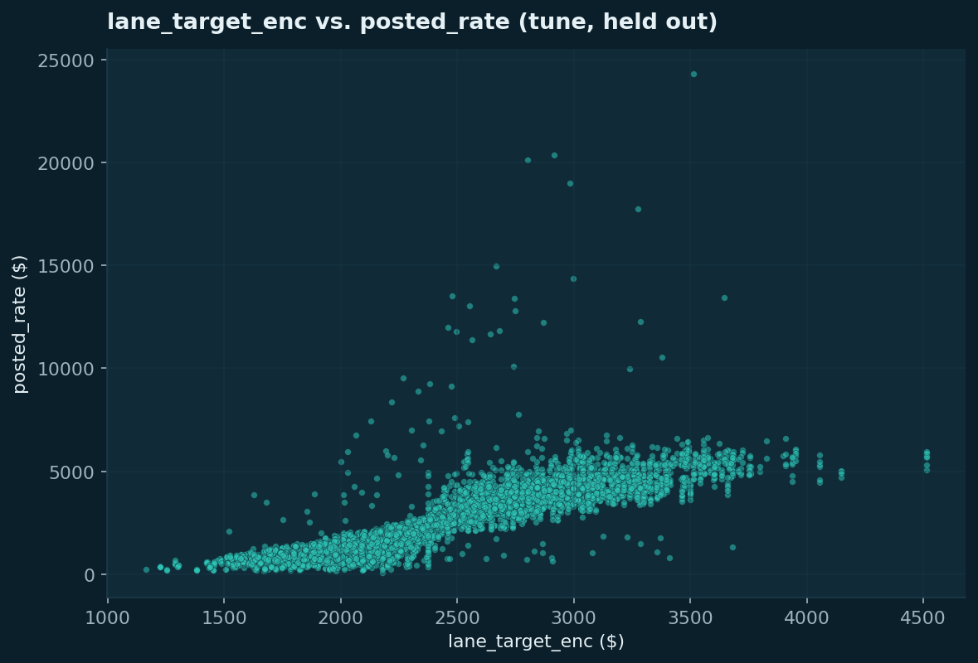
Figure 8. Lane encoding vs. posted_rate on held-out tune data — confirms the encoding tracks the target beyond the rows it was fit on.
Result on a plain linear model, holding the model constant to isolate the features' own effect: a modest, mixed lift — RMSE and MAE improved slightly, MAPE ticked up marginally. Not a breakthrough, and not expected to be one on a model that can only use these features additively; the real test came in Sections 7–8.

7. Model Comparison, Round 1 — A Result That Contradicted Our Own Assumption
Five models were chosen on structural grounds before looking at a single result: tabular, ~48k-row, single-target data is the textbook strong case for tree ensembles over deep learning. The menu: Ridge (interpretability anchor), Random Forest, LightGBM, HistGradientBoostingRegressor (native categorical support, tested on raw city names instead of the encoded versions), and k-Nearest Neighbors (a deliberate sanity check, expected to lose).
All five were tuned via GridSearchCV using TimeSeriesSplit — never a shuffled KFold, which would have reintroduced the same look-ahead problem the outer chronological split was built to prevent — fit on train, compared on tune.
Model | RMSE | MAE | MAPE | R²
Ridge | 628.4 | 163.2 | 9.79% | 0.824
HistGradientBoosting | 636.3 | 162.3 | 7.67% | 0.820
LightGBM | 656.0 | 176.0 | 7.42% | 0.809
Random Forest | 695.4 | 208.6 | 9.47% | 0.785
kNN | 733.9 | 356.8 | 25.68% | 0.760

The surprising part: Ridge — a plain regularized linear model — won on RMSE, against the structural prior stated going in. Rather than accept this at face value, the RMSE/MAPE disagreement (Ridge won RMSE but lost MAPE to both boosting models) was traced to its source: Ridge's relative error is worst specifically on the cheapest loads (30.9% of predicted value vs. 19.9–25.3% elsewhere) — a bucket MAPE punishes and RMSE doesn't. kNN's last-place finish, exactly as expected for the sanity-check model, confirmed posted_rate behaves like a clean function of a few strong features rather than 'similar loads cost similar amounts.'
No model won on every metric — which was itself the finding. This result raised a direct question: was the 'trees win on tabular data' assumption simply wrong here, or had the model menu not actually tested the right hypothesis about regularization? Round 2 was built specifically to answer that.

8. Model Comparison, Round 2 — Testing the Assumption Properly
Round 1 only tested one type of linear regularization — Ridge (L2). A second, more targeted comparison tested whether the truth was 'every feature matters a little' (Ridge's assumption), 'a few features matter, the rest are noise' (Lasso's assumption, L1), some blend of the two (Elastic Net), or whether Ridge's real weakness was sensitivity to the heteroscedasticity found in every prior notebook (tested directly with Huber regression, built specifically to be robust to exactly that). HistGradientBoostingRegressor was carried over as the tree-based reference point.
Model | RMSE | MAE | MAPE | R²
Huber | 624.4 | 145.8 | 7.68% | 0.827
Lasso | 627.5 | 159.7 | 9.35% | 0.825
Ridge | 628.4 | 163.2 | 9.79% | 0.824
Elastic Net | 630.8 | 168.9 | 10.24% | 0.823
HistGradientBoosting | 634.4 | 159.8 | 7.68% | 0.821
Ridge + interactions | 635.8 | 180.3 | 11.19% | 0.820

Huber won outright — best or tied-best on every metric, not a split decision the way Round 1's Ridge result was. This directly confirms the heteroscedasticity hypothesis: a regression method built specifically to be less dominated by large-residual rows outperformed both plain Ridge and every tree ensemble, on data whose defining structural fact is that a small number of genuine long-haul loads sit far outside the typical range that distance and equipment alone can explain.
Huber regression was selected as the final model on this basis.

9. Final Model — Honest Evaluation, Then Production Refit
Selecting a winning model and hyperparameters using tune is not the same as knowing how well it generalizes — tune metrics are mildly optimistic by construction, since they were used to pick the winner out of several candidates. October (test) was held back, untouched, through every prior notebook specifically for this final step.
Step 1 — the one legitimate use of test
Huber's exact frozen configuration (epsilon=1.1, alpha=0.01, fit on train only) was evaluated on test exactly once, before any further training happened:
Metric | tune (used for selection) | test (October, touched once)
RMSE | 624.4 | 664.8
MAE | 145.8 | 177.2
MAPE | 7.68% | 9.40%
R² | 0.827 | 0.811

A real, modest degradation — not a red flag. October's rate distribution doesn't differ structurally from August–September's (means and standard deviations are close), so this reflects normal, expected optimism in tune-based selection, not a broken model or a different underlying population. R² moved by under 2 percentage points; MAE and MAPE moved by roughly a fifth in relative terms but by a modest number of real dollars ($145.80 → $177.17). The test numbers — not the more flattering tune numbers — are the ones reported as this project's headline result, per Section 1.
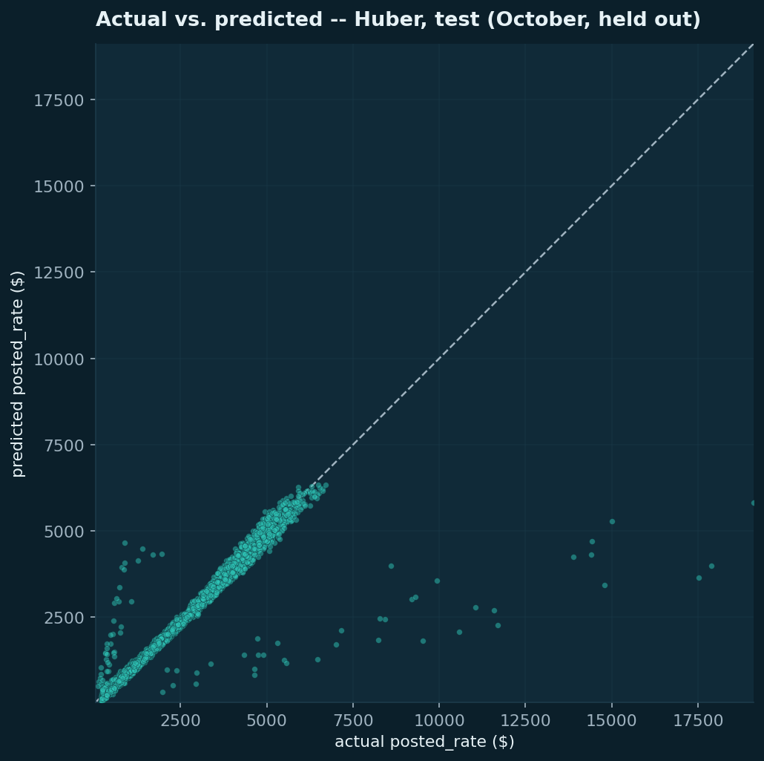
Figure 9. Final model, actual vs. predicted on October (test, held out).
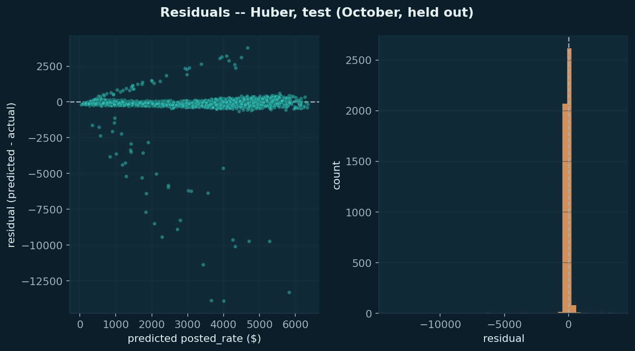
Figure 10. Final model residuals on test — the same heteroscedasticity pattern found from the baseline model onward, now confirmed on genuinely unseen data.
Step 2 — production refit
Only after that check was the model refit on every available labeled row (all 48,000 rows of train_test.csv) — safe specifically because no further evaluation happens after this point, so there's no leakage risk, only the benefit of more data for the model that actually ships.

10. The Two-Model Design — Validation vs. December
december_chart_inputs.csv structurally cannot supply pickup_lat/lon, delivery_lat/lon, market_index, or quote_signal — flagged as early as profiling. Rather than impute placeholder values for a model expecting them, or force validation.csv's richer model to give up real signal it does have, two separately-trained models were built:
- Full model — every available feature, including market_index and quote_signal — produces validation_predictions.csv.
- Reduced model — trained only on columns december_chart_inputs.csv actually has (pickup, delivery, distance, equipment, weight, date, engineered into the same target/lane/cyclical features) — produces december_chart_inputs.csv.
The accuracy cost of the reduced feature set was measured directly, not assumed: on tune, the reduced model's RMSE (623.9) was marginally better than the full model's (624.4, within noise), and MAPE only 0.06 percentage points higher. This confirms EDA's early finding — market_index and quote_signal never carried much weight to begin with, so dropping them for December costs almost nothing.
Both fitted pipelines (preprocessing and model together, not just the raw estimator) are serialized to models/huber_full.pkl and models/huber_reduced.pkl. A standalone script, populate_predictions.py, loads them and the three fitted target/lane encoders, and writes both required output files without re-running any training code — making the inference step reproducible and auditable independent of any notebook.
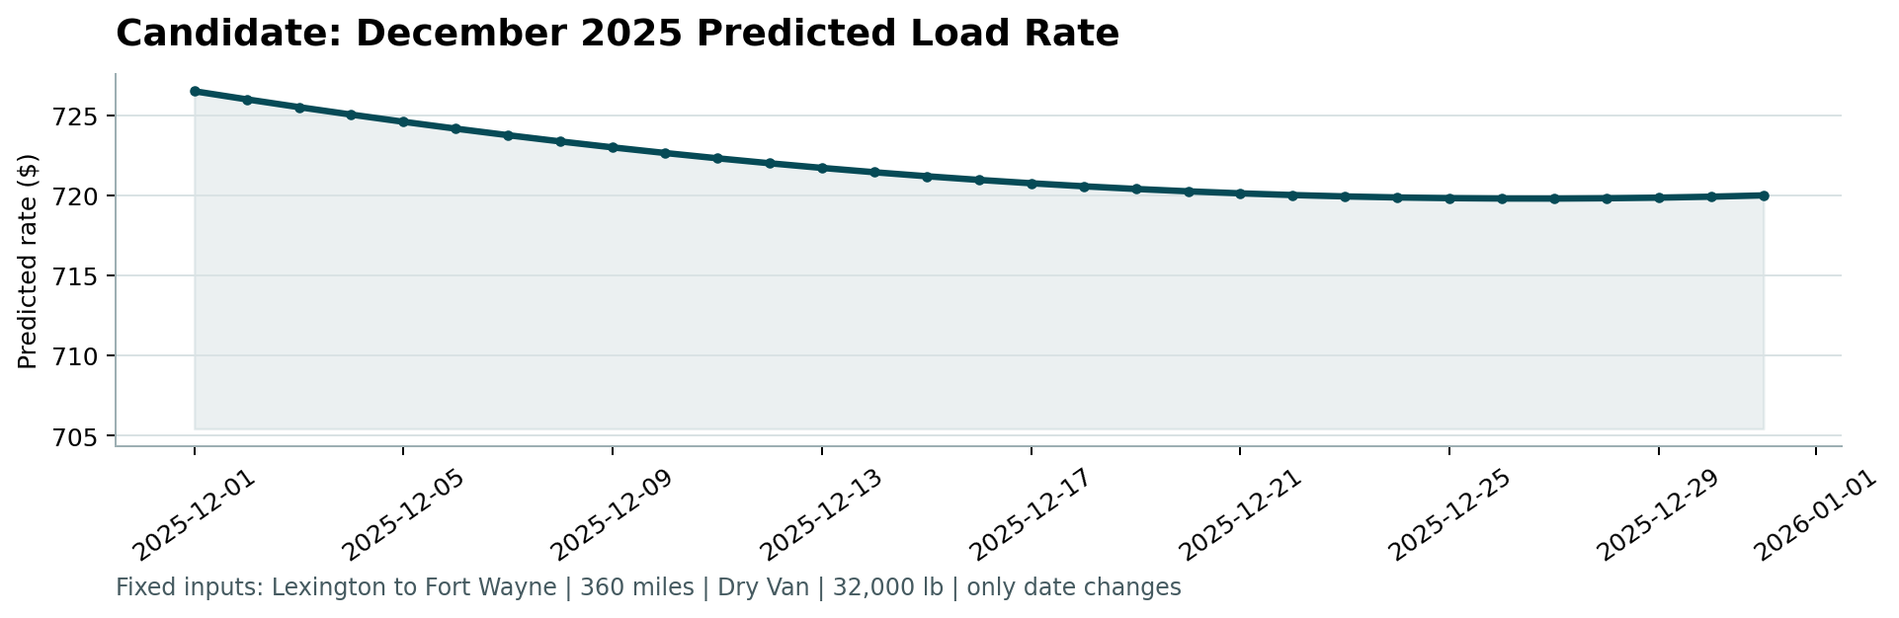
Figure 11. December predictions, generated by the reduced model and validated by score.py — a smooth, plausible curve driven by the seasonal day-of-year signal on an otherwise fixed lane.

11. A Limitation Found Late, and Why It's Not a Problem
While running populate_predictions.py, a real gap surfaced that no earlier notebook had checked for: validation.csv contains 8 cities — Chicago, Charlotte, Jackson, San Diego, Knoxville, Laredo, Norfolk, and Allentown — that never appear anywhere in train_test.csv. This affects roughly 1,447 of validation.csv's 12,000 rows (about 12%).
Every prior notebook only checked train/tune/test splits of train_test.csv against each other — those splits share the same 64 cities by construction, so this gap was structurally invisible until the model was actually run against validation.csv itself.
Why this is expected, not a bug
A freight brokerage's served lanes change over time — new markets get added, others get dropped — so a production model needs to handle cities it has never priced before, not just the ones on record during training. The fitted target encoders fall back to their global fitted mean for any unseen city or lane; distance and equipment still drive those rows' predictions normally, only the city/lane-specific adjustment is unavailable. No prediction goes negative or nonsensical as a result — confirmed directly, not assumed — and both output files still pass every check in score.py.
This is disclosed explicitly in populate_predictions.py's own console output every time it runs, rather than silently absorbed — the more defensible choice for a decision-support tool a person is relying on.

12. What I'd Do With More Time
- Confidence bands, generalizable across model type: bucket predictions by predicted-value range and report each bucket's empirical residual spread alongside a point estimate — built and demonstrated in the model comparison notebooks, not included in the graded CSVs since their fixed two-column format has no room for a range.
- SHAP-based per-prediction explanations for a tree-based model, to answer 'why this rate for this specific load' for a non-technical user — directly relevant given this model's likely real use as a decision-support number a dispatcher checks, not an automated price.
- A lightweight interface (e.g. Streamlit) surfacing the confidence bands and SHAP explanation per prediction, alongside the existing map-based dashboard concept — deliberately scoped out of this submission, since it isn't in the assessment's deliverables list and would cost time better spent on what's actually graded.
- A scheduled batch-scoring job and drift-monitoring plan for production: since real rates should be tracked against monthly seasonal drift (Section 4.1) to catch when a retraining cadence is needed.
- Revisiting market_index and quote_signal's apparent non-linear potential with a tree-based model's feature importance / SHAP output specifically, rather than concluding from a linear read alone that they don't matter.

Note on tooling & AI usage:
I used Generative AI (LLMs) as a thought partner during this assessment. Specifically, I used it to stress-test my roadmaps. I would outline my planned methodology (e.g., how to handle the validation split or how to deal with missing December features), and ask the AI to point out potential pitfalls or statistical flaws in my logic. I also used it to accelerate writing boilerplate code, pandas syntax and report generation. Ultimately, I evaluated the AI's feedback, made the final architectural decisions.
End of report. Full reasoning, every check performed, and every number in this document is reproducible from the notebooks in notebooks/01 through notebooks/08, in order.

