SALES PERFORMANCE
ANALYSIS & GROWTH REPORT
Multi-Category Retail Business | FY2024 – FY2025
Prepared by: Data Analytics Team
Report Date: July 2026

Executive Summary
Over the two-year period from January 2024 through December 2025, the business generated $1,518,360 in net sales and $499,230 in profit, holding a healthy average profit margin of 32.9%. Revenue grew 17.0% year-over-year, from $699,649 in 2024 to $818,711 in 2025, driven by strong Q4 seasonal demand and consistent online-channel growth.
This report breaks down performance by product, category, region, and sales channel to identify what is working, what is underperforming, and where the business should focus resources to accelerate growth.
$1,518,360  TOTAL NET SALES (2024–25) | $499,230  TOTAL PROFIT | 32.9%  AVG PROFIT MARGIN | +17.0%  YoY REVENUE GROWTH
12,180  TOTAL ORDERS | $125  AVG ORDER VALUE | $699,649  2024 REVENUE | $818,711  2025 REVENUE

1. Revenue Trend Over Time
Monthly revenue shows a clear seasonal pattern: sales dip in January-February after the holiday peak, hold steady through mid-year, and climb sharply from September through December — with November and December consistently the strongest months of the year (roughly 35-45% above the monthly average). This is a classic retail seasonality curve and should directly inform inventory planning and marketing spend timing.
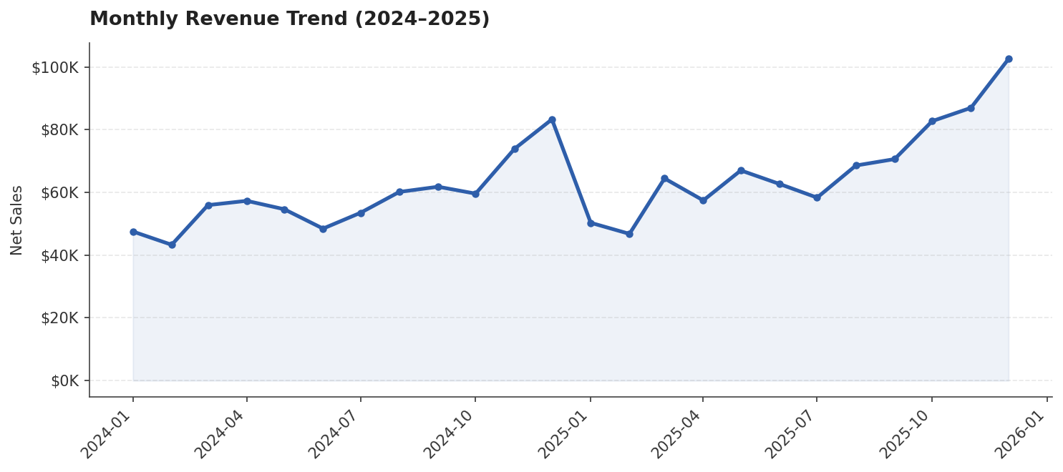

Insight
- Q4 (Oct–Dec) is the single most important revenue window of the year — inventory, staffing, and ad budgets should be front-loaded for this period.
- January and February are consistently the softest months — a good window for clearance promotions, supplier negotiations, or planned maintenance rather than aggressive new-product pushes.
- 2025 outperformed 2024 by 17.0%, indicating the underlying growth trend is healthy, not just seasonal noise.

2. Top-Selling Products
The chart below ranks the top 10 products by net revenue. Outdoor and fitness-related items (Camping Tent, Water Bottle, Fitness Tracker, Cooler Box, Bike Helmet) dominate the top of the list, signaling strong demand in the Sports & Outdoors category specifically.
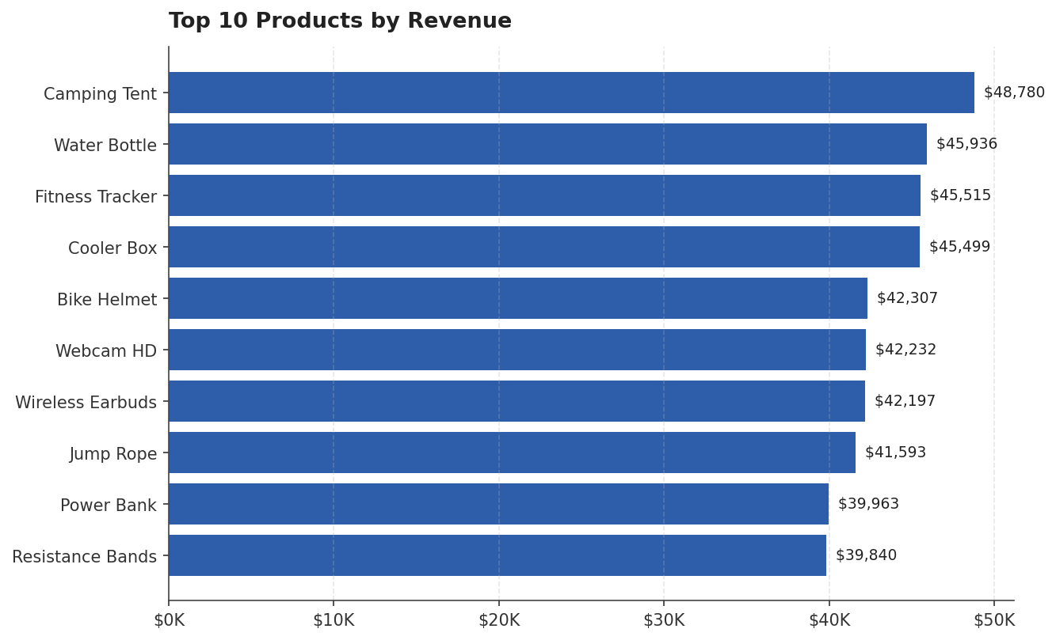
Rank | Product | Net Sales
1 | Camping Tent | $48,780
2 | Water Bottle | $45,936
3 | Fitness Tracker | $45,515
4 | Cooler Box | $45,499
5 | Bike Helmet | $42,307
6 | Webcam HD | $42,232
7 | Wireless Earbuds | $42,197
8 | Jump Rope | $41,593
9 | Power Bank | $39,963
10 | Resistance Bands | $39,840

Insight
- 6 of the top 10 products by revenue come from Sports & Outdoors and Electronics — these two categories should be prioritized for stock depth and promotional placement.
- Products outside the top 10 collectively still make up the majority of revenue, so the business is not overly dependent on a handful of SKUs — a healthy sign for risk management.

3. Category & Regional Performance
Sports & Outdoors is the top-grossing category, followed by Electronics and Home & Kitchen. However, revenue and profitability don't move together: Apparel has the smallest revenue footprint but the highest profit margin of any category, while Electronics generates strong revenue but carries the thinnest margin.
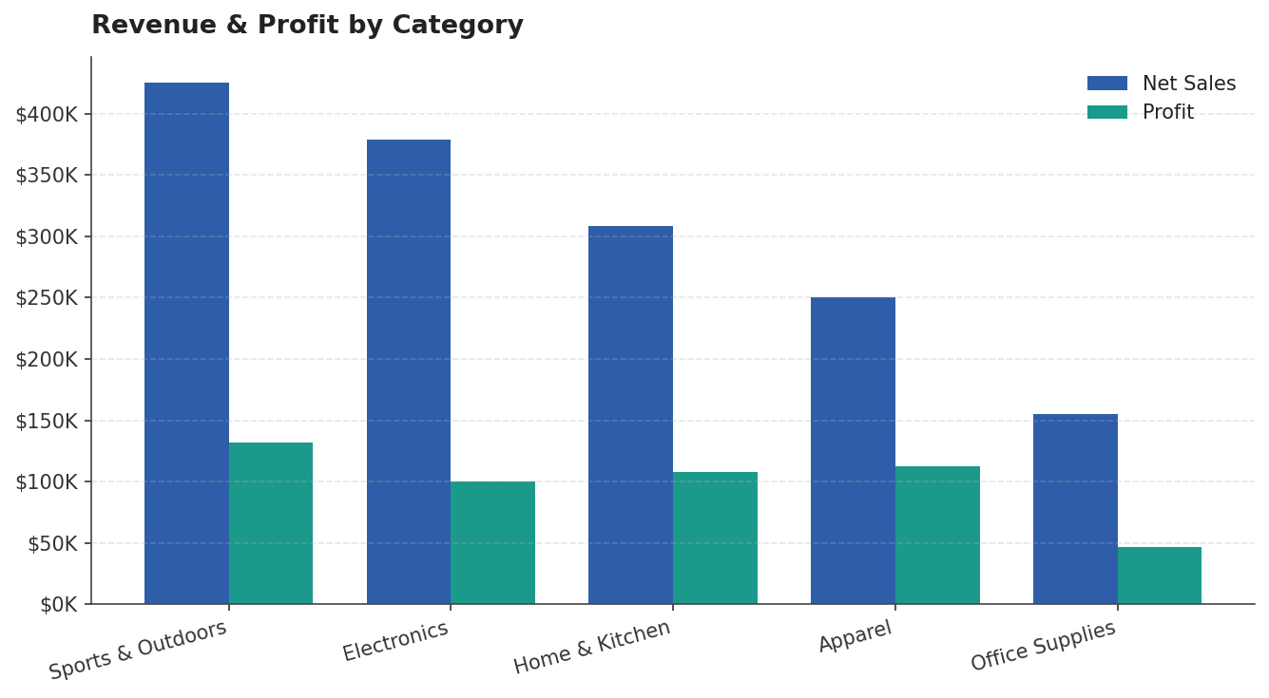
Category | Net Sales | Profit | Margin
Sports & Outdoors | $424,918 | $131,803 | 31.0%
Electronics | $379,137 | $100,294 | 26.5%
Home & Kitchen | $308,391 | $108,002 | 35.0%
Apparel | $250,601 | $112,766 | 45.0%
Office Supplies | $155,314 | $46,365 | 29.9%
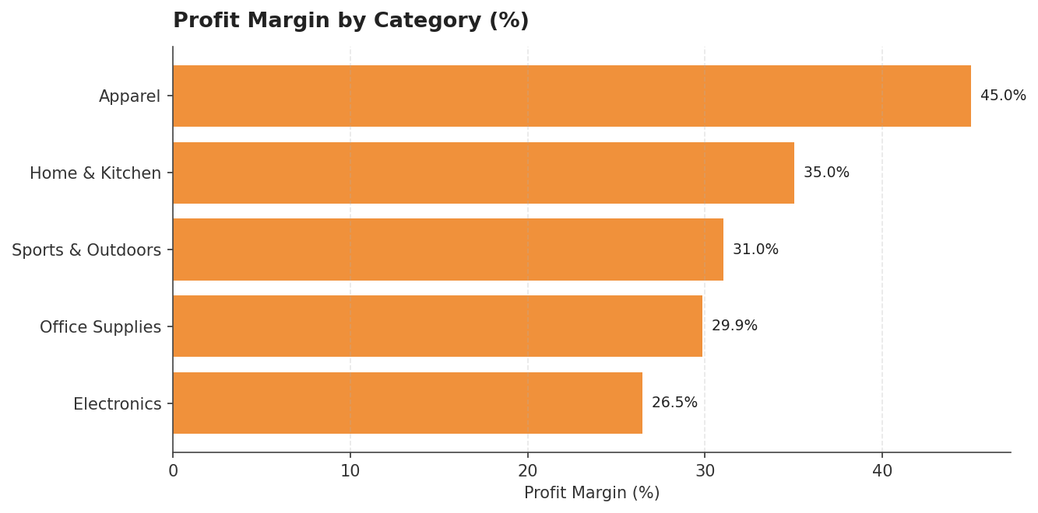

Insight
- Apparel converts revenue into profit most efficiently (~45% margin) — worth expanding assortment even though it's currently the lowest-revenue category.
- Electronics has the lowest margin (~26%) despite strong sales volume — likely due to competitive pricing pressure or higher discounting; worth a pricing/discount-policy review.
Regionally, performance is fairly balanced, with no single region dominating:
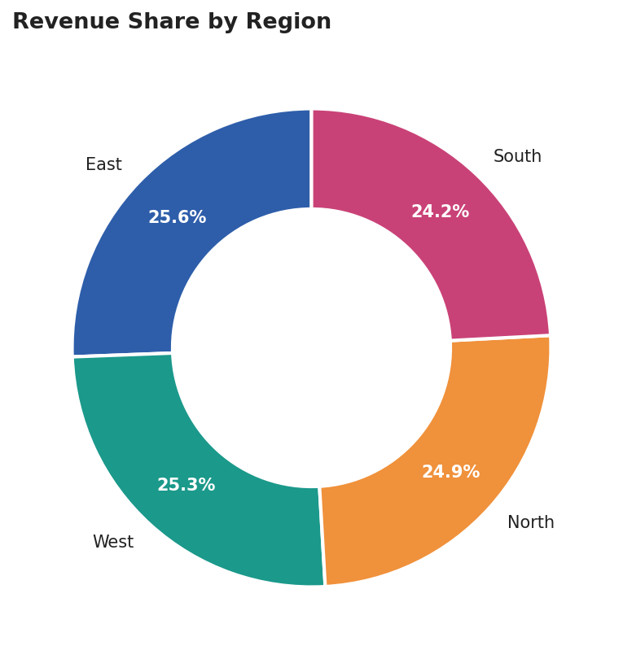
Region | Net Sales
East | $388,727
West | $384,343
North | $378,279
South | $367,011
- East and West regions lead marginally, but the spread across all four regions is under 6% — the business has a well-diversified geographic footprint rather than a single dependent market.

4. Sales Channel Performance
Online is by far the strongest channel, generating over twice the revenue of Retail Store and Marketplace combined. This reflects the broader shift toward e-commerce and suggests where future investment will have the greatest return.
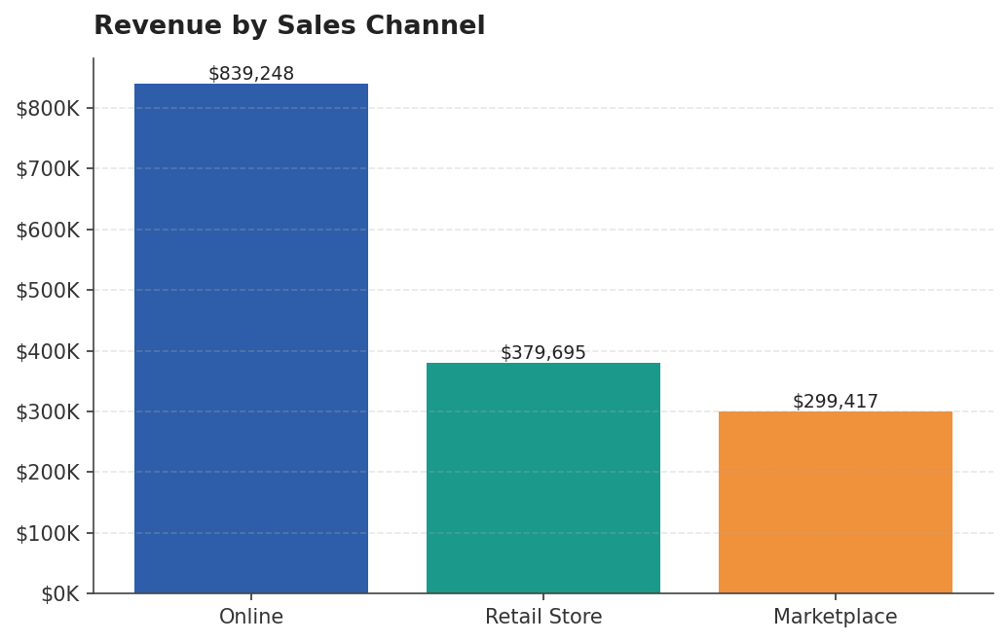
Channel | Net Sales
Online | $839,248
Retail Store | $379,695
Marketplace | $299,417

Insight
- Online drives ~55% of total revenue — continued investment in site experience, digital ads, and online-exclusive promotions is likely to have the highest marginal return.
- Marketplace is the smallest channel — worth evaluating whether this reflects limited catalog listing, fee structure, or genuinely lower demand before deciding whether to expand or deprioritize it.

5. Recommendations
- Double down on Q4: shift a larger share of marketing budget and inventory investment into September–December to capture the proven seasonal peak, rather than spreading spend evenly across the year.
- Protect and grow Apparel: its high margin makes it the most profitable category per dollar of sales — expanding the product range here compounds profit faster than growing lower-margin categories.
- Review Electronics pricing/discounting: investigate whether current discount levels or supplier costs are compressing margin, and test smaller discount tiers to see if volume holds.
- Prioritize the Online channel: allocate additional budget to digital marketing and website/app improvements, since it already delivers the highest revenue share and likely the best return on incremental spend.
- Use the January–February lull productively: run clearance campaigns, renegotiate supplier terms, or test new product launches when competitive and customer attention is lower.
- Re-evaluate the Marketplace channel: a focused audit (fees, listing coverage, ad spend) will clarify whether it's worth scaling or better used only for overflow inventory.

6. Methodology
This analysis uses a simulated dataset of 12,180 order line items spanning January 2024 to December 2025, modeled on realistic retail patterns across five product categories, four regions, and three sales channels, including holiday seasonality, weekday effects, discounting behavior, and year-over-year growth. In a live engagement, the same analytical framework (revenue trend, product ranking, category/region/channel breakdown, and margin analysis) would be applied directly to the client's raw transaction export after a data-cleaning pass (deduplication, currency normalization, and outlier review).

