CIVE 202

Spring 2026

Project 5 Infra 1-16

Project Report

By Tessa Soukup, Ava Lavene, and Jamie Krab

Date submitted for review: 5/8/2026
Submitted to: Civil and Environmental Engineering Department faculty

Introduction
In this project, our group analyzed drinking water access for our client, The Water Project, utilizing the WHO JMP database. The Water Project is an NGO based in Concord, NH that provides drinking services across the world. Their goal is to expand access to clean drinking water for communities in need in Sub-Saharan Africa. By doing so, they hope to alleviate the strain that falls disproportionately on women and girls to obtain water daily. Usually, they are the family members that spend the most time and effort walking and getting water every day, which is usually not clean or nearby. This prevents girls from going to school and getting an education. With the construction of new wells, rainwater capture systems, and rehabilitation of existing water resources, the Water Project intends to better sanitation, food production, and equality in education (The Water Project - a Charity Providing Access to Clean Water in Africa, 2025). Because the NGO has focused on the Sub-Saharan region in Africa more recently, they want a better idea of how their NGO has impacted the region as well as what needs to be implemented in the future.
We completed this by using the WHO JMP database, which is a census-based database of countries around the world. The data set includes estimates for 234 countries with over 5,000 national datasets. The dataset is often used to monitor water safety on the household level. It also measures service levels between rural areas and urban areas, wealth, and other sub-groups. The data is updated annually to remain accurate. Our group analyzed trends in the JMP data in drinking water access in different Sub-Saharan countries.

Methods
The group plotted the JMP data using Python on Jupyter notebook. In our code we utilized pandas, seaborn, matplotlib, and Plotly libraries. First, the data was read and loaded. The data was then separated based on location and population. Because rural areas face a greater need for drinking water services, our group mainly used the rural data.
The 2025 data for each country was extracted and converted into a data frame. The 2025 data was then plotted as a bar chart using Plotly. Plotly is a new library for our group. While matplotlib and seaborn also visualize data, Plotly has more interactive visualizations. In the coding file, the user can click on the bar chart and see exact percentages. The bar chart is also colored by the percentage. This overall makes the chart much easier to understand and doesn’t rely on a singular communication of results. The visualization of 2025 data is helpful because it shows the most recent gaps in drinking water access. This is necessary for our group to provide The Water Project with recommendations.
For the remaining plots, seaborn was used to create time series plots. Sns.lineplot creates a line plot which can be customized. The second plot created is a time series plot of all Sub-Saharan regions over the past 2 decades. This plot allows us to see how access has changed over time, but also how those changes compare to each other. The last 2 plots created using seaborn are of individual countries, Cameroon and Burundi. Looking at individual countries makes growth easier to understand. When large data sets are compiled and compared, it can scale down increases or decreases because of an outlier country. Having these two plots helps with the scaling of increase in countries.

Results
Plot 1: Rural Piped Water Access Percentage in 2025
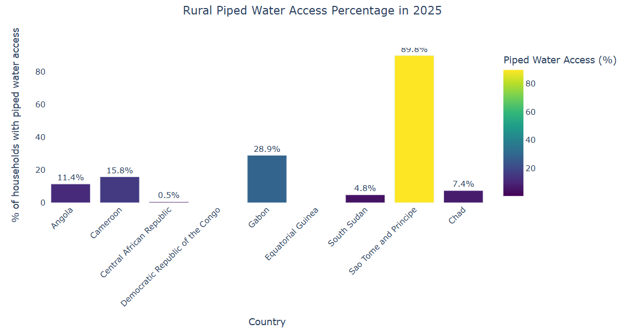
Plot 2: Rural Piped Water Access Percentage
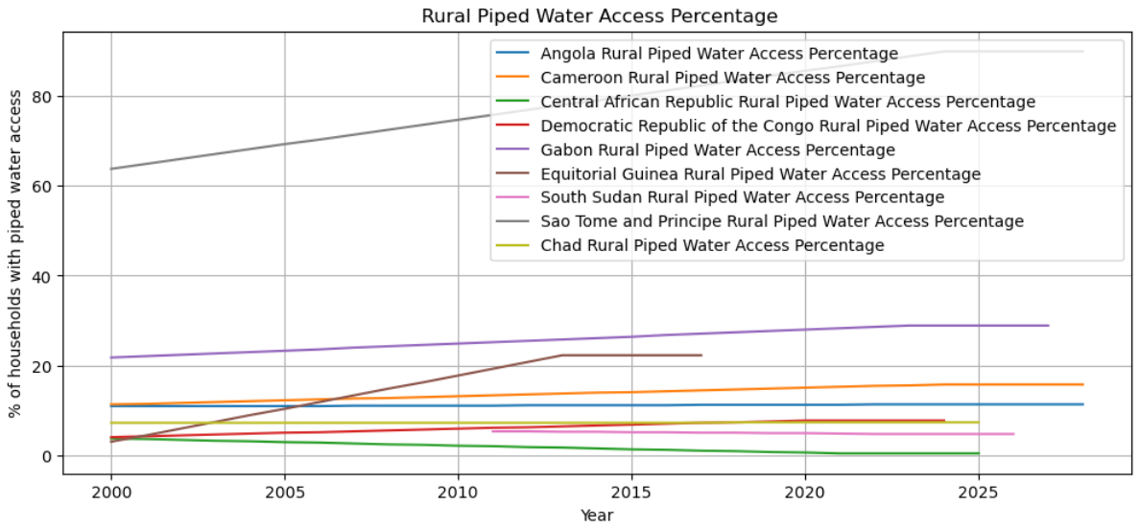Plot 3: Cameroon Rural Piped Water Access Percentage
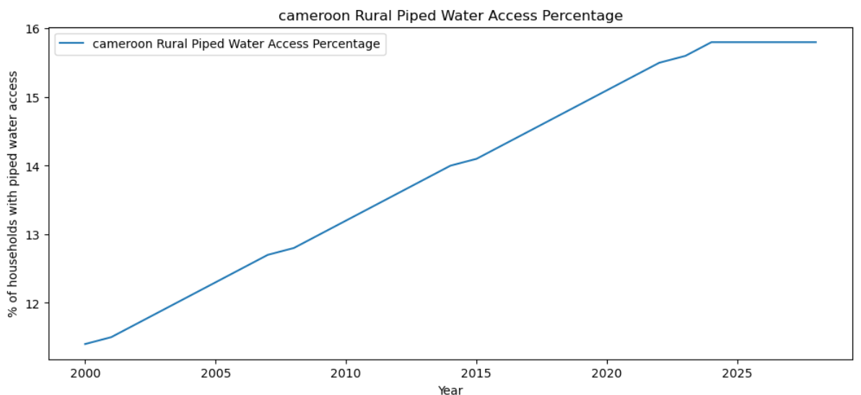
Plot 4: Burundi Rural Piped Water Access Percentage
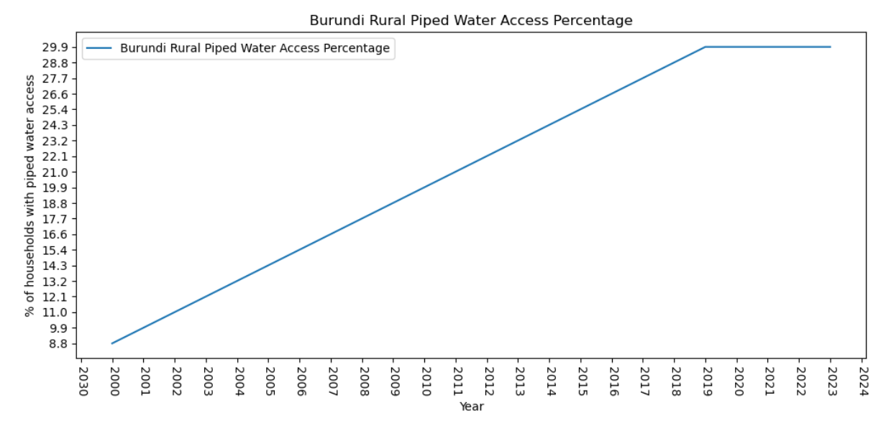

Discussion
After plotting the data from different countries, our data was analyzed. We found a steady increase in water access across the past 2 decades in a majority of countries based on plots 2-4. Central South African region is an example of a much slower rate of increase in services. Plot 1 shows rural piped water access percentage in the most recent data set of 2025. Soa Tome and Principe has a very high percentage of 89.8%, the highest percentage in the Sub-Saharan region. This is an outstandingly large percentage compared to the other counties on this diagram. However, Sao Tome and Principe is an island nation with a population of only about 250,000 people (Sao Tome & Principe Population (2019) - Worldometers, 2019); so this perceived excellence is due to a very small population and even smaller rural populations, which would be easier to guarantee water access to.
The countries with the lowest percentages are Central African Republic, South Sudan, and Chad with 0.5%, 4.8%, and 7.4%, respectively. It seems that the region in most need of water services is in the center of Sub-Saharan Africa since Chad, Central African Republic, and South Sudan all lie within center of the region. The transportation infrastructure is not fully developed with poorly maintained dirt and gravel roads. South Sudan, Central African Republic, and Chad are also listed as a “level 4 – do not travel” level (Travel Advisories | Travel.State.gov, 2025). The countries have high risk of civil unrest, crime, kidnapping, landmine, and health threats. The instability in government has led to severe unrest in these countries, making implementation impossible.
Because of these circumstances, our group recommends implementing more drinking water services into Angola to The Water Project. In plot 1, Angola has a lower percentage of 11.4% and is rated as a “level 2 – exercise increased caution”, which will be much easier to travel and work within.

References
Sao Tome & Principe Population (2019) - Worldometers. (2019). Worldometers.info. https://www.worldometers.info/world-population/sao-tome-and-principe-population/
The Water Project - A Charity Providing Access to Clean Water in Africa. (2025). The Water Project. https://thewaterproject.org
Travel Advisories | Travel.State.gov. (2025). State.gov. https://travel.state.gov/en/international-travel/travel-advisories.html

