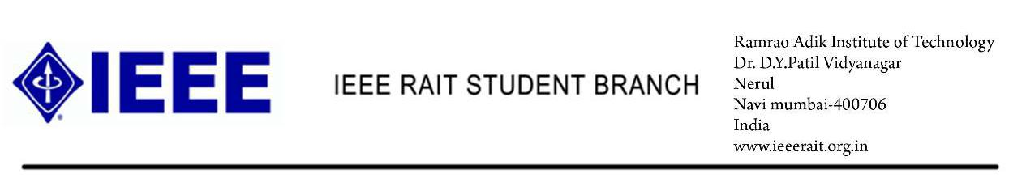To,

Faculty member,

Ramrao Adik Institute Of Technology,

Dr. D. Y. Patil Vidyanagar, Nerul , Navi Mumbai-400706

**Subject: Invitation to IEEE RAIT’s ‘TECHTALK’.**

Dear Sir,

The extra-curricular activities for the students have proven to contribute much to their social well-being. It is also a portal where the students could express and show out their output in relation to what is being learned in the classroom.

We would like to take this opportunity to cordially invite you for our event ‘TECHTALK’ to be held on 4thof August in Room no. ­­­­­­­615 at 2.30 PM.

This event would be open for the teachers also. We are looking forward to your presence to grace the occasion.

**TOPIC – MATH FOR BETTER PATH**

**SPEAKER – Dr. Vishwesh Vyawahare**

**DATE – 04/08/2016**

**TIME – 2.30 to 3.30 PM**

Thanking you,

Yours sincerely,

Kunal Nevrekar

(Public Relations Officer, IEEE RAIT)