For Assignment 3 section 1Searching my task was to construct two classes. The first class utilized sequential searching and the second used binary search. The results were as follows.

[‘florida’,'beautifully', 'gradual', 'station', 'sour', 'apple', 'safety', 'simple', 'skilled', 'core', 'transport',

'pick', 'anxiously', 'practically', 'profession', 'courage', 'Sunday', 'funeral', 'inside', 'generously']

For Sequential Search:

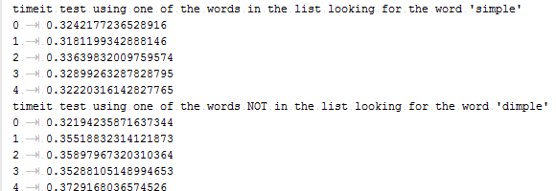

For Binary Search:

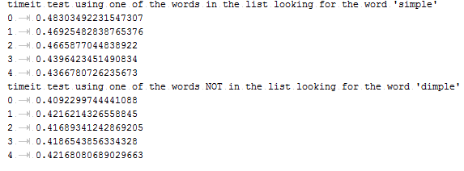

From the results I found that Sequential searching was noticeable faster than Binary search. This is due to the time complexity of that each class has. For example, in Sequential search the algorithm runs in linear time (O(n)) which basically compares the item that is being searched for to each item in the list. Because of this in terms of ‘worst case scenario’ the time it takes for the algorithm is correlated to the size of the list. For Binary search its time complexity is (O(log(n))) so its algorithm runtime was had a moderate impact. When I compared the results to the “Big-O Complexity chart”, I confirmed that my results were where they should be given their respective Time complexities. 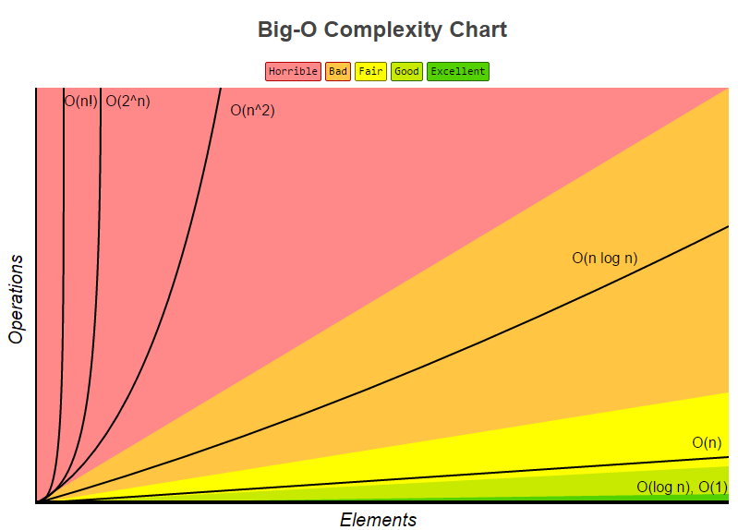

Sequential Search

Binary Search