# Table of Content

**MECHANISM OF THE DC MOTOR 3**

**DETECTION OF FAULT IN A DC MOTOR 4**

ACS712 CURRENT SENSOR 4

OPERATION 4

FAULT DETECTION MECHANISM 5

**CONCLUSION 9**

# INTRODUCTION

A fault is a physical shortcoming in hardware or software. To detect fault in a system, all accessible information from the system should be gathered and analysed to check for deviations from the system's normal behavior.

A DC motor converts electrical energy into mechanical energy. It uses direct current to convert electrical energy into mechanical rotation. The DC motor's operating concept is that anytime a current carrying conductor enters a magnetic field, it is subjected to a mechanical force. This is a consequence of Lorentz Law, which states that “a current carrying conductor placed in a magnetic field will experience a force”. The direction of this force is gotten by Fleming's left hand rule. This force is what causes rotation of the motor.

Faults in DC motor can occur for various reasons, such as blowing of fuse in the main switch, failure of brush and commutator to contact each other, field or armature winding open circuited, overload, break in wiring connection and earthing of the motor. These faults lead to the motor stopping rotation or the motor drawing too much current which is dangerous.

To detect if a fault has occurred in a motor therefore, one can monitor the amount of current flowing into a motor.

# MECHANISM OF THE DC MOTOR

A DC motor transforms electrical energy (DC current) into mechanical energy. It uses direct current to convert electrical energy into mechanical rotation. The DC motor's operating concept is that anytime a current carrying conductor enters a magnetic field, it is subjected to a mechanical force. This is a consequence of Lorentz Law, which states that “a current carrying conductor placed in a magnetic field will experience a force”. The direction of this force is gotten by Fleming's left hand rule, which states that "any time an electric current passes through a coil in the field of a magnet, the magnetic force developed produces a torque that turns the DC motor". This force is what causes rotation of the motor.

The magnitude of this force, F = BIL Newtons.

In the DC motor, the commutator is segmented to achieve unidirectional torque; so that the rotation is in one direction.

# DETECTION OF FAULT IN A DC MOTOR

There are several methods to detect fault in a DC motor. One is to measure the amount of current flowing into the motor; the magnitude of the current will be a pointer to the state of the motor.

## ACS712 CURRENT SENSOR

To measure the DC current flowing into the DC motor, ACS712 current sensor is used. The ACS712 is a current sensor that calculates and measures the amount of current applied through its conductor. It has 66 to 185 mV/A output sensitivity, total output error of 1.5% at 25°C and a stable output offset voltage. It operates at 4.5V to 5.5V and -30A to +30A.

## OPERATION

The table below shows the rating of a 12V DC motor.

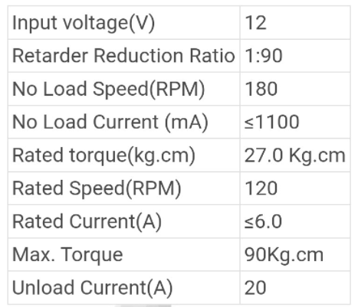

When the current measured by the ACS712 current sensor, connected to the DC motor, exceeds the unload or maximum current or is way less than the rated current, then there's a fault in the DC motor.

As the speed of the DC motor increases, the current drawn reduces.

## FAULT DETECTION MECHANISM

In this design, the Arduino micro-controller does the comparison between the measured current and the maximum or minimum current and gives an output to the screen.

The Liquid Crystal Display displays the current flowing in the DC motor and the implication.

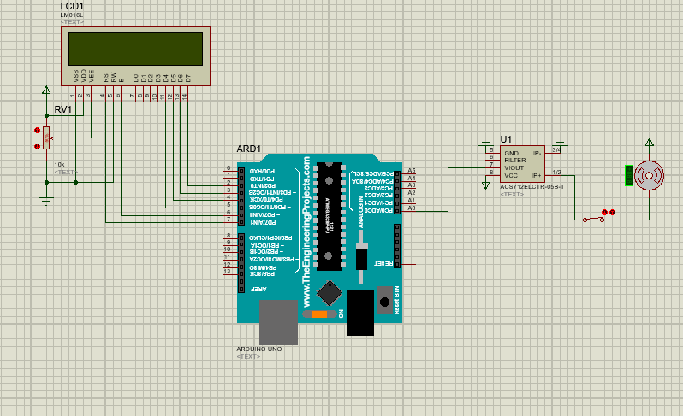

Assuming the minimum current of the DC motor is 0.8A and the maximum is 10A, the following images illustrates the operation of detection of fault with a current sensor.

If the current flowing in the DC motor is less than the minimum operating current, then the motor will be off.

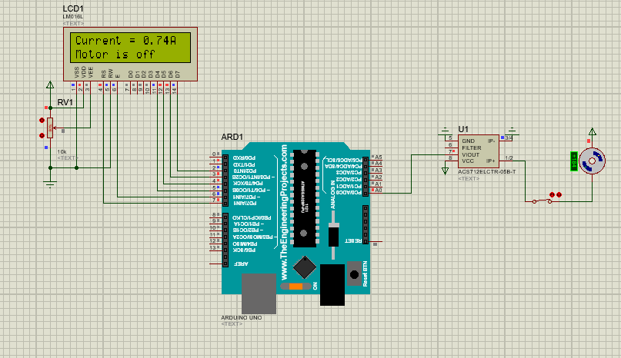

If the current flowing in the DC motor is 0A, then the motor will be off.

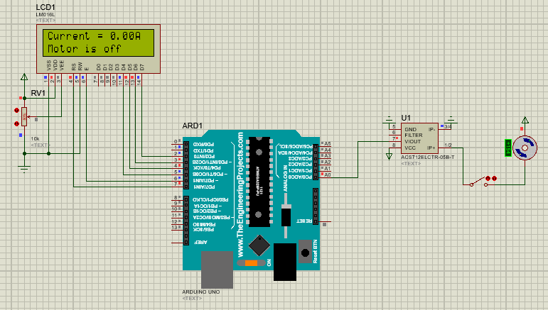

If the current flowing in the DC motor is greater than the maximum current, then the motor will be drawing too much current and there's a fault in the motor.

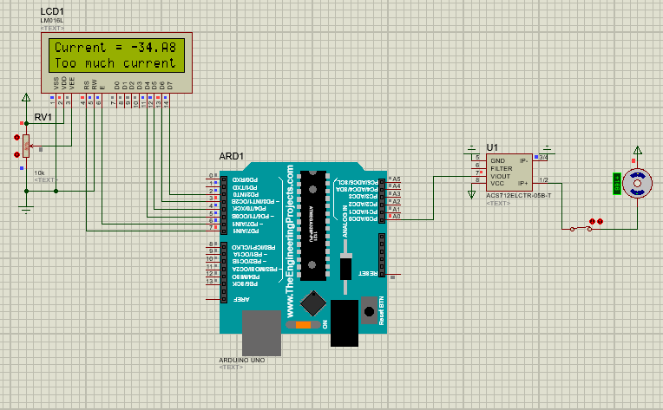

If the current flowing in the DC motor is greater than the minimum current and less than the maximum current, the motor will work normally; it will rotate.

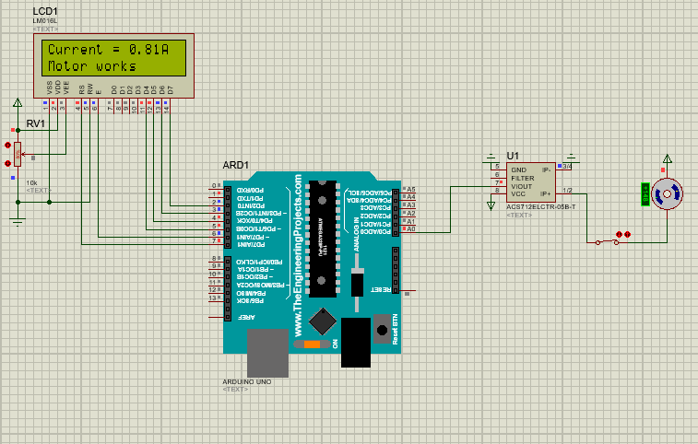

The direction of rotation depends on the polarity of the voltage across the DC motor. If the polarity is positive, the motor will rotate clockwise; if it's negative, the motor will rotate counterclockwise.

# CONCLUSION

The DC motor has various applications, so it is pertinent that one is able to detect faults in them as faults can be dangerous. Faults in DC motor can occur for various reasons, such as blowing of fuse in the main switch, failure of brush and commutator to contact each other, failure of motor to rotate, field or armature winding open circuited, overload, break in wiring connection and earthing of the motor. These faults lead to the motor stopping rotation or the motor drawing too much current which is dangerous.

To detect if a fault has occurred in a motor therefore, one can monitor the amount of current flowing into a motor.