1. Create a new VM in GCP or clone existing VM that mimics below details.

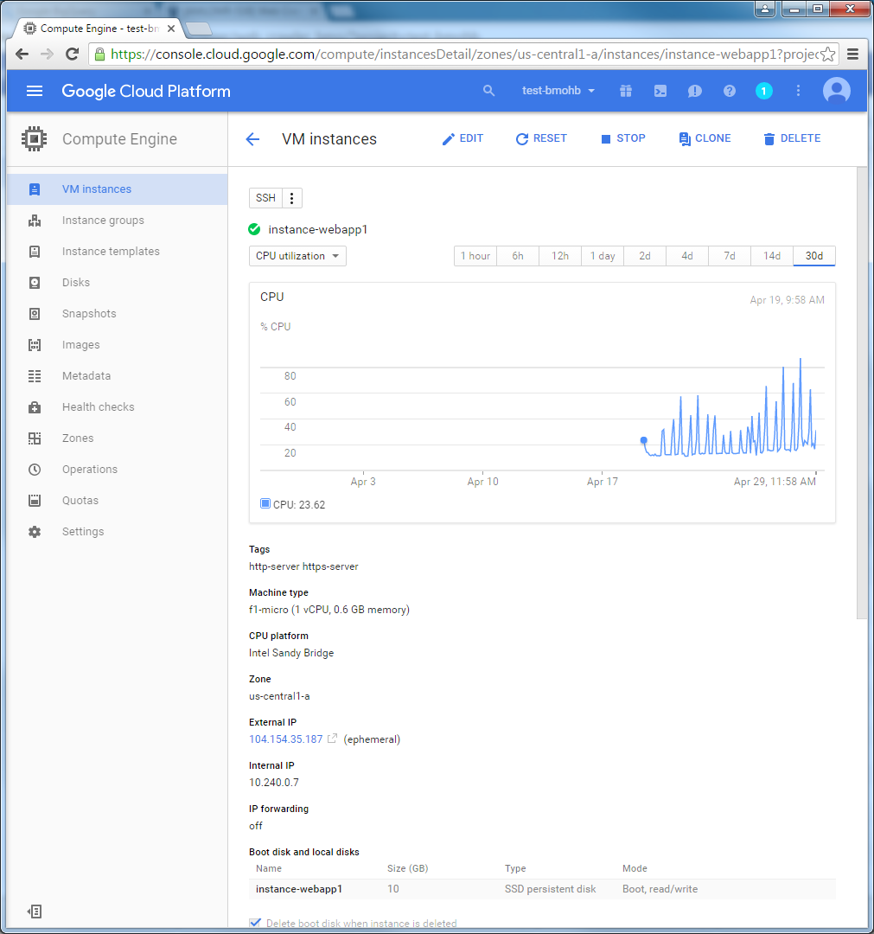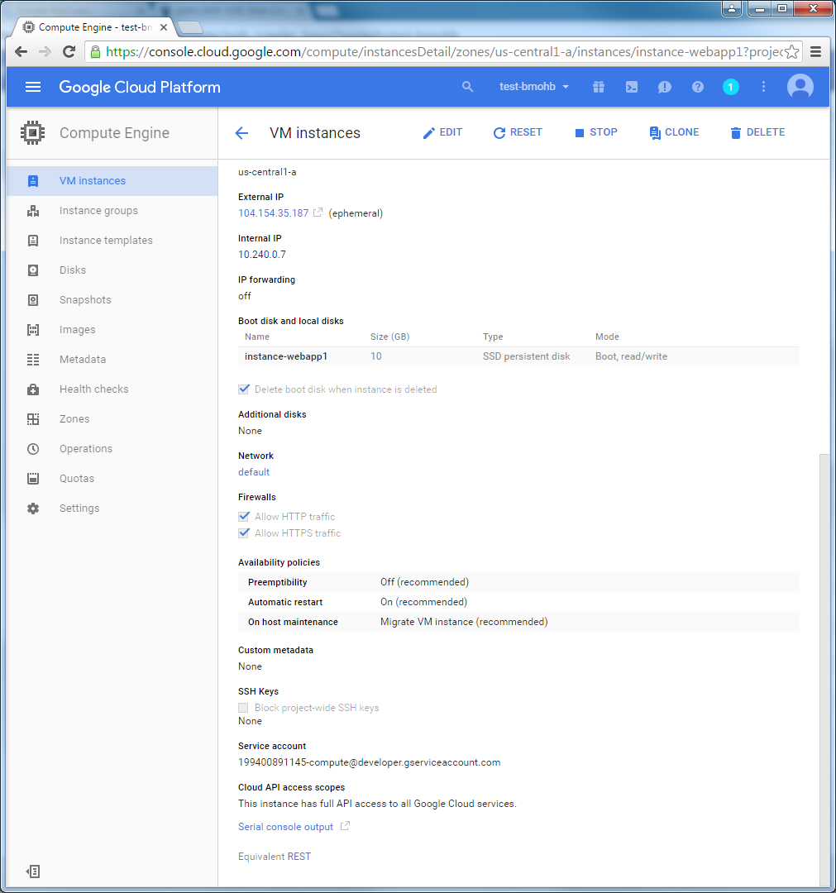

1. SSH into VM
2. Run the following commands in order

* sudo apt-get upgrade

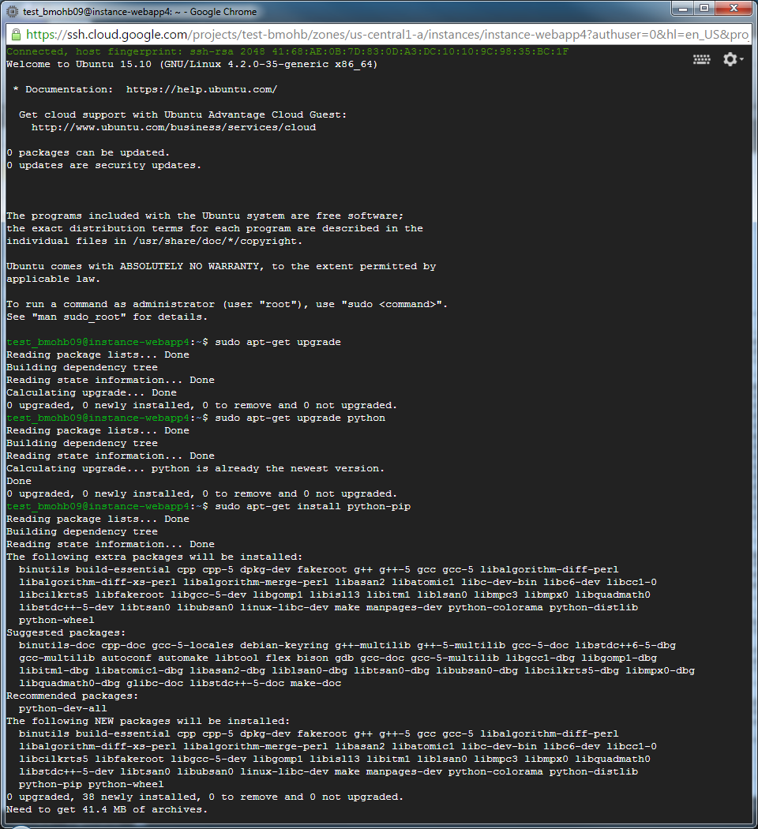

* sudo apt-get upgrade python



* sudo apt-get install python-pip
  + - * Will need to continue by typing ‘Y’ + Enter

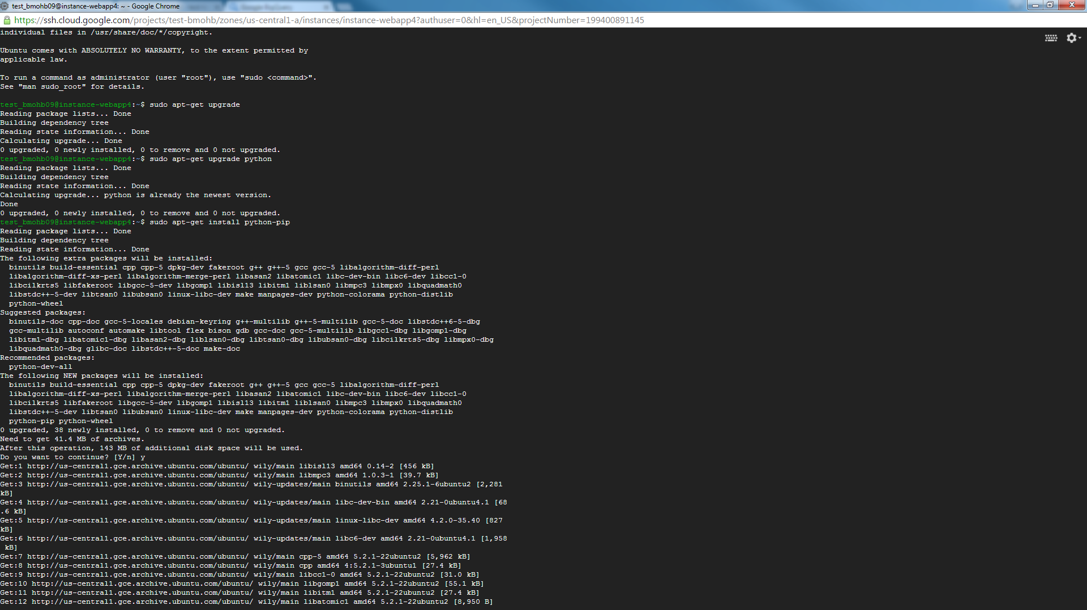

* sudo apt-get install python-dev
  + - * Will need to continue by typing ‘Y’ + Enter

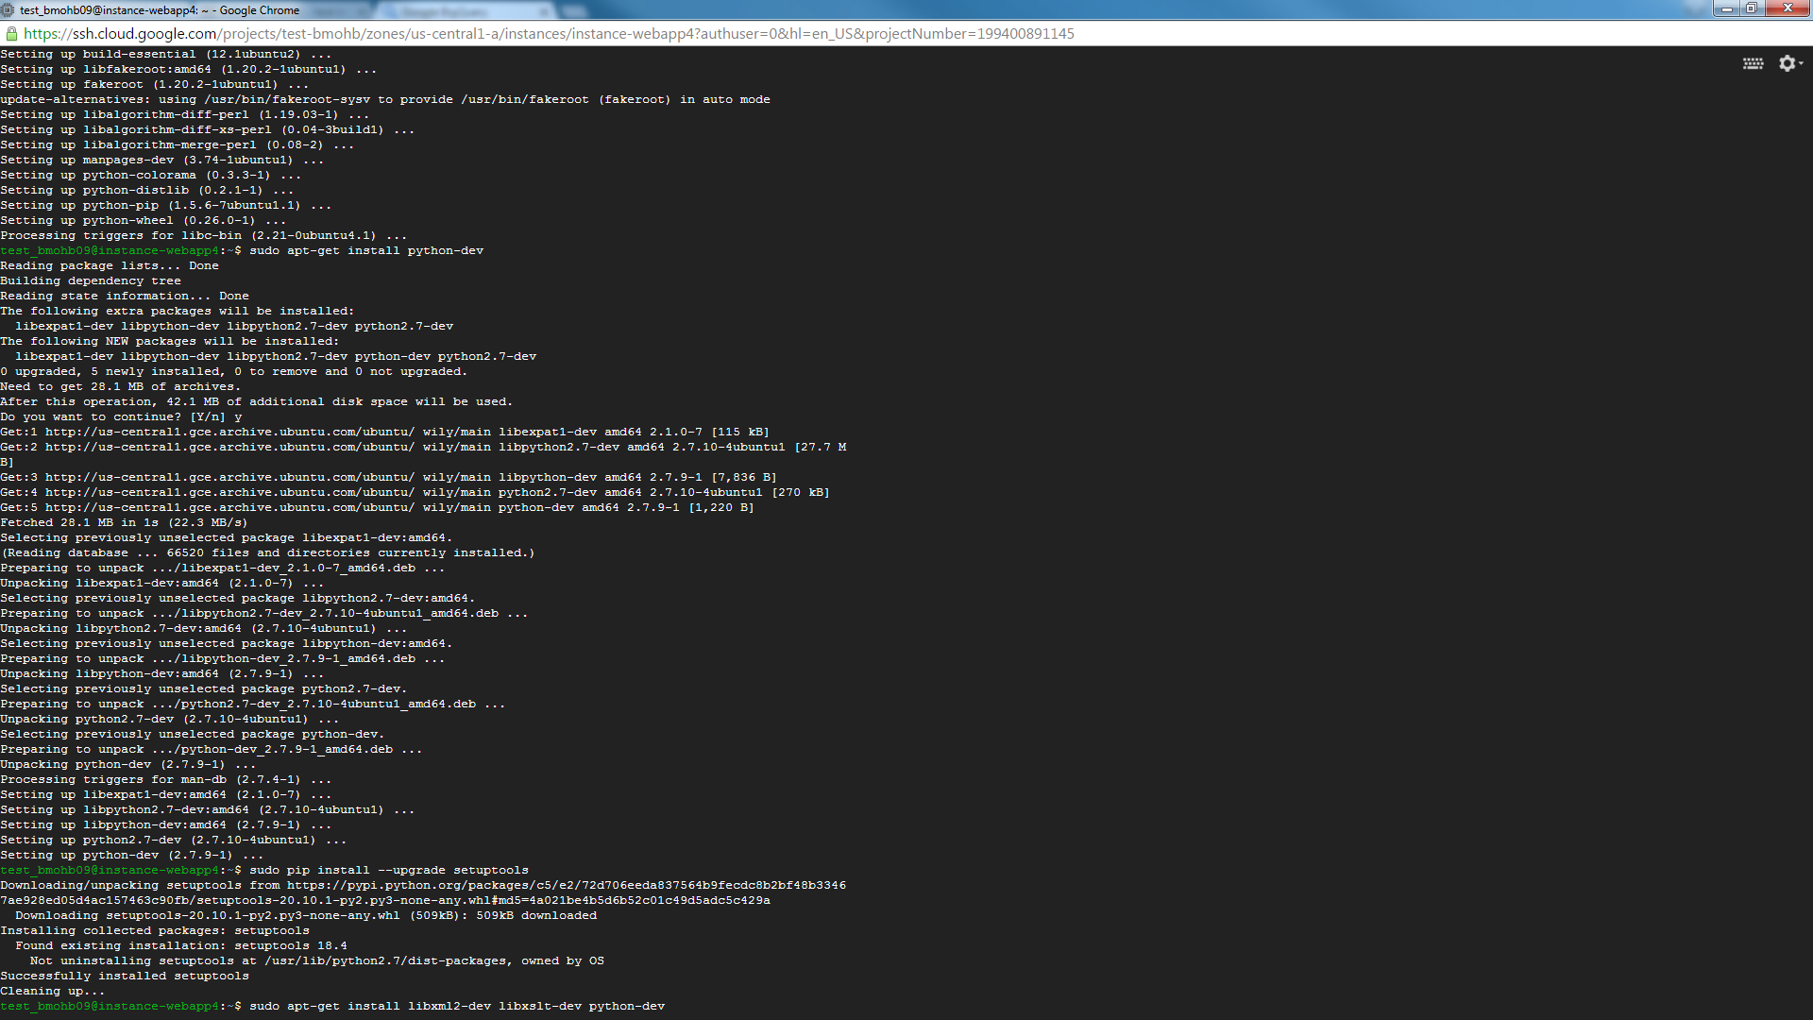

* sudo pip install --upgrade setuptools



* sudo apt-get install libxml2-dev libxslt-dev python-dev
  + - * Will need to continue by typing ‘Y’ + Enter

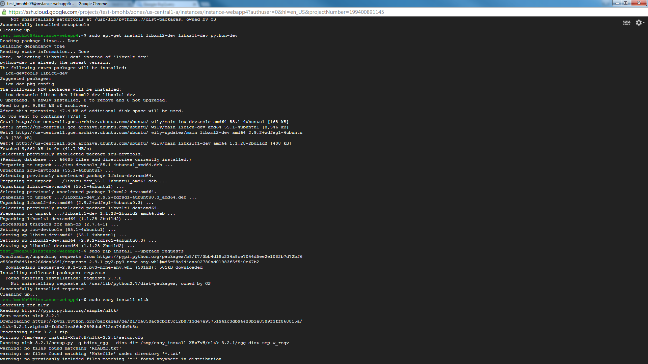

* sudo pip install --upgrade requests



* sudo easy_install nltk

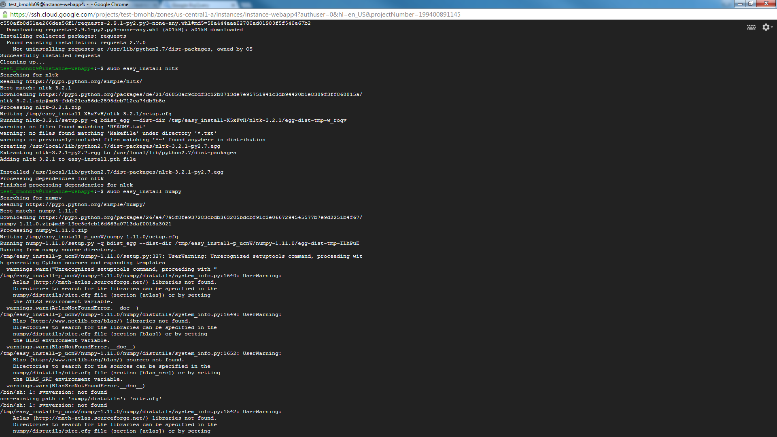

* sudo easy_install numpy
  + - * This install takes several minutes on Micro server (when tested ~13 minutes)

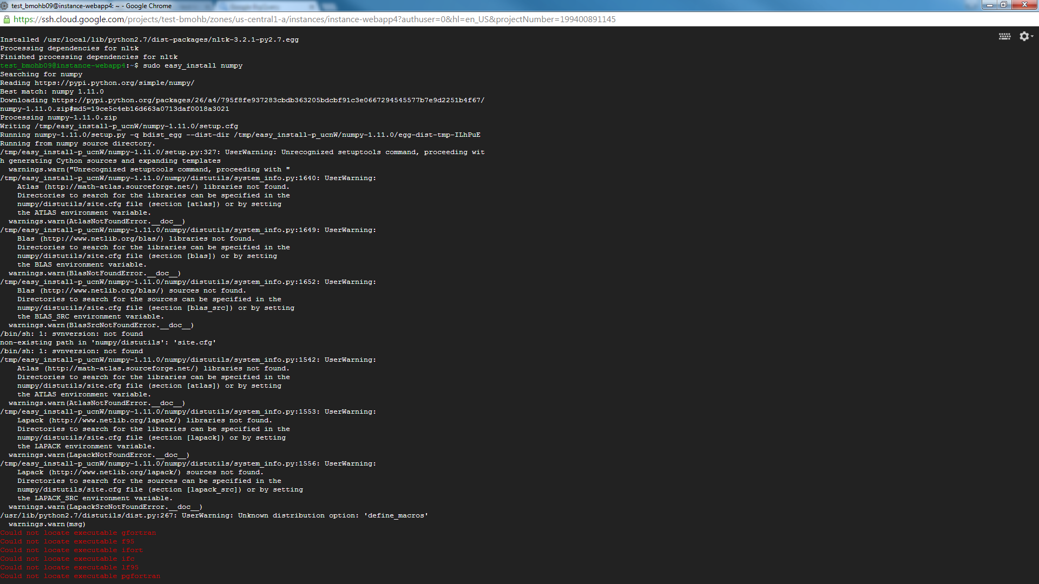

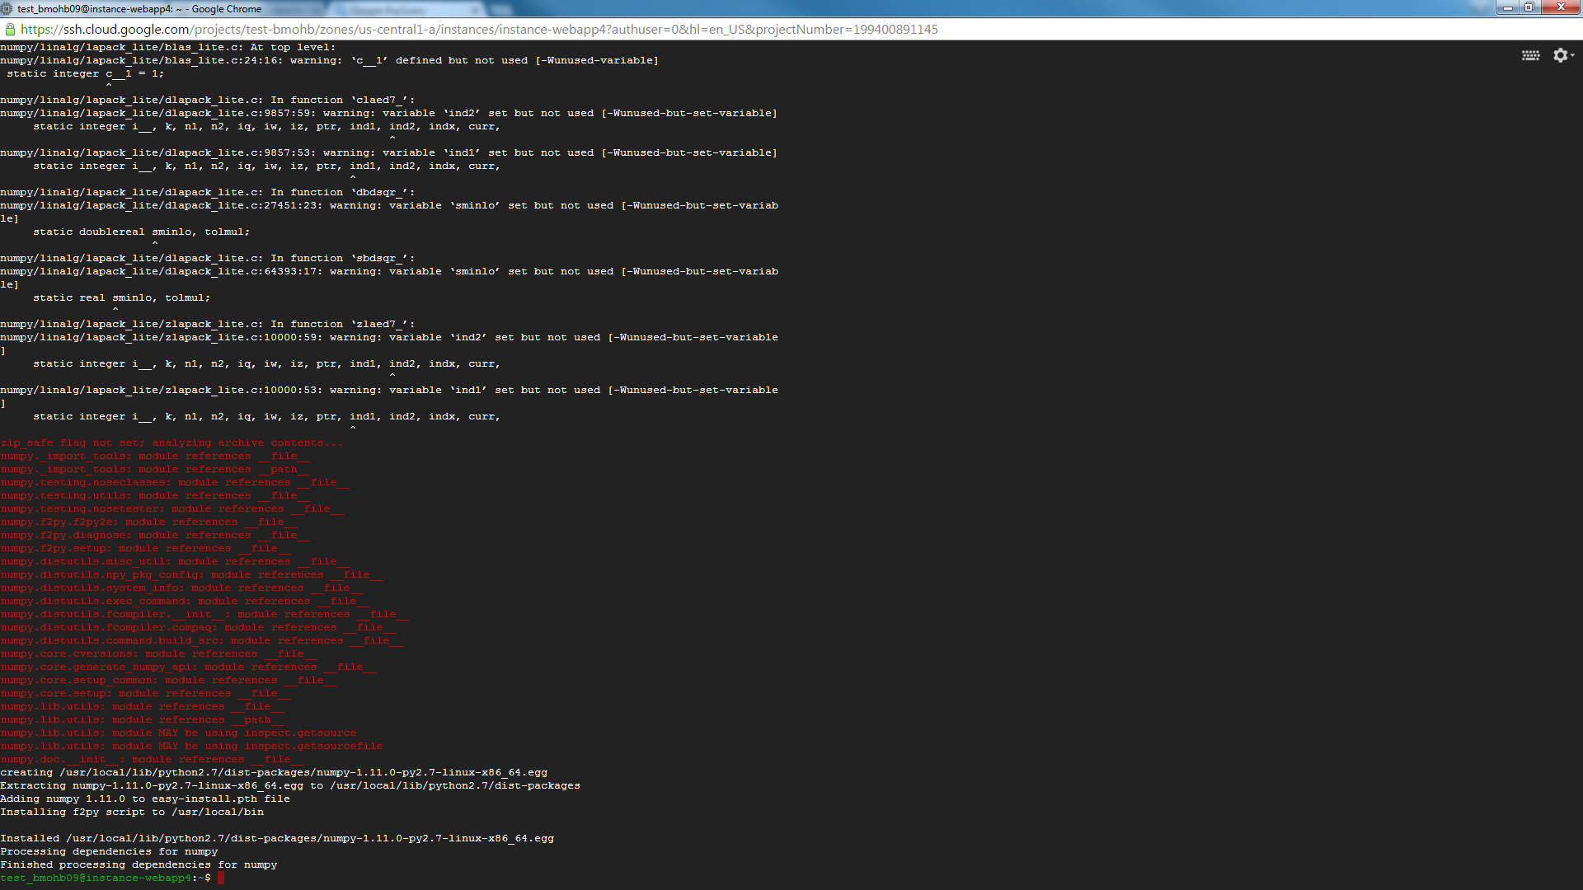

1. Change directories to root

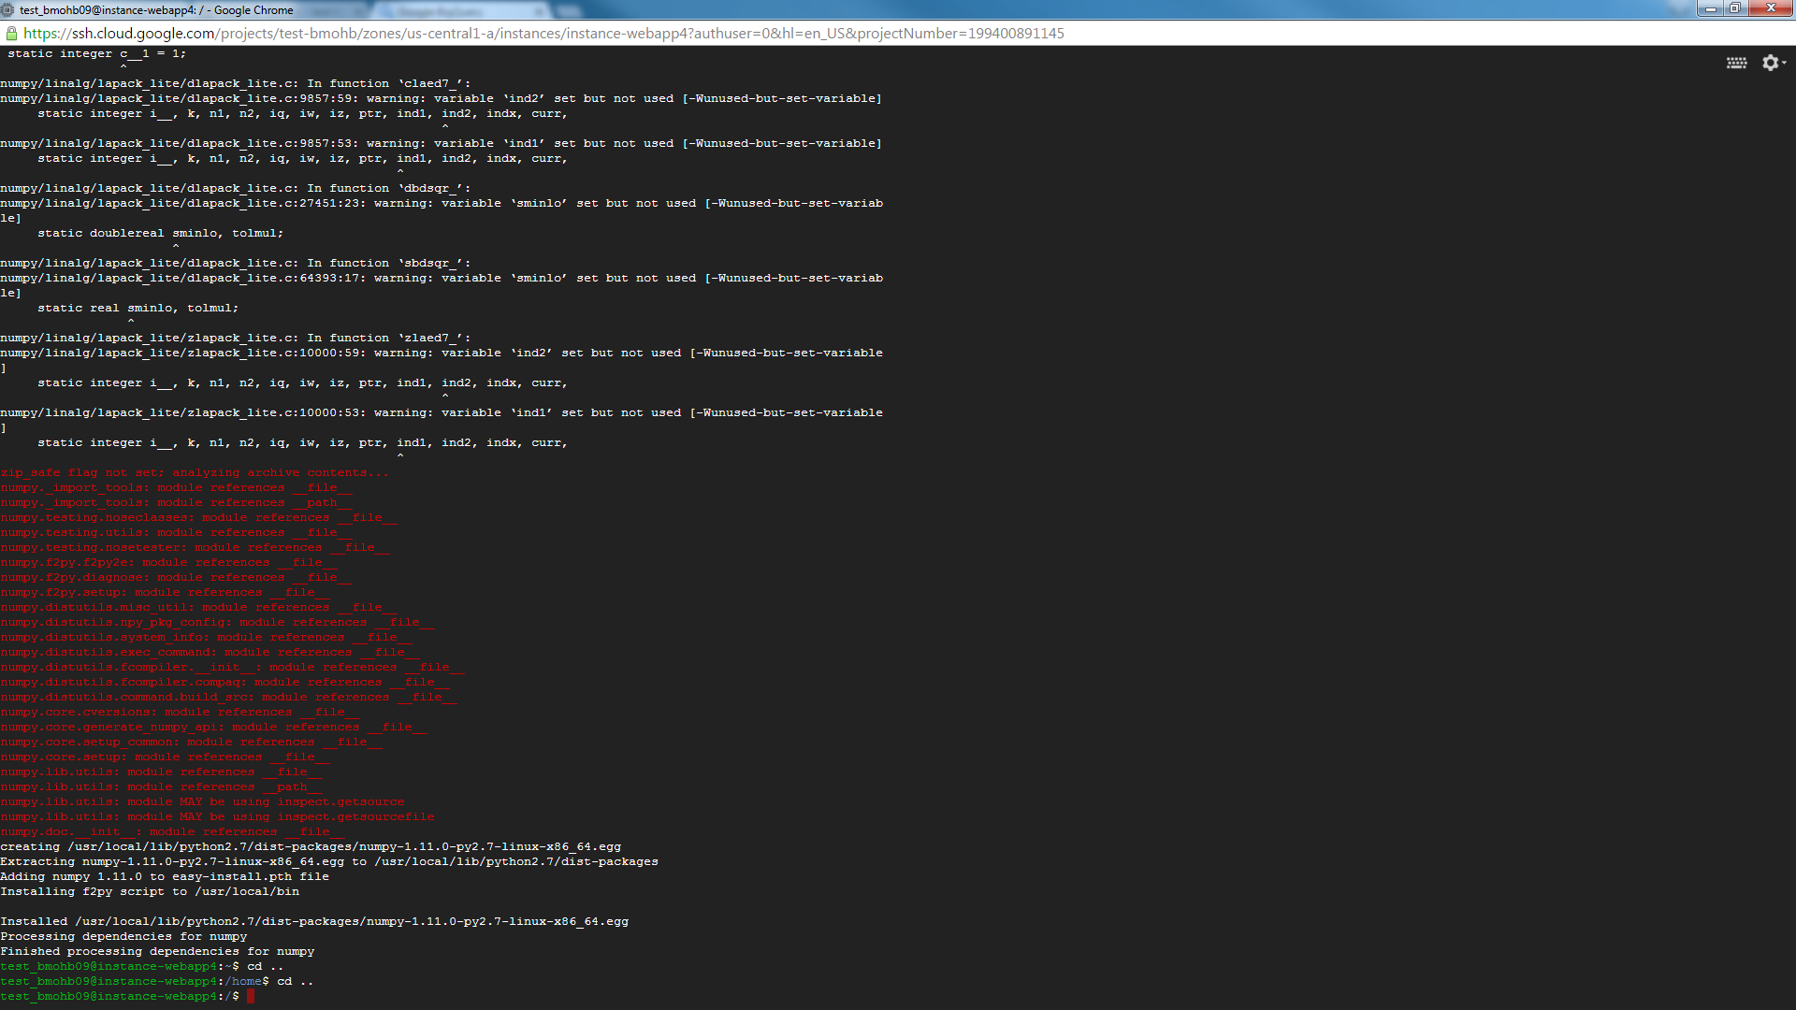

1. Create directories for where the scrapes are going to be located, the logs, the code and the archived scrapes

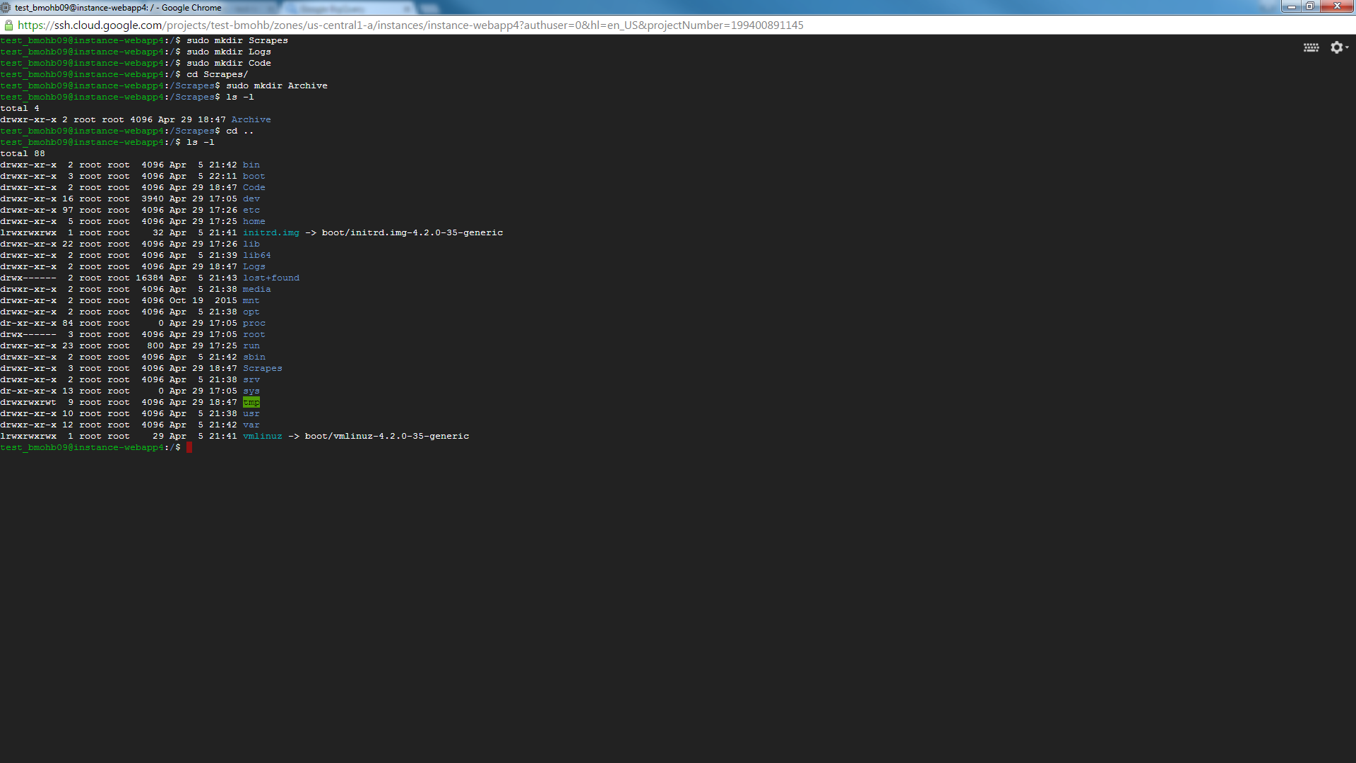

1. Scrapes located <https://github.com/Test-BMOHB/Media-Monitoring>
   1. Most scrapes need to have files paths changed to reflect the folder directory structure. Use pyScrape_CBCNews.py as an example for this folder structure.