Bike Rental

Draft requirement specifiation & Technical Specification

Authors

2020

Contents

1. Introduction 2

Purpose 2

Project Scope 2

References 2

2. System Description 2

3. Functional Requirements 2

4. UX Design 2

5. ER Diagram 0

6. UI Screens 0

7. Project Plan 1

8. References 2

9. Appendix A 3

Sample Data for reference 3

# Introduction

## Purpose

## Project Scope

## References

# System Description

# Functional Requirements

# UX Design

# ER Diagram

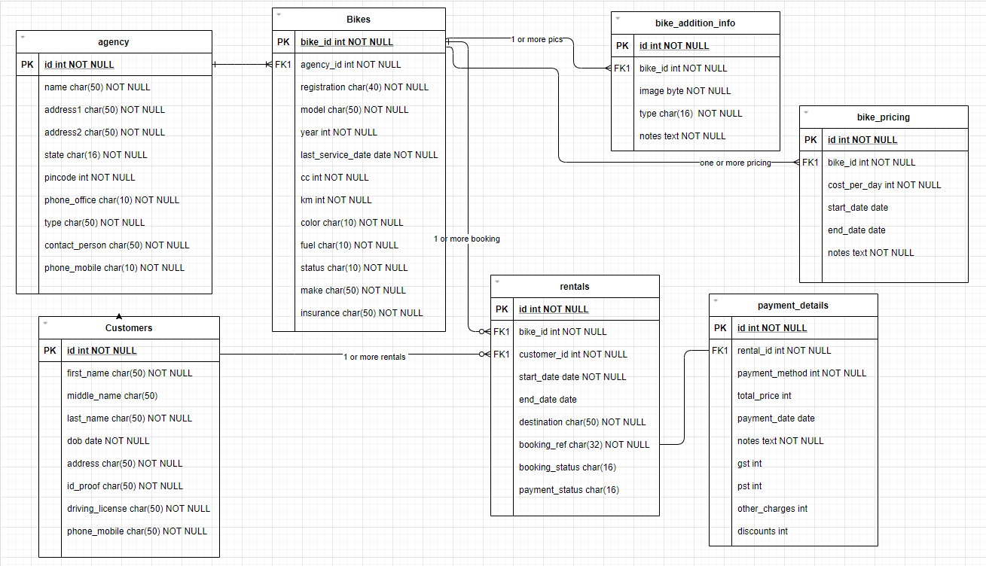

# UI Screens

1. Registry Agency : Add data about agency
2. Add Bikes - Add data about bikes –
3. List Bikes - List all bikes in grid format
   1. Bikes Selection
4. Confirm Booking : Allow user to book or block bikes
   1. What Next page : Details on what needs to be done next
   2. When to confirm payment i.e., 2 days in advance
   3. Where to pick up bikes (address)
   4. What to carry (document – DL (Mandatory) additional Govt.ID)
   5. Helmets will be provide
   6. Insurance information
   7. Timings and pricing
   8. Damage charges
   9. Service helpline
5. Confirmation Page (Displayed for printout and email)
   1. List customer details
   2. Booking Details
   3. Pickup location
   4. Contact Person
   5. QR Code (booking ref.no)
6. Tours – List all tours
7. Blogs – Provide guidance
8. Terms and Conditions

# Project Plan

|  |  |  |  |
| --- | --- | --- | --- |
| Action Item | Ownership | Notes |  |
| ER Diagram | Sajive |  |  |
| UX Design | Soumen |  |  |
| SEO (Search Engine Optimization) |  |  |  |
| Communication with agency | Soumen + |  |  |
| Backend Development |  |  |  |
| Deployment |  |  |  |
| Infrastructure |  |  |  |
| On Boarding – Agency details, vehicle images |  |  |  |
| Tours & Blog (Text and images only) |  |  | Tours can be added to itinerary later |
|  |  |  |  |

# References

<https://www.rental819.com/english/>

<https://www.komoot.com/guide/831/road-cycling-routes-in-the-alps>

<https://thefrenchride.com/> ** (Popup of bike info)

<https://www.adriaticmototours.com/tour/top-of-the-alps> (Like the menu and information displayed)

Large image screen background

Popup bike info

# Appendix A

## Sample Data for reference

**Table: Agency**

|  |  |  |  |  |
| --- | --- | --- | --- | --- |
| Id | Name | Address | Type | Contact |
| 1 | Royal Rentals | NH27, Bagdogra, West Bengal 734421 | BIKE_CARS | Xyz, 9019590195 |
| 2 | Darjeeling Riders | B35 Burdwan rd, Siliguri, West Bengal 734015 | BIKE | Abc, 9810098100 |

**Table: Bikes**

|  |  |  |  |  |  |  |  |  |  |  |  |
| --- | --- | --- | --- | --- | --- | --- | --- | --- | --- | --- | --- |
| Id | Ag.id | Reg.No | Make | Model | year | ShortCode  Make+model+yr | Last service dt (dd-mm-yyyy) | Cc/Color/fuel | status | Insurance | Notes |
| 1 | 1 | WB 54 EC 9876 | Royal Enfield | Thunderbird | 12-2018 | RETH18 | 10-11-2020 | 350/Black/Petrol | Available |  |  |
| 2 | 1 | WB 21 CN 2376 | Royal Enfield | Himalayan | 12-2017 | REHI17 | 10-11-2020 | 350/Black/Petrol | Service |  |  |
| 3 | 1 | WB 14 AL 5474 | Duke | ME500 | 02-2019 | DUME19 | 11-12-2020 | 250/Orange/Petrol | Rented |  |  |
| 4 | 1 | WB 14 AI 6475 | Duke | ME500 | 02-2019 | DUME19 | 11-12-2020 | 250/Orange/Petrol | Rented |  |  |
| 5 | 1 | WB 14 BL 7476 | Duke | ME500 | 02-2019 | DUME19 | 11-12-2020 | 250/Green/Petrol | Rented |  |  |
| 6 | 1 | WB 14 ME 8477 | Honda | SP125 | 02-2019 | HOSP19 | 11-12-2020 | 125/Silver/Petrol | Rented |  |  |
| 7 | 1 | WB 14 MI 9478 | Bajaj | Pulsar | 02-2018 | BJPU18 | 11-12-2020 | 250/Black/Petrol | Rented |  |  |
| 8 | 1 | WB 14 MI 9478 | Yamaha | Fazer | 02-2020 | YHFA20 | 11-12-2020 | 150/Black/Petrol | Rented |  |  |

**Table: Bike additional info**

|  |  |  |  |  |
| --- | --- | --- | --- | --- |
| Id | Bike_id | Image | Type | Notes |
| 1 | 2 | 1.PNG | Primary |  |
| 2 | 2 | 2.PNG | Secondary |  |
| 3 | 2 | 3.png | Blog |  |
|  |  |  |  |  |

**Table: Customers**

|  |  |  |  |  |  |
| --- | --- | --- | --- | --- | --- |
| Id | Name | Address | Id_proof | DL | Phone_mobile |
| 1 | Rahul | Delhi | PAN Image | DL Image | 9019590195 |
| 2 | Bose | Mumbai | Aadhar image | DL Image | 9810098100 |
| 3 | Vipin | Bangalore | PAN Image | DL Image | 9019590195 |
| 4 | Navin | Punjab | Aadhar Image | DL Image | 9810098100 |
| 5 | Gopal | Bangalore | PAN Image | DL Image | 9019590195 |
| 6 | Sukbir | Punjab | Aadhar image | DL Image | 9810098100 |

**Table: Rentals**

|  |  |  |  |  |  |  |  |  |
| --- | --- | --- | --- | --- | --- | --- | --- | --- |
| Id | Bike_id | Cust_id | Start_date | End_date | Destination | Booking ref.no  Random Code 16 digits | Status | Payment Status |
| 1 | 3 | 1 | 20/01/2021 | 25/01/2021 | Peling, SK |  | Advance | Pending |
| 2 | 2 | 2 | 20/11/2020 | 27/11/2020 | Nepal |  | Complete | Complete |
| 3 | 3 | 4 | 20/12/2020 | 27/12/2020 | Darjeeling |  | InProgress | Partial |
| 3 | 4 | 4 | 20/12/2020 | 27/12/2020 | Darjeeling |  | InProgress | Partial |
| 3 | 5 | 4 | 20/12/2020 | 27/12/2020 | Darjeeling |  | InProgress | Partial |
| 3 | 6 | 4 | 20/12/2020 | 27/12/2020 | Darjeeling |  | InProgress | Partial |
| 3 | 7 | 4 | 20/12/2020 | 27/12/2020 | Darjeeling |  | InProgress | Partial |

# Screenshots

Popup bike information

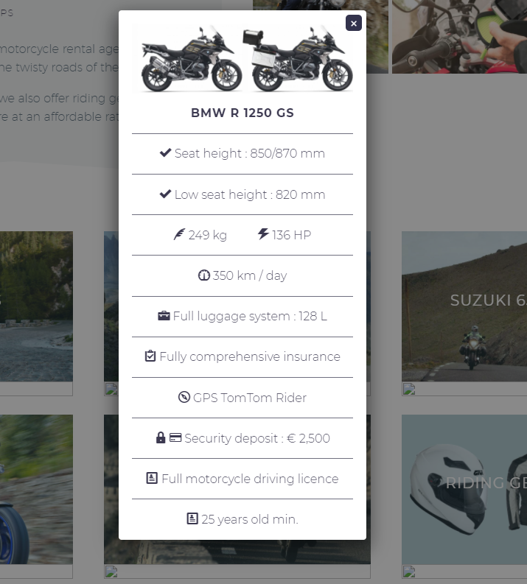

On mouse over popup (<https://www.edelweissbike.com/en/touren/?mid=all>)

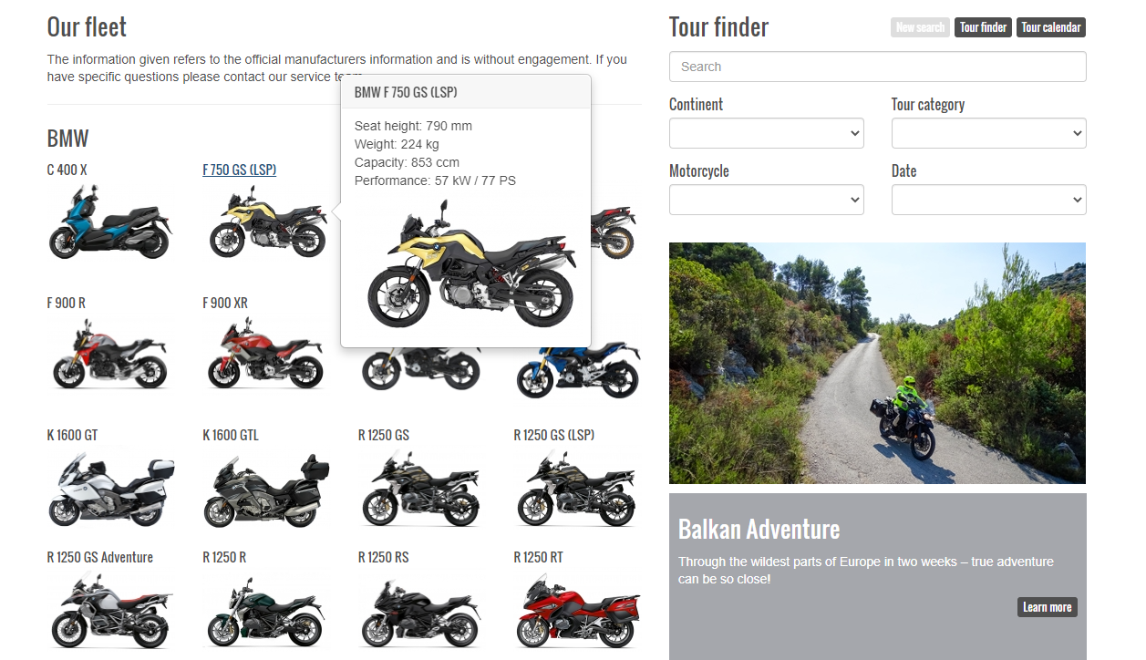

Rent a bike (<https://www.hertzride.com/en/motorcycle-rental>)

Select place, date and number of bikes, then list the bikes.

A grid is listed and user selects the bikes.

Like the blurring effect of the background bottom.

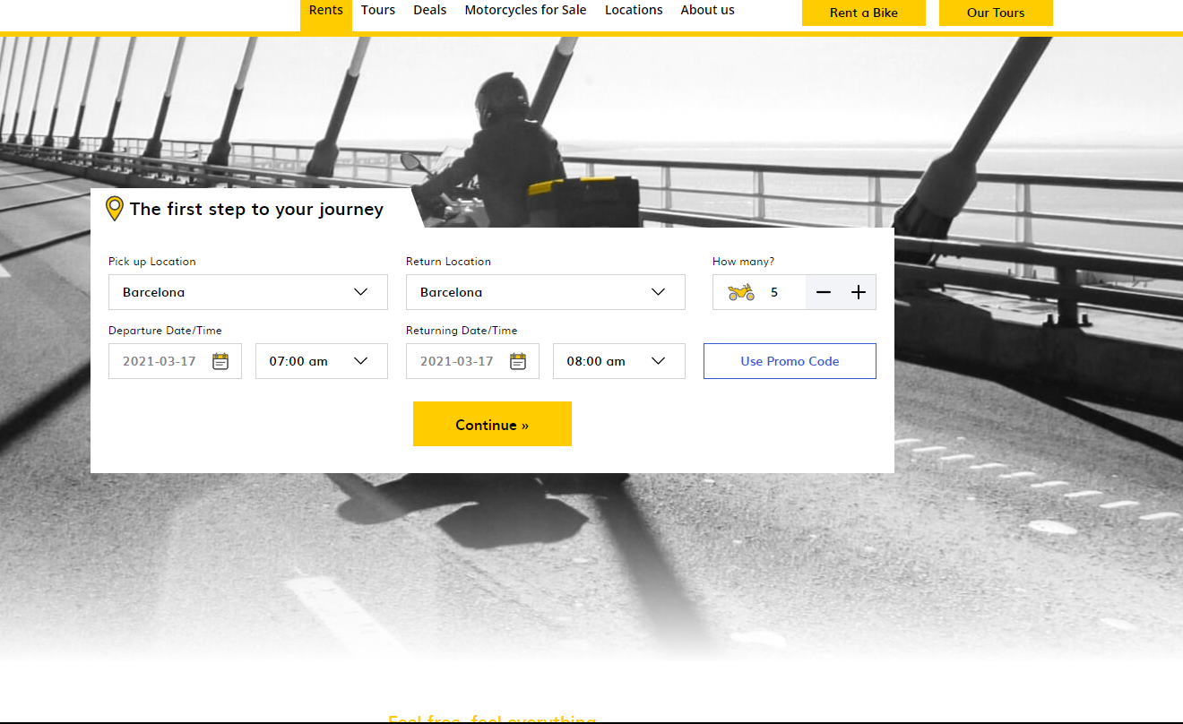

Bike selection screen, on mouse over pop up and color change.  
On right you see how many bikes selected

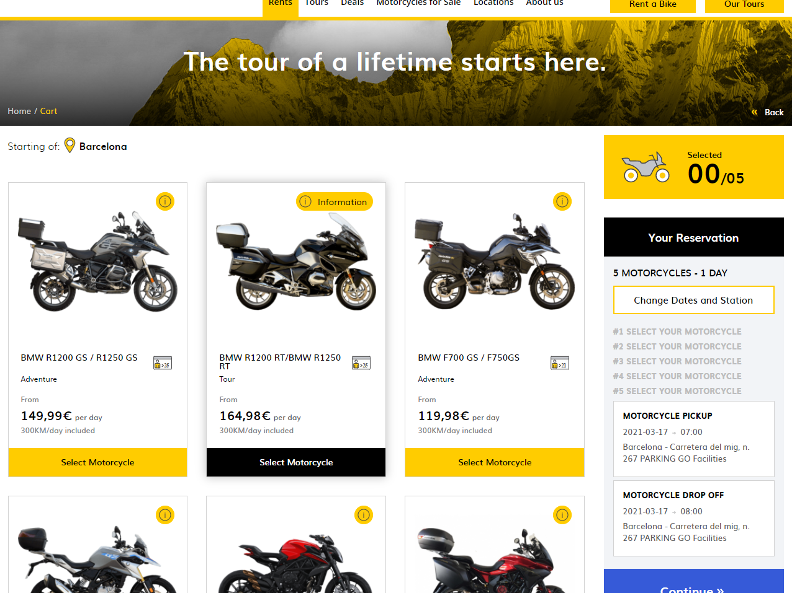

Once selection is done list the bikes and reservation details.

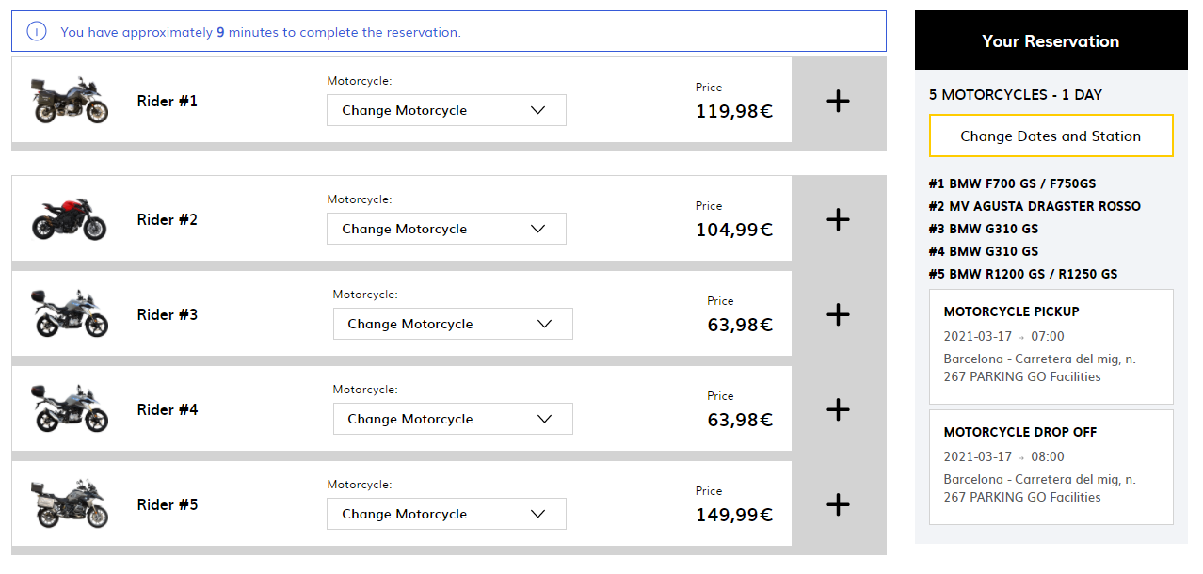

On click of **+** expand the bike details

Source: <https://www.eaglerider.com/sydney>

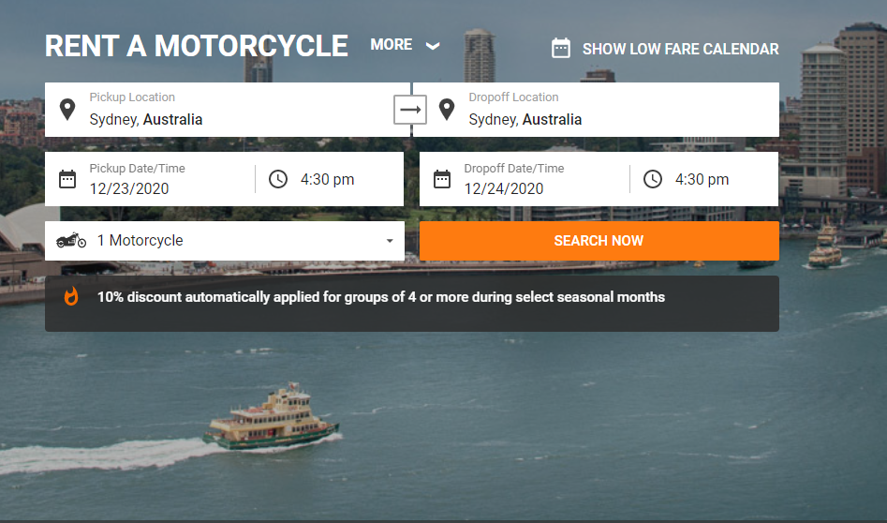

Add the details above and continue, List the reservation details on right and bike selections on top.

