Question 1

Question 2

Question 3
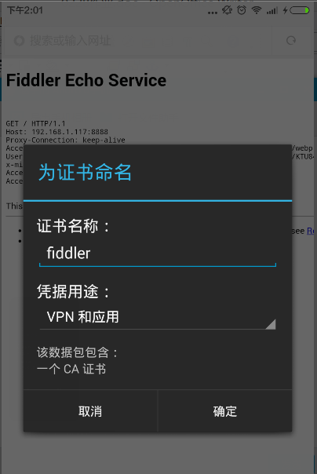

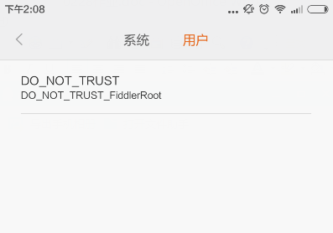

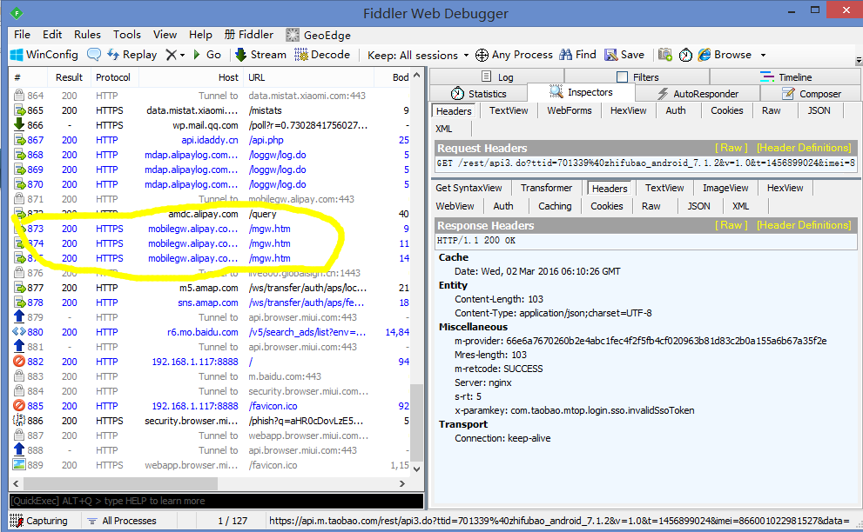
Question 4 (debug app):

pls download from following url: http://pan.baidu.com/s/1hqSzNIc

