|  |  |
| --- | --- |
| **Capstone Project**  **Machine Learning Engineer Nanodegree** | Priyanka Dwivedi  September 2016 |

**Definition**

**Project Overview**

The project I chose is an active Kaggle competition called Dogs vs Cats.

<https://www.kaggle.com/c/dogs-vs-cats-redux-kernels-edition>

The goal of the project is to use supervised learning to be able to distinguish images of dogs from cats. The training dataset for this project is a set of 25000 images that have been labelled as either a cat or a dog. The dataset available on Kaggle has 12,500 images for cats and 12,500 images for dogs. The images are very real life with photos having varying degree of lightening, other objects/people in the dataset along with cats or dogs and the animals are not always centered in the image.

The problem domain for this exercise is **computer vision** and **deep learning**. I am excited about this project as it gives me the chance to explore a field that is up and coming and out of my comfort zone. My background is in consumer finance and this project gives me a chance to learn about image processing and deep neural networks.

To succeed in this project I have leveraged several sources to build my understanding of Deep learning and also learn about implementation using TensorFlow. These sources include:

* Udacity Course: [Deep Learning](https://www.google.com/url?q=https://www.udacity.com/course/deep-learning--ud730&sa=D&ust=1473187237687000&usg=AFQjCNEh1l5QuBAKB9jBxl7CM_kpkv_tpw) by Vincent Vanhoucke (Google and Udacity).
* TensorFlow tutorial from TensorFlow website: <https://www.tensorflow.org/versions/r0.10/tutorials/index.html>
* Books on Deep Learning
  + Artificial Intelligence for Humans, Volume 3: Deep Learning and Neural Networks by Jeff Heaton
  + Getting started with TensorFlow by Giancarlo Zaccone
* [CS231n: Convolutional Neural Networks for Visual Recognition](https://cs231n.github.io/) — Andrej Karpathy's Stanford CS class
* Papers from Geoffery Hinton

**Problem Statement**

The problem here is to use Supervised Learning to train a computer to distinguish between images of dogs and cats. We have a dataset of 25000 images for cats and dogs with labels to accomplish this. Once the computer is trained, we have a test dataset of 12,500 mixed images for which a label (cat or dog) needs to be provided. The success of the project will depend on our accuracy in classifying cat or dog images in the test dataset.

This problem is a classic case of a computer vision challenge. The images are not centered and there are often other objects on the image. Due to variation in scale, rotation and noise between images, my approach would be to train a **deep convolution neural network (CNN)** using TensorFlow to teach the computer to analyze various aspects of the image. My goal is to start with a simple classic implementation of CNN with several layers of convolution and max pooling. And gradually improve on this basic model by adding dropout, regularization and learning rate decay.

At the outset, this problem presents two main challenges:

1. The dataset available for training a deep network is relatively small – Only about 25000 images. If the accuracy obtained is low then we might have to think about ways of augmenting the dataset

2. I don’t have a GPU computer and I am not sure if my Mac with CPU will have enough processing power. If I do need access to GPU, then I will leverage Amazon Web Services, Elastic Cloud 2 GPU for training the model. This will be new for me and another learning experience. The challenge here is to approach the problem in a computationally efficient manner

**Metrics**

For this project we have two datasets:

* Train dataset of 25,000 images with labels provided for each image
* Test dataset of 12,500 images. **No labels provided**. After the model has been trained, the test set will be scored and the output submitted to Kaggle.

My plan is to divide the train dataset into 3 different sets – 1.Ttraining dataset of 20,000 images that will be used to train the model, 2. Validation dataset of 4,000 images for testing the performance of the CNN and 3. A test set of 1000 images that will be used to do a final evaluation before submission. The goal of creating this test set is that as the CNN is repeatedly trained and tested on validation set, it will eventually “see” the validation set. This test set will be a more objective evaluation of the accuracy of CNN on an out of sample. I will be using two metrics for measuring the success of the project:

1. Accuracy Score – Defined as % labels correctly classified when comparing model prediction vs actual. This metric will be computed on the training dataset and the validation set which is the population for which we have labels for the images

2. Log Loss function – Kaggle uses a log loss function to rate different contestants. In plain English, this error metric is used where contestants have to predict that something is true or false with a probability (likelihood) ranging from definitely true (1) to equally true (0.5) to definitely false (0).

The use of log on the error provides extreme punishments for being both confident and wrong. In the worst possible case, a single prediction that something is definitely true (1) when it is actually false will add infinite to your error score and make every other entry pointless. In Kaggle competitions, predictions are bounded away from the extremes by a small value in order to prevent this.

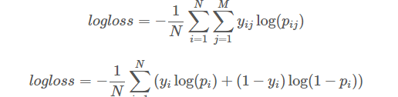

Log loss will be computed on training and validation sets before submission. The Log loss for testing dataset will be provided by Kaggle.

**Analysis**

**Data Exploration and Exploratory Visualization**

The data for this project can be found on Kaggle website and is a zip file of 25,000 images for training and for which labels are provided and a zip file of 12,500 images for testing with no labels for submission to the competition.

<https://www.kaggle.com/c/dogs-vs-cats-redux-kernels-edition/data>

Each image in the training has the format “cat.250.jpg” which includes a label for cat or dog and an image sequence number. The data includes real images of cats and dogs. A few images are shared below:

Cats

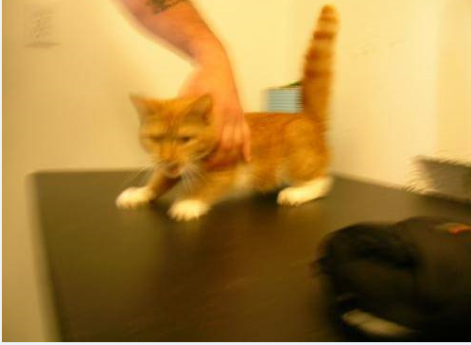 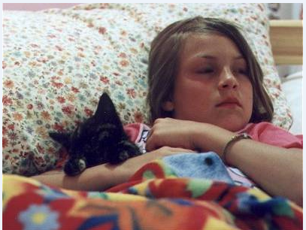 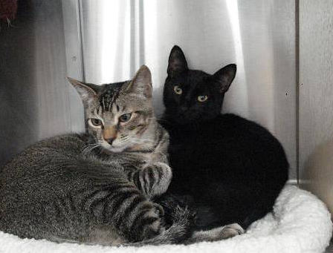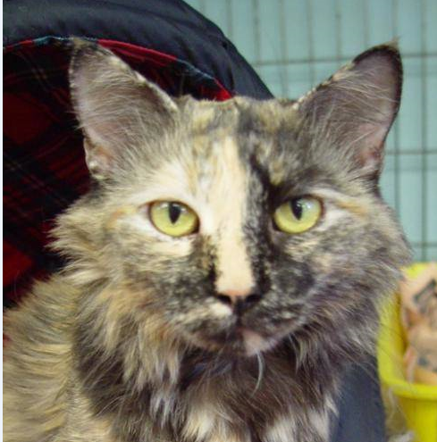 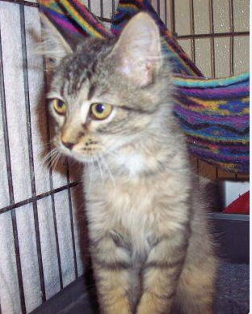

Dogs

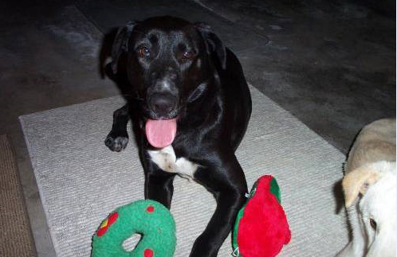 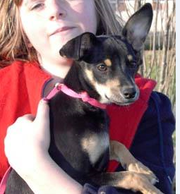 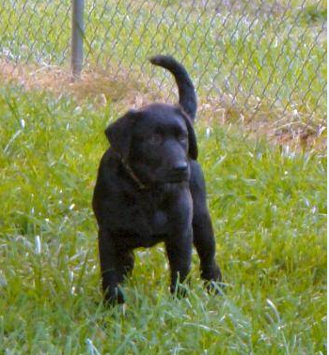 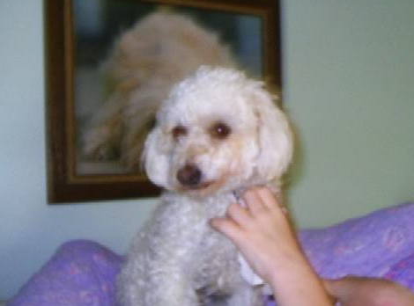

Here are a few characteristics of the dataset that make this classification exercise challenging:

1. Presence of people and other objects in the image
2. Some images have multiple animals
3. Images are shot under different amount of light
4. Some images are blurry
5. Animals are not always centered in the image
6. Varying amount of color in the images
7. Images have different height and width

The histogram below takes a random sample of 225 images from the dataset and plots image width and height

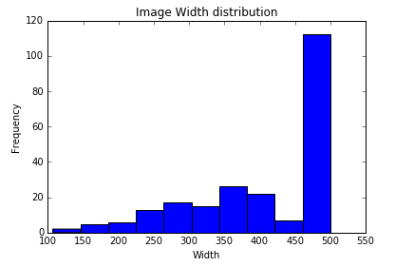 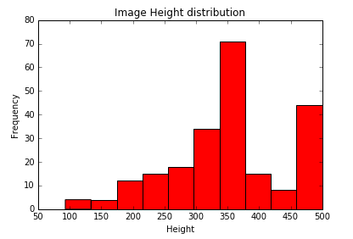

We can observe that images have different width and heights. Most pictures have width around 500 pixels and height varies b/w 300-500 pixels.

I think this is a first challenge to solve for. I would like to

1. Have each picture be reduced to a uniform width and height
2. The images are big. To deal with processing efficiently, images should be smaller. Each pixel will be an input into a neural network so large images would require substantial computing power. Example each 56x56 gray image would be convereted to an array of 56x56x1 pixels = 3136 pixels. If instead we go with a colored image of 128x128 then it will have 128x128x3 = 49152 pixels i.e each image will have a dataset that’s 15 times bigger. Multiplying that with 25k images and we can see how this can quickly become a massive dataset. I will start with a dataset if 56x56 pixels. I will create a second data set of 128x128 pixels to be tested as part of the hyperparameter optimization.
3. For the dataset 1, 56x56 pixels all images will be converted to grey scale. The 128x128 pixels dataset will retain RGB images

**Algorithms and Techniques**

Given the nature of this problem – images with difference in scale, rotation and noise, I think a deep convoluted neural network is the best algorithm to choose for this problem.   Convolutional neural networks are biologically inspired variants of multilayer perceptrons (MLP), designed to emulate the behaviour of a visual cortex. These models mitigate the challenges posed by the MLP architecture by exploiting the strong spatially local correlation present in natural images Also all neurons in a given convolutional layer share the same weights and detect exactly the same thing. Replicating units in this way allows for features to be detected regardless of their position in the visual field, thus constituting the property of translation invariance.

Here is the approach I have in mind:

1. Start with a basic convolution neural network structure – A Convolution Layer with RELU activation function followed by a max pool layer. Multiple such convolution layers will be connected each with different depth. Finally have one fully connected layer before the output layer

Input Layer -> Conv Layer 1 with RELU -> Max Pool Layer 1 -> Conv Layer 2 with RELU -> Max Pool Layer 2 -> Fully Connected Layer with RELU -> Output Layer

1. Evaluate performance of basic convolution neural network by introducing dropout, regularization and learning rate decay
2. Explore hyper parameter and training paramater optimization to identify the best possible settings for the convolution network. The ones that I want to explore are:
   1. Filter shape and Image size: The challenge here is to find the right level of granularity so as to create abstractions at the proper scale, given a particular dataset. I will start with image resized to a small size and use a small filter size and gradually increase to larger images and large filter combination. (Best results on MNIST-sized images (28x28) are usually in the 5x5 range on the first layer, while natural image datasets (often with hundreds of pixels in each dimension) tend to use larger first-layer filters of shape 12x12 or 15x15.)
   2. ConvNet Architecture: Explore different combinations of convolution layers, max pool layers
   3. Stochastic Pooling??
3. Further explore improving performance of conv net through data augmentation

**Benchmark**

The Benchmark performance for this project will be based on the leaderboard for this competition.

1. Accuracy score attained from the first run of this competition on Kaggle in 2014.

<https://www.kaggle.com/c/dogs-vs-cats/leaderboard/private>

My goal would be to get an accuracy of >85%

2. Log Loss error rate compared to the current leaderboard for this competition in Kaggle:

<https://www.kaggle.com/c/dogs-vs-cats-redux-kernels-edition/leaderboard>

**Methodology**

**Data Preprocessing**

Here are the image processing steps that were undertaken:

1. Resize the images to similar width and height and reduce the size. I created two datasets:

* Dataset 1 – 56x56 pixels
* Dataset 2 – 128x128 pixels

PIL Image library was used to do the resize and save images as Jpeg



2. Use scipy ndimage to read the image files as a dataset. Dataset 1 – 56x56 pixels was read as a grey scale dataset by setting Flatten = True. Dataset 2 – 128x128 pixels was read as a RGB dataset with 3 channels.



3. Normalize the data by pixel depth to reduce to a scale b/w -0.5 to 0.5. Pixel depth was set as 255. This is to ensure that the input to neural network is within the proper range



4. Create a dataset for labels. The Kaggle dataset has a jpeg labelled as either cat or dog. The target was extracted from the file name

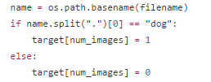

5. Shuffle the cat and dog images within the dataset since the pictures were read as first all cat pics and then all dog pics

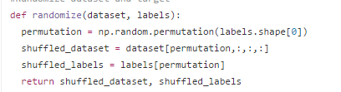

6. Use sklearn cross validation to split the overall dataset into 3 parts – 1. Train set of 20k images, 2. Validation set of 4k images and 3. Testing set of 1k images. This was done in two steps:





7. Reshape Labels to have two output classes for cats and dogs as the desired output format for a neural network



**Implementation**

I started with implementing a simple convolution neural network in TensorFlow. This neural network had the following structure

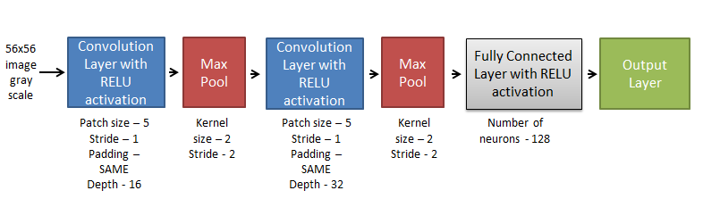

Figure 1: Simple Convolution Neural Network

The algorithm was created using TensorFlow tutorial at

<https://www.tensorflow.org/versions/r0.10/tutorials/mnist/pros/index.html>

Batch size of 16 neurons was used to train the model. I found the model impossible to run on my Mac CPU so I used Amazon Web Service Elastic Cloud 2 GPU 2.2x Large to train this model. After experimenting with several parameters I got to an accuracy of **72%** on the validation set after 2400 runs. This was obtained by using the parameters listed in the Figure 1 above. Gradient Descent Optimizer was used. It took about 15 mins to run on the full set of 20k images.

As a second part of this exercise I implemented:

* L2 regularization on the Fully Connected Layers. Code below:

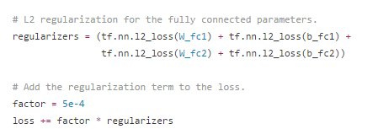

* Dropout on Fully Connected hidden Layer for Training Sample. Code below:

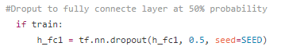

* Learning Rate Decay

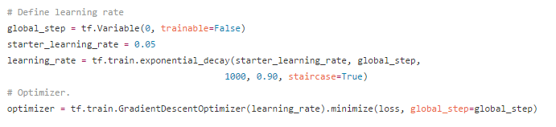

The full code for these two steps is on my GitHub repository:

<https://github.com/priya-dwivedi/Udacity-ML-Nano-Degree/blob/master/P5/catvsdogs_1.py>

After applying L2 regularization, Dropout and Learning Rate Decay on the simple convolution neural network in the Figure 1 above, the accuracy on validation sample dropped to **70%.** This was surprising and I suspected this happened because the training parameters used in the above algorithms were not tuned. The refinements done to this first implementation are discussed below.

**Refinement**

Bulk of my time in this project was spent on this stage – tuning of hyper parameters and training parameters. This section summarizes all the different steps I took and the results for the same.

1. Increasing image size and adding RGB channels

The simple convolution neural network in figure 1 had as input 56x56 pixels grey scale images. I was worried that reducing my large images to this scale and removing the color component might be materially affecting the performance of convolution network. To test this hypothesis, I created a second set of 128x128 pixel images with RGB. As expected this led to a massive increase in the size of input dataset from 56x56x1 array to 128x128x3 sized array which was about 15 times bigger for each image! Creating this dataset and manipulating it was extremely slow. As well as it led to a massive increase in the no. of weights in the neural network and GPU memory limitations on how big of a network could be designed. The most complicated network that could be managed on AWS GPU was:

The performance on validation set was only **65%!** This was a huge relief moment for me as it gave me comfort to proceed with further optimization on my original 56x56 greyscale images dataset

The python code for this implementing is at my GitHub repository below:

2. Hyper parameter and training parameter optimization

The parameters that I tried to optimize included:

* Layer structure – addition of more convolution and fully connected layer, change in placement of max pool layer, removal of some max pool layers
* Patch size and depth of convolution layers
* Number of neurons in fully connected layers
* Optimization function
* Training parameters like keep probability of dropout, initial learning rate, learning rate decay etc.

1. Resize the images to similar width and height and reduce the size. I created two datasets:

* Dataset 1 – 56x56 pixels
* Dataset 2 – 128x128 pixels

“*Real-world example*. The [Krizhevsky et al.](http://papers.nips.cc/paper/4824-imagenet-classification-with-deep-convolutional-neural-networks) architecture that won the ImageNet challenge in 2012 accepted images of size [227x227x3]. On the first Convolutional Layer, it used neurons with receptive field size F=11F=11, stride S=4S=4and no zero padding P=0P=0. Since (227 - 11)/4 + 1 = 55, and since the Conv layer had a depth of K=96K=96, the Conv layer output volume had size [55x55x96]. Each of the 55*55*96 neurons in this volume was connected to a region of size [11x11x3] in the input volume. Moreover, all 96 neurons in each depth column are connected to the same [11x11x3] region of the input, but of course with different weights. As a fun aside, if you read the actual paper it claims that the input images were 224x224, which is surely incorrect because (224 - 11)/4 + 1 is quite clearly not an integer. This has confused many people in the history of ConvNets and little is known about what happened. My own best guess is that Alex used zero-padding of 3 extra pixels that he does not mention in the paper.”

INPUT -> [CONV -> RELU -> CONV -> RELU -> POOL]*3 -> [FC -> RELU]*2 -> FC Here we see two CONV layers stacked before every POOL layer. This is generally a good idea for larger and deeper networks, because multiple stacked CONV layers can develop more complex features of the input volume before the destructive pooling operation.

*Prefer a stack of small filter CONV to one large receptive field CONV layer*. Suppose that you stack three 3x3 CONV layers on top of each other (with non-linearities in between, of course). In this arrangement, each neuron on the first CONV layer has a 3x3 view of the input volume. A neuron on the second CONV layer has a 3x3 view of the first CONV layer, and hence by extension a 5x5 view of the input volume. Similarly, a neuron on the third CONV layer has a 3x3 view of the 2nd CONV layer, and hence a 7x7 view of the input volume. Suppose that instead of these three layers of 3x3 CONV, we only wanted to use a single CONV layer with 7x7 receptive fields. These neurons would have a receptive field size of the input volume that is identical in spatial extent (7x7), but with several disadvantages. First, the neurons would be computing a linear function over the input, while the three stacks of CONV layers contain non-linearities that make their features more expressive. Second, if we suppose that all the volumes have CC channels, then it can be seen that the single 7x7 CONV layer would contain C×(7×7×C)=49C2C×(7×7×C)=49C2 parameters, while the three 3x3 CONV layers would only contain 3×(C×(3×3×C))=27C23×(C×(3×3×C))=27C2 parameters. Intuitively, stacking CONV layers with tiny filters as opposed to having one CONV layer with big filters allows us to express more powerful features of the input, and with fewer parameters. As a practical disadvantage, we might need more memory to hold all the intermediate CONV layer results if we plan to do backpropagation.

Layer Sizing Patterns

Until now we’ve omitted mentions of common hyperparameters used in each of the layers in a ConvNet. We will first state the common rules of thumb for sizing the architectures and then follow the rules with a discussion of the notation:

The **input layer** (that contains the image) should be divisible by 2 many times. Common numbers include 32 (e.g. CIFAR-10), 64, 96 (e.g. STL-10), or 224 (e.g. common ImageNet ConvNets), 384, and 512.

The **conv layers** should be using small filters (e.g. 3x3 or at most 5x5), using a stride of S=1S=1, and crucially, padding the input volume with zeros in such way that the conv layer does not alter the spatial dimensions of the input. That is, when F=3F=3, then using P=1P=1 will retain the original size of the input. When F=5F=5, P=2P=2. For a general FF, it can be seen that P=(F−1)/2P=(F−1)/2 preserves the input size. If you must use bigger filter sizes (such as 7x7 or so), it is only common to see this on the very first conv layer that is looking at the input image.

The **pool layers** are in charge of downsampling the spatial dimensions of the input. The most common setting is to use max-pooling with 2x2 receptive fields (i.e. F=2F=2), and with a stride of 2 (i.e. S=2S=2). Note that this discards exactly 75% of the activations in an input volume (due to downsampling by 2 in both width and height). Another slightly less common setting is to use 3x3 receptive fields with a stride of 2, but this makes. It is very uncommon to see receptive field sizes for max pooling that are larger than 3 because the pooling is then too lossy and aggressive. This usually leads to worse performance.

*Reducing sizing headaches.* The scheme presented above is pleasing because all the CONV layers preserve the spatial size of their input, while the POOL layers alone are in charge of down-sampling the volumes spatially. In an alternative scheme where we use strides greater than 1 or don’t zero-pad the input in CONV layers, we would have to very carefully keep track of the input volumes throughout the CNN architecture and make sure that all strides and filters “work out”, and that the ConvNet architecture is nicely and symmetrically wired.

*Why use stride of 1 in CONV?* Smaller strides work better in practice. Additionally, as already mentioned stride 1 allows us to leave all spatial down-sampling to the POOL layers, with the CONV layers only transforming the input volume depth-wise.

*Why use padding?* In addition to the aforementioned benefit of keeping the spatial sizes constant after CONV, doing this actually improves performance. If the CONV layers were to not zero-pad the inputs and only perform valid convolutions, then the size of the volumes would reduce by a small amount after each CONV, and the information at the borders would be “washed away” too quickly.

*Compromising based on memory constraints.* In some cases (especially early in the ConvNet architectures), the amount of memory can build up very quickly with the rules of thumb presented above. For example, filtering a 224x224x3 image with three 3x3 CONV layers with 64 filters each and padding 1 would create three activation volumes of size [224x224x64]. This amounts to a total of about 10 million activations, or 72MB of memory (per image, for both activations and gradients). Since GPUs are often bottlenecked by memory, it may be necessary to compromise. In practice, people prefer to make the compromise at only the first CONV layer of the network. For example, one compromise might be to use a first CONV layer with filter sizes of 7x7 and stride of 2 (as seen in a ZF net). As another example, an AlexNet uses filer sizes of 11x11 and stride of 4.