**Automation Execution Doc :**

**Approach or Tool:**

*Automation framework is Cucumber using Java with maven build tool*

**Prerequisites:**

Test execution is carried with following pre conditions

1. Java latest version

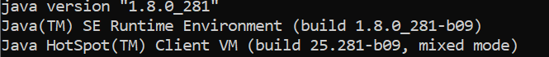

1. MAVEN **- Apache Maven 3.6.3**

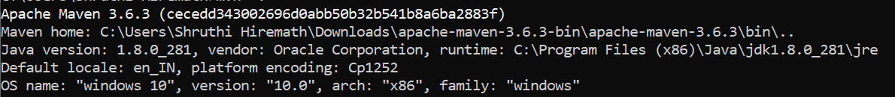

1. Firefox ( v 94.0.1) and Chrome (Version 95.0.4638.69 (Official Build) (64-bit))
2. Windows 10

**Note**: Framework is platform independent

* **Tested and verified on windows 10 (Chrome - Version 95.0.4638.69) successfully**

**Execution Steps:**

Execution is pretty simple:

1. Navigate to src folder
2. Run command “mvn clean install “ or run Run.bat (windows machine) or Run.sh (linux/Mac machine) - UI execution starts after all dependencies are downloaded and all tests will run
3. To check for report, go to target\cucumber-html-report\index.html

**Important configurations in Confguration.properties** **File:**

1. Please update properties file with for key Browser to select “Firefox” or “Chrome”
2. Since every time task challenges user to select different type of items ie first time it might as for Almond/Aloe next time it will ask SPF-50/SPF-30. So we have provided with such variable parameters which can be updated in the properties file so that next time any new criteria can be added by just appending to ItemsToAddToCart

**Use Cases :**

Following is the use case automated: Shop for the Moisturizers (if the temperature is below 19 degree) or Sunscreens (if the temperature is above 34 degrees , please find the path for Flink.feature

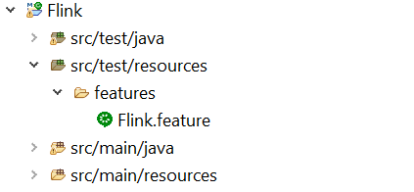

Please kindly look for doc folder to understand the API documentation for the functions and its usage