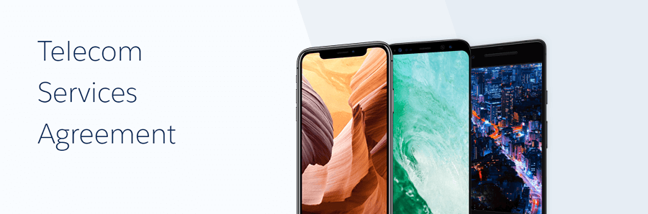

This Subscription Agreement (the “Agreement”) is by and between Telecom Inc., with business offices located at 50 Fremont Street, Suite 2250, San Francisco, CA 94105, (“Telecom”), and {{#company}} **{{name}}** with business offices located at **{{address}}** {{/company}}(the “Subscriber”). This Agreement shall be effective on **{{contract_start_date}}** provided on the Telecom signature block hereto (“Effective Date”). Each of Telecom and Subscriber is a “Party” and together they are the “Parties”.

WHEREAS, Telecom has developed and maintains a software-as-a-service (“SaaS”) internet-based solution that allows End-Users to manage certain customer relationships and perform certain business processes. These Services are provided by Telecom under the trade names identified in an applicable Order and as described on Telecom’s Site.

WHEREAS, Telecom agrees to provide such Services to Subscriber pursuant to the terms and conditions of this Agreement.

## **Items Ordered**

|  |  |  |  |
| --- | --- | --- | --- |
| Name | Quantity | One Time Total | Recurring Total |
| {{#line_item}}{{name}} | {{quantity}} | {{oneTimeTotal}} | {{recurringTotal}} {{/line_item}} |

# Contract Summary

This is the end of the contract document.

Contract generated by **{{contract_generation_user}}** on *{{contract_generation_date}}*.