Assignment Three

HTML5 & CSS3 – II

***Complete the tasks below. If you need help, please use the learning content provided for each topic. Have fun!***

## Part A: Alien Life

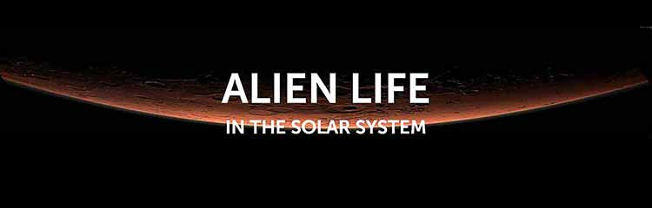

### [ Learn: [1](https://www.internetingishard.com/), [2](https://www.khanacademy.org/computing/computer-programming/html-css), [3](https://web.dev/learn/css/), [4](https://developers.google.com/web/fundamentals), [5](https://developer.mozilla.org/en-US/docs/Learn), [6](https://css-tricks.com/snippets/css/complete-guide-grid/)]

This exercise features challenges that include embedded fonts, captioned images, backgrounds, and a pullquote.

1. Recreate the page pictured below.
2. There is no need for PhotoShop: everything you see in the mockup has been produced with HTML, CSS, and the assets as supplied to you. You can use any other combination of applications you wish to achieve the final goal.
3. Create your CSS in a separate linked style sheet.
4. The page is set in [**Museo Sans**](https://exljbris.com/museosans.html) by Jos Buivenga.
5. You will have to convert the typeface into webfont formats and embed it on the page.
6. The result should be valid code. (Google Lighthouse).
7. Add appropriate microdata to the HTML.
8. Make the page responsive.
9. Add a print stylesheet.
10. Download [**the source files**](https://1drv.ms/u/s!AnLYPxKmUDfciLIZbuo008muPteRYw?e=UmXA49), which include the original essay in Microsoft Word format, a JPEG mockup of the final page, & the original images.

## Part B – Advanced Typography

1. All instructions are the same as Part A.
2. The illustration caption text (which reads “Chrysaora quinquecirrha, Patrice Stephens-Bourgeault”) is set in [**Jane Austen**](http://dafont.com/jane-austen.font).
3. The illustration of the [**Sea Nettle Jellyfish**](http://studiopatrice.com/scientific-illustrations/C_quinquecirrha_3.html).
4. The “Journal of Jellyfish Studies” and “May 2014” text is in [**Aspira by Durotype**](https://www.myfonts.com/fonts/durotype/aspira/demo/).
5. All other text is in [**Pesaro**](http://myfonts.com/fonts/hoftype/pesaro/) by Hoftype; again, you can download the Light version of the font from myFonts.Add a print stylesheet.
6. Resources [**HERE**](https://1drv.ms/u/s!AnLYPxKmUDfciLIVCf3ETLux59ETmw?e=VGts8d)

