For this assignment, I decided to run ZAP using Kali Linux via Oracle VirtualBox. Here are the vulnerabilities that I was able to find:

Without even utilizing zap, I found this vulnerability. Email addresses of those who leave reviews should not be displayed publicly.

And, it seems there should be more validation when it comes to review text. This looks like an attempt and a JavaScript injection.

The version of jquery is outdated, leaving it susceptible to known vulnerabilities.

I don’t fully understand ‘Clickjacking’, or ‘cross domain configuration’, but I found these vulnerabilities as well.

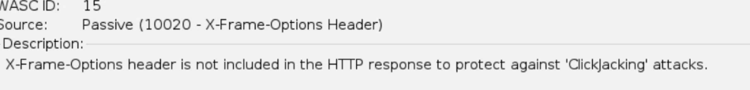

Merely how quickly ZAP was able to point out vulnerabilities was impressive, and somewhat terrifying.