# PHP Responsive application -

# Online course registration

**Redesigned and Implemented by – V. Vinoth Adaikalaraj**

Technology Stack

**HTML5 , CSS & Boostrap4.**

**AWS Cloud EC2 Services with Virtual Server.**

**PHP7 & MySQL 5.7**

**\*\*\* Compatible with both Desktop and Mobile**

Admin Home page

<http://ec2-52-66-199-191.ap-south-1.compute.amazonaws.com:3002/admin>

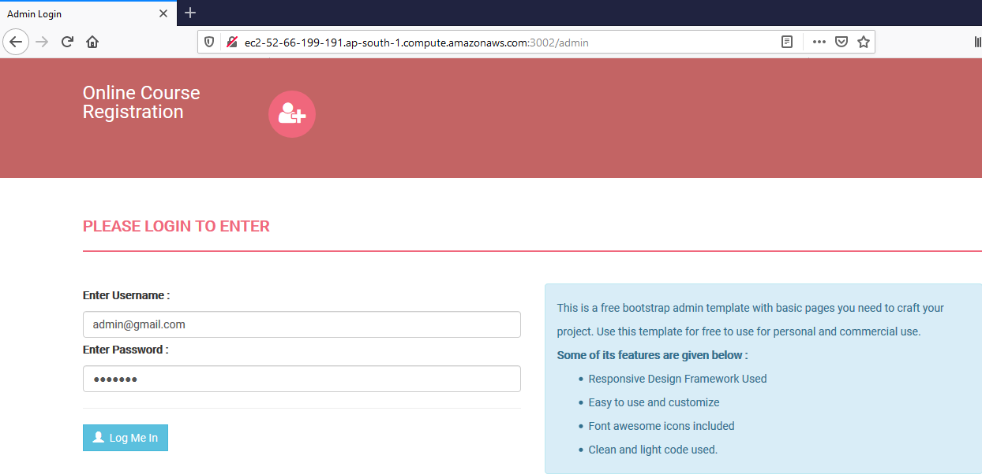

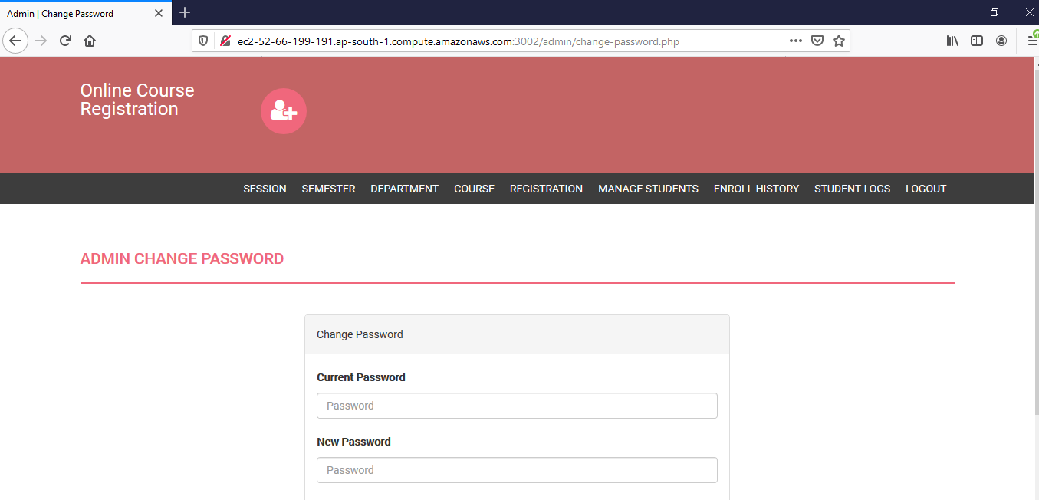

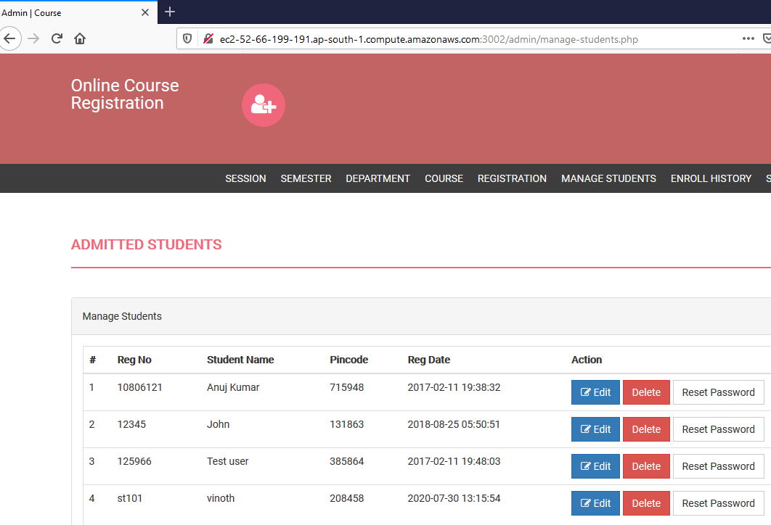

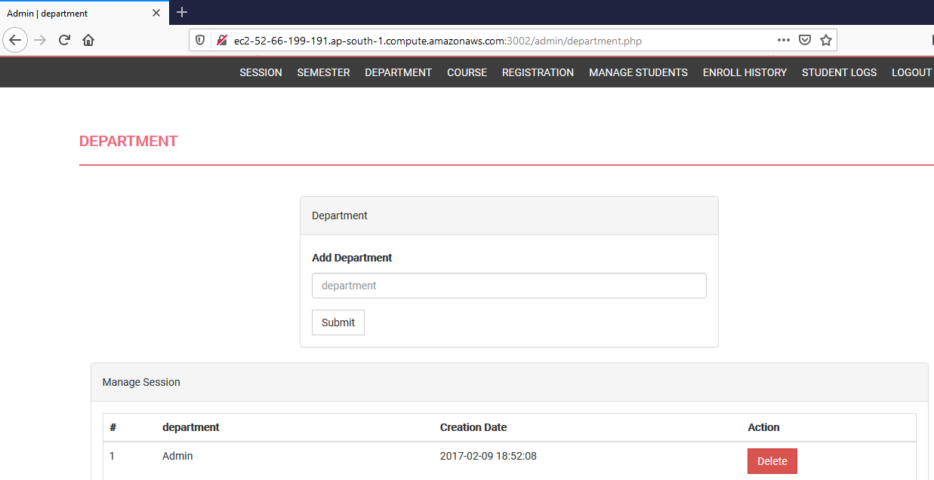

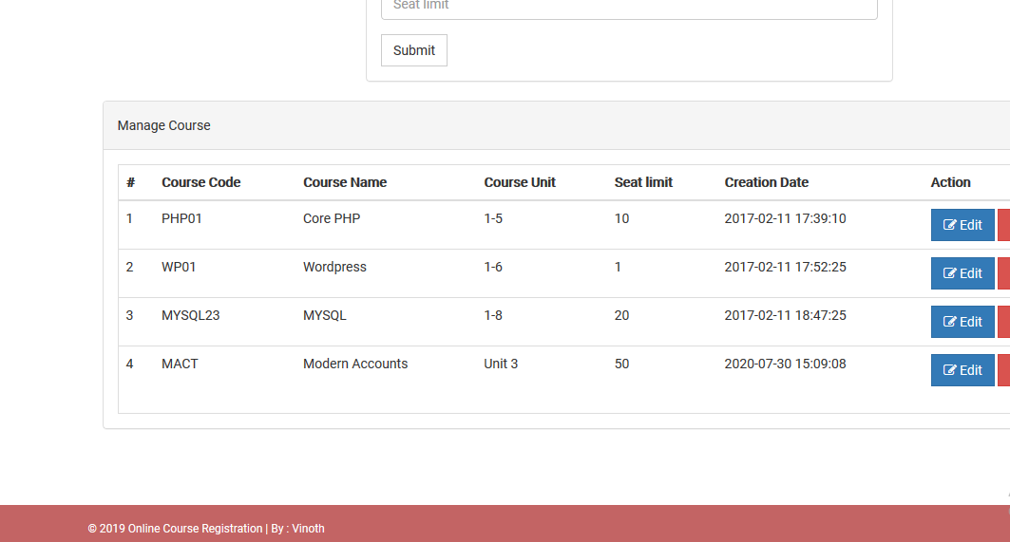

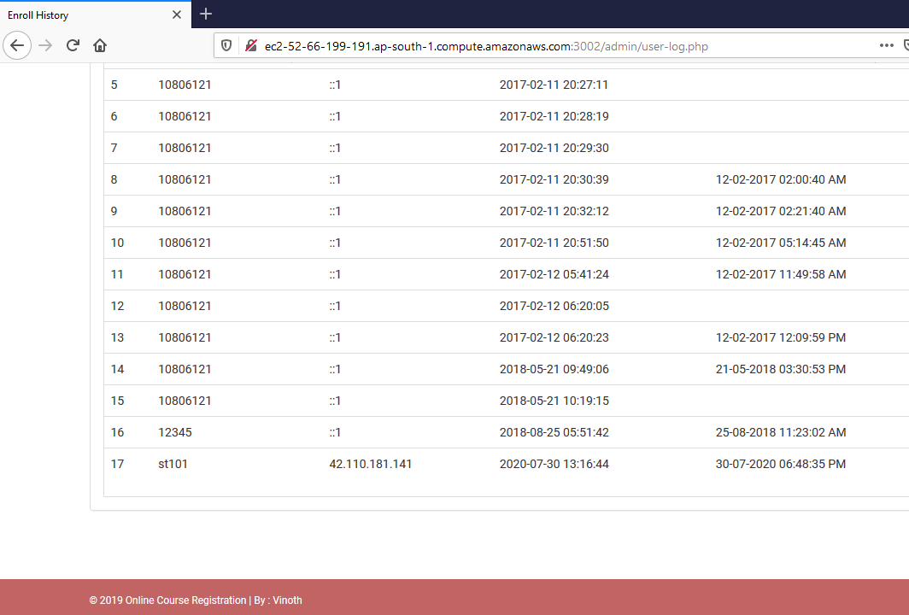

Student Login Page

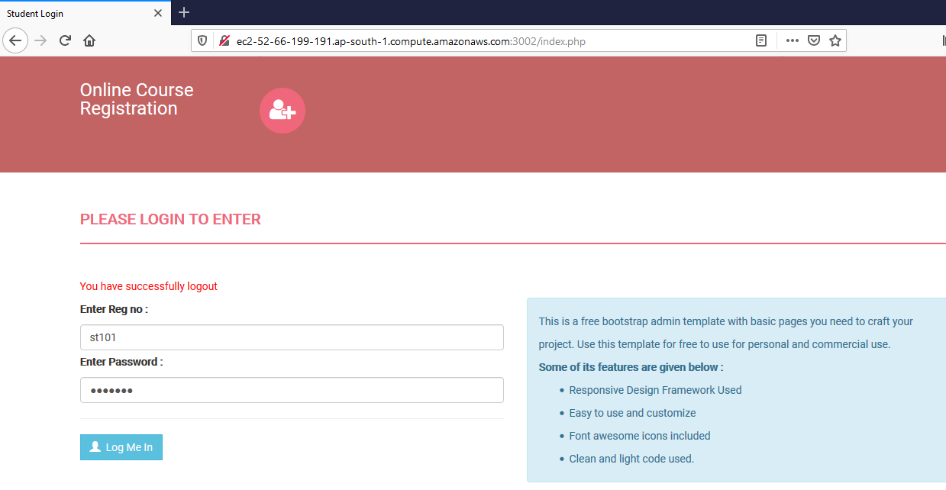

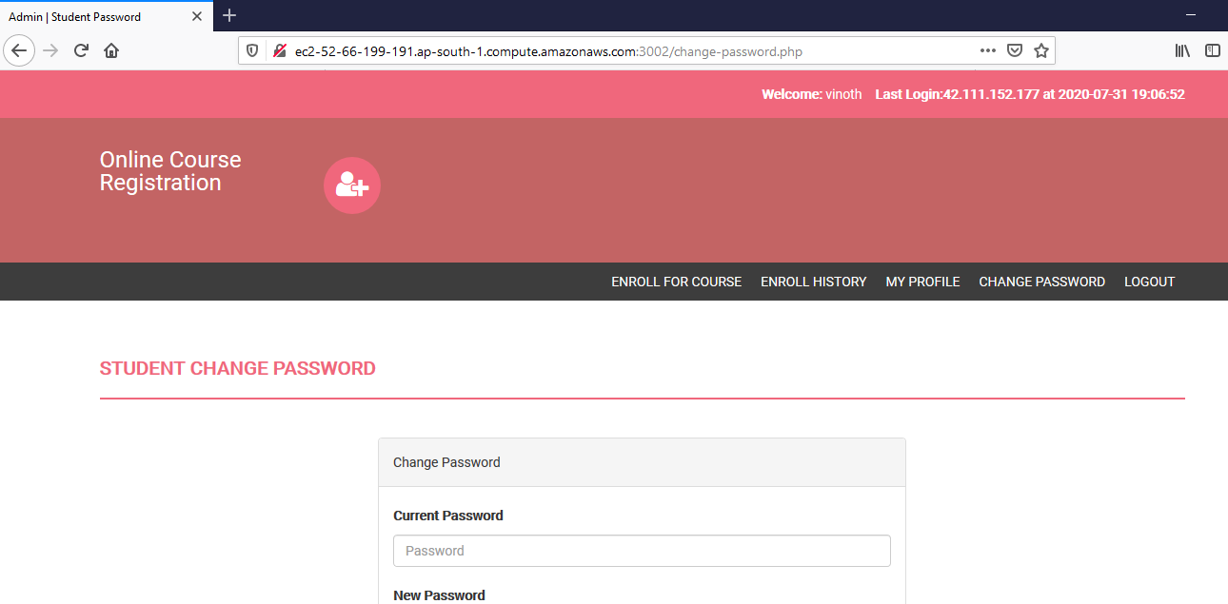

Getting Pin Number from Admin’s registration process

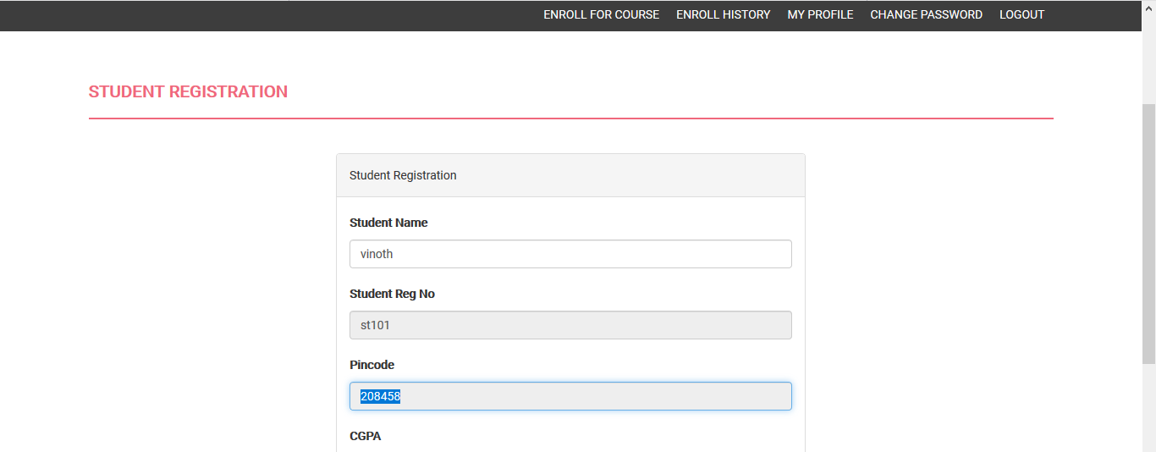

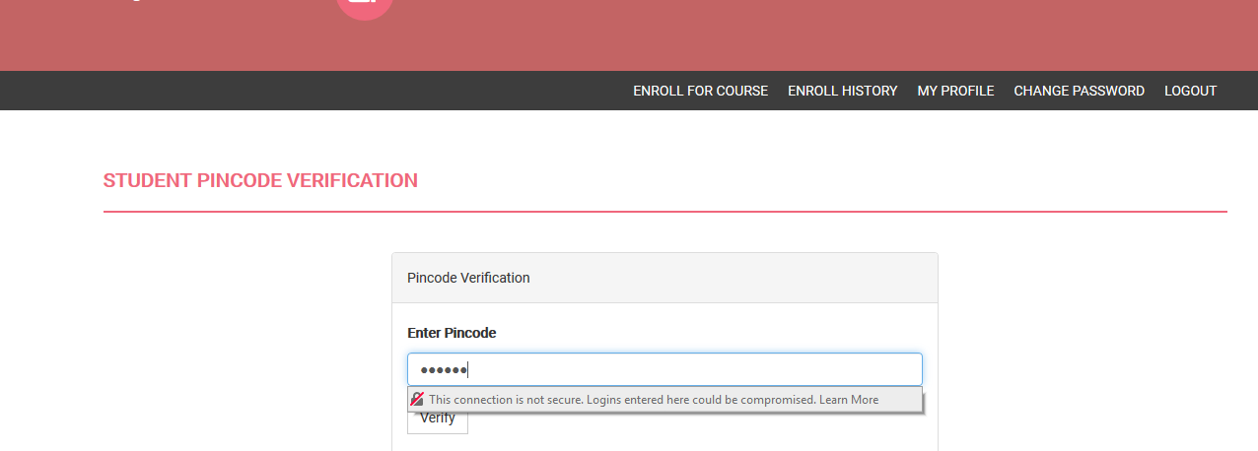

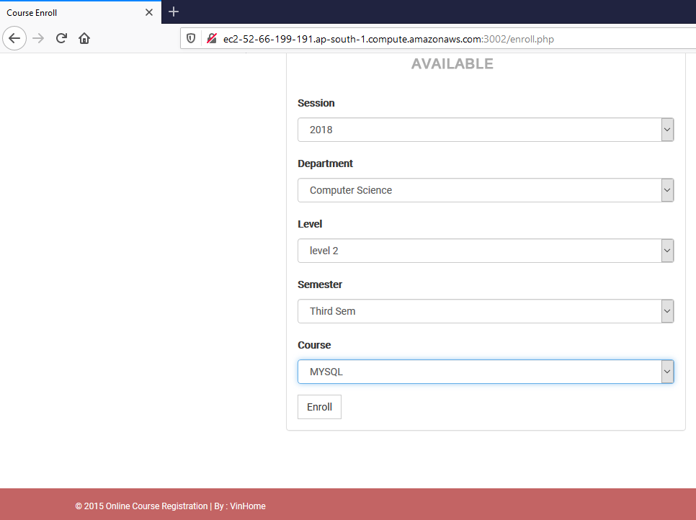

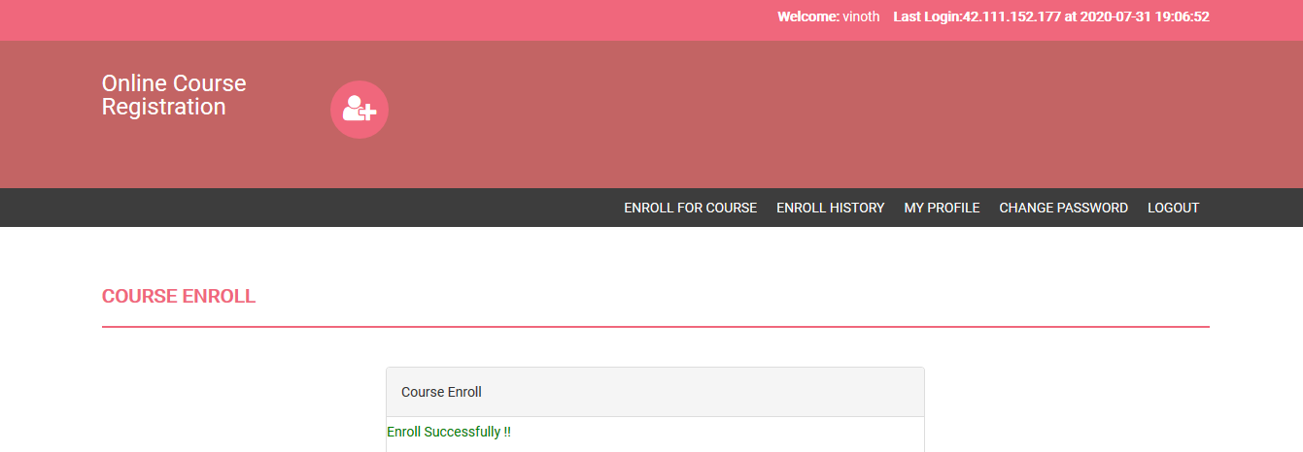

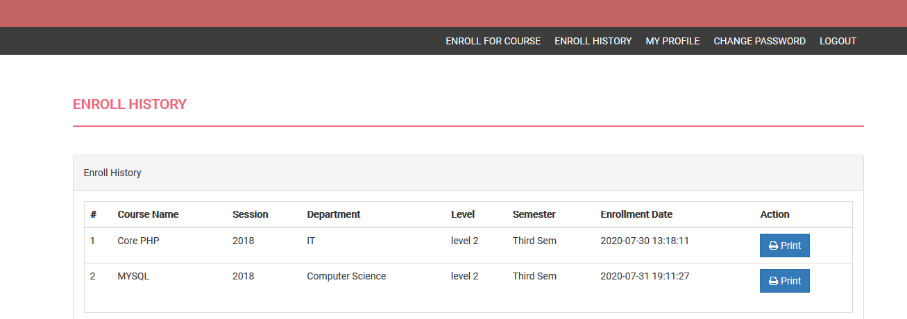

Database Storage

MySQL 5.7 with database tables as below:

