
User Manual
TestLink version 1.9

Version: 1.21
Status: Updated for TL 1.9.3

© 2004 - 2012 TestLink Community
Permission is granted to copy, distribute and/or modify this document under the terms of the GNU Free Documentation License, Version 1.2 published by the Free Software Foundation; with no Invariant Sections, no Front-Cover Texts, and no Back-Cover Texts. The license is available in "GNU Free Documentation License" homepage.
Revision History
# | Description | Date | Author
1.21 | Screen shots and accompanying text updated to release 1.9.3. Section 1.4 “User interface introduction” added. | 2012-08-26 | S. Poley
1.20 | Tidied up the English grammar and layout. A few sections clarified and several minor corrections. | 2012-03-18 | S. Poley
1.19 | Added new features “Direct Links”, “Internal Links for Requirements and Requirement Specifications”, “Requirement and Requirement Specification Search”, “Freeze Requirement”, “Requirement and Requirement Specification Type”, “Improved Filters for Test Execution”, “Comparison of Requirement and Test Case Versions”, “Improved Generation of Test Cases from Requirements” | 2010-03-05 | J. Krien
1,.8 | Removed Import/Export as this information is duplicated in external document | 2010-03-04 | M. Havlat
1.17 | Update for 1.9; Platforms; Inventory | 2010-01-08 | M. Havlat
1.16 | Minor updates according to User feedback. Final 1.8 version. | 2009-12-09 | M. Havlát

Table of Contents
1 General information 4
1.1 Overall structure 4
1.2 Basic Terminology 5
1.3 Example of TestLink simple work-flow 5
1.4 User interface introduction 7
2 Test Projects 10
2.1 Creating new Test Projects 10
2.2 Editing and deleting Test Projects 10
2.3 Inventory 11
3 Test Specifications 13
3.1 Test Suites 13
3.2 Test Cases 14
3.3 Keywords 17
3.4 Generating Test Specification document 18
4 Requirement-based testing 19
4.1 Availability 19
4.2 Requirements Specification Document 19
4.3 Requirements 21
4.4 Text Links between Requirements and Requirement Specification 23
5 Test Plans 25
5.1 Creating and deleting Test Plans 25
5.2 Builds 25
5.3 Test Set - adding Test Cases to Test Plan 26
5.4 Removing Test Cases from Test Plan 28
5.5 Text execution assignment 28
5.6 Platforms 30
5.7 Prioritising testing 34
5.8 Milestones 35
6 Test Execution 37
6.1 General 37
6.2 Navigation and settings 37
6.3 Executing tests 39
7 Test Reports and Metrics 41
7.1 Introduction 41
7.2 General Test Plan Metrics 42
7.3 Query Metrics 43
7.4 Blocked, Failed, and Not Run Test Case Reports 45
7.5 Test Report 45
7.6 Charts 45
7.7 Total Bugs For Each Test Case 46
7.8 Requirements based report 46
7.9 How to add a new report 46
8 Administration 47
8.1 User account settings 47
8.2 Role Permissions 47
8.3 Test Plan assignment to users 48
8.4 Custom Fields 48
9 Import and Export data 54

General information
TestLink is a web-based Test Management system, providing support for the specification, execution and monitoring of test activities.
This manual helps users to understand the processes, terms used and organisation of work with TestLink. See the Installation manual for more information about system requirements, installation steps and configuration. The latest documentation is available on www.teamst.org or testlink.sourceforge.net.
Please use our forum if you have questions that the manual doesn't answer: http://www.teamst.org/forum/
TestLink code is often updated faster than the documentation and so the description of some TestLink enhancements may be missing. If you find errors or omissions, please notify us via our tracker: http://mantis.testlink.org/

Overall structure
There are three corner-stones to TestLink: Test Project, Test Plan and User. All other data are relations or attributes of this base.
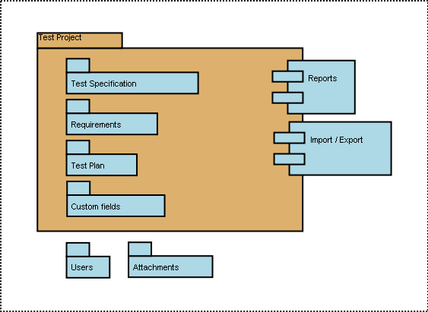Illustration 1: Test Project is the basic component in TestLink

Basic Terminology
First, we will define terms that are used throughout the documentation and the testing world.
Test Case: describes a testing task via steps (actions, scenario) and expected results. The Test Case is the fundamental element of TestLink.
Test Suite: (Test Case Suite) organises Test Cases into units. It subdivides a Test Specification into logical parts.
Test Suite replaces the components and categories in TL 1.6 and earlier.
Test Plan: is created when you wish to execute Test Cases. Test Plans are made up of the Test Cases from the current Test Project. A Test Plan includes Builds, Milestones, user assignment and Test Results.
Test Project: is something that will exist forever in TestLink. A Test Project undergoes many different versions throughout its lifetime. A Test Project includes Test Specifications with Test Cases, Requirements and Keywords. Users within the project have defined roles.
Test Project was called Product in TL 1.6 and earlier.
User: each TestLink user has a Role that defines available TestLink features. See more in chapter “User Administration”. Illustration 2 shows common activities according to user roles.

Example of TestLink simple work-flow
- Administrator creates a Test Project “Fast Food” and two users, Adam with rights “Leader” and Bela with rights “Senior Tester”.
- Leader Adam imports Software Requirements and for part of these requirements generates empty Test Cases. He reorganise them into two Test Suites: “Fish” and “Chips”.
- Tester Bela describes a test scenario (create a content of empty Test Cases) using these Test Specification that is organised into Test Suites.
- Adam creates keyword “Regression testing” and assigns this keyword to ten of these Test Cases.
- Adam creates a Test Plan “Fish & Chips 1”, Build “Fish 0.1” and links all Test Cases in Test Suite “Fish” to this Test Plan. He assigns himself and Bela as resources to this Test Plan too.
- Now developers produce a first build. Adam and Bela execute and record the testing with the result: 5 passed, 1 failed and 4 are blocked.
- Developers make a new Build “Fish 0.2” and Bela tests the failed and blocked Test Cases only. This time these all blocked and failed Test Cases passed. They retest also all Test Cases with keywords “Regression testing” in addition.
- A manager of this team would like to see the results. Administrator explains to him that he can create an account himself on the login page. Manager does it. He has default “Guest” rights and can see Test Results and Test Cases. He can see that everything passed in the overall report ;-) and problems in Build “Fish 0.1” in a report for that particular Build.
- Later, developers finally add also “Chips” functionality. Adam creates a Test Plan “Fish & Chips 2”. He can reuse the first Test Plan as template. All “Fish” Test Cases and roles will be automatically added. He create a new Build “Fish 1.1” and links all “Chips” Test Cases to this Test Plan too.
- Now testing starts as usual.
- Later, Admin creates a new Test Project for another product “Hot Dog”. But this is another test team and a different story.
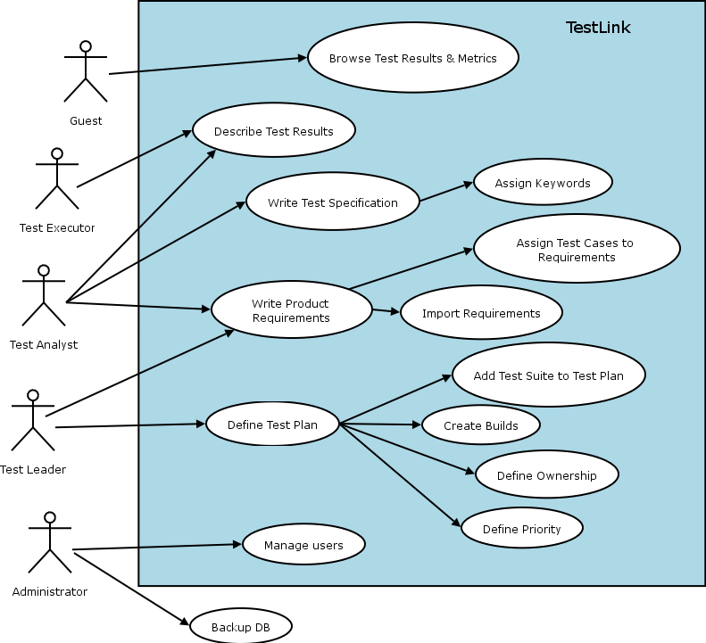Illustration 2: Functionality overview

User interface introduction

Main page
This is the TestLink main page, shown after logging in. Most actions are initiated from here. You can return to this page at any time using the “Project” link in the top menu bar.
The exact operations available depend on the rights of the logged-in user: this is a page of a test leader, who can carry out most operations.
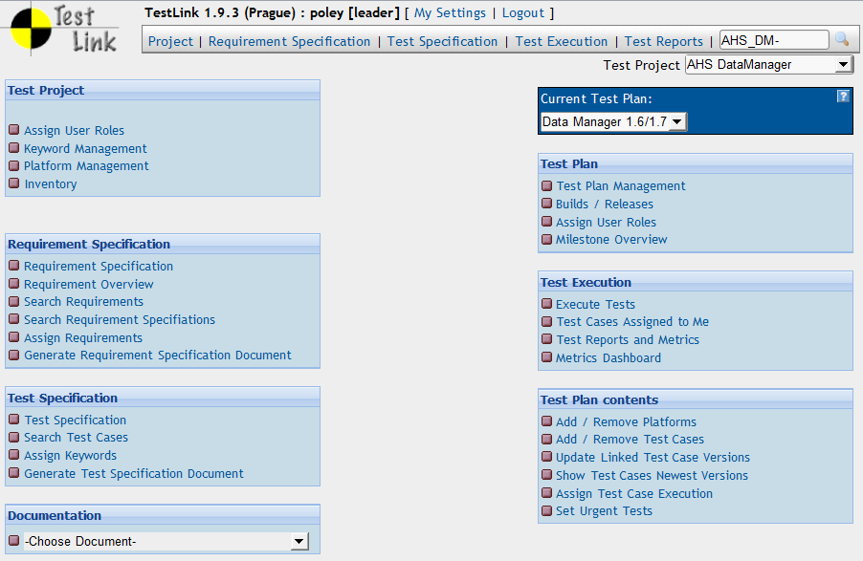

Graphical Interface
The main elements of the graphical user interface should be easily recognisable to most users. Black text is static, while links are indicated in dark blue.
Aspects which may perhaps not be immediately obvious to everyone are as follows.
A two-tone blue panel with downward-pointing triangle indicates a collapsed panel. Click on it to expand the panel.

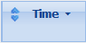
A double-arrow indicates a sortable column heading: click on it to sort in ascending order.
A small downward triangle then appears to indicate that clicking on it again sorts in descending order.

Short-cuts
TestLink has short-cuts to speed up a navigation. Use ALT (+ shift) + key. The globally available short-cuts are:
- [h] Home
- [s] Test Specification
- [e] Test execution
- [r] Reports
- [i] Personal
- [q] Logout/quit
- [u] Administration (admin only)
Create Test Case short-cut [t] is available in View Test Suite page.
Browser support: The accesskey attribute is currently supported by the following web browsers:
- Firefox
- Internet Explorer 4+ (Windows) 5+ (Mac)
- Mozilla (Windows + Linux)
- Opera 7+ (Windows + Linux)

FCKeditor short-cuts
The following short-cuts are supported in edit text mode:

Short-cut | Action
Ctrl + A | Select All
Ctrl + C, Ctrl + Ins | Copy to clipboard
Ctrl + V, Shift + Ins | Paste from clipboard
Ctrl + X, Shift + Del | Cut
Ctrl + Z | Undo
Ctrl + Y | Redo
Ctrl + K | Insert Link
Ctrl + W | Insert Link without pop-up of the dialogue
Ctrl + B | Bold
Ctrl + I | Italic
Ctrl + U | Underline
Ctrl + Shift + S | Save
Ctrl + Alt + Enter | Fit Window
Ctrl + L | Justify Left
Ctrl + R | Justify Right
Ctrl + E | Justify Centre
Ctrl + J | Justify Block
Ctrl + [1-5] | Header 1-5 Format
Ctrl + 0, Ctrl + N | Paragraph Format
Ctrl + Shift + L | Toggles between Bulleted List, Numbered List and Paragraph
Tab, Shift + Tab | Increases and Decreases (with Shift) Indent. If cursor is inside the text and FCKConfig.DekiTabSpaces > 0, inserts the spaces. Inside the tables cursor jumps to the next/previous cell or inserts the new line if there is no next cell. If cursor is in title or header, jump to the next paragraph.
Shift + Space | Non-break space (&nbsp;)

Test Projects
Test Projects are the basic organisational unit of TestLink. Test Projects could be products or solutions of your company that may change their features and functionality over time but for the most part remain the same. A Test Project includes requirements documentation, Test Specification, Test Plans and specific user rights.
Test Projects are independent and do not share data. Consider using just one Test Project for one product.
For example: there are two test teams for one product: system testing and integration testing. These teams share some test cases. You should create one project for the product. The work of the teams will be structured in two or more trees in the Test Specification and testing results will be collected in different Test Plans.

Creating new Test Projects
Creating a new Test Project requires "admin" rights. Select the “Test Project Management” link on the main page and press the “Create” button.
Each Test Project must have a unique name. There is a text area to characterise the object of project. There are several features that are enabled/disabled on Test Project level:
- Admin can enable requirements related functionality.
- Background colours can be assigned to Test Project templates to visually distinguish them.
Note: This feature is only available if enabled in the configuration file.
- Test prioritisation could be enabled to select an appropriate testing set when there is limited time.
- Test automation support could be enabled as well.
Things to note when creating a new Test Project:
- Test Plans represent the testing of a Test Project at a certain point in time. Consequently, Test Plans are created from Test Project Test Cases. We do not recommend creating separate Test Projects for versions of one Product.
- TestLink supports importing XML or CSV data into a Test Project. This is explained further in the Import section, below.

Editing and deleting Test Projects
Editing Test Projects requires "admin" rights. One can change the Test Project name, background colour and availability of requirements functionality, test prioritisation and test automation.
User can inactivate the Test Project if it is obsolete. This means that the Test Project is no longer visible in the list within the top navigation bar.
Admin will see this Test Project marked by '*' in the list.
One can also delete a Test Project. This action also deletes all related data from database. This action is not reversible. Deleting Test Projects from the system is not normally recommended as this either orphans Test Cases or deletes the Test Cases from the system: use inactivate instead. Deletion is intended for when a Test Project was created mistakenly and little or no information has yet been entered for it.

Inventory
Users can list their hardware in a table per project. The feature should be enabled on the “Edit Project” page. Leaders can edit this page by default and testers can browse it only. The Inventory link is available on the Main Project page in the “Test Project” menu.
The Inventory page offers three actions: create, update and delete.
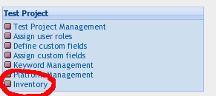Illustration 3: Navigation to Inventory
The table shows all devices and allows sorting on any field.
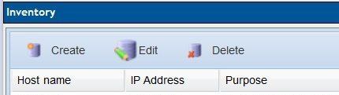Illustration 4: Actions on Inventory table
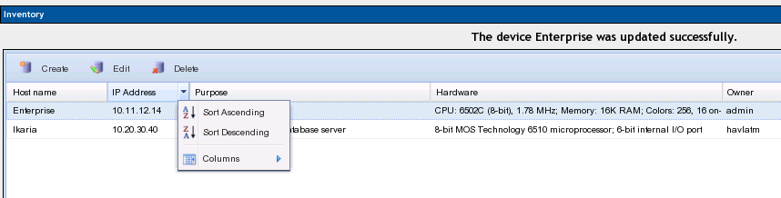Illustration 5: Inventory table with sorting
Select the “Create” button to define a device. The following parameters are supported:
- Host name (unique mandatory value)
- IP address
- Purpose (simple text with maximally 2000 characters)
- Hardware (simple text with maximally 2000 characters)
- Notes (simple text with maximally 2000 characters)
- Owner (optional) could be anybody who has at least view ability
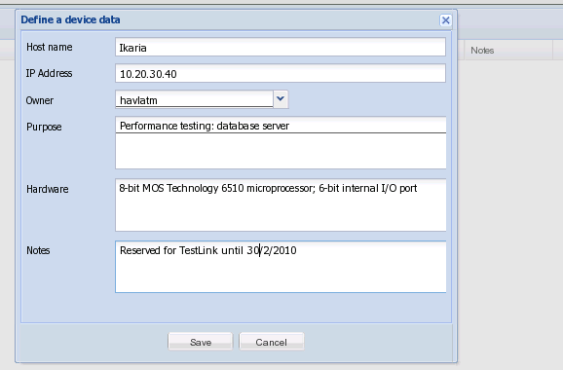Illustration 6: Create a new device into Inventory table
Update and delete action requires a selected row.

Test Specifications
TestLink breaks down the Test Specification structure into Test Suites and Test Cases. These levels are persisted throughout the application. A Test Project has just one Test Specification.
Future consideration: we plan to implement the following abilities: Test patterns, review process and status of Test Cases, variable Test Case structure (for example step by step design).

Test Suites
Users organise Test Cases into Test (Case) Suites. Each Test Suite consists of a title, a formatted description, Test Cases and possibly other Test Suites. TestLink uses a tree structure for Test Suites.
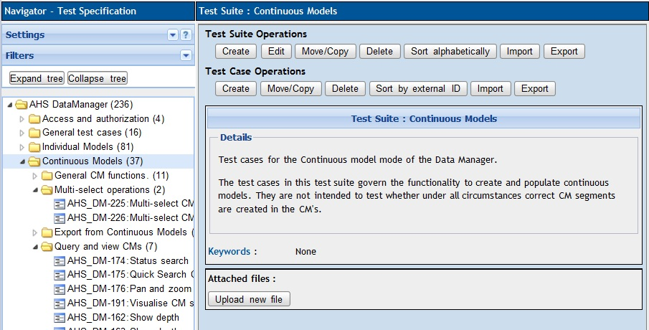Illustration 7: Test Specification is structured by Test Suites
The Details section would typically hold a summary of the purpose and context of the Test Suite including, for example: scope of included tests, default configuration, preconditions, links to related documentation, list of tools, infrastructure overview, etc.
Creating one or more Test Suites is one of the first steps when creating your Test Project. Users (with edit right) can create, delete, copy, move, export and import both nested Test Suites and Test Cases. The title and description can be modified too.
You can reorder both Test cases and child Test Suites via by dragging and dropping items in the navigation tree.
Recommended practice: Consider the structure of your test specification carefully at the beginning. You could divide tests by functional/non functional testing, particular features, components. You can change the structure later – moving Test Suites without loss of any information – but it is easier if you get the basic structure correct at the beginning.
Recommended practice: Later versions of your product could have some features removed. You can create a special Test suite 'Obsolete' or 'Your product 0.1' and move test cases there. Deleting Test Cases causes the corresponding test results to be deleted too, and can usually better be avoided.
Attachments with external documents or pictures could be added into particular Test Suites.
Note: The functionality must be enabled via TestLink configuration.
More information about import and export is in section 9.
FAQ: Could I copy/move Test suites between projects?
You cannot directly in this version. We designed Test projects to be fully independent each from other. Use import/export.

Test Cases
A Test Case is a set of inputs, execution preconditions, and expected results (outcomes) developed for a particular objective, such as to exercise a particular program path or to verify compliance with a specific requirement.
Test Cases have the following parts:
- Identifier of a Test Case is assigned automatically by TestLink, and can not be changed by users. This ID is composed of the Test Project prefix and a counter related to the Test Project in which the Test Case is created.
- Title: could include either short description or abbreviation (e.g. TL-USER-LOGIN)
- Summary: should be really short; just for overview, introduction and references.
- Steps: describe test scenario (input actions); can also include precondition and clean-up information here.
FAQ: Our test steps are pretty detailed and use a lot of formatting coming from Word.
Use "Paste from msword" feature of FCKeditor. It cleans garbage. (Configure toolbar if not available.)
- Expected results: describe checkpoints and expected behaviour of a tested product or system.
- Attachments: could be added if configuration allows it.
- Importance: Test designer could set importance of the test [HIGH, MEDIUM or LOW]. The value is used to compute the priority in the Test Plan.
- Execution type: Test designer could set automation support of the test [MANUAL/AUTOMATED].⁶
- Custom fields: Administrator can define own parameters to enhance Test Case description or categorisation. See section 8.4 for more information.
Large custom fields (more than 250 characters) are not possible. But information could be added to the parent Test Suite and referred to via custom fields. For example you can describe Configuration 'standard', 'performance', 'standard_2' and refer via CF to these labels.
Note: There is a planned development to make the Test Case structure more flexible in future.

Test Case - Active Attribute
Versions of a Test Case can be marked as Active or Inactive, as follows:
- Every Test Case version is created Active.
- An Inactive Test Case Version is not available in "Add Test Cases to Test Plan". This can be useful for Test Designers. They can edit or change the Test Case Version and only when he/she decides it is completed, change Status to ACTIVE.
- Once a Test Case Version has been linked to a Test Plan, and has results, it can't be made Inactive.

Spell checker
You can use the spell-checker in your web browser. For example Firefox has an add-on “British English Dictionary”, and a number of dictionaries for other languages.
FCKeditor supports its own solution. See their Developers Guide for more.
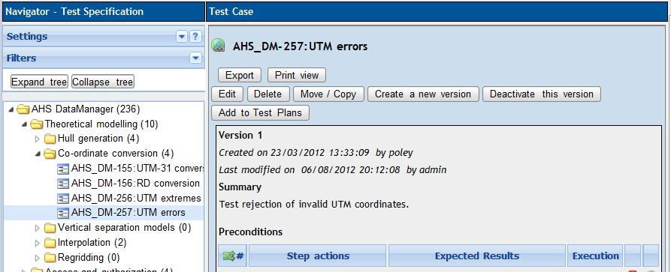
Illustration 8: Test Case specification

Removing Test Cases
Test Cases and Test Suites may be removed from a Test Plan by users with “lead” permissions. This operation may be useful when first creating a Test Plan since there are no results. However, removing Test Cases will cause the loss of all results associated with them. Therefore, extreme caution is recommended when using this functionality.

Requirements relation
Test Cases can be related to the software/system requirements as n to n. The “requirements” functionality must be enabled for a Test Project. Users can assign Test Cases and Requirements via the “Assign Requirements” link in the main screen.

Test Plan relation
Test Cases can be assigned to particular Test Plans for execution. The Test Leader uses “Add / Remove Test Cases” in the main page to select the appropriate Test set. The related Test Plans are listed on the View Test Case page under title “Test Plan usage”. See the screenshot below.
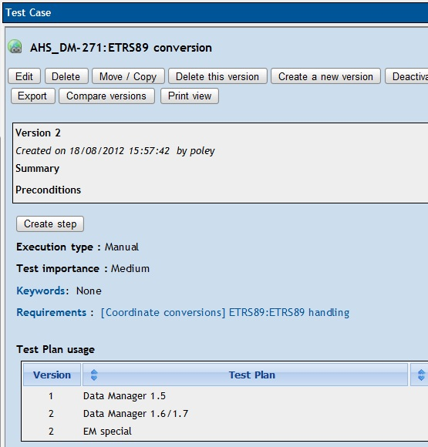
Illustration 9: Related Test Plans are listed on the "View Test Case" page

Search Test cases
Select the link “Search Test Cases” in the main page (section: Test Specification). The user can use the following items to compose the required query:
- Test case identifier
- Version of Test case
- Keyword in title
- Keyword in Summary, Steps and/or Expected results (Warning: this search simply parse texts including HTML tags. For example keyword “hello word” doesn't find a text “<p>hello <b> word</b></p>”).
- Assigned keyword.
- Assigned requirement ID.
The resulting list includes for each Test case: related parental Test Suite(s) and a link to a Test case page.

Comparison of Test Case Versions
If more than one version of a Test Case exists, it is possible to compare versions by their content (Summary, Preconditions, Steps, Expected Results). Click the “Compare versions” button. The next page allows selection of the versions to be compared and the context (in lines) that will be shown next to the changes.

Direct Link to Test Cases
By clicking the “Show/Hide Direct Link” Button TestLink automatically generates a link to the currently shown Test Case. You can use this link outside of TestLink to directly open this test case including the surrounding frame structure.
Notes:
- The user using the link to the Test Case needs appropriate rights to view the Test Case otherwise the user will be redirected to the main page.
- The user needs to be logged in to TestLink otherwise he will be redirected to the login page.
- If the Test Case does not exist an error-message is shown.
- You can manually extend the link if you want to jump to an anchor defined in the Test Case by adding “&anchor=<anchorname>”.

Keywords
Keywords were created to give users another level of depth when categorising Test Cases. Keywords are ideal for filtering. Keywords serve as a means of grouping Test Cases with some attribute within a Test Specification. For example, you can use it to define:
- Regression set (or Sanity for ability to filter mandatory tests)
- Reviewed Test Cases (to indicate formal status)
- Solaris (set of Test Cases valid for one platform)
- Change request 12345 (related to new features in specific release)
- Your_product 3.2.1 (related to certain version of product)
Note: You could use also Custom Fields if you need something more sophisticated.

Create a Keyword
Keywords can only be created by users with the mgt_modify_key rights. These rights are currently held by role Leader. Once a keyword or grouping of keywords has been created users may assign them to Test Cases.
Each project has own set of keywords.

Assigning Keywords
Keywords may be assigned to Test Cases either from the assign keyword screen (in batch) or via Test Case management (individually).

Filter by Keyword
Users have the ability to filter by Keywords in:
- navigation tree of Test specification;
- Search Test Cases in Test Specification;
- Add Test Cases in a Testing Set (Test Plan);
- “Execute test” page.
Some reports also give results with respect to keywords.

Generating Test Specification document
Users can generate the current Test Specification as a document. Use the link from the main page. There are structural options and the option to select a required Test Suite or get all content.
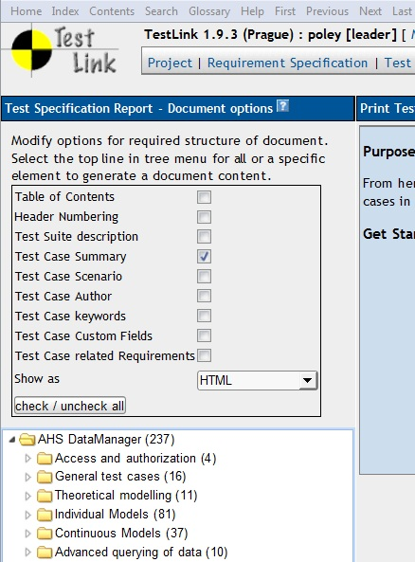
Illustration 10: Options for generated Test Specification
The user can choose:
- the desired optional content (Test Suite description, Test Case scenario etc);
- the document format (HTML, OpenOffice text document or Microsoft Word document).

Requirement-based testing
To prove that a system is built as specified, testers use requirement-based testing. For every requirement, they design one or more Test Cases. At the end of the test execution a test manager reports on the tests that have been executed and the requirements that are covered. Based on this information the client and the various stakeholders decide whether a system can be transferred to the next test phase or can go live. Test managers use a combination of risk and requirement-based testing to ensure that a system is built as specified from the customer's and stakeholders' perspective. As a result, this complete testing delivers the following advantages:
- Linking risks and requirements will reveal vague or missing requirements. This is especially interesting for risks with a high priority.
- Testing can be focused on the most important parts of an information system first: covering the risks with the highest priority.
- Communicating in the same language as the client and the stakeholders. This makes it easier to report on the status of the Test Project. Then a better founded decision can be made whether to invest more in testing or take the risk.
- The risks and their priority make negotiating on the Test Project in times of pressure easier. What risks have to be covered within this Test Project and which ones can be postponed. Risk and requirement-based testing results in a better controlled Test Project. The communication with the client and the stakeholders is improved. The test manager begins testing with risks of the highest priority. The process is streamlined and the end result is higher quality.

Availability
The functionality is available at the Test Project level. i.e. the Administrator should enable it for a specified Test Project (Edit Test Project link in Main window). Otherwise links are not shown.
There are two user levels for this feature. Most roles can view requirements, but not modify them. Refer to User section for more details.

Requirements Specification Document
Requirements are grouped in one or more System/Software/User Requirement Specifications.
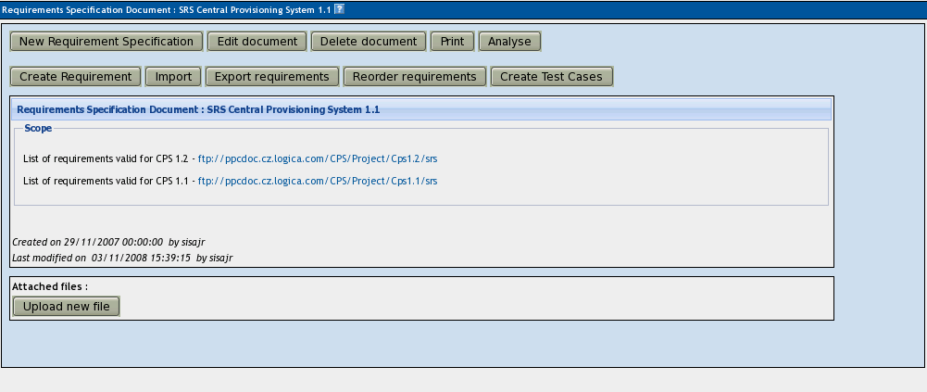Illustration 11: Manage a Requirements Specification
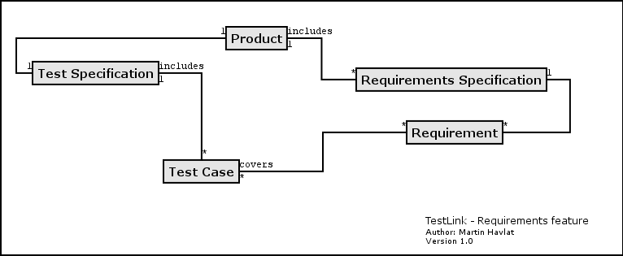Illustration 12: Dependencies between requirement related objects
Create a document with Requirements:
- Click Requirements Specification in Main window. The list of Requirement Specifications is shown.
- Press Create button to create a document.
- Adjust Req. Spec. ID, Title, Scope and Type.
- Press Create button to add data to database. You can see the title of your newly created document in the list of Requirement Specifications.
- Click the title of document for next work. The Requirement Specification window is shown.
Each Requirement Specification has its own statistics and report related to included data.
All Specifications can be printed using the "Print" button in the "Requirement Specification" window. The Administrator can define company, copyright and confidentiality text via configuration files.
Warning: TestLink 1.8 brings support of n-depth tree structure for requirements (this should be enabled by configuration). However some related features (for example import/export, document generation) aren't compliant with this yet. These features behave as if only direct child requirements exist and all inner sub folders are ignored.

Search Requirement Specifications
On the Main Page you can find a link leading to the requirement search called “Search Requirement Specification”. The search offers you the possibility to search requirements by:
- Req Spec Doc. ID
- Title
- Scope
- Type
- Custom Field + Custom Field Value (if defined for Requirement Specifications within the project)

Direct Link to Requirement Specifications
By clicking the “Show/Hide Direct Link” Button TestLink automatically generates a link to the currently shown requirement specification. You can use this link outside of TestLink to directly open this requirement specification including the surrounding frame structure.
Notes:
- The user who wants to use the link to the requirement specification needs appropriate rights to view the requirement specification otherwise the user will be redirected to the main page.
- The user needs to be logged in to TestLink otherwise he will be redirected to the login page.
- If requirement specification does not exist an error-message is shown.
- You can manually extend the link if you want to jump to an anchor defined in the requirement specification by adding “&anchor=<anchorname>”.

Requirements
Each requirement has Requirement (doc) Identifier, Title, Scope (html format), Status and Type. Optional parameter “Expected test coverage” specifies the number of test cases needed (this value specifies how many test cases will be needed to cover this requirement).
Document ID must be unique within the project and has max. 64 characters. Scope parameter is text in HTML format.
Status can have the values VALID or NOT_TESTABLE. A NOT_TESTABLE requirement is not counted in metrics.
The following requirement types are available by default:
- Functional
- Non functional
- Use-case
- Informational (behaves as not-testable)
- Constrain
Requirements could be created/modified or deleted manually via TestLink interface or imported as XML file.

Import requirements
TestLink supports two types of CSV. The first 'simple' is composed from title and scope in each row. The second 'Export from Doors' tries to detect the header and choose the correct fields. Import compares titles and tries to resolve conflicts. There are three ways to do this: update, create requirements with same title and skip adding the conflicted ones.

Requirements to Test Case relation
Test Cases are related to software/system requirements as N to N. I.e. you can assign one or more Test Cases to one Requirement and one or more requirements could be covered by one Test Case. The User can assign Requirements to Test Cases via the Assign Requirements link in the Main window.
The coverage of the Test Specification could be viewed via pressing the Analyse button in the Requirement Specification window.

Requirement based Report
The Requirements-based Report (in the Test Reports menu) gives the test status for each requirement. For each requirement in the current Requirement Specification and Test Plan, the linked Test Cases are analysed and the worst test result reported. The order of results from worst to best is: Failed, Blocked, Not Run and Passed. If there are no linked Test Cases then the requirement is reported as 'Not Covered'.
Example of requirement coverage
A requirement is covered by three Test Cases. Two of them are included in the current Test Plan. One passed and one was not tested for the Build 1. Now the Requirement has an overall result of Not Run. The Second Test Case was tested with Build 2 and passed. So Requirement passed too.

Freeze Requirements
To avoid changes to requirements that should not be changed any more, it is possible to freeze these requirements. If a requirement has been frozen you have to create a new version in order to edit it.

Search Requirements
On Main Page is a “Search Requirements” link. You can search requirements by:
- Req Doc. ID
- Version
- Title
- Scope
- Status
- Type
- Expected no. of test cases
- Test Case ID
- Custom fields (if defined for requirements within the project)

Comparison of Requirement Versions
If more than one version of a requirement exists it is possible to compare versions by their content (scope). Click the “Compare versions” button. The next page allows selection of the versions to be compared and the context (in lines) that will be shown next to the changes.

Direct Link to Requirements
By clicking the “Show/Hide Direct Link” Button TestLink automatically generates a link to the currently shown requirement. You can use this link outside of TestLink to directly open this requirement including the surrounding frame structure.
Notes:
- The user who wants to use the link to the requirement needs appropriate rights to view the requirement otherwise the user will be redirected to the main page.
- The user needs to be logged in to TestLink otherwise he will be redirected to the login page.
- If requirement does not exist an error-message is shown.
- You can manually extend the link if you want to jump to an anchor defined in the requirement by adding “&anchor=<anchorname>”.

Generation of Test Cases from Requirements
In order to generate test cases from requirements, open the Requirement Specification Document that contains the requirement you want to generate test cases for and click the “Create Test Cases” Button.
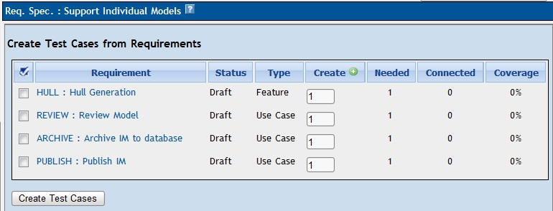
Illustration 13: Test Case Generation from Requirements
Select those Requirements you want to create test cases for, specify the number of test cases you want to create for each requirement by considering the value “Needed” that shows the number of test cases needed to fully cover this requirement. Then click on “Create Test Cases”.
TestLink now automatically generates all necessary Test Suites and empty Test Cases (i.e. without steps) and creates the same structure in the test case tree as it is on requirement tree. The Test Suites are marked as automatically generated. TestLink also shows the current coverage of the requirements.

Text Links between Requirements and Requirement Specification
In order to create Links between requirements and/or requirement specifications a special syntax was introduced that allows one to specify links while editing the scope of the requirement/ requirement specification.

Create Links to requirements/ requirement specifications within the same project
Simply type...
- [req]<ReqDocID*>[/req]
- [req_spec]<ReqSpecDocID*>[/req_spec]
and then save to create a link to a requirement or a requirement specification.
Example: [req]MyDocID[/req]

Create Links to requirements/ requirement specifications in a different project
Simply type...
- [req tproj=<TestProjectPrefix>]<ReqDocID*>[/req]
- [req_spec tproj=<TestProjectPrefix>]<ReqSpecDocID*>[/req_spec]
and then save to create a link to a requirement or a requirement specification.
Example: [req tproj=other]MyDocID[/req]

Using Anchors in Links
You can also specify an anchor that was set in the document you want to create a link to. To do so you simply add “anchor=<anchorName>” to the tag.
Example: [req anchor=myAnchor]DocumentWithAnchor[/req]

Test Plans
“A record of the test planning process detailing the degree of tester involvement, the test environment, the Test Case design techniques and test measurement techniques to be used, and the rationale for their choice.”

Test Plans are the basis for test execution activity. A Test Plan contains name, description, collection of chosen Test Cases, Builds, Test Results, milestones, tester assignment and priority definition. Each Test Plan is related to the current Test Project.

Creating and deleting Test Plans
Test Plans may be created from the “Test Plan management” page by users with lead privileges for the current Test Project. Press the “Create” button and enter data.
A Test Plan definition consists of title, description (html format) and status “Active” check-box. The description should include the following information with respect to company processes:
- Summary/Scope
- Features to be tested
- Features to not be tested
- Test criteria (to pass tested product)
- Test environment, Infrastructure
- Test tools
- Risks
- References (Product plan or Change request, Quality document(s), etc.)
Test Plans are made up of Test Cases imported from a Test Specification at a specific point of time. Test Plans may be created from other Test Plans. This allows users to create Test Plans from Test Cases that exist at a desired point in time. This may be necessary when creating a Test Plan for a patch. In order for a user to see a Test Plan they must have the proper rights. Rights may be assigned (by leads) in the define User/Project Rights section. This is an important thing to remember when users tell you they can't see the project they are working on.
Test Plans may be deleted by users with lead privileges. Deleting Test Plans permanently deletes both the Test Plan and all of its corresponding data, including Test Cases (not in Test Specification), results, etc. This should be reserved only for special cases. Alternatively, Test Plans may be deactivated on the same page, which suppresses display on selection menus in the “main” and “Execute” pages.

Builds
A user with lead privileges could follow the link “Build management” in the main page.
A Build is a specific release of software. Each project in a company is most likely made up of many different Builds. In TestLink, execution is based on Builds and Test Cases. If there are no Builds created for a project the execution screen will not allow you to execute. The metrics screen will also be completely blank.
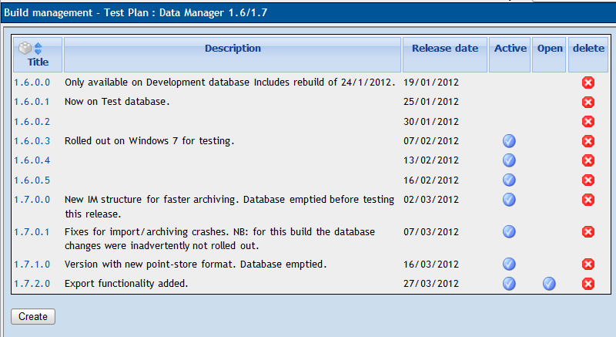Illustration 14: Build management
Each Build is identified via title. It includes description (html format) and two states:
- Active / Inactive – defines whether the Build is available for TestLink functionality. An Inactive Build is not listed in either the execution or reports pages.
- Opened / Closed – defines if Test Results can be modified for the Build.
Builds can be edited (via link under a Build title) and deleted (by clicking the appropriate “bin” icon) in the table of existing Builds.

Test Set - adding Test Cases to Test Plan
Test Plan content is defined by adding a Testing set (of Test Cases) from the Test Specification. Use a link “Add / Remove Test Cases” on the Home page. Test Specification data can be filtered by keywords (adjusted in the navigation pane). Once data has been linked into a Test Plan it is marked with a check-mark.
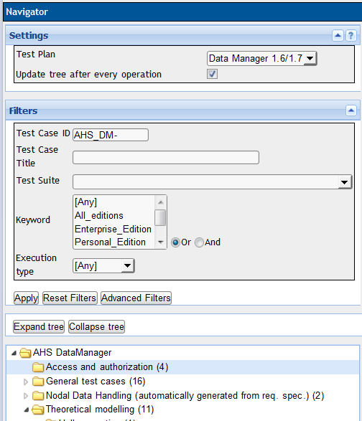
Illustration 15: Test Case navigation: Select an appropriate Test Suite
One can choose Test cases via the check-box and hit the “Add selected” button to define the Test Set. Click on the 'check' icon to select all Test Cases in each Test Suite. All Test Cases could be added by clicking on the label under the Test Suite title.
A certain version of a Test Case is assigned to a Test Plan. One could update version for later testing if the Test Case is updated. The content of an executed Test Case version can not be modified.
Note: a Test Plan has just one set of Test Cases. One can add new Test Cases during testing, but this affects the metrics of older builds, as the new Test Cases count as "not run" for those builds. In most cases this is not important. If however this is important to you, you have two options:
- Create a new Test Plan for the second round of testing.
- Use Keywords to recognise phases of testing within one Test Plan.
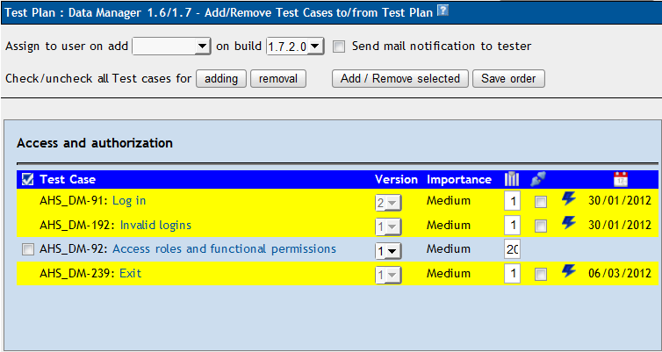
Illustration 16: Frame for Adding Test Cases into Test Plan
User can reorder Test cases within a Test Set. This modification has no influence on the Test Specification. Modify numbers in column “Execution order” and push “Save order” button.

Removing Test Cases from Test Plan
Test Cases and Test Suites can be removed from a Test Plan by users with lead permissions. Removing data may be useful when first creating a Test Plan since there are no results. However, removing Test Cases will cause the loss of all results associated with them. Therefore, extreme caution is recommended when using this functionality.
Removal takes place from the "Add / Remove Test Cases" page, shown above. Select the cases to be removed and click the button “Add/Remove selected”.

Text execution assignment
You can assign Test Cases for execution to different users. Test execution assignment affects both the execution and reports. In the execution screen users have the ability to sort the executable Test Cases to see the ones they have been assigned. In the reports there is a table that shows the remaining Test Cases by tester. A Tester can also see the metrics of his/her own executed tests on the main page if these metrics are enabled (see Installation manual).
Link from the home page:
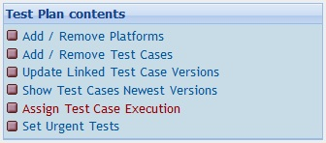
The test case assignment screen has extensive filter options:

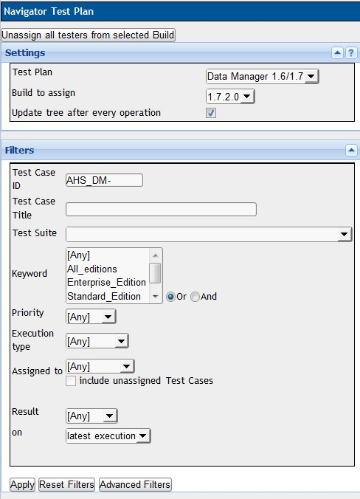
Using the tree menu in the left frame below the filters, you can choose a whole test suite, that will be displayed in detail in the right frame.

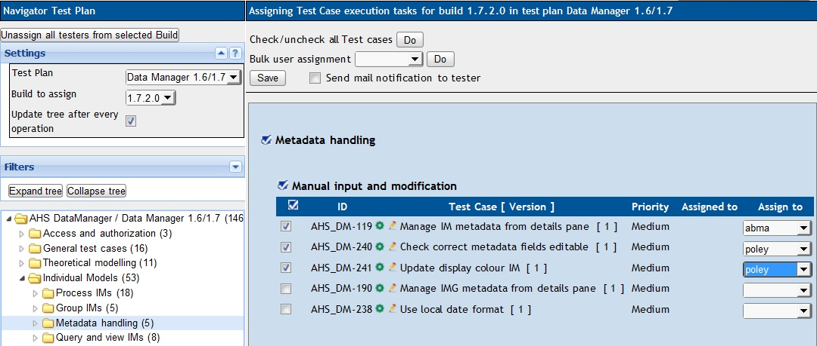

To assign a test case to an user, select the required user in the combo-box to the right of each test case and click the 'Save' button at the top of screen.
One can notify assigned testers (provided that e-mail has been configured) – select check-box “Send mail notification to tester”.
To simplify test case assignment when you need to assign a whole test suite to a user, a bulk user assignment feature has been developed.

Bulk user assignment
For bulk user assignment, proceed as follows:
- First select the test cases to be assigned. This can be done at three levels:
  - Use the button next to “check/uncheck all”;
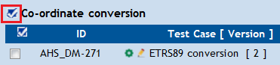
  - Use the tick mark above a test suite. This checks/unchecks all cases in the suite.
  - Use the checkboxes next to each individual test case.
- The next step is to choose the user. This is done using the bulk user assignment combo-box at the top of the section.
- Then, using the 'Do' button, combo boxes of all checked check boxes are set to the selected user.
- The last step is to click on the 'Save' button. The “assigned to” field next to each test case is updated.

Platforms
A Platform describes a “unit” that test cases could be executed on. For example a platform can be a web browser, operating system, spaceship, hardware device or configuration. A Test Plan can have associated platforms which are chosen when a test case is executed.
A Test project might have several platforms that need testing. For example a website needs to be tested in different browsers, or an application needs to run on different operating systems or hardware devices. TestLink calls this concept Platforms. Platforms are a way of connecting Test cases in a Test plan to a specific software platform, device or configuration.
To use the platforms feature, some platforms must first be created under “Platform Management” (accessible from the Project page). It requires “platform management” right (which only admin has by default). Created platforms can be assigned to particular Test plans. (If you haven't created a Test plan yet, do this first.)
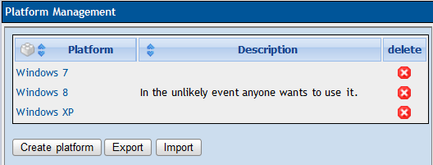Illustration 17: Create platforms in Platform Management
Select a Test plan and click “Add / Remove Platforms”. Assign platforms to a Test plan by moving them to the right panel and Save.
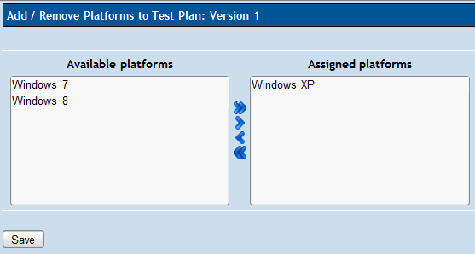Illustration 18: Assign platforms to Test Plan
Now Test Cases may be added to the Test Plan. This is done in the same way as normal, with the exception that a Test Case must be checked once for every platform it should be executed on. See Illustration 19: Add test case to test plan.
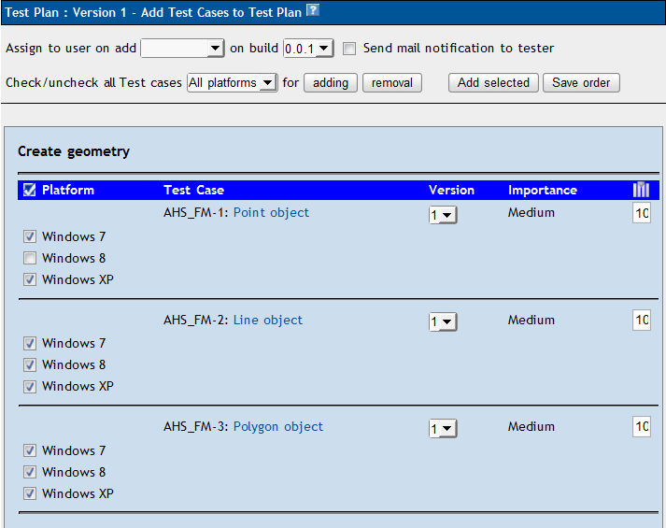Illustration 19: Add test case to test plan

The next step is to assign users to execute the test cases. You are free to associate users as you wish. One approach is to have a user to execute one test case on all platforms. Another approach is to let a user execute all test cases on one platform; or you can use a mix of the two approaches.

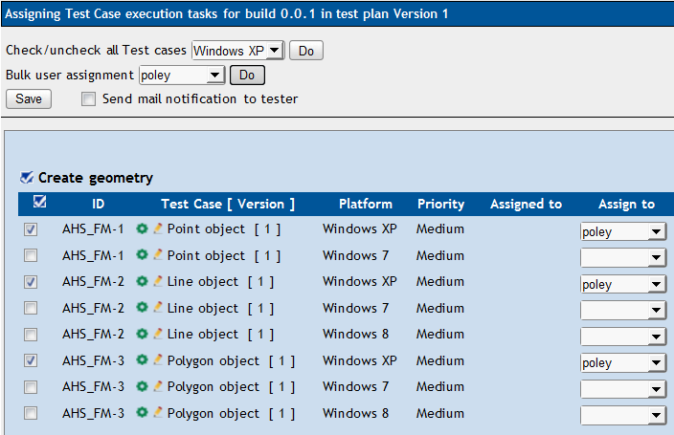Illustration 20: Assign users
When multiple platforms are used the execution step of TestLink gets one additional settings option. Make sure the platform selection is set to the platform you are going to execute test cases on. The tree then only shows the test cases for the currently selected platform.
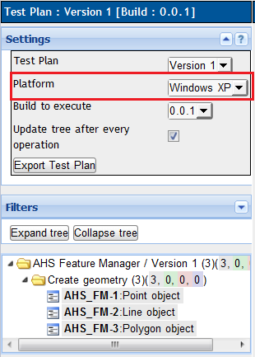Illustration 21: Filter on platform in execution navigator
Test reports include the platform in the metrics. Note: a test case that is linked to three platforms counts as three different test cases in reports. The reason is that it has to be executed once per platform for full test coverage and this is reflected in the results.

Prioritising testing
Test priority is an optional feature. Typically, some features of a release are new or subject to heavy development; these should receive the most attention. On the other hand some features were nearly untouched, and for these only the most important tests need to be run.
Configuration: This feature must be enabled on Test Project level by the administrator (“Test project management” link on main page).
Parameter Test priority is defined as a combination of Test Case Importance and Suite urgency in a Test Plan. Test priority can be used as a filter setting for test execution and is also reported in metrics.
TestLink gives users the ability to assign Importance to Test Cases. There are three levels: Low, Medium (default) and High. This value is adjustable during test design in Test Specification.
Urgency is the second parameter that affects Test Priority. Urgency is defined for a certain Test Plan and is not depended on Test Importance. Follow the link “Set Urgency” at the Test plan menu (right side of project page). There are also three levels: Low, Medium (default) and High.
Urgency is not copied if you copy a Test Plan. A new plan is expected to have different urgency values.
TestLink combines both these attributes into Priority levels High, Medium and Low. Priority should help to choose the right set of execution to test at first. Test report “Test Plan metrics” includes prioritised results then. Milestones allows to define goals for these three levels as well.
Example: A client-server product “Tam-tam” has two interfaces GUI and web-GUI. Each user interface includes login, a button “Bum” and setting the colour of the interface background. Testers design three Test Cases for both interfaces (each interface has own Test Suite):
- Login (medium Importance)
- Bum action (high Importance)
- Background colour (low Importance)
A Tam-tam 1.0 release has bug in the web interface and a hot-fix is created. Testers need to test the product in a really short time. A manager decides to test only tests with High priority before delivery and others later. The Test Plan for the hot-fix is copied from the Test Plan for release 1.0. Testers have the same set of tests but the Test leader sets the Test urgency of Test Suite “Web GUI” to High and “Application GUI” to Low (because there is no change).
Now, Two tests have high priority: Login and “Bum” action via web interfaces. Bum action via application GUI receive Medium priority (High Importance, but low urgency).

Milestones
The Test leader can define a milestone for a certain date with a goal of the expected percentage of finished tests. This goal could be defined for three levels of priority in the case that test prioritisation is allowed.
See the “Test Plan metrics” report to check the completion of these goals.
To define a milestone, use the Milestone Overview link:
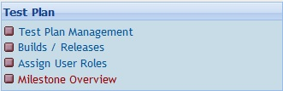
and press the Create button in the subsequent screen.
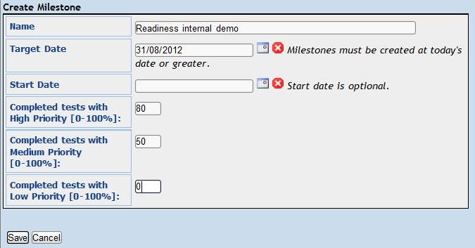
Illustration 22: Test leader can define one or more milestones for a Test Plan

Test Execution

General
Test execution is available after:
- A Test Specification has been written.
- A Test Plan has been created.
- Test Cases have been added into the Test Plan.
- At least one Build has been created.
- Testers have been given appropriate rights to work with the this Test Plan.
Select the “Execute” link in the top menu or the “Execute Tests” link on the Main page to navigate to the “Test Execution” window. The left pane allows navigation within the Test Cases via a tree menu, and the set-up of settings and filters. The execution window shows relevant information on a Test Case and enables the entry of test results.

Navigation and settings
The navigation pane consists of a Settings box, a Filter box and a tree menu containing Test Cases. These are described below.
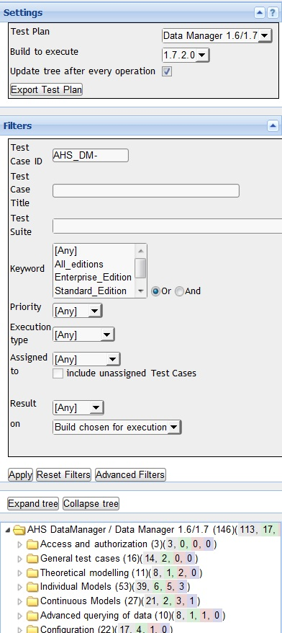Illustration 23: Execution Settings, Filter and Test Case Tree

Settings
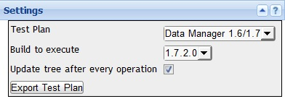
Users must specify the Test Plan for which Test Cases should be executed. Only Test Cases belonging to that Test Plan are shown.
Users must specify the Build under test, selecting from the list of active Builds. The latest Build is set by default. Usually each Test Case is run just once against each Build. However it is possible to run it multiple times (for example if the tester made a mistake).
Builds can be created by the Test Leader using the Create New Build page.
Note the “update tree” option. It can be useful to uncheck this, for faster refreshing and avoiding flicker: but it does obviously mean that the information in the tree display will be out of date. If the tree information ever seems to be wrong, examine the setting of this checkbox.

Filtering Test Cases
This panel allows the user to filter Test Cases for smart navigation before they are executed. Use the “Apply” button to apply a new filter setting.
Test Cases are shown for which all the specified filters apply (i.e. there is an implicit “and” between all the conditions.)
The filters should all be self-explanatory, except for the following points:
- all text filters are applied as a substring match: it is not necessary to enter wildcard characters;
- Tester: Users can filter Test Cases by their tester. Choosing “Nobody” will show all unassigned test cases, “Somebody” will show all assigned test cases. Setting the “include unassigned Test Cases” checkbox shows all test cases assigned to a specific user plus all unassigned test cases.
- Result: Users can filter Test Cases by result (not run / passed / failed / blocked). They can filter by result "on chosen build for execution", "on latest execution", "on ALL builds", "on ANY build" and "on specific build". If "specific build" is chosen users then can specify a build.
Common example filters here would be:
- Not Run / All Builds (tests that have never been run)
- Failed / Latest execution (tests currently failing)

Tree menu
The tree menu in the navigation pane shows the chosen list of Test Cases in the Test Plan. It allows the appropriate Test Case(s) to be opened for test execution in the right-hand frame. Test Suites in the menu are enhanced by a short test status overview after the title. This gives a colour-coded count of test case results: not-executed, passed, failed and blocked respectively.
Each individual test case is also colour-coded according to its result.
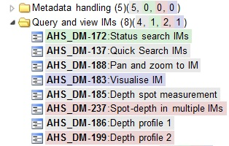

Executing tests

Test Status
Execution is the process of assigning a result (pass, fail, blocked) to a Test Case for a specific Build. A 'Blocked' Test Case cannot be tested for some reason (e.g. a problem in configuration prevents a function from being run).

Insert Test Results
The Test Results screen is shown by a click on an appropriate Test Suite or Test Case in the navigation pane. The title shows the current Build and owner. The coloured bar indicates the status of the Test Case.
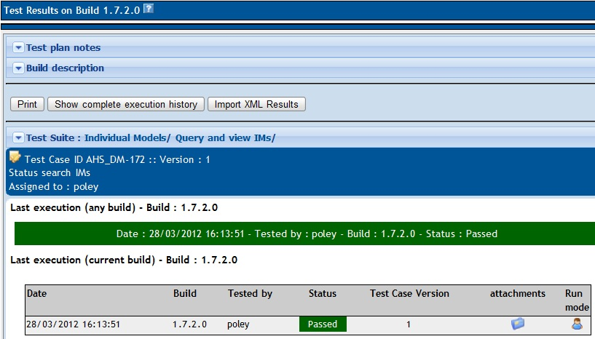Illustration 24: Test results
The user can consult the descriptions of test plan, build and test suite by clicking open the respective panels.
Under the results, the steps to execute the test are displayed.
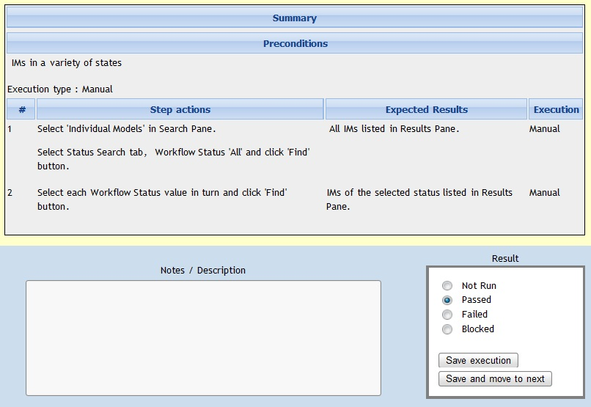
The user carries these out and enters the result of the test using the radio buttons.
Optionally he can enter notes on the test execution: for example a description of what exactly failed.
These notes cannot subsequently be updated, so try to get them correct! (Of course it is possible to enter a new test execution, but this does not delete the erroneously-recorded execution).

Test Reports and Metrics

Introduction
Test Reports and Metrics are accessed by clicking the “Test reports and Metrics” link on the main page. Reports and Metrics are based on the selected Test Plan (from the combo box menu). The page that is displayed to the user includes:
The right pane is populated with instructions on how to use the controls and how each report is produced.
The left pane is used for navigating to each report and operating controls which effect how reports behave and are displayed. The button “Print” initializes printing of the right pane (no navigation will be printed).
Test reports can be generated in a variety of formats:
- HTML - report is displayed in a web page
- OpenOffice Writer – calls OO Writer to show a report
- OpenOffice Calc - calls OO Calc to show a table based report
- MS Excel – calls Microsoft Excel to show a table based report
- MS Word – calls Microsoft word to show a report
- HTML Email – send report to user's email address
All reports can be displayed as HTML. Selecting one of the other formats from the report-format list shows the list of reports that can be displayed in that format.
The purpose and function of the reports are explained below. Currently there are no reports which compile results across multiple Test Plans.
Note: more reports have been added beyond those given below. Descriptions will be added here in due course; however the purpose and use of the extra reports should be fairly obvious.

Latest Test Result
Latest Test Result is a concept used in several reports, and is determined as follows:

- The order in which Builds are added to a Test Plan determines which Build is most recent. The results from the most recent Build will take precedence over older Builds. For example, if you mark a test as “fail” in Build 1, and mark it as “pass” in Build 2, its latest result will be “pass”.
- If a Test Case is executed multiple times on the same Build, the most recent execution will take precedence. For example, if Build 3 is released to your team and tester 1 marks it as “pass” at 2PM, and tester 2 marks it as “fail” at 3PM – it will appear as “fail”.
- If a Test Case has never been run it is listed as “not run”.
- Test Cases listed as “not run” against a Build are not taken into account if the Test Case has previously been executed. For example, if you mark a case as “pass” in Build 1, and don't execute it in Build 2, its latest result will be considered as “pass”.

General Test Plan Metrics
This page shows you only the current status of a Test Plan by test suite, owner, milestone, priority and keyword. In addition there are also basic metrics for all enabled builds.
If a Test Case was executed over multiple Builds, only the latest test result is taken into account.
The following tables are displayed :

Results by top level Test Suites
Lists the results of each top level suite. Total cases with status are listed: passed, failed, blocked, not run, and percent completed. A “completed” Test Case is one that has been marked pass, fail, or block. Results for top level suites include all children suites.

Results by Build
Lists the execution results for every Build. For each Build, the total Test Cases, total pass, % pass, total fail, % fail, total blocked, % blocked, total not run, and % not run are displayed. If a Test Case has been executed twice on the same Build, the most recent execution will be taken into account.

Results By Keyword
Lists all keywords that are assigned to cases in the current Test Plan, and the results associated with them.
Example :
Keyword | Total | Passed | Failed | Blocked | Not run | Completed [%]
P3 | 1128 | 346 | 47 | 55 | 680 | 39.72
P2 | 585 | 372 | 25 | 31 | 157 | 73.16
P1 | 328 | 257 | 6 | 51 | 14 | 95.73

Results by owner
Lists each owner that has Test Cases assigned to them in the current Test Plan. Test cases which are not assigned are tallied under the “unassigned” heading.
Example:
Tester | Total | Passed | Failed | Blocked | Not run | Completed [%]
Dominika | 579 | 217 | 34 | 47 | 281 | 51.47
Mohammad | 246 | 82 | 9 | 2 | 153 | 37.80
unassigned | 35 | 19 | 0 | 1 | 15 | 57.14
Ken | 289 | 110 | 1 | 21 | 157 | 45.67
Mallik | 430 | 269 | 5 | 18 | 138 | 67.91
Ali | 227 | 123 | 28 | 13 | 63 | 72.25
Mike | 24 | 22 | 0 | 0 | 2 | 91.67
Alex | 272 | 155 | 1 | 36 | 80 | 70.59

Query Metrics
This report is a general-purpose query, offering the possibility of querying test execution status using a wide variety of criteria. It consists of a query form page, and a query results page.

Query Form Page
One is presented with a query page with 4 controls. Each control is set to a default which maximises the number of Test Cases and Builds the query should be performed against. Altering the controls allows the user to filter the results and generate specific reports for specific owner, keyword, suite, and Build combinations.
Builds – 1->n Builds can be selected. By default – all Builds are selected. Only executions performed on Builds you select will be taken into account when producing metrics. For example – if you wanted to see how many Test Cases were executed on the last 3 Builds – you would alter this control.
top level suite - 0-> n top level suites can be selected. By default – all suites are selected. Only suites that are selected will be queried for result metrics. If you are only interested in the results for a specific suite you would alter this control.
keyword – 0->1 keywords can be selected. By default – no keyword is selected. If a keyword is not selected, then all Test Cases will be considered regardless of keyword assignments. Keywords are assigned in the Test Specification or Keyword Management pages. Keywords assigned to Test Cases span all Test Plans, and span all versions of a Test Case. If you are interested in the results for a specific keyword you would alter this control.
owner – 0->1 owners can be selected. By default – no owner is selected. If an owner is not selected, then all Test Cases will be considered regardless of owner assignment. Currently there is no functionality to search for “unassigned” Test Cases. Ownership is assigned through the “Assign Test Case execution” page, and is done on a per Test Plan basis. If you are interested in the work done by a specific tester you would alter this control.
Keyword, owner, and top level suite selections dictate the number of Test Cases from your Test Plan that are used to compute per suite and per Test Plan metrics. For example, if you select owner=“Greg”, Keyword=”Priority 1”, and all available test suites – only Priority 1 Test Cases assigned to Greg will be considered. The “# of Test Cases” totals you will see on the report will be influenced by these 3 controls.
Build selections influence whether a case is considered “pass”, “fail”, “blocked”, or “not run”. Please refer to “Latest Test Result” rules as they appear above.
Press the “submit” button to proceed with the query and display the output page.
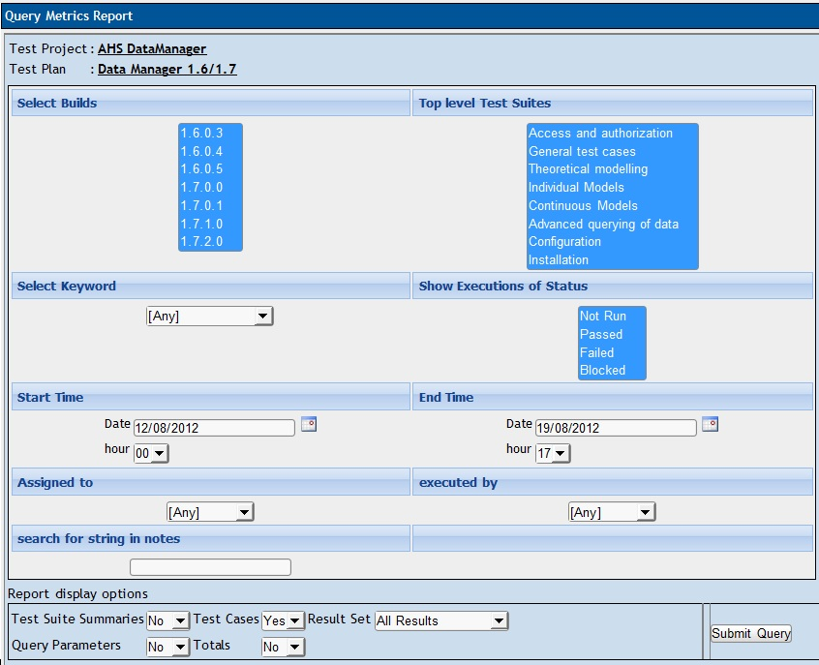
Illustration 25: Query metrics - Input parameters

Query Report Page
The report page displays:
- the query parameters used to create the report;
- totals for the entire Test Plan;
- a per suite breakdown of totals (sum / pass / fail / blocked / not run) and all executions performed on that suite. If a Test Case has been executed more than once on multiple Builds – all executions will be displayed that were recorded against the selected Builds. However, the summary for that suite will only include the “Latest Test Result” for the selected Builds.
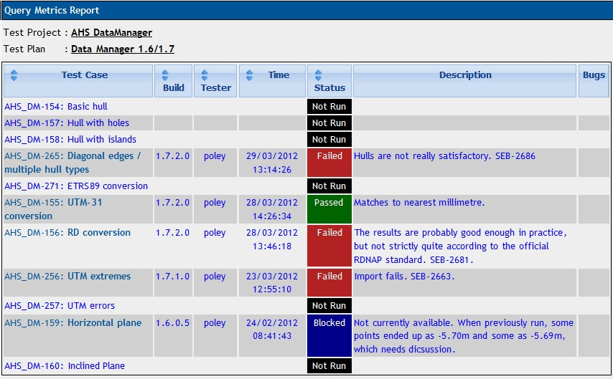Illustration 26: Query metrics - results

Blocked, Failed, and Not Run Test Case Reports
These reports show all of the currently blocked, failing, or not run Test Cases. “Latest Test Result” logic (described above) is again employed to determine if a Test Case should be considered blocked, failed, or not run. Blocked and failed Test Case reports display the associated bugs if the user is using an integrated bug tracking system.

Test Report
View status of every Test Case on every Build. If a Test Case was executed multiple times on the same Build, the most recent execution result will be used. It is recommend to export this report to Excel format for easier browsing if a large data set is being used.

Charts
This report page requires graphic library installed on your web server. “Latest Test Result” logic is used for all 4 charts that you will see.
The four charts provide are :
- Pie chart of overall pass / fail / blocked / and not run Test Cases
- Bar chart of Results by Keyword
- Bar chart of Results By Owner
- Bar chart of Results By Top Level Suite
The bars in the bar charts are coloured such that the user can identify the approximate number of pass, fail, blocked, and not run cases.

Total Bugs For Each Test Case
This report shows each Test Case with all of the bugs filed against it for the entire project. This report is only available if a Bug Tracking System is connected.

Requirements based report
This report is available if requirements are allowed for the current Test Project. The report is generated against one Requirement Specification document chosen from combo box menu.
There are two sections: metrics and results overview.
The following metrics are available:
- Total number of requirements
- Requirements within TestLink
- Requirements covered by Test Cases
- Requirements not covered by Test Cases
- Requirements not covered or not tested
- Requirements not tested
Requirements are divided into four sections. Each requirement is listed together with all related Test Cases (coloured according to Test Case result):
- Passed Requirements
- Failed Requirements
- Blocked Requirements
- Not-executed Requirements

How to add a new report
Copy one of the current reports and modify it according to your needs. Don't forget that we use templates for rendering (<testlink_root>/gui/templates/<report_name>.tpl) and logic (<testlink_root>/lib/results/<report_name>.php). We recommend reusing existing functions to collect data for the report instead of creating new ones.
Edit <testlink_root>/lib/results/resultsNavigator.php to add a link to your new report. There is an array, that could be easily enhanced. You must add a new URL and “name keyword” of report.
You can modify the CSS style for a report. We suggest creating new classes instead of modifying current ones (to avoid unwanted changes in other pages).
If you contribute your new report(s) via our tracker, you can find it also in the next versions ... otherwise you risk that it will not work for the next main release.

Administration

User account settings
Every guest can create their own account on the login page.
The auto-create feature can be disabled by configuration. There is also configurable default role parameter ('guest' by default).
Every user on the system can edit their own information via the Account settings window ('Personal' link in menu bar). He can modify own Name, e-mail address, password and generate API key (if enabled).
TestLink allows users with administrator rights to create, edit, and delete users within the system. However, TestLink does not allow administrators to view or edit user's passwords. If users forget their passwords there is link on the login screen to mail the user their password based upon their user name and the e-mail address they entered.

Role Permissions
One can see the current role in the top line of the TestLink window. Each user has 'generic role' that applies on all projects. The Administrator can assign a specific project role for a particular project. Users can have a modified role for a particular Test Plan as well.
For example Jack could be guest by default (can see all test cases and reports) and Test leader on project 'XYZ' to lead this project testing.

TestLink is built with 6 different default permission levels built in. These default permission levels are as follows:
- Guest: A guest only has permission to view Test Cases, reports and metrics. He cannot modify anything.
- Tester: A tester has permissions to see and run tests allocated to them.
- Test Designer: A user can fully work (view and modify) with Test Specification and Requirements.
- Senior Tester: A tester can view, create, edit, and delete Test Cases as well as execute them. Testers lack the permissions to manage Test Plans, manage Test Projects, create milestones, or assign rights.
- Test Leader: A lead has all of the same permissions as a Senior Tester but also has the ability to manage Test Plans, assign rights, create milestones, and manage keywords.
- Administrator: An admin has all possible permissions (leader plus the ability to manage Test Projects and users).
Changing of these rights is handled by the user administration link which is accessible by administrators. Admin can add a new custom roles and modify existing ones via GUI.
See Developer's Guide to understand more.
If you view the table you will see rows for each of the permissions levels (guest ,tester, senior tester, leader, admin). The second column holds all of the different rights levels which will be defined below. These levels have been determined as standard for use but they can be edited to define new roles (for an experienced administrator). The user table contains a foreign key that points to the appropriate permission level in the rights table.
Note: Test Plan related features needs also assign a Test Plan to be available. See Test Plan Assignment.

Case study – restrict access by default
Situation
In our organisation we would like to restrict access to projects unless it is specifically granted. We currently have about 150 users with just over 90 different projects. Many of the users are not QA, but are business analysts, and in some cases end users doing UAT. From what I can tell, all rights are inherited based on how the user was set-up.
But we don't want a Business Analyst who is working on only one project have access to all 90.
Solution
Set these users with the global role <No rights> and granted an appropriate role on a Test project or Test plan base. In custom_config.inc.php you can also set the default role id to <No rights>:
$tlCfg->default_roleid = TL_ROLES_NO_RIGHTS;

You can also rename the role “No rights” to something more polite.

Test Plan assignment to users
Users can execute only assigned Test Plans. In order to gain Test Plan permissions a user with lead or admin status must give them rights through the “Define user/project rights” link under “Test Plan Management”.
All users in the system will by default not have permissions to view newly created Test Plans (except for the Test Plan creators who can give themselves permissions at creation). Zero Test Plan permissions means that users will not see any Test Plans in the Test Plan drop-down box on the main screen.
However he can browse reports.

Custom Fields
Users can extend the most important objects (Test Cases, Test Suites, Test Plans) in TestLink with customised fields. After you have created a Custom Field, you need to assign it to the Test Project in which you want to use it. So each project has its own set of additional fields.
Examples of Custom Fields could be: review notes, review status, estimated or actual execution time, platform (OS, HW, ...), test script name or owner, etc.
Navigate to “Custom field management” link on main page. This page is the base point for managing custom fields. It lists the custom fields defined in the system. Custom field definitions are system wide, i.e., you can not define two custom fields with same field ID.
The "Create" button takes you to a page where you can define the details of a custom field. These include its name, type, value and availability/display information. On the edit page, the following information is defined to control the custom field:
- name
- type - possible values are listed below.
- Value constraints (Possible values, default value, regular expression, minimum length, maximum length).
- Availability/Display control (where the field will show up and must be filled in
All fields must be greater than or equal to the minimum length, and less than or equal to the maximum length, unless these values are 0. If the values are 0, the check is skipped. All fields are also compared against the regular expression. If the value matches the expression, then the value is stored. For example, the expression "/^-?([0-9])*$/" can be used to constrain an integer.
There is data format verification for types numeric, float and email. On submit (when created a Test case or while executing) CF of this type are validated. Empty values are accepted, but if the value is not empty but does not conform to a regular expression (NOT USER DEFINED but coded) the submission will be blocked, with a message on the screen.
The table below describes the field types and the value constraints.
Type | Field Contents | Value Constraints
String | text string up to 255 characters
Numeric | an integer
Float | a floating point number
Email | an email address string up to 255 characters | When displayed, the value will also be encapsulated in a mailto: reference.
Checkbox | zero or more of a list of text strings | Enter the list of text strings separated by "|" (pipe character) in the Possible Values field. The Default value should match one of these strings as well. This will be displayed as a list of text strings with a checkbox beside them.
List | one of a list of text strings | Enter the list of text strings separated by "|" (pipe character) in the Possible Values field. The Default value should match one of these strings as well. This will be displayed as a multi-line drop-down menu.
Multi-selection List | zero or more of a list of text strings | Enter the list of text strings separated by "|" (pipe character) in the Possible Values field. The Default value should match one of these strings as well. This will be displayed as a multi-line drop-down menu.
Date | text string defining a date | This is displayed as a set of drop-down menus for day, month, and year. Defaults should be defined in yyyy-mm-dd format.
Text Area | Rich text
Table 1: Custom field types
The display entries are used as follows:
Entry | Meaning
Display on  test specification | If checked, the field will be shown on Test Specification tree
Enable on  test specification | If checked, the field will be editable (assign/change) on Test Specification
Display on  test execution | If checked, the field will be shown on Test Execution
Enable on  test execution | If checked, the field will be editable on Test Execution
Available for | Test case, Test plan or Test suite
Table 2: Custom fields: Availability/Display Attributes
Example 1.
Custom Field : Additional Notes
Type : string
applicable to test suites, to be edited ONLY during
Test Case specification, but useful to be seen during test execution.
show on design = YES
enable on design = YES
show on execution = YES
enable on execution = NO
Example 2.
Custom Field : Operating System
Type : list
applicable to Test Cases, to be edited ONLY during
Test Case EXECUTION, unused during Test Case DESIGN.
show on design = NO
enable on design = NO
show on execution = YES
enable on execution = NO
Note: the Custom Field feature has been implemented using a mix of functionality from the Mantis (http://www.mantisbt.org/) and dotproject (http://www.dotproject.net/) models.

Custom fields: Estimated and Actual execution time
“Estimated Execution Time” and “Actual Execution Time” custom fields can be added to any project and TestLink will automatically summarise those fields during the reporting process.

Step 1 – Create the custom fields
NOTE: The user must have permissions (i.e. “Custom Field Management” must be enabled for the user's role) to define and assign custom fields.
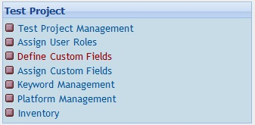
First select “Define custom fields” from the Test Project group as shown here.

Next select the “Create” button.

The Name field must be exactly CF_ESTIMATED_EXEC_TIME due to the built-in queries for this field. The Type field must be either Numeric, String or Float, as the queries will only work on numerical data. It is suggested that Float type is used as it allows more flexibility.

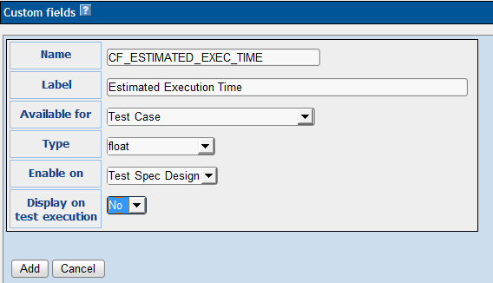

Once completed, click “Add” to create the new custom field to the system.
The actual execution time can be added similarly, using field name CF_EXEC_TIME.

The new custom fields will be available for assignment to ANY project in TestLink. Make sure the Test Project is set to the project that you want before assigning the custom fields.

Step 2 – Assign custom fields

Select “Assign custom fields” from the Test Project group.
Select each of the custom fields and click “Assign”.
Now each of the custom fields have been assigned to the current project.
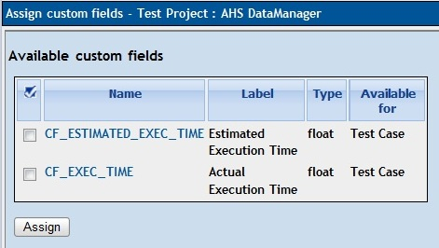
When you create a new test case (or edit a previous entered test case), above the Keywords section you will see the custom fields.
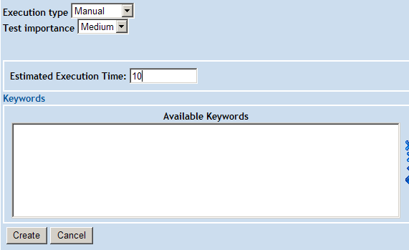
Add the estimated time and click “Create” (or “Save” on an edit).
Localisations: Use “ . “ (dot) as decimal separator or sum will be wrong.

Step 3 – Add the test cases to the Test Plan
See chapter 5.3 for details.

Step 4 – Summation of the Estimations

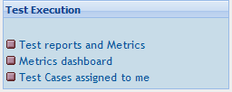
Select “Test reports and Metrics” from the Test Execution group.
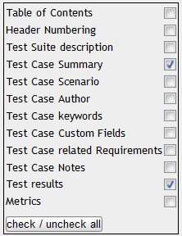

Select “Test Report” from the left-hand menu, then check the Metrics option.
Finally select the Test Suite or Test Case that you wish to create the report.

At the bottom of the report will be a summary of the estimated execution time for all of the test cases.

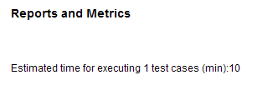

NOTE: The time entered into the custom fields doesn't have to be in units of minutes, hours can also be used. The $TLS_estimated_time_hours and $TLS_estimated_time_min strings are predefined strings can be selected based on your preference.

Import and Export data
TestLink supports several ways to share data. The Data Format is described in the separate document <testlink>/docs/tl-file-format.pdf. In addition you can consider using the TestLink API to deliver data from script or an external tool.
There is a number of file examples in directory <testlink>/docs/file_examples/.

He, however, can edit nothing. ;-)
IE only selects the link. Enter key must follow.
Admin can modify roles rights to extend these rights.
It requires EXT-JS component (default).
TestLink 1.7 and earlier versions have had this ID as a global counter independent of the Test Project. TestLink 1.8 still uses this unique ID for API calls.
The feature must be enabled on Test project management.
Optional: expected count of requirements. The parameter is used for statistics. Use only if you have a valid Requirement document but not all requirements are available at the moment in TestLink. Default value '0' means that the current count of requirements in a specification is used.
The parameter is not available for type: “Information”
Further statuses and types can be defined via configuration.
Customisation of Simple Link Feature - Examine config.inc.php parameters: $tlCfg->internal_links->enable (allows to disable feature) $tlCfg->internal_links->target (allows to specify the target of the link) $tlCfg->internal_links->req_link_title (allows to specify the link prefix for requirements $tlCfg->internal_links->req_spec_link_title (allows to specify the link prefix of requirement specifications
The string must be defined in locale/en_gb/string.txt

