Test Link 1.7

Software requirements specification
Copyright © 2005 TestLink Development Team
Permission is granted to copy, distribute and/or modify this document under the terms of the GNU Free Documentation License, Version 1.2 or any later version published by the Free Software Foundation; with no Invariant Sections, no Front-Cover Texts, and no Back-Cover Texts. The license is available in "GNU Free Documentation License" homepage.
Table of Contents
1.1 Purpose 1
1.2 Document Layout 1
1.3 Abbreviations 1
1.4 Document organisation 1
1.5 Results of First Round of Comments 1
1.5.1 Features That will be added on TL 1.7 1
1.5.2 Features OUT OF SCOPE for TL 1.7 1
2.1 Terminology 1
2.2 Database 1
2.2.1 Database Naming Conventions 1
2.2.2 DB changes for V1.7 1
2.2.3 User ID in all tables instead of Login Name 1
2.2.4 Keyword ID in all tables instead of Keyword value 1
2.2.5 Custom Fields 1
2.3 Graphical User Interface 1
2.3.1 Bulk Updates 1
2.3.2 Use of on change event must be avoided to launch database operations 1
2.4 User Management 1
2.4.1 User account states 1
2.4.2 Delete User 1
2.5 Test Project attributes - Notes 1
2.6 Test Plan Notes 1
2.7 Test Specification 1
2.7.1 Delete TC 1
2.7.2 TC Version Management 1
2.7.3 Test Case - Active Attribute 1
2.8 Test Plan 1
2.8.1 Extensive Test Execution Log 1
2.8.2 Update Test Case with New Version - Results will be DELETED 1
2.8.3 Test Plan - Possibility to Close / Freeze a pair (Test Plan,Build) 1
2.8.4 Automatic closure of old builds 1
2.8.5 Test Execution - Next/Previous Test Case 1
2.8.6 Test Execution - Execute TC and display next Test Case 1
2.8.7 Assigning Test Case to Test Plan (Linking) 1
2.8.8 Test Plan - Update Modified Test Cases 1
2.9 Requirement based testing 1
2.9.1 Requirements Specification 1
2.9.2 Creating Requirements 1
2.9.3 Assigning Requirements to Test Cases 1
2.10 Reports and Metrics 1
2.11 API 1
2.11.1 API Architecture 1
2.11.2 API Functions 1
3.1 External ID for certain Objects 1
3.2 Import / Export In XML 1
3.3 Test Plan Management - Assign Test Cases to Testers 1
3.4 New Test Case Attributes 1
3.5 Test Execution/Results - Actual Execution Time 1
3.6 Attachments 1
4 Using PHP Trigger Error 1
4.1 User Management 1
4.1.1 Authentization 1
4.1.2 Login history 1
4.1.3 User Preferences 1
4.1.4 Permissions System 1
5.1 Generalized Log/History System 1
5.2 Email notification 1
5.3 Test Plan Monitoring 1
6.1 Unique Test Case (external) Numbering Inside Test projects 1
6.2 Configuration Option - Use Text Area Without HTML Editor 1

IMPORTANT:
To better understand this document you should first read the companion document:
tl_dbschema.odt “Testlink 1.7 – Proposal of Database Architecture”.
It would be best to merge both documents, but the effort needed to do this work is too high at this time. Waiting for this merge would delay the start of development.

General

Purpose
For TestLink next generation (1.7) there are two main areas where work can be done
- Technological infrastructure
- Product architecture
- To reduce the "time to market" (i.e. time span between releases) and development efforts, trying to use pieces from other well-known open source projects seems a good solution.
- The "not invented here syndrome" must not exists for this Development Team.
- Installing and playing with other test management solutions or other types of solutions, can be seen as rapid prototyping that can help to focus the development efforts.
- In particular Mantis and dotproject can provide useful pieces of code, without excluding other projects.

Document Layout
For better organization use the next styles:
Requirement implemented
Requirement approved but not implemented
Requirement suggested
Comments (italic) – explanation of problem(use your name in the begin)

Abbreviations
BTS | Bug Tracking System
TC | Test Case
TMS | Test Management System

Document organization
To simplify / organize some aspect of this analysis we defined the following areas:
Functional/Technical Area | Item
Database | Abstraction Layers  Database constrains
Graphical User Interface | Layout  Styles  Smarty templates
Product | Product
Reporting | Reports and Metrics  Export
Requirement Based testing | Software Requirements Specifications  Requirements
Test Specification | Containers (Component, Category)  Test Case  Import
Test Execution | Test Plan  Results  Build  Milestones  Test Assignment
User management | Users  Rights

Results of First Round of Comments
After the first round of ideas/comments from Andreas Morsing and Martin Havlat this document will be reorganized.
The requirements present in early versions of this document will be grouped in:
- Features that will be added on TL 1.7
- Features OUT OF SCOPE for TL 1.7
- Features Not Accepted => (will be never implemented ?)
The features of group "Features that will be added on TL 1.7" will be grouped in:
- Accepted Features 100%
- Accepted Features that needs more discussion

Features that will be added on TL 1.7

Feature | Detailed Feature | Notes | Comments
Database Abstraction Layer
Database Naming Conventions
 | Using only lower case with "_" between words/abbreviations for database objects
 | Using plural or singular on field names
 | Name of test plan table
 | length of Database Object Identifiers (Table, Index, Constraints and Field names) | Not discussed yet is NEW
test project attributes
 | test project Notes | Low Priority
Test Plan Notes
 | Using FCKeditor
Extensive Test Execution Log
Attachments
User Management
 | User account states
Custom Fields
Test Execution
 | Next/Previous Test Case
 | Exec TC and display next Test Case
Test Plan
 | Possibility to Close / Freeze a Test Plan
Import / Export In XML
User Interface
 | Bulk Updates
 | Some kind of Standard must be applied
 | Requirements
Managing the delete of a Test Case Specification
Container Hierarchy
Test Case Specification
 | Version Management
Test Case Linking to Test Plan
Permissions System

Features OUT OF SCOPE for TL 1.7

Feature | Detailed Feature | Notes | Comments
Automatic e-mail on events
Test Plan Monitoring
Generalized Log/History System
User Preferences

System Architecture

Terminology
The following changes will be done
Object on TL 1.7 | Object on TL <= 1.6
Test Project | Product
Test Suite | Component  Category
Test Case | Test Case
Test Case Version | Not present
Test Plan | Test Plan

The old terms must be not be used anymore, in new documentation, or discussions.
The term Test Suite that was used associated to Test Plan, must be used for Test Projects and Test Plans.

Database
Database Abstraction Layer is implemented via third party component ADODB.
This allows to transform all database related function calls to a neutral database call is needed.

Database Naming Conventions
Lower case for database objects identifiers: The identifier (name) of any type of database object will use only lower case with "_" between words/abbreviations.
Examples:
requirement identifier: req_id
test plan identifier : testplan_id

Table names and field names must be user plural.
Length of Database Object Identifiers should be maximally 25 characters
Having as long term objective to support other DBMS than MySQL, it's important to limit the length of database objects identifiers, to avoid problems in future portings. The limit must be established by analyzing the most popular DBMS:
- Oracle
- Microsoft SQL Server
- Postgres
- MySQL
For Oracle (at least version 8i, 9i) the limit is 30 characters. Additionally, Oracle automatically names all primary keys by adding the PK_ prefix to the table name. This creates a natural limit for table names of 27 characters.
In addition to the portability limits described above, there is another issue to consider - field names. Field names which are too long add an excessive degree of verbosity, provide no advantages and force developers to type a lot.

DB changes for V1.7
Internal ID:
Every object in the system has an internal identifier. This ID is assigned automatically by the system, and the user has no control over it's value.
External ID:
For certain objects in the system can be useful to allow the assigned of an user's controlled ID, Example the DOCID in the Requirements Management.
User have full control on this ID (or code), anyway the system will do check to ensure no duplicate External ID when needed.

User ID in all tables instead of Login Name

Keyword ID in all tables instead of Keyword value

Custom Fields

Graphical User Interface

Bulk Updates
In current versions of TestLink (<= 1.6), the management of users, keywords, and other items allow “bulk update” modifications.
This means changes can be applied to all element at the same time. This kind of approach has lower added value, because in normal operation bulk updates are not used frequently.

Use of on change event must be avoided to launch database operations
Instead of this | Use this kind of interface (taken from Mantis)
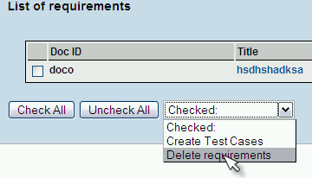 | 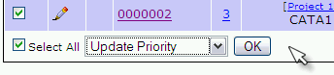
Model A | Model B

Model B is clearer, because the user makes their choice, and then applies it (using the OK button).
Basically the difference is the use of the OK button.
The same criteria doesn't apply in selection operations (for example the selection of Test Projects, or Test Plans) because these operations don't
trigger changes on data in the database.

User Management

User account states
A user account can have the following states:
- Active/Enabled
- Inactive/Disabled
This will be implemented using the field "ACTIVE".
Effects of User Account disable/inactive:
- When a user account is in state inactive/disabled, it will not be possible to login to the system.

- The user name and/or login name will be MARKED in an special way (to be defined) on every occurrence at user interface level, where can be used as a choice. (ex: combo box)

- When used as additional information, like in reports, or when signaling who has made some kind of operation there will no distinction between active and inactive users, because has no added value.

- Assignment and visibility of disabled users will be controlled by a configuration parameter. This means that normally test plan can not be assigned to inactive users, but with a configuration option, this operation can be enables.
- Modifying state account from active to inactive produce no loose of any kind of data.

Delete User
This means physical elimination of data regarding the user (basically remove the record from tables containing only user related info, like name, surname, roles, test plan assignments, etc).
No control will be done regarding items assigned to the user, the delete will be done. The use of a delete field to maintain the user information on the database table, but without any possibility to do operations on the user (active, de-active, assign) and to maintain the user name and surname, seems an excessive complication.
In the similar way as happen in a UNIX system, once the user will be deleted, instead of name and surname or login name, the internal user id (a number) associated to the deleted user, will be displayed as owner, assignee, etc of the items.
In order to cope with other points of view regarding “user delete”, seams clever to add a configuration option, to enable/disable user delete.
Alternatives when user delete = DISABLE
DELETE alias of DISABLE | The delete button will be present, but the delete operation will remove NOTHING, and will result only on change of account state form Active to Inactive. It will be possible to change again form Inactive to Active.
DELETE not possible | Similar to the previous option, but delete button will be removed at user interface level.

Test Project attributes - Notes
The test project notes will be managed at user interface level using html editor.
The notes attributes will be used in the reports.

Test Plan Notes
Test Plan Notes will be managed using a HTML Editor.
Installer must convert text to html by nl2br function during update from 1.6 and earlier.

Test Specification

Delete TC
When deleting a Test Case Specification, we can face the following situations:
- TC has NO links (i.e. it's not used in any Test Plan)
- TC is linked to one or more Test Plans

TC has NO links
The TC will be deleted without asking anything to the user.

TC is linked to one or more Test Plans
The system will warn the user this situation, signaling:
- Test Plan where the TC has been linked
- Existence of TC executions (i.e. results).
To delete the TC specs, all references to TC must be deleted for other system tables.
The system will inform user that deleting TC will automatically delete results and unlink TC from TP.

TC Version Management

Storage Management
See the document regarding new schema

Version Management for TC Specs not linked to Test Plans or linked but NEVER EXECUTED
- User creates a new test case (TCXX), version 1.
- TCXX Version 1 is not linked to any Test Plan
- Later user make changes to TCXX and saves it; there will be NO AUTOMATIC change of TC version.
- Should the user want to create a new version, he/she has to use the new feature Create New Version.

Version Management for TC Specs linked to Test Plans AND EXECUTED
- User creates a new test case (TCXX), version 1.
- User links TCXX Version 1 to Test Plan TP1 and Test Plan TP2.
- TCXX Version 1 is executed on Test Plan TP1.
- TCXX Version 1 is NOT EXECUTED on Test Plan TP2.
- Later user make changes to TCXX and saves it
- Because an execution exists (on TP1) a new version (Version 2) is AUTOMATICALLY CREATED.
- Nothing Changes for TP1 and/or TP2, the linked version still is Version 1.
- If the user wants to use TCXX Version 2, on TP1 and/or TP2, must do an update.

User Interface (a possible model)
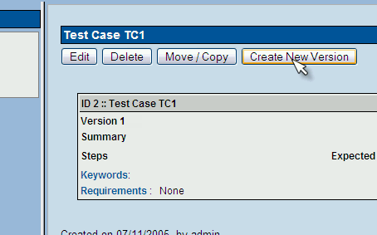

Unused TC Specs versions
a TC spec version is considered unused if TC spec version is not used in Test Plan.

Accessing different versions (a prototype)
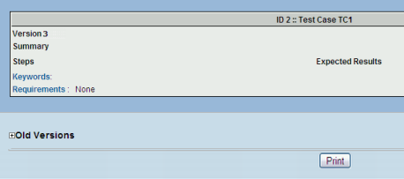
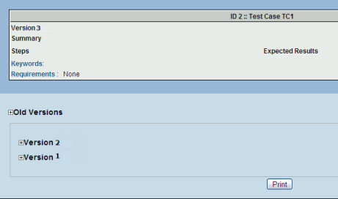
Using the Navigation Tree the user click on the TC Spec for TC1
Because TC1 has 3 versions, version 3 is displayed.
Clicking on "Old versions"
Clicking on one version (as example Version 2)

Test Case - Active Attribute
If several versions of a Test Case can exist, it would be useful to have a new attribute Active/Inactive, to use in this way:
- Every Test Case version is created Inactive
- Inactive Test Case Version will not be available in "Add Test Cases to Test Plan", this can be useful for Test Designers. They can edit or change the TC Version and only when he/she decide is completed => change Status to ACTIVE, will be available to be included an used in a Test Plan.
- Once a TC Version has been linked to a Test Plan, and have results, it can't be turned INACTIVE.
- A "Set All TC Versions to Inactive" option will be present.

Test Plan

Extensive Test Execution Log
An example of a model of user interface
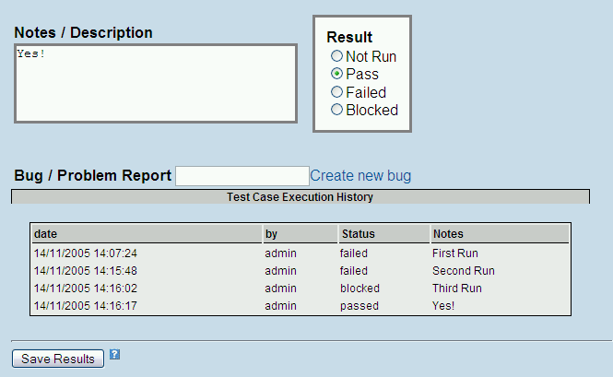

Changes on Reports will be needed
This new way to record test case execution will have impacts in the logic that creates the different reports

Update Test Case with New Version - Results will be DELETED
Using the "Update Modified Test Cases" feature will be possible to link to the Test Plan, a new version of a TC.
If the user chooses to use this action, the results of the previous linked version WILL BE DELETED.
Example
- User creates Test project TOASTER, Test suite TSU1, than contains the test suite TXX, with Test Case TC1
- A Test Plan is created and version 1 of TC1 is added to test plan.
- A Build is created and TC1 is executed generating a result.
- A new version, (version 2) of TC1 is created.
- User updates the Test Plan to use TC1 version 2
- Results of execution of TC1 version 1 are destroyed.

Test Plan - Possibility to Close / Freeze a pair (Test Plan, Build)
- Tests Plans which are finished should be "closed/frozen" and stored in the system forever.
- Closing a (Test Plan, Build) closes all Test Cases Versions linked to it, turning them read only.
- Closing a (Test Plan, Build) blocks the execution of Test Cases linked to it, turning them read only.
- It will be possible to view the results of a Closed Test Plan, and a legend will be displayed to inform user
why execution is not possible.
- You can create a new Test Plan using a closed one.
- A new specific right must be created to control this operation.
Because a Test Plan is a set of Test Cases Versions, closing a Test Plan will have effects on Test Cases.
The next example can help to understand the problem.
- Test Cases TC1 Version 1, TC2 Version 1 and TC3 Version 1 are created.
- Using TC1 Version 1 a new version (Version 2) is created.
- Test Plans TP1 and TP2 are created
- TP1 has links to the following test cases (TC1 - Version 2, TC2 - Version 1, TC3 - Version 1)
- TP2 has links to the following test cases (TC2 - Version 1, TC3 - Version 1)
- Build B1 is created for TP1
- Execution of TP1 on B1 begins.
- Using TC1 Version 2 a new version (Version 3) is created.
- Build B2 is created for TP1.
- Using TC1 Version 1 a new version (Version 4) is created.
- (TP1,B1) is Closed
The effects of Test Plan Closing/Freezing:
- It's NOT possible to execute test cases of TP1 for B1.
- It's possible to execute test cases of TP1 for B2.
- TC1 - version 1 -> CAN BE MODIFIED and saved with or without creating a new version.
- TC1 - version 2 -> CAN NOT BE MODIFIED and saved as the same version 2.
- TC1 - version 2 -> CAN BE MODIFIED BUT HAS TO BE SAVED AS A NEW VERSION.
- TC1 - version 3 -> same that version 1.
- TC1 - version 4 -> same that version 1.
- No effects on Test Plan TP2.

Automatic closure of old builds
One contributor (xxxx) has implemented the following feature that seems to be a simplified version of the Close/Freeze (Test Plan, Build).
A new configuration option has been added in config_inc.php, which controls this feature.
If set to disabled - all functions as you know.
If set to enabled - when you try to execute a test case, a comparison is done between the internal build id (remember user has no control on it) of the build you want to use and the maximum value for builds id associated to the test plan.
If set to selected - build id = max build id for test plan
normal test case execution operation.

else
test case can not be executed
the save button is removed form the execution screen
all html inputs becomes read only
end if
This implementation is present on TL 1.6 Branch.

Test Execution - Next/Previous Test Case
- Using the navigation tree, user clicks on a test suite that contains Test Cases.
- The first TC is displayed
- A Button "NEXT TEST CASE" is displayed, and can be used to loop though all Test Cases in the container.
- "NEXT TEST CASE" on last Test Case, displays the First Test Case.
- "PREVIOUS TEST CASE" on first Test Case, displays the Last Test Case.

Test Execution - Execute TC and display next Test Case
Salome uses this approach.
Example: you have a Test Plan with 3 Test cases in a Test Suite, TC1, TC2, TC3
1. User click TC1 on the navigation tree
2. User choose a result for the TC
3. User click on Save Button
4. The results are saved, and screen changes, presenting TC2
This can be also useful to loop through all TC in the Test Plan (going from test suite to test suite).

Assigning Test Case to Test Plan (Linking)
A Test Plan will be built/constructed doing links from Test Case Specifications.
No data from Test Case will be duplicated in Test Case Execution (link of Test Case to Test Plan).
Using this solution all changes made to the Test Case Version linked to the Test Plan, are acquired automatically.
This means that when a user launches "Update Modified Test Cases" nothing will be done.

Test Plan - Update Modified Test Cases
What kind of Changes will be signaled by this feature?
Changes to Test suite (Container) of a Test Case?
NO. When Test suite on test project will be changed will be updated automatically on Test Case Execution, because we are using linking, not copy as was done on TL <= 1.6
Changes of Test Case Order inside the Container?
NO. This kind of change will be updated automatically on Test Case Execution, because we are using linking, not copy as was done on TL <= 1.6
What about new version of Test Case Specification?
YES, User must be warned or May be the user can choose if check for new versions?

Requirement based testing
Requirement based testing is allowed only if the functionality is allowed on test project level (by option). The functionality is disabled as default.
Navigate to Edit test project page to allow REQ functionality.

Requirements Specification
Requirement feature gives users metrics to evaluate sufficient amount of required tests. Only users with “mgt_modify_req” rights can edit this functionality.
A user can create none, one or more documents (Requirement Specification) with requirements for a test project.

Creating Requirements
A user creates Requirement Specification which include a set of requirements. This element has these attributes: title, scope, total count of requirements. Total count of requirements is N/A if all requirements are already created. Date of change and user are automatically stored.
Requirements Specification includes particular requirements. A set of requirements should be created manually via GUI or by Import (CSV file). Requirements have these attributes: Title, Scope and Status. The Status could be "Valid" or "Not testable". Date of change and user are automatically stored.

Assigning Requirements to Test Cases
User can assign Test cases and Requirements as n to n relation.
User can see assigned requirements from Test Specification (via link), Test Execute, (via link) and printed documents (list of REQ titles).

Reports and Metrics
Users have the ability to show metrics for count of tested functionality.
TL allows comments and edit results before reporting (options: 'auto' and 'edit'). Edit generates a preliminary report with allows to mark otherwise covered requirements and comment.
Report includes: list of covered, uncovered and not testable requirements, count of total, covered, uncovered and not testable REQs, test coverage [percentage]. If every TC connected witch REQ is passed then REQ is correct implemented. If only one TC connected witch R is not passed or blocked then R is incorrectly implemented.
Report should be able to show test cases for each requirement as option. Failed Test cases will be marked.

API

API Architecture
Goal of this component is allow interaction for third party tools, scripts and products. Via GET and POST of http protocol is possible to set and get data. TestLink returns XML with error code and data/error description. Session ID with authorization is required for all communication.
Error code “0” means that request was successfully completed.
MHT: DTD and other Error code must be defined.
Francisco – 20060212 : This need a lot of rework, because the amount of information present here is not enough to do any kind of development.

API Functions
- login (login name, password) return sessionID
- setResult (sessionID, testcaseID or testcaseName, build, result, Note)
- logout (sessionID)

Needs More Discussion and/or Details

External ID for certain Objects
In TL 1.6 the element used to identify an object is the title or name, example Test Case Title, Build Name, etc.
See the following table with a proposal for adding an external ID or Code to identify some objects.
Functional Area | Item | External ID usefulness | Notes
Test Case Specification | test project | NO
 | Component | NO
 | Category | NO
 | Test Case | YES/HIGH | Test Case Title is not a good workaround.  Useful to build Traceability Matrix
Test Case Execution | Test Plan | YES | Using TP is an useless workaround because TL allows to create to TP with same name for the same test project => user is not able to know who's who.
 | Results | NO
 | Build | YES(*) | (*) Build Name covers this functionality. TL checks for Name uniqueness (case sensitive)
Requirement Specification | Software Requirements Specifications | YES
 | Requirements | YES/HIGH(*) | (*)This ID exists in 1.6 (requirements table REQ_DOC_ID field)
The proposal is to add a field with the characteristics of Requirements.REQ_DOC_ID (varchar (16)).
To simplify "user's life" the system provides an External ID, and the user can change it if he/her don't like it.
A configuration option can be added to allow the user to choose in certain degree the algorithm used to generate the External ID.
examples:
for TC use TEC + progressive number
for SRS use First 3 letters of test project NAME + REQ + progressive

Import / Export in XML
Need to choose what items will be imported/exported using XML
Complete test projects -> Complete Test Case Specifications (the whole Test Case Specification Tree)
Only a Complete Container -> Complete Test Case Specifications (a whole Test Case Specification SUB TREE)

Test Plan Management - Assign Test Cases to Testers
This new feature will allow the Test Manager during the Test Plan construction to assign to different testers:
- one or more test cases
- one or more Test suites

History of Changes in Test Case Assigments
Using as the model Mantis Issue Tracking System, may be can be important to have a log of changes in Test Case Assignments.
Example:
During Test Plan Creation TC1 is assigned to Tester Alfa (2005-10-29 10:00)
Two days after the initial assignment, TC1 is reassigned to Tester Beta (2005-11-02 14:30)
The History will show:
2005-10-29 10:00 Assigned to Alfa by Test Manager
2005-11-02 14:30 Assigned to Beta by Master Test Leader
This features can be implemented using the "Generalized Log/History System" (see below).

New Test Case Attributes

Estimated Execution Time
While creating the test case it will be possible to add to every test case an estimated execution time. This time value
will be used as guideine for testers. (metric related data)
During test case execution, the testers will be able to record the effective/actual execution time for every test run cycle.
(see Extensive Test Execution Log)
Suggested implementation: use a custom field.

Test Execution/Results - Actual Execution Time
This attribute is related to the Test Case Attribute "Estimated Execution Time".
Suggested implementation: use a custom field.

Attachments
Functional Area | Item that can have attachments
Test Case Specification | Test Project
 | Test Suite
 | Test Case
 | Test Case Version
Test Case Execution | Test Plan
 | Results
Requirement Specification | Software Requirements Specifications
 | Requirements

Using PHP Trigger Error
To manage error feedback, Mantis uses a custom error handler and the trigger_error()
Question. can be this approach useful for TL
MHT: I don't see benefit. We implement own logging system.
Francisco 20060212: Is something similar to java exceptions. No conflict with the TL logging system.

User Management

Authentication
Internal or external authentication is allowed.
Internal authentication uses md5 encryption.
External authentication is configurable. For the first access is created a new user record to internal DB table with default values.
For 1.7: LDAP.

Login history
Out of scope 1.7
Some systems (example Mantis) maintains information about the last time a user has login to the system.
This information can be useful to control user behavior.
There is a proposal to store this information in a text file, using the existent log-API.
The drawback of this proposal is using another storage media (not the DB).

User Preferences
One Issue has been reported asking for a new feature:
remember last test project the user has used.
MHT: Why not use cookie?
SCS: I would prefer a db-solution because cookies don't move around in a free-seating environment!
Francisco 200600212: I agree with Andreas, but as usual may be a mixed solution can be found.
It's time to add some sort of user preference management?
Example Mantis:
The user can choose the project to view after login,
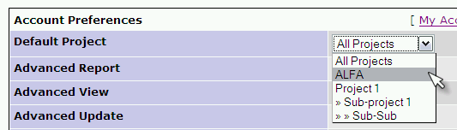
What Can be these preferences?
- On Login select Last test project used
- On Login select Default test project
How to implement this feature?
Adding new columns to the user table don't seem too clever.
new tables ?
preference_dict: the preferences that can be managed
ID, DESCR
example: 10, On Login select Last test project used
user_pref_cfg
ID , User ID, Preference ID, Preference Value

Permissions System
The permissions system will be overhauled in TL 1.7.
At the moment one can assign each user a role. This role is global, that means it applies to the user for all test project and all test plans.
This is not always practicable as one cannot limit user access to certain test project or certain test plans.
Also these roles are fixed in that way, that you cannot configure them in TestLink.
The permission system will be changed in several milestones:

Milestone1: Global but configurable
All roles are still global but one can configure them per GUI, also there will be a field which can be used for description and purpose of the roles. There will be a Role-Management Page where you can:
- Create new roles: The page shows the available rights of Test Link and one can simply assign (with a checkbox per each right) the right to the role. After editing the rights one can save the role with a name and description to the DB.
- Modify existing roles: The page shows a combo box containing the current roles, after selection a role the assigned rights are checked and the user change the assignment and either update the selected role or save it with a new name. If users have currently assigned the role which is modified a warning containing the users is given to the user and the user can either proceed or cancel update
- Delete roles: Deletes to role from the DB. If there are users which have this role currently assigned a warning containing all those users is given to the user and he has the choice to either delete the role and sets all those user roles to guest, or not deleting.
Tasks for this milestone:
- TODO: Either leave the current DB-Scheme regarding to roles and rights, or make a new vertical one
- The role management page has to be developed
- The user management page must be changed to show all roles which are currently stored.

Available functionality is control by user role. Default role is defined in configuration (e.g. Guest). Administrator can assign or change an every user role.

Features OUT OF SCOPE for TL 1.7

MHT: Later we should merge this section with previous. The information about what should be implemented in 1.7 must be stored in Release plan. This document should not double the information.
Francisco 20060212: this document can not duplicate info that not really don't exist yet. Just create a new document with SRS for 1.8 moving to that document what will not be implemented in TL 1.7, and then voilà this document will serve to scopes: SRS and Release plan, reducing the amount of work to be done.

Generalized Log/History System
Mantis uses the following table:
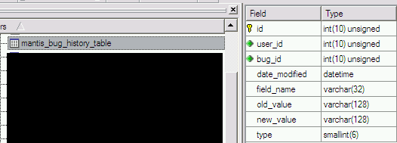
Bugzilla:
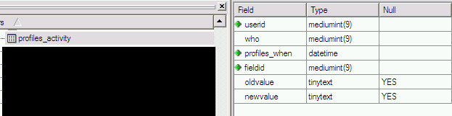

Email notification
E-mail notification for certain events is supported. Default notification settings are configurable via configuration. Each user can allow/disallow own notification.
This requirement is out of scope V1.7.
The next events should cause a notification:
- to TestPlan Administrator when milestone reached .
- to TestPlan Administrator when all test in a container have been run.
- to user monitoring this Test Plan when all tests have been run .
- TC assigned to tester.
- Review request.
Example:
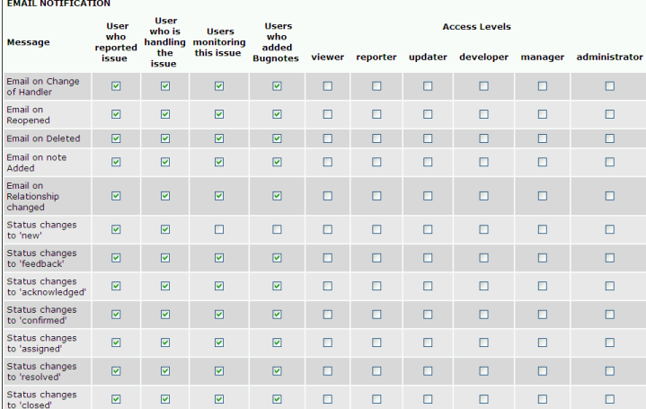Illustration 1: Mantis BTS manage automatic e-mail generation on different events.
is the configuration that will be applied to PROJECTS (remember main container / organization item in Mantis is the project).
This configuration is applied to USERS OF ALL PROJECTS, but can be OVERRIDEN for specific PROJECTS.
Each user can made changes specific to his/her account, see following image:
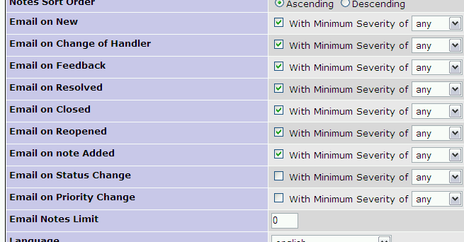

Test Plan Monitoring
In Mantis is possible for the user to ask the system to send e-mail automatically if some change is done to an issue.
Can be useful for TL a feature like this?
Examples :
I want to be informed when a Test Case in the Test Plan got status of Passed.

Never Discussed

Unique Test Case (external) Numbering inside Test Projects
Today the TC Specification number (the internal ID) is presented to the user.
Because this id is system wide, a set of TC spec for a test project can has very different numbers (example:1,2,78,89,200) depending
the activity of spec. writing of other test projects. This results in a bit of confusion for users.
Suggested:
add a numeric field (tcspec_counter) to every test project and display this number as the TCspec number instead of the internal ID.
add a new field to TC specs to hold the tcnumber inside test project.
All user searches by TC Id must be done using this new external ID.
Drawbacks: if possible create test plans using TCspec from different test projects.
Solution add new field test project Code that with the TCspec_counter value generate the external TCSPec code.
This is related to the external ID issue.

Configuration Option - Use Text Area without HTML Editor
Can be useful give this configuration option (SYSTEM WIDE => applies to all users)?

Appendixes
Revision history:
 | Description | Date | Authors
1.0 | Initial version of Next generation analyses | 2005/11/12 | Francisco Mancardi
1.1 | Update | 2005/11/12 | Francisco Mancardi
1.2 | Added images regarding execution history user interface | 2005/11/14 | Francisco Mancardi
1.3 | adding features from TL 1.7 test Plan document | 2005/11/15 | Francisco Mancardi
1.4 | Internal and External ID concept | 2005/11/20 | Francisco Mancardi
1.5 | Reorganization after receiving comments from Martin Havlat and Andreas Morsing. | 2005/11/27 | Francisco Mancardi
1.6 | Last revision before releasing to the public | 2006/01/04 | Francisco Mancardi
1.7 | Conversion to OpenOffice 2.0 format  Add comments; transform organization; added documentation rules | 2006/01/10 | Martin Havlat
1.7.1 | Corrected image import | 2006/01/16 | Martin Havlat
1.8 | Corrections related to new terminology and removed some items. Using verdana font | 2006/02/12 | Francisco Mancardi

