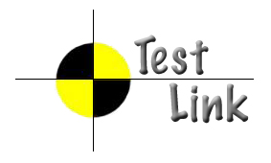
TestLink Design
Requirements management

Version: 0.4
Status: Updated

© 2009 - 2010 TestLink Community
Permission is granted to copy, distribute and/or modify this document under the terms of the GNU Free Documentation License, Version 1.2 published by the Free Software Foundation; with no Invariant Sections, no Front-Cover Texts, and no Back-Cover Texts. The license is available in "GNU Free Documentation License" homepage.
Revision History
# | Description | Date | Author
0.1 | Initial version | 20090401 | Francisco
0.2 | Added new considerations | 20090503 | Francisco
0.3 | Review | 20090513 | M. Havlát
0.4 | Format update; added requirements; added REQs relation analyse by Julian | 26/02/10 | M. Havlát

Introduction
This document should describe architecture, requirements and implementation of requirement management functionality in TestLink.

Terms and abbreviations
Requirement: A condition or capability needed by a user to solve a problem or achieve an objective that must be met or possessed by a system or system component to satisfy a contract, standard, specification, or other formally imposed document.
Functional requirement: A requirement that specifies a function that a component or system must perform.
Non-functional requirement: A requirement that does not relate to functionality, but to attributes such as reliability, efficiency, usability, maintainability and portability.
Requirements-based testing: An approach to testing in which test cases are designed based on test objectives and test conditions derived from requirements, e.g. tests that exercise specific functions or probe non-functional attributes such as reliability or usability.
Requirements management tool: A tool that supports the recording of requirements, requirements attributes (e.g. priority, knowledge responsible) and annotation, and facilitates traceability through layers of requirements and requirements change management.
Requirement Specification: a layer with collection of requirements.
Testable requirements: The degree to which a requirement is stated in terms that permit establishment of test designs (and subsequently test cases) and execution of tests to determine whether the requirements have been met.
Traceability: The ability to identify related items in documentation and software, such as requirements with associated tests.

GPL That license thing that means its free. Like TestLink is.
REQ Requirement
RMS Requirements Management System
ROUS Rodent of Unusual Size. (From the movie Princess Bride)
SRS System requirements Specification
TL TestLink
URS User Requirements Specification

Table of Contents
1. Introduction 3
Terms and abbreviations 3
2. Roadmap 6
2.1. TestLink 1.9 6
2.2. TestLink 2.0 6
2.3. TestLink 2.1 6
3. System Requirements 7
3.1. Requirement management 7
3.1.1. REQ Requirement management supported 7
3.1.2. REQ Requirement management rights 7
3.1.3. REQ Requirements organisation 7
3.1.4. REQ Requirement content 7
3.1.5. REQ Requirement type 7
3.1.6. REQ Requirements relations 8
3.1.7. REQ Requirement relations report (future) 8
3.2. Test case relation 8
3.2.1. REQ Traceability between requirements ans Test cases 8
3.2.2. REQ Requirement based report 8
3.2.3. REQ Ability to set expected count of related Test cases 9
4. Analyses 10
4.1. Analyse - External RMS collaboration 10
4.1.1. Background 10
4.1.2. Upgrading internal requirements management 10
Advantages 10
Disadvantages 10
4.1.3. Linking with external requirements management systems 11
Advantages 11
Disadvantages 11
4.1.4. Both upgrade and linking 11
Advantages 11
Disadvantages 11
4.1.5. Requirements Systems to link to 11
4.1.6. New option on test projects for requirement management 12
4.1.7. Discussions 12
4.1.8. Personal Critical Issues 13
4.2. Analyse- Requirements relations 14
4.2.1. Analyse by Julian ( 01/03/2010 ) 14
4.2.2. Character of Relations 14
Hierarchical relations 14
Flat relations 14
Default Set of Relation Types 15
4.2.3. Additional / Custom Relation Types 15
4.2.4. Extension of Requirement Search 16
4.2.5. Use Cases 16
Adding Relations while viewing Requirement 16
Adding Relations while editing Requirement 16
4.2.6. Analysis of Relations 17
4.3. Analyse - Requirement versions 17
4.3.1. Physical model TL 1.8 (no versions) 17
4.3.2. How to manage versioning? 18
4.3.3. Test specification data-model comparison 19
4.3.4. Test plan 19
4.3.5. Requirement specification 19
New model to manage requirements versioning 20
4.4. Analyse - Requirements Coverage 21
4.4.1. Discussion 21
5. Misc consideration 24
Appendix 25

Roadmap

TestLink 1.9

- Requirements versions
- Finish trees structure support for requirements throughout the rest of TL
- Requirements type implementation
- Ability to set expected count of TC for coverage
- Linking requirements

TestLink 2.0

- Req. Spec. Document generator refactoring

TestLink 2.1
- Synchronization with external requirements management systems. (URS #410)
- Review process

System Requirements

Requirement management

REQ Requirement management supported
TestLink shall manage requirements and organise them to Requirement Specifications. The feature is disabled by default on project level.

REQ Requirement management rights
TBD

REQ Requirements organisation
Requirements can be structured hierarchically (tree) into sections. Top level of tree are special sections called “Requirement Specification”. This level allows to be pointed as compact collection of requirements through the tool.

REQ Requirement content
Each requirement has the next parameters and abilities:
- DOC-ID – unique identifier for a Project
- Title – descriptive string
- Description – HTML formatted text
- Status – indicate validity of requirement (see review design for more)
- Type – basic category
- Expected coverage count – (optional) TBD

REQ Requirement Specification structure
Requirement specification consists from the next parameters:
- DOC-ID (string[64]) - mandatory
- Title (string[100]) – mandatory
- Description (HTML Text) – optional
- Expected count of REQ (INT) – optional (disabled by configuration)
- Type (INT) – unused (see 3.1.6. )
Requirement specification doesn't hold history (versions).

REQ Requirement Specification type
Req. Specification type is used to indicate process layers during development. Valid values for requirement specification are:
- Section (default) is structural container like Suite
- User Requirement Specification
- System Requirement Specification
User can add own types via configuration.
Terminology: We avoid terms like Product Req, Market Req. We uses ISTQB terminology by default. User can modify these term by custom_string.php.
To clarify: Technically there could be constrain, that only first level of tree could be URS or SRS and higher will be sections. It should help implementation.

TL 1.9 TODO: DB schema includes unused field type [char] – need to be redefined to INT before use (include migration

REQ Requirement type
TestLink allows to set category of requirement. Default types are:
- Functional (default)
- Non-functional
- Informational – this type causes that the requirement behaves as not-testable.
- Use-case – specific kind of functional type.
- Constrain – definition of functional limit
User can add own types via configuration. Help window shall be provided to explain types.
TestLink 1.8 and earlier versions recognize only two types (valid => functional, not-testable => informational).

REQ Requirements relations
User can define relations between requirements. The next relations are supported:
Hierarchical model:
- parent – child
- blocks – depends (specific subset of parent – child)
Logical model:
- “relates to” (unconditional relation)
Users can add new types via TL configuration.
Since TL 1.9 (? TBC); URS: #1748
TBD: Scope of default relations: conflicts, contains, refines, requires.
TBD: requirements or req. version should be linked?

REQ Requirement relations report (future)
User can generate a horizontal coverage report for any Requirement Specification with respect to another. The next sections and counters shall be available:
- Covered by child requirements
- Uncovered by child requirements
Note: Logical relations are not traced in the report.

Test case relation

REQ Traceability between requirements ans Test cases
User can connect and trace Requirements and Test cases with n..n relation. User can analyse which requirements are not covered. User can set any requirement as not testable.

REQ Requirement based report
User can generate a report for a selected Requirement Specification and Test Cases listed in the current Test Plan. The report shows for each requirement (include path) with coverage by all related Test Cases with result. The report is divided into sections:
- All passed test cases (per requirement),
- At least one failed Test case,
- At least one blocked Test case (and no failed),
- Not run Test cases (and no failed or blocked)
Metrics should be produced: count of all requirements in Requirement Specification, only passed, at least one failed, at least one blocked (no failed), not run or not fully run requirements and not covered requirements.
#3299 – the requirement need update regarding tree structure in TL 1.9 or 2.0

REQ Expected count of related Test cases
User can define expected count of Test cases to fully cover a requirement. The feature is disabled by default via configuration.
The parameter is used for coverage analyse. The analyse report shall indicate requirements that are covered only partly; i.e. the parameter value is larger than the current count of linked Test Cases.
A user can link more Test Cases than is expected. This information is notified on REQ view page (but not by Analyse).
#0003208: Usability: "Number of test cases needed"
Discussion:
Julian: I have to disagree to disable by default as this value can perfectly be used for reports. Please check “Requirement Overview”. There I can see the Coverage for each requirement if this value is defined!
Further more there is this feature “Overwritten count of REQs” for ReqSpecs - This is also not useful for everyone but it cannot be disabled. BTW could you please give this another label ? I did not understand what this feature means for a long time
Martin: Added requirement to hide “Expected count of requirements” as well.

REQ Expected count of requirements within a Requirement Specification
User can manually define an expected count of requirements to fully cover a Requirement Specification. The value affects metrics on the coverage analyse. The feature is disabled by default via configuration.
#0003317: Disable Total count of requirements be default
Use case: User can import/design only a part of requirements or some of requirements are obsolete/future but he need correct metrics.

Analyses

Analyse - External RMS collaboration
This analyse was done during 1.9 development (but not implemented in this release)
Name | Contact | Position
Martin Havlat | havlatm@seznam.cz | System owner – Functional
Francisco Mancardi | francisco.mancardi@gmail.com | System owner – Technical
Mark Butler | slow_steamer@yahoo.com | Aggravator
Stephan Meyn | smeyn@bigfoot.com | Co-conspirator
Andreas Schachl | aschachl@thegoldensource.com | Owner/Lead developer RTH
Table 1: Participants

Background
Which directions we might take the development effort.
Need to discuss advantages and disadvantages of each of the directions. Also need to keep in mind the concept of treating the existing requirements system as an external one.

From what I (Mark) can see there are three ways to interact with requirements from TestLink. One is where they are totally internal to TL. The expectation here is that everyone is going to manage requirements and their relationships to test cases in TestLink. Imports can happen but it’s a one time thing. The next is to do some kind of syncing of data with external systems. That means managers, developers, designers, or others, work in an external application(s) and then we try to periodically synchronize requirements in TL with whatever tool that is. An unlinked copy of the requirements are maintained locally. The third is to integrate with the external tool. Links between requirements and test cases would be maintained in TL. That would be a view only of requirements in TL. To modify the requirement the application it is in would need to be opened. A link could be provided in TL if the external tool allowed for that.

Upgrading internal requirements management
See bug list below for SOME of the considerations.

Advantages
- TestLink stays standalone. - consistent.
- Editing and other management of requirements is directly through the TL user interface.
- Feature set is in “our” control.

Disadvantages
- TestLink stays standalone – more work.
More to maintain which dilutes development efforts for the rest of TL.
- Would require a synchronization tool of some kind be developed to deal with situations where the entire process is not managed in TL.
- Lots of work.

Linking with external requirements management systems
See the table of potential systems below.

Advantages
- Takes advantage of someone else work for requirements management.
That includes major corporations such as Microsoft and IBM.
- Doesn’t require the entire organization to use TL.
In shops where testing and tools for it is an afterthought then integration would be doable.
- Systems are never out of sync.
There is only one instance of a requirement and it’s the same for everyone.

Disadvantages
- Users of TL would always need an external RMS.
Maybe not so bad a thing as there isn’t an internal bug system now.
- There is no end to external integrations.
We won’t be able to test all integrations with new releases.
- We’ll have to figure out a generic way to translate the way items in external systems are managed to one that makes sense in TL.
- Not a lot of active GPL RMS projects to integrate with out there.

Both upgrade and linking
Do both modifications. Keep and upgrade the internal RMS and also enable linking to external systems.
Consider making it so that both internal and external linking are treated the same. In effect, decouple the RMS in TL so that it actually must be configured to use the apparently internal functionality.

Advantages
- Best of both worlds

Disadvantages
- Lots and lots more work.

Requirements Systems to link to
A list of external requirements management systems that TestLink can or should integrate with based on known requests.
System Name | URL | Type | Comments
RTH – Requirements Testing Hub | http://sourceforge.net/projects/rth/ | GPL | Also written in PHP  Semi-alive project.  Has an API.
OSRMT - Open Source Requirements Management Tool | http://sourceforge.net/projects/osrmt | GPL | Written in Java  Semi-dead project.  I couldn’t find an API.
Requisite Pro |  | COTS | IBM  Had an API in the past.
DOORS |  | COTS | IBM (They just bought it)  Has an own API.  havlatm: I plan to investigate possibilities more. There could be external script that will check changes and update TL data. A direct connection is probably not possible.
TRAC | http://trac.edgewall.org/ | BSD | VERY popular development tool.  Would have to link to tasks of type Requirement.  There is an add-in that allows for parenting but it’s not native.
TFS – Team Foundation Studio |  | COTS | Microsoft.  Same issues with tasks as TRAC.

Notes on…
- COTS tools: I have no idea how we would go about getting a dev/test bed for any of these. Yes, I have an instance of TFS where I work but it’s an older version and we’re working away from it.
- Task based systems: Trac and TFS are both what I call task based systems. That is their primary focus. I think of them as bug tracking systems that can have different flags on the bugs.

New option on test projects for requirement management
As someone has suggested, may be we will need to add an attribute external_reqmgmt

external_reqmgmt=1
requirement management will be managed in an external system, then following TL feature will be disabled for target test project.

- Requirement import/export
- Req Spec management (will not be possibile navigate req structure on TL)
- Create Test Case from requirement.

Need to create a complete list.

User will interact with external RMS system in same way today he/she interacts with BTS, has links to launch native RMS GUI, and create coverage i.e. link a test case version to an requirement version ID (that is managed in an external system).

external_reqmgmt=0
Internal TL RMS code will be used, with the actual User Interface

Discussions
Topic Starter | Topic |  | Comments
Francisco | We maintain relationship between requirement and TEST CASE no TEST CASE VERSION.  Do we think this must be changed in future? |  | Mark: I am for keeping this relationship as is for now. I know that was one of the feature requests. Maybe we can get the same thing with a query where we check which version of a test case was in force when a particular version of a requirement was in force using the dates of the versions?  Martin: I agree to left the current relation ship for now.
Mark | In TL, the user would be able to see a list or tree of requirements. |  | Francisco: But if we use this solution I do not think how we can cover this Mark requirement.  Only way to do this is if external RMS expose a Web Service or have an API that allows TL to request Requirements tree.  Mark: Many of the other tools do have APIs. Check the table of external tools.  Martin: The code for an external RMS connector should care about tree in the case that this RMS supports it. Otherwise it will synchronize just the current node without inner nodes. We need to look at concrete cases.
Francisco | `srs_id` int(10) unsigned NOT NULL,  Attention: maybe in future must be removed and this information must be got from nodes_hierarchy.parent_id |  | Mark: I think it’s a good idea to do the move but will defer to whoever has better understanding. (I was kind of impressed with the concept of external parenting when I saw you had used it.)
Mark | What about “Suspect” links |  | Martin: Please clarify?

Personal Critical Issues
Issues or beliefs that individuals have that colour their perceptions and goals with this effort.
Mark:
- To me, no software development documentation system does what it needs to if management can not track from a test execution result back to the requirement stating the need for the tested feature. In other words each requirement must show it has a passed test result for it. I've found few systems that come close and have never used one that did it well. If TL could at least do that I think we would have added a whole lot of tool to the software development community.
- I HATE syncing things. I don’t want to try and build a stand alone RMS and then build tools to try and sync with external RMTs. One way synchronization is difficult, round trip is VERY difficult. They never seem to work right.

Analyse- Requirements relations

Analyse by Julian ( 01/03/2010 )
URS: #1748
It is necessary to define relations between requirements to avoid side-effects in developlment. There are a couple of standard relations we know from Mantis or Bugzilla like „is parent of“, „is child of“, „blocks“, „depends“, „is duplicate“, „has duplicate“ or a simple „is related to“.
Relations in my eyes should not trigger any special testlink behaviour. They only should help the user to keep the overview of all requirements to avoid side-effects or specifying things redundant. (see used by/ uses relation on chapter „Additional / Custom Relation Types“)

Character of Relations
There exist two sorts of relations that have to be used.

Hierarchical relations
Like parent-child relations this sort of relations express a hierarchy.
Example:
Requirement1 is „child of“ Requirement2
→ Requirement2 is implicitly „parent of“ Requirement1
This means if i add a hierarchical relation to Requirement1 the counterpart of this relation has to be shown for Requirement2

Flat relations
Relations that do not express a hierarchy.
Example:
Requirement3 is „related to“ Requirement4
→ Requirement4 is „related to“ Requirement3

Default Set of Relation Types
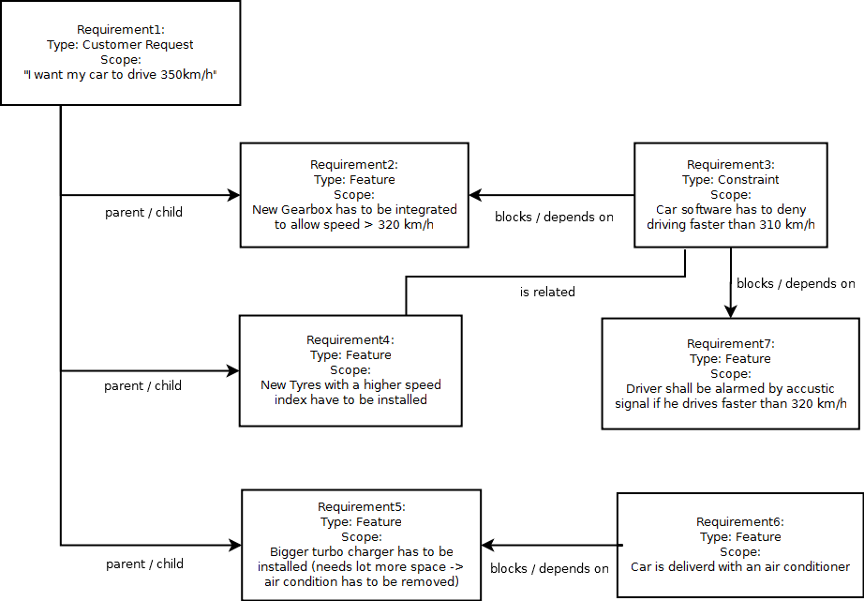
I tried to think of a scenario that uses all relation types mentioned above except of duplicate relations as those should be avoided in requirement management. Has to be decided if „is duplicate“ and „has duplicate“ should be a part of default relation types.

I suggest offerting this set of relations as „default relations“:
- parent of / child of
- blocks / depends
- is related to

Additional / Custom Relation Types
In many cases those default relation types are not enough. Here is a simple example for another relation type that makes sense.

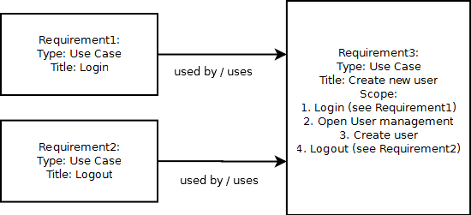
Relation types will be much more powerful if user has the option to define custom relation types to fit their own special situation. This is why i suggest to offer the possibility to define custom relation types to every user. It must be possible to define hierarchical and flat relation types.

Extension of Requirement Search
Requirement Search has to be extended to find requirements by relation type. The search should offer another drop down list containing all defined relation types.

Use Cases
Here i want to show some use cases how i personally would use relations between requirements.

Adding Relations while viewing Requirement
When viewing a requirement i want to be able to easily define relations – compare to „Mantis“

Adding Relations while editing Requirement
I also would like to add relations while i am editing a requirement.
- open requirement
- edit requirement
- describe a use case in scope
- come to the point where a relation to another use case has to be established
- define relation (e.g.: this use case USES use_case_login → Relation #1327)
- make a reference in scope to the relation (e.g.: now user has to login (see relation #1327)
I want to point out that it is very necessary to create links while editing and directly referencing those links in the scope of the requirement.

Analysis of Relations
The most powerful way to analyse relation types is by searching requirements that are in a relationship.
- Open Search Requirements
- Set relation type
Result now shows me all requirements that are in this relation. If i search for example for all requirements that block other requirements i get an overview of requirements that are in conflict with others (needs to be resolved).
Here again i can get great benefit of custom relation types because i can efficiently find those requirements in those (maybe very important) relations.

Analyse - Requirement versions

Physical model TL 1.8 (no versions)

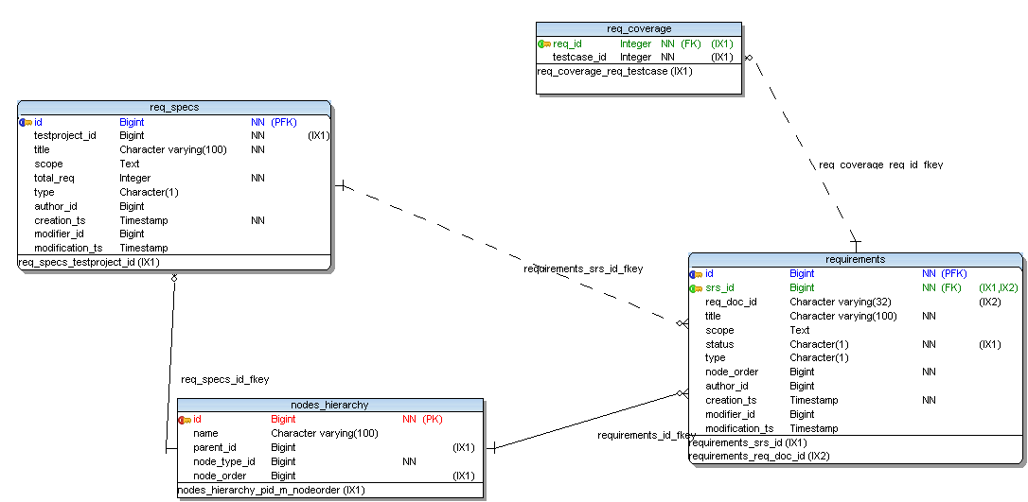
Figure 1 – physical model AS is

Before version 1.8 requirements specification can be structured in a flat way, where specifications can contain only requirements.
In this model parent-child relationship (req spec – requirement) was implemented linking table REQ_SPEC to table REQUIREMENTS using column REQUIREMENTS.SRS_ID.

After several user requests regarding possibility to structure requirements spec in similare way used to organize Test Suites and Test Cases, a decision was taken and a quick and dirty solution used.

Decision was: OK let's implement same N-depth tree model, then to reuse code, parent-child relationship will be stored on NODES_HIERARCHY table.
To avoid refactor of all requiremnt related features, old fields that express relationship WERE NOT REMOVED, and relationship was maintained SYNCRONIZED in TWO PLACES (this is the dirty part of solution).

Now that we want to add Requirement versioning concept, similar to Test Case Versioning, is time to clean up physical model with actions that will require refactoring and regression test of ALL REQUIREMENTS RELATED FEATURES.

First Action to be done

remove column SRS_ID from REQUIREMENTS TABLE that will change model depicted on figure one deleting dashed line between REQ_SPEC and REQUIREMENTS table.

This surelly will BREAK a lot of REQ method , but this is not a problem because we need lot of other changes.

Next Actions
Define new model to express relationships and versioning.

How to manage versioning?
In order to answer this question, can be a good to review tree types used by Test Link.
Every TEST PROJECT is parent of following trees or virtual trees:

- Test specification (Test project)
- Test plan (virtual tree)
- Requirement specification

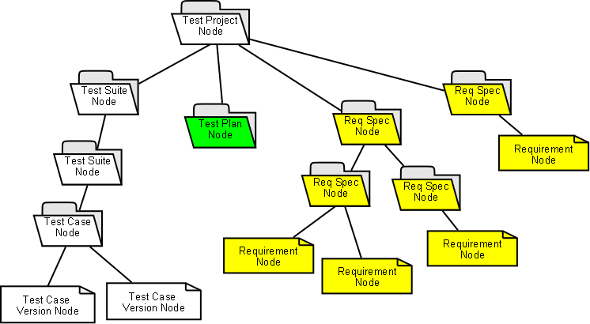
Figure 2 – proposed trees

Test specification data-model comparison
is a tree that has root node of type test project and have only one node of this type.
All other nodes on this tree are of following types:

Test Suite: a container of other Test Suites or Test Cases
Test Case: a cointainer of test case versions
Test Case version: the real leaf of this kind of tree.

When displaying this tree test case versions are NEVER DISPLAYED on tree structure.

Test plan
Test plan actually are subsets of Test case specification (Test project), and then a test plan is a test project CHILD.
We say that is a virtual tree because tree displayed at user interface (that normally is a different view of complete test project tree) is build “walking backwards” from leaves (test case versions linked to test plan) to root using data present on TESTPLAN_TCVERSIONS table.
We can not walk tree from root node (test plan) because this information is not present on NODES_HIERARCHY table.

Requirement specification
Can have several branches, than have as root Test Project node.
First level nodes are container nodes of type Requirement Specification.
Requirement Specification nodes can contain other container nodes ( Requirement Specification ) or leaf nodes (Requirements).
Francisco: is ok to use req spec node under first level req spec node, or can be useful to create a new node type called 'Req Suite' similar to 'Test Suite' ? What will be the attributes of this new entity?. IMHO we can live without it using only nodes of type “Req Spec”.
Martin: Test reports need to have the clear definition of valid list of requirements. There are two models:
- There will be two kinds of structural nodes: Req. Specification and Suite. Req. Spec. will be available in reporting for coverage report. Suite will serve the same way as Test suite.
- Tree will be structure just via Suites. Leader could define a new object: Baseline. The baseline will include all valid requirements for certain testing. Leader can connect a Test Plan with one requirements baseline and reports will be generated accordingly.
I personally vote for the second model, because it looks more flexible and elegant. On the other hand it means more work in the first phase.

New model to manage requirements versioning
In order to reuse code and experience done with Test Case versioning, we need to add to present requirements implementation a new node type: Requirement Version.
Then for Requirement specifications, tree will be:
On database we need to create a new table reqversions that will hold part of information today present on requirements table.
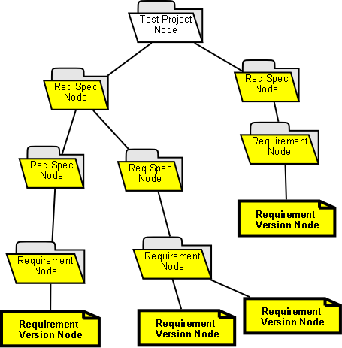Drawing 1: requirements version tree
Removing fields from existen tables and adding new table, will result in following physical model.
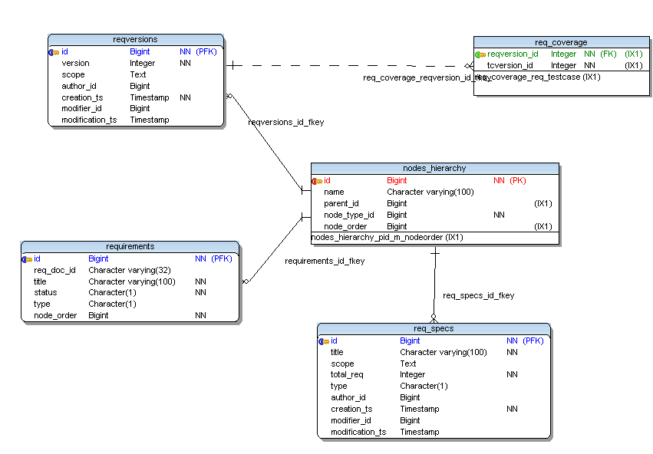Drawing 2: Requirements physical data-model (with versions)

Analyse - Requirements Coverage
REQ: User can define relationship between requirement and test case, and because we are not using test case versions, this means that we accept that ALL version of test case are covered by requirement.
REQ: The relation TCxREQ should have also own date value and user ID.
It could be useful for later analysis.

Discussion
If we plan to introduce requirement version and express coverage as a link between ONE requirement version and ONE test case version, how will change features like “display test cases not linked to requirement” ?
Martin: The latest versions of requirements will be proceed against any version of TC. Test case version update will create a new coverage relation to requirements based on user decision. Process should show him a list of connected requirements include information that there is a new version and allow to modify to the different versions or remove relation. I.e.
- if there are changes – a section with list of relations is shown in view/edit TC. All newer REQ versions are highlighted (compare modified_date).
- User can confirm or remove relation edit page.

Every time we will create a NEW test case version, this new version will be automatically liked to requirement version linked to test case we are using as starting point?
Martin: Meantime yes with respect to answer above.
Or new test case version will be considered NOT LINKED to a requirement version ?

Does this will not add a new level of complexity ?
Linking Requirements to test cases as was done till today, is not enough ?
Martin: answered above.
High level of attention must be taking with these decissions that can result in a lot of refactoring and regression test.
Martin: for this reason I agree to don't care about versions and hold direct connection TC to REQ.

After re-reading what was written before in this document, seems that a possible approach is going in direction taken for Bug Tracking Systems (BTS) integration:

- we will do not import requirement information on TL
- we will maintain only a link between external RMS and TL:

requirements coverage table, modeled in a similar way to bugs table

CREATE TABLE `execution_bugs` (
`execution_id` int(10) unsigned NOT NULL default '0',
`bug_id` varchar(16) NOT NULL default '0',
PRIMARY KEY (`execution_id`,`bug_id`)
) DEFAULT CHARSET=utf8;

then our req_coverage table

CREATE TABLE `req_coverage` (
`req_id` int(10) NOT NULL,
`testcase_id` int(10) NOT NULL,
KEY `req_testcase` (`req_id`,`testcase_id`)
) DEFAULT CHARSET=utf8 COMMENT='relation test case ** requirements';

Where req_id is a Foreing Key

will be changed to

CREATE TABLE `req_coverage` (
`rqversion_id` varchar(64) NOT NULL,
`tcversion_id` int(10) NOT NULL,
KEY `req_testcase` (`req_id`,`tcversion_id`)
)

rqversion_id will be the requirement id as present on EXTERNAL RMS System, then can not be FOREING KEY Anymore. I've called it rqversion_id to state clearly that we will link to a version of a requirement, if EXTERNAL SYSTEM is able to manage REQ versioning.

We also made a change on test case side, linking to a test case version and NOT to a test case.

To assign a requirement version (managed on an external RMS) to a test case we will need to work as we do with BTS, i.e. we will need to open a window into external RMS User interface to navigate requirements and choose one.

20090503 -Francisco

After given a look to UML sent by Martin Havlat, I would like to reconsider physical model, making it similar lo test specification model.
On test specification we have following hierarchy:

Test Project → Test Suites → Test Cases → Test Case versions.

Then on Requirements Specification model will be

Req Spec → Req Suites → Requirements → Req Versions.

There is on ly a difference, Test Project node has no parent (ok we can think parent is Test Link), while requirement specifications have a Test Project as parent.
Accepting this model figures 2,3 wil change an every folder/node of type Req Spec under the main Req Spec node, must be a Req Suite node. (Attention: when we all agree I will update figures).

Figure 4 (new physical model) need to be changed to add a new table (req_suites) with following simple structure: just a scope field (in the same way that happens for test suites table).

Misc consideration
Use-case: Linking to use cases and stories

Linking to text use cases and stories is something that needs to be considered. Some development shops don’t go very granular on requirements and utilize use cases and stories instead. (That’s the kind Mark works in.) It would be nice if TL could link to some kind of anchor in a use case and treat that like a requirement. We don’t know if this can be accomplished yet.

Appendix
Overview of open issues (18/03/10):

Id | Assigned To | Summary | Status
1748 | asimon | Requirement Management need to be improved with requirement relations between requirements | work in progress
3067 | asimon | Generation of Requirement Specification Document | assigned
3227 | asimon | New Feature Requirement Overview | assigned
3022 | fman | Option to import and export ALL req spec on a test project | assigned
3232 | fman | EXPORT / IMPORT XML - use for Requirements same pattern used for test cases | assigned
3142 | asimon | Req versions new attribute active | assigned
1871 | fman | import/export exigence | assigned
3108 | asimon | Generate Document must print tree like TC | assigned
2169 | fman | Export of requirements doesn't save Custom Fields | assigned
1571 | fman | Contribution: dirty Rational Requisite Pro integration | assigned
791 | fman | Search/Find test cases based on Requirement | assigned
3137 | Julian | Change of Requirement Specification Types | acknowledged
3194 |  | Allow to link requirement with keywords | acknowledged
2428 |  | Create requirement spec printout word format | acknowledged
2308 |  | Export requirements to CSV | acknowledged
1703 |  | Ability to set Priorities to requirements | acknowledged
2315 | fman | Field 'Document ID' for Requirement | acknowledged
1614 |  | Enhancement of "Requirements" funtionality (plan) | acknowledged
449 |  | Integrations for requirement management tools - like OSRMT | acknowledged
3238 | fman | Option to generate Document IDs automatically | feedback
3299 |  | Overall Requirement based report when using Several requirements levels | new
3284 |  | Auto Id for Requirement | new
3285 |  | Requirements based testplan | new
2890 |  | Unable to search Requirement ID via Filter | new
2556 |  | Requirement registration form is not re-populated after save failure | new
785 |  | Some kind of report or dashboard that flags when TCs need to be updated in response to a (linked) Requirement changing. | new
2565 |  | Auto-update in Requirement Specifications | new
1874 |  | Import status field | new

Based on ISTQB Glossary.
Custom test results are also listed there.

