TestLink 1.7 Reports Design Specification
6/11/2006
Kevin Levy

This document discusses the new TestLink 1.7 DB schema and how Result and Metrics reports will be generated based on this new structure. This is a work in progress.

Contents:

Section 1 – DB Schema Definitions
Section 2 – Tables which contain RESULT/METRIC data
Section 3 – Query Metrics Proposal
Section 4 – Logic and Pseudo - Code
Section 5 – Limited use of simple graphs using PHPGraphs

Section 1

This view of the DB schema is important because it shows how execution_logs (now called the executions table) is linked to testplan_tcversions, which are in turn linked to tcversions.

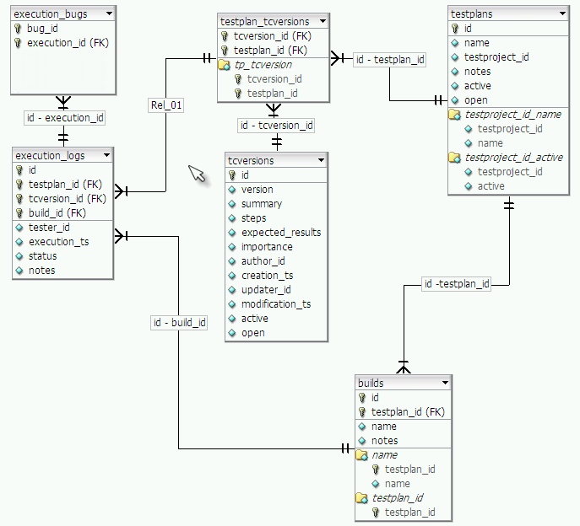
The following table relationships are key to understanding how structure is related to results:
executions_logs -> testplan_tcversions -> tcversions -> nodes_hierarchy

Figure A. shows the relationship of the executions table to the tcversions table.

SECTION 2 – TABLES WHICH CONTAIN RESULT/METRIC DATA

The executions table contains the information we will want to tally for report based data.
Here is the current definition of the executions table :

mysql> desc executions;
+--------------+------------------+------+-----+---------+----------------+
| Field | Type | Null | Key | Default | Extra |
+--------------+------------------+------+-----+---------+----------------+
| id | int(10) unsigned | | PRI | NULL | auto_increment |
| build_id | int(10) | | | 0 | |
| tester_id | int(10) unsigned | YES | | NULL | |
| execution_ts | datetime | YES | | NULL | |
| status | char(1) | YES | | NULL | |
| testplan_id | int(10) unsigned | | | 0 | |
| tcversion_id | int(10) unsigned | | | 0 | |
| notes | text | YES | | NULL | |
+--------------+------------------+------+-----+---------+----------------+
8 rows in set (0.00 sec)

The execution_bugs table simply links to a bug_id.

mysql> desc execution_bugs;
+--------------+------------------+------+-----+---------+-------+
| Field | Type | Null | Key | Default | Extra |
+--------------+------------------+------+-----+---------+-------+
| execution_id | int(10) unsigned | | PRI | 0 | |
| bug_id | varchar(16) | | PRI | 0 | |
+--------------+------------------+------+-----+---------+-------+

The builds table has info on the builds associated with a particular testplan.

mysql> desc builds;
+-------------+------------------+------+-----+-----------+----------------+
| Field | Type | Null | Key | Default | Extra |
+-------------+------------------+------+-----+-----------+----------------+
| id | int(10) unsigned | | PRI | NULL | auto_increment |
| testplan_id | int(10) unsigned | | MUL | 0 | |
| name | varchar(100) | | | undefined | |
| notes | text | YES | | NULL | |
+-------------+------------------+------+-----+-----------+----------------+
4 rows in set (0.00 sec)

FIGURE B. - This schema demonstrates how tcversions are related to the nodes_hierarchy table. (testcases is no longer part of the schema) The nodes_hierarchy table is table which defines all structural associations between testprojects, testplans, testsuites, testcases, and tcversions.

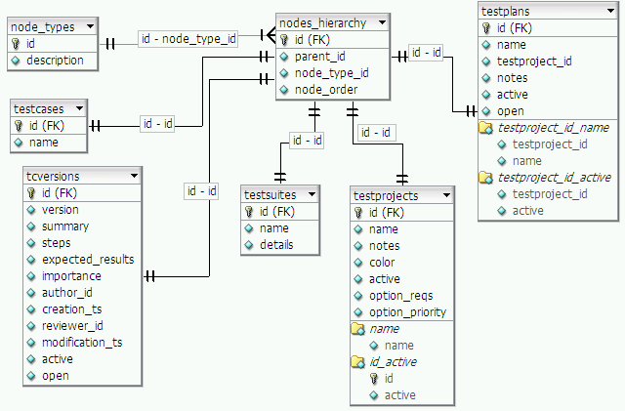

SECTION 3 : TestLink 1.7 Query Metric Proposal

The report I will first attempt to 1.7 will be the query metric report because it is the report I am most familiar with. The hope is by coding this report well, other reports can be built using the methods created during this construction.

The first change that must be considered is the fact that multiple level deep test suites are now allowed. The UI should be constructed so that the user can drill down deep into a path if they choose, but not be forced to see all the data if they choose not to.

There will be 2 pages associated with the query metrics report. The first page will be the page the user can choose their query options. The second page will display the data.

I will focus on how the second page will be constructed in the simplest condition – by initially displaying the 1st level deep of test suites and test cases which are children of the Test Plan node. Test Cases will have the execution rows associated to them displayed underneath them. Test Suites will display their aggregate result data.

The purpose of displaying this UI is not a final UI but only for the purposes of discussing the DB queries and logic necessary to get the data we need. This is to start thinking about the methods needed and what data structures will be needed to pass onto Smarty templates for the GUI layer to display.

Proposed UI :
==========================================================
Test Plan Name – %not run, %pass, %fail, %blocked
Test Suite 1 - % not run, % pass, % fail, %blocked
Test Suite 2 - % not run, % pass, % fail, %blocked
Test Case 1 – last result, date last run, last user executed, list of executions
Test Case 2 – last result, date last run, last user executed, list of executions

SECTION 4 – LOGICAL STRUCTURE – PSUEDO - CODE

A key difference between 1.6 and 1.7 is that in 1.7 the organizational structure of a test plan is the same as the test project. I will need to retrieve the tree structure for the test project, which will contain test suites, test cases, and test case versions – which are ultimately linked to execution results.

It's important to understand how the test plan is related to the testproject. A test plan is a child of a test project in terms of the nodes_hierarchy table.

We will be able to determine the current test plan, and testproject ids using:

$testprojectID = isset($_SESSION['testprojectID']) ? $_SESSION['testprojectID'] : 0;
$testplanID = isset($_SESSION['testPlanId']) ? $SESSION['testPlanId'] : 0 ;

The nodes_hierarchy table consists of rows of varying node_types. It's important to understand the relationships between these node types.

A testproject can be the parent of testsuites, testcases, and testplans.
A testsuite can be the parent of testsuite and testcases
A testcase can be the parent of testcase_version

Traversing the tree will mainly be making queries from the nodes_hierarchy table.
We will know what a node is by inspecting nodes_hierarchy.node_type_id.

mysql> select * from node_types;
+----+------------------+
| id | description |
+----+------------------+
| 1 | testproject |
| 2 | testsuite |
| 3 | testcase |
| 4 | testcase_version |
| 5 | testplan |
+----+------------------+

Now it's time to look down the tree from the top level node. We will want to tell the difference between test suites, test cases, and test case versions.

Goal of code – build out a tree with result information attached to each test case version.

1. Build a tree of test suites and testplan_tcversions
2. Attach information from executions, execution_bugs tables
3. Perform aggregation calculations – attach object to each testsuite node which describes summary statistics for that test suite.

function buildTree($testplanID, $nodeId){
/**
* tree will consist of array of objects typed “resultNode”
* resultNode has 4 fields –
* nodes_hierarchy.id
* nodes_hierarchy.name
* nodes_hierarchy.node_type_id
* $arrayOfResultNodes
*
* The last field will be null if the node_type_id = 4 -> testcase_version
* If node_type_id = 2 -> testsuite, that testsuites children will be stored in
* an array of resultNodes.
*/

// the list of resultNodes objects will have the 1st 3 fields defined, but the forth
// field, $arrayOfResultNodes, will need to be populated by logic in this function
$listOfResultSuiteNodes = getNodesForSuite($nodeId);

// recursive call will only be made if the node is a testsuite node
foreach $resultNode in $listOfResultTcNodes {
// recursive call
$branch = buildTree($testplanId, $nodeId);
// $branch is an array of nodes contained in the testsuite
$resultNode.setArray($branch);
}

// getTcVersions will return list of resultNodes, the 4th field – the array,
// will be set to null
$listOfResultTcNodes = getTcVersions($nodeId, $testplanID);

$tree = $listOfResults + $listOfResultTcNode;

return $tree;
}

1.
get testsuites in current testsuite

function getNodesForSuite($parentNode) {
select nodes_hierarchy.id from nodes_hierarchy where nodes_hierarchy.parent_id=$ parentNode AND node_type_id=2;
// notice note_type_id = 2 is a testsuite type
}

mysql> Select nodes_hierarchy.id, nodes_hierarchy.name from nodes_hierarchy where nodes_hierarchy.parent_id=1 AND node_type_id=2;
+----+-----------+
| id | name |
+----+-----------+
| 2 | suite 1 |
| 3 | suite 2 |
| 13 | suite 1.2 |
+----+-----------+
3 rows in set (0.00 sec)

2. get testcases in current testsuite
Retrieve testcase for test suite (node_type_id = 3 --> testcase)

function getTestCasesInSuite($suiteID){
select nodes_hierarchy.id, nodes_hierarchy.name from nodes_hierarchy where nodes_hierarchy.parent_id = $suiteID AND node_type_id = 3;
}
$suiteID = 2
+----+-------------------+
| id | name |
+----+-------------------+
| 10 | test case 2.1.1.1 |
+----+-------------------+

3. get testcase versions that belong to the current test plan
Retrieve testcase_version (node_type_id = 4 --> test case version)

function getTestCaseVersions($testCaseNodeID){
select nodes_hierarchy.id from nodes_hierarchy where nodes_hierarchy.parent_id = $testCaseNodeID AND node_type_id = 4;
}

$testCaseNodeID = 10
+----+
| id |
+----+
| 11 |
+----+

4. get execution results
Retrieve executions for that tcversion

function getExecutions($tcversion_id){
select * from executions where tcversion_id = 11;
}

SECTION 5 – Limited Use of PHP Graphs

PHPCharts is a nice tool that we could probably use on a limited basis. I believe the need for very simple graphical charts in TestLink Results should warrant the use of this tool.
http://www.phpcharts.se/index.php?treeviewid=treeviewmain&nodeid=phpcharts1&siteid=7

I have done some initial investigation and have liked the results. We will just introduce the use of pie charts displaying pass, fail, not run, and blocked percentages for any given query results.

The figure below demonstrates the use of this code with our Smary template GUI architecture:
