TestLink Detailed Design
Review process feature

# | Description | Date | Author
0.1 | Initial draft | 18/07/09 | M. Havlat
 | Review | 07/24/09 | F. Mancardi
0.3 | Update after review | 03/08/09 | M. Havlat

© 2009 TestLink Community
Permission is granted to copy, distribute and/or modify this document under the terms of the GNU Free Documentation License, Version 1.2 published by the Free Software Foundation; with no Invariant Sections, no Front-Cover Texts, and no Back-Cover Texts. The license is available in "GNU Free Documentation License" homepage.

Introduction

Scope
Review is basic process to assure quality of testing and satisfy standards.

The purpose of this design review is to give your team a chance to look over the design document before it is turned to final version for using. Remember, the purpose of a review is to raise problems with the artefact under review, not to solve those problems. The important result of a review is a list of issues/problems to be prioritized and followed up after the review.

Reference: ISO 10005:2005

Implementation Plan (TL 1.9)
Phase 0. - agreed design
Phase 1. - option to allow review process for a project, new rights
Phase 2. - possibility to add a Test cases review
Phase 3. - approve Test cases (status Final)

Tracking
0001810: Test Specification audit (maintain review process)

Terms
Approver – an user with project_approve right can approve using data for work. For example test case could be used for test execution.
Reviewer – an user with project_review right can review text (mark as ok or add comment)
Designer – an user with edit a reviewed text right can modify text for review

Functional Requirements: Review process feature

REQ Review availability
Document review process will be optional feature, disable by default.
Document review process feature will be a project feature.
Then at user interface level user while creating a project will be presented a new option:

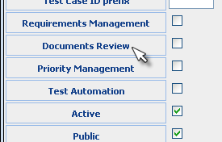

It could be enabled per project for particular documents. The next text objects are supported for review:
- Test case,
- Requirement,
- Test Plan.

Test Case review should be implemented in 1.9 version (other later).

REQ Review relation to Text status
Text object can receive the next states:
- Draft – initial status indicates that text is not ready for review
- Review – text is ready for review
- Final – text passed review process successfully
- Obsolete – text does is not available for work
- Future – text does is not available for work
Status Draft is default DB (showed as 'Valid') and Obsolete are offered if review process is disabled.

REQ review rights
Two rights are available:
- project_review – role with the right create a review for a text object
- project_approve – role with the right can set status Final
User with right to edit text can set the all statuses except Final.
Test analyst, leader and Admin have project_review right. Test Leader and Admin have project_approve right.
TBD: do we need extra rights for particular object? i.e. different right for TCs and REQs. Havlatm: I think not (to stay simple).

REQ Review disabled behaviour
Status Draft, Review and Final is externally visible under term 'Valid'. Status Valid, Obsolete and Future are offered for users if review process is disabled.
TBD: Requirements already offer status 'Valid' and 'Not testable'. We need to consider migration to a new terms. Havlatm: Use term 'Type' instead of status. Requirements can received types according to common standards. For example: info (=not testable), functional, use case, etc.

REQ Review process
A reviewed text can have none, one or more reviews. One or more reviewers can create one or more reviews for one text object. Initial review result could be positive (review status = “passed”) or negative (review status = “failed”).
A text under review can have a status final if at least one positive review result exists and no other.

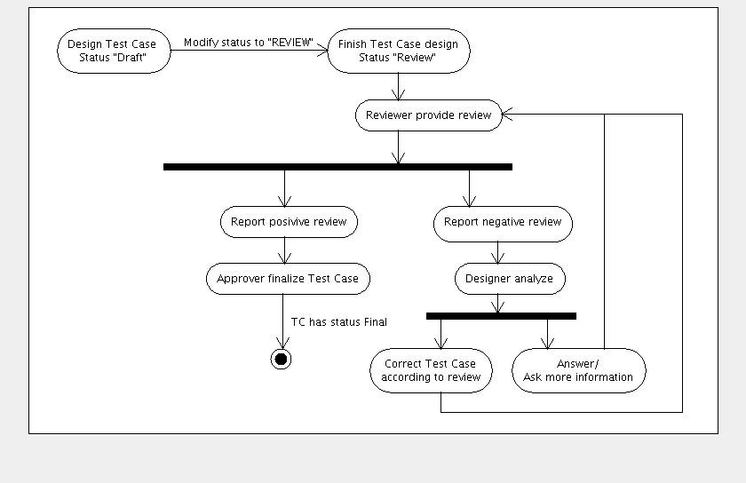
For example: Test case can have two negative comments from one reviewer and one positive review comment from another reviewer. This means that test case should not be used for testing (added to Test Plan).

REQ Review status
There are three review states of a review record.
Review status “Passed” indicates that a reviewed text could be finalized. It says that reviewer checked the related text and he is happy with.
A text with at least one review status “Failed” blocks a possibility to change the text status to Final. Reviewer want a modification of the related text or explanation.
Review status “Verify” means that a designer fixed or responded the review text. The reviewer should confirm (review status = “passed”) or reject (review status = “failed”) reaction on the review record.

Note: Review status and text status are different things.

REQ General review notes
Reviewer can add general review note (not related to a specific text but a parental object).
Havlatm: how to case review notes that are not related to any exact text object? For example: review is related to a missing TC – could not be related to any existing TC. No generic idea – we probably should use Test Suite to hold review notes.

REQ Negative review procedure
Reviewer must add a text with description of problem, assign owner and status Failed. Optionally can define type of problem (undefined is default).
GUI should offer a list of users with edit the related text rights. User who the last updated the text is pre-selected (should be author if no update).
Users with rights edit object, project_review or project_approve right can add a new note, modify the assigned user, and review status to 'verify' (response or fix applied) or 'failed'. Only Users with project_review or project_approve rights can set the review status to 'passed'.
Review page displays description and no, one or more notes. Each note has visible time-stamp and author. Author can edit or delete own notes. Review notes are plain text.
Such behaviour is similar like in many projects as bug trackers, forums, etc. Notes could be stored in review.notes text field.

REQ Review notification
GUI offers a notification for create a negative review, new notes and changes of review status
- A designer (assigned fixing user),
- A reviewer,
- Anybody who added note or monitor issue.
Email notification includes a link to review page, notes and status. Email subject should indicate that review created or new note added or status changed.

TestLink doesn't hold information who should review what. Test manager can send an email notification to particular users only. Anybody who have rights can review texts with REVIEW status.

REQ Review logging
TestLink traces information in audit log (review status changed or created, a text status changed). Logged information: TC title + review result or a text status.

REQ Test Case review process
Test Case version can be reviewed. Only Test cases version with status final can be added to a Test Plan. Update of Testing set indicates final versions too.
Note, that already added TC remains valid for a Test Plan.
Status replaces the feature activate/deactivate Test Case version. TBC by Francisco.

REQ Test case review management
An user with either view TCs, project_review or project_approve right can see a page with overview of review progress. The page offers metrics: Count of TCs without review, Count of TCs with particular review states (passed only, at least one failed, at least one verified). The page is related to a Test Suite (include inner suites).
An approver can approve all TCs in a Test Suite with only passed review result(s) by one click. i.e. TC status is modified to 'Final'.
The user can send a notification request for review of a current Test Suite (a predefined localized text is possible edit before send).

REQ Test case review support
Reviewer can see a list of all own TC reviews with status 'Failed' or 'Verify' in the current project. He can also select the same report for other users with the same right. The user is able navigate to the listed reviews from the report.

REQ Test Case status navigation
Test Specification have a filter for TC status.

REQ Test case status constrain
A new TC version is created automatically if user choose to edit final version of TC.

Disagree, why can not set STATUS to DRAFT and start a new review process without having to
create a new version

REQ Review Report
User can generate a document with overview about review process for particular feature (for example Test Specification). The report should include the next information for each note: reviewed object title, review type, status, review note, reviewer, assigned designer and create date.

REQ Simple review process
Some companies could use simplified review process.
TBD: Think how to simplify more; should be some of the next points default behaviour?
The next option should simplify process to achieve maximal usability. The behaviour depends on general configuration.
- Approver can finalize also text objects not-reviewed and/or with review status is 'verify'. He should be clearly notified which texts are not fully reviewed.
- Review verification is optional. Assigned designer could set a review as passed directly. Generally such case happens if the user has right both edit and review text. The case should be related to case that designer has edit text right only.

Detailed Design

Database schema changes
Tables tcversion, testplan, requirements
- status ENUM("DRAFT", "FINAL", "FUTURE", "OBSOLETE", "REVIEW") NOT NULL default "DRAFT";

TODO: ENUM → CHAR[1] (not supported by mssql)

Review table
- text_type ENUM("TESTCASE", “TESTSUITE”, "REQ", “REQSPEC”, "TESTPLAN");

ANOTHER ISSUE HERE YOU HAVE NOT READ carefully actual schema where we have used for this kind of field node_type as name.

Then I will use node_type that will be FK on nodes_types.
Martin: Ok. To use node_types

- text_id [int] not null

this field must be rename to node_id or object_id.

- reviewer_id [int] not null FK ; [~ users.id]
- create_ts [datetime]
DO NOT FOLLOW CURRENT STANDARD must be creation_ts

- author_id [int] not null FK ; [~ users.id]

What is difference between reviewer_id and author_id ?
NOT CLEAR NEED MORE DETAILS .
Martin: author_id … could be designer_id – generally who is supposed to fix the text if review is negative

- notes [text]
- update_ts [datetime]
DO NOT FOLLOW CURRENT STANDARD must be modification_ts

- status ENUM("PASSED", "FAILED", "VERIFY") NOT NULL default "PASSED",

AGAIN ENUM NOT OK
CAN CREATE review_status master data and use FK. Field must be INTERGER TYPE

- type ENUM("UNDEFINED", "TYPE", "RECOMMENDATION", "QUESTION", "UNCLEAR", “MAJOR”) NOT NULL default "UNDEFINED";

AGAIN ENUM NOT OK
CAN CREATE review_type master data Field must be INTERGER TYPE

DO not think TYPE express field usage.
In addition RANGE IS NOT CLEAR => need more details
Martin: TODO add REQ with the list (explanation is out of scope)

- ??? project_id (havlatm: not sure if we need it to improve performance for lists)

Configuration changes
TestLink review process requires the next configuration:
- text object states
- review types
/**
* data status constants are applicable for data like requirement, test case
* <b>Warning: keys must be compliant with ENUM values for DB tables</b>: tcversions, requirements, testplan
*/
/** Review status: data was reviewed and are available for using */
define('TL_REVIEW_STATUS_FINAL', 'FINAL');
/** Review status: design phase; data are not available for review or using */
define('TL_REVIEW_STATUS_DRAFT', 'DRAFT');
/** Review status: data wait for review */
define('TL_REVIEW_STATUS_REVIEW', 'REVIEW');
/** Review status: data are not applicable for using (not listed in reports and lists) */
define('TL_REVIEW_STATUS_OBSOLETE', 'OBSOLETE');
define('TL_REVIEW_STATUS_FUTURE', 'FUTURE');

DO NOT LIKE, DO NOT UNDERSTAND WHY have to declare CONSTANTS
AND THEN cfg for localization
Simpler approach using naming standard for TL_ strings

$tlCfg->workflowStatusCode =
array('draft' => 1, 'review' => 2, 'final' => 3,
'obsolete' => 4, 'future' => 5);

if you accept that TL_ strings are created this way
TL_configStructure_key
then
on this example we need to create on strings file
TL_workflowStatusCodedraft='Draft';
TL_workflowStatusCodereview='Review';
TL_workflowStatusCodefinal='APROVED';

When you get value for DB and you want to get label
is enough
$codeStringKey=array_flip(config_get('workflowStatusCode'));
$label = lang_get('workflowStatusCode' . $codeStringKey[$valueFromDB]);

Or if you want we can create a new function or method in a class that can return alllabels
$workflowLabels = getLabels('workflowStatusCode');

/* return map with strings translated (using lang_get()) to be used on user
interface for a Test link configuration option that is structure in this way:
config_option=array( string_value => any_value, ...)
All this works if TL_ strings defined on strings.txt follows
this naming standard.
For a config option like:
$tlCfg->workflowStatus=array('draft' => 1, 'review' => 2);

will exists: $TL_workflowStatus_draft='...';
$TL_workflowStatus_review='...';

@param string configKey: valus used on call to standard test link
method to get configuration option
@param string accessMode: two values allowed 'key', 'code'
indicates how the returned map must be
indexed.
'key' => will be indexed by string
value that is key of config option
'code' => will be indexed by value of config option
@example
$tlCfg->workflowStatus=array('draft' => 1, 'review' => 2);
$i18nlabels = getLabels('workflowStatus','key');
array_keys($i18nlabels) will return array('draft','review');

$tlCfg->workflowStatus=array('draft' => 1, 'review' => 2);
$i18nlabels = getLabels('workflowStatus','code');
array_keys($i18nlabels) will return array(1,2);
*/
function getLabels($configKey,$accessMode='key')
{
$stringKeyCode=config_get($configKey);
$labels=null;
foreach( $stringKeyCode as $accessKey => $code )
{
$index = ($accessMode == 'key') ? $accessKey : $code;
$labels[$index] = lang_get($configKey . '_' . $accessKey);
}
return $labels
}

/**
* @var array localization identifiers for review statuses
* @since 1.9 review process is not implemented yet (1.8)
**/
$tlCfg->text_status_labels = array(
TL_REVIEW_STATUS_DRAFT => 'review_status_draft',
TL_REVIEW_STATUS_REVIEW => 'review_status_review',
TL_REVIEW_STATUS_FINAL => 'review_status_final',
TL_REVIEW_STATUS_OBSOLETE => 'review_status_obsolete',
TL_REVIEW_STATUS_FUTURE => 'review_status_future');

IS NOT CLEAR IF THIS VARIABLES AND CONSTANTS ARE RELATED TO THIS DEVELOPMENT
SEEMS NOT => NEED MORE DETAILS

/**
* Types of requirements (with respect to standards)
* <ul>
* <li><b>Info</b> -informational character, project and user documentation.
* The type is not testable = not used for testing logic (except metrics).</li>
* <li><b>Feature</b> - valid and testable functional definition (default selection)</li>
* <li><b>Use case</b></li>
* <li><b>Interface</b> - user interface, communication protocols</li>
* <li><b>Non-functional</b> - performance, infrastructure, robustness, security, safety, etc.</li>
* <li><b>Constrain</b> - Constraints and Limitations</li>
* </ul>
**/
define('TL_REQ_TYPE_INFO','INFO');
define('TL_REQ_TYPE_FEATURE','FEATURE');
define('TL_REQ_TYPE_USE_CASE','USE_CASE');
define('TL_REQ_TYPE_INTERFACE','INTERFACE');
define('TL_REQ_TYPE_NON_FUNCTIONAL','NON_FUNC');
define('TL_REQ_TYPE_CONSTRAIN','CONSTRAIN');

/** @var array localization identifiers for requirements types */
$tlCfg->req_cfg->type_labels = array(
TL_REQ_TYPE_INFO => 'req_type_info',
TL_REQ_TYPE_FEATURE => 'req_type_feature',
TL_REQ_TYPE_USE_CASE => 'req_type_use_case',
TL_REQ_TYPE_INTERFACE => 'req_type_interface',
TL_REQ_TYPE_NON_FUNCTIONAL => 'req_type_non_functional',
TL_REQ_TYPE_CONSTRAIN => 'req_type_constrain');

GUI design: Test Case with review functionality
TC version Status is available as Combo-box with all values except 'Final' in the Edit TC page. Previous value is pre-selected.
User with project_approve right can see a button “Approve” in the View TC page if no review with status 'failed' or 'verified' is assigned.
User with TC view right can see all information about reviews. The review list is available on the TC view page: status, reviewer, fixing user and 50 characters of text. The list is interactive – user can see all review info in a widget.

Review, discussion and questions
Requirements and design to be clarified:
TODO later: TC status could change on updated associated requirement
Fman: My very first request is please write with more detail, and add as much examples as possible.  We can use UML diagrams when we reach final point, but meanwhile I think free style can be useful. | Martin: Rejected. We have a time for basic design; not detailed.
Roles for this process (forgetting TL concept of roles) must be clearly defined.  This info is not enough:  Approver – an user with project_approve right  Reviewer – an user with project_review right  Designer – an user with edit a reviewed text right  detail of what actions every role can do must be written. | OK. text improved
- review will be done only by ONE PEOPLE, or must be DONE by several people ? | OK. Both is possible - Updated req.
please enable OpenOffice Versions, | I recommend to use Edit->Changes->Record = On
We need a general description of this process before start talking of technical details.  This is what I have understood. | OK. Updated Scope section.
MAJOR  Documents (objects) to which review process must be applied  A clear detail of what review means for each document must be written.  Example for a Test plan what does means review?  Analize test plan description  Analize test case assigned to test plan  Analize testers assigned to test cases  Analize platform assigned | Martin: TODO
What will be the outcome of reviewer activity  Will be add notes with comments related to document who review was requested ? | TODO - add future REQ  Martin: I don't care in this phase … only email and event log is used for. Of course we should have a table with job assignment. i.e. similar like test execution assignment; check dotProject for appropriate functionality design
Review result could be positive (review status = “passed”) or negative (review status = “failed”).  This statuses has not been explained before .  Are their part of these set of statuses ?  - Draft – initial status indicates that document/object is not ready for review  - Review – document/object is ready for review  - Final – document/object passed review process successfully  - Obsolete – document/object is not available for work  - Future – document/object does is not available for work | OK. Updated requirement. Anyway “Review status” is the next requirement.
REQ Review process  A reviewed text can have none, one or more reviews.  Not clear explain with example  One reviewer can create more reviews for one text object.  Not clear explain with example | OK. Added example.
Workflow must be configurable  this means transitions from one status to other. As usual at implementation level best thing is to read Mantis one. | TBC reject  Martin: workflow of Mantis should differ for different companies. Review process is more simple.  I have discussed review process with colleagues that uses another professional tool with review support. Generally teams that apply a review in the tool uses notes only (without functionality of the implemented review support). i.e. we should stay really really simple if the feature should be usable.  Let me know exact point. I do not see a reason.
Log of review events  Review events has to written to a different event table or must be tagged as not deletable ?  What do you want to log ? Explain. | OK. Moved text to added: REQ Review logging
Documents review/authorization process overview  Documents must follow an review/authorization process before being ready to be used on different features.  The live cycle for documents that need to be reviewed/authorized will be:  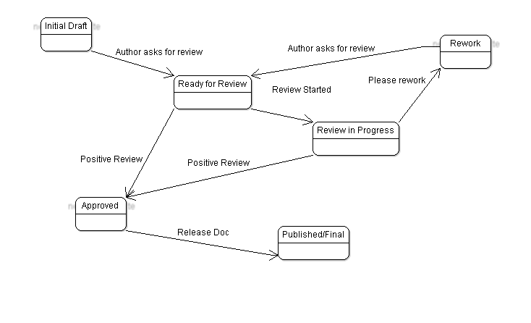  In order to be able to be used on different feature, documents must be reviewed. | Comment to picture: Technically Draft and rework are the same & Ready for review and Review in Progress are also same state.  Review is short time process and MUST be simple.  I believe that the doc is compliant with the review text by Francisco.
Ready for Review Documents can not be edited or deleted or moved (test cases), but can be copied | Rejected. Martin: such constrains brings more work without significant benefits. I can grant that user will complain to disable such limits.
User A creates a Test Plan, system automatically assigns DOCUMENT WORKFLOW STATUS ( I would like to use this term) equal DRAFT.  After a certain amount of time, User A feels his/her work is good enough to be review then he/she set DOCUMENT WORKFLOW STATUS = WAITING FOR REVIEW.  Q1.we will have people with REVIEW grant/right than can take documents from the REVIEW QUEU, assigning document to himself/herself ?  Q2.alternative to Q2, we will have people with REVIEWER LEADER grant/right, and he / she will assign document for review to other people with REVIEW. | Added a note to Notification requirement:  TestLink doesn't hold information who should review what. Test manager can send email notification to particular users only. Anybody who have rights can review texts with REVIEW status.
Q1.if review will be done by several people, how will be acceptance criteria all must say OK in order to change DOCUMENT WORKFLOW STATUS to ACCEPTED, or the first reply received will be used to set DOCUMENT WORKFLOW STATUS ? | OK. Updated REQ Review process
If DOCUMENT WORKFLOW STATUS = ACCEPTED then DOCUMENT can be published setting DOCUMENT WORKFLOW STATUS=FINAL.  Who will responsible of publication: author or reviewer ? | Reject. Martin: we need not extra status ACCEPTED.
If DOCUMENT WORKFLOW STATUS has been set to FINAL, document can be edited or became READ ONLY ?.  Remember that people is asking for editing Test Case Spec while executing. | TODO  TC, REQ: edit will create a new version. This new version is draft. So invisible for update until review and approve will be applied.  Test Plan: status Final should means read only for Testing Set and TP description.
DOCUMENT with WORKFLOW STATUS=FINAL what statuses can be setted :  OBSOLETE  DRAFT (if you want to edit and restart review process) | TODO  No limit for approver and designer.
FIRST PROBLEM WE CAN USE ENUM FIELD TYPE ONLY IF SUPPORTED BY ALL OUR SUPPORTED DB  MSSQL 2005 do not support it  POSTGRES needs to define a new data type  (CREATE TYPE mood AS ENUM ('sad', 'ok', 'happy'); | TODO  OK. ENUM → CHAR(1)
Then IMHO is better if we want to maintain a set of values create a master data table  workflow_status as we have done with nodes_types and set a FK to this table from new field to this table. | Rejected. Martin: No plan to modify significantly workflow. Consts are suitable.
=> if FK PROBLEMS WITH DELETE USER | TODO  Delete user must verify if there is no relation. Otherwise cannot be deleted.

Add/remove TC to/from Test Plan
A list of approved TCs could be generated as feedback.

