Testlink 1.7

Proposal of Database Architecture

Table of Contents
Revision history 1
Objective 2
Object Model used by Test Link. 3
Main Test Link test specification tables (TL <= 1.6) 7
Alternative object model for test specification 7
First thing: name changes 7
Test Specification Nodes Table (nodes_hierarchy) 9
Proposed Node Types / Object Types 9
Note about Test Plan nodes 9
New Schema – whole picture 10
New Database Schema – Test Case Specification tables 11
Test case versions keywords management 11
Attribute delete on nodes_hierarchy table 12
Note about moving Test Cases 13
Note about copying Test Cases 14
Note about open field 14
Custom Fields 14
Roles and rights 16
Main Test Link test case executions tables ( TL <= 1.6) 17
Schema 18
Risk Assignment 18
About Importance and Risk 19
Test execution assignment 20
Table Equivalences 21
Missing pieces 21

Revision history
20060212 - Francisco Mancardi | Official Release – after 20060210 deadline

Objective
Analyze the database schema and structure of tables for Test Link version 1.6, and develop the schema for Test link 1.7.

Object Model used by Test Link.
From a Testing Perspective two are the areas to be covered:

- specification/design (test cases and requirements)
- execution/results

The testing process consists of:

- choose the artifact/process/project/service to be tested
- develop the test specifications (what has to be tested, how the test must be done)
- choose the subset of the test specifications, that will be exercised.
- do the tests (using the specifications, do actions on the artifact, recording the outcomes)
- analyze the results.

In Test Link (before version 1.7) the object/artifact/service/product under test was called product, and we can consider at least on a first approach as a container of test case specifications.

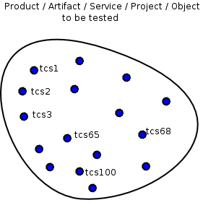
Figure 1 – A test cases specifications container
The blue dots are the test cases or probes to be done to assert product features or services characteristics or projects areas.
It natural to think that different test case specifications can have a relationship due to the feature area they put under stress, or simply to reduce the number of objects to manage (the old Caesar concept “Divide and conquer”) , this means that groups of test case specs can be created.

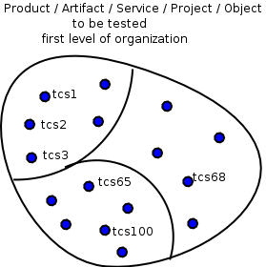
Figure 2 – A first level of test case specifications organization

It would be possibility made several levels of grouping, getting as a possible situation

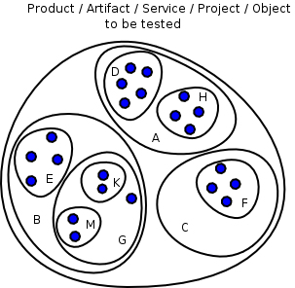
Figure 3 – test case specifications organized on several levels

Another graphical representation that we can use to show the organization of test case specifications is a a tree, resulting in:
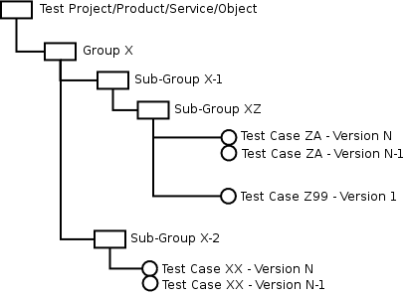
Figure 4 – test case specifications organization view as a tree
We will consider the organization items (here noted as group and subgroup) as test case specification items, other than the proper test case specification ( what has to be tested, how the test must be done).
In the figure above Group X and Sub-Group X-2 are test case specification items.
The tree nodes represents an organization concept, with the round objects that are the leaf nodes, and represents the different versions of a test case specification (evolution on time).

The definition of the subset of test case specifications that will be using during the execution or experiment phase is called in test link the test plan.
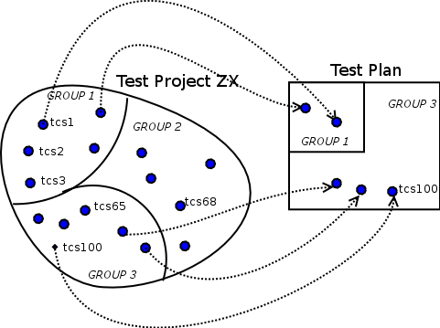

Figure 5 – From test case specifications to Test Plan

Using the Tree representation:

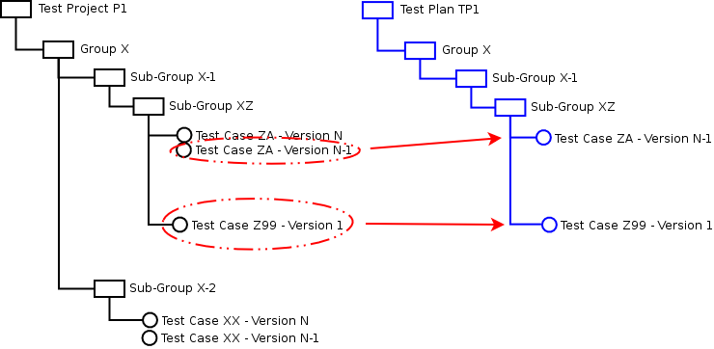
Figure 6 – Test Plan Tree

A test plan is not simply a part of the test case specifications , because there are some additional information that must be present, like risk, importance that has semantic meaning, or administrative attributes like active/inactive status.
And the value of this attributes can be different for the same test case specification item in different Test Plans.

Examples: Test Case Z99 can be active for Test Plan TP1, but inactive for Test Plan TP2
Group X can have high importance for Test Plan 2, and minimal for Test Plan 1.

Is important to note that a Test Plan can be constructed using test case specifications belonging to more than one Test Project. This situation has been signaled multiple times by different test link users.
Think as the following example:
you build the Test Project ZX for a system A and Test Project XL5 for system X, and later system A and X are used to build system Z. The following figure explains this situation.:

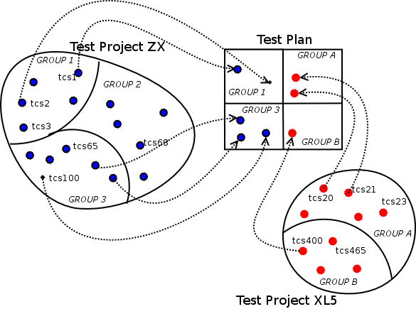
Figure 7 – Test Plan for System Integration of System A and System X

Main Test Link test specification tables (TL <= 1.6)

Object | Hierarchy Level | Table
Products | 1 (Top Level) | mgtproduct
Components specification | 2 | mgtcomponent
Categories specification | 3 | mgtcategory
Test case specification | 4 (Bottom Level) | mgttestcase

The hierarchy level help us to understand the parent-child relationship, level N is father of level N+1.

Alternative object model for test specification

First thing: name changes
Object on TL 1.7 | Object on TL <= 1.6
Test Project | Product
Test Suite | Component  Category
Test Case | Test Case
Test Case Version | -

I will try to do some research an would be great if other team members/ users can help.
The name changes from TL <= 1.6 objects (product, component,category) are proposed to follow the standard nomenclature used in the testing community, and to be a little bit more generic. I think this change can simplify the understanding of Test Link architecture and user interface.
On other hand other open source and commercial test management products uses concepts like test book, test lab, test project, instead of product.
Some definitions from several Internet Resources:
Resource
http://readyset.tigris.org/nonav/templates/test-suite.html | A test case suite is simply a table of contents for the individual test cases.  Organizing the suite of test cases by priority, functional area, actor, business object, or release can help identify parts of the system that need additional test cases.
http://en.wikipedia.org/wiki/Software_testing | The most common term for a collection of test cases is a test suite.  The test suite often also contains more detailed instructions or goals for each collection of test cases.  It definitely contains a section where the tester identifies the system configuration used during testing.  A group of test cases may also contain prerequisite states or steps, and descriptions of the following tests.

An example can be useful to understand the (possible) advantages of these names.
Suppose you want to test Test Link, then you can use the following organizations:
  Product | Test Link
  Component | User Management
  Category | Performance
  Category | Usability
  Category | I18N
  Component | Test Plan Management
  Category | Performance
  Category | Usability
  Category | I18N
  Product | Test Link
  Component | Performance
  Category | User Management
  Category | Test Plan Management
  Component | Usability
  Category | User Management
  Category | Test Plan Management
  Component | I18N
  Category | User Management
  Category | Test Plan Management
Organization A | Organization B

In Organization A the Components maps to functional features, and seams natural, while in Organization B components are mapped to non functional features, but to more cross system characteristics, and IMHO don't map very well, as happen with component Performance (does not sound good.)
Compare old and new terminology
  Product | Test Link
  Component | Performance
  Category | User Management
  Category | Test Plan Management
  Component | Usability
  Category | User Management
  Category | Test Plan Management
  Component | I18N
  Category | User Management
  Category | Test Plan Management
  Test Project | Test Link
  Test Suite | Performance
  Test Suite | User Management
  Test Suite | Test Plan Management
  Test Suite | Usability
  Test Suite | User Management
  Test Suite | Test Plan Management
  Test Suite | I18N
  Test Suite | User Management
  Test Suite | Test Plan Management
Old name | New proposed names

The changes applied to organization A and B results in:
  Test Project | Test Link
  Test Suite | User Management
  Test Suite | Performance
  Test Suite | Usability
  Test Suite | I18N
  Test Suite | Test Plan Management
  Test Suite | Performance
  Test Suite | Usability
  Test Suite | I18N
  Test Project | Test Link
  Test Suite | Performance
  Test Suite | User Management
  Test Suite | Test Plan Management
  Test Suite | Usability
  Test Suite | User Management
  Test Suite | Test Plan Management
  Test Suite | I18N
  Test Suite | User Management
  Test Suite | Test Plan Management
Organization A | Organization B

In this example the new names fit very well in both types or organizations.
The new objects hierarchy
Object | Hierarchy Level | Notes
Test Project | 1 (Top Level) | Can contain only Test Suites
Test Suite | 2,3,....., N-1 | Can contain other Test Sets or Test Cases
Test Case | N (Bottom Level)

The ER Diagram (may be not the best one but ...):
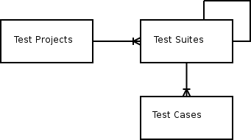

Test Specification Nodes Table (nodes_hierarchy)
Field | Notes
id
parent_id | Container Parent ID . NULL means is a ROOT node
node_type | From the types defined in node_types table
node_order | Order inside the parent_id (user interface level, useful to organize the views.)

Test Projects will be treated as nodes, with parent_id = NULL => will be the ROOT NODE of the test cases specifications tree. Then we will have one tree for every Test Project.
As happens in the traditional tree / nodes / entity , there will be an specific table for every node type/object type (entity).

Important:
users will not be able to create new node types because new tables needs to be created.

Proposed Node Types / Object Types
Node Type | Notes
Test Project | Product concept on TL <= 1.6
Test Suite | Component and Category concept on TL <= 1.6
Test Case | Works with Test Case Version
Test Case Version
Test Plan

Note about Test Plan nodes
We can inserted also Test Plan nodes, but we have to duplicate the hierarchy. With this its also possible to user different hierarchy for the same Tcs. But is really needed and useful?.
Constructing again the same hierarchy is not wise. We will return to the old TL 1.6 problems regarding updating the test plan hierarchy due to changes on the test specification hierarchy.
The ability of change description of nodes on the test plan hierarchy, has very low value and a lot of work to develop. Then this feature is considered out of scope for TL 1.7, but this doesn't mean will be not considered in future releases.

New Schema – whole picture
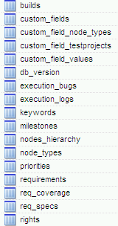 | 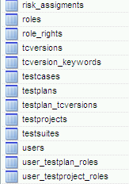

New Database Schema – Test Case Specification tables

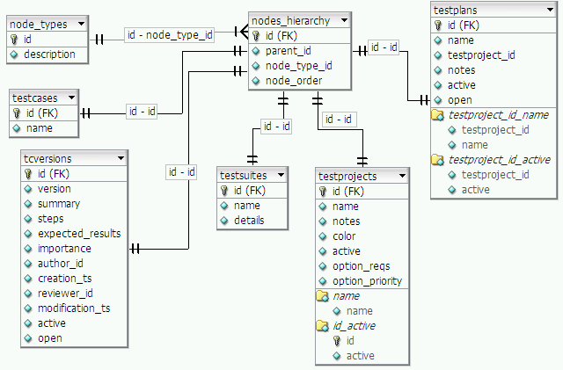
Important Note:
testplans table is present in the figure although is not a test specification table, only to note that test plan ID is generated using the nodes_hierarchy table.
Due to the choice to use only one type of entity (Test suite) instead of two (Component and category) the following changes results at field level:
Table TL 1.7 | Fields from component and category melted in new field details
Test suites | Intro, scope, ref, method, lim (old component fields)
 | Objective, config, data, tools (old category fields)

Test case versions keywords management
Will be done with the new table

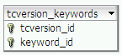
This will allow to have different keywords for different version of the same test case

Attribute delete on nodes_hierarchy table
The attribute/field deleted (present in the Andreas document) has been removed because (IMHO) when a user choose to remove a node, the node has to be physically removed from the system.
If we want remove some nodes from user view without removing the info from system, we can can the active field on the specific node table if needed, as has been done on the mgtproduct table (TL <= 1.6).

Test Case Version Management
The model is similar to the model used on dotproject files table.
Here an explanation of how this works (taken from an old mail by Andreas Morsing).
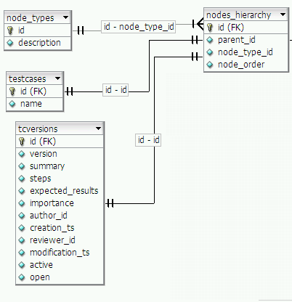
Conditions: Fresh Install
User Action | Events on Database (inserted records)
Creates Test Project Demo | table nodes_hierarchy: id=1, , parent_id=NULL  table testprojects: id=1 (taken from previous insert on nodes_hierarchy )
Creates Test Suite Performance | table nodes_hierarchy: id=2, parent_id=1  table testsuites: id=2 (taken from previous insert on nodes_hierarchy )
Creates Test Set Metrics inside of Test Suite Performance | table nodes_hierarchy: id=3, parent_id=2  table testsets: id=3 (taken from previous insert on nodes_hierarchy)
Creates Test Case TC ZX  inside of Test Set Metrics | table nodes_hierarchy: id=4, parent_id=3 (TEST SET ID of Metrics)  table testcase: id=4 (taken from previous insert on nodes_hierarchy )  table nodes_hierarchy: id=5, parent_id=4 (TEST CASE ID of TC ZX)  table tcversions: id=5 (taken from previous insert on nodes_hierarchy ),  version=1
Creates Test Case TC QW  inside of Test Set Metrics | table nodes_hierarchy: id=6, parent_id=3 (TEST SET ID of Metrics)  table testcase: id=6 (taken from previous insert on nodes_hierarchy )  table nodes_hierarchy: id=7, parent_id=6 (TEST CASE ID)  table tcversions: id=7 (taken from previous insert on nodes_hierarchy ),  version=1
Creates a NEW version of TC ZX | table nodes_hierarchy: id=8, parent_id=4 (TEST CASE ID of TC ZX)  table tcversions: id=8 (taken from previous insert on nodes_hierarchy ),  version=2

Note about moving Test Cases
When moving a test case all tcversions belonging to the test will be moved as a block.

Note about copying Test Cases
When copying a test case user copies only one version.

Note about open field
The open field present in tcversions and testplans tables, is used to implement the proposed feature (see SRS document in the document module on CVS) of close/freeze a test plan.
When open=0 (means close) the tcversion can not be modified, because is linked to a closed test plan (has open=0). This field in tcversion table can return to value 1 (open) only if all test plans that have a link to the tcversion becomes open.

Custom Fields
The proposed schema is modeled as a mix from mantis and dotproject:
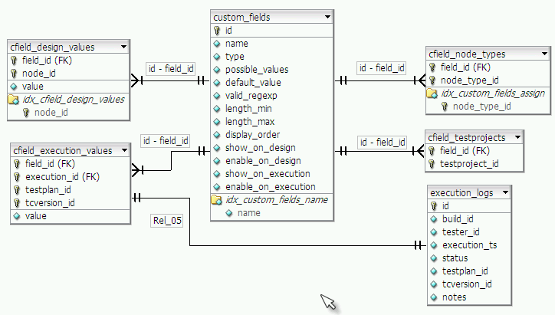
table | notes
custom_fields | Stores the custom field definition.
cfield_testprojects | Defines on what test projects the custom field will be available
cfield_node_types | defines in what object_type (= node_type_id), i.e. Test Project, Test Plan, Test Suite, Test Set, Test Case the custom field can be used.  Example:  you define a custom field limitations, string(60) and want to use it only on Test Suites and Test Plans.
cfield_design_values | Stores the values inserted by the user, during test case design
cfield_execution_values | Stores the values inserted by the user, during test case executions.  The values stored here will be related only to tcversions, not to any other of node_type. See table structure to understand this

Example:

First Step: Custom Field Definition
Name | DBMS | This will be the label
Type | Enumeration | On User Interface will be a single selection combo box
Values | ORACLE,MYSQL,BD2
Valid for nodes of type | TEST CASES, TEST SUITES
show on Design | NO | This field has only meaning for test cases.  NO means will not be available while creating the test case specification.
Enable on design | NO
Use on Execution | YES | This field has only meaning for test cases.  YES means will be available when the test case will be effectively executed.
Enable on execution | YES | Means user will be able to change the value. In this cas the combo will be enable.

Second Step: Assign Custom Field to Test Projects

In a similar way to mantis operation, the user will choose a Test Project and will be presented with a combo box populated with all Available Custom Fields Definitions, to choose what Custom Field will be available inside it.

Roles and rights
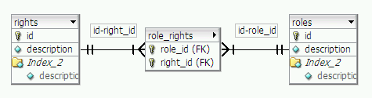
Rights table | Roles table
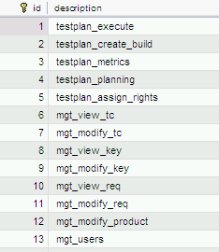 | 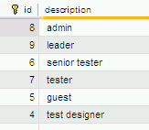

The example for the administrator (role_rights table):
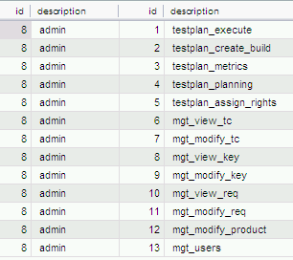

Main Test Link test case executions tables ( TL <= 1.6)
Object | Table
Test Plans | testplans
Components used on Test Plans | component
Categories used on Test Plans | category
Test case used on Test Plans | testcase

Component Table
have no additional information to the info contained on mgtcomponent

Category Table
Adds importance, risk and owner to mgtcategory

Test Case Table
Add Active/Inactive attribute.

The link logic between Test Case Specifications items and Test Plans Items for Test Link <= 1.6 was to copy every test case specification item (component, category and test case) to the corresponding test plan table in this way:

From Table | To Table
mgtcomponent | component
mgtcategory | category
mgttestcase | testcase

The association testplan <-> testcase, was not written in the testcase table, but in the higher level container table -> component table.

If in the new TL version (1.7) we want to manage the new unlimited level of containers this logic seems not to be valid anymore.

If we return to the test link <= 1.6, seems that there is no need to copy component id information to the test plan, because knowing the test case id (that is unique on the system), walking back the tree we can got the component id.
May be for a two level container architecture it's OK to copy the whole tree, but with an unlimited level of containers, the solution is not feasible.

Schema

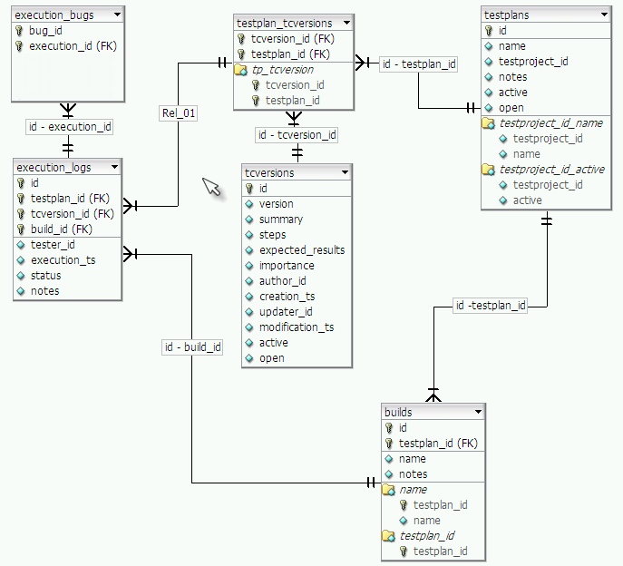

Risk Assignment
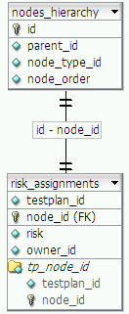

To draw the Test Case Execution tree we need to walk backwards on the node_hierarchy table using the tcversion_id as starting point.

About Importance and Risk
After comments by Martin Havlat, the model of importance and risk has been changed.

Importance will be an attribute of test cases during the design, while you are creating your test project.
Risk will be an attribute useful during test case executions, while you are creating your test plan, and will be an important information for testers.

The following example (adapted from Martin Havlat's comments) should be clear enough (I hope)

Test Designer create test project UBOAT RED OCTOBER, with the following content:

Test Project | UBOAT RED OCTOBER
Test Suite | Sonar
Test Suite | Performance
Test Case | Warm Water – Importance HIGH
Test Case | Cold Water – Importance HIGH
Test Suite | Usability
Test Case | Day light – Importance LOW
Test Case | Night Light – Importance MEDIUM
Test Case | No light – Importance MEDIUM
Test Suite | Colors and design
Test Case | TCCX – Importance LOW
Test Case | TCCY – Importance MEDIUM
Test Case | TCCZ – Importance LOW

Test suite sonar contains three test suites (Performance,Usability, Colors and Design), with a total count of 8 test cases.

Test plan T-UBOAT-1 is created :
Test Plan | T-UBOAT-1
Test Suite | Sonar
Test Suite | Performance
Test Case | Warm Water – RISK VERY HIGH
Test Case | Cold Water – RISK VERY HIGH
Test Suite | Usability
Test Case | Day light – RISK LOW
Test Case | Night Light – RISK LOW
Test Case | No light – RISK LOW

As you can see there is no direct relationship between the degree of importance and the risk.

After the execution of Test plan T-UBOUT-1 has been completed, a lot of changes are introduced into the code that must be checked by Test suite usability, while no change has been done to code related to Test suite Performance. Due to this the Test Leader creates a new test plan T-UBOAT-2 as a copy of T-UBOAT-1 just to retain history of previous decisions, to change the risk of test cases, resulting in:

Test Plan | T-UBOAT-2
Test Suite | Sonar
Test Suite | Performance
Test Case | Warm Water – RISK LOW
Test Case | Cold Water – RISK LOW
Test Suite | Usability
Test Case | Day light – RISK VERY HIGH
Test Case | Night Light – RISK VERY HIGH
Test Case | No light – RISK VERY HIGH

Test execution assignment
I was not able to fully understand the ideas explained by Martin Havlat, then I prefer to put here the comments done by Martin leaving to him the work to write it as clear as possible.

MHT: TL 1.6 includes test assign on category level. For 1.7 I suggest to use a special table which allow to assign testplan_testcase to user. Why a special table. Because test leader can assign also different task in future if this will be general. E.g. Write TC for a REQuirements or review TC. So this table will include TYPE (type 1 = testing assignment, etc.), assignment_id (for case of testing it will be refference to testplan_testcase table), user_id, creator_id, create_ts, deadline_ts).

The important unwritten information is that each test execution should have own record about who should test it. It's because leader cannot assign tests from one category to two or more testers in 1.6.
Structure:
table actions (
user_id INT FK
creator_id INT FK
assignment_id INT FK (for case of execution assignment this value point to id of testplan_tcspecs)
type INT
create_ts DATETIME
deadline_ts DATETIME )

Table Equivalences

Test link <= 1.6 | Test Link 1.7 | Notes
user | users
mgtproduct | testprojects
mgtcomponent  mgtcategory | testsuites
mgttestcase | testcases  tcversions
rights | roles
projrights | user_testplan_roles
 | user_testproject_roles
- | risk_assignments
- | nodes_hierarchy
- | node_types

Missing pieces
There is no mention to the tables needed to implement the attachments features. (this is probably because this document initially was devoted only to discuss the containers hierarchy)

