User Manual
TestLink 1.6

Copyright © 2004,2005,2006 TestLink Development Team
Permission is granted to copy, distribute and/or modify this document under the terms of the GNU Free Documentation License, Version 1.2 or any later version published by the Free Software Foundation; with no Invariant Sections, no Front-Cover Texts, and no Back-Cover Texts. The license is available in "GNU Free Documentation License" homepage.

General information
TestLink is web based Test Management system. This manual should serve as source for users to understand processes and organization of testing with TestLink. See to Installation manual for more information about system requirements, installation steps and configuration. The latest documentation is available on www.teamst.org or testlink.sourceforge.net.
See an example of TestLink workflow:
- Administrator create a Product “Fast Food” and a user Adam with rights “leader” and Bela with rights “Senior tester”.
- Adam imports Software Requirements and for part of these requirements generates empty Test cases.
- Bela describe test sneario of these Test cases that are organized according to Components and Categories.
- Adam creates Keyword: “Regression” and assignes this keyword to ten of these test cases.
- Adam creates a Test Plan “Fish & Chips”, Build “Fish 0.1” and add Test Cases with keywords “Regression”.
- Adam and Bela execute and record the testing with result: 5 passed, 1 failed and 4 are blocked.
- Developers make a new build “Fish 0.2” and Bela tests the failed and blocked test cases only. Exceptionaly all these five Test cases passed.
- Manager would like to see results. Administrator explain him that he can create account himself on the login page. Manager do it. He has “Guest” rights and could see results and Test cases. He can see that everything passed in overal report ;-) and problems in build “Fish 0.1” in a report for particular Build. But he can change nothing.

Overall structure
There are three cornerstones: Product, Test Plan and User. All other data are relations or attributes for this base. First, definition of a couple of terms that are used throughout the documentation.

Products and Test Plans
Product: A Product is something that will exist forever in TestLink. Products will undergo many different versions throughout their life times. Product includes Test Specification with Test Cases and should be sorted via Keywords.
Test Plan: Test Plans are created when you'd like to execute test cases. Test plans can be made up of the test cases of one or many Products. Test Plan includes Builds, Test Case Suite and Test Results.
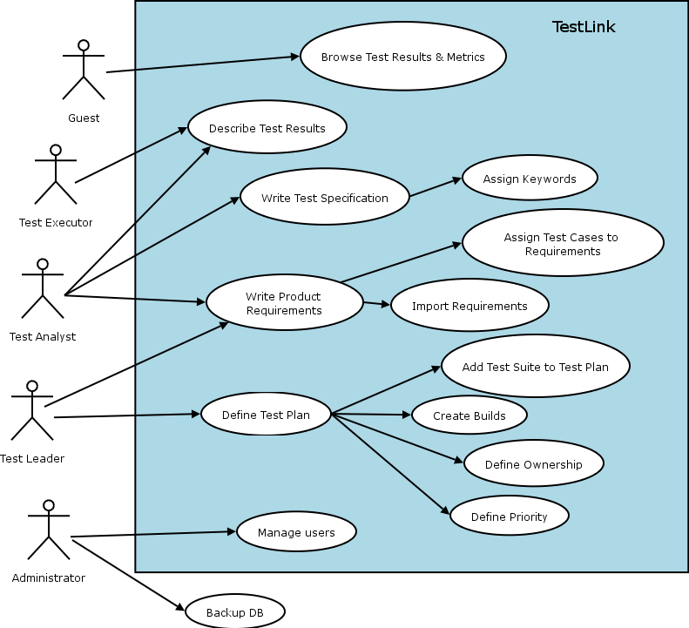Illustration 1: Functionality overview

Test Case Categorization
TestLink breaks down the test case structure into three levels Components, Categories, and test cases. These levels are persisted throughout the application.
Component: Components are the parents of Categories. Each Component can have many Categories.
Category: Categories are the parents of test cases. Each Category can have many test cases.
Test Case: Test cases are the fundamental piece of TestLink.
Test Specification: All Components, Categories and test cases within Product.
Test Case Suite: All Components, Categories and test cases within Test Plan.

Users
An User has a Role, that defines available TestLink features. See more in chapter User Administration.
The picture 1 shows common activity according to user roles.

Test Specification

Creating Test Cases
Tester must follow this structure: Component, Category and test case. At first you create Component(s) for your Product. You can fill description which can be printed then. Component includes Categories. Category has the similar meaning but is second level of Test Specification and includes just Test Cases.
User can also copy or move Test Cases.
Test Cases has next parts:
- Title: could include either short description or abbreviation (e.g. TL-USER-LOGIN)
- Summary: should be really short; just for overview.
- Steps: describe test scenario (input actions); can also include precondition and cleanup information here.
- Expected results: describe checkpoints and expected behaviour a tested Product or system.

Deleting Test Cases
Test cases, Categories, and Components may be deleted from a test plan by users with lead permissions from the "delete test cases" screen. Deleting data may be useful when first creating a test plan since there are no results. However, Deleting test cases will cause the loss of all results associated with them. Therefore, extreme caution is recommended when using this functionality.

Requirements relation
Test cases could be related with software/system requirements as n to n. The functionality must be enabled for a Product. User can assign Test Cases and Requirements via link Assign Requirements in the main screen.

Keywords

Using keywords
Keywords were created to give users another level of depth when categorizing test cases. Keywords serve as a collection of Test cases with some attribute within a Test specification. You can use it to define e.g.
- Regression or Sanity set
- Reviewed Test cases
- Set of test cases valid for one platform

Keyword Creation
At this time keywords can only be created by users with the mgt_modify_key rights. These rights are currently held only by Leaders. Once a keyword or grouping of keywords have been created users may assign them to test cases.

Assigning Keywords
Keywords may be assigned to test cases either from the assign keyword screen (in batch) or via the test case management (individually).

Filter by Keyword
Users have the ability to filter by Keywords for:
- Search Test Cases in Test Specification.
- Add groups of Test cases in a Test case Suite (Test plan).
- Execute test screen.

Requirement based testing

Introduction
To prove that a system is built as specified, testers use requirement based testing. For every requirement, they design one or more test cases. At the end of the test execution a test manager reports on the tests that are executed and the requirements that are covered. Based on this information the client and the various stakeholders decide whether a system can be transferred to the next test phase or can go live. To ensure that a system is built as specified, test managers use a combination of risk and requiremetn-based testing to ensure that a system is build as specified from the customer and stakeholders perspective. As a result, this complete testing delivers the following advantages:
- Linking risks and requirements will reveal vague or missing requirements. This is especially interesting for risks with a high priority.
- Testing can be focused on the most important parts of an information system first: covering the risks with the highest priority.
- Communicating in the same language as the client and the stakeholders. This makes it easier to report on the status of the test project. Beside that a better founded decision can be made whether to invest more in testing or take the risk.
- The risks and their priority make negotiating on the test project in times of pressure easier. What risks have to be covered within this test project and which ones can be postponed. Risk and requirement-based testing results in a better controlled test project. The communication with the client and the stakeholders improved. The test manager begins testing with risks with the highest priority. The process is streamlined and the end result is higher quality.

Availability
The functionality is available on Product level. I.e. Administrator should enable it for a specified Product (Edit Product link in Main window). Otherwise links are not shown.
There are two user levels for this feature. The most of roles can view requirement but not modify. Refer to User section for more.

Requirements Specification
Requirements are grouped to one or more System/Software/User Requirement Specifications.
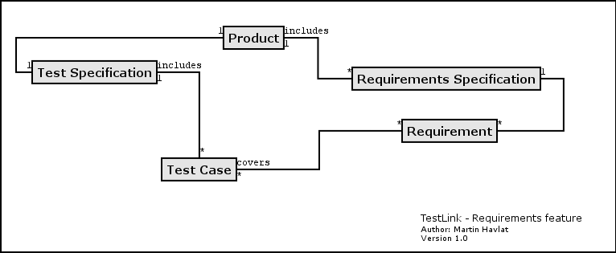Illustration 2: Dependencies between requirement related objects
Create a document with Requirements:
- Click Requirements Specification in Main window. The List of Requirement Specification window is shown.
- Press Create button to create a document.
- Adjust Title, Scope and eventually Count of Test cases. The last parameter is used for statistics. Use only if you have a valid Requirement document but not all requirements are available at the moment in TestLink. Default value 'n/a' means that the current count of requirements in a specification is used.
- Press Create button to add data to database. You can see the title of your new created document in the table of List of Requirement Specification window.
- Click the title of document for next work. The Requirement Specification window is shown.
Each Requirement Specification has own statistics and report related to included data.
All Specifications can be printed using the "Print" button in the "Requirement Specifcation" window. Administrator can define company, copyright and confident text via configuration files.

Requirements
Each requirement has Title, Scope (html format) and Status. Title must not be unique and has max. 100 characters. Scope paramter is text in HTML format. Status can have vale VALID or NOT_TESTABLE. A NOT_TESTABLE requirements are not counted to metrics.
Requirements could be created/modified or deleted manually via TestLink interface or imported as CSV file.

Import requirements
TestLink support two types of CSV. The first 'simple' is composed from title and scope in each row. The second 'Export from Doors' try to detect header and chooses correct fields. Import compare titles and allow to solve conflicts. There are three ways: update, create requirements with same title and skip adding the conflicted ones).

Requirements to Test Case relation
Test cases are related with software/system requirements as * to *. I.e. you can assign more Test cases to one Requirement and more requirements could be covered by one Test Case. User can assign Requirements to Test Cases via the Assign Requirements link in the Main window.
A coverage of Test Specification could be view via pressing the button Analyse in the Requirement Specification window.

Requirement based Report
Navigate to Reports and Metrics menu. There is Requirements based Report link. Requirements in currect Requirement Specification and Test Plan are analysed for this report. All the latest result of test cases (available in Test Plan) are proceeded for each requirement. The result with the highest priority is applied for the requirement. Priority from the highest are: Failed, Blocked, Not Run and Passed.
Example of requirement coverage
A requirement is covered by three Test Cases. Two of them are included in the current Test Suite. One passed and one was not tested for the Build 1. Now Requirement has overall result: Not Run. Second test case was tested with Build 2 and passed. So Requirement passed too.

Products
Products are the cornerstone of TestLink. Products are releases of your company that may change their features and functionality over time but for the most part remain the same. Product includes requirements documentation, test specification, test plans and keywords.

Creating new Products
Creating a new Product requires "admin" rights. Each Product must have a unique name. Background colors can be assigned to Product templates to visually distinguish them.
Things to note when creating a new poduct:
- Deleting Products from the system is not recommended as this either orphans a large number of test cases or deletes the test cases from the system.
- Test plans represent the testing of a Product at a certain point in time. Consequently, test plans are created from Product test cases.
- TestLink supports importing CSV data into a Product. This is explained further in the Import section, below.

Edit and delete Products
Edit Products requires "admin" rights. User can change Product name, color of background and availability of requirements functionality.
User with the privileges also can inactivate the Product if it's obsolete. This cause that the Product is not visible in list within the top navigation bar (except admin who see such Product in the list marked by '*'.
User can also delete a Product. This action delete also all related data from database. This action is not reversible. We strongly recommend to use inactivate instead of delete.

Test Plans
Test plan contains name, description, collection a chosen test cases, builds, test results, milestones, tester assignment and priority definition.

Creating a new Test Plan
Test Plans may be deleted from the “Create test plan” page (link “Create Test Plan”) by users with lead privileges.
Test plans are the basis for test case execution. Test plans are made up of test cases imported from Products at a specific point of time. Test plans can only be created by users with lead privileges. Test plans may be created from other test plans. This allows users to create test plans from test cases that at a desired point in time. This may be necessary when creating a test plan for a patch. In order for a user to see a test plan they must have the proper rights. Rights may be assigned (by leads) in the define User/Project Rights section. This is an important thing to remember when users tell you they can't see the project they are working on.

Builds
An user with lead privileges could follow the link “Build management” in the main page.
Builds are a specific release of software. Each project in a company is most likely made up of many different builds. In TestLink execution is made up of both builds and test cases. If there are no builds created for a project the execution screen will not allow you to execute. The metrics screen will also be completely blank.
Builds currently cannot be edited. A build could be deleted by click on the appropriate “bin” icon in the table of existing builds.

Deleting TestPlans
Test Plans may be deleted from the “Edit test plan” page (link “Edit / Delete Test Plan”) by users with lead privileges. Deleting Test Plans permanently deletes both the test plan and all of its corresponding data, including test cases, results, etc. This should be reserved only for special cases. Alternatively, Test Plans may be deactivated on the same page, which supresses display on selection menus in the “main” page.

Test Case Suite

Adding new Test Cases
Test Case Suite is set of test cases which are defined to be run within Test Plan. Test case Suite is created via Add Test Cases from Test Specification to Test Plan. Test cases are added including Steps and Expected result. So, you must use 'Update modified Test Cases' page to update test scenario (version of test case).
Data from multiple Products can be added into one test plan. Test Specification data can be filtered by keywords (adjusted in navigation pane).
Once data has been imported into a test plan it will be marked with checkmark. If a test case has already been imported it will be ignored if it is imported again.

Removing Test Cases from Test Case Suite
Test cases, Categories, and Components may be deleted from a test plan by users with Leader permissions from the "Remove test cases" page. Deleting data may be useful when first creating a test plan since there are no results. However, Deleting test cases will cause the loss of all results associated with them. Therefore, extreme caution is recommended when using this functionality.

Priority
TestLink gives users with Leader rights the ability to assign ownership and priority to test cases. General Risk/Ownership is done at the Category level. TestLink currently does not allow users to assign risk or ownership at the individual test case level.
Risk levels are low, medium, high and Importance levels are 3, 2, 1. Users can rank the combinations of risk and importance (L1, L2, L3, M1, H2, M3, H1, H2, H3) as priority A,B,C.
Assigning risk, importance, ownership, and priority are all optional and will default to priority B in the metrics screen.

Ownership
Ownership affects both the execution and metrics screens. In the execution screen users have the ability to sort the executable test cases by the ones they have ownership of. In the main metrics screen there is a table that shows the remaining test cases by ownership. If there are no test case owners it defaults to none.
A Tester can also see a metrics of own executed tests in main page if these metrics are enabled (see Installation manual).

Test Execution

General
Test execution is available when:
- A Test Specification is written.
- A Test Plan is created.
- Test Case Suite (for the Test Plan) is defined.
- A Build is created.
- The Test plan is assigned to testers (otherwise they cannot navigate to this Test Plan).
Select a required Test Plan in main page and navigate to the 'Execute tests' link. Left pane serves for navigation in Test Case Suite via tree menu, filtering and define a tested build.

Navigation
The navigation pane consists from a 'Filter & Settings' box and a tree menu with Test Case Suite.

Filtering Test Cases
This table allows the user to filter test cases for smart navigation before they are executed.
- Owner: Users can filter test cases by their owner. Ownership is determined at the Category level, is determined by leads, and can be changed at the Assign Risk and Ownership page under metrics.
- Keyword: Users can filter test cases by keyword. Keywords are set either using the Create/Edit/Delete Test Cases or by the Assign Keywords To Multiple Cases. Keywords can only be created, edited, or deleted by leads but may be assigned to test cases by testers.
- Result: Users can filter test cases by results. Results are what happened to that test case during a particular build. Test cases can pass, fail, be blocked, or not be run.

Define a tested build
Users can filter test cases by builds. Builds are the basic Component for how test cases are tracked. Each test case may be run once and only once per build. Builds can be created by leads using the Create New Build page.

Tree menu
The tree menu in navigation pane includes Test Case Suite colored by results.
Menu colored: By default the tree will be sorted by the results for the defined build that is chosen from the dropdown box.
Example TC colored according to the build
User selects build 2 from the dropdown box and doesn't check the "most current" check box. All test cases will be shown with their status from build 2. So, if test case 1 passed in build 2 it will be colored green.
Second possibility Last result is that menu is colored according to the latest test result.
Example TC colored according to the latest result
User selects build 2 from the dropdown box and this time checks the "most current" check box. All test cases will be shown with most current status. So, if test case 1 passed in build 3, even though the user has also selected build 2, it will be colored green.

Execution

Test Status
Execution is the process of assigning a result (pass, fail, blocked) to a test case for a specific build. 'Blocked' test case is not possible to test for some reason (e.g. a problem in configuration disallows to run a tested functionality).

Insert Test results
Test Results screen is shown via click on an appropriate Component, Category or test case in navigation pane. The title shows the current build and owner. The colored bar indicate status of the test case. Yellow box includes test scenario of the test case.
The indication that the test case was updated or deleted in test Specification is not supported in 1.5 version.
Updated Test Cases: TL 1.0.4 version has indication by flag, that is missing in 1.6 version. If users have the proper rights they can go to the “Update modified test case” page through the link on main page. It is not necessary for users to update test cases if there has been a change (newer version or deleted).

Test Reports and Metrics
The metrics pages sum up the results of execution into reports. Metrics are broken down by both individual builds and across all builds.

General Test Plan Metrics
This page shows you only the most current status of a test plan. For instance, you have test case 1 which was executed in builds 1,2, and 3. Build 1 2 3 Status Pass Fail Blocked Since the most recent result of the test case is blocked the result on the "Across All Builds" page would be blocked. If a user would go and change the status of build 3 to something else or not run the current result would be fail.
(in TL 1.0.4: View Project Status Across All Builds)

Metrics of active Build
This report shows the detailed results for a particular build defined in navigation pane.
(in TL 1.0.4: View Status by an Individual Build)

The Overall Build Status
View The Overall Build Status This report show a high level view of each build's result.

Query Metrics
Query results for specific test cases based on keyword, Component, owner, last result, and 1 or more builds. For example if you wanted to know if a test case has failed, passed, blocked, or has not been run in builds 2, 3, and 4 you would want to use this query functionality. Additionally you could determine if test cases assigned to a tester have been executed in a set of builds. This is important because test passes may occur over multiple builds, and multiple test passes may occur during the development cycle. This is especially handy at the end of a development cycle when you want to know if certain cases have been run over the past few builds of the Product. This functionality differs from other reports which display results on a specific build, or all builds.
Export to MS Excel is also available.

Test Report
View Status By Individual Test Cases This report shows each test case's result for every build. An user can navigate to Test Execution screen via link for each test Status.
Export to MS Excel is also available.

Blocked/Failed Test Cases
These reports show all of the currently blocked or failing test cases.

Total Bugs For Each Test Case
This report shows each test case with all of the bugs filed against it for the entire project. This metrics are available only if Bug Tracking System is connected.

E-mail Test report
Email Test Plan Info This page allows users to email the results of the entire test Plan or for a particular build. It also allows users to email the status of a Component

User Administration

Account settings
Every user on the system will also be able to edit their own information via the Account settings window (link Personal in menu bar).
TestLink allows users with administrator rights to create, edit, and delete users within the system. However, TestLink does not allow administrators to view or edit user's passwords. If users forget their passwords there is link on the login screen, that will mail the user their password based upon their user name and the email address they entered.

Role Permissions
TestLink is built with 6 different default permission levels built in. Changing of these rights is handled by the user administration link which is accessible by admins. These permission levels are as follows:
- Guest: A guest only has permission to view test cases and project metrics.
- Test Executor: A tester outside of the company that only has permissions to run tests allotted to them. (initially in 1.0.4 – otester).
- Test Designer: A user can fully work with Test Specification and Requirements.
- Test Analyst: A tester can view,create, edit, and delete test cases as well as execute them. Testers lack the permissions to manage test plans, manage Products, create milestones, or assign rights. (initially tester, senior tester).
- Test Leader: A lead has all of the same permissions as a Tester but also gains the ability to manage test plans, assign rights, create milestones, and manage keywords.
- Admininstrator: An admin has all of the same permissions as a lead but gains the ability to manage Products.
Note: Test plan related features needs also assign a Test Plan to be available. See Test Plan Assignment.

User Roles
There are predefined user roles. Adminstrator gives appropriate ability to modify data within TestLink. Each user has assigned just one of these roles.
If you view the table you will see rows for each of the permissions levels (guest ,tester, senior tester, leader, admin). The column next to the row holds all of the different rights levels which will be defined below. These levels have been determined as standard for the use but they are free to be edited or define a new roles (for experienced administrator). The user table contains a foreign key that points to the appropriate permission level in the rights table.
Role | List of Rights | Permissions
Guest | mgt_view_tc, mgt_view_key, tp_metrics | Browse data only.
Test Executor  (Tester) | tp_execute,tp_metrics | Execute test only.
Test Analyst  (Senior Tester) | tp_execute, tp_metrics, tp_create_build, mgt_view_tc, mgt_modify_tc, mgt_view_key, mgt_view_req | Edit Test Specification, execute tests, create build.
Test Designer | tp_metrics, mgt_view_tc, mgt_modify_tc, mgt_view_key, mgt_modify_req, mgt_view_req | Edit Test Specification and Requirements.
Test Leader | tp_execute, tp_create_build, tp_metrics, tp_planning, tp_assign_rights, mgt_view_tc, mgt_modify_tc, mgt_view_key, mgt_modify_key, mgt_view_req, mgt_modify_req | All Test Plan permissions, edit Test Specification and execute tests.
Admin | tp_execute, tp_create_build, tp_metrics, tp_planning, tp_assign_rights, mgt_view_tc, mgt_modify_tc, mgt_view_key, mgt_modify_key, mgt_view_req, mgt_modify_req, mgt_modify_product, mgt_users | Everything possible. Only this role can maintain products and users.
Table 1: Role description

Rights Definitions
Next tables list keywords used for definition of role abilities.

Right | Description
mgt_view_tc | Viewing Test Specification (data of Component, Category, and test case)
mgt_modify_tc | Edit Test Specification (create,modify,delete,order, move, and copy Components, Categories, and test cases)
mgt_view_key | Viewing keywords
mgt_modify_key | Modifying keywords
mgt_modify_product | Create,edit and delete Products
mgt_view_req | View requirements
mgt_modify_req | Create,edit, associate and delete requirements
Table 2: Product related Rights

Right | Description
tp_execute | Ability to execute test cases (insert test results)
tp_create_build | Ability to create builds
tp_metrics | Viewing metrics
tp_planning | create, edit, delete Test Plans, assign risk/ownership, milestones, edit Tes Case Suite
tp_assign_rights | Assigning the rights to view projects
Table 3: Test Plan related Rights

Test Plan Assignment
Users can see only assigned Test Plans. In order to gain test plan permissions a user with lead or admin status must give them rights through the “Define user/project rights” link under “Test Plan Management”.
All users in the system will by default not have permissions to view newly created test plans (except for the test plan creator who can give themselves permissions at creation). Zero test plan permissions means that users will not see any Test Plans in the Test Plan dropdown box on main screen.
There is a table with Test Plan rights (i.e. which users can see which Test plan). This table is made up of a combined user id and project id. The main page contains code which checks to see if the logged in user has the appropriate permissions (and then shows the allowed projects. It is not recommended that this be hacked with.

Revision History:
# | Description | Date | Author
0.x | Document for TL 1.5 and update for TL 1.6 | 2005 | M. Havlat  A. Morsing  F. Mancardi
1.0 | Converted to OO2 format; | 2005/03/12 | M. Havlat
1.1 | Minor update; FIX 372, 352 | 2006/02/14 | M. Havlat

Older version TL have independent Products and Test Plans. This is configurable for back compatibility.

