Test Link 1.7

Jump Start
Copyright © 2006 TestLink Development Team
Permission is granted to copy, distribute and/or modify this document under the terms of the GNU Free Documentation License, Version 1.2 or any later version published by the Free Software Foundation; with no Invariant Sections, no Front-Cover Texts, and no Back-Cover Texts. The license is available in "GNU Free Documentation License" homepage.
Table of Contents
Test Case numeric ID 1
Test Case - Active Attribute 1
Adding test cases 1
Removing test cases 1

Test case specification

Test Case numeric ID
The numeric ID of a test case is assigned automatically by Test Link, and can not be changed by users. This ID is system wide, means when a test case is created a global counter is used, independent of test project where test case is created.
The 'holes' you will see in the ID (i.e. Missing numbers) are due to implementation details.

Test Case - Active Attribute
If several versions of a Test Case can exist, it would be useful to have a new attribute Active/Inactive, to use in this way:
- Every Test Case version is created ACTIVE
- An Inactive Test Case Version will not be available in "Add Test Cases to Test Plan", this can be useful for Test Designers. They can edit or change the TC Version and only when he/she decide is completed => change Status to ACTIVE, will be available to be included an used in a Test Plan.
- Once a TC Version has been linked to a Test Plan, and have results, it can't be turned INACTIVE.

Here several screen shoots:
What you see in test case specification
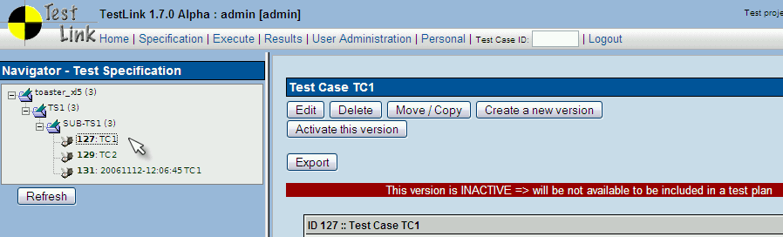
What you see when trying to add test cases to a test plan:
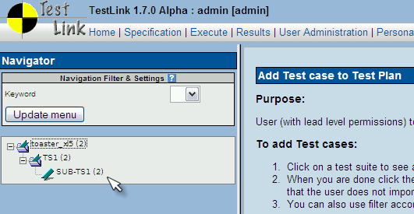

As you can note, the number near test project name (in this example: toaster_xl5) is 2, but the test project has 3 test cases.
Test case TC1 is not counted, because is inactive.

Test plan

Adding test cases
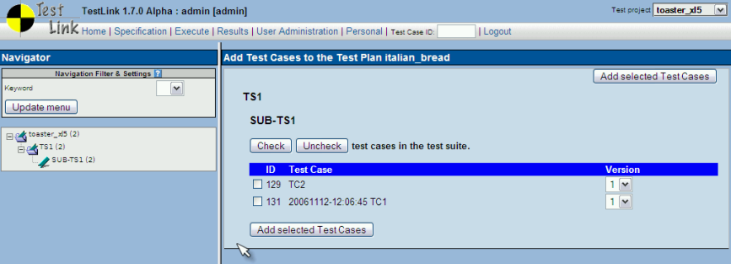
After the operation
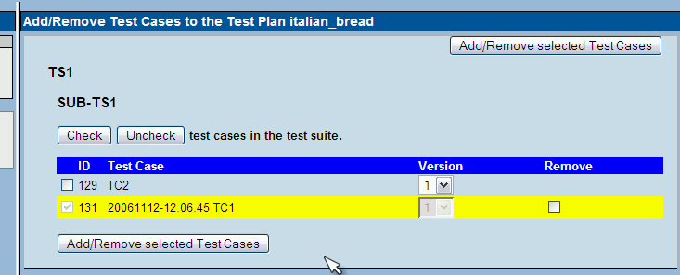

Removing test cases
Another way to remove test case is using the menu option that allows only the remove operation. You will see:
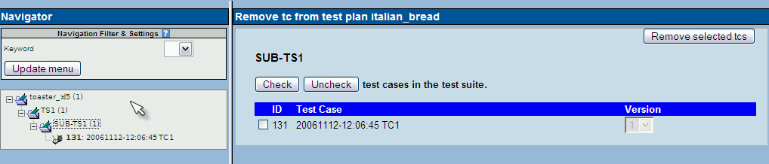
Tree on left pane, show only the test cases present in test plan.

Test execution history
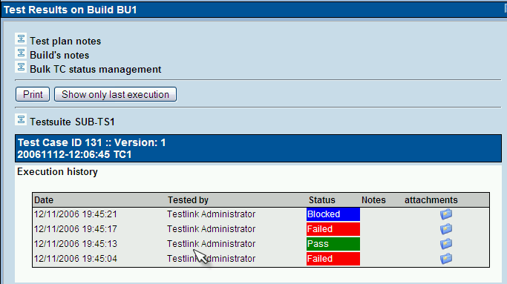
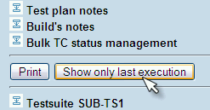
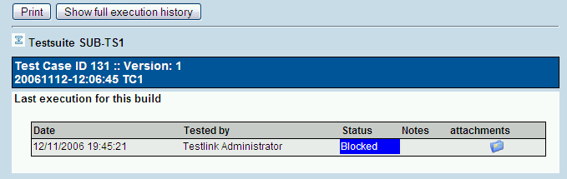

Appendixes
Revision history:
 | Description | Date | Authors
1.0 | Initial version | 2006/11/12 | Francisco Mancardi

