How to setup bugtracking system integration

Mantis and Bugzilla examples

Date | Author | Notes
20071123 | Francisco Mancardi | Bugzilla example
20070728 | Francisco Mancardi | Initial version

Overview 1
Configuration example - Mantis 2
Environment 2
Step 1 – Mantis Configuration 2
Step 2 – Test Link – Configure Mantis interface 2
Step 3 – Test Link - Enable BTS integration 3
Configuration example - Bugzilla 4
Environment 4
Step 1 – Test Link – Configure Mantis interface 4
Step 2 – Test Link - Enable BTS integration 4
Screenshoots 5

Overview

The integration between Test Link 1.7 and a Bug Tracking System (BTS) has the following characteristics

- All communication between Test Link and the BTS is done through database tables.
- Testlink (at the time of this writing) is neither able to send data to the BTS, either able to receive data from the BTS, in the traditional model of function call.

After all the configuration is up and running, from a testlink user point of view the process will be:

- While executing a test, it fails.
- User saves execution result.
- On the table displaying execution results data, an icon to access BTS feature will be available.
- User clicks on link that opens BTS web page used for issue reporting.
- After issue reporting, user has to take note of issue ID assigned by BTS, to input it into Testlink.
- User returns to Testlink test execution page, and writes the issue ID in the bug input.
- After user saves the execution, Testlink will display data taken from the BTS database.

Configuration example - Mantis

This configuration is valid for Test Link 1.7.0 or greater.

Environment
• Testlink and Mantis installed on the same webserver

Mantis URL | http://calypso/mantis
Test Link URL | http://calypso/testlink
Mantis Database name | mantis_bt
MySQL user/password to access Mantis DB | mantis_bt_user/mantis_bt_password

Step 1 – Mantis Configuration

- anonymous login into mantis has to be turned on.
- a mantis user with viewer rights to all public projects, must be created. (anonymous account)

Change/add following lines in your mantis config_inc.php (replace dummy with the anonymous account you will use)

# --- anonymous login -----------
# Allow anonymous login
$g_allow_anonymous_login = ON;
$g_anonymous_account = 'dummy';

Step 2 – Test Link – Configure Mantis interface

Edit file <your testlink main directory>/cfg/mantis.cfg.php.

/** The DB host to use when connecting to the mantis db */
define('BUG_TRACK_DB_HOST', 'calypso');

/** The name of the database that contains the mantis tables */
define('BUG_TRACK_DB_NAME', 'mantis_bt');

/** The DB type being used by mantis */
define('BUG_TRACK_DB_USER', 'mantis_bt_user');

/** The DB password to use for connecting to the mantis db */
define('BUG_TRACK_DB_PASS', 'mantis_bt_password');

/** link to the bugtracking system, for viewing bugs */
define('BUG_TRACK_HREF', "http://calypso/mantis/view.php?id=");

/** link to the bugtracking system, for entering new bugs */
define('BUG_TRACK_ENTER_BUG_HREF',"http://calypso/mantis/");

Step 3 – Test Link - Enable BTS integration

Copy the following lines from config.inc.php to custom_config.inc.php.

// ----------------------------------------------------------------------------
/** [Bug Tracking systems] */
/**
* TestLink uses bugtracking systems to check if displayed bugs resolved, verified,
* and closed bugs. If they are it will strike through them
*
* NO : no bug tracking system integration
* BUGZILLA : edit configuration in TL_ABS_PATH/cfg/bugzilla.cfg.php
* MANTIS : edit configuration in TL_ABS_PATH/cfg/mantis.cfg.php
* JIRA : edit configuration in TL_ABS_PATH/cfg/jira.cfg.php
* TRACKPLUS : edit configuration in TL_ABS_PATH/cfg/trackplus.cfg.php
*/
$g_interface_bugs='NO';

On custom_config.inc.php change line:

$g_interface_bugs='NO';

Final result:

$g_interface_bugs='MANTIS';

Configuration example - Bugzilla

This configuration is valid for Test Link 1.7.0 or greater.

Environment
• Testlink and Bugzilla installed on the same webserver

Bugzilla URL | http://calypso/bugzilla
Test Link URL | http://calypso/testlink
Bugzilla Database name | bugs
MySQL user/password to access Mantis DB | bugzilla_user/bugzilla

Step 1 – Test Link – Configure Mantis interface

Edit file <your testlink main directory>/cfg/bugzilla.cfg.php.

define('BUG_TRACK_DB_HOST', 'calypso');
define('BUG_TRACK_DB_NAME', 'bugs');
define('BUG_TRACK_DB_USER', 'bugzilla_user');
define('BUG_TRACK_DB_PASS', 'bugzilla');

/** link to the bugtracking system, for viewing bugs */
define('BUG_TRACK_HREF', "http://calypso/bugzilla/show_bug.cgi?id=");

/** link to the bugtracking system, for entering new bugs */
define('BUG_TRACK_ENTER_BUG_HREF',"http://calypso/bugzilla/");

Step 2 – Test Link - Enable BTS integration

On custom_config.inc.php create line:

$g_interface_bugs='BUGZILLA';

Screenshoots

After your configuration is OK, Login to TestLink, and go to execute one test case:

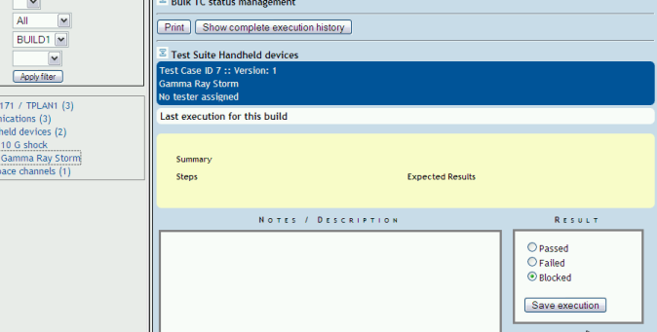
A difference with previous TestLink versions, is that there is no sign, that BTS integration is enabled.

After test case has been executed, access to bug management will be available:

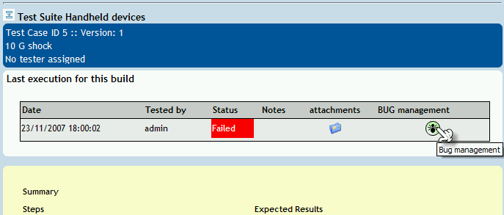

After clicking on icon, the following window will be opened:

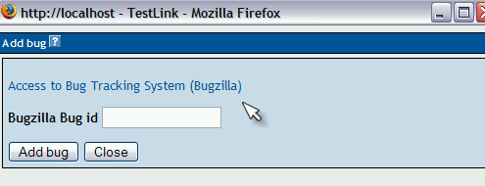

If you already have an issue number you can use it,otherwise you click on link to access to Bugzilla, opening a new window:

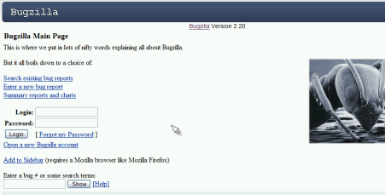

After having created the issue, you return to add issue number on TestLink window:

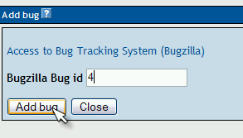

After successful operation:

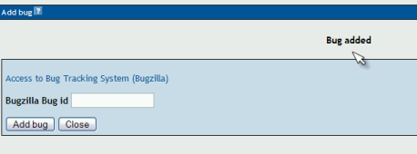

Clicking on Close, you return to execute screen, to find:

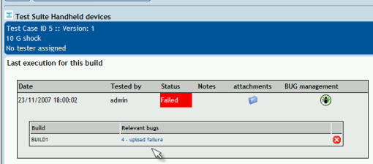

Clicking on link, you will get (if you are still logged on Bugzilla):

