Import / export

File formats

Date | Author | Notes
20080911 | Francisco Mancardi | Notes about internal and external ID  New tag supported for results on TL 1.8
20071101 | Francisco Mancardi | Added XLS format for test cases. Code contributed by lightbulb  Added XML format for results
20070728 | Francisco Mancardi

Items that can be exported/imported 2
Limits 2
Keyword 3
CSV 3
Example 3
XML - Example 3
Test project 4
Test suite 5
Example – without keywords 5
Example – with keywords 5
Test case 6
Just one test case 6
Example – XML - with keywords 6
All test cases in test suite 7
XLS 7
Requirement 8
CVS 8
Example 8
XML 8
Results 9

Items that can be exported/imported

Item | File format | Import | Export | Notes
Keyword | CSV,XML | X | X | All test project’s keywords
Test project | XML | X | X | All test suites and test cases.  You can choose if export also assigned keywords.
Test suite | XML | X | X | Test suite details, All test cases and child test suites and test cases.  You can choose if export assigned keywords.
Test case | XML | X | X | Two types of exports can be done:  Just one test case  All test cases in test suite.  You can choose if export assigned keywords.
Test case | XLS | X |  | Keywords import is NOT supported.
Requirement | CSV,XML | X | X
Requirement | CSV DOORS | X
Results | XML | X

Limits
Attached files are not exported.

Definitions

Internal and External ID

Every object has its internal ID , this ID is value of ID column in database table

Test cases are special case because they have internal and external ID.

Every time you see keyword ID in xml format it indicates INTERNAL ID.

Keyword

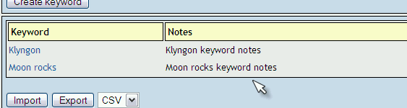

CSV
Keyword;Notes

Example

Klyngon;Klyngon keyword notes
Moon rocks;Moon rocks keyword notes

XML - Example

<?xml version="1.0" encoding="UTF-8"?>
<keywords>
<keyword name="Klyngon">
<notes>
<![CDATA[Klyngon keyword notes]]>
</notes>
</keyword>
<keyword name="Moon rocks">
<notes>
<![CDATA[Moon rocks keyword notes]]>
</notes>
</keyword>
</keywords>

Test project

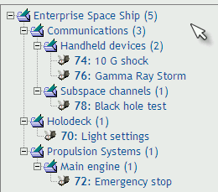

<?xml version="1.0" encoding="UTF-8"?>
<testsuite name="">
<details><![CDATA[]]></details>
<testsuite name="Communications">
<details><![CDATA[<p>Communication Systems of all types</p>]]></details>
<testsuite name="Handheld devices">
<details><![CDATA[]]></details>
<testcase name="10 G shock">
<summary><![CDATA[]]></summary>
<steps><![CDATA[]]></steps>
<expectedresults><![CDATA[]]></expectedresults>
</testcase>
<testcase name="Gamma Ray Storm">
<summary><![CDATA[]]></summary>
<steps><![CDATA[]]></steps>
<expectedresults><![CDATA[]]></expectedresults>
</testcase>
</testsuite>
<testsuite name="Subspace channels">
<details><![CDATA[<p>Only basic subspace features</p>]]></details>
<testcase name="Black hole test">
<summary><![CDATA[]]></summary>
<steps><![CDATA[]]></steps>
<expectedresults><![CDATA[]]></expectedresults>
</testcase>
</testsuite>
</testsuite>
<testsuite name="Holodeck">
<details><![CDATA[]]></details>
<testcase name="Light settings">
<summary><![CDATA[]]></summary>
<steps><![CDATA[]]></steps>
<expectedresults><![CDATA[]]></expectedresults>
</testcase>
</testsuite>
<testsuite name="Propulsion Systems">
<details><![CDATA[]]></details>
<testsuite name="Main engine">
<details><![CDATA[]]></details>
<testcase name="Emergency stop">
<summary><![CDATA[]]></summary>
<steps><![CDATA[]]></steps>
<expectedresults><![CDATA[]]></expectedresults>
</testcase>
</testsuite>
</testsuite>
</testsuite>

Test suite

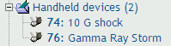

Example – without keywords

<?xml version="1.0" encoding="UTF-8"?>
<testsuite name="Handheld devices">
<details><![CDATA[]]></details>
<testcase name="10 G shock">
<summary><![CDATA[]]></summary>
<steps><![CDATA[]]></steps>
<expectedresults><![CDATA[]]></expectedresults>
</testcase>
<testcase name="Gamma Ray Storm">
<summary><![CDATA[]]></summary>
<steps><![CDATA[]]></steps>
<expectedresults><![CDATA[]]></expectedresults>
</testcase>
</testsuite>

Example – with keywords

<?xml version="1.0" encoding="UTF-8"?>
<testsuite name="Handheld devices">
<details><![CDATA[]]></details>
<testcase name="10 G shock">
<summary><![CDATA[]]></summary>
<steps><![CDATA[]]></steps>
<expectedresults><![CDATA[]]></expectedresults>
<keywords>
<keyword name="Klyngon">
<notes><![CDATA[Klyngon keyword notes]]></notes>
</keyword>
</keywords>
</testcase>
<testcase name="Gamma Ray Storm">
<summary><![CDATA[]]></summary>
<steps><![CDATA[]]></steps>
<expectedresults><![CDATA[]]></expectedresults>
<keywords>
<keyword name="Klyngon">
<notes><![CDATA[Klyngon keyword notes]]></notes>
</keyword>
<keyword name="Moon rocks">
<notes><![CDATA[Moon rocks keyword notes]]></notes>
</keyword>
</keywords>
</testcase>
</testsuite>

Test case

Just one test case

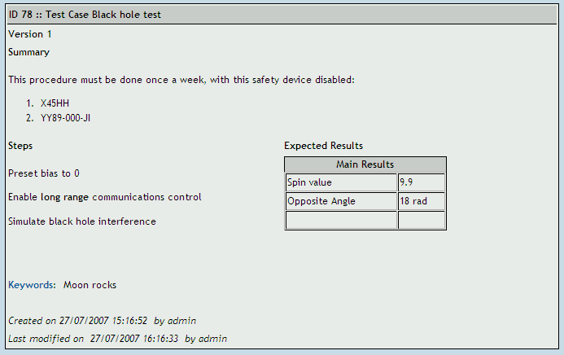

Example – XML - with keywords

<?xml version="1.0" encoding="UTF-8"?>
<testcases>
<testcase name="Black hole test">
<summary>
<![CDATA[<p>This procedure must be done once a week, with this safety device disabled:</p>
<ol><li>X45HH</li><li>YY89-000-JI</li></ol>]]>
</summary>
<steps><![CDATA[
<p>Preset bias to 0</p>
<p>Enable <strong>long range</strong> communications control</p>
<p>Simulate black hole interference</p>]]> </steps>
<expectedresults><![CDATA[
<table width="200" cellspacing="1" cellpadding="1" border="1">
<caption>Main Results</caption>
<tbody>
<tr><td>Spin value</td><td>9.9</td></tr>
<tr><td>Opposite Angle</td><td>18 rad</td></tr>
<tr><td>&nbsp;</td><td>&nbsp;</td></tr>
</tbody>
</table>]]>
</expectedresults>
<keywords>
<keyword name="Moon rocks">
<notes><![CDATA[Moon rocks keyword notes]]></notes>
</keyword>
</keywords>
</testcase>
</testcases>

All test cases in test suite

<?xml version="1.0" encoding="UTF-8"?>
<testcases>
<testcase name="10 G shock">
<summary><![CDATA[]]></summary>
<steps><![CDATA[]]></steps>
<expectedresults><![CDATA[]]></expectedresults>
</testcase>
<testcase name="Gamma Ray Storm">
<summary><![CDATA[]]></summary>
<steps><![CDATA[]]></steps>
<expectedresults><![CDATA[]]></expectedresults>
</testcase>
</testcases>

XLS

Every row must have four columns:

Column number | Contents
1 | Test case name
2 | summary
3 | steps
4 | Expected results

First row will be skipped, because is supposed it contains column descriptions.

Example:

Name | Summary | Steps | Expected results
Engine fast start up | Start up on 5 second | Bla, bla,bla | Bla, bla
Engine emergency stop | Engine stop due to panic button. | - Unlock panic button  - Press panic button  - Press confirm | Engine must stop right now
xxxx | xxxx | xxxx | xxx

Requirement

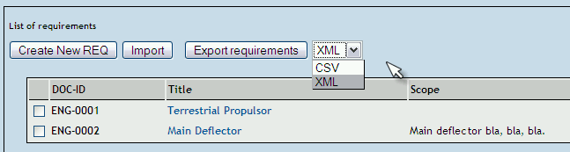

CVS
req_doc_id,title,”description”

Example

ENG-0001,Terrestrial Propulsor,
ENG-0002,Main Deflector,"<p>Main deflector bla, bla, bla.</p>"

XML

<?xml version="1.0" encoding="UTF-8"?>
<requirements>
<requirement>
<docid><![CDATA[ENG-0001]]></docid>
<title><![CDATA[Terrestrial Propulsor]]></title>
<description><![CDATA[]]></description>
</requirement>
<requirement>
<docid><![CDATA[ENG-0002]]></docid>
<title><![CDATA[Main Deflector]]></title>
<description><![CDATA[<p>Maindeflector bla, bla, bla.</p>]]></description>
</requirement>
</requirements>

Results

Example 1 – Format supportes on TL 1.7 and UP

<?xml version="1.0" encoding="UTF-8"?>
<results>
<testcase id="100"> <!-- ID: internal/DB id --->
<result>p</result>
<notes>functionality works great </notes>
</testcase>
<testcase id="200">
<result>f</result>
<notes>this case failed due to error </notes>
</testcase>
<testcase id="150">
<result>b</result>
<notes>this test case is blocked</notes>
</testcase>
</results>

Example 2 – Format supported on TL 1.8 beta 3 and UP

<?xml version="1.0" encoding="UTF-8"?>
<!-- Comment -->
<results>
<testcase external_id="POL-1" >
<!-- if not present logged user will be used -->
<tester>u0113</tester> <!-- tester LOGIN Name--->
<!-- if not present now() will be used -->
<timestamp>2008-09-08 14:00:00</timestamp>
<result>p</result>
<notes>functionality works great </notes>
</testcase>
<testcase external_id="POL-1" > <!-- ANOTHER EXE for SAME test case --->
<result>f</result>
<notes>functionality works great KIMI</notes>
</testcase>

<testcase external_id="1256" > <!-- Using INTERNAL ID --->
<result>f</result>
<notes>Using INTERNAL ID as link </notes>
</testcase>

</results>

You can import several / multiple execution results using a single XML file

