
User Manual
TestLink version 1.7

© 2004 - 2008 TestLink Community
Permission is granted to copy, distribute and/or modify this document under the terms of the GNU Free Documentation License, Version 1.2 published by the Free Software Foundation; with no Invariant Sections, no Front-Cover Texts, and no Back-Cover Texts. The license is available in "GNU Free Documentation License" homepage.

Table of Contents
1 General information 4
1.1 Overall structure 4
1.2 Basic Terminology 4
1.3 Example of TestLink simple work-flow 5
2 Test Projects 7
2.1 Creating new Test Projects 7
2.2 Edit and delete Test Projects 7
3 Test Specification 8
3.1 Test Suite 8
3.2 Test Cases 8
3.3 Keywords 9
4 Requirement based testing 11
4.1 Availability 11
4.2 Requirements Specification 11
4.3 Requirements 12
5 Test Plans 14
5.1 Create and delete Test Plan 14
5.2 Builds 14
5.3 Populating Test Plan - adding Test Cases 14
5.4 Test execution assignment 16
5.5 Priority 16
5.6 Milestones 16
6 Test Execution 18
6.1 General 18
6.2 Navigation 18
6.3 Execution 19
7 Custom Fields 21
8 Test Reports and Metrics 22
8.1 General Test Plan Metrics 22
8.2 The Overall Build Status 23
8.3 Query Metrics 23
8.4 Blocked, Failed, and Not Run Test Case Reports 24
8.5 Test Report 24
8.6 Charts 24
8.7 Total Bugs For Each Test Case 25
8.8 Requirements based report 25
8.9 How to add a new report 25
9 User Administration 26
9.1 Account settings 26
9.2 Role Permissions 26
9.3 Rights Definitions 28
9.4 Test Plan Assignment 28
10 Import and Export data 30
10.1 Import/Export Keywords 30
10.2 Export/Import Test Project 31
10.3 Import/Export Test suite 32
10.4 Just one Test Case 33
10.5 All Test Cases in test suite 34
10.6 Import/Export Software Requirements 34
10.7 Import Test Cases from Excel via XML 35

General information
TestLink is web based Test Management system. This manual should serve as source for users to understand processes, terms and organization of work with TestLink. See the Installation manual for more information about system requirements, installation steps and configuration. The latest documentation is available on www.teamst.org or testlink.sourceforge.net.
Please use our forum if you have questions that the manual doesn't answer.

Overall structure
There are three cornerstones: Test Project, Test Plan and User. All other data are relations or attributes of this base. First, we will define terms that are used throughout the documentation and testing world.
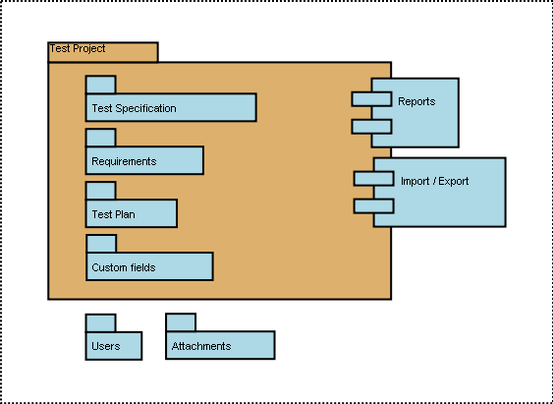Illustration 1: Test Project is the basic component in TestLink

Basic Terminology
Test Case describes a testing task via steps (actions, scenario) and expected results. Test Cases are the fundamental piece of TestLink.
Test Suite (Test Case Suite) organizes Test Cases to units. It structures Test Specification into logical parts.
Test Suite replaces the components and categories in TL 1.6 and earlier.
Test Plan is created when you'd like to execute Test Cases. Test Plans can be made up of the Test Cases from one or many Test Projects. Test Plan includes Builds, Milestones, user assignment and Test Results.
Test Project is something that will exist forever in TestLink. Test Project will undergo many different versions throughout its lifetime. Test Project includes Test Specification with Test Cases, Requirements and Keywords. Users within the project have defined roles.
Test Project was called Product in TL 1.6 and earlier.
User: each TestLink user has a Role that defines available TestLink features. See more in chapter “User Administration”. Illustration 2 shows common activities according to user roles.

Example of TestLink simple work-flow
- Administrator creates a Test Project “Fast Food” and two users, Adam with rights “Leader” and Bela with rights “Senior Tester”.
- Leader Adam imports Software Requirements and for part of these requirements generates empty Test Cases. He reorganize them into two Test Suites: “Fish” and “Chips”.
- Tester Bela describes a test scenario (create a content of empty Test Cases) using these Test Stecification that is organized into Test Suites.
- Adam creates keyword “Regression testing” and assignes this keyword to ten of these Test Cases.
- Adam creates a Test Plan “Fish & Chips 1”, Build “Fish 0.1” and links all Test Cases in Test Suite “Fish” to this Test Plan. He assignes himself and Bela as resources to this Test Plan too.
- Now developers produce a first build. Adam and Bela execute and record the testing with the result: 5 passed, 1 failed and 4 are blocked.
- Developers make a new Build “Fish 0.2” and Bela tests the failed and blocked Test Cases only. This time these all blocked and failed Test Cases passed. They retest also all Test Cases with keywords “Regression testing” in addition.
- A manager of this team would like to see the results. Administrator explains to him that he can create an account himself on the login page. Manager does it. He has default “Guest” rights and can see Test Results and Test Cases. He can see that everything passed in the overall report ;-) and problems in Build “Fish 0.1” in a report for that particular Build.
- Later, developers finally add also “Chips” functionality. Adam creates a Test Plan “Fish & Chips 2”. He can reuse the first Test Plan as template. All “Fish” Test Cases and roles will be automatically added. He create a new Build “Fish 1.1” and links all “Chips” Test Cases to this Test Plan too.
- Now, a testing starts as usually.
- Later, Admin creates a new Test Project for another product “Hot Dog”. But this is another test team and different story.
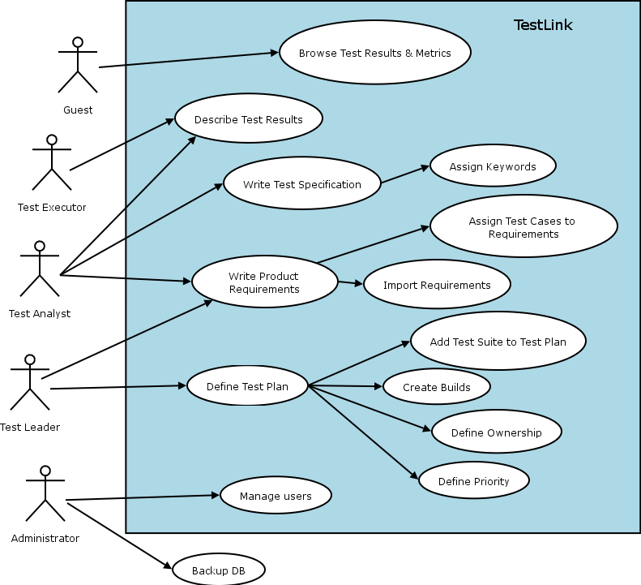Illustration 2: Functionality overview

Test Projects
Test Projects are the basic organisational unit of TestLink. Test Projects are releases of your company that may change their features and functionality over time but for the most part remain the same. Test Project includes requirements documentation, Test Specification, Test Plans and specific user rights.

Creating new Test Projects
Creating a new Test Project requires "admin" rights. Each Test Project must have an unique name. Background colors can be assigned to Test Project templates to visually distinguish them. Admin can enable requirements related functionality.
Things to note when creating a new Test Project:
- Deleting Test Projects from the system is not recommended as this either orphans a large number of Test Cases or deletes the Test Cases from the system.
- Test Plans represent the testing of a Test Project at a certain point in time. Consequently, Test Plans are created from Test Project Test Cases. We do not recommend to create separate Test Projects for versions of one Product.
- TestLink supports importing XML or CSV data into a Test Project. This is explained further in the Import section, below.

Edit and delete Test Projects
Editing Test Projects requires "admin" rights. User can change Test Project name, color of background and availability of requirements functionality.
User can inactivate the Test Project if it's obsolete. This will mean that the Test Project is not visible in the list within the top navigation bar (admin will see this Test Project in the list marked by '*').
User can also delete a Test Project. This action will also delete all related data from database. This action is not reversible. We strongly recommend using inactivate instead of delete.

Test Specification
TestLink breaks down the Test Specification structure into Test Suites and Test Cases. These levels are persisted throughout the application.

Test Suite
Users organize Test Cases into Test (Case) Suites. Each Test Suite consists of a title, formatted description Test Cases and possibly other Test Suites. TestLink uses tree structure for Test Suites. The common practise is that the description holds information valid for most of included data. For example, the following could be specified: scope, configuration, precondition, related documentation, tools, infrastructure, etc.
Creating one or more Test Suites is one of the first steps when creating your Test Project. Users (with edit right) can create, delete, copy, move, export and import both nested Test Suites and Test Cases. Title and description can be modified too.
Attachments with external documents or pictures could be added into particular Test Suites. The functionality must be allowed via TestLink configuration.

Test Cases
Test Case is a set of inputs, execution preconditions, and expected results (outcomes) developed for a particular objective, such as to exercise a particular program path or to verify compliance with a specific requirement.
Test Cases have the following parts:
- Title: could include either short description or abbreviation (e.g. TL-USER-LOGIN)
- Summary: should be really short; just for overview.
- Steps: describe test scenario (input actions); can also include precondition and cleanup information here.
- Expected results: describe checkpoints and expected behaviour of a tested product or system.
- The numeric ID of a Test Case is assigned automatically by TestLink, and can not be changed by users. This ID is system wide, meaning that when a Test Case is created a global counter is used, independent of the Test Project in which the Test Case is created.
- Attachments: could be added if configuration allows it.

Test Case - Active Attribute
If several versions of a Test Case exist, it would be useful to have a new attribute, Active/Inactive, to use in this way:
- Every Test Case version is created ACTIVE
- An Inactive Test Case Version will not be available in "Add Test Cases to Test Plan". This can be useful for Test Designers. They can edit or change the Test Case Version and only when he/she decides it is completed, change Status to ACTIVE so it will be available to be used in a Test Plan.
- Once a Test Case Version has been linked to a Test Plan, and has results, it can't be turned INACTIVE.

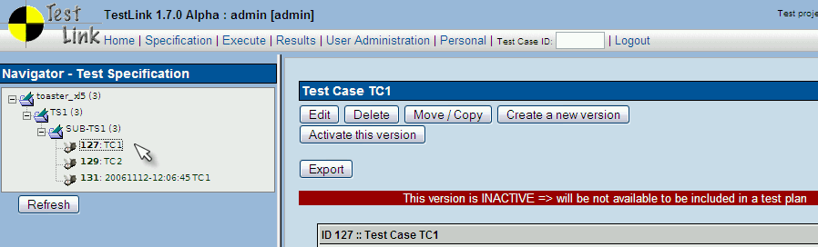Illustration 3: What you see in Test Case specification

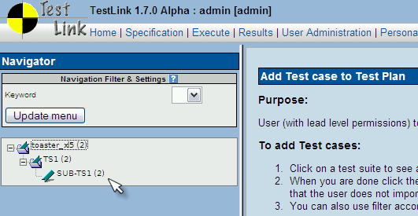Illustration 4: What you see when trying to add Test Cases to a Test Plan

As you can note, the number near Test Project name (in this example: toaster_xl5) is 2, but the Test Project has 3 Test Cases. Test Case TC1 is not counted, because is inactive.

Removing Test Cases
Test Cases and Test Suites may be removed from a Test Plan by users with “lead” permissions. This operation may be useful when first creating a Test Plan since there are no results. However, removing Test Cases will cause the loss of all results associated with them. Therefore, extreme caution is recommended when using this functionality.

Requirements relation
Test Cases could be related to software/system requirements as n to n. The functionality must be enabled for a Test Project. User can assign Test Cases and Requirements via the Assign Requirements link in the main screen.

Keywords
Keywords were created to give users another level of depth when categorizing Test Cases. Keywords serve as a means of grouping Test Cases with some attribute within a Test Specification. For example, you can use it to define:
- Regression or Sanity set
- Reviewed Test Cases
- Set of Test Cases valid for one platform

Keyword Creation
At this time keywords can only be created by users with the mgt_modify_key rights. These rights are currently held only by Leaders. Once a keyword or grouping of keywords has been created users may assign them to Test Cases.

Assigning Keywords
Keywords may be assigned to Test Cases either from the assign keyword screen (in batch) or via the Test Case management (individually).

Filter by Keyword
Users have the ability to filter by Keywords to:
- Search Test Cases in Test Specification.
- Add groups of Test Cases in a Test Case Suite (Test Plan).
- Execute test screen.

Requirement based testing
To prove that a system is built as specified, testers use requirement based testing. For every requirement, they design one or more Test Cases. At the end of the test execution a test manager reports on the tests that are executed and the requirements that are covered. Based on this information the client and the various stakeholders decide whether a system can be transferred to the next test phase or can go live. Test managers use a combination of risk and requirement-based testing to ensure that a system is built as specified from the customer and stakeholders perspective. As a result, this complete testing delivers the following advantages:
- Linking risks and requirements will reveal vague or missing requirements. This is especially interesting for risks with a high priority.
- Testing can be focused on the most important parts of an information system first: covering the risks with the highest priority.
- Communicating in the same language as the client and the stakeholders. This makes it easier to report on the status of the Test Project. Then a better founded decision can be made whether to invest more in testing or take the risk.
- The risks and their priority make negotiating on the Test Project in times of pressure easier. What risks have to be covered within this Test Project and which ones can be postponed. Risk and requirement-based testing results in a better controlled Test Project. The communication with the client and the stakeholders is improved. The test manager begins testing with risks with the highest priority. The process is streamlined and the end result is higher quality.

Availability
The functionality is available at the Test Project level. I.e. Administrator should enable it for a specified Test Project (Edit Test Project link in Main window). Otherwise links are not shown.
There are two user levels for this feature. Most roles can view requirements, but not modify them. Refer to User section for more details.

Requirements Specification
Requirements are grouped to one or more System/Software/User Requirement Specifications.
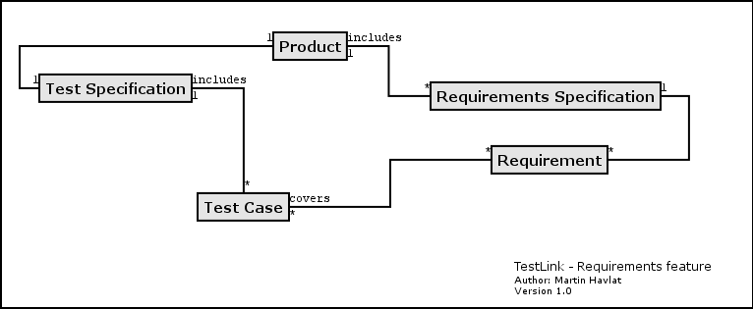Illustration 5: Dependencies between requirement related objects
Create a document with Requirements:
- Click Requirements Specification in Main window. The list of Requirement Specifications is shown.
- Press Create button to create a document.
- Adjust Title, Scope and eventually Count of Test Cases. The last parameter is used for statistics. Use only if you have a valid Requirement document but not all requirements are available at the moment in TestLink. Default value 'n/a' means that the current count of requirements in a specification is used.
- Press Create button to add data to database. You can see the title of your new created document in the table of list of Requirement Specifications.
- Click the title of document for next work. The Requirement Specification window is shown.
Each Requirement Specification has own statistics and report related to included data.
All Specifications can be printed using the "Print" button in the "Requirement Specifcation" window. Administrator can define company, copyright and confident text via configuration files.

Requirements
Each requirement has Title, Scope (html format) and Status. Title must be unique and has max. 100 characters. Scope paramter is text in HTML format. Status can have the values VALID or NOT_TESTABLE. A NOT_TESTABLE requirement is not counted in metrics.
Requirements could be created/modified or deleted manually via TestLink interface or imported as CSV file.

Import requirements
TestLink supports two types of CSV. The first 'simple' is composed from title and scope in each row. The second 'Export from Doors' tries to detect the header and choose the correct fields. Import compares titles and tries to resolve conflicts. There are three ways to do this: update, create requirements with same title and skip adding the conflicted ones.

Requirements to Test Case relation
Test Cases are related with software/system requirements as * to *. I.e. you can assign one or more Test Cases to one Requirement and one or more requirements could be covered by one Test Case. User can assign Requirements to Test Cases via the Assign Requirements link in the Main window.
The coverage of the Test Specification could be viewed via pressing the Analyse button in the Requirement Specification window.

Requirement based Report
Navigate to Reports and Metrics menu. There is a Requirements based Report link. Requirements in the current Requirement Specification and Test Plan are analysed for this report. The latest results of Test Cases (available in Test Plan) are processed for each requirement. The result with the highest priority is applied for the requirement. Priorities, from the highest to lowest, are: Failed, Blocked, Not Run and Passed.
Example of requirement coverage
A requirement is covered by three Test Cases. Two of them are included in the current Test Suite. One passed and one was not tested for the Build 1. Now Requirement has overall result of Not Run. Second Test Case was tested with Build 2 and passed. So Requirement passed too.

Test Plans
A record of the test planning process detailing the degree of tester involvment, the test environment, the Test Case design techniques and test measurement techniques to be used, and the rationale for their choice.

Test Plans are the basis for Test Case execution. Test Plan contains name, description, collection of chosen Test Cases, Builds, Test Results, milestones, tester assignment and priority definition.

Create and delete Test Plan
Test Plans may be created from the “Test Plan management” page by users with lead privileges for the current Test Project. Press button “Create” and enter data.
Test Plans are made up of Test Cases imported from a Test Specification at a specific point of time. Test Plans may be created from other Test Plans. This allows users to create Test Plans from Test Cases that exist at a desired point in time. This may be necessary when creating a Test Plan for a patch. In order for a user to see a Test Plan they must have the proper rights. Rights may be assigned (by leads) in the define User/Project Rights section. This is an important thing to remember when users tell you they can't see the project they are working on.
Test Plans may be deleted by users with lead privileges. Deleting Test Plans permanently deletes both the Test Plan and all of its corresponding data, including Test Cases (not in Test Specification), results, etc. This should be reserved only for special cases. Alternatively, Test Plans may be deactivated on the same page, which suppresses display on selection menus in the “main” page.

Builds
An user with lead privileges could follow the link “Build management” in the main page.
Builds are a specific release of software. Each project in a company is most likely made up of many different Builds. In TestLink, execution is made up of both Builds and Test Cases. If there are no Builds created for a project the execution screen will not allow you to execute. The metrics screen will also be completely blank.
Each Build is identified via title. It includes description (html format) and two states:
- Active / Inactive – defines whether the Build is available for TestLink functionality. Inactive Build is not listed in either execution or reports pages.
- Opened / Closed – defines if Test Results can be modified for the Build.
Builds can be edited (via link under a Build title) and deleted (by click on the appropriate “bin” icon) in the table of existing Builds.

Populating Test Plan - adding Test Cases
Data from multiple Test Projects can be added into one Test Plan. Test Specification data can be filtered by keywords (adjusted in navigation pane).
Once data has been linked into a Test Plan it will be marked with checkmark. If a Test Case has already been imported it will be ignored if it is imported again.

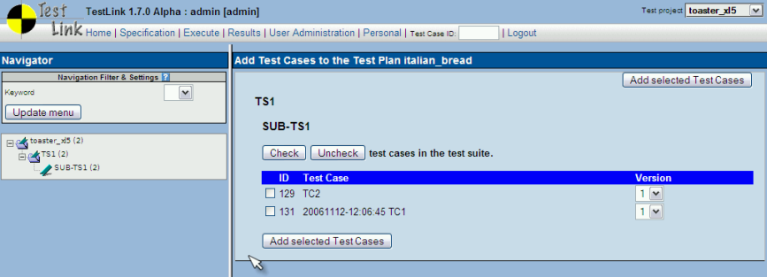Illustration 6: Frame for Adding Test Cases into Test Plan
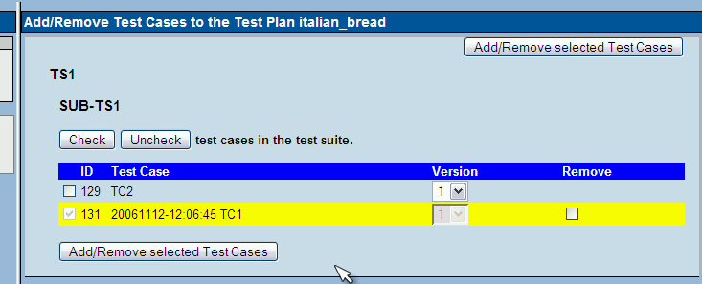Illustration 7: Frame for modifying content of test cases within Test Plan

Removing Test Cases from Test Plan
Test Cases and Test Suites can be removed from a Test Plan by users with lead permissions from the "Remove Test Cases" page. Removing data may be useful when first creating a Test Plan since there are no results. However, removing Test Cases will cause the loss of all results associated with them. Therefore, extreme caution is recommended when using this functionality.
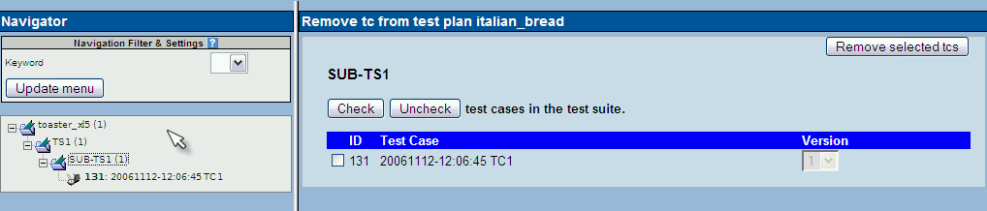
Tree in left pane, shows only the Test Cases present in Test Plan.

Test execution assignment
Test execution assignment affects both the execution and metrics screens. In the execution screen users have the ability to sort the executable Test Cases to see the ones they have been assigned. In the main metrics screen there is a table that shows the remaining Test Cases by tester. If there are no Test Case tester assigned it defaults to none.

A Tester can also see the metrics of his/her own executed tests in main page if these metrics are enabled (see Installation manual).

Priority
This feature is temporary unavailable in 1.7 version. It needs an update to allow Importance assignment to particular Test Cases.
TestLink gives users the ability to assign Importance to Test Cases. General Risk is done at the Test suite level within a particular Test Plan.
TestLink combines both these attributes into Priority. These attributes (Risk, Importance and Priority) have three levels (Low, Medium, High). Medium is default value.
Assigning risk, importance, and priority are all optional. It could be allowed by administrator for a chosen Test Project.

Milestones
Note: Version 1.7 doesn't include default report for milestones.
Test leader can define the percentage of finished tests with respect to a defined date. The current solution expects defined priorities.
Illustration 8: Test leader can define one or more milestones for a Test Plan

Test Execution

General
Test execution is available after:
- A Test Specification is written.
- A Test Plan is created.
- Test Cases are added to Test Plan.
- A Build is created.
- The Test Plan is assigned to testers (otherwise they cannot navigate to this Test Plan).
Select a Test Plan in main page and navigate to the 'Execute tests' link. The left pane allows navigation in Test Case Suite via a tree menu, filtering by keyword, result, Build, and tester.

Navigation
The navigation pane consists of a 'Filter & Settings' box and a tree menu with Test Case Suite.

Filtering Test Cases
This table allows the user to filter Test Cases for smart navigation before they are executed.
- Tester: Users can filter Test Cases by their tester.
- Keyword: Users can filter Test Cases by keyword. Keywords are set either using the Create/Edit/Delete Test Cases or by the Assign Keywords To Multiple Cases. Keywords can only be created, edited, or deleted by leads but may be assigned to Test Cases by testers.
- Result: Users can filter Test Cases by results. Results are what happened to that Test Case during a particular Build. Test Cases can pass, fail, be blocked, or not be run.

Define a tested Build
Users can filter Test Cases by Builds. Builds are the basic Component for how Test Cases are tracked. Each Test Case may be run once and only once per Build. Builds can be created by leads using the Create New Build page.

Tree menu
The tree menu in navigation pane includes Test Case Suite colored by results.
Menu colored: By default the tree will be sorted by the results for the defined Build that is chosen from the dropdown box.
Example TC colored according to the Build
User selects Build 2 from the dropdown box and doesn't check the "most current" check box. All Test Cases will be shown with their status from Build 2. So, if Test Case 1 passed in Build 2 it will be colored green.
A second possibility is that the menu is colored according to the latest Test Result.
Example TC colored according to the latest result
User selects Build 2 from the dropdown box and this time checks the "most current" check box. All Test Cases will be shown with most current status. So, if Test Case 1 passed in Build 3, even though the user has also selected Build 2, it will be colored green.

Execution

Test Status
Execution is the process of assigning a result (pass, fail, blocked) to a Test Case for a specific Build. A 'Blocked' Test Case is not possible to test for some reason (e.g. a problem in configuration disallows to run a tested functionality).

Insert Test Results
Test Results screen is shown via click on an appropriate Test Suite or Test Case in navigation pane. The title shows the current Build and owner. The colored bar indicate status of the Test Case. Yellow box includes test scenario of the Test Case.
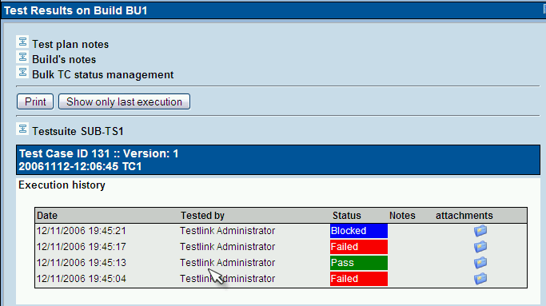Illustration 9: Frame with several results of one Test Case
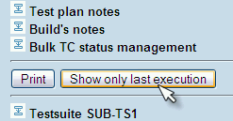Illustration 10: User can select to print only the last result
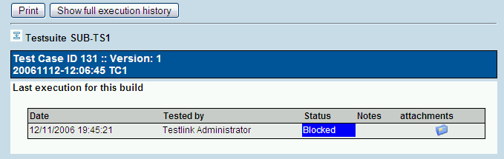Illustration 11: The last result could be printed only
The indication that the Test Case was updated or deleted in test Specification is not supported after 1.5 version.
Updated Test Cases: TL 1.0.4 version has indication by flag, that is missing from 1.6 version. If users have the proper rights they can go to the “Update modified test case” page through the link on main page. It is not necessary for users to update Test Cases if there has been a change (newer version or deleted).

Custom Fields
Custom field definitions are system wide, i.e., you can not define two custom fields with same field ID. After you have created a Custom Field, you need to assign it to the Test Project in which do you want to use it.
Custom field has been implemented using a mix functionality from Mantis (http://www.mantisbt.org/) and dotproject (http://www.dotproject.net/) models.
Show / Enable Attributes
show on design:
Custom field will be displayed during Test Case specification
enable on design:
User will be able to assign/change custom field value during Test Case specification
show on execution:
Custom field will be displayed during Test Case execution
enable on execution:
User will be able to assign/change custom field value during Test Case execution.
Value assigned will be saved.
Example 1.
Custom Field : Additional Notes
Type : string
applicable to test suites, to be edited ONLY during
Test Case specification, but useful to be seen during test execution.
show on design = YES
enable on design = YES
show on execution = YES
enable on execution = NO
Example 2.
Custom Field : Operating System
Type : list
applicable to Test Cases, to be edited ONLY during
Test Case EXECUTION, unused during Test Case DESIGN.
show on design = NO
enable on design = NO
show on execution = YES
enable on execution = NO

Test Reports and Metrics
Test Reports and Metrics are accessed by clicking the “Results” or “Test reports and Metrics” links on the main page. Reports and Metrics are based on the selected Test Plan (from combo box menu). The page that is displayed to the user includes:
The right pane will be populated with instructions on how to use the controls and how each report is produced.
The left pane is used for navigating to each report and operating controls which effect how reports behave and are displayed. The button “Print” initializes printing of the right pane (no navigation will be printed).
All test reports (except charts) can be generated in 1 of 3 format :
- Normal - report is displayed in web page (html)
- MS Excel – report exported to Microsoft Excel
- HTML Email – report is emailed to user's email address
There are currently 9 separate reports to choose from, their purpose and function are explained below. Currently, there are no reports which compile results across multiple Test Plans.

General Test Plan Metrics
This page shows you only the most current status of a Test Plan by test suite, owner, and keyword. The most “current status” is determined by the most recent Build Test Cases were executed on. For instance, if a Test Case was executed over multiple Builds, only the latest result is taken into account. “Last Test Result” is a concept used in many reports, and is determined as follows :
- The order in which Builds are added to a Test Plan determines which Build is most recent. The results from the most recent Build will take precendence over older Builds. For example, if you mark a test as “fail” in Build 1, and mark it as “pass” in Build 2, it's latest result will be “pass”.
- If a Test Case is executed mulitple times on the same Build, the most recent execution will take precedence. For example, if Build 3 is released to your team and tester 1 marks it as “pass” at 2PM, and tester 2 marks it as “fail” at 3PM – it will appear as “fail”.
- Test Cases listed as “not run” against a Build are not taken into account. For example, if you mark a case as “pass” in Build 1, and don't execute it in Build 2, it's last result will be considered as “pass”.

The following tables are displayed :
Results by top level Test Suites
Lists the results of each top level suite. Total cases, passed, failed, blocked, not run, and percent completed are listed. A “completed” Test Case is one that has been marked pass, fail, or block. Results for top level suites include all children suites.
Results By Keyword
Lists all keywords that are assigned to cases in the current Test Plan, and the results associated with them.
Example :
Keyword | Total | Passed | Failed | Blocked | Not run | Completed [%]
P3 | 1128 | 346 | 47 | 55 | 680 | 39.72
P2 | 585 | 372 | 25 | 31 | 157 | 73.16
P1 | 328 | 257 | 6 | 51 | 14 | 95.73

Results by owner
Lists each owner that has Test Cases assigned to them in the current Test Plan. Test cases which are not assigned are tallied under the “unassigned” heading.
Example:
Tester | Total | Passed | Failed | Blocked | Not run | Completed [%]
Dominika | 579 | 217 | 34 | 47 | 281 | 51.47
Mohammad | 246 | 82 | 9 | 2 | 153 | 37.80
unassigned | 35 | 19 | 0 | 1 | 15 | 57.14
Ken | 289 | 110 | 1 | 21 | 157 | 45.67
Mallik | 430 | 269 | 5 | 18 | 138 | 67.91
Ali | 227 | 123 | 28 | 13 | 63 | 72.25
Mike | 24 | 22 | 0 | 0 | 2 | 91.67
Alex | 272 | 155 | 1 | 36 | 80 | 70.59

The Overall Build Status
Lists the execution results for every Build. For each Build, the total Test Cases, total pass, % pass, total fail, % fail, blocked, % blocked, not run, and %not run are displayed. If a Test Case has been executed twice on the same Build, the most recent execution will be taken into account.

Query Metrics
This report consists of a query form page, and a query results page which contains the queried data.
Query Form Page:
User is presented with a query page with 4 controls. Each control is set to a default which maximizes the number of Test Cases and Builds the query should be performed against. Altering the controls allows the user to filter the results and generate specific reports for specific owner, keyword, suite, and Build combinations.
keyword – 0->1 keywords can be selected. By default – no keyword is selected. If a keyword is not selected, then all Test Cases will be considered regardless of keyword assignments. Keywords are assigned in the Test Specification or Keyword Management pages. Keywords assigned to Test Cases span all Test Plans, and span across all versions of a Test Case. If you are interested in the results for a specific keyword you would alter this control.
owner – 0->1 owners can be selected. By default – no owner is selected. If an owner is not selected, then all Test Cases will be considered regardless of owner assignment. Currently there is no functionality to search for “unassigned” Test Cases. Ownership is assigned through the “Assign Test Case execution” page, and is done on a per Test Plan basis. If you are interested in the work done by a specific tester you would alter this control.
top level suite - 0-> n top level suites can be selected. By default – all suites are selected. Only suites that are selected will be queried for result metrics. If you are only intested in the results for a specific suite you would alter this control.
Builds – 1->n Builds can be selected. By default – all Builds are selected. Only executions performed on Builds you select will be taken into account when producing metrics. For example – if you wanted to see how many Test Cases were executed on the last 3 Builds – you would alter this control.
Keyword, owner, and top level suite selections will dictate the number of Test Cases from your Test Plan that are used to compute per suite and per Test Plan metrics. For example, if you select owner=“Greg”, Keyword=”Priority 1”, and all available test suites – only Priority 1 Test Cases assigned to Greg will be considered. The “# of Test Cases” totals you will see on the report will be influenced by these 3 controls.
Build selections will influence whether a case is considered “pass”, “fail”, “blocked”, or “not run”. Please refer to “Last Test Result” rules as they appear above.
Press the “submit” button to proceed with the query and display the output page.
Query Report Page:
The report page will display:
- the query parameters used to create the report
- totals for the entire Test Plan
- a per suite breakdown of totals (sum / pass / fail / blocked / not run) and all executions performed on that suite. If a Test Case has been executed more than once on multiple Builds – all executions will be displayed that were recorded against the selected Builds. However, the summary for that suite will only include the “Last Test Result” for the selected Builds.

Blocked, Failed, and Not Run Test Case Reports
These reports show all of the currently blocked, failing, or not run Test Cases. “Last Test Result” logic (which is described above under General Test Plan Metrics) is again employed to determine if a Test Case should be considered blocked, failed, or not run. Blocked and failed Test Case reports will display the associated bugs if the user is using an integrated bug tracking system.

Test Report
View status of every Test Case on every Build. If a Test Case was executed multiple times on the same Build – the most recent execution result will be used. It is recommened to export this report to Excel format for easier browsing if a large data set is being used.

Charts
This report page requires your browser have a flash plugin. “Last Test Result” logic is used for all 4 charts that you will see. The graphs are animated to help the user visualize the metrics from the current Test Plan.
The four charts provide are :
- Pie chart of overall pass / fail / blocked / and not run Test Cases
- Bar chart of Results by Keyword
- Bar chart of Results By Owner
- Bar chart of Results By Top Level Suite
The bars in the bar charts are colored such that the user can identify the approximate number of pass, fail, blocked, and not run cases.
It uses flash technology provided by http://www.maani.us to display results in a graphical format.

Total Bugs For Each Test Case
This report shows each Test Case with all of the bugs filed against it for the entire project. This report is only available if a Bug Tracking System is connected.

Requirements based report
This report is available if requirements are allowed for the current Test Project. Report is generated against one Requirement Specification document chosen from combo box menu.
There are two sections: metrics and results overview.
The following metrics are available:
- Total number of requirements
- Requirements within TestLink
- Requirements covered by Test Cases
- Requirements not covered by Test Cases
- Requirements not covered or not tested
- Requirements not tested
Requirements are divided into four sections. Each requirement is listed together with all related Test Cases (colored according to Test Case result):
- Passed Requirements
- Failed Requirements
- Blocked Requirements
- Unexecuted Requirements

How to add a new report
Copy one of the current reports and modify it according to your need. Don't forget that we use templates for rendering (<testlink_root>/gui/templates/<report_name>.tpl) and logic (<testlink_root>/lib/results/<report_name>.php). We recommend reusing existing functions to collect data for report instead of creating new ones.
Edit <testlink_root>/lib/results/resultsNavigator.php to add a link to your new report. There is an array, that could be easily enhanced. You must add a new URL and “name keyword” of report.
You can modify CSS style for a report. We suggest creating new classes instead of modifying current ones (to avoid unwanted changes in other pages).
If you contribute your new report(s) via our tracker, you can find it also in the next versions ... otherwise you risk that it will not work for the next main release.

User Administration

Account settings
Every user on the system will be able to edit their own information via the Account settings window (Personal link in menu bar).
TestLink allows users with administrator rights to create, edit, and delete users within the system. However, TestLink does not allow administrators to view or edit user's passwords. If users forget their passwords there is link on the login screen, that will mail the user their password based upon their user name and the email address they entered.
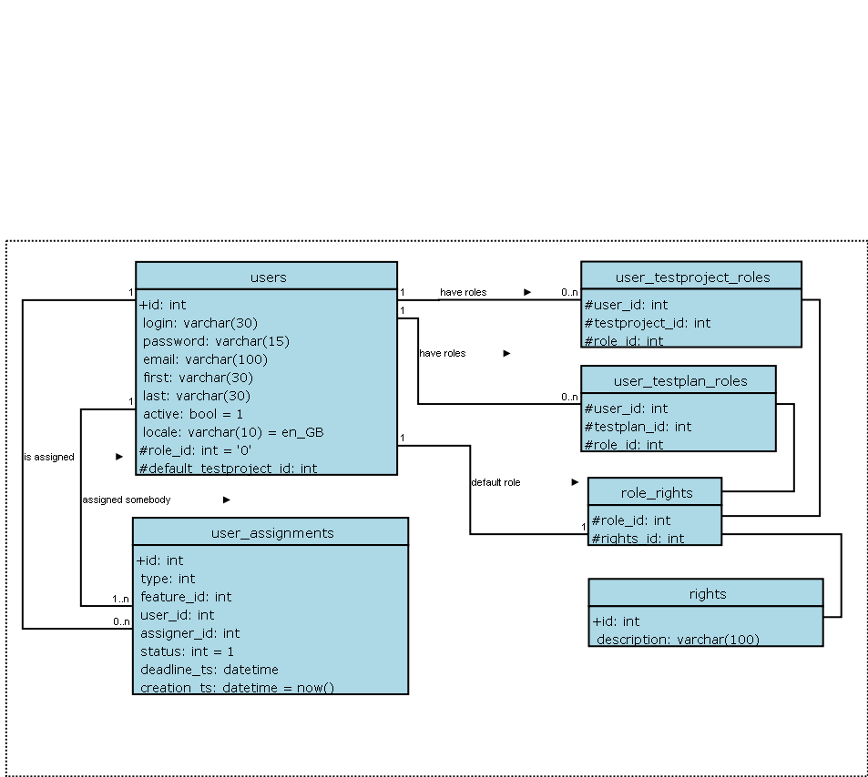

Role Permissions
TestLink is built with 6 different default permission levels built in. Changing of these rights is handled by the user administration link which is accessible by admins. These permission levels are as follows:
- Guest: A guest only has permission to view Test Cases and project metrics.
- Test Executor: A tester outside of the company that only has permissions to run tests allotted to them. (initially in 1.0.4 – otester).
- Test Designer: A user can fully work with Test Specification and Requirements.
- Test Analyst: A tester can view, create, edit, and delete Test Cases as well as execute them. Testers lack the permissions to manage Test Plans, manage Test Projects, create milestones, or assign rights. (initially tester, senior tester).
- Test Leader: A lead has all of the same permissions as a Tester but also gains the ability to manage Test Plans, assign rights, create milestones, and manage keywords.
- Admininstrator: An admin has all possible permissions (lead plus the ability to manage Test Projects and users).
Note: Test Plan related features needs also assign a Test Plan to be available. See Test Plan Assignment.

User Roles
There are predefined user roles. Adminstrator gives appropriate ability to modify data within TestLink. Each user has assigned just one of these roles.
If you view the table you will see rows for each of the permissions levels (guest ,tester, senior tester, leader, admin). The second column holds all of the different rights levels which will be defined below. These levels have been determined as standard for use but they can be edited to define new roles (for experienced administrator). The user table contains a foreign key that points to the appropriate permission level in the rights table.
Role | List of Rights | Permissions
Guest | mgt_view_tc, mgt_view_key, tp_metrics | Browse data only.
Test Executor  (Tester) | tp_execute,tp_metrics | Execute test only.
Test Analyst  (Senior Tester) | tp_execute, tp_metrics, tp_create_build, mgt_view_tc, mgt_modify_tc, mgt_view_key, mgt_view_req | Edit Test Specification, execute tests, create Build.
Test Designer | tp_metrics, mgt_view_tc, mgt_modify_tc, mgt_view_key, mgt_modify_req, mgt_view_req | Edit Test Specification and Requirements.
Test Leader | tp_execute, tp_create_build, tp_metrics, tp_planning, tp_assign_rights, mgt_view_tc, mgt_modify_tc, mgt_view_key, mgt_modify_key, mgt_view_req, mgt_modify_req | All Test Plan permissions, edit Test Specification and execute tests.
Administrator | tp_execute, tp_create_build, tp_metrics, tp_planning, tp_assign_rights, mgt_view_tc, mgt_modify_tc, mgt_view_key, mgt_modify_key, mgt_view_req, mgt_modify_req, mgt_modify_product, mgt_users | Everything possible. Only this role can maintain Test Projects and users.
Table 1: Role description

Case study – restrict access by default
Situation
In our organization we would like to restrict access to projects unless it is specifically granted. We currently have about 150 users with just over 90 different project. Many of the users are not QA, but are business analysts, and in some cases end users doing UAT. From what I can tell, all rights are inherited based on how the user was setup.
But we don't want a Business Analyst who is working on only one project have access to all 90.
Solution
Set these users with the global role <No rights> and granted an appropriate role on a testproject or testplan base. In const.inc.php you can also set the default role id to <No rights> (parameter $g_default_roleid).
You can also would like to rename a role “No rights” to something more polite.

Rights Definitions
Keywords used for definition of role abilities.

Right | Description
mgt_view_tc | View Test Specification (Test Suites and Test Cases)
mgt_modify_tc | Edit Test Specification (create, modify, delete, order, move, and copy - both Test Suites and Test Cases)
mgt_view_key | View keywords
mgt_modify_key | Modify keywords
mgt_modify_product | Create,edit and delete Test Projects
mgt_view_req | View requirements
mgt_modify_req | Create,edit, associate and delete requirements
Table 2: Test Project related Rights

Right | Description
tp_execute | Ability to execute Test Cases (insert Test Results)
tp_create_build | Ability to create Builds
tp_metrics | View metrics
tp_planning | Create, edit, delete Test Plans, assign risk/ownership, milestones, edit Test Case Suite
tp_assign_rights | Assign the rights to view projects
Table 3: Test Plan related Rights

Test Plan Assignment
Users can see only assigned Test Plans. In order to gain Test Plan permissions a user with lead or admin status must give them rights through the “Define user/project rights” link under “Test Plan Management”.
All users in the system will by default not have permissions to view newly created Test Plans (except for the Test Plan creators who can give themselves permissions at creation). Zero Test Plan permissions means that users will not see any Test Plans in the Test Plan dropdown box on main screen.
There is a table with Test Plan rights (i.e. which users can see which Test Plan). This table is made up of a combined user id and project id. The main page contains code which checks to see if the logged in user has the appropriate permissions (and then shows the allowed projects). It is not recommended that this be hacked with.

Import and Export data
TestLink supports several ways to share data.

Item | File format | What you get
Keyword | CSV  XML | All Test Project’s keywords
Test Project | XML | All Test Suites and Test Cases.  You can choose whether to also export assigned keywords.
Test Suite | XML | Test Suite details, All Test Cases and child test suites and Test Cases.  You can choose whether to also export assigned keywords.
Test Case | XML | Two types of exports can be done:  - Just one Test Case  - All Test Cases in Test Suite.  You can choose whether to also export assigned keywords.
Requirement | CSV  CSV DOORS (*)  XML | (*) Only import is supported for this format.
Table 4: Items that can be exported/imported
Limitation: Attached files and custom fields are not exported.

Import/Export Keywords

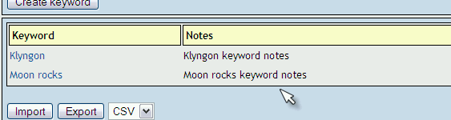Illustration 12: Keywords frame includes buttons for import and export

Example of CSV “Keyword;Notes”:

Klyngon;Klyngon keyword notes
Moon rocks;Moon rocks keyword notes

Example of XML with keywords:

<?xml version="1.0" encoding="UTF-8"?>
<keywords>
<keyword name="Klyngon">
<notes>
<![CDATA[Klyngon keyword notes]]>
</notes>
</keyword>
<keyword name="Moon rocks">
<notes>
<![CDATA[Moon rocks keyword notes]]>
</notes>
</keyword>
</keywords>

Export/Import Test Project
User can import or export Test Project including Description of the project, Test Specification and Keywords. The next two pictures show tree menu with data and the same data as XML file.

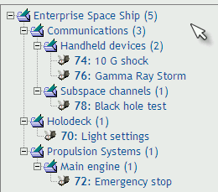
<?xml version="1.0" encoding="UTF-8"?>
<testsuite name="">
<details><![CDATA[]]></details>
<testsuite name="Communications">
<details><![CDATA[<p>Communication Systems of all types</p>]]></details>
<testsuite name="Handheld devices">
<details><![CDATA[]]></details>
<testcase name="10 G shock">
<summary><![CDATA[]]></summary>
<steps><![CDATA[]]></steps>
<expectedresults><![CDATA[]]></expectedresults>
</testcase>
<testcase name="Gamma Ray Storm">
<summary><![CDATA[]]></summary>
<steps><![CDATA[]]></steps>
<expectedresults><![CDATA[]]></expectedresults>
</testcase>
</testsuite>
<testsuite name="Subspace channels">
<details><![CDATA[<p>Only basic subspace features</p>]]></details>
<testcase name="Black hole test">
<summary><![CDATA[]]></summary>
<steps><![CDATA[]]></steps>
<expectedresults><![CDATA[]]></expectedresults>
</testcase>
</testsuite>
</testsuite>
<testsuite name="Holodeck">
<details><![CDATA[]]></details>
<testcase name="Light settings">
<summary><![CDATA[]]></summary>
<steps><![CDATA[]]></steps>
<expectedresults><![CDATA[]]></expectedresults>
</testcase>
</testsuite>
<testsuite name="Propulsion Systems">
<details><![CDATA[]]></details>
<testsuite name="Main engine">
<details><![CDATA[]]></details>
<testcase name="Emergency stop">
<summary><![CDATA[]]></summary>
<steps><![CDATA[]]></steps>
<expectedresults><![CDATA[]]></expectedresults>
</testcase>
</testsuite>
</testsuite>
</testsuite>

Import/Export Test suite

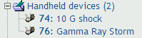

XML Example – Test Suite without keywords
<?xml version="1.0" encoding="UTF-8"?>
<testsuite name="Handheld devices">
<details><![CDATA[]]></details>
<testcase name="10 G shock">
<summary><![CDATA[]]></summary>
<steps><![CDATA[]]></steps>
<expectedresults><![CDATA[]]></expectedresults>
</testcase>
<testcase name="Gamma Ray Storm">
<summary><![CDATA[]]></summary>
<steps><![CDATA[]]></steps>
<expectedresults><![CDATA[]]></expectedresults>
</testcase>
</testsuite>

XML Example – Test Suite with keywords

<?xml version="1.0" encoding="UTF-8"?>
<testsuite name="Handheld devices">
<details><![CDATA[]]></details>
<testcase name="10 G shock">
<summary><![CDATA[]]></summary>
<steps><![CDATA[]]></steps>
<expectedresults><![CDATA[]]></expectedresults>
<keywords>
<keyword name="Klyngon">
<notes><![CDATA[Klyngon keyword notes]]></notes>
</keyword>
</keywords>
</testcase>
<testcase name="Gamma Ray Storm">
<summary><![CDATA[]]></summary>
<steps><![CDATA[]]></steps>
<expectedresults><![CDATA[]]></expectedresults>
<keywords>
<keyword name="Klyngon">
<notes><![CDATA[Klyngon keyword notes]]></notes>
</keyword>
<keyword name="Moon rocks">
<notes><![CDATA[Moon rocks keyword notes]]></notes>
</keyword>
</keywords>
</testcase>
</testsuite>

Just one Test Case

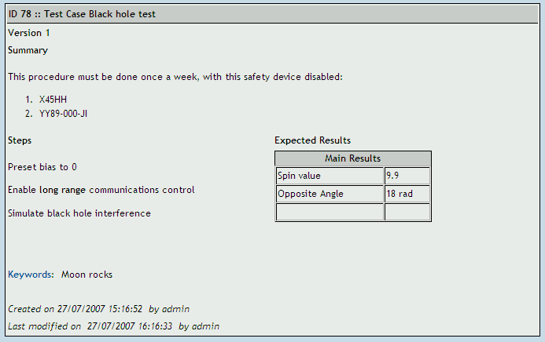

Example of XML file:
<?xml version="1.0" encoding="UTF-8"?>
<testcases>
<testcase name="Black hole test">
<summary>
<![CDATA[<p>This procedure must be done once a week, with this safety device disabled:</p>
<ol><li>X45HH</li><li>YY89-000-JI</li></ol>]]>
</summary>
<steps><![CDATA[
<p>Preset bias to 0</p>
<p>Enable <strong>long range</strong> communications control</p>
<p>Simulate black hole interference</p>]]> </steps>
<expectedresults><![CDATA[
<table width="200" cellspacing="1" cellpadding="1" border="1">
<caption>Main Results</caption>
<tbody>
<tr><td>Spin value</td><td>9.9</td></tr>
<tr><td>Opposite Angle</td><td>18 rad</td></tr>
<tr><td>&nbsp;</td><td>&nbsp;</td></tr>
</tbody>
</table>]]>
</expectedresults>
<keywords>
<keyword name="Moon rocks">
<notes><![CDATA[Moon rocks keyword notes]]></notes>
</keyword>
</keywords>
</testcase>
</testcases>

All Test Cases in test suite

<?xml version="1.0" encoding="UTF-8"?>
<testcases>
<testcase name="10 G shock">
<summary><![CDATA[]]></summary>
<steps><![CDATA[]]></steps>
<expectedresults><![CDATA[]]></expectedresults>
</testcase>
<testcase name="Gamma Ray Storm">
<summary><![CDATA[]]></summary>
<steps><![CDATA[]]></steps>
<expectedresults><![CDATA[]]></expectedresults>
</testcase>
</testcases>

Import/Export Software Requirements

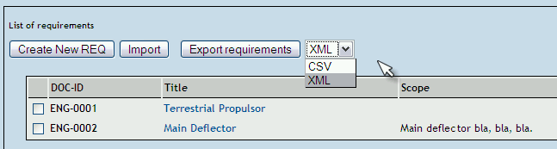

CSV file includes “Identifier of document, title, description”.
Example of CSV file:
ENG-0001,Terrestrial Propulsor,
ENG-0002,Main Deflector,"<p>Main deflector bla, bla, bla.</p>"

Example of XML file:
<?xml version="1.0" encoding="UTF-8"?>
<requirements>
<requirement>
<docid><![CDATA[ENG-0001]]></docid>
<title><![CDATA[Terrestrial Propulsor]]></title>
<description><![CDATA[]]></description>
</requirement>
<requirement>
<docid><![CDATA[ENG-0002]]></docid>
<title><![CDATA[Main Deflector]]></title>
<description><![CDATA[<p>Maindeflector bla, bla, bla.</p>]]></description>
</requirement>
</requirements>

Import Test Cases from Excel via XML

Creating XML file to import in TestLink
Step 1. Export one or more dummy Test Cases from TestLink into a XML file.
Step 2. Open new blank spread sheet document file.
Step 3. Navigate through menu bar Data > XML > Import & select the sample XML file. It creates appropriate structure in Excel.

Step 4. Then we will get dialog box asking "Where do you want to put the data?"
Step 5. Choose option one "XML list in existing worksheet" with first cell $A$1

Step 6. You will be able to see following columns : name, summary, steps & expected results

Step 7. Copy your data into this file accordingly & save the file in XML Data
(*.xml) format
Step 8. Check your XML file for correctness by opening with the help of internet
explorer.

Importing XML file into TestLink
Step 1. Login in to TestLink > Select your project in dropdown list.
Step 2. Click on Specification > Create New Suite > Select Suite > Click on Import Test Cases

Step 3. Browse for the XML file, submit it and you are done with the Importing.

Revision History:
# | Description | Date | Author
0.x | Documents for TL 1.5 and update for TL 1.6 | 2005 | M. Havlát  A. Morsing  F. Mancardi
1.0 | Converted to OO2 format; | 2005/03/12 | M. Havlát
1.1 | Minor update; FIX 372, 352 | 2006/02/14 | M. Havlát
1.2 | Updated as draft for TL 1.7 | 2006/11/17 | M. Havlát
1.3 | Removed TL 1.6 terms  Added initial information about Custom Fields | 2007/03/01 | F. Mancardi
1.4 | Added content and updated Francisco's “jumpstart_manual” and tl_file_format.  General style clean-up and update. | 2007/09/06 | M. Havlát
1.5 | General update and restructuring; added Test Suite chapter; requirements report | 2007/12/17 | M. Havlát
1.6 | Overall language review | 2008/01/24 | W. Pollans
1.7 | Minor update; Added section Import Test Cases from Excel via XML (prepared by Prem) | 2008/02/02 | M. Havlat

He, however, can edit nothing. ;-)
The string must be defined in locale/en_gb/string.txt

