
Import / export file formats
TestLink version 1.9.15 dev

Author: Mr.Bricodage
Version: 1.9.15 dev
Status: Validated

© 2004 - 2015 TestLink Community
Permission is granted to copy, distribute and/or modify this document under the terms of the GNU Free Documentation License, Version 1.2 published by the Free Software Foundation; with no Invariant Sections, no Front-Cover Texts, and no Back-Cover Texts. The license is available in "GNU Free Documentation License" homepage.
Revision History
Description | Date | Tested TestLink Version | Author
Updated documentation for TestLink 1.9.13  Based on version 1.21 provided for TestLink 1.9.3 | 20150322 | 1.9.13 | Mr. Bricodage
Add XML Export/Import for TestPlan Links. | 20150503 | 1.9.14 dev | Mr. Bricodage
Add XML Export/Import for Links between requirements. | 20150527 | 1.9.14 dev | Mr. Bricodage
Add XML format used for assigned users in TestPlan export (Ticket 7513)  Modify TestCases XML Format for fullexternalid (project prefix + external ID, ticket 7609)  Add <active> and <is_open> information for each testcase (Ticket 7516, 7517 for Export and 7519 for Import) | 20160717 | 1.9.15 dev | Mr. Bricodage

Introduction
TestLink is web based Test Management tool. This manual describes a format of files for import and export data.
See the User manual and Installation manual for more information about tool. The latest documentation is available on web http://testlink.org. Feel free to use our forum if you have questions that the manual doesn't answer.

Table of Contents
Introduction 3
Import and Export data : overview 5
Customs Fields 8
Customs Fields – XML 8
Customs Fields – XML - Access Import/Export 8
Access Import Functionality 8
Access Export Functionality 9
Customs Fields – XML Format 9
Keywords 10
Keywords – XML and CSV 10
Keywords – XML and CSV - Access Import/Export 10
Access Import Functionality 10
Access Export Functionality 10
Keywords – CSV Format 11
Keywords – XML Format 11
Platforms 12
Platforms – XML 12
Platforms – XML - Access Import/Export 12
Access Import Functionality 12
Access Export Functionality 13
Platforms – XML Format 13
Requirements Specification 14
Requirements Specification – XML 14
Requirements Specification – XML - Access Import/Export 14
Access Import Functionality 14
Access Export Functionality 15
Requirements Specification – Export a branch – XML Format 15
Requirements Specification – Export all requirements Specification – XML Format 16
Requirements Specification – Linked Requirements – XML Format 17
Requirements Specification – Export a branch with links between requirements – XML Format 18
Requirements 20
Requirements – XML 20
Requirements – XML - Access Import/Export 20
Access Import Functionality 20
Access Export Functionality 21
Requirements – XML Format 21
Requirements – CSV Format 22
Requirements – CSV Doors Format 22
Requirements – DocBook Format 22
Requirements – XML Mantis Format 24
Test Suites 25
Test Suites – XML 25
Test Suites – XML - Access Import/Export 25
Access Import Functionality 25
Access Export Functionality 25
Test Suites – XML Format 26
Test Cases 28
Test Cases – XML 28
Test Cases – XML - Access Import/Export 28
Access Import Functionality 28
Access Export Functionality 28
Test Cases – XML Format 29
Test Plan Links 33
Test Plan Links – XML 33
Test Plan Links – XML - Access Import/Export 33
Access Import Functionality 33
Access Export Functionality 33
Test Plan Links – XML Format 34
TestPlan Content 36
TestPlan Content – XML 36
TestPlan Content – XML - Access Export 36
Access Export Functionality 36
TestPlan Content – XML Format 36
Execution Results 39
Execution Results – XML 39
Execution Results – XML - Access Import/Export 39
Access Import Functionality 39
Access Export Functionality 40
Execution Results – XML Format 41
Creating XML file to import in TestLink with Excel 43

Import and Export data : overview
TestLink supports several ways to share data. See the next table for overview. In addition you can consider to use TestLink API to deliver supported data.
There is amount of file examples in directory testlink/docs/file_examples/.
Troubleshooting: No answer for import action? Check size of imported file. There are limits in TestLink configuration and web server settings. Check if DOM module is loaded for your web server.

Managed Item | File format | Import | Export | Notes
Custom Fields | XML | X | X | Since TestLink 1.9
Issue Tracker | N/A |  |  | TestLink doesn't provide Import/Export functions for Issue Tracker
Test Project | N/A |  |  | TestLink doesn't provide Import/Export functions for Test Project
User Roles | N/A |  |  | TestLink doesn't provide Import/Export functions for User Roles
Keywords | CSV | X | X | All test project’s keywords.
Keywords | XML | X | X | All test project’s keywords.
Platforms | XML | X | X | Since TestLink 1.9
Inventory | N/A |  |  | TestLink doesn't provide Import/Export functions for Inventory
Requirements Spec | XML | X | X
Requirements | CSV | X |  | No more CSV export in TestLink 1.9.13
Requirements | CSV DOORS | X
Requirements | XML | X | X
Requirements | DocBook | X
Requirements | Mantis XML | X |  | Since TestLink 1.9.13 (create from Issue)
Test Suite | XML | X | X | Test Suite details, All testcases present in the Test Suite and child Test Suites and Testcases.  Export can be adapted (with or without keywords, prefix and others).
Test Case | XML | X | X | Two types of exports can be done:  - Just one test case  - All test cases in test suite.  Use of Custom Fields, Requirements assigned, Keywords during export is optional.
Test Case | XLS |  |  | No more XLS Import in TestLink 1.9.13. This line was checked in previous version of the TestLink 1.9 documentation
Test Plan Definition | XML | X | X | TestLink doesn't provide Import/Export functions for Test Plan definition
Build Definition | N/A |  |  | TestLink doesn't provide Import/Export functions for Build definition
Milestone Definition | N/A |  |  | TestLink doesn't provide Import/Export functions for Milestone definition
Test Plan Content | XML |  | X
Execution Results | XML | X | X | Since TestLink 1.9.8
Table 1: Items that can be exported/imported

Limitation: Attached files are not imported/exported.
Table format (CSV) is not directly supported in some cases. You should convert it into XML before import. See below for more.
Definition for Internal and Documentation Identifiers
- Every object has its internal ID , this ID is value of ID column in database table
- Test cases and requirements are special case because they have internal and document ID.
- Every time you see keyword ID in xml format it indicates INTERNAL ID.

Following chapters provide explanation about XML/CSV format for each row that present at least one import or export available in current TestLink version.

Customs Fields

Customs Fields – XML
Definition of custom field can be both in imported and exported since TL 1.9.

Customs Fields – XML - Access Import/Export

Access Import Functionality
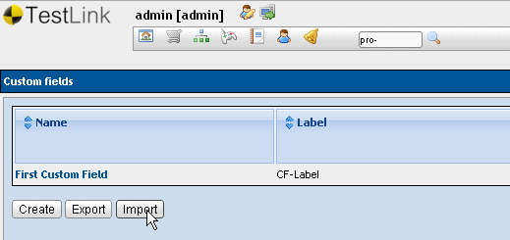
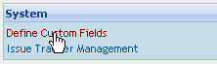
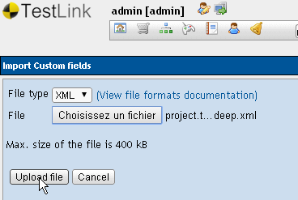
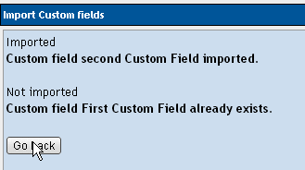

Access Export Functionality
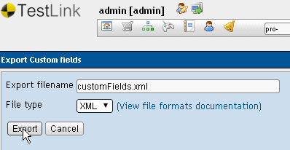

Customs Fields – XML Format
<?xml version='1.0' encoding='ISO-8859-1'?>
<custom_fields>
<custom_field>
<name><![CDATA[First Custom Field]]></name>
<label><![CDATA[CF-Label]]></label>
<type><![CDATA[0]]></type>
<possible_values><![CDATA[]]></possible_values>
<default_value><![CDATA[]]></default_value>
<valid_regexp><![CDATA[]]></valid_regexp>
<length_min><![CDATA[0]]></length_min>
<length_max><![CDATA[0]]></length_max>
<show_on_design><![CDATA[1]]></show_on_design>
<enable_on_design><![CDATA[1]]></enable_on_design>
<show_on_execution><![CDATA[0]]></show_on_execution>
<enable_on_execution><![CDATA[0]]></enable_on_execution>
<show_on_testplan_design><![CDATA[0]]></show_on_testplan_design>
<enable_on_testplan_design><![CDATA[0]]></enable_on_testplan_design>
<node_type_id><![CDATA[7]]></node_type_id>
</custom_field>
<custom_field>
<name><![CDATA[second Custom Field]]></name>
<label><![CDATA[CF-Label2]]></label>
<type><![CDATA[0]]></type>
<possible_values><![CDATA[]]></possible_values>
<default_value><![CDATA[]]></default_value>
<valid_regexp><![CDATA[]]></valid_regexp>
<length_min><![CDATA[0]]></length_min>
<length_max><![CDATA[0]]></length_max>
<show_on_design><![CDATA[0]]></show_on_design>
<enable_on_design><![CDATA[0]]></enable_on_design>
<show_on_execution><![CDATA[1]]></show_on_execution>
<enable_on_execution><![CDATA[1]]></enable_on_execution>
<show_on_testplan_design><![CDATA[0]]></show_on_testplan_design>
<enable_on_testplan_design><![CDATA[0]]></enable_on_testplan_design>
<node_type_id><![CDATA[7]]></node_type_id>
</custom_field>
</custom_fields>
There is limited support of import for documents in such formats as is MSWord or openoffice. You can export original document as DocBook (tested with openoffice2 and 3). Choose import button for your SRS in TestLink. Select type “DocBook”.

Keywords

Keywords – XML and CSV
Definition of Keywords can be both in imported and exported since TL 1.9.

Keywords – XML and CSV - Access Import/Export

Access Import Functionality
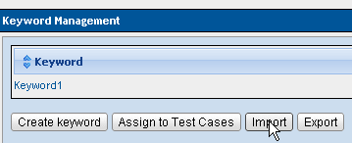
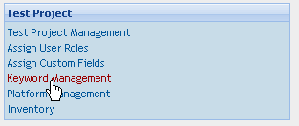
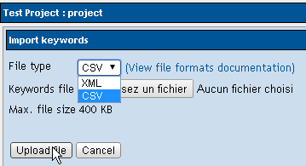

Access Export Functionality
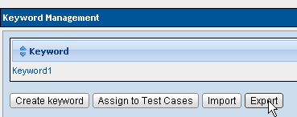
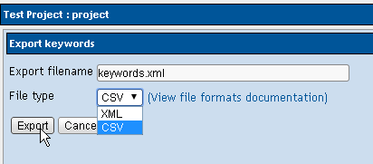

Keywords – CSV Format
Keyword1;Keyword1
Keyword2;Keyword 2 description
Keyword3;Keyword 3 description

Keywords – XML Format
<?xml version="1.0" encoding="UTF-8"?>
<keywords>
<keyword name="Keyword1"><notes><![CDATA[Keyword1]]></notes></keyword>
<keyword name="Keyword2"><notes><![CDATA[Keyword 2 description]]></notes></keyword>
<keyword name="Keyword3"><notes><![CDATA[Keyword 3 description]]></notes></keyword>
</keywords>

Platforms

Platforms – XML
Platforms can be both imported and exported. The feature is available from TL 1.9

Platforms – XML - Access Import/Export

Access Import Functionality
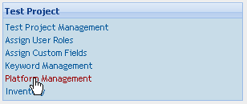
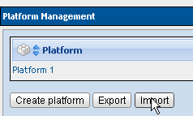

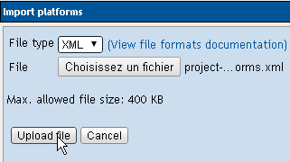
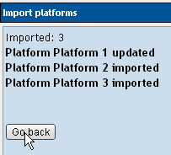

Access Export Functionality
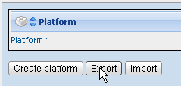
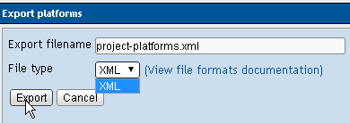

Platforms – XML Format
<?xml version='1.0' encoding='UTF-8'?>
<platforms>
<platform>
<name><![CDATA[Platform 1]]></name>
<notes><![CDATA[Description of the platform 1]]></notes>
</platform>
<platform>
<name><![CDATA[Platform 2]]></name>
<notes><![CDATA[Description of the platform 2]]></notes>
</platform>
<platform>
<name><![CDATA[Platform 3]]></name>
<notes><![CDATA[Description of the platform 3]]></notes>
</platform>
</platforms>

Requirements Specification

Requirements Specification – XML
Requirements specification tree (or sub-tree) can be both in imported and exported. User should be aware that the node where import/export operation is done has an impact on results. Drag and drop can be used between Requirements Folders if data has not be imported in the right folder.
Links between requirements can be defined using XML import.

Requirements Specification – XML - Access Import/Export

Access Import Functionality
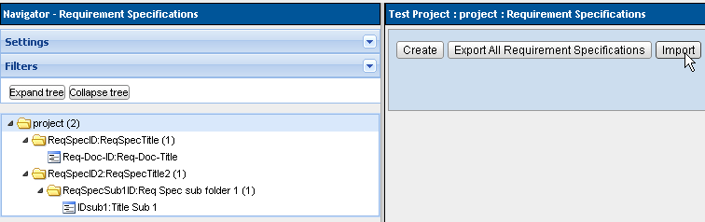Illustration 1: Import Requirements Specifications in Root directory
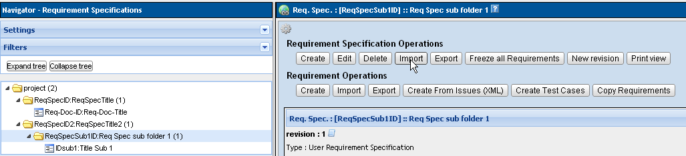Illustration 2: Import Requirements Specifications in a branch
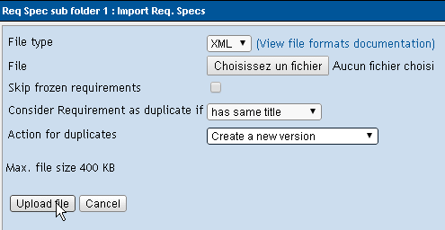Illustration 3: User choice for duplicate detection / Action For Duplicates on import

Access Export Functionality
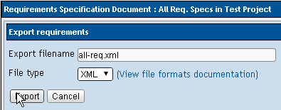
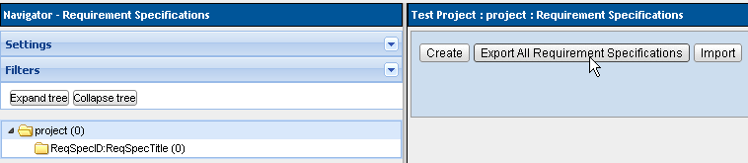Illustration 4: Export All requirements Specifications (all branches)

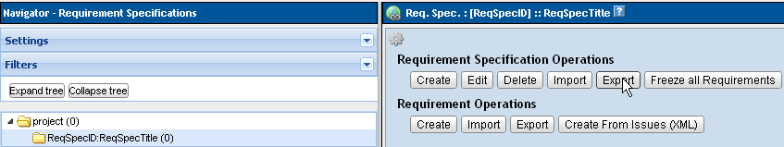Illustration 5: Export a branch of Requirement Specifications
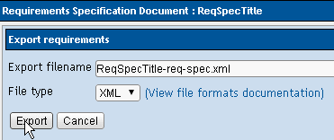

Requirements Specification – Export a branch – XML Format
XML Example – One requirement Spec with one requirement.
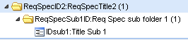
<?xml version="1.0" encoding="UTF-8"?>
<requirement-specification>
<req_spec title="ReqSpecTitle2" doc_id="ReqSpecID2" >
<revision><![CDATA[1]]></revision>
<type><![CDATA[3]]></type>
<node_order><![CDATA[2]]></node_order>
<total_req><![CDATA[0]]></total_req>
<scope>
<![CDATA[scope 2]]>
</scope>
<req_spec title="Req Spec sub folder 1" doc_id="ReqSpecSub1ID" >
<revision><![CDATA[1]]></revision>
<type><![CDATA[2]]></type>
<node_order><![CDATA[2]]></node_order>
<total_req><![CDATA[0]]></total_req>
<scope>
<![CDATA[scope]]>
</scope>
<requirement>
<docid><![CDATA[IDsub1]]></docid>
<title><![CDATA[Title Sub 1]]></title>
<version>1</version>
<revision>1</revision>
<node_order>1</node_order>
<description><![CDATA[
Scope Sub 1
]]></description>
<status><![CDATA[I]]></status>
<type><![CDATA[2]]></type>
<expected_coverage><![CDATA[1]]></expected_coverage>
</requirement>
</req_spec></req_spec></requirement-specification>

Requirements Specification – Export all requirements Specification – XML Format
XML Example – Requirement Spec sub-tree with one requirement in each Requirement-specification.
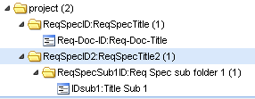
<?xml version="1.0" encoding="UTF-8"?>
<requirement-specification>
<req_spec title="ReqSpecTitle" doc_id="ReqSpecID" >
<revision><![CDATA[1]]></revision>
<type><![CDATA[3]]></type>
<node_order><![CDATA[1]]></node_order>
<total_req><![CDATA[0]]></total_req>
<scope>
<![CDATA[ReqSpec Scope]]>
</scope>
<requirement>
<docid><![CDATA[Req-Doc-ID]]></docid>
<title><![CDATA[Req-Doc-Title]]></title>
<version>1</version>
<revision>1</revision>
<node_order>1</node_order>
<description><![CDATA[
requirement Document Scrope
]]></description>
<status><![CDATA[F]]></status>
<type><![CDATA[7]]></type>
<expected_coverage><![CDATA[1]]></expected_coverage>
</requirement>
</req_spec><req_spec title="ReqSpecTitle2" doc_id="ReqSpecID2" >
<revision><![CDATA[1]]></revision>
<type><![CDATA[3]]></type>
<node_order><![CDATA[2]]></node_order>
<total_req><![CDATA[0]]></total_req>
<scope>
<![CDATA[scope 2]]>
</scope>
<req_spec title="Req Spec sub folder 1" doc_id="ReqSpecSub1ID" >
<revision><![CDATA[1]]></revision>
<type><![CDATA[2]]></type>
<node_order><![CDATA[2]]></node_order>
<total_req><![CDATA[0]]></total_req>
<scope>
<![CDATA[scope]]>
</scope>
<requirement>
<docid><![CDATA[IDsub1]]></docid>
<title><![CDATA[Title Sub 1]]></title>
<version>1</version>
<revision>1</revision>
<node_order>1</node_order>
<description><![CDATA[
Scope Sub 1
]]></description>
<status><![CDATA[I]]></status>
<type><![CDATA[2]]></type>
<expected_coverage><![CDATA[1]]></expected_coverage>
</requirement>
</req_spec></req_spec></requirement-specification>

Requirements Specification – Linked Requirements – XML Format
Links between requirements can be added using XML import. 3 types of links can be created. The following table provide the type code to use in XML file :

Type | Code
Parent / Child | 1
Block / Depends On | 2
Related To | 3

A “Parent / Child” link is always declared as a “Parent” link, with the “Parent” requirement as source and “Child” as destination.
<relation>
<source>req-parent</source>
<destination>req-child</destination>
<type>1</type>
</relation>

A “Block / Depends On” link is always declared as a “Block” link, with the “Block” requirement as source and “Depends On” as destination.
<relation>
<source>req-block</source>
<destination>req-dependsOn</destination>
<type>2</type>
</relation>

A “Related To” link can be declared in both order.
<relation>
<source>req-equal-1</source>
<destination>req-equal-2</destination>
<type>3</type>
</relation>
or
</relation>
<source>req-equal-2</source>
<destination>req-equal-1</destination>
<type>3</type>
</relation>

Links between requirements can be declared if the following option is set in custom_config.inc.php
$tlCfg->req_cfg->relations->interproject_linking = TRUE;

The following structure should be used to declare link between two requirements of different projects using XML
<relation>
<source>req1-project1</source>
<source_project>project1</source_project>
<destination>req1-project2</destination>
<destination_project>project2</destination_project>
<type>3</type>
</relation>

the “actual” project (project used to import XML file) can be forgotten.
<relation>
<source>req1-project1</source>
<source_project>project1</source_project>
<destination>req1-project2</destination>
<type>3</type>
</relation>
or
<relation>
<source>auto-1</source>
<destination>req-toto-1</destination>
<destination_project>requirements_links</destination_project>
<type>3</type>
</relation>
depending if actual project is the “source project” or the “destination project”.

Requirements Specification – Export a branch with links between requirements – XML Format
XML Example – One requirement Spec with one requirement linked to another requirement in another project.

<?xml version="1.0" encoding="UTF-8"?>
<requirement-specification>
<req_spec title="ReqSpecTitle2" doc_id="ReqSpecID2" >
<revision><![CDATA[1]]></revision>
<type><![CDATA[3]]></type>
<node_order><![CDATA[2]]></node_order>
<total_req><![CDATA[0]]></total_req>
<scope>
<![CDATA[scope 2]]>
</scope>
<req_spec title="Req Spec sub folder 1" doc_id="ReqSpecSub1ID" >
<revision><![CDATA[1]]></revision>
<type><![CDATA[2]]></type>
<node_order><![CDATA[2]]></node_order>
<total_req><![CDATA[0]]></total_req>
<scope>
<![CDATA[scope]]>
</scope>
<requirement>
<docid><![CDATA[IDsub1]]></docid>
<title><![CDATA[Title Sub 1]]></title>
<version>1</version>
<revision>1</revision>
<node_order>1</node_order>
<description><![CDATA[
Scope Sub 1
]]></description>
<status><![CDATA[I]]></status>
<type><![CDATA[2]]></type>
<expected_coverage><![CDATA[1]]></expected_coverage>
</requirement>
<relation>
<source>req-1</source>
<source_project>another_project</source_project>
<destination>IDsub1</destination>
<type>3</type>
</relation>
</req_spec></req_spec></requirement-specification>

Requirements

Requirements – XML
Definition of Requirements can be both in imported and exported with TestLink 1.9.13.
A requirement can be created from a Mantis Issue since TestLink 1.9.13.

Requirements – XML - Access Import/Export

Access Import Functionality
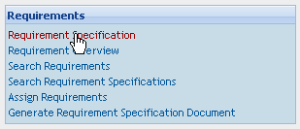
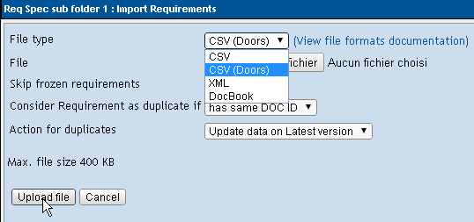
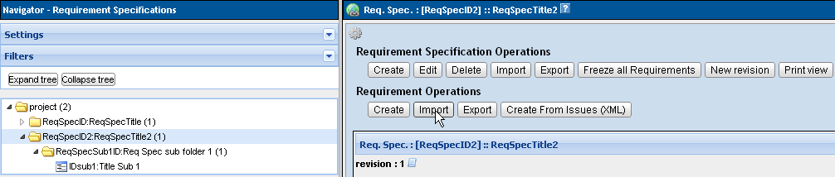Illustration 6: Import Function in Requirement Operations Section

Illustration 7: Create Requirement from Mantis Issue

Access Export Functionality
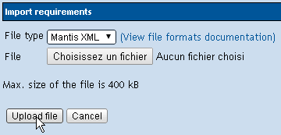
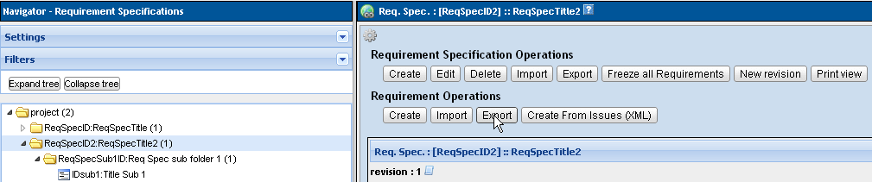Illustration 8: Export Function in Requirement Operations Section

Requirements – XML Format
Available for Export and Import
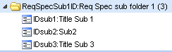
<?xml version="1.0" encoding="UTF-8"?>
<requirements>
<requirement>
<docid><![CDATA[IDsub1]]></docid>
<title><![CDATA[Title Sub 1]]></title>
<version>1</version>
<revision>1</revision>
<node_order>1</node_order>
<description><![CDATA[Scope Sub 1]]></description>
<status><![CDATA[I]]></status>
<type><![CDATA[2]]></type>
<expected_coverage><![CDATA[1]]></expected_coverage>
</requirement>
<requirement>
<docid><![CDATA[IDsub2]]></docid>
<title><![CDATA[Sub2]]></title>
<version>1</version>
<revision>3</revision>
<node_order>1</node_order>
<description><![CDATA[Scope Sub 2]]></description>
<status><![CDATA[I]]></status>
<type><![CDATA[2]]></type>
<expected_coverage><![CDATA[1]]></expected_coverage>
</requirement>
<requirement>
<docid><![CDATA[IDsub3]]></docid>
<title><![CDATA[Title Sub 3]]></title>
<version>1</version>
<revision>2</revision>
<node_order>1</node_order>
<description><![CDATA[Scope Sub 3]]></description>
<status><![CDATA[I]]></status>
<type><![CDATA[2]]></type>
<expected_coverage><![CDATA[1]]></expected_coverage>
</requirement>
</requirements>
Testcases that are linked to the requirement are not listed in the XML.
Informations are provided by the TestCase XML format.

Requirements – CSV Format
Available for Import only (seems that TestLink was able to Export to CSV in previous versions)
CSV file includes “Identifier of document, title, description”.
ENG-0001,Terrestrial Propulsor,
ENG-0002,Main Deflector,"Main deflector bla, bla, bla"
This CSV format and content was provided by a previous version of this documentation.
It has been tested in TestLink 1.9.13. The result was :
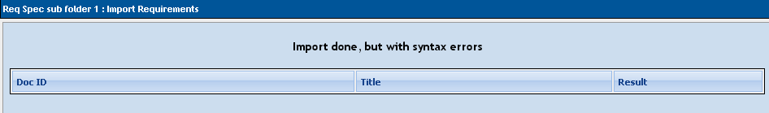
No Requirement has been imported into TestLink using CSV.

Requirements – CSV Doors Format
Available for Import only.
No example to provide until now in this documentation. Feel free to provide a working sample to testlink team.

Requirements – DocBook Format
Available for Import only.
There is limited support of import for documents in such formats as is MSWord or openoffice. You can export original document as DocBook (tested with openoffice2 and 3).
The exported file is XML. Basic element for default settings could be the next:
...
<sect3>
<title>Title</title>
...
<para>Description</para>
...
<orderedlist>
<listitem>Item</listitem>
...
</orderedlist>
...
<informaltable>
<tgroup>
<thead>
<row> ... <entry></entry> ... </row>
</thead>
<tbody>
<row> ... <entry></entry> ... </row>
</tbody>
</tgroup>
</informaltable>
...
</sect3>
TestLink uses such element as data for just one requirement. This element is defined via constant DOCBOOK_REQUIREMENT (check the code). i.e. <sect3> is default but could be modified.
Each requirement content is maintain the following way:
title – receive text in tag <title>
req_doc_id – parse title for the first two words and add counter. You can modify regular expression directly in code. Default is "[ a-zA-Z_]*[0-9]*".
description – parse following elements after title (<para>, <orderedlist>, <informaltable>, etc.). DocBook elements are modified to HTML tags. Unknown ones are ommited.
Warning: the original code could be modified to fit your structure of DocBook. Check lib/functions/requirements.inc.php (function importReqDataFromDocBook($fileName)) and related constants.
Warning: generated REQ_DOC_ID is danger for the case of update. Because it's generated from file content without relation to existing testlink data.
This DocBook format and content was provided by a previous version of this documentation.
It has been tested in TestLink 1.9.13. The result was :
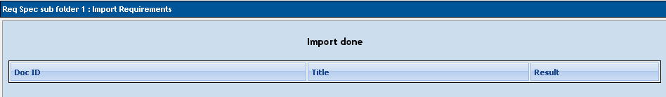
No Requirement has been imported into TestLink using DocBook.
An import has been done with content provided in docs/file_examples/requirements/DOCBOOK-EURO-NCAP-REQ.xml and the result is the same : no data imported.

Requirements – XML Mantis Format
Available for Import only.
No example to provide until now in this documentation. Feel free to provide a working sample to testlink team.
TestLink code provide a content (in lib/requirements/reqCreateFromIssueMantisXML.php header) but import the following content doesn't work).

Test Suites

Test Suites – XML
User can import or export Test Suite including Test Specification and Keywords using XML.
Warning: You can rich a server memory limit for larger amount of Test cases

Test Suites – XML - Access Import/Export

Access Import Functionality
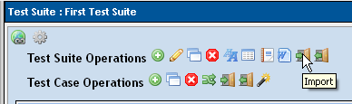
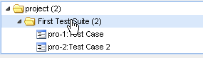
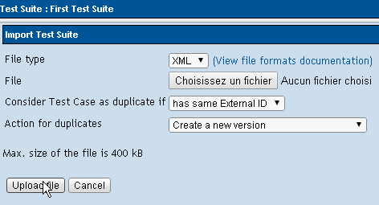

Access Export Functionality
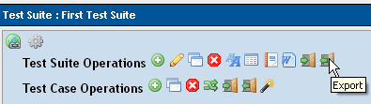
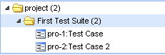

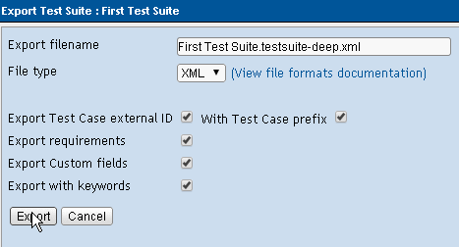

Test Suites – XML Format
XML Example – Test Suite without additionnal informations (External ID, requirements, ...)
<?xml version="1.0" encoding="UTF-8"?>
<?xml version="1.0" encoding="UTF-8"?>
<testsuite id="5" name="First Test Suite" >
<node_order><![CDATA[1]]></node_order>
<details><![CDATA[Details about First Test Suite]]></details>
<testcase internalid="6" name="Test Case">
<node_order><![CDATA[1000]]></node_order>
<version><![CDATA[1]]></version>
<summary><![CDATA[Test Case Summary ]]></summary>
<preconditions><![CDATA[ ]]></preconditions>
<execution_type><![CDATA[1]]></execution_type>
<importance><![CDATA[2]]></importance>
<estimated_exec_duration></estimated_exec_duration>
<status>1</status>
<is_open>1</is_open>
<active>1</active>
</testcase>
<testcase internalid="8" name="Test Case 2">
<node_order><![CDATA[1001]]></node_order>
<version><![CDATA[1]]></version>
<summary><![CDATA[ summary ]]></summary>
<preconditions><![CDATA[ ]]></preconditions>
<execution_type><![CDATA[1]]></execution_type>
<importance><![CDATA[2]]></importance>
<estimated_exec_duration></estimated_exec_duration>
<status>1</status>
<is_open>1</is_open>
<active>1</active>
</testcase>
</testsuite>
XML format example: Test Suite with all additionnal informations ; External ID provided with Test Case Prefix.
<?xml version="1.0" encoding="UTF-8"?>
<testsuite id="5" name="First Test Suite" >
<node_order><![CDATA[1]]></node_order>
<details><![CDATA[Details about First Test Suite]]></details>
<custom_fields>
<custom_field>
<name><![CDATA[First Custom Field]]></name>
<value><![CDATA[]]></value>
</custom_field>
</custom_fields>
<testcase internalid="6" name="Test Case">
<node_order><![CDATA[1000]]></node_order>
<externalid><![CDATA[1]]></externalid>
<fullexternalid><![CDATA[proj-1]]></fullexternalid>
<version><![CDATA[1]]></version>
<summary><![CDATA[Test Case Summary ]]></summary>
<preconditions><![CDATA[ ]]></preconditions>
<execution_type><![CDATA[1]]></execution_type>
<importance><![CDATA[2]]></importance>
<estimated_exec_duration></estimated_exec_duration>
<status>1</status>
<is_open>1</is_open>
<active>1</active>
<keywords><keyword name="Keyword1"><notes><![CDATA[
Keyword1
]]></notes></keyword>
<keyword name="Keyword2"><notes><![CDATA[
Keyword 2 description
]]></notes></keyword>
<keyword name="Keyword3"><notes><![CDATA[
Keyword 3 description
]]></notes></keyword>
</keywords>
<requirements>
<requirement>
<req_spec_title><![CDATA[Req Spec sub folder 1]]></req_spec_title>
<doc_id><![CDATA[IDsub1]]></doc_id>
<title><![CDATA[Title Sub 1]]></title>
</requirement>
<requirement>
<req_spec_title><![CDATA[Req Spec sub folder 1]]></req_spec_title>
<doc_id><![CDATA[IDsub2]]></doc_id>
<title><![CDATA[Sub2]]></title>
</requirement>
</requirements>
</testcase>
<testcase internalid="8" name="Test Case 2">
<node_order><![CDATA[1001]]></node_order>
<externalid><![CDATA[2]]></externalid>
<fullexternalid><![CDATA[proj-2]]></fullexternalid>
<version><![CDATA[1]]></version>
<summary><![CDATA[ summary ]]></summary>
<preconditions><![CDATA[ ]]></preconditions>
<execution_type><![CDATA[1]]></execution_type>
<importance><![CDATA[2]]></importance>
<estimated_exec_duration></estimated_exec_duration>
<status>1</status>
<is_open>1</is_open>
<active>1</active>
<keywords><keyword name="Keyword1"><notes><![CDATA[
Keyword1
]]></notes></keyword>
<keyword name="Keyword2"><notes><![CDATA[
Keyword 2 description
]]></notes></keyword>
<keyword name="Keyword3"><notes><![CDATA[
Keyword 3 description
]]></notes></keyword>
</keywords>
<requirements>
<requirement>
<req_spec_title><![CDATA[Req Spec sub folder 1]]></req_spec_title>
<doc_id><![CDATA[IDsub3]]></doc_id>
<title><![CDATA[Title Sub 3]]></title>
</requirement>
</requirements>
</testcase>
</testsuite>

Warning
<fullexternalid> is the concatenation of Test Project Prefix and Test External ID and is not handle by TestLink Import.

Test Cases

Test Cases – XML
Definition of Test Cases can be both in imported and exported.

Test Cases – XML - Access Import/Export

Access Import Functionality
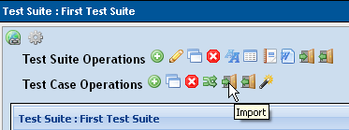
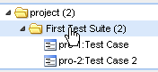
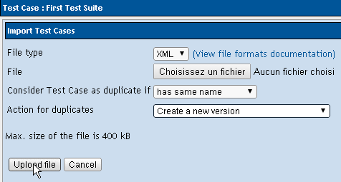

Access Export Functionality
Export All TestCases of a Test Suite :
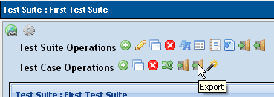
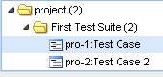
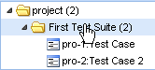
Export only one TestCase
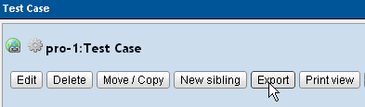
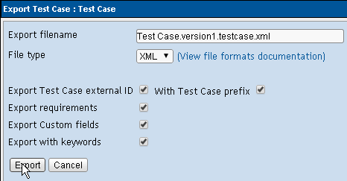

Test Cases – XML Format
XML format example: One Test Case without additionnal informations (External ID, requirements, ...)
<?xml version="1.0" encoding="UTF-8"?>
<testcases>
<testcase internalid="6" name="Test Case">
<node_order><![CDATA[1000]]></node_order>
<version><![CDATA[1]]></version>
<summary><![CDATA[Test Case Summary ]]></summary>
<preconditions><![CDATA[ ]]></preconditions>
<execution_type><![CDATA[1]]></execution_type>
<importance><![CDATA[2]]></importance>
<estimated_exec_duration></estimated_exec_duration>
<status>1</status>
<is_open>1</is_open>
<active>1</active>
<steps>
<step>
<step_number><![CDATA[1]]></step_number>
<actions><![CDATA[<p> step 1</p>]]></actions>
<expectedresults><![CDATA[<p> result 1</p>]]></expectedresults>
<execution_type><![CDATA[1]]></execution_type>
</step>
<step>
<step_number><![CDATA[2]]></step_number>
<actions><![CDATA[<p> step 2</p>]]></actions>
<expectedresults><![CDATA[<p> result 2</p>]]></expectedresults>
<execution_type><![CDATA[1]]></execution_type>
</step>
</steps>
</testcase>
</testcases>
XML format example: One Test Case with additionnal informations (External ID, requirements, ...)
<?xml version="1.0" encoding="UTF-8"?>
<testcases>
<testcase internalid="6" name="Test Case">
<node_order><![CDATA[1000]]></node_order>
<externalid><![CDATA[1]]></externalid>
<version><![CDATA[1]]></version>
<summary><![CDATA[ Test Case Summary ]]></summary>
<preconditions><![CDATA[ ]]></preconditions>
<execution_type><![CDATA[1]]></execution_type>
<importance><![CDATA[2]]></importance>
<estimated_exec_duration></estimated_exec_duration>
<status>1</status>
<is_open>1</is_open>
<active>1</active>
<steps>
<step>
<step_number><![CDATA[1]]></step_number>
<actions><![CDATA[<p> step 1</p>]]></actions>
<expectedresults><![CDATA[<p> result 1</p>]]></expectedresults>
<execution_type><![CDATA[1]]></execution_type>
</step>
<step>
<step_number><![CDATA[2]]></step_number>
<actions><![CDATA[<p> step 2</p>]]></actions>
<expectedresults><![CDATA[<p> result 2</p>]]></expectedresults>
<execution_type><![CDATA[1]]></execution_type>
</step>
</steps>
<keywords>
<keyword name="Keyword1"><notes><![CDATA[Keyword1]]></notes></keyword>
<keyword name="Keyword2"><notes><![CDATA[Keyword 2 description]]></notes></keyword>
<keyword name="Keyword3"><notes><![CDATA[Keyword 3 description]]></notes></keyword>
</keywords>
<custom_fields>
<custom_field>
<name><![CDATA[Custom Field Test Case]]></name>
<value><![CDATA[custom field value for testcase]]></value>
</custom_field>
</custom_fields>
<requirements>
<requirement>
<req_spec_title><![CDATA[Req Spec sub folder 1]]></req_spec_title>
<doc_id><![CDATA[IDsub1]]></doc_id>
<title><![CDATA[Title Sub 1]]></title>
</requirement>
<requirement>
<req_spec_title><![CDATA[Req Spec sub folder 1]]></req_spec_title>
<doc_id><![CDATA[IDsub2]]></doc_id>
<title><![CDATA[Sub2]]></title>
</requirement>
</requirements>
</testcase>
</testcases>

XML format example: Several Test Cases in a Test Suitewithout additionnal informations (External ID, requirements, ...)
<?xml version="1.0" encoding="UTF-8"?>
<testcases>
<testcase internalid="6" name="Test Case">
<node_order><![CDATA[1000]]></node_order>
<version><![CDATA[1]]></version>
<summary><![CDATA[ Test Case Summary ]]></summary>
<preconditions><![CDATA[ ]]></preconditions>
<execution_type><![CDATA[1]]></execution_type>
<importance><![CDATA[2]]></importance>
<estimated_exec_duration></estimated_exec_duration>
<status>1</status>
<is_open>1</is_open>
<active>1</active>
<steps>
<step>
<step_number><![CDATA[1]]></step_number>
<actions><![CDATA[<p>step 1</p>]]></actions>
<expectedresults><![CDATA[<p>result 1</p>]]></expectedresults>
<execution_type><![CDATA[1]]></execution_type>
</step>
<step>
<step_number><![CDATA[2]]></step_number>
<actions><![CDATA[<p>step 2</p>]]></actions>
<expectedresults><![CDATA[<p>result 2</p>]]></expectedresults>
<execution_type><![CDATA[1]]></execution_type>
</step>
</steps>
</testcase>
<testcase internalid="8" name="Test Case 2">
<node_order><![CDATA[1001]]></node_order>
<version><![CDATA[1]]></version>
<summary><![CDATA[ summary ]]></summary>
<preconditions><![CDATA[ ]]></preconditions>
<execution_type><![CDATA[1]]></execution_type>
<importance><![CDATA[2]]></importance>
<estimated_exec_duration></estimated_exec_duration>
<status>1</status>
<is_open>1</is_open>
<active>1</active>
<steps>
<step>
<step_number><![CDATA[1]]></step_number>
<actions><![CDATA[<p>Open web page</p>]]></actions>
<expectedresults><![CDATA[<p>page opened</p>]]></expectedresults>
<execution_type><![CDATA[1]]></execution_type>
</step>
<step>
<step_number><![CDATA[2]]></step_number>
<actions><![CDATA[<p>Click on testlink icon</p>]]></actions>
<expectedresults><![CDATA[<p>testlink page is displayed</p>]]></expectedresults>
<execution_type><![CDATA[1]]></execution_type>
</step>
</steps>
</testcase>
</testcases>

XML format example: Several Test Cases in a Test Suite with additionnal informations (External ID, requirements, …). « Test Case Prefix » is not checked in this example.
<?xml version="1.0" encoding="UTF-8"?>
<testcases>
<testcase internalid="6" name="Test Case">
<node_order><![CDATA[1000]]></node_order>
<externalid><![CDATA[1]]></externalid>
<version><![CDATA[1]]></version>
<summary><![CDATA[ Test Case Summary ]]></summary>
<preconditions><![CDATA[ ]]></preconditions>
<execution_type><![CDATA[1]]></execution_type>
<importance><![CDATA[2]]></importance>
<estimated_exec_duration></estimated_exec_duration>
<status>1</status>
<is_open>1</is_open>
<active>1</active>
<steps>
<step>
<step_number><![CDATA[1]]></step_number>
<actions><![CDATA[<p>step 1</p>]]></actions>
<expectedresults><![CDATA[<p>result 1</p>]]></expectedresults>
<execution_type><![CDATA[1]]></execution_type>
</step>
<step>
<step_number><![CDATA[2]]></step_number>
<actions><![CDATA[<p>step 2</p>]]></actions>
<expectedresults><![CDATA[<p>result 2</p>]]></expectedresults>
<execution_type><![CDATA[1]]></execution_type>
</step>
</steps>
<keywords>
<keyword name="Keyword1"><notes><![CDATA[Keyword1]]></notes></keyword>
<keyword name="Keyword2"><notes><![CDATA[Keyword 2 description]]></notes></keyword>
<keyword name="Keyword3"><notes><![CDATA[Keyword 3 description]]></notes></keyword>
</keywords>
<custom_fields>
<custom_field>
<name><![CDATA[Custom Field Test Case]]></name>
<value><![CDATA[custom field value for testcase]]></value>
</custom_field>
</custom_fields>
<requirements>
<requirement>
<req_spec_title><![CDATA[Req Spec sub folder 1]]></req_spec_title>
<doc_id><![CDATA[IDsub1]]></doc_id>
<title><![CDATA[Title Sub 1]]></title>
</requirement>
<requirement>
<req_spec_title><![CDATA[Req Spec sub folder 1]]></req_spec_title>
<doc_id><![CDATA[IDsub2]]></doc_id>
<title><![CDATA[Sub2]]></title>
</requirement>
</requirements>
</testcase>
<testcase internalid="8" name="Test Case 2">
<node_order><![CDATA[1001]]></node_order>
<externalid><![CDATA[2]]></externalid>
<version><![CDATA[1]]></version>
<summary><![CDATA[ summary ]]></summary>
<preconditions><![CDATA[ ]]></preconditions>
<execution_type><![CDATA[1]]></execution_type>
<importance><![CDATA[2]]></importance>
<estimated_exec_duration></estimated_exec_duration>
<status>1</status>
<is_open>1</is_open>
<active>1</active>
<steps>
<step>
<step_number><![CDATA[1]]></step_number>
<actions><![CDATA[<p>Open web page</p>]]></actions>
<expectedresults><![CDATA[<p>page opened</p>]]></expectedresults>
<execution_type><![CDATA[1]]></execution_type>
</step>
<step>
<step_number><![CDATA[2]]></step_number>
<actions><![CDATA[<p>Click on testlink icon</p>]]></actions>
<expectedresults><![CDATA[<p>testlink page is displayed</p>]]></expectedresults>
<execution_type><![CDATA[1]]></execution_type>
</step>
</steps>
<keywords>
<keyword name="Keyword1"><notes><![CDATA[Keyword1]]></notes></keyword>
<keyword name="Keyword2"><notes><![CDATA[Keyword 2 description]]></notes></keyword>
<keyword name="Keyword3"><notes><![CDATA[Keyword 3 description]]></notes></keyword>
</keywords>
<custom_fields>
<custom_field>
<name><![CDATA[Custom Field Test Case]]></name>
<value><![CDATA[]]></value>
</custom_field>
</custom_fields>
<requirements>
<requirement>
<req_spec_title><![CDATA[Req Spec sub folder 1]]></req_spec_title>
<doc_id><![CDATA[IDsub3]]></doc_id>
<title><![CDATA[Title Sub 3]]></title>
</requirement>
</requirements>
</testcase>
</testcases>

Test Plan Links

Test Plan Links – XML
Links between TestPlan and Testcases / Platforms can be both imported and exported.

Test Plan Links – XML - Access Import/Export

Access Import Functionality
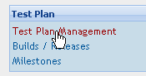
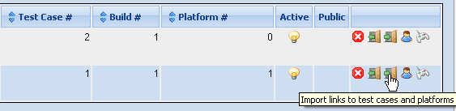
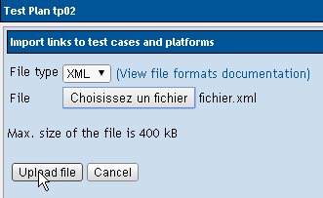

Access Export Functionality
Export all TestCases and Platforms linked to a TestPlan
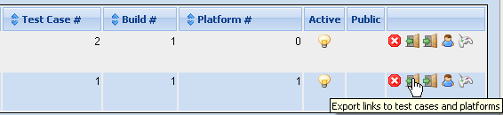
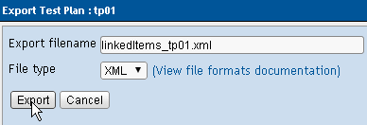

Test Plan Links – XML Format
XML format example: PlatForms information not used
<?xml version="1.0" encoding="UTF-8"?>
<testplan>
<name><![CDATA[tp01]]></name>
<executables>
<link>
<platform>
<name><![CDATA[]]></name>
</platform>
<testcase>
<name><![CDATA[TC101-1]]></name>
<externalid><![CDATA[1]]></externalid>
<version><![CDATA[1]]></version>
<execution_order><![CDATA[10000]]></execution_order>
</testcase>
</link>
<link>
<platform>
<name><![CDATA[]]></name>
</platform>
<testcase>
<name><![CDATA[TC101-2]]></name>
<externalid><![CDATA[2]]></externalid>
<version><![CDATA[1]]></version>
<execution_order><![CDATA[10010]]></execution_order>
</testcase>
</link>
</executables>
</testplan>

XML format example: with PlatForms information
<?xml version="1.0" encoding="UTF-8"?>
<testplan>
<name><![CDATA[tp02]]></name>
<platforms>
<platform>
<name><![CDATA[PF1]]></name>
<internal_id><![CDATA[1]]></internal_id>
</platform>
<platform>
<name><![CDATA[PF2]]></name>
<internal_id><![CDATA[2]]></internal_id>
</platform>
</platforms>
<executables>
<link>
<platform>
<name><![CDATA[PF1]]></name>
</platform>
<testcase>
<name><![CDATA[TC101-1]]></name>
<externalid><![CDATA[1]]></externalid>
<version><![CDATA[1]]></version>
<execution_order><![CDATA[10000]]></execution_order>
</testcase>
</link>
<link>
<platform>
<name><![CDATA[PF1]]></name>
</platform>
<testcase>
<name><![CDATA[TC101-3]]></name>
<externalid><![CDATA[3]]></externalid>
<version><![CDATA[1]]></version>
<execution_order><![CDATA[10020]]></execution_order>
</testcase>
</link>
<link>
<platform>
<name><![CDATA[PF2]]></name>
</platform>
<testcase>
<name><![CDATA[TC101-2]]></name>
<externalid><![CDATA[2]]></externalid>
<version><![CDATA[2]]></version>
<execution_order><![CDATA[10010]]></execution_order>
</testcase>
</link>
<link>
<platform>
<name><![CDATA[PF2]]></name>
</platform>
<testcase>
<name><![CDATA[TC101-3]]></name>
<externalid><![CDATA[3]]></externalid>
<version><![CDATA[1]]></version>
<execution_order><![CDATA[10020]]></execution_order>
</testcase>
</link>
</executables>
</testplan>
- TestPlan name is not used during import (information is optionnal in imported file). The target TestPlan is defined by the GUI (click on the Import icon for the target TestPlan)
- Even if platform is not used, platform tag must be present for each link (see 1st example without platform)
- TestCase name is optionnal (used only to display log after import). The TestCase external ID is mandatory.
- TestCase Version an Execution Order are mandatory
- TestPlan links XML file can be imported to update execution order : if a link between a TestCase and TestPlan is already known by TestLink, execution order is updated.

TestPlan Content

TestPlan Content – XML
Definition of TestPlan Content can be exported since TL 1.9.

TestPlan Content – XML - Access Export

Access Export Functionality
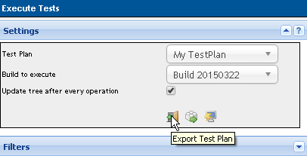
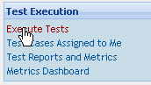
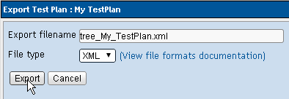

TestPlan Content – XML Format
<?xml version="1.0" encoding="UTF-8"?>
<testplan>
<name><![CDATA[My TestPlan]]></name>
<testproject>
<name><![CDATA[project]]></name>
<prefix><![CDATA[pro]]></prefix>
<internal_id><![CDATA[1]]></internal_id>
</testproject>
<build>
<name><![CDATA[Build 20150322]]></name>
<internal_id><![CDATA[1]]></internal_id>
</build>
<testsuites>
<testsuite name="First Test Suite" >
<node_order><![CDATA[1]]></node_order>
<details><![CDATA[Details about First Test Suite]]>
<custom_fields>
<custom_field>
<name><![CDATA[Custom Field Test Suite]]></name>
<value><![CDATA[]]></value>
</custom_field>
</custom_fields>
</details>
<testcase internalid="6" name="Test Case">
<node_order><![CDATA[1000]]></node_order>
<exec_order><![CDATA[10000]]></exec_order>
<assigned_users>
<assigned_user><![CDATA[user1_login]]></assigned_user>
<assigned_user><![CDATA[user2_login]]></assigned_user>
<assigned_user><![CDATA[user3_login]]></assigned_user>
</assigned_users>
<externalid><![CDATA[1]]></externalid>
<version><![CDATA[1]]></version>
<summary><![CDATA[ Test Case Summary ]]></summary>
<preconditions><![CDATA[ ]]></preconditions>
<execution_type><![CDATA[1]]></execution_type>
<importance><![CDATA[2]]></importance>
<estimated_exec_duration></estimated_exec_duration>
<status>1</status>
<steps>
<step>
<step_number><![CDATA[1]]></step_number>
<actions><![CDATA[<p>step 1</p>]]></actions>
<expectedresults><![CDATA[<p>result 1</p>]]></expectedresults>
<execution_type><![CDATA[1]]></execution_type>
</step>
<step>
<step_number><![CDATA[2]]></step_number>
<actions><![CDATA[<p>step 2</p>]]></actions>
<expectedresults><![CDATA[<p>result 2</p>]]></expectedresults>
<execution_type><![CDATA[1]]></execution_type>
</step>
</steps>
<keywords>
<keyword name="Keyword1"><notes><![CDATA[Keyword1]]></notes></keyword>
<keyword name="Keyword2"><notes><![CDATA[Keyword 2 description]]></notes></keyword>
<keyword name="Keyword3"><notes><![CDATA[Keyword 3 description]]></notes></keyword>
</keywords>
<custom_fields>
<custom_field>
<name><![CDATA[Custom Field Test Case]]></name>
<value><![CDATA[custom field value for testcase]]></value>
</custom_field>
</custom_fields>
</testcase>
<testcase internalid="8" name="Test Case 2">
<node_order><![CDATA[1001]]></node_order>
<assigned_users>
<assigned_user><![CDATA[user1_login]]></assigned_user>
</assigned_users>
<externalid><![CDATA[2]]></externalid>
<version><![CDATA[1]]></version>
<summary><![CDATA[ summary ]]></summary>
<preconditions><![CDATA[ ]]></preconditions>
<execution_type><![CDATA[1]]></execution_type>
<importance><![CDATA[2]]></importance>
<estimated_exec_duration></estimated_exec_duration>
<status>1</status>
<steps>
<step>
<step_number><![CDATA[1]]></step_number>
<actions><![CDATA[<p>Open web page</p>]]></actions>
<expectedresults><![CDATA[<p>page opened</p>]]></expectedresults>
<execution_type><![CDATA[1]]></execution_type>
</step>
<step>
<step_number><![CDATA[2]]></step_number>
<actions><![CDATA[<p>Click on testlink icon</p>]]></actions>
<expectedresults><![CDATA[<p>testlink page is displayed</p>]]></expectedresults>
<execution_type><![CDATA[1]]></execution_type>
</step>
</steps>
<keywords>
<keyword name="Keyword1"><notes><![CDATA[Keyword1]]></notes></keyword>
<keyword name="Keyword2"><notes><![CDATA[Keyword 2 description]]></notes></keyword>
<keyword name="Keyword3"><notes><![CDATA[Keyword 3 description]]></notes></keyword>
</keywords>
<custom_fields>
<custom_field>
<name><![CDATA[Custom Field Test Case]]></name>
<value><![CDATA[]]></value>
</custom_field>
</custom_fields>
<requirements>
<requirement>
<req_spec_title><![CDATA[Req Spec sub folder 1]]></req_spec_title>
<doc_id><![CDATA[IDsub3]]></doc_id>
<title><![CDATA[Title Sub 3]]></title>
</requirement>
</requirements>
</testcase>
</testsuite>
</testsuites>
</testplan>

Execution Results

Execution Results – XML
Execution Results import is supported from TL 1.7.
You can import several / multiple execution results using a single XML file.
Each TestCase can be identified by its Internal ID or its External ID in the XML file.

Execution Results – XML - Access Import/Export

Access Import Functionality
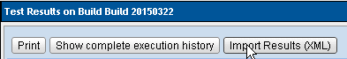
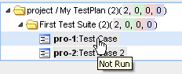
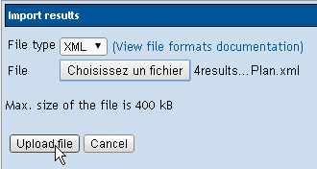
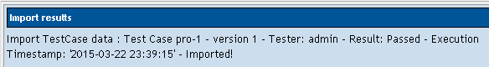

Access Export Functionality
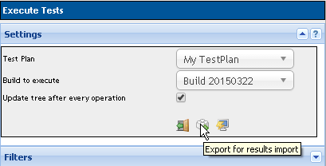

Execution Results – XML Format
XML « Export For Result Export » provide a empty structure with technical information about TestCase to execute. Note that the steps information are optional.
<?xml version="1.0" encoding="UTF-8"?>
<!-- TestLink - www.testlink.org - xml to allow results import -->
<results>
<testproject name="project" prefix="pro" />
<testplan name="My TestPlan" />
<build name="Build 20150322" />
<testcase external_id="pro-1">
<result>X</result>
<notes>test link rocks </notes>
<tester>put login here</tester>
<!-- if not present now() will be used -->
<timestamp>YYYY-MM-DD HH:MM:SS</timestamp>
<bug_id>put your bug id here</bug_id>
<steps>
<step>
<step_number>1</step_number>
<result>p</result>
<notes>your step exec notes</notes>
</step>
<step>
<step_number>2</step_number>
<result>p</result>
<notes>your step exec notes</notes>
</step>
</steps>
</testcase>
<testcase external_id="pro-2">
<result>X</result>
<notes>test link rocks </notes>
<tester>put login here</tester>
<!-- if not present now() will be used -->
<timestamp>YYYY-MM-DD HH:MM:SS</timestamp>
<bug_id>put your bug id here</bug_id>
<steps>
<step>
<step_number>1</step_number>
<result>p</result>
<notes>your step exec notes</notes>
</step>
<step>
<step_number>2</step_number>
<result>p</result>
<notes>your step exec notes</notes>
</step>
</steps>
</testcase>
</results>
XML format example: Results in XML format using Internal ID
<?xml version="1.0" encoding="UTF-8"?>
<results>
<testcase id="1"> <!-- ID: internal/DB id --->
<result>p</result>
<notes>functionality works great </notes>
</testcase>
<testcase id="2">
<result>f</result>
<notes>this case failed due to error </notes>
<tester>admin</tester>
<!-- if not present now() will be used -->
<timestamp>2015-03-22 12:34:56</timestamp>
</testcase>
</results>
XML format example: Results in XML format using External ID
<?xml version="1.0" encoding="UTF-8"?>
<results>
<testcase external_id="pro-1">
<result>p</result>
<notes>test link rocks </notes>
<tester>admin</tester>
<steps>
<step>
<step_number>1</step_number>
<result>p</result>
<notes>your step exec notes</notes>
</step>
<step>
<step_number>2</step_number>
<result>p</result>
<notes>your step exec notes</notes>
</step>
</steps>
</testcase>
<testcase external_id="pro-2">
<result>b</result>
<notes>test link blocks </notes>
<!-- if not present now() will be used -->
<timestamp>2015-03-22 23:50:00</timestamp>
<bug_id>5120</bug_id>
<steps>
<step>
<step_number>1</step_number>
<result>p</result>
<notes>your step exec notes</notes>
</step>
<step>
<step_number>2</step_number>
<result>p</result>
<notes>your step exec notes</notes>
</step>
</steps>
</testcase>
</results>

Creating XML file to import in TestLink with Excel
Excel can be used as editor to define Requirements, TestCases and/or TestCases Execution content.
See Excel Files Content and associated documentation here :
https://github.com/MrBricodage/TestLink--ImportExcelMacro

