 ­

L2 Case Study Template – <DA TSR Selenium>

© Hexaware Technologies Limited. All rights reserved.

www.hexaware.com

* Content Area Content Area Content Area Content Area Content Area Content Area Content Area
* Content Area Content Area Content Area Content Area Content Area Content Area Content Area
* Content Area Content Area Content Area Content Area Content Area Content Area Content Area
* Content Area Content Area Content Area Content Area Content Area Content Area Content Area
* Content Area Content Area Content Area Content Area Content Area Content Area Content Area

**Grow Digital >>**

**Shrink IT <<**

VERTICALS

Contents

1 Introduction 3

1.1 General 3

1.2 Evaluation Details 3

1.3 Prerequisites Developer Machine 4

1.4 Instructions 4

2 Case Study 5

2.1 Problem Statement/Use Case 5

2.2 Requirement Details 5

2.2.1 Master management 6

2.2.2 Ordering Module 6

2.2.3 Reporting Module 7

2.3 Allowed tools and libraries 7

2.4 7

3 Expected Results 8

4 Appendix 9

**5 Revision history**

Introduction

General

|  |  |
| --- | --- |
| **TSR** | **DA_TSR_Automation_Selenium** |
| **Skillset(s)** | **Core Java,Selenium,TestNG** |
| **Competency** | **DA** |
| **SME Name** |  |
| **SME Email Id** |  |

Evaluation Details

|  |  |
| --- | --- |
| **Time Limit** | 40 hours [Min 3hrs – Max 5 days] |
| **Total Max. Score** | 100 |
| **Total Min. Passing Score** | 80 |

**Scoring Structure**

|  |  |  |  |
| --- | --- | --- | --- |
| **Skillset** | **Scoring Category** | **Max. Score** | **Min. Passing Score** |
| **Core Java** | **Organization of Project structure** | 5 | 4 |
| **Concepts**   * Control Statements * Java Object Class * String Operations * **OOPS Concept**  1. Object 2. Class 3. Inheritance 4. Polymorphism 5. Abstraction 6. Encapsulation  * Exception Handling * Arrays * Collection * JDBC Connections | 30 | 20 |
| Implementation/Coding Practices   * String Reverse * String Swap | 10 | 6 |
|  | **Total Score** | 45 | 30 |

|  |  |  |  |
| --- | --- | --- | --- |
| **Skillset** | **Scoring Category** | **Max. Score** | **Min. Passing Score** |
| **Selenium & TestNG** | **Organization of Project structure** | 5 | 4 |
| Technology Features   * **WebDriver Commands**  1. Browser 2. Navigation 3. WebElement 4. FindElement and FindElements 5. Checkbox & Radio Button 6. DropDown 7. Selenium WebDriver  * Identifying 8 types of Locators   **WebDriverWaits**   1. ImplicitWait 2. ExplicitWait 3. FluentWait   **TestNG**   * List TestNG Annotations in order. * Group & On Depends * Prioritizing & Sequencing * Reporters & Asserts * Data Provider * Listener | 30 | 22 |
| Implementation/Coding Practices   * Write code for multiple browsers like FF, GC, and IE. * Mouseover action in selenium webdriver * Create Reusable Function for given scenario. | 20 | 14 |
| **Total Score** | 55 | 40 |

**Note to Author**: Please add more tables for additional skillsets. The total max score of all skillsets should add to 100.

Prerequisites Developer Machine

* OS [Windows 10.1 with IIS]
* IDE/Tools [Eclipse]
* Java 8
* Selenium 3.1.8
* TestNG Framework

Instructions

* Read the Case study details
* Create manual test cases
* Develop Selenium Automation Framework

(Like Hybrid, Keyword Driven)

* Create function library with business related functions
* Develop script as per scenario
* Execute Test script
* Add detailed reporting for all the steps with (Pass, Fail & NIL)

Case Study

Problem Statement/Use Case

This case study requires you to develop a “Creating_New_Bank_Account” model on ParaBank. The YOUR LOGO provides useful modules for creating access, Viewing products and purchasing product.

Application URL=”<https://parabank.parasoft.com/parabank/index.htm>”

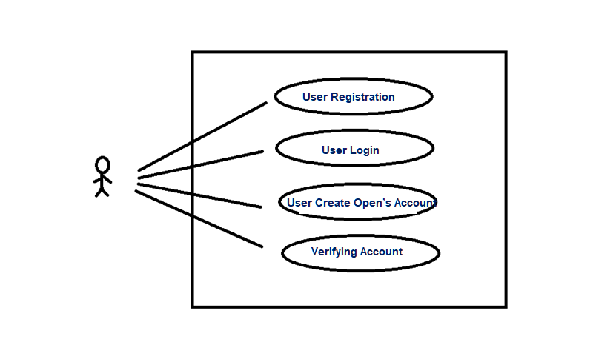

User product purchase model

Requirement Details

The structure of the system is divided into four main modules.

### User Registration

In this Module, user registers in an application.

* User clicks on register Hyper-Link button.

**Personal information**

-First Name

-Last Name

-Address

-City

-State

-Zip Code

-Country

-Mobile Number

-Username

-Password

-Conform Password

* And user has to click on Register.

### User Login

In this Module, user login in to application with created username

* The user enters the login details

-User Name

-Password

* Then user clicks on login button

### User Create Open’s Account

In this Module, user opens new savings account

* User clicks on the Open New account
* Select Savings account from the drop down
* Please choose an existing account to transfer funds into the new account.
* Click on open New account Button

### Verifying Account

In this Module, User verifies whether account created.

User has to verify the text” Congratulations, your account is now open”

User has to write custom code passing the Acc no to data sheet

Allowed tools and libraries

Eclipse, Selenium, TestNG, POI

Expected Results

|  |  |  |
| --- | --- | --- |
| Sr. No. | Output Description | Output Snapshot |
| 1 | Selenium Script: Data in Data Table |  |
| 2 | Selenium Script |  |
| 3 | Function Libraries |  |
| 4 | Selenium Report |  |

Appendix

Revision history

|  |  |  |  |  |  |
| --- | --- | --- | --- | --- | --- |
| Date | Version No | Prepared By | Reviewed By | Approved By | Summary of  Changes |
| **12-Oct-2019** | **1.0** | **Kirthivasan** | **Kirthivasan** | **Kirthivasan** | First version |
| **15-Oct-2020** | **1.1** | **Kirthivasan** | **Kirthivasan** | **Kirthivasan** | Revision history section added |
|  |  |  |  |  |  |
|  |  |  |  |  |  |
|  |  |  |  |  |  |
|  |  |  |  |  |  |