GITHUB CODE CHECKOUT CONFLICT ISSUES
- Code in our eclipse
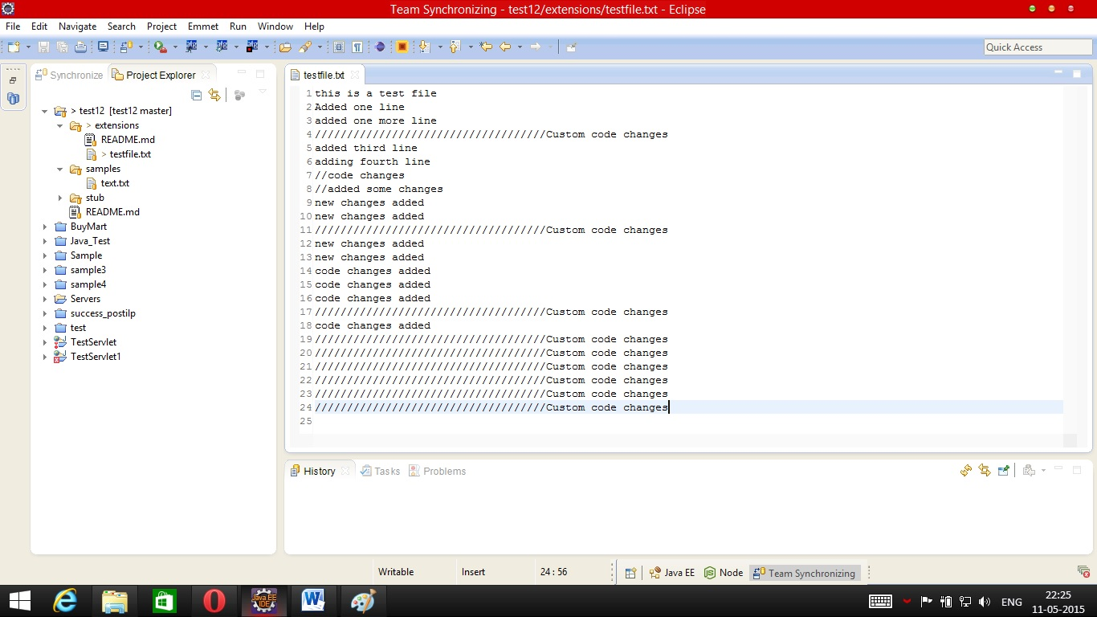

- Code in github (latest one changed by some developer)
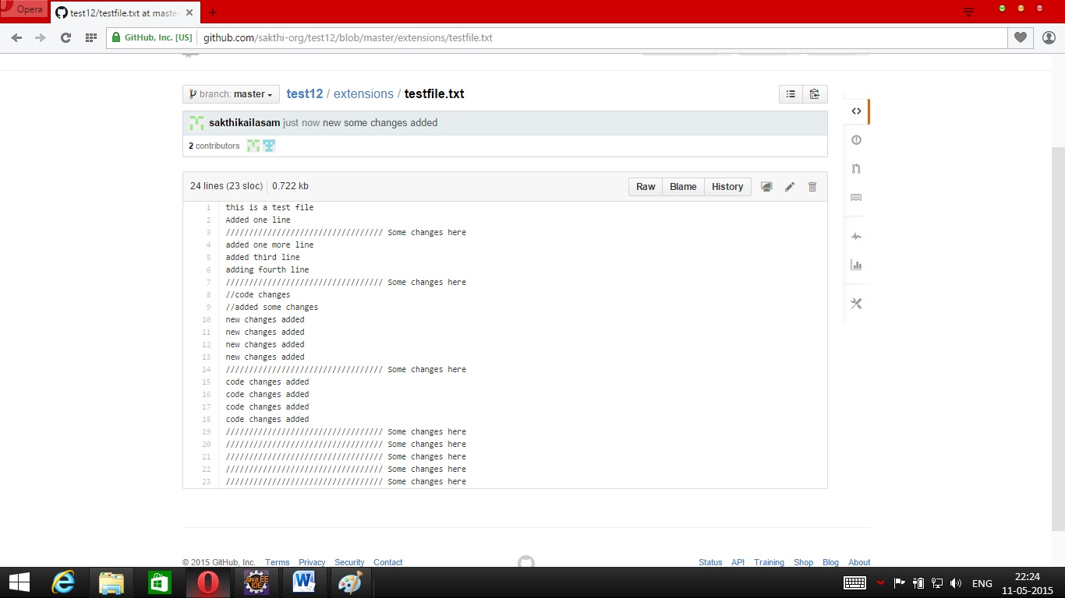

- Pull the code from repository, before committing.
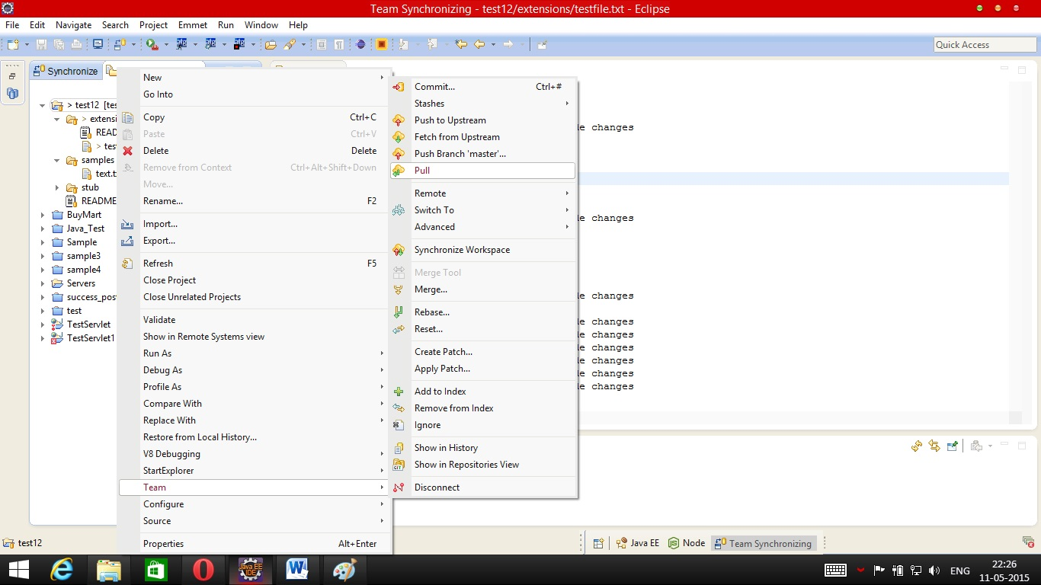

- Checkout conflicts occurs
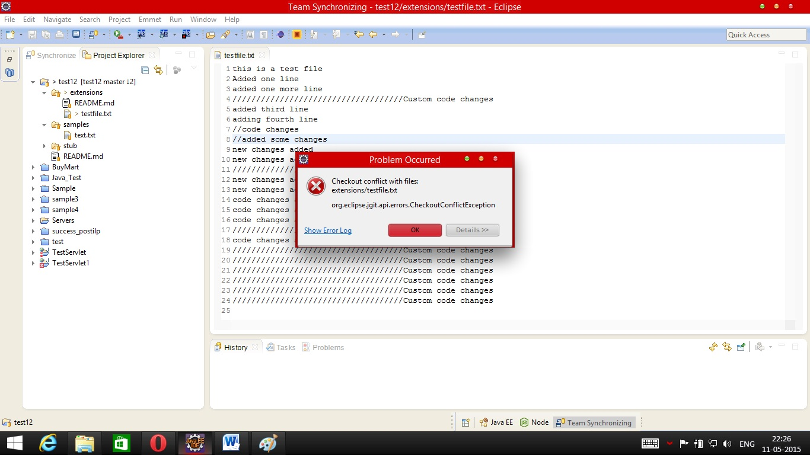

- Commit the changes (Please review your changes with synchronize if necessary)
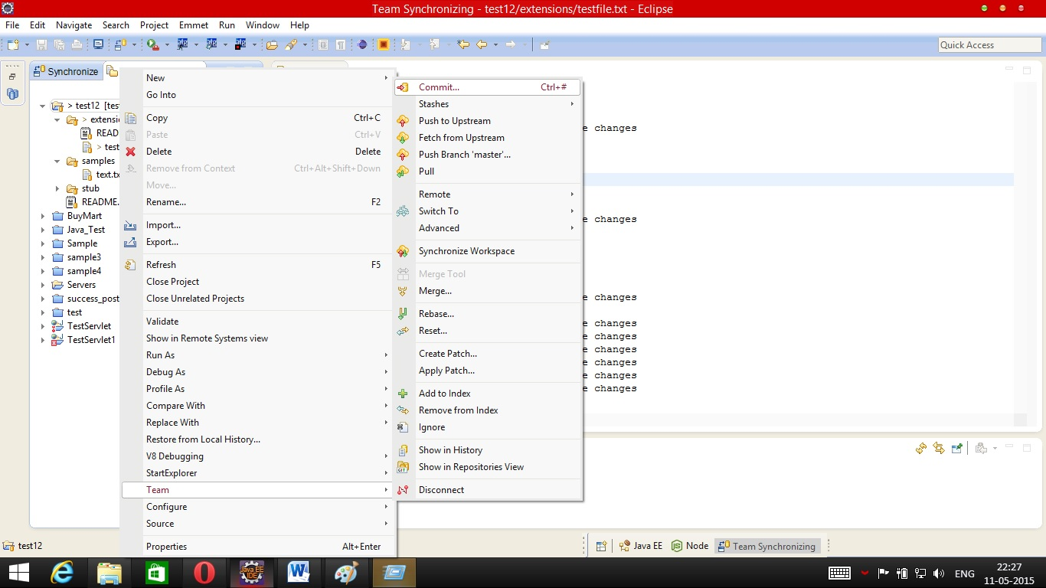

- Enter the comments for your changes.
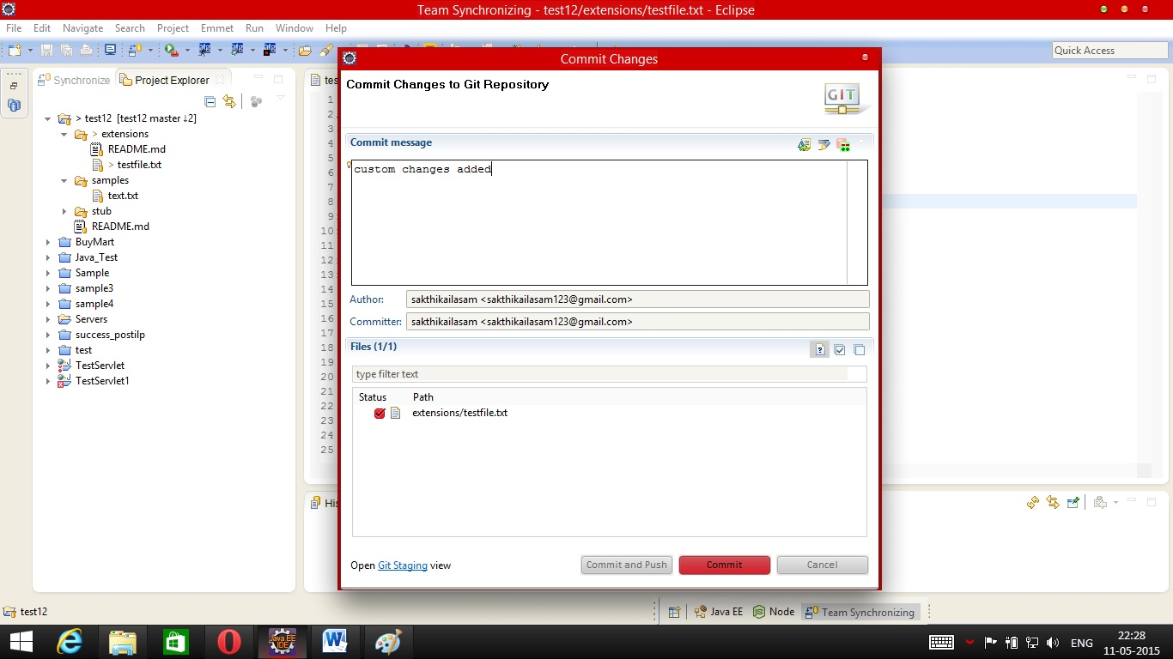

- Pull the code again
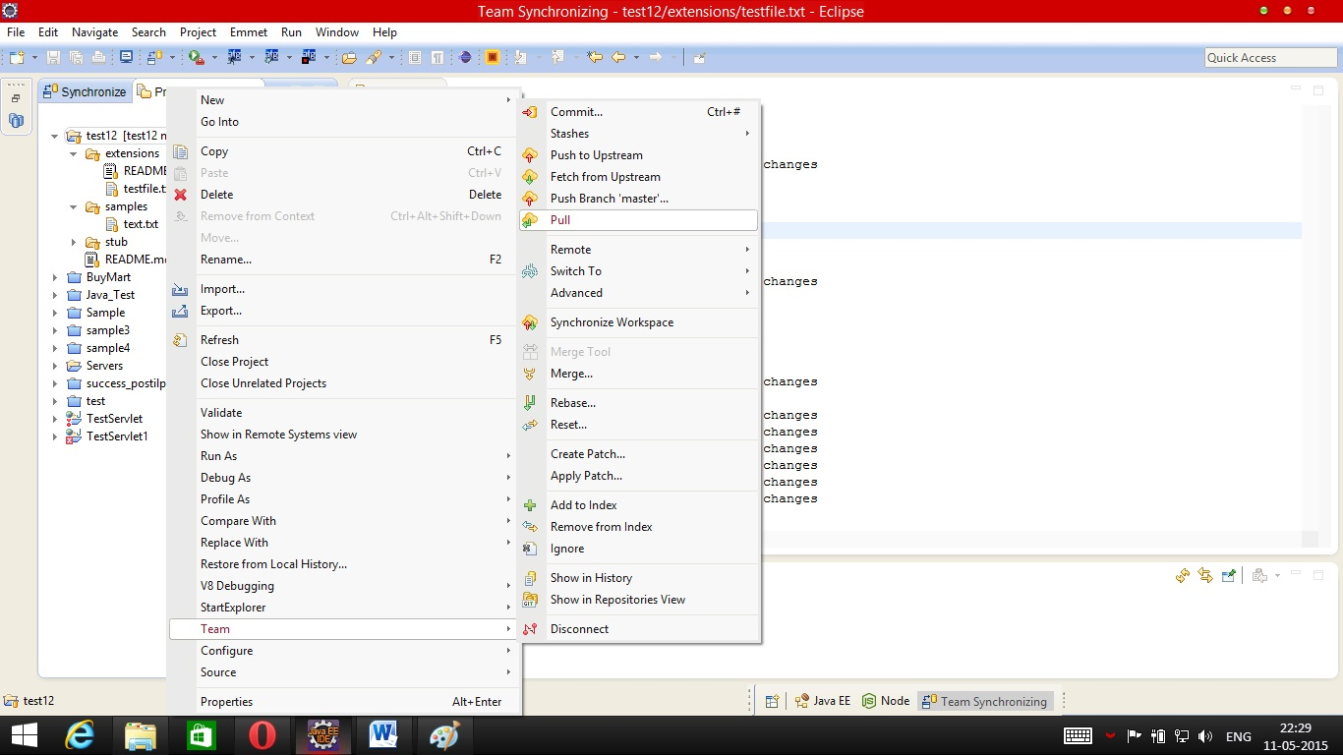

- Pull status should be conflicting and the window shows the conflicting commits.
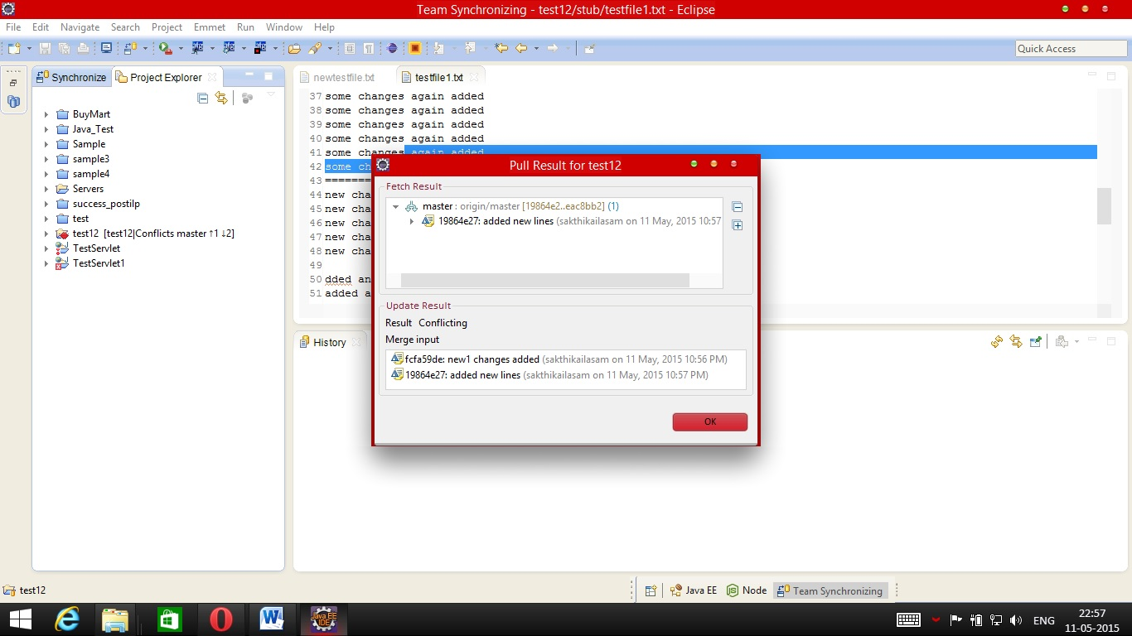

- Merge the code manually (As soon as clicking ok in the previous window, all the conflicting files will be with red marker or you can see the conflicting files in the synchronize perspective). Just like other versioned repositories remove the unwanted lines.
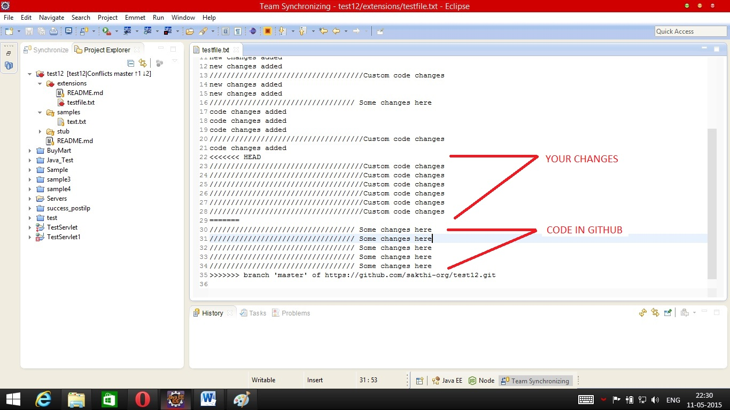
- Once you are done with the merge, Add your new code to index
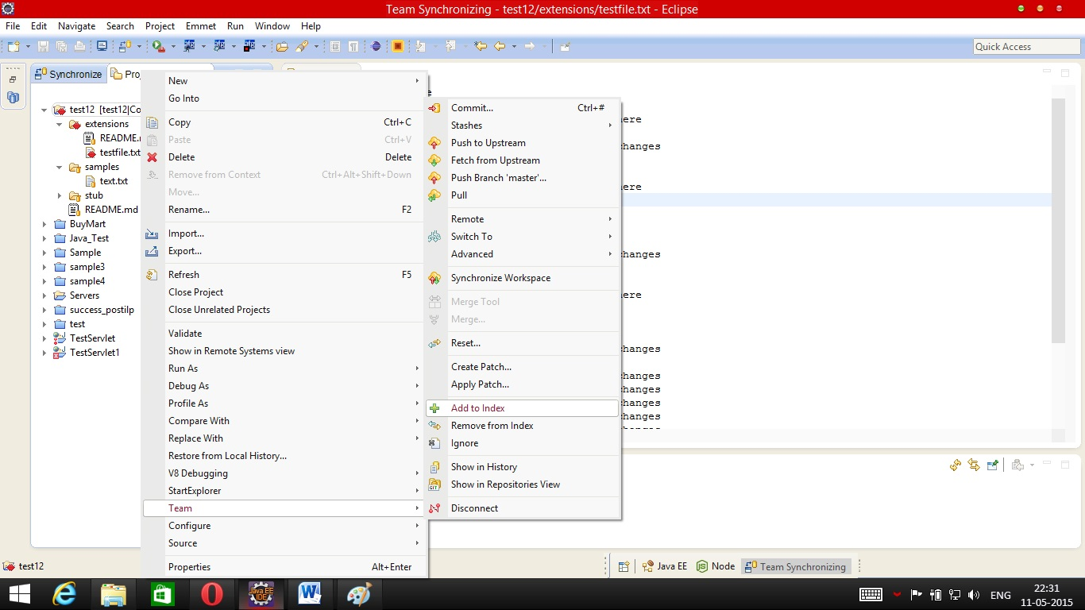

- Commit the code (You can try pulling again and if there are conflicts then please resolve it).
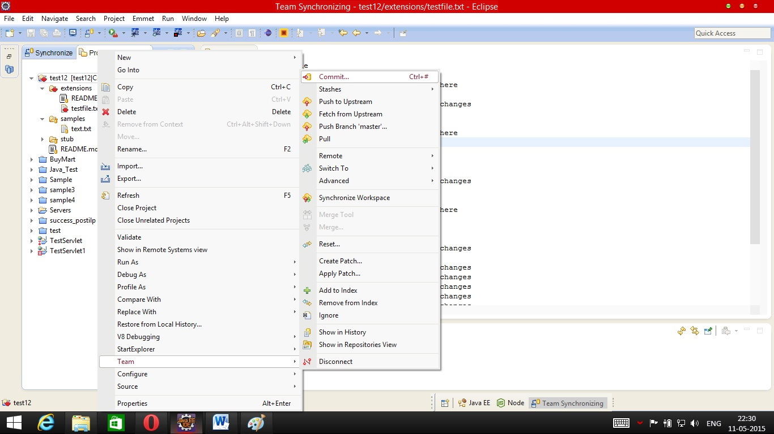

- Provide appropriate commit message for merging commits
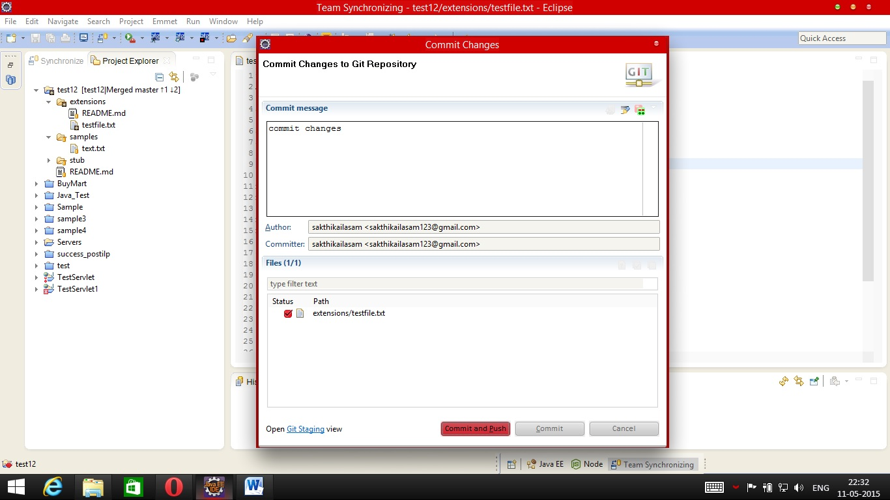

- Provide credential (Optional if the username and password already stored in eclipse).
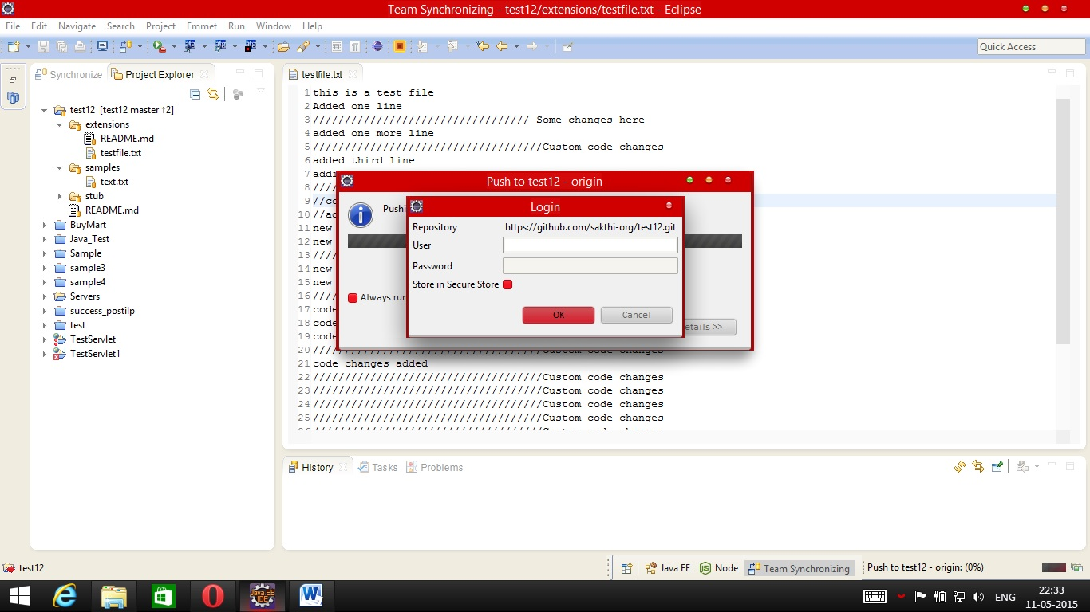
- Code Pushed to repository
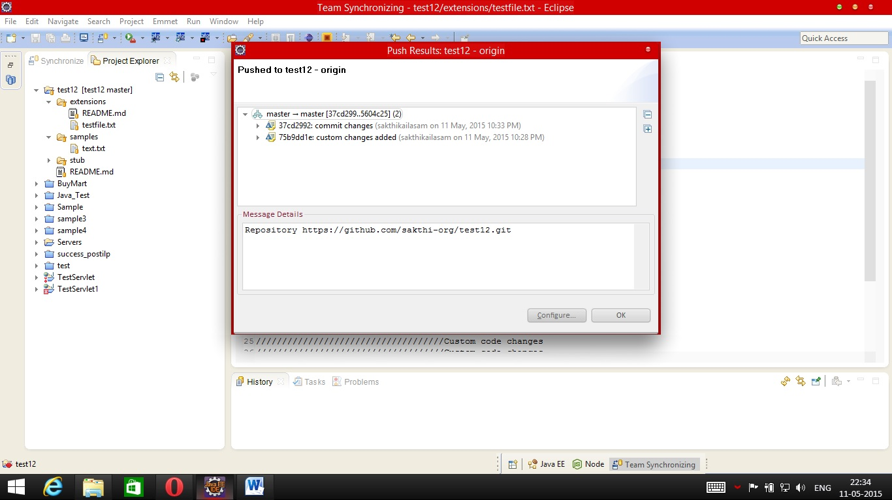

Failure scenarios of this Merge
- Auto generated files (Inadequate knowledge of files which was pushed to repository).
- Committing changes again and again without pushing the code to github.
- Code pull is not frequent.
- Failure to follow these steps.
- Eclipse version/configuration.

Prerequisites
- In “Team” → “Commit” , Only the files you have changed should be there.

