Importing a project from Git repository

- From project explorer select import
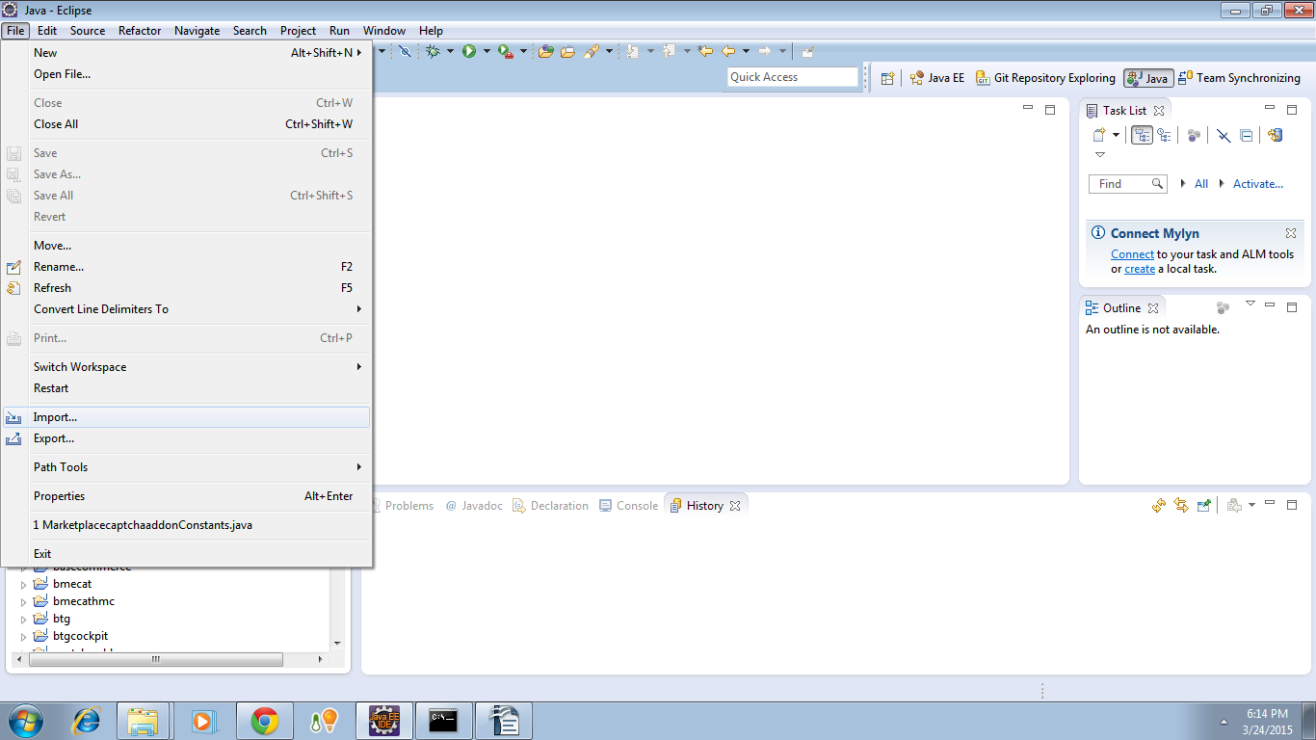
- Choose Git → Projects from Git
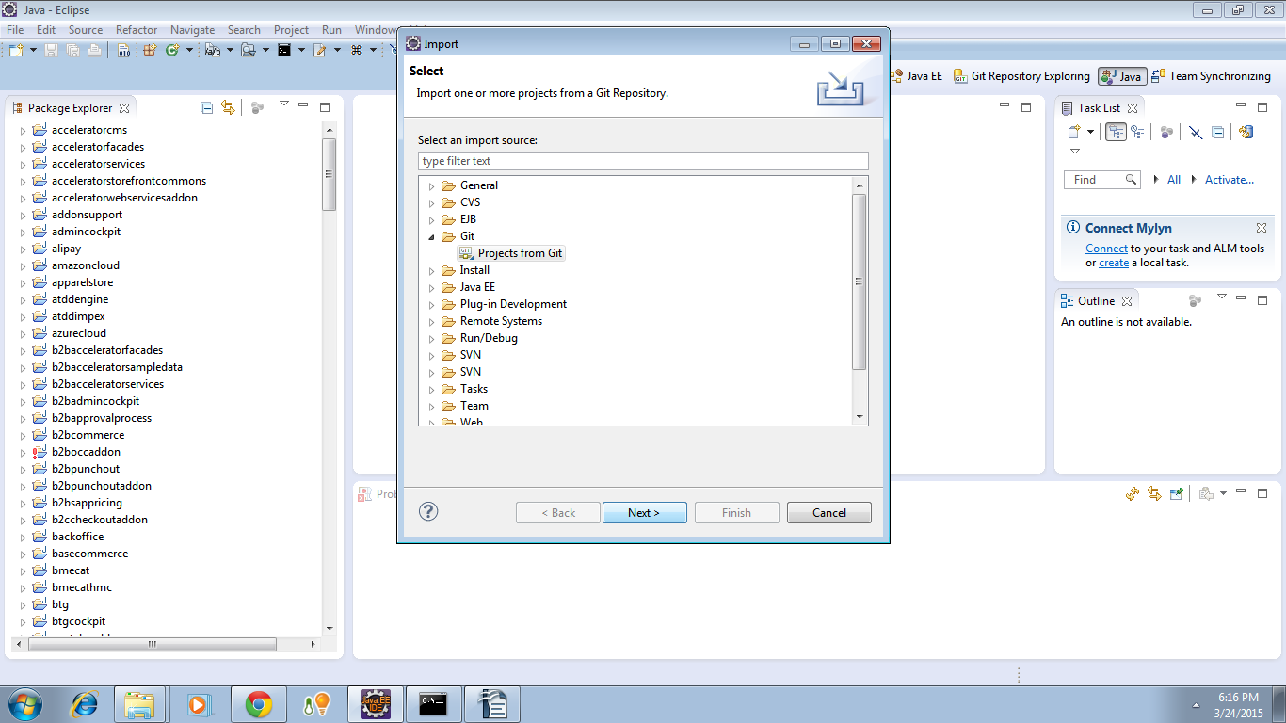

- Select URI
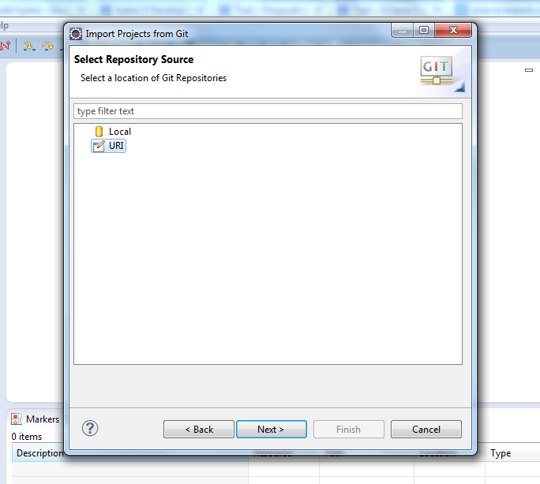
- Enter URI for source Git repository and provide username and password and select next.

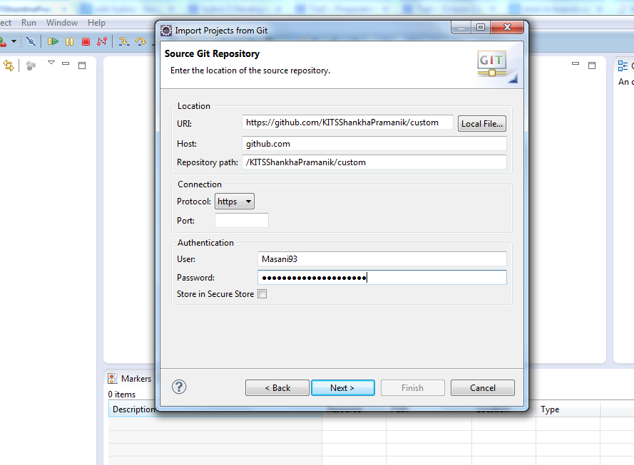

5. Select the appropriate branch and click next.
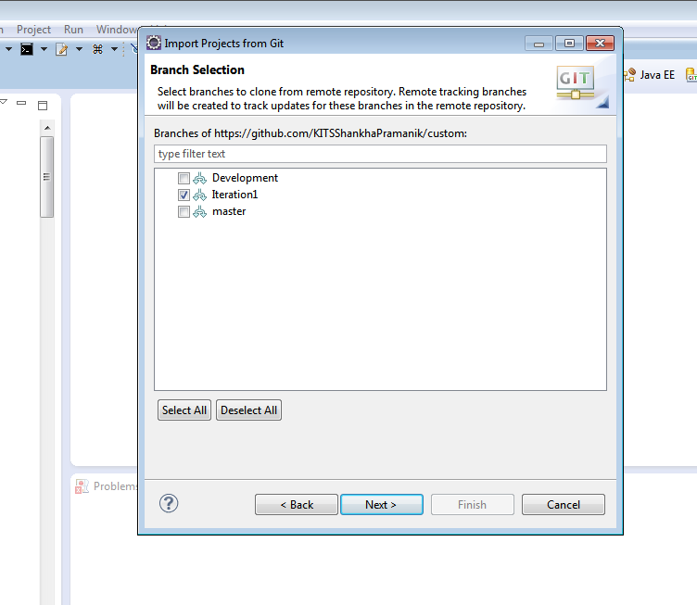
- Select path for local repository. Select path from hybris commerce suite upto its bin folder, inside where the custom folder will be created.

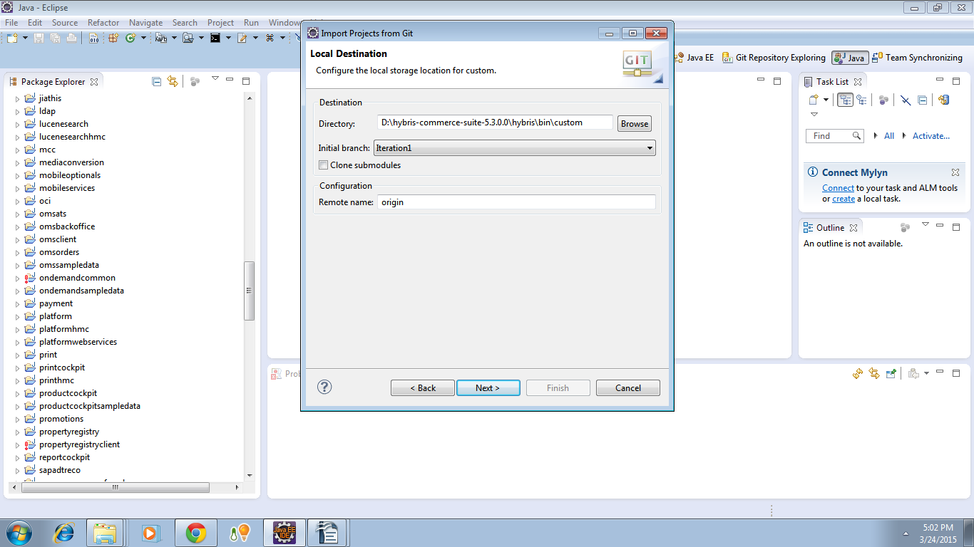

7. wait till all the objects are received.

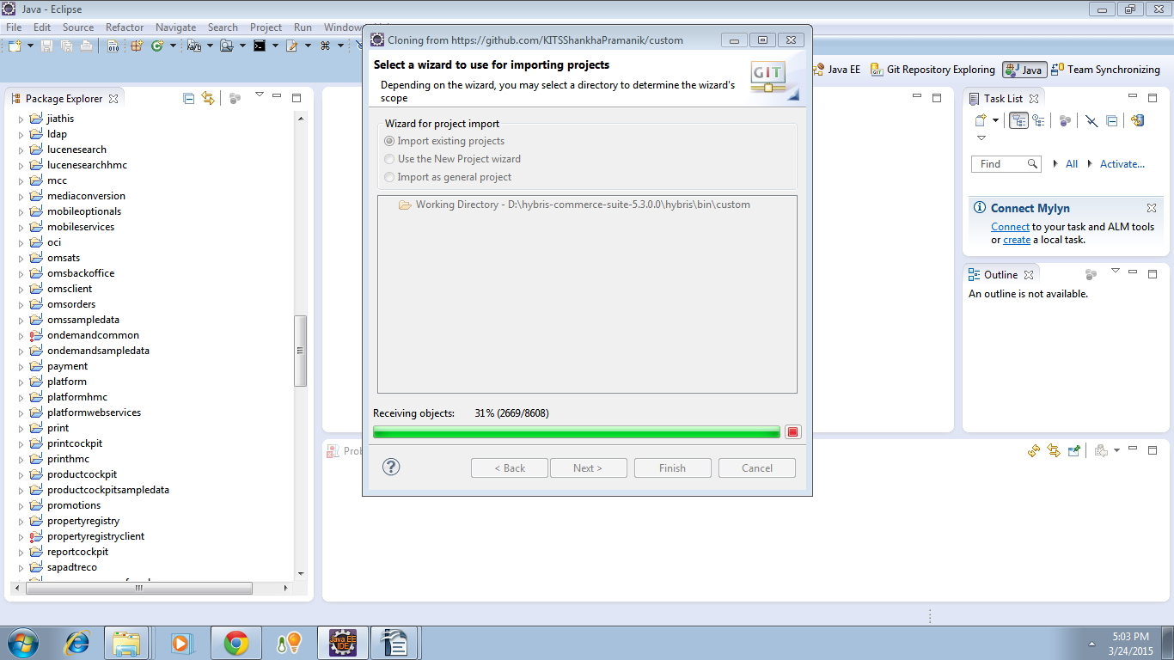
8. If there are some other projects present, then wizard should be Import existing project. Otherwise import as general project can be selected.

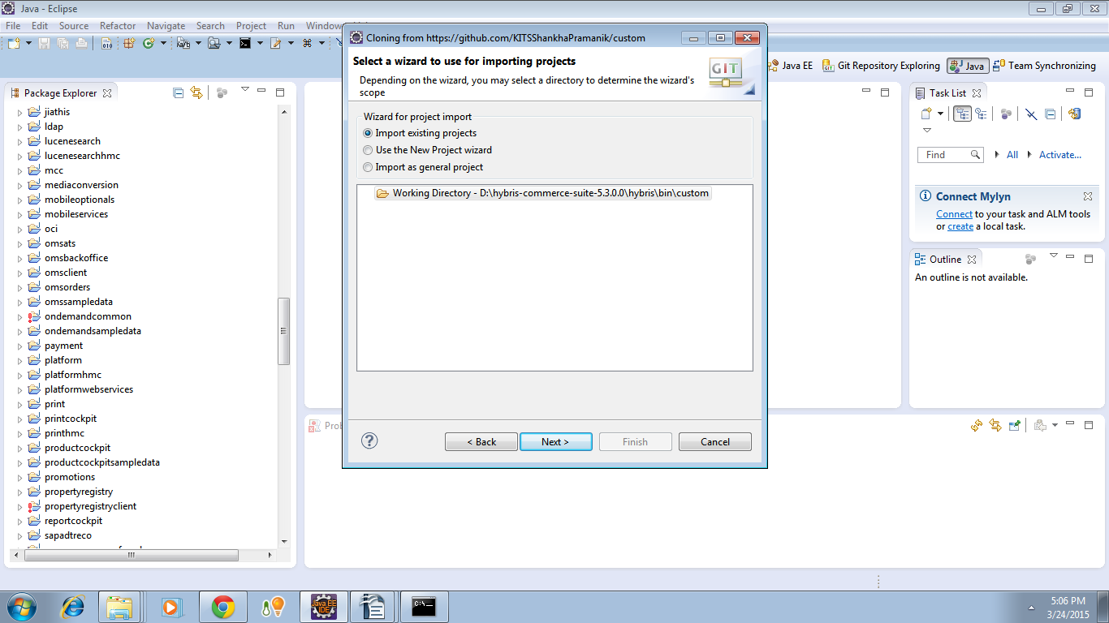
9. All the projects which are to be imported are marked as selected an finish is clicked.
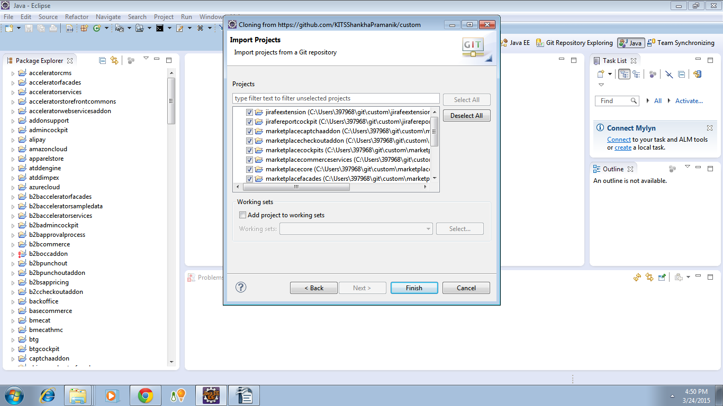
10. Projects are successfully imported. Each project name is trailed by directory name [custom] and branch repository name [iteration 1]

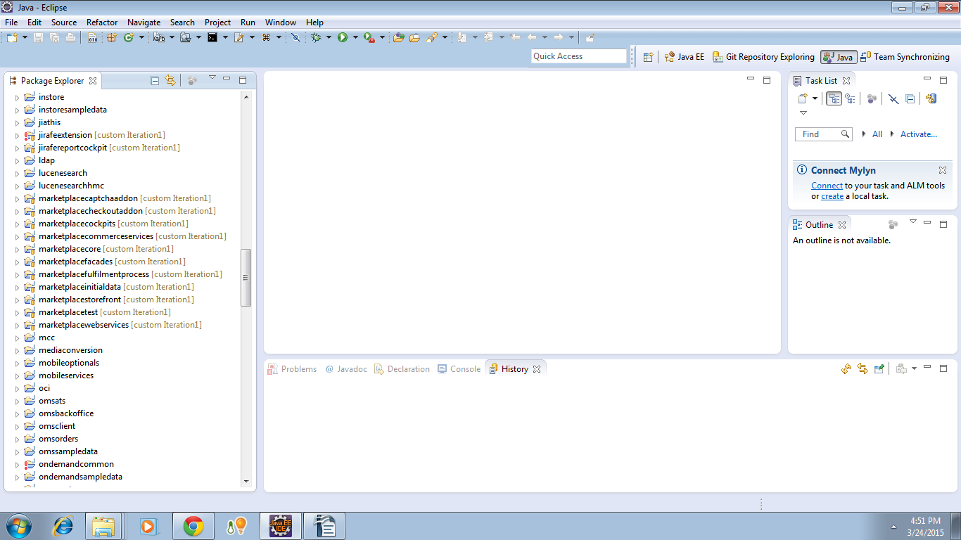

11. As clearly shown, the custom folder is created inside bin.
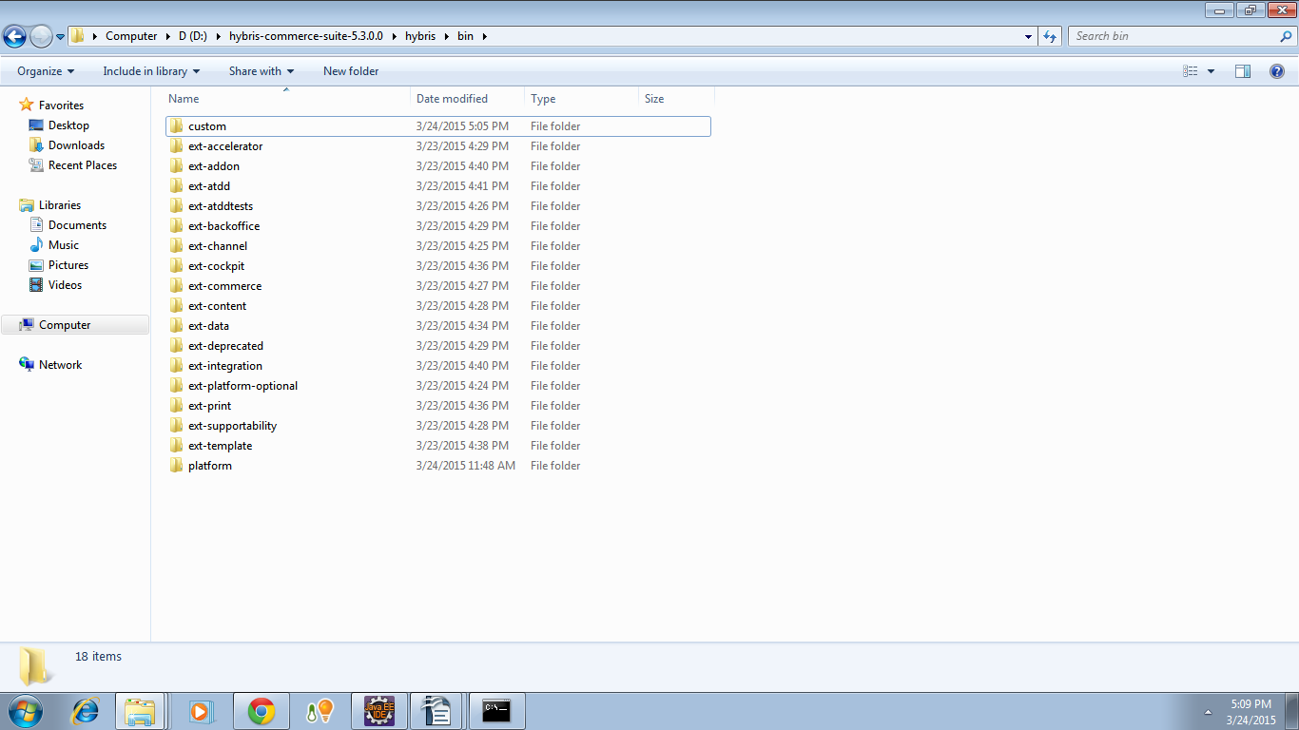
12. Inside custom all the projects are imported.

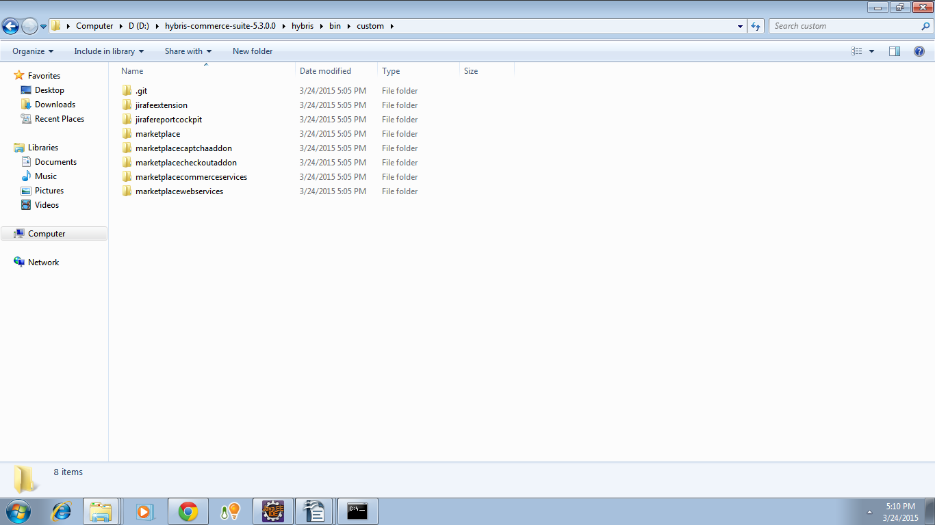

Now if the project is built from platform, build should be successful.

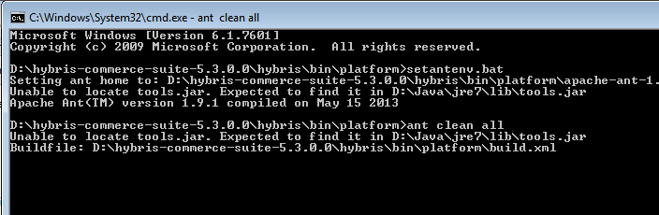

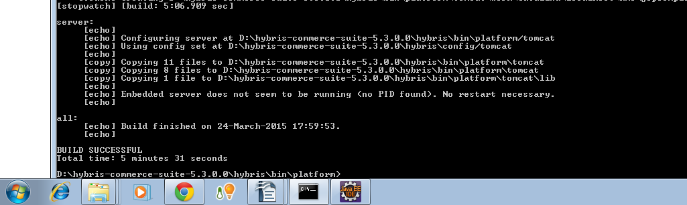

13. After checkout, another pull operation is executed.

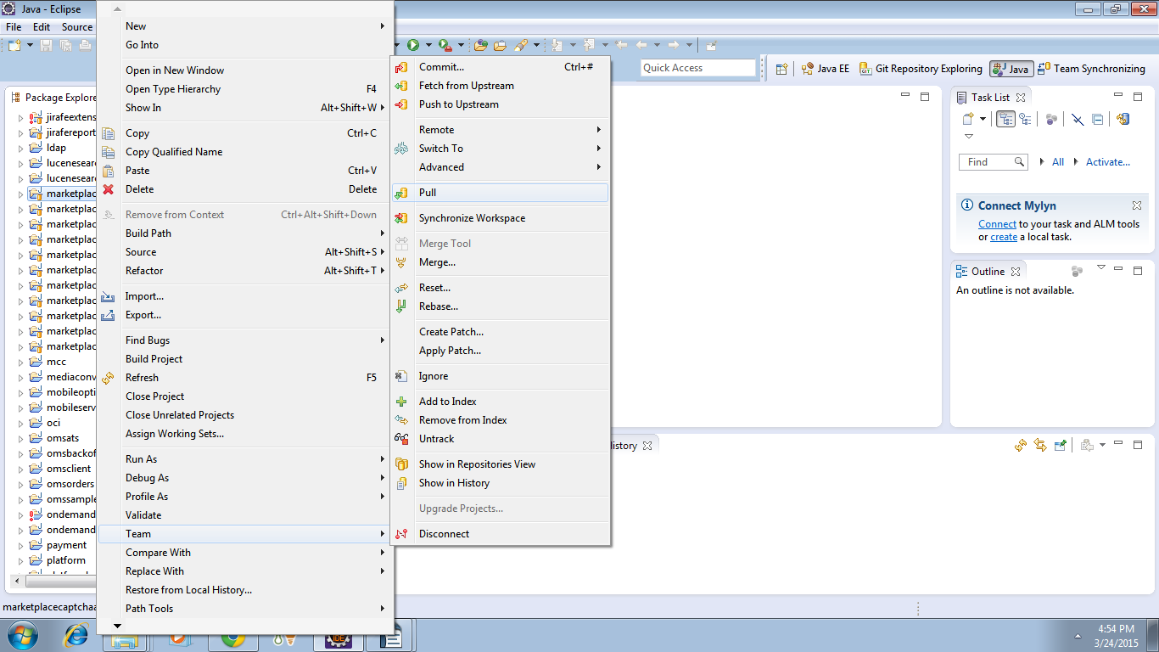
14. Operation is being processed.

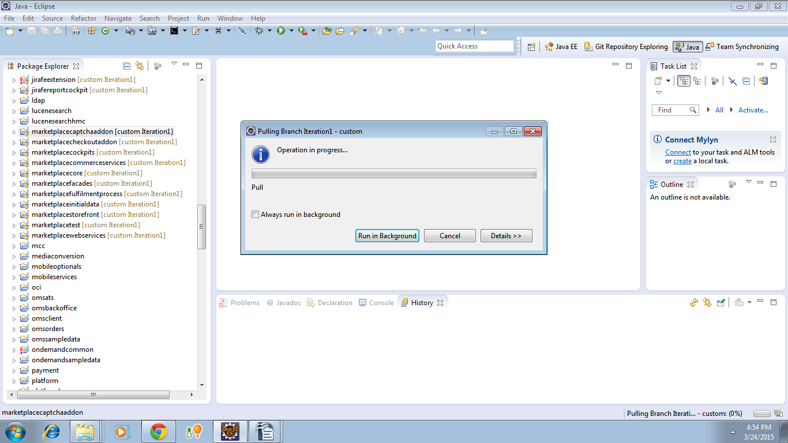

15. No new files are pulled since everything is already up to date.

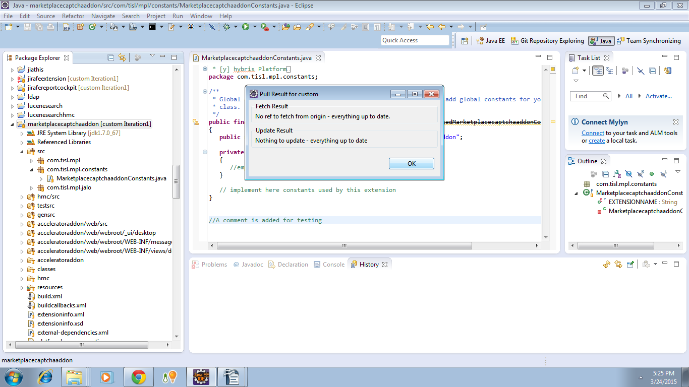
16. A change is made in a particular file. A comment is added at the end of file.

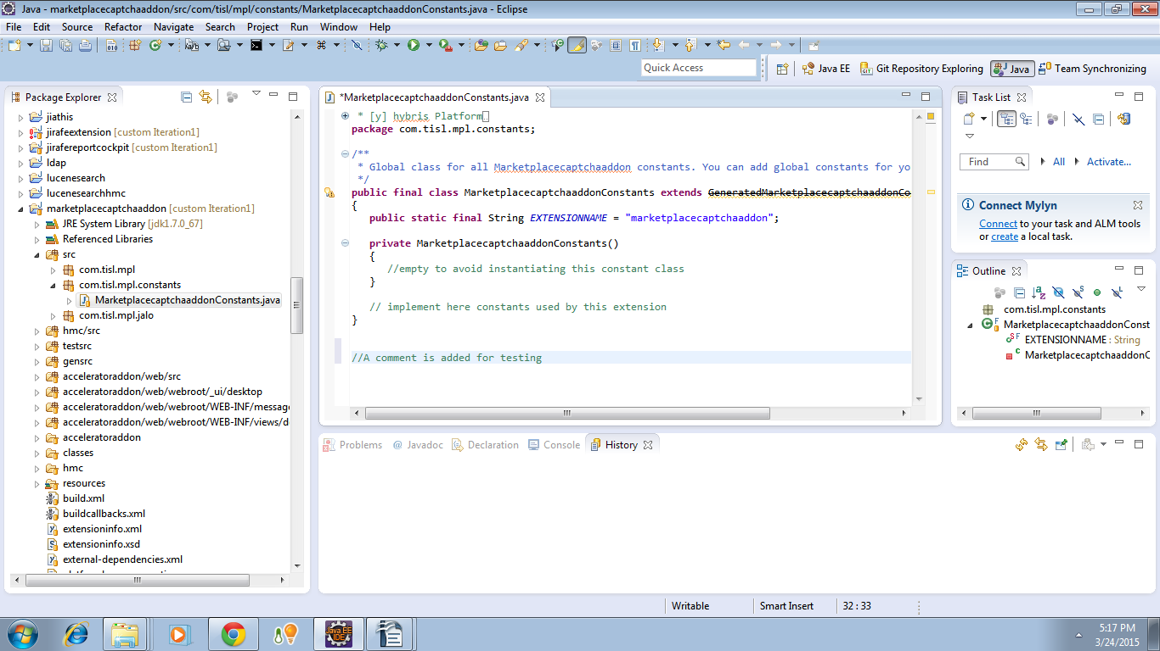

17. Right click on Project → Team → Commit to make the change permanent.

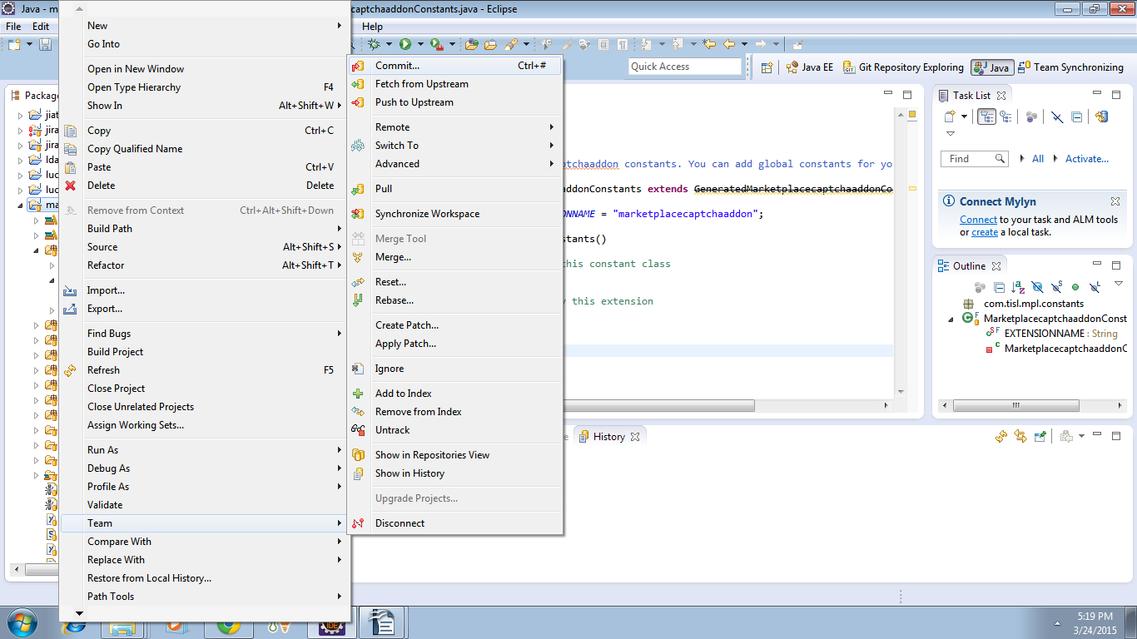

18. A meaningful comment is added which describes the change.
Files where changes are made are selected and comment and push is selected.

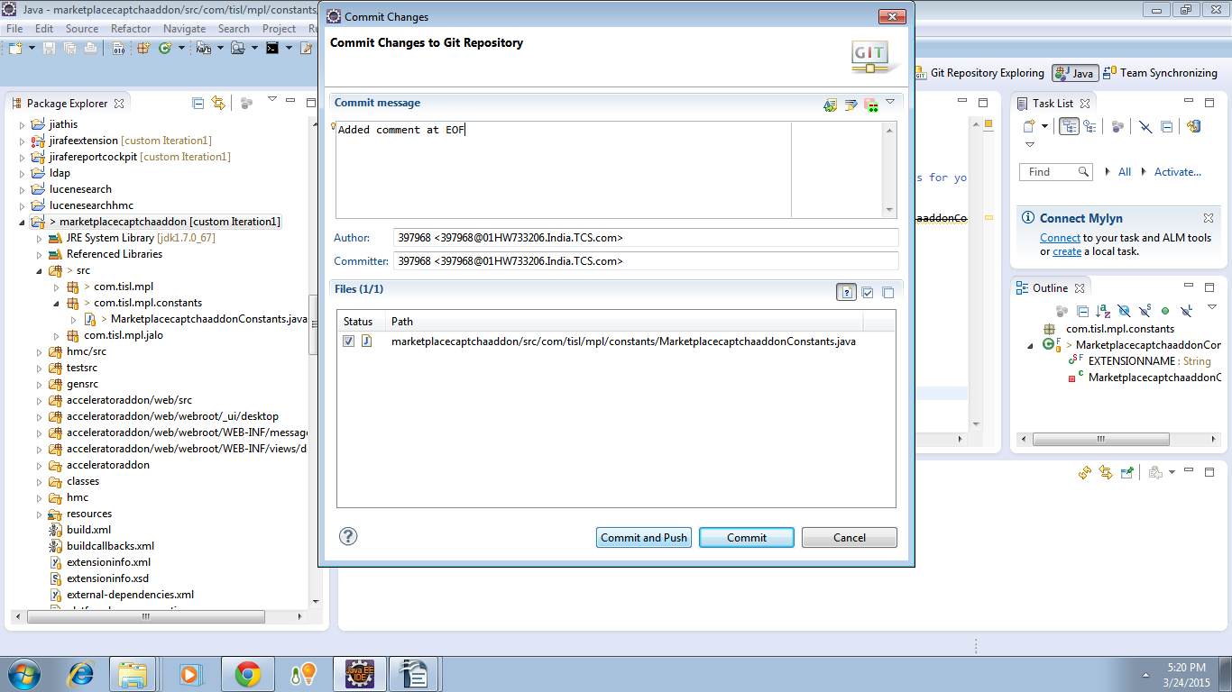

19. Push to remote repository is on process.

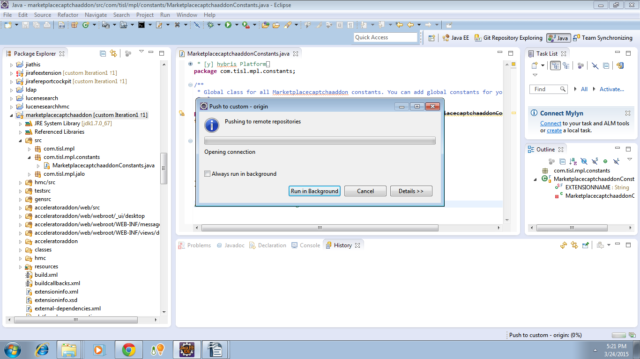
20. ok is selected.

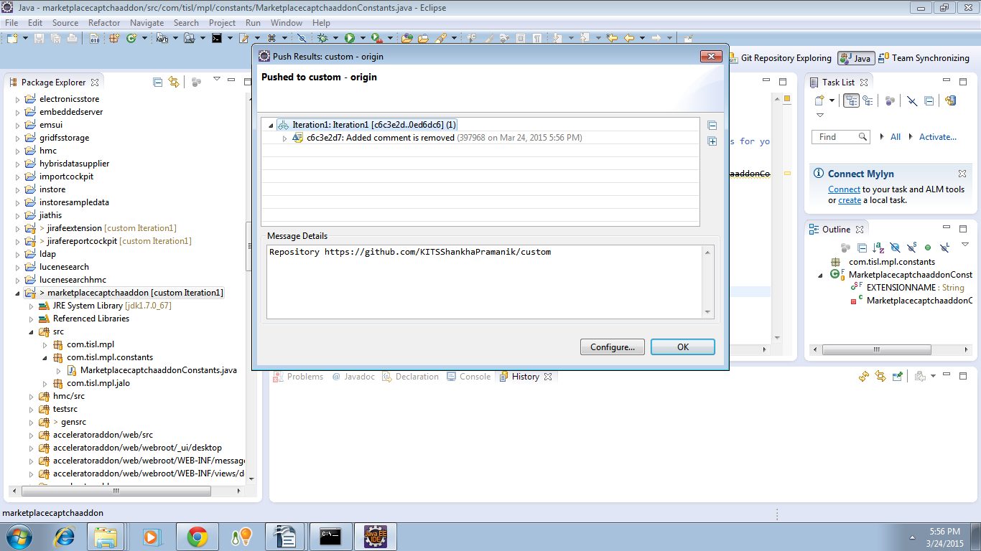

21. Changes are reflected at remote repository.
In this example, project marketplaceaptchaaddon is updated 6 minutes ago.

