Send Marketplace Working files to Repository

In this section, our requirement is to keep all our work files secure so that no data loss occurs in later stage of development. Hence we will transfer all our working files to remote repository (Github) through Git-Bash by following the steps below.

Prerequisite:
- You need to have a remote repository in Github, where all the files are going to be stored.
- Git-Bash should be installed in local system and configured such that channelization lasts between local and global repository.

Step 1.
We have all the files in our workspace directory according to the correct hierarchy.
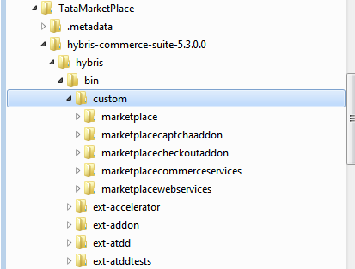

As we see, all the user-defined extensions are kept inside a separate folder named custom. We need to shift the entire content of the custom folder into our remote repository.

Step 2.
As the reason described in step 1, the repository is named as custom in Github.
In case we do not have one remote repository, we need to login to our account in Github, then click on create a new repository, and name it as custom.

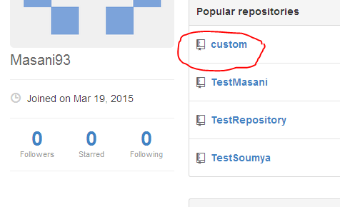

Now we have a remote repository where all our work will be safe.

Step 3.
Please open Git-Bash. Go to your local custom directory where all the working files are residing.

Step 4.
Now we have to make this directory our local repository. Type $ git init to initialize it to a repository.
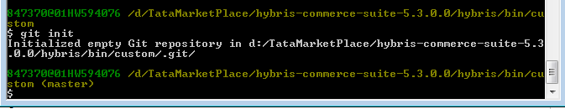
As we see, the custom folder is now being treated as a local repository whose default branch is master as shown beside the directory name.

Step 4.
Now we need to connect our local repository with our global repository custom.
Type $ git remote add <name> <URI>
Here URI is the URI of remote repository and name is a name that we like to assign as a alias to that URI.
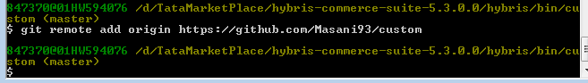
Here we named the URI of custom as origin.

Step 5.
Since we are pushing files to our remote repository for the first time, we only need to add and push the working files.
From $git status we can figure out what are the file that needs to be added or committed.
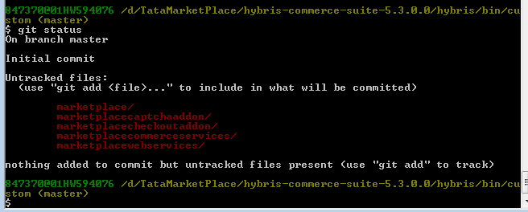
We need to add entire work present in our current directory. Hence we will type
$ git add .
(The dot represents current directory)
Some times there might be situations where for only a file or two an entire directory is treated as unstracked. You must add all the files.

In such cases use this command
$ git config core.longpaths true

This enables Git to extend its character limit for file names. After doing this, perform add again.

Step 6.
After adding all the files, we need to perform a commit with a suitable comment.

$ git commit -m <commit message>

Step 7.
Now we need to push the files to our remote repository.

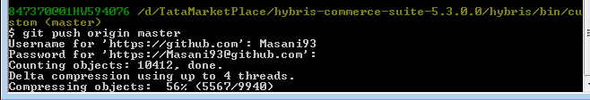

Step 8.
Go to your remote repository and check whether all the files are added or not.

Step 9.

Tomorrows work
FATAL ERROR, THE REMOTE END HUNG UP UNEXPECTEDLY
we have to resolve
and some inquiries regarding adding files when for one litile file entire folder is not being added.

