Introduction :

Hybris supports built-in scripting API for using dynamic typed languages in the hybris Platform at runtime. The scripting engine saves time and makes it possible to improve existing logic like cron job, task engine, and other similar tools. Scripts may be stored in various repositories like a database (based on the Script model), classpath, file system.

Advantage:
Traditionally, creating a new cronjob was time-consuming and entailed many manual steps, for example, you had to create a new java class, take care of spring bean definition, rebuild the platform, restart the server and so on and so forth.
Using dynamic scripting, creating cronjobs becomes much easier and, most importantly, it can be done dynamically at runtime.

Sample Groovy script :

import de.hybris.platform.servicelayer.search.FlexibleSearchQuery

//get flexibleSearchService from Hybris container
flexibleSearchService = spring.getBean "flexibleSearchService"

//get modelService from Hybris container
modelService = spring.getBean "modelService"

//defining a method
def findCart() {
query = new FlexibleSearchQuery("SELECT {PK} FROM {AbstractOrder} where {code}='15481123719086096-00009005'")

//execute the query through flexibleSearchService
flexibleSearchService.search(query).result
}

//Defining list
def cartList= []

//calling findCart() method
findCart ().each {
cartList.add(it)
}

println "to remove - ${cartList}"
//Removing the carts using modelService
modelService.removeAll(cartList)

Execution:

Groovy script can be executed through HAC or through cron job.

- Through HAC.
- Go to HAC -> Console->Scripting Languages
- Put the groovy script in “Edit Statement” area.
- Click “Execute”
Do not forget to enable the “COMMIT” option if you are doing any DB operation.

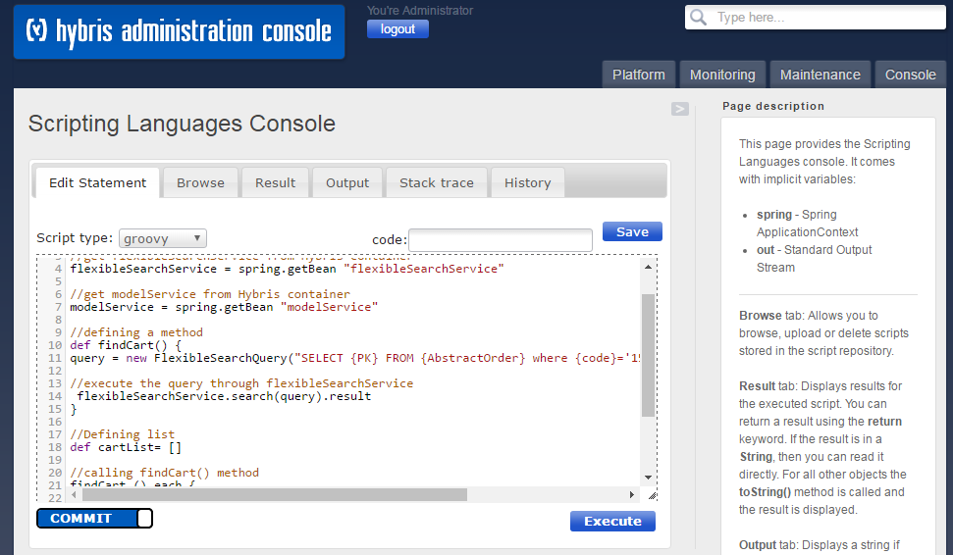

- Through Cronjob

The groovy script can be saved in DB through HMC and can be associated with a job to make it scheduled.

- Go to HMC->Scripting->Scripts
- Create New script and save.

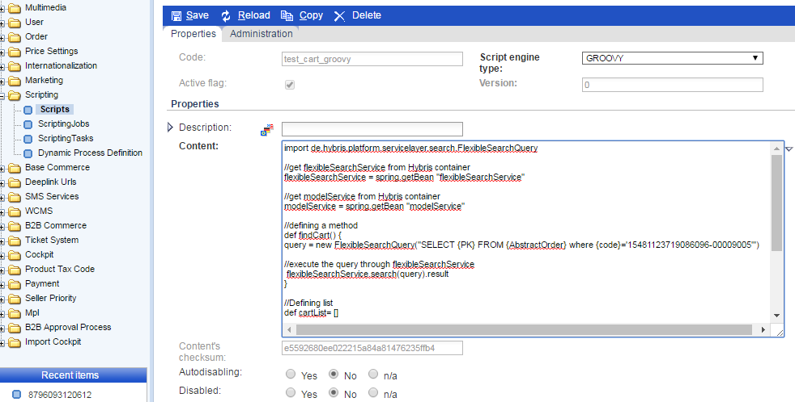

- Then Go to Scripting->ScriptingJobs
- Create new Script Job , scriptURI would be model://<script name>

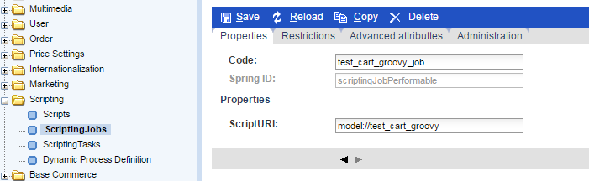

- Now associate the script job with a cron job and schedule it.

