GITHUB CODE CHECKOUT CONFLICT ISSUES
- Code in our eclipse
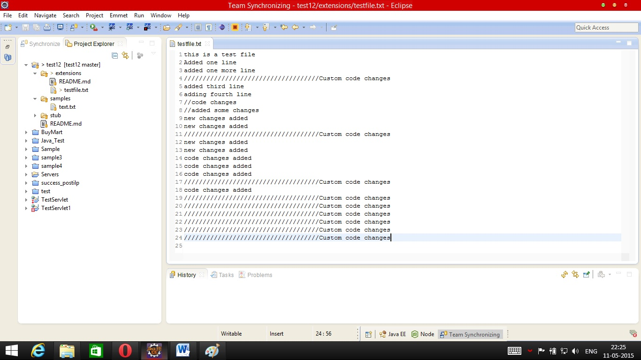

- Code in github (latest one changed by some developer)
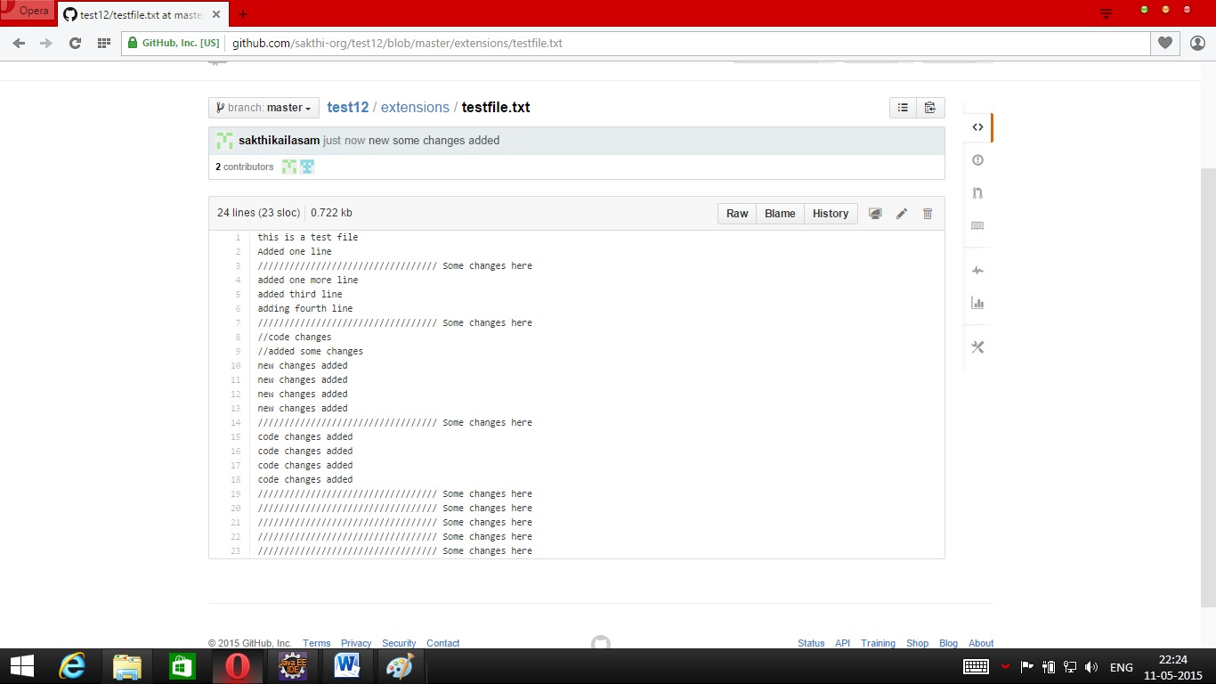

- Pull the code from repository, before committing.
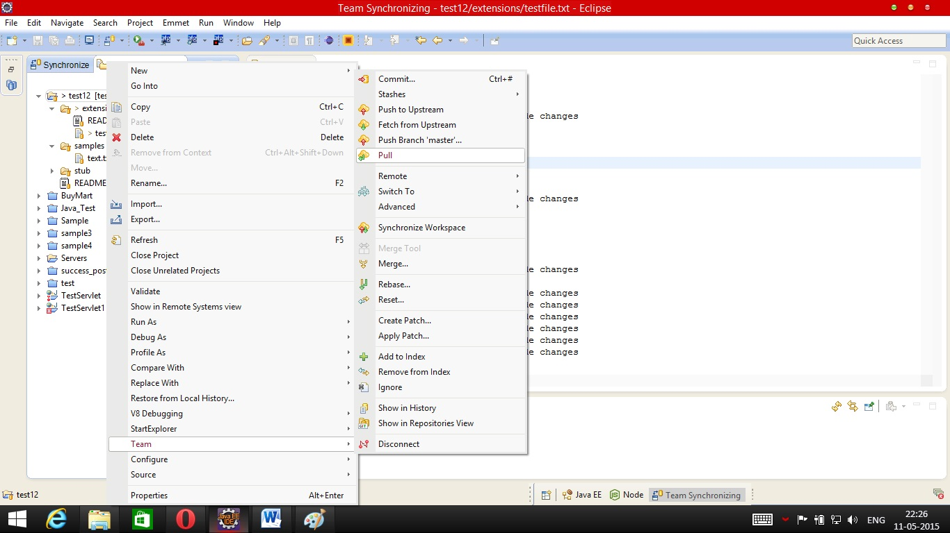

- Checkout conflicts occurs
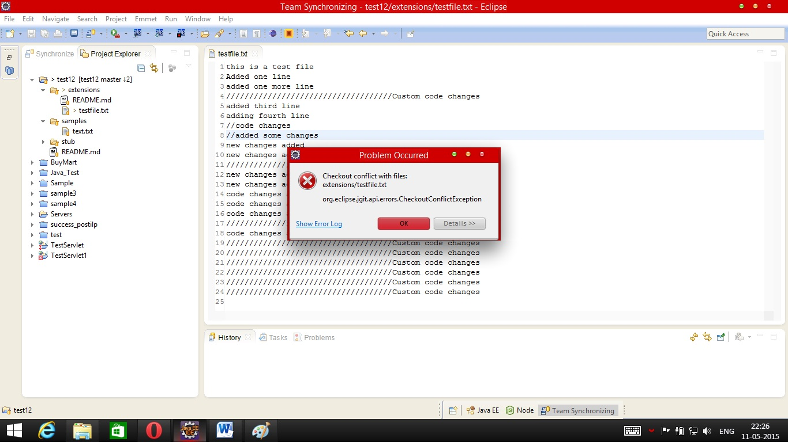

- Commit the changes (Please review your changes with synchronize if necessary).
Please do a gitignore in the unwanted/auto generated files and commit the git ignore files if necessary.
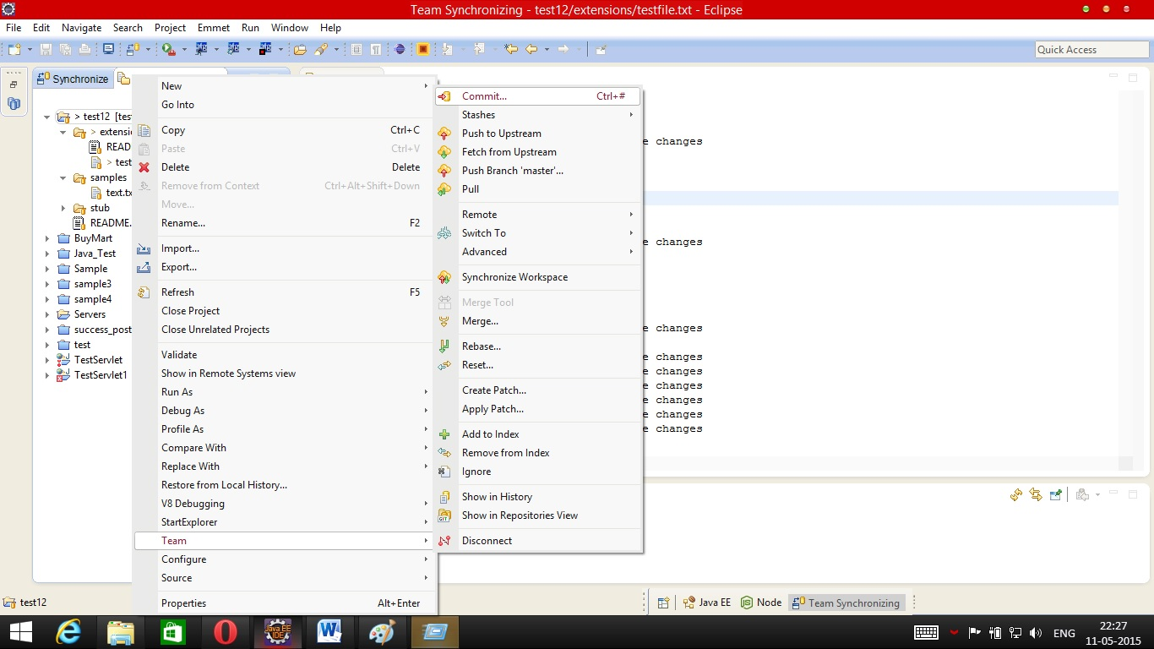

- Enter the comments for your changes.
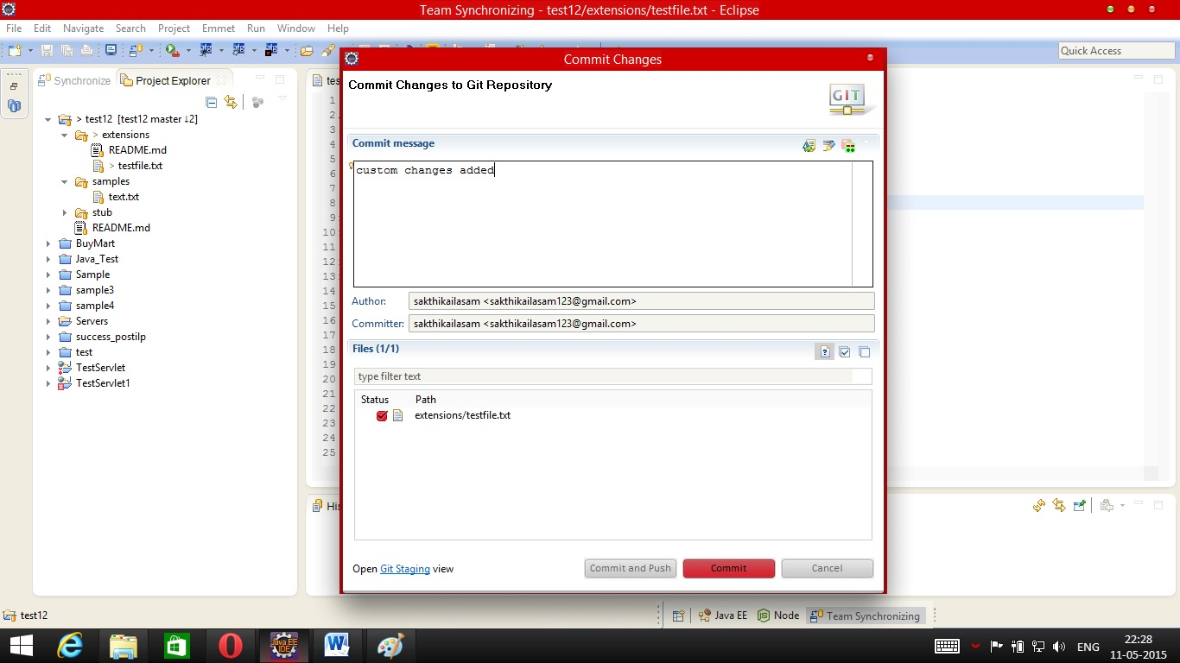

- If you are still having un-staged changes(the files you wanted to commit later/auto-generated files) , Please stash them before pulling the code again. (Optional)

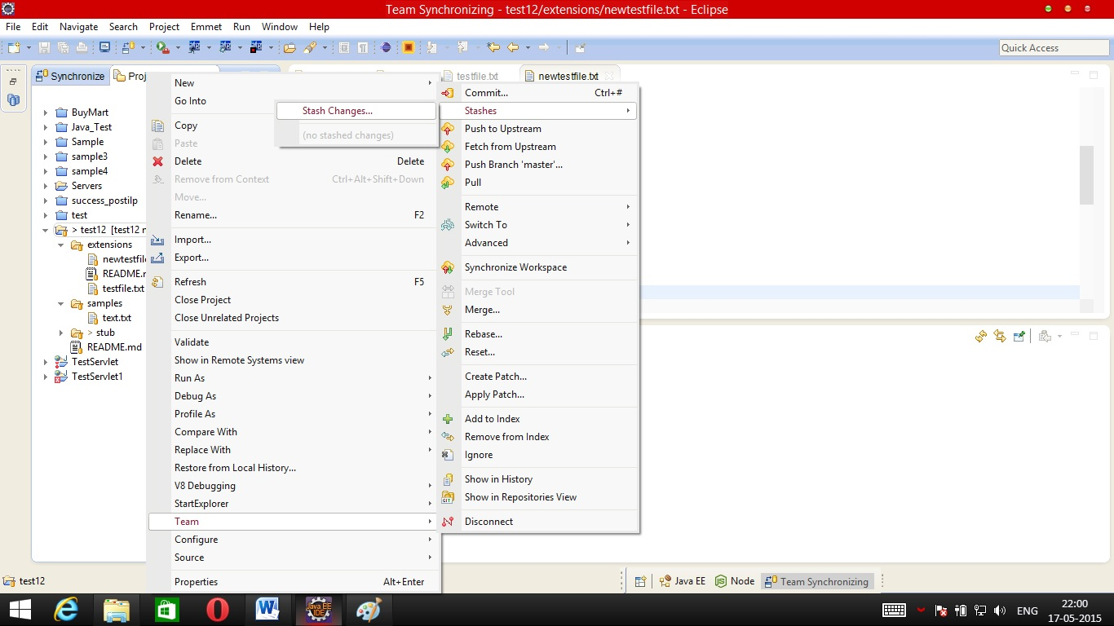

- Provide stash Name (Applicable if step 7 executed)

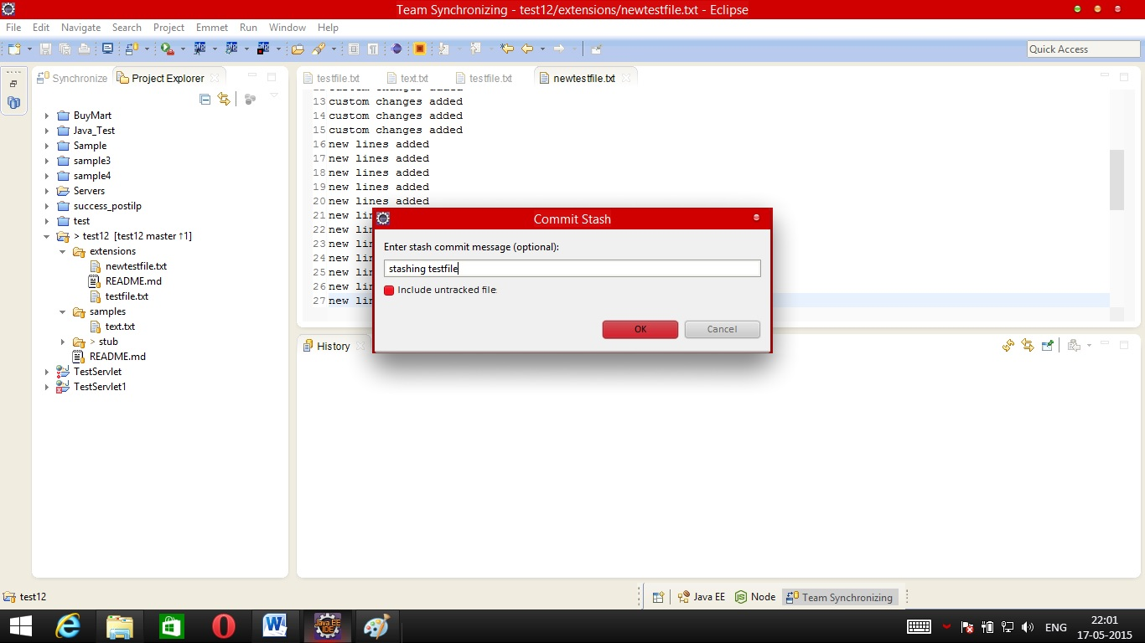

- Pull the code again
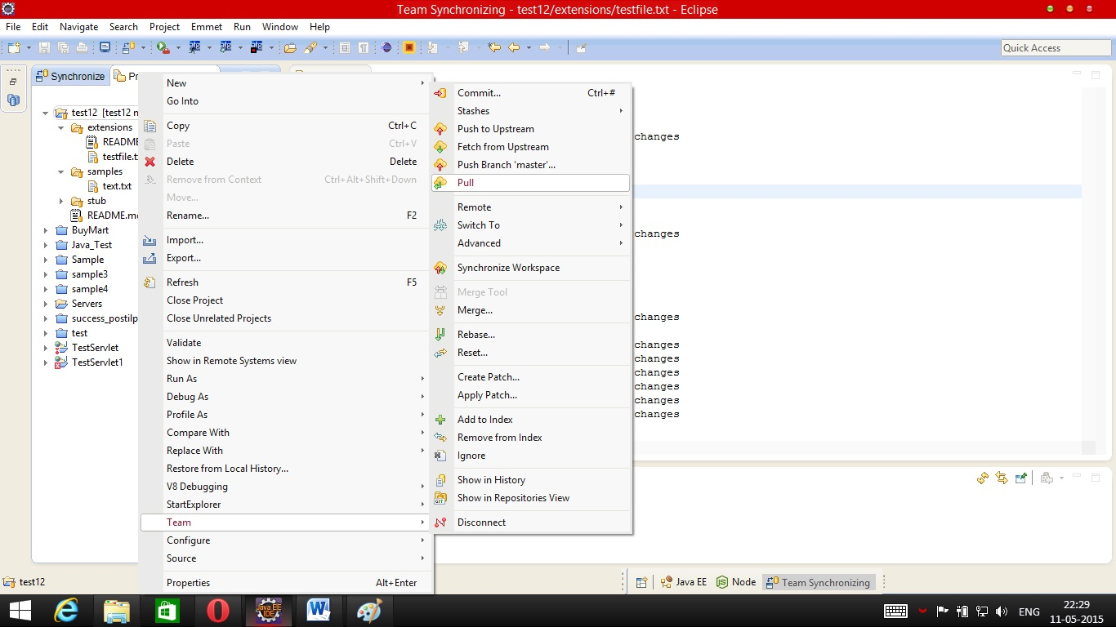

- Pull status should be conflicting and the window shows the conflicting commits.
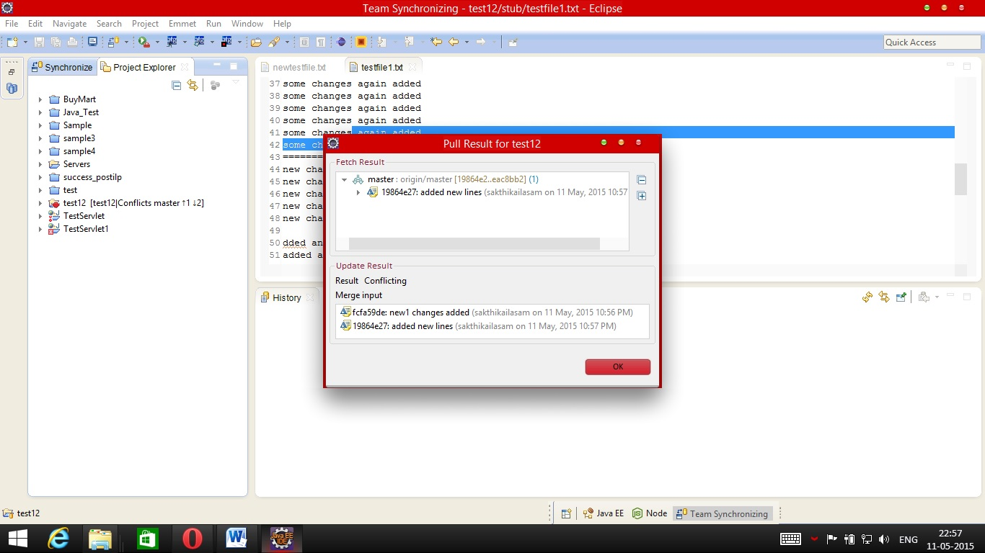

- Merge the code manually (As soon as clicking ok in the previous window, all the conflicting files will be with red marker or you can see the conflicting files in the synchronize perspective). Just like other versioned repositories remove the unwanted lines.
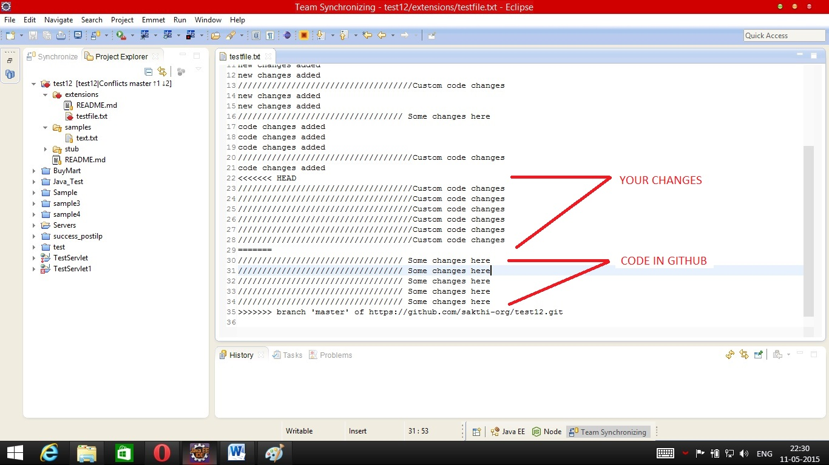
- Once you are done with the merge, Add your new code to index
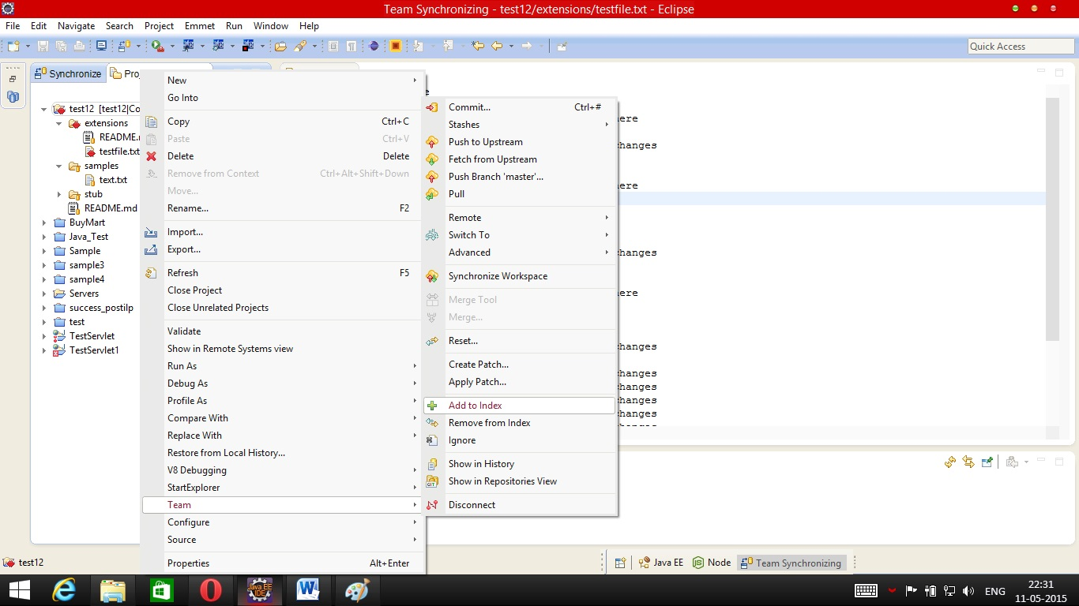

- Commit the code (You can try pulling again and if there are conflicts then please resolve it).
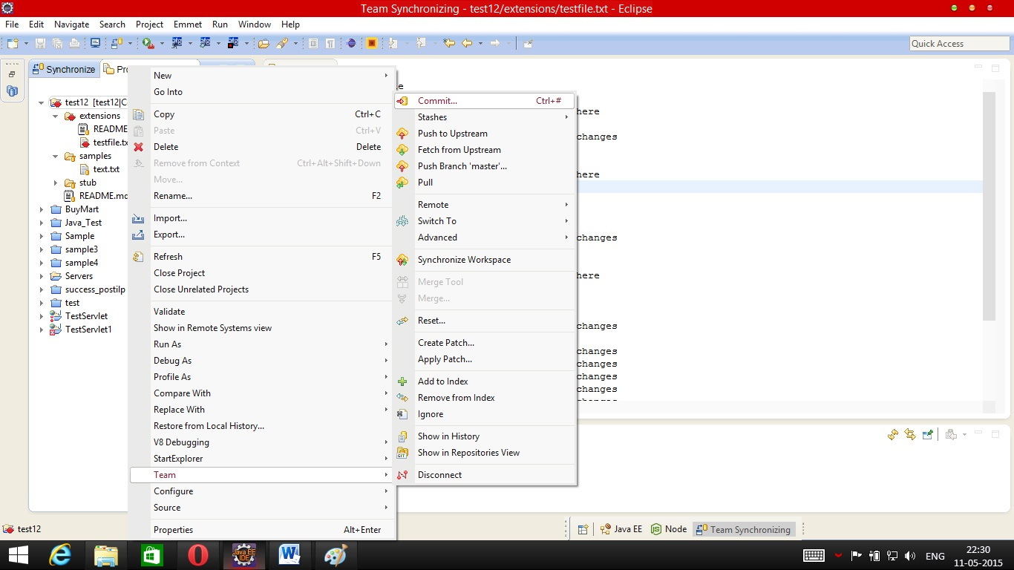

- Provide appropriate commit message for merging commits
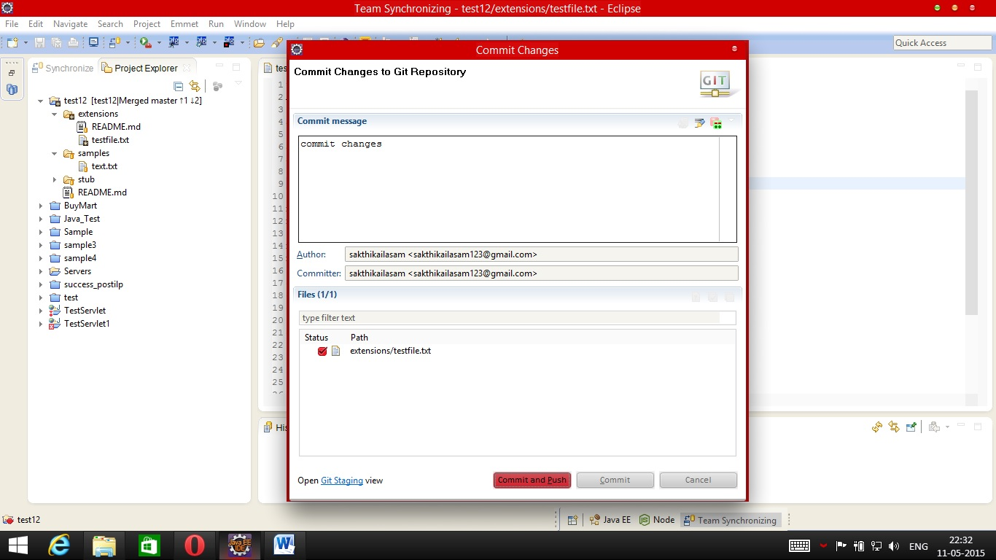

- Provide credential (Optional if the username and password already stored in eclipse).
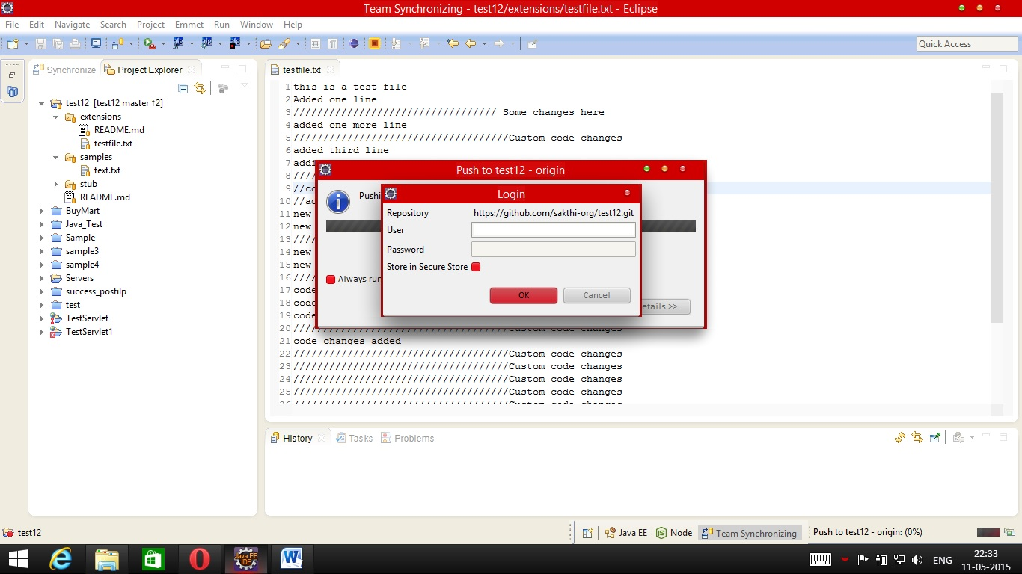
- Code Pushed to repository
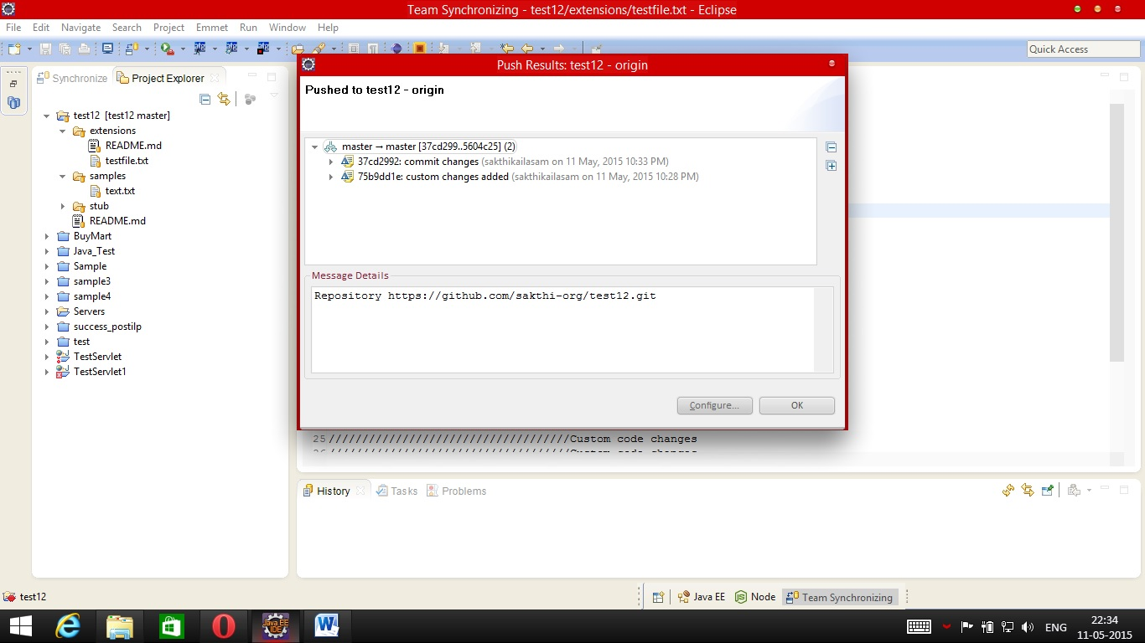
Failure scenarios of this Merge
- Committing changes again and again without pushing the code to github.
- Code pull is not frequent.
- Failure to follow these steps.
Prerequisites
- In “Team” → “Commit” , Only the files you have changed should be there.

To get the changes from stash
- Goto Team -> stashes -> your stash name
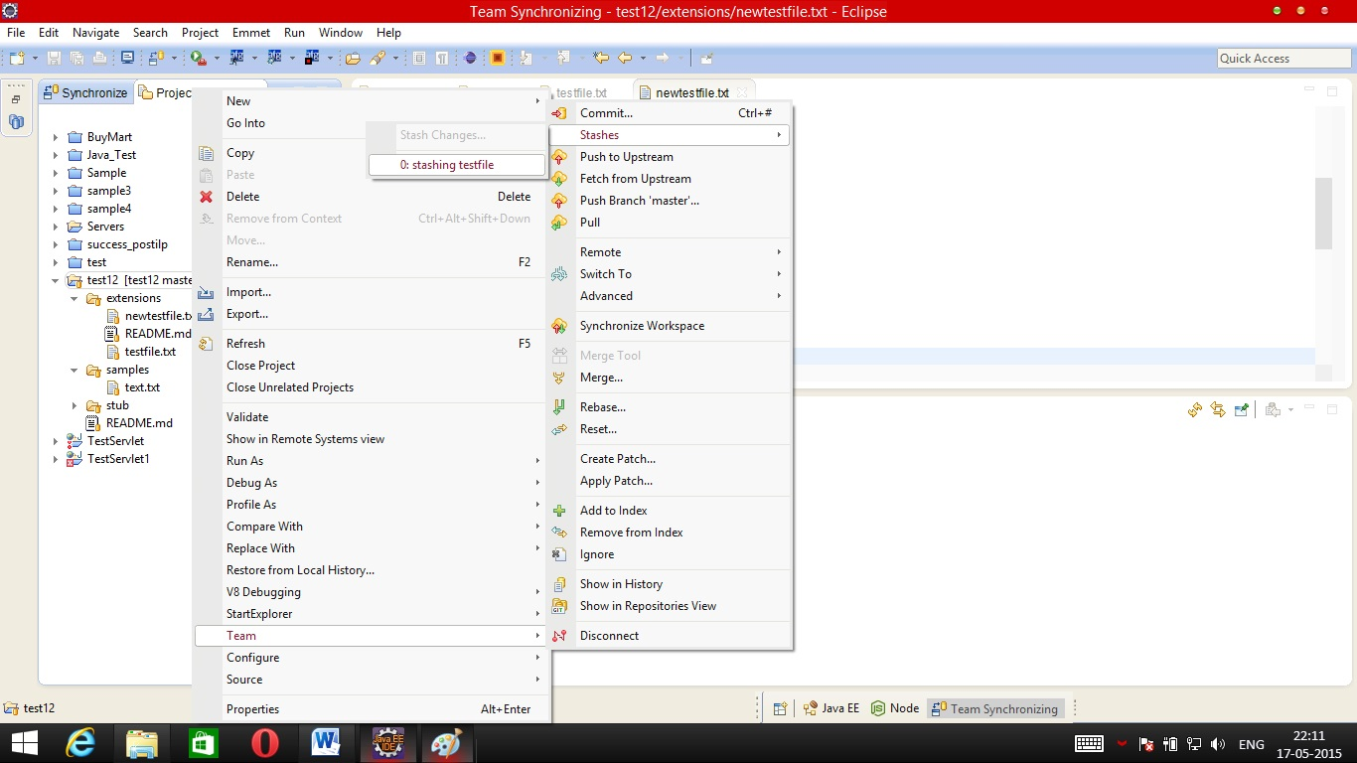
- Open the stash and you can see your changes, Click on apply changes
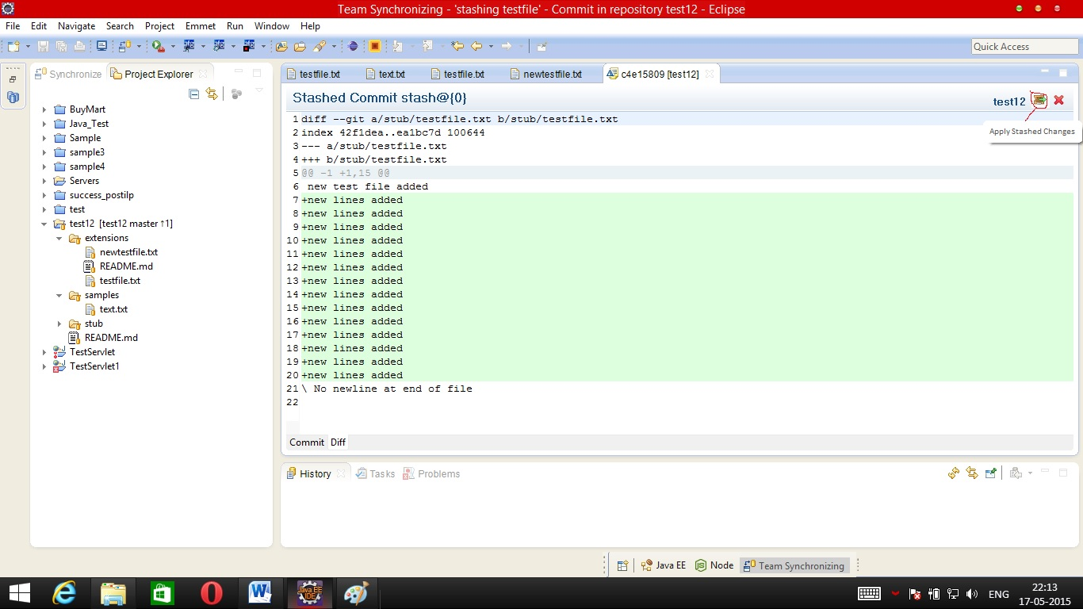

- Then your changes will be pop back to the file
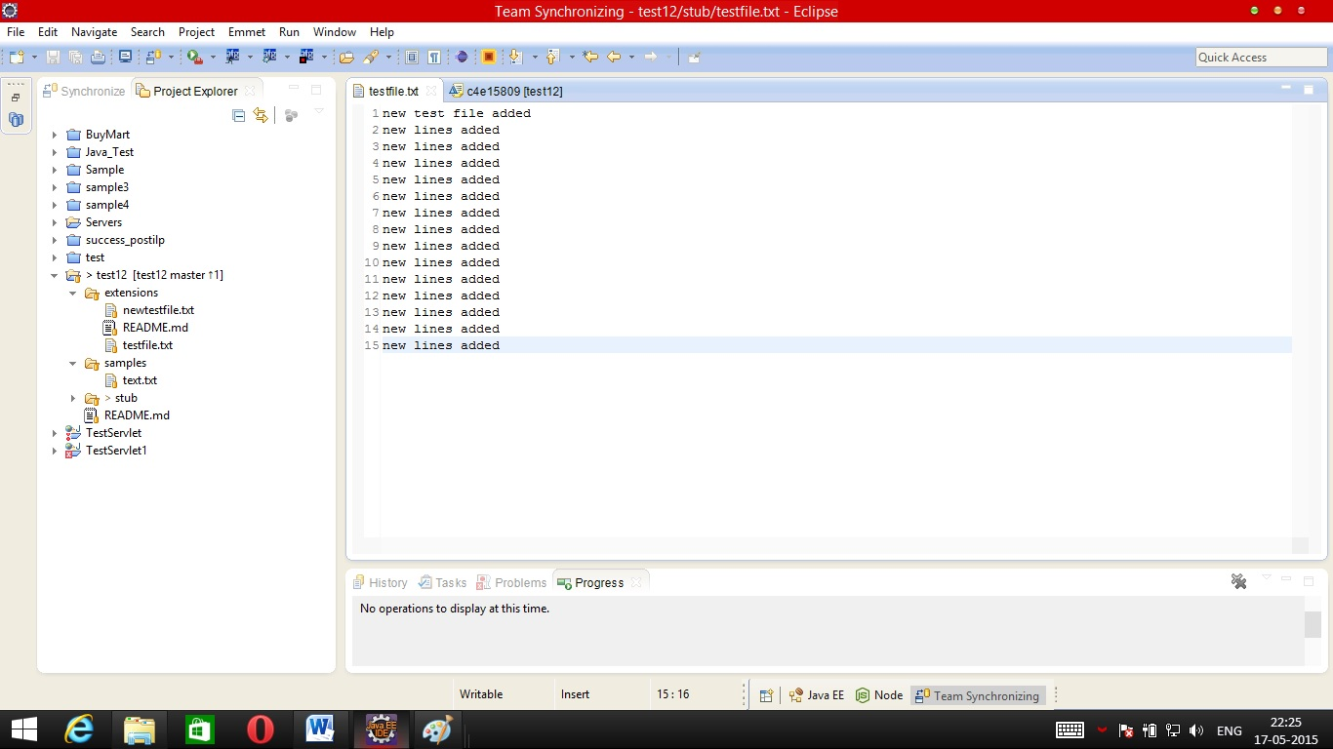

Here again if the files you stashed has been changed by someone else then you will get conflicts, at that time you have to go to stash and manually copy paste the changes to the file.

If these Procedures are being followed there will be no issue in using github

