Getting started with Git bash

Git bash is Command Line Interface through which user is allowed to create a local repository, or clone an existing repository, add and modify files in it and so on. All these activities are performed via adequate commands.

Creating a local Repository

First of all, user needs to create a folder which later on will be the repository. It is done by command 'mkdir directory_name'.
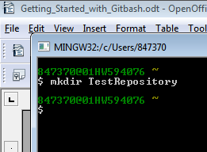

Here TestRepository is an empty directory.

Now to make it a local repository, we need to initialize through command 'git init'. But before that we have to step into the directory first. Reason behind initialization is to get this directory ready to interact with remote repository located in GitHub.
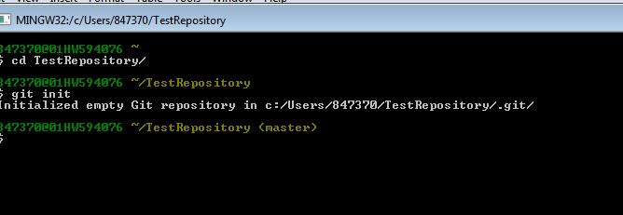

Now as we see, the empty directory becomes a local repository with a default branch master.
The directory has a hidden directory inside named .git, within which lots of other directories and files are created where all the records of commits and logs are going to be recorded.

Now we need to get our local repository in sync with a remote repository. This can be done by
$ git remote add origin [URI of the remote repository]

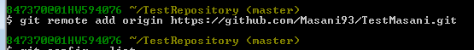

Add Files to the repository

All the files or the directory structure which is needed to be added, first should be present inside repository directory.

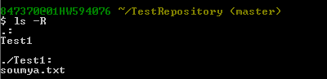
Here, we have created a directory named Test1 and inside Test1, we have created a file name soumya.txt.

To confirm about the status of our repository
$ git status

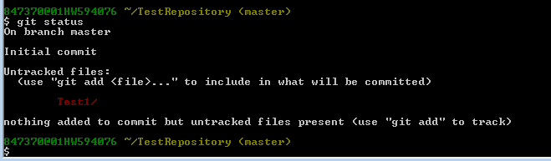
It tells that, no commits are made after the initialization but there are untracked(not committed) files present in the repository. The directory with untracked files are marked as red. We need to add the files first, in order to make them staged data.

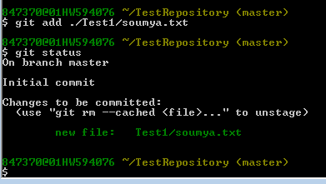
After adding them, the files becomes staged files (diplayed in green) which are now ready for commit.

After adding up files, commit must be made in order to make the changes permanent.
Command to commit is
$ git commit -m <Message>

Messages are important because at later stage, any changes in version shall be detected by means of these commit messages.

After commit, we can view commit details by “$ git log”

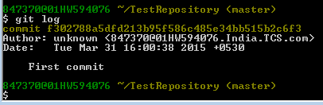

Adding files to Remote repository
After last commit, now it is time to push all the files into remote repository.
It is done by $ git push <remote name> <branch>
Here console will ask for Username and password for remote repository.

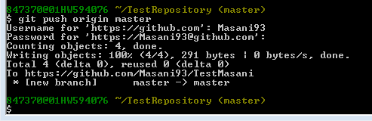

Now if we check our remote repository we will see,
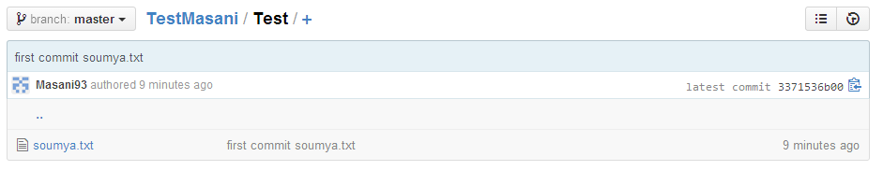
Here we see the entire directory Test has been saved in our remote repository with the commit message as “first commit soumya.txt”.

Add files to a working repository

First we need to add some files to local repository which later on we will add on our remote repository.
After the files are created, we first check the status like before.

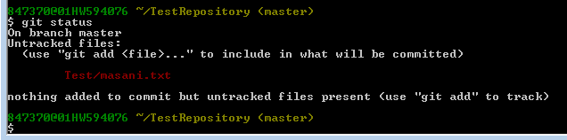
Here it shows that the new file is still at untracked stage. It needs to be added first.

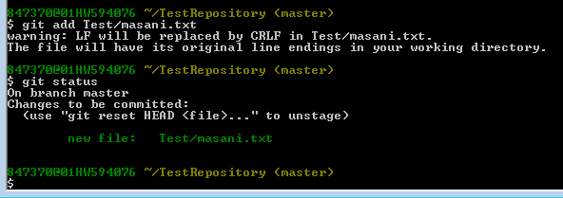

Here we see after adding the new file is ready for commit.

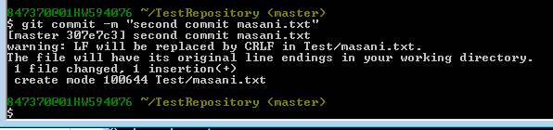
After commit we will push all the new changes made. Hence in this case the new file
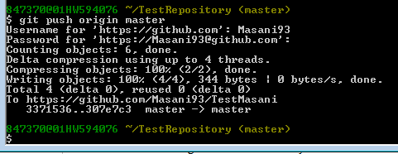
After pushing the file the remote repository will look somewhat like this.

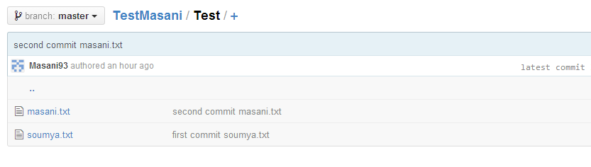
Check commit history

With the help of command '$ git log' we can see the commit histories as they are listed up according to the time, latest commit made resides on the top of list.

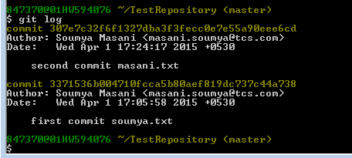

See commit details

To see the details of any particular commit, type
$ git show <commit id>
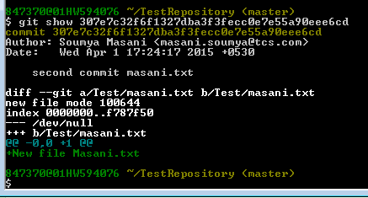
Here first the commit id, followed by Author details and time are displayed. After that the commit message is displayed. We can also see the content of the file which has been added.

Make changes in a file

First make some change in a file. Then find status.

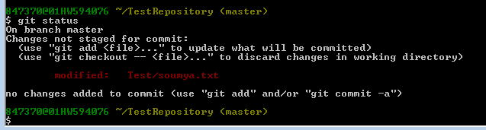
Here we see that file Test/soumya.txt has been modified and not yet commited. In order to commit, first the file needs to be added. After that, we can commit the changes with proper message.

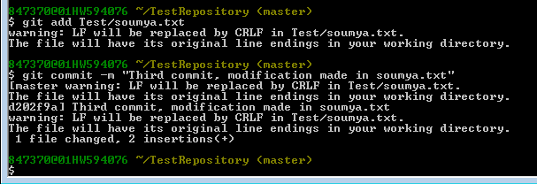

Now, we will push the modified file at remote repository.

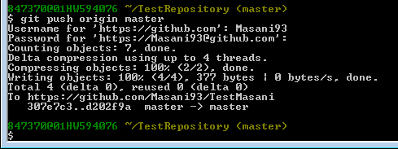

The remote repository will look somewhat like this.

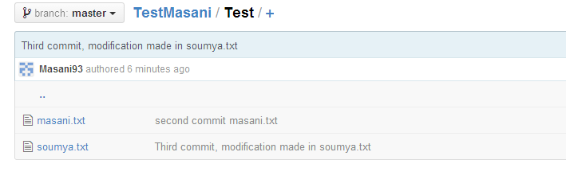

The details can be seen using the commit id.
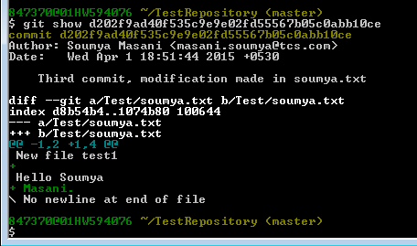
Here the first green '+' signs indicates that a new line has introduced after first line.
The second one indicates that a new word “Masani.” is added at the end of previous line.

Pull Data from repository

First of all create a new directory which will be our new repository.
After that we will initialize using '$ git init' command.

Next we will sync the local repository to our remote repository.

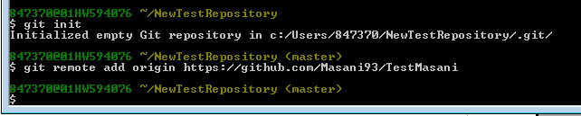
Now we will pull data from remote repository using command ' git pull '
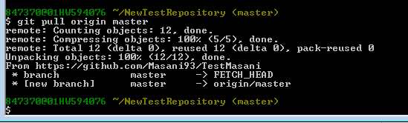

Now we have fetched all the files from remote repository into our local repository where branch name is the same as the branch of remote repository (master).

Pull when conflict occurs

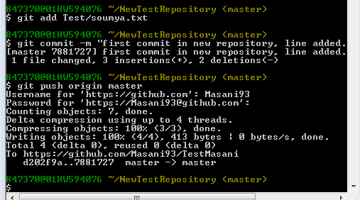
Generally conflict occurs when local repository and remote repository are not at sync. User has made some modification in a file in his local repository and commits it. By that time if the state of remote repository is changed, then Git will not allow new changes to be reflected at the remote repository. When user tries to pull the previous state from remote repository, a conflict occurs due to change in state.

Modification in soumya.txt is made in NewTestRepository and commit is done. Commit is pushed into remote repository.

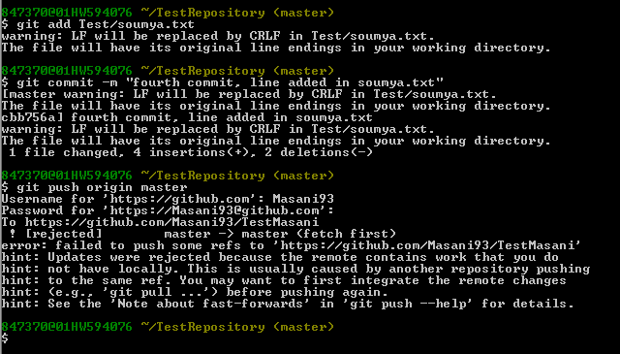
In TestRepository, soumya.txt is also modified and the changes are committed. When the changes are to be pushed, the operation is rejected because, the content of remote and local were not in sync anymore. Hence a pull in TestRepository is required to bring both repositories into sync.

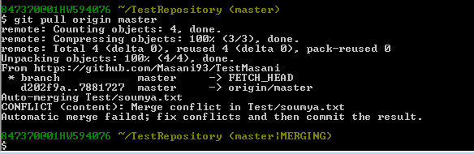
In case of a pull operation, one merge conflict took place which needs to be solved manually and result should be committed.
After solving the conflict, the file can be pushed normally as before.

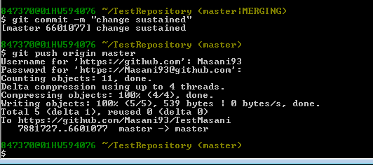
Here, we have kept the changes which were made later on. In the remote repository the commit from TestRepository will be reflected. Now a pull is needed in both local repositories to bring them up dated.
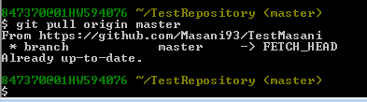

As we see, since the changes of TestRepository were kept as the final, hence the repository is already up to date.

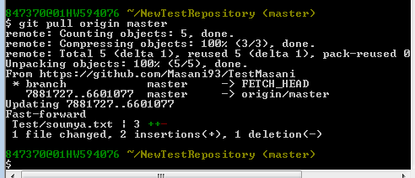
But since the changes made in NewTestRepository were rejected, hence after pull operation, the repository is updated from remote.

Clone Remote repository

First we will create an empty directory, and get inside that directory. After that we will be needing the URI of the remote repository of which we are going to clone.
The command for doing that is $ git clone <Remote URI>

It creates a clone of the remote repository inside the newly created folder.

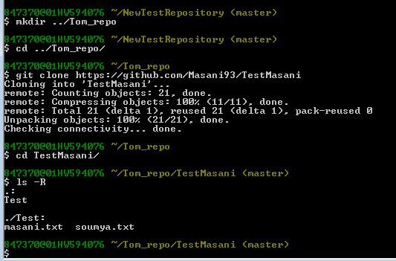

Merging of branches

In cases where user makes changes to a file, but wants to keep the original as a reference, there branching comes with a role.
In our case, branch master has several commits already. Now suppose we want to make changes to the file soumya.txt. First we will create a temporary branch, say soumya. This can be done by
$ git checkout -b <new branch name>
The option '-b' is used for creation of a new branch.
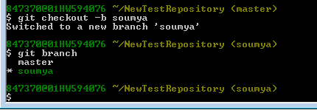
Here we see, a new branch soumya is created and it is automatically selected.
Another important property of branch is, whenever a new branch is created, by default it is in the same state where we have left the previous branch. That means, branch soumya now has all the directory structure of branch master.
Now, a change is made in the file Test/soumya.txt. We will commit the necessary changes.
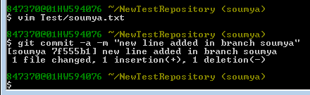
Now we will go back to branch master by command “checkout”.

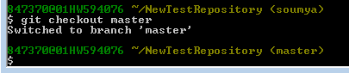
The actual utility of merge is, when the modification is only about addition/deletion of data, where in the other branch the file is kept unchanged. To make the changes reflect use,
$ git merge soumya
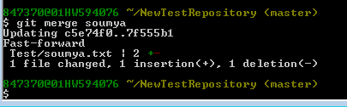
Now this change can be pushed into remote by push command.

Merge-Conflict

When same file from both the branches are changed simultaneously, then in case of merging, conflict occurs.
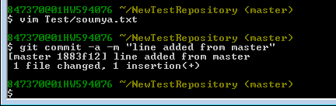
Here changes made in soumya.txt in master branch.

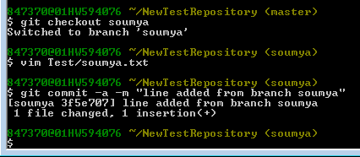
Here changes are made in soumya.txt in soumya branch.

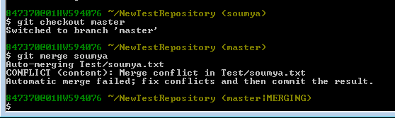

As we see, when branch soumya were being merged in branch master, conflict occurred which needs to be solved manually.

