**LiPo Batteries**

Lithium Polymer batteries are the batteries which consists layers of Lithium and Polymers. These batteries are highly dangerous if they get punctured also they are highly inflammable and can be explosive as well. Thus these batteries need to be charged and used with proper caution. Every Lithium Polymer Batteries have some number written on them which means something. These batteries have less life span as compared to the NiMH and Lead acid Batteries but they are more compact and more powerful.



1. Nominal Voltage and Battery Structure-: LiPO can be charged to a maximum potential of 4.2V,but they come with default charging upto 3.7V and the minimum safe charging for them is 3 V. Every batteries have some figure written on it like “4S” or “3S” this means that three batteries or 4 batteries are connected in series thus suppose if the capacity of 1 battery as 3.7V thus 4S means that the total capacity of the battery is 4*3.7=14.8V. The voltage of the battery determines the speed of the motors specially for Brushless motors.
2. Capacity-: Capacity of the battery is the amount of charge stored in the battery.
3. C Rate/Discharge Rate-: C Rating of a battery is the number which is when multiplied with the capacity gives the safe discharge rate, we also have burst C Rate and charging C Rate for the battery, burst C Rate when multiplied with capacity gives the maximum burst current that can be flown through the battery for few seconds and charging C Rate when multiplied with the capacity gives the safe charging rate.

**H-Bridge**

H-Bridge is basically a circuit which is used to change the polarity across the device whenever we want, mostly H-bridge are used in motor drivers to control the direction of rotation of motors. H-Bridge basically consist of switches, and these switches are turned on and off in a particular way to change the direction of rotation across the motors. The switches are the Transistors which are paired with Diodes and resistors to prevent overvoltage and back current across the transistors.

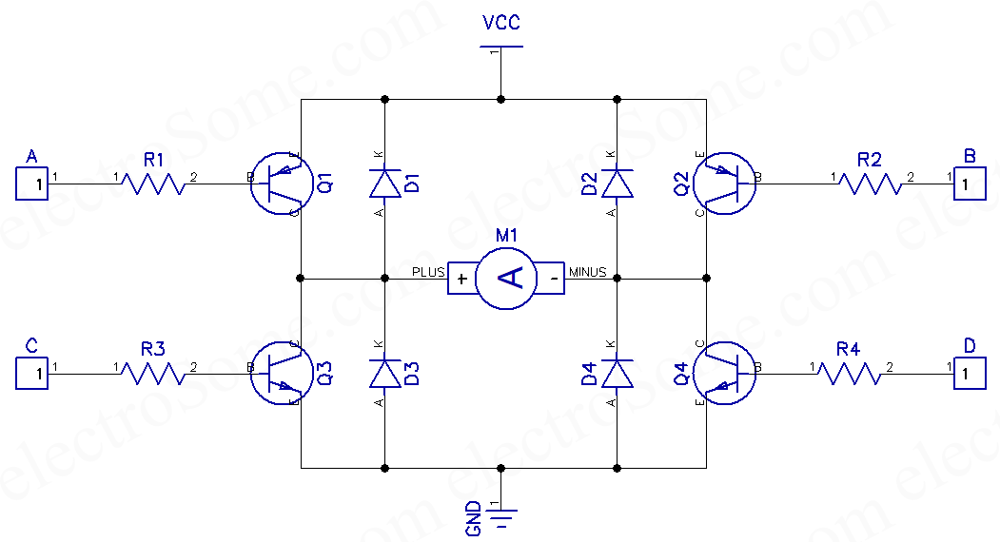

The transistors that are connected to the supply are PNP type and the transistors that are connected to the ground are NPN type. Role of Diodes is to prevent reverse current across the transistors because when motors gets turned off it gives a reverse current feedback.

**Buck Convertors-:** Buck convertors are the DC to DC voltage convertor they convert high input voltage to low output voltage. They have a transistor, diode, capacitor, inductor. They work on the switching and charging discharging principle of inductor and capacitor. They are power regulator circuits thus input power is same as output power. The transistors switches at a particular rate thus they

Keep charging and discharging the inductors and the capacitors.

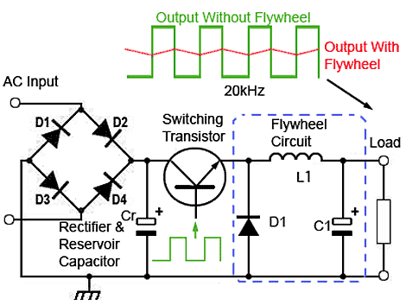

Now when a DC voltage is supplied to the circuit since inductor has opposing nature to the change in current thus it starts building potential in opposite direction as of the current flow direction also capacitor starts getting charged and when the transistor is on the diode is reversed biased thus no current flows through the diode. Now when the transistors is turned off the inductor starts using it’s stored energy to maintain the current flow and soon capacitor also uses it’s stored energy to maintain the current flow and for this circuit the diode is forward biased thus no current is flown through the transistor. Buck convertors have high efficiency. The output voltage of the buck convertor can be changed.

**Boost Convertors-:**

Boost Convertors are the convertors whose output voltage is higher than the input voltage. It also has Transistors for switching purpose and inductors and capacitors as well.

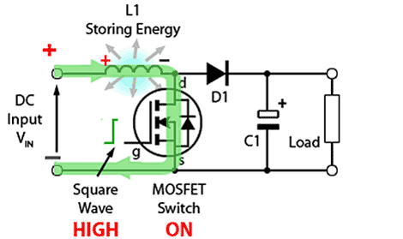

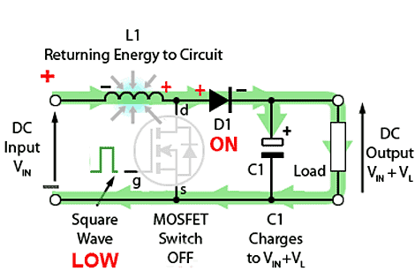

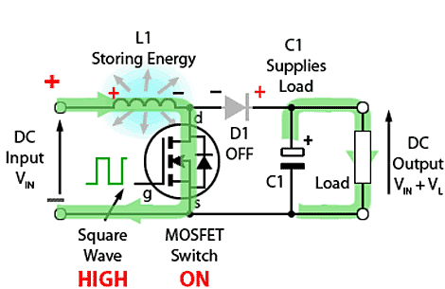

The first circuit shows the very first on time of the boost convertors, when they are turned on for the first time, the current flows through the inductor and hence charging the inductor and also diode becomes reverse biased thus preventing the current flow to the further circuit and thus the transistor gets turned on and get current flows through it now when transistor is switched off that is when it gets low input, then the energy stored in the inductor flows through the circuit as the diode gets forward biased and thus the load gets Vin and the voltage stored in the inductor thus the voltage across load is higher than the input voltage also the capacitor parallel to the load gets charged up with the same voltage , thus when the transistors gets switched on again the capacitor starts discharging with the same voltage and hence maintaining the voltage across the load.

**BUCK- BOOST CONVERTOR-:**

Buck Boost convertor as the name suggest can do both works that is buck and boost when time needs it. For this they have one control unit to change the switching from Buck to boost and vice versa. The control unit keeps a check on the input voltage.

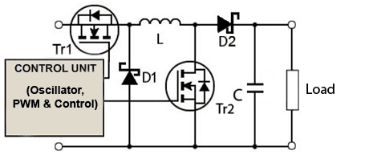

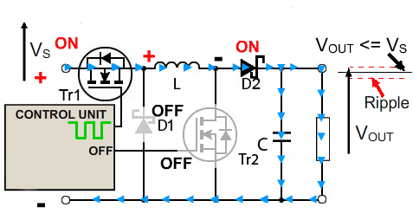

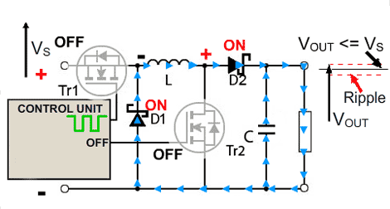

The above circuit is for the circuit when it acts as a  **BUCK CONVETOR.** In this circuit as we can see when we supply on and off to a particular switch /Transistor it acts as a Buck convertor.

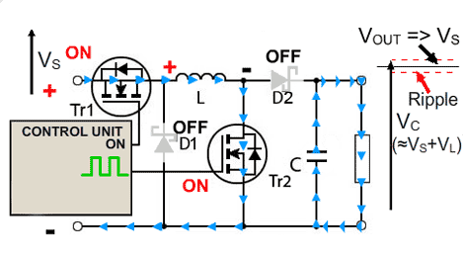

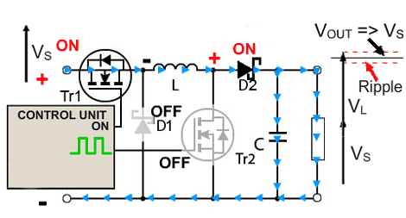

In the above circuit it is acting as a BOOST CONVERTOR.

**HALF WAVE RECTIFIER-:**

Rectifier are the devices which converts a bidirectional signal that is a AC signal to a unidirectional signal that is a DC signal but with variation in magnitude. Rectifier uses Diodes to convert AC to DC as we Diodes acts as a switch since they conduct current in only one direction that is in a Forward Bias, thus when current is in a particular direction or when the diode is forward biased then it conducts thus we get unidirectional output. In **HALF WAVE**  we use one diode and thus we get output only when it is forward biased.

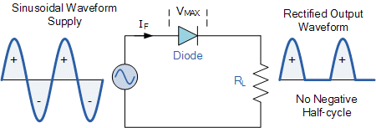

The above diagram shows the half wave rectifier circuit diagram and it’s output waveform as we can see that the frequency of the waveform is same as the input waveform.

**FULL WAVE RECTIFIER-:**

As the name suggest they do the full wave rectification that convert the negative signal also to the positive signal thus they convert full ac wave to full dc with frequency twice the input signal. There are two different circuits of Full wave rectifier 1.Bridge Rectifiers, 2. Full wave rectifier with center tapped transformer.

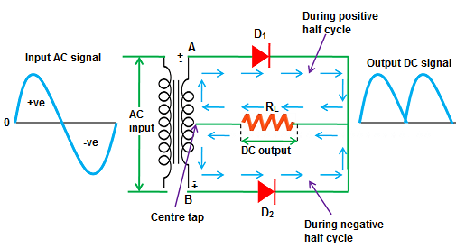

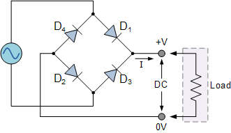

**TORQUE-**

Torque of a motor is the driving force that motor applies on the shaft of the motor to complete each rotation.

**SPEED-:**

Speed is basically rotations per unit time that motors shaft does.

Torque and Speed of the motors are inversely related to each other. Although Torque can remain same even at the low and at the highest speed.

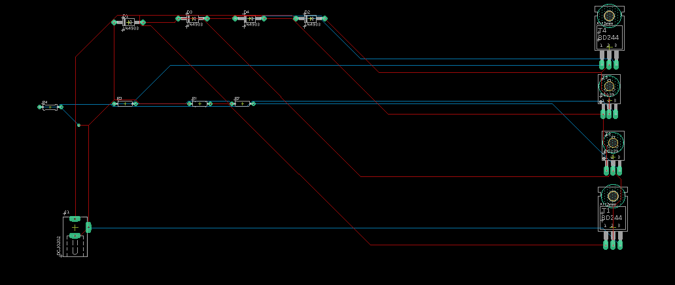

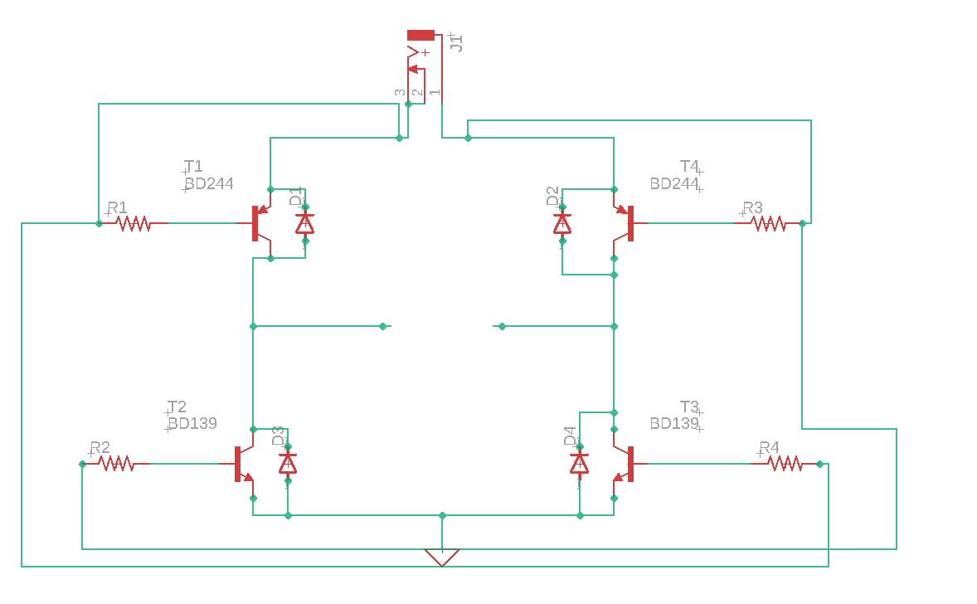

**SAR REVIEWS-:**

IIT M 2019 ROVER CAESAR-:

They used high compression video encoding algorithm so as to reduce the frequency bandwidth and also stitching the feed of the various cameras to reduce the bandwidth. They used 2.4 GHz Ominidirectional antenna, 13dBi Omnidirectional and 15 dbi Sector antenna on Rover, and Their soil testing mechanism on rover. The actuator and the wheels and **ROCKER BOGIE MECHANISM COUPLED WITH DIFFERENTIAL.**  The processor they used and the battery monitoring system.

AGH ROVER-:

CAN Bus, RS 485 BUS , Independent Control of each wheel.Their wheel design.