Setting up a node server

Install node js

Check for the node version in command prompt

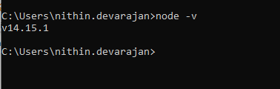

Document to go through for json server

<https://www.npmjs.com/package/json-server>

This command will install a json server

npm install -g json-server

This command will create a db.json file which will have a sample json file

npx json-server --watch db.json

paste the working json file in the db.json and re run the command

npm install -g json-server

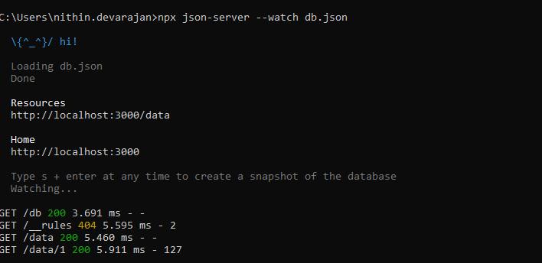

Working json

{

"data": [

{

"id": "1",

"employee_name": "Tiger Nixon",

"employee_salary": "320800",

"employee_age": "61",

"profile_image": ""

},

{

"id": "2",

"employee_name": "Garrett Winters",

"employee_salary": "170750",

"employee_age": "63",

"profile_image": ""

},

{

"id": "3",

"employee_name": "Ashton Cox",

"employee_salary": "86000",

"employee_age": "66",

"profile_image": ""

},

{

"id": "4",

"employee_name": "Cedric Kelly",

"employee_salary": "433060",

"employee_age": "22",

"profile_image": ""

},

{

"id": "5",

"employee_name": "Airi Satou",

"employee_salary": "162700",

"employee_age": "33",

"profile_image": ""

},

{

"id": "6",

"employee_name": "Brielle Williamson",

"employee_salary": "372000",

"employee_age": "61",

"profile_image": ""

},

{

"id": "7",

"employee_name": "Herrod Chandler",

"employee_salary": "137500",

"employee_age": "59",

"profile_image": ""

},

{

"id": "8",

"employee_name": "Rhona Davidson",

"employee_salary": "327900",

"employee_age": "55",

"profile_image": ""

},

{

"id": "9",

"employee_name": "Colleen Hurst",

"employee_salary": "205500",

"employee_age": "39",

"profile_image": ""

},

{

"id": "10",

"employee_name": "Sonya Frost",

"employee_salary": "103600",

"employee_age": "23",

"profile_image": ""

},

{

"id": "11",

"employee_name": "Jena Gaines",

"employee_salary": "90560",

"employee_age": "30",

"profile_image": ""

},

{

"id": "12",

"employee_name": "Quinn Flynn",

"employee_salary": "342000",

"employee_age": "22",

"profile_image": ""

},

{

"id": "13",

"employee_name": "Charde Marshall",

"employee_salary": "470600",

"employee_age": "36",

"profile_image": ""

},

{

"id": "14",

"employee_name": "Haley Kennedy",

"employee_salary": "313500",

"employee_age": "43",

"profile_image": ""

},

{

"id": "15",

"employee_name": "Tatyana Fitzpatrick",

"employee_salary": "385750",

"employee_age": "19",

"profile_image": ""

},

{

"id": "16",

"employee_name": "Michael Silva",

"employee_salary": "198500",

"employee_age": "66",

"profile_image": ""

},

{

"id": "17",

"employee_name": "Paul Byrd",

"employee_salary": "725000",

"employee_age": "64",

"profile_image": ""

},

{

"id": "18",

"employee_name": "Gloria Little",

"employee_salary": "237500",

"employee_age": "59",

"profile_image": ""

},

{

"id": "19",

"employee_name": "Bradley Greer",

"employee_salary": "132000",

"employee_age": "41",

"profile_image": ""

},

{

"id": "20",

"employee_name": "Dai Rios",

"employee_salary": "217500",

"employee_age": "35",

"profile_image": ""

},

{

"id": "21",

"employee_name": "Jenette Caldwell",

"employee_salary": "345000",

"employee_age": "30",

"profile_image": ""

},

{

"id": "22",

"employee_name": "Yuri Berry",

"employee_salary": "675000",

"employee_age": "40",

"profile_image": ""

},

{

"id": "23",

"employee_name": "Caesar Vance",

"employee_salary": "106450",

"employee_age": "21",

"profile_image": ""

},

{

"id": "24",

"employee_name": "Doris Wilder",

"employee_salary": "85600",

"employee_age": "23",

"profile_image": ""

}

]

}