1、数据乱码，如果传中文，格式保存不对

前端字段名称：

Company Name / Trading Name\*

Company Address\*

2、数据丢失，比如：Company Website\*

VAT / Tax ID / Company ID

Facebook

LinkedIn

Youtube

Twitter

Blog

Preferred phone number

Secondary phone number

Your product focus

Email subscription

SMS update subscription

Other countries of interest

Total company employees

Total sales employees

Yearly total revenue

PC client

Server

Service

Software

Others

Reseller type

Your company's product focus

Targeted customer market type (Pick by your customer size)

Industry segment (Pick your primary industry segments)

3、数据篡改，前端输入值和保存值不一致，字段：

Date of the company creation

Did someone refer you?

No, I am not authorized to sign.

4、前端界面跳转过程中，有些数据没有带入到下个界面

Country / Region\*未带入下个界面

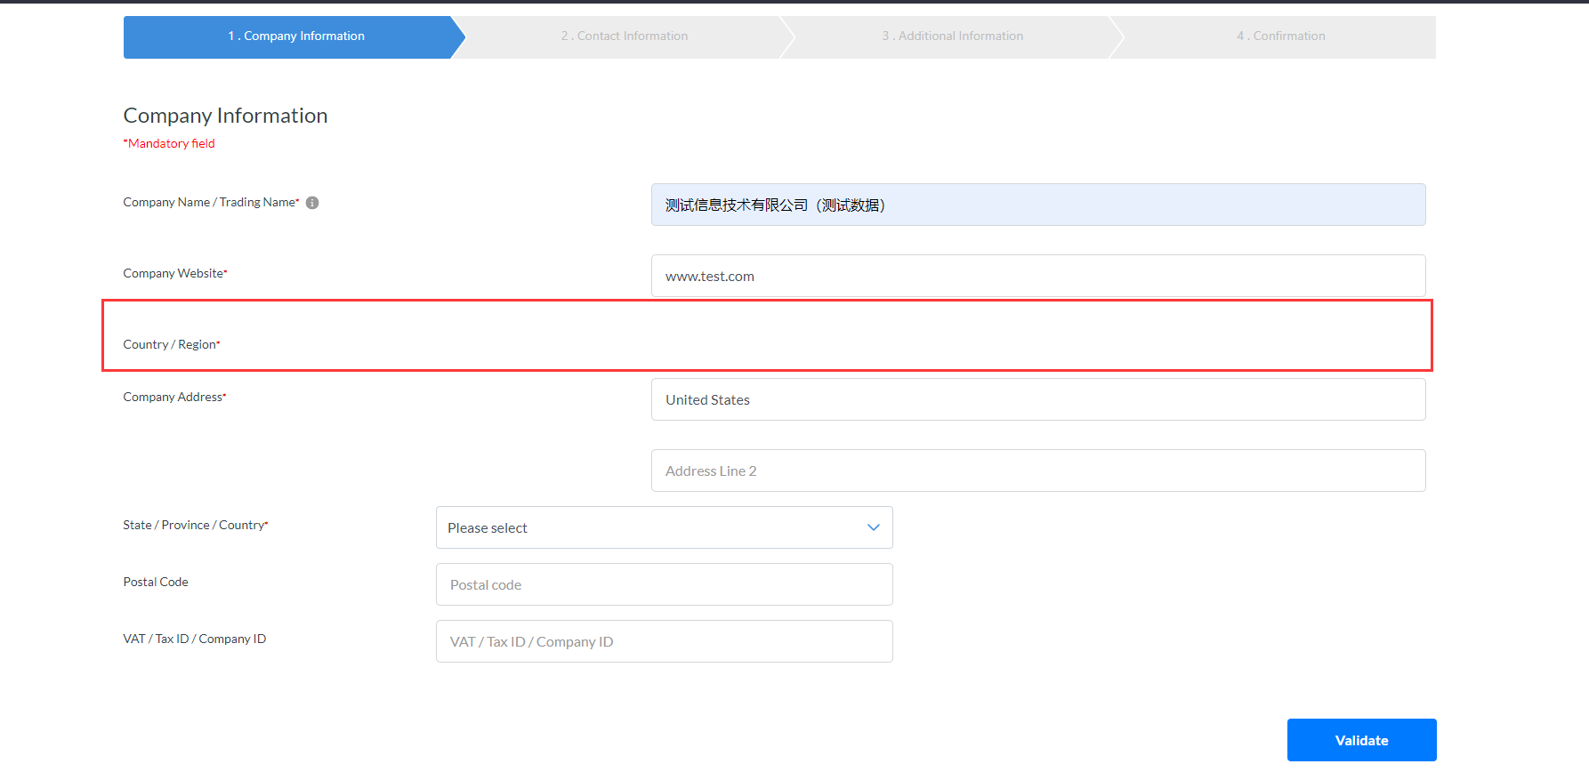

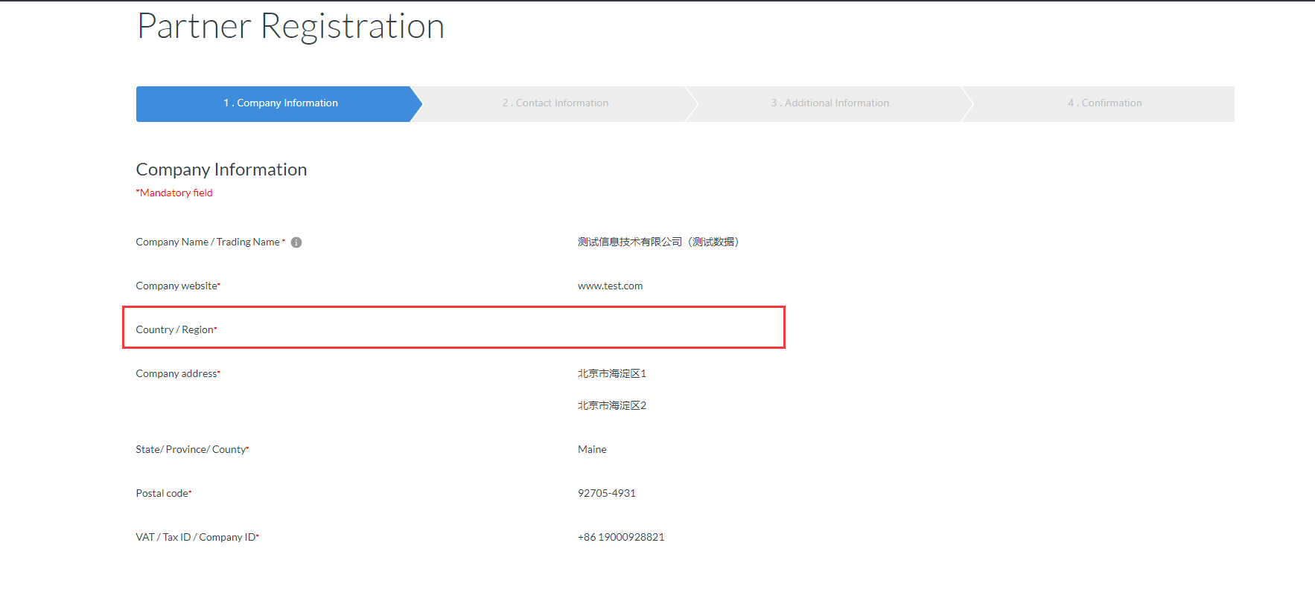

5、功能缺失

1.Is the owner or principal of your company a current or former Lenovo Vice President, Lenovo Senior Vice President, or such officer of a Lenovo subsidiary?

选择Yes时没有提供录入联系人姓名的位置

2.Does any owner of principal of your company or any of their immediate family members, own or control over 5% in Lenovo stock and/or stock in a Lenovo subsidiary

选择Yes时没有提供录入联系人姓名的位置