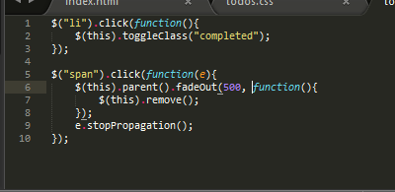
1.To avoid bubbling effetcs

Upper layers firing when firing a lower layer : you have to use a
function(e){
e.stopPropagation();
}

2. To first fadeOut and then remove something
You can call a function inside fadeOut
fadeout(function(){
$("something").remove();
});

3. To reach an element from a parent element :
You can use $("something").parent()

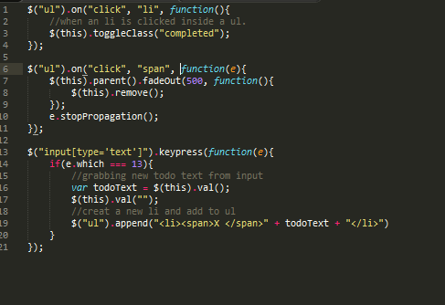
1. Append method
It will add an element to the element we selected.
$("something").append("<span id="momo">Hello!</span>

2. On()
We used on() because it targets present and future elements on the page. What .click() can't do !

For example we wanted to target present and future "li" inside of a certain "ul".
$("ul").on("click", "li", function(){
});

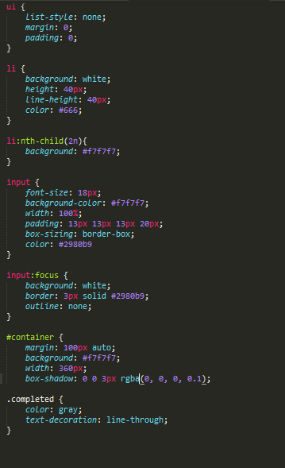

list-style: none;
=> takes off the styling of list

line-height: 40px;
=> center a line inside a range of 40px (height)

li:nth-child(2n){};
=> reach each 2nd li.

Input:focus
=> input' styling when it is focused.

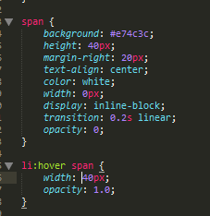
This is the span we used to shape our font awesome icon.
Display : inline-block; made a nice block out of the icon, squarelike, taking the whole space.
Transition: 0.2s linear; made it appear sidewise taking 0.2s

li:hover span {} means what happens when we hover a span inside an li
so the span takes 40px with an opacity of 1.0

