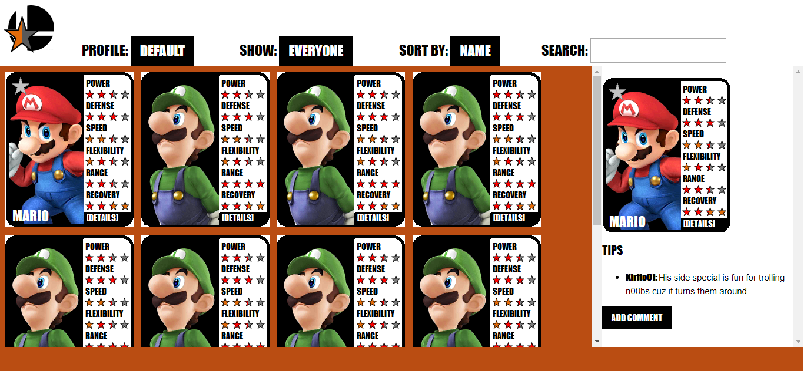

Prototype image (In the actual thing it won’t be 7 Luigis…)

# Design Details

## Included Characters

We should include all the playable characters in the latest generation of games, including ones from downloaded content. In the case of Mii Fighter, we should include separate cards for the three different types (Brawler, Sword Fighter, and Gunner).

## Graphics

General rules: The font for most of the website will be “Impact”.

  Buttons will use the “w3-button” class from the w3.css document (available at w3schools.com). By default they’ll use an 18pt Impact font with a black background and white text. On hover, use the default on-hover color of the w3-button class (Shown here as grey with black foreground). The same color scheme will be used for drop-down menus.

Smash Bros Ratings Logo (100x100px)

 The rating stars: (User selected, Site average, not selected) (20x20 px ea.)

Favorite stars (Not favorited, favorited) (30 x 30 px)

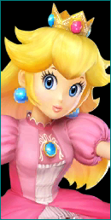Character portrait (example: Peach) (129x257px)

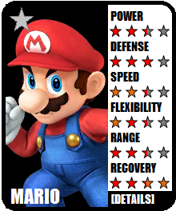 Character card (219x264 px). Favorite star is 8 pixels from the top, 10 from the left. The majority of the text and the rating stars are 30 pixels from the top, and 134 pixels from the left. Each row of rating stars is 40px lower than the one before. The font for all of it is “Impact,” 11 pt, except for the character name. It can be up to 18 pt., but it can be lower for longer character names. For the rating stars, if a user ranking exists, the lower of the two rankings (user and site average) has higher display priority, so that you can see both. If they’re the same, choose the user ranking.

The character portrait is 4 pixels from the top and 5 from the left. These are available from the link provided below. The provided source has many skins for the same characters, and some non-playable characters. Use the default skin for all included characters on the site.

The stars should be clickable to register a user ranking. If a row of stars is being hovered over, it should display as if the user ranked the star they’re hovering over. Likewise with the favorite star, it should look like it is favorited when hovered over, whether it is or not. The majority of the rest of the card should also be clickable to bring up the character side-pane.

Character Portrait source: https://www.spriters-resource.com/resources/sheets/60/62679.png

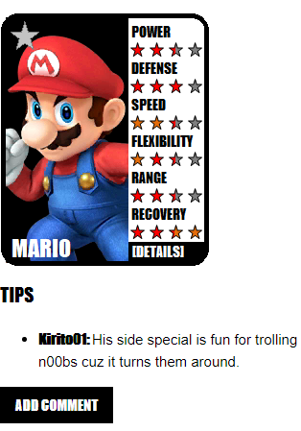The character pane should be on the right and should take up a pleasing amount of space. The tips should be located under the character, with an unordered list for the comments. The title of the profile used to make the comment will be 11pt Impact but the text itself will be 11pt Arial or Helvetica for readability. The add comment button will follow standard formatting for buttons.