run.bat:
* Please change the Automation_MIZ.jar folder path
* And change java jdk path plz follow the below steps
Step:1
Right click run.bat . open with notepad
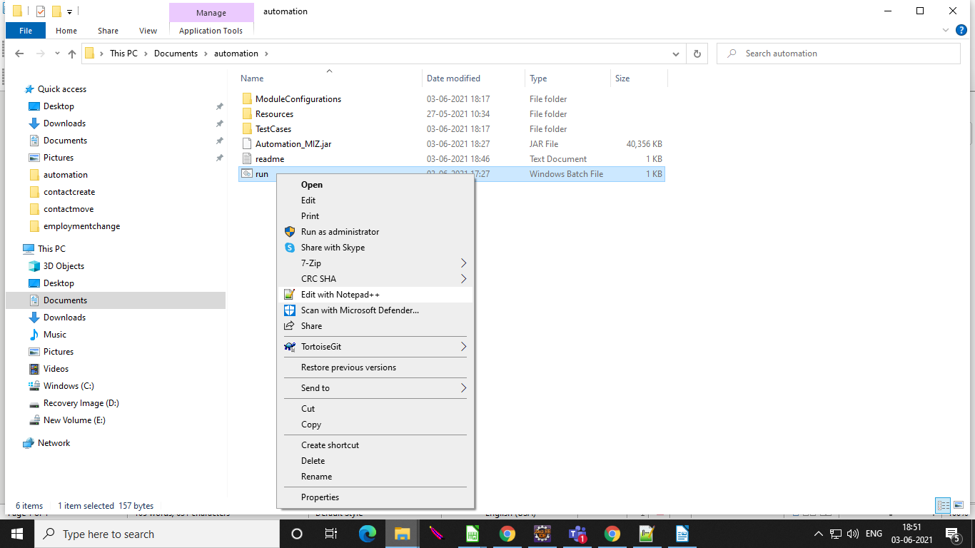
Step:2
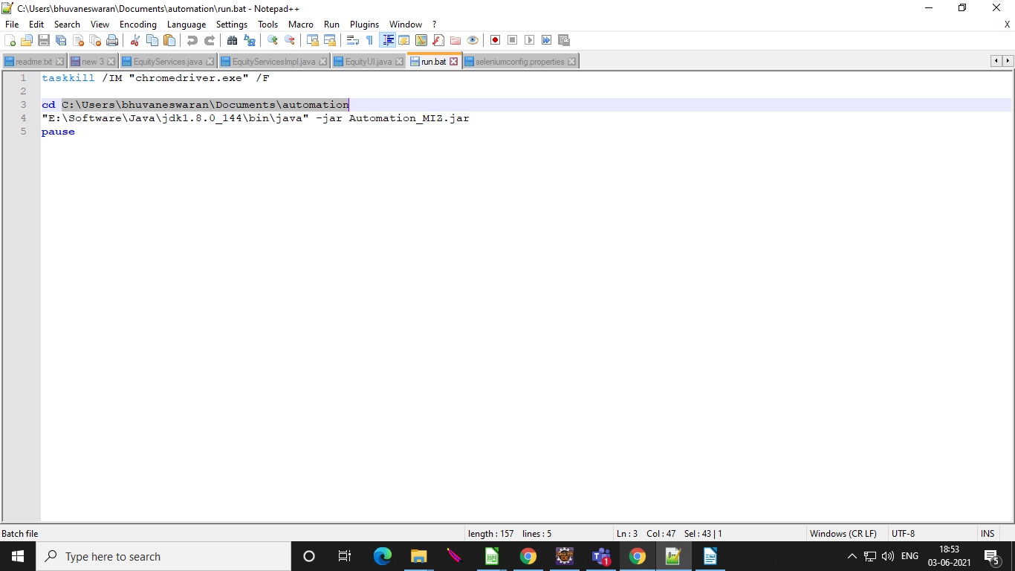
Change your folder path :

Step:3
Change your java JDK path
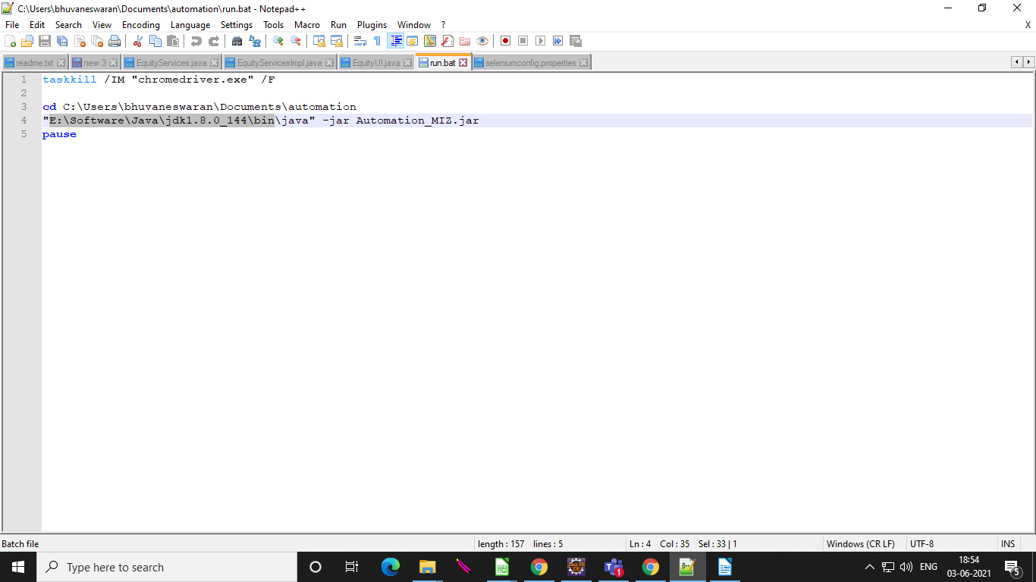
Step:4
Finally save your file

Module Configuration :

Step 1:
Open Module Configurations folder
Step 2:
Right Click the seleniumconfig.properties Open with notepad
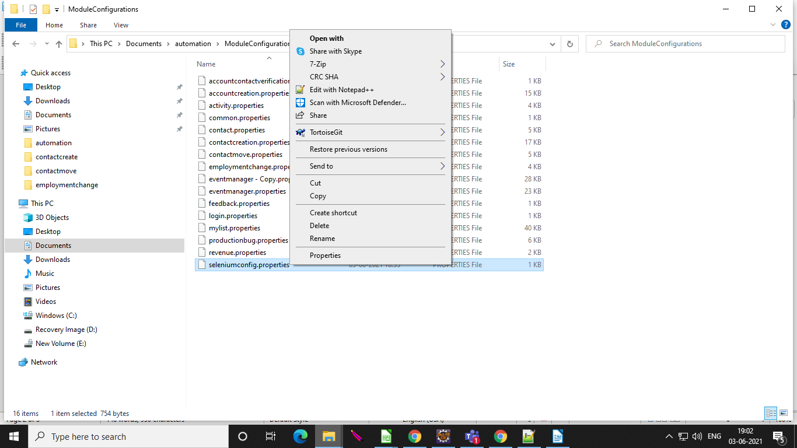

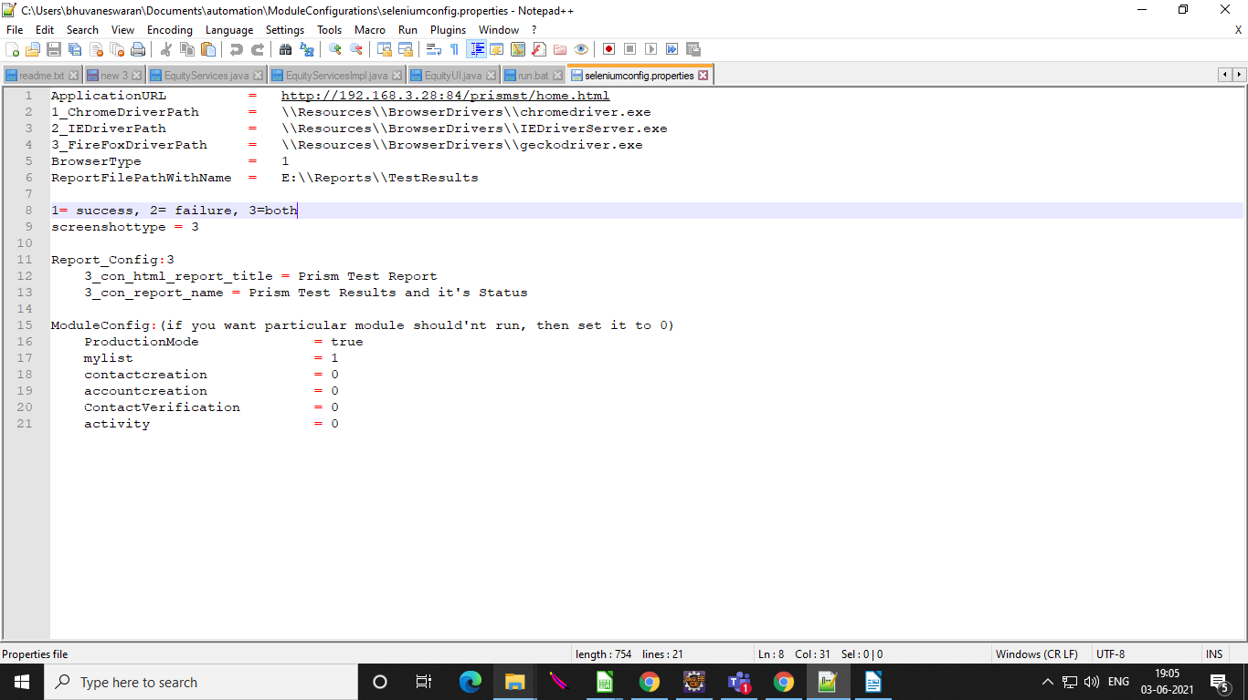
Step 3:
Change your application url , ReportFilePathWithName and module setup

Step :4
Change the module config in 1 .it execute particular module
Change the module config in 0 .it not ececuted

General Info:

Contact Creation:

* All the contact creation test sample test data are available in excel
* please enter account name in excel sheet then contact create under the account
* After the Creation of new account delete the created account manully

Account Creation:

* All the Account creation test sample test data are available in excel
* please enter account name in excel sheet
* After the Creation of new account delete the created account manully

my list:
* All the my list test sample test data are available in excel

